# Employee Work Productivity Analysis - Solutions (Q&A)

## Q1: Top 5 Productive Employees

Answer: Used SORT/FILTER logic to rank employees by Productivity_Score and display top 5.  
Excel formula example: =SORT(A2:G100, <column_of_Productivity_Score>, -1)

Top 5 employees (table):

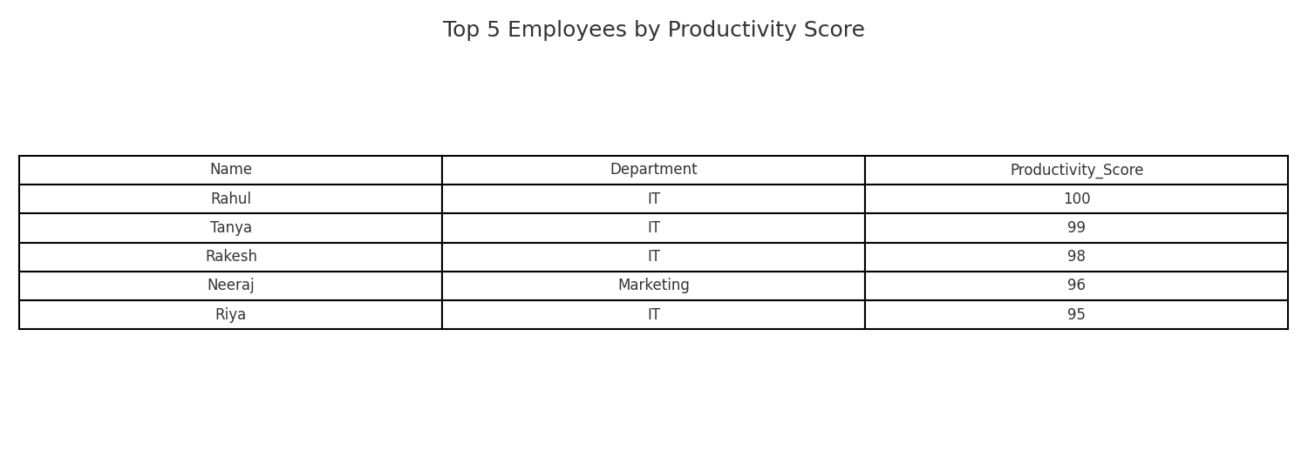

Bar chart visualization:

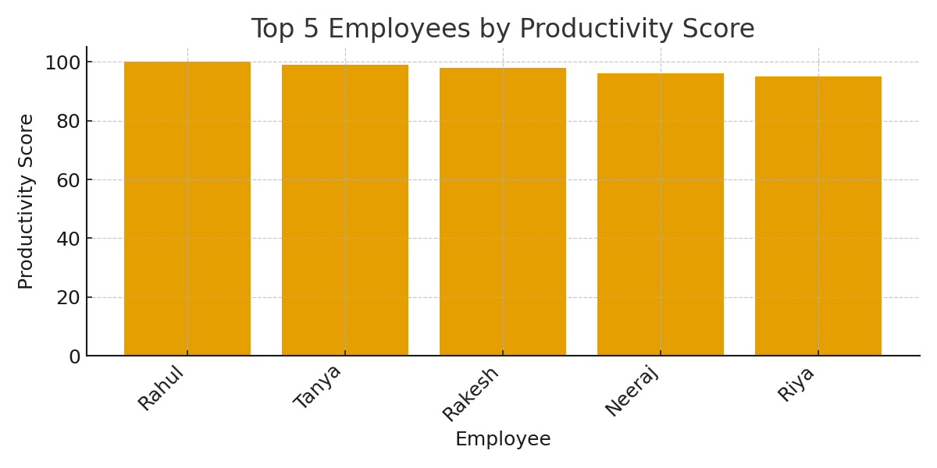

## Q2: Department-wise Productivity Consistency (Std Dev)

Answer: Calculated population standard deviation (STDEV.P) of Productivity_Score within each department using a PivotTable or formula.  
Excel formula example: =STDEV.P(IF(DepartmentRange=DeptName, ProductivityRange))

Std deviation by department:

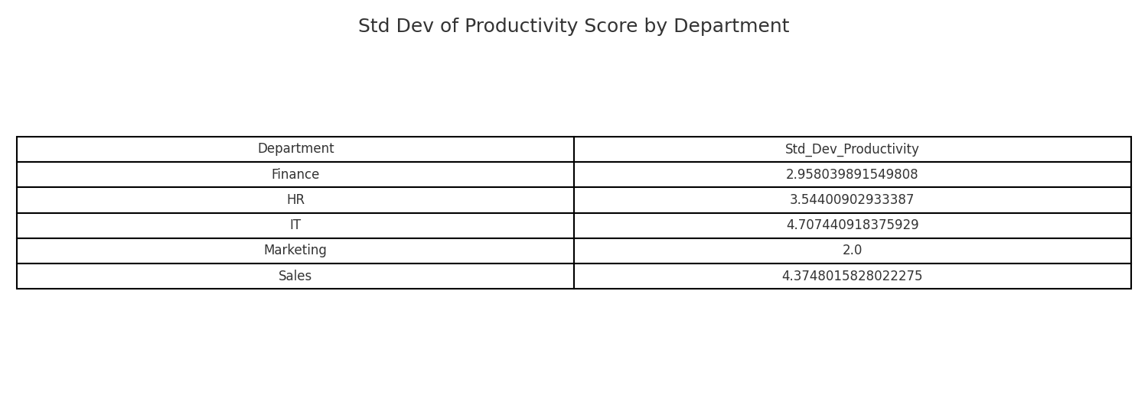

Department with least variation: Marketing (Std Dev = 2.0000)

## Q3: Productivity Efficiency Index (PEI) and Top 3

Answer: PEI calculated as PEI = (Productivity_Score × Performance_Rating) / Hours_Worked.  
Excel formula example: = (E2 * F2) / D2

Top 3 employees by PEI:

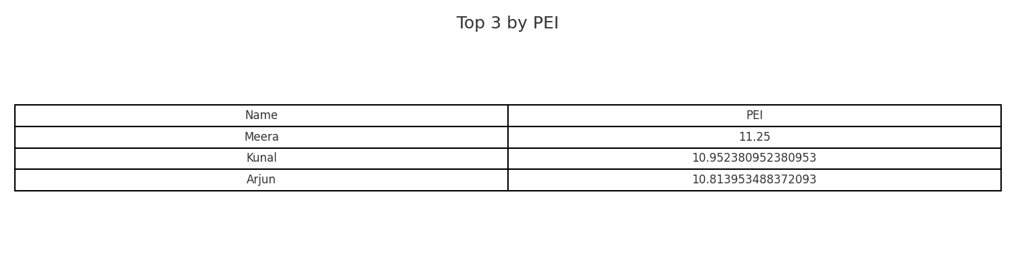

## Q4: Correlation Analysis - Influence on Performance Rating

Answer: Compared correlation coefficients between Performance_Rating vs Hours_Worked and Performance_Rating vs Tasks_Completed using CORREL.  
Excel formula examples:  
=CORREL(Performance_Rating_Range, Hours_Worked_Range)  
=CORREL(Performance_Rating_Range, Tasks_Completed_Range)

Correlation (Performance_Rating vs Hours_Worked): 0.9462348583818776

Correlation (Performance_Rating vs Tasks_Completed): 0.9574553703647626

Stronger influence on Performance_Rating: Tasks_Completed

Scatter plot Hours Worked vs Productivity Score:

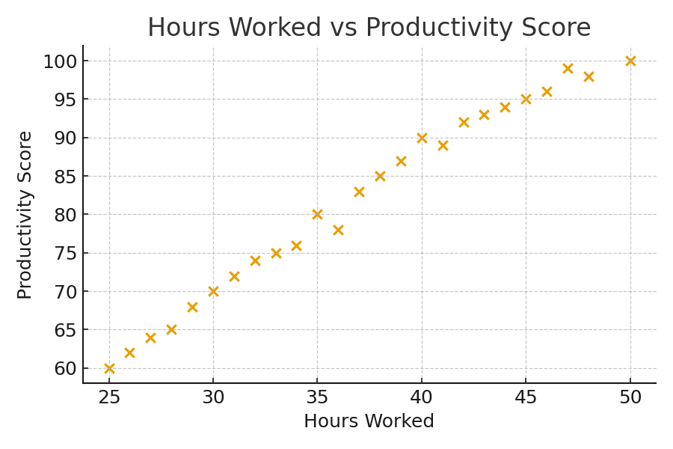

## Q5: Underutilized High Performers

Answer: Identified employees with Performance_Rating ≥ 4 and Hours_Worked < Average Hours.  
Excel formula example: =FILTER(TableRange, (Performance_Rating>=4)*(Hours_Worked<AVERAGE(Hours_WorkedRange)))

Average hours across employees: 37.04

Underutilized high performers (table):

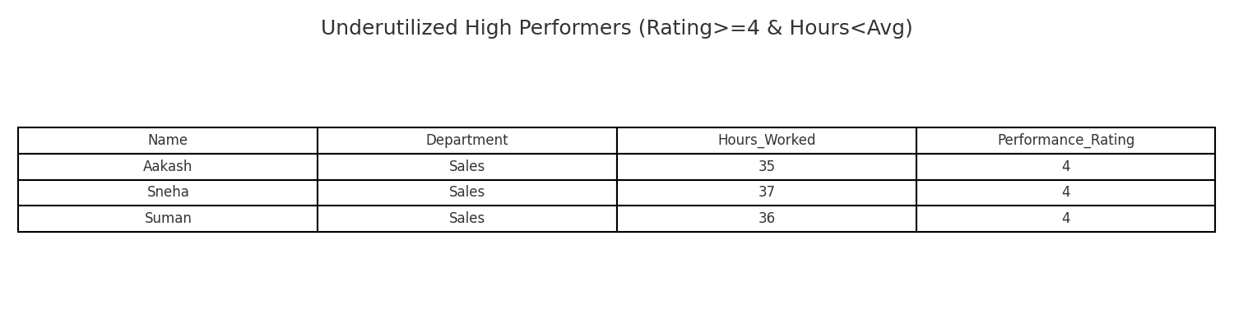

## Q6: Tasks per Hour Efficiency

Answer: Added column Tasks_per_Hour = Tasks_Completed / Hours_Worked.  
Excel formula example: =C2 / D2

Most task-efficient employee:

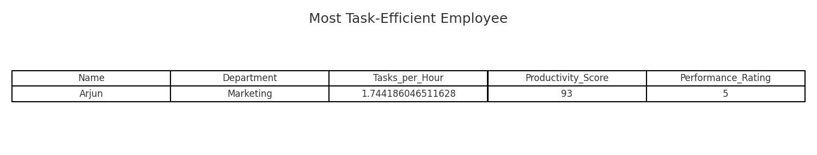

Notes & Assumptions:

- Numeric coercion: Columns Hours_Worked, Tasks_Completed, Productivity_Score, Performance_Rating were converted to numeric; non-numeric entries treated as missing.  
- PEI and Tasks_per_Hour calculations skip rows with missing/zero hours to avoid division errors.