Contents
1. Quick Project Summary (What We’re Building / Running) 1
2. Versions We Are Using (Match with Dev Environment) 1
3. Tools — What They Are & Why We Need Them 2
4. Installation — Step by Step with Verification 2
5. Clone the Repositories 3
6. Running the Backend (Spring Boot) 4
7. Backend Troubleshooting — Common Errors & Fixes 5
8. Running the Frontend (Angular) 5
9. Connect Frontend to Backend 5
10. Troubleshooting & Rescue Plan 5
11. Verification Checklist 6

OrderKraft — Local Setup & Run Guide
This document provides a comprehensive, step-by-step setup and run guide for the OrderKraft full-stack application. It includes explanations for beginners about what each tool does, why it is required, how to install the correct versions, how to clone repositories from GitLab, open and run the backend in Spring Tool Suite (STS), run the frontend in Visual Studio Code (VS Code), configure ports, and troubleshoot common errors. This guide follows enterprise-level documentation standards suitable for onboarding new developers.
________________________________________________________________________________

1. Quick Project Summary (What We’re Building / Running)
OrderKraft is a full-stack enterprise application built using Spring Boot (for backend) and Angular (for frontend). It manages orders, inventory, and communication between various user roles such as admins, managers, and customers. This guide helps new developers or testers to set up and run the project on a new Windows system using GitLab, STS 4, and VS Code.
We will:
- Clone both repositories (backend and frontend) from GitLab.
- Run the backend in Spring Tool Suite 4 (STS).
- Run the frontend in Visual Studio Code using Angular CLI + Node + npm.
- Configure ports and fix common issues during the setup process.
________________________________________________________________________________

2. Versions We Are Using (Match with Dev Environment)
Before running the project, ensure that all software versions listed below are properly installed. Version mismatches may cause compatibility issues between backend and frontend components.
- GitLab (platform): Hosted at organization’s GitLab instance (web UI).
- Spring Tool Suite (STS): Version 4.x
- OpenJDK: Version 17.0.14
- Angular CLI: 20.1.1
- Node.js: 22.17.1
- npm (Node Package Manager): 10.9.2
- Visual Studio Code: 1.105.1 (Electron 37.6.0, Node 22.19.0, Chromium 138.x)
- Operating System: Windows 10/11 x64
Note: The Node version within VS Code (used internally by Electron) may differ. Use the Node version installed on your system (verified using node -v) for Angular CLI.
________________________________________________________________________________

3. Tools — What They Are & Why We Need Them
- Git: Version control system that allows cloning, pulling, pushing, and managing branches.
- GitLab: Remote server platform used to host repositories, track issues, and manage merge requests.
- Java (JDK 17+): Provides the runtime and compiler required for building and running Spring Boot applications.
- STS 4 (Spring Tool Suite): An IDE optimized for Spring applications. Simplifies running Spring Boot apps directly.
- Node.js & npm: Node.js is the JavaScript runtime, and npm is the package manager required for Angular projects.
- Angular CLI: A command-line tool to create, run, and build Angular applications (provides ng serve, ng build, etc.).
- VS Code: A lightweight editor for frontend development with extensive plugin support for Angular, TypeScript, and debugging.
________________________________________________________________________________

4. Installation — Step by Step with Verification
- Install Git:
Download from https://git-scm.com/downloads and follow default installation steps.
Verify installation using: git --version
- Install Java (JDK 17 or newer):
Download from https://adoptium.net/ and set JAVA_HOME if not automatically configured.
Verify installation using: java -version (expect: openjdk version "17.0.x")
- Install Spring Tool Suite (STS 4):
Download STS 4 for your OS from https://spring.io/tools. Open STS once after installation to finalize setup.
- Install Node.js & npm:
Download Node.js v22.17.1 (LTS) from https://nodejs.org/en/download/.
Verify versions:
node -v → v22.17.1
npm -v → 10.9.2
- Install Angular CLI:
Run: npm install -g @angular/cli@20.1.1
Verify installation using: ng version
- Install Visual Studio Code:
Download from https://code.visualstudio.com/ and verify using: code --version
________________________________________________________________________________

5. Clone the Repositories
Open a terminal or PowerShell window and navigate to your preferred workspace directory.
- cd C:\Users\<YourUser>\projects
- git clone http://capstone-gitlab.career-shaper.com/orderkraft_squad-4/orderkraft_team4_backend.git
- git clone http://capstone-gitlab.career-shaper.com/orderkraft_squad-4/orderkraft_team4_frontend.git
Expected directory structure:
C:\Users\<YourUser>\projects\
├─ OrderKraft_team4_backend\ # backend (Spring Boot)
└─ Orderkraft_team4_frontend\ # frontend (Angular)

6. Running the Backend (Spring Boot)
- Open STS → File → Import → Existing Maven Projects.
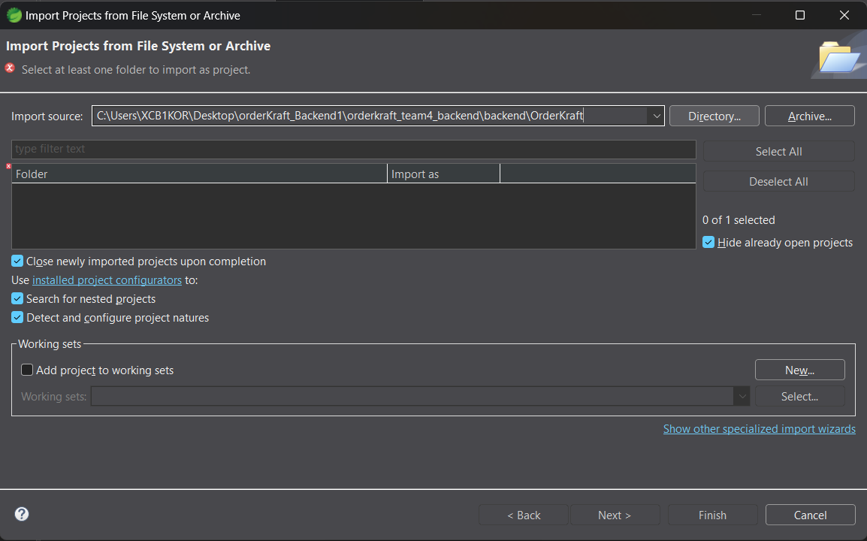
- Point to OrderKraft folder → Finish → Wait for dependency build.
- Update Project: Right-click project → Maven → Update Project → Select checkboxes → OK.

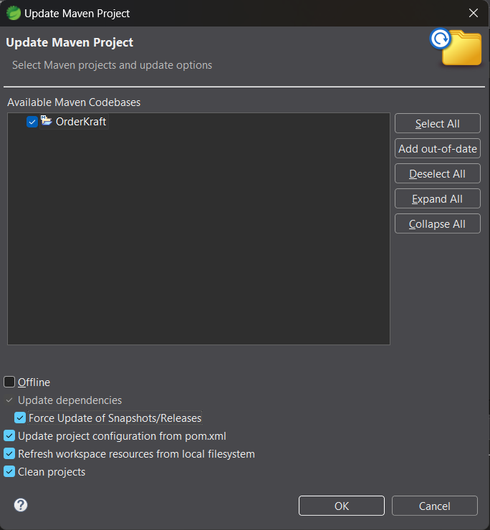
- Run Project: Right-click → Run As → Spring Boot App.
- Console output should show: Tomcat started on port(s): 8080 (http).
- To change backend port, modify src/main/resources/application.properties:
server.port=8081

7. Backend Troubleshooting — Common Errors & Fixes
- Maven dependency issues → Right-click project → Maven → Update Project or run mvn clean install.
- JAVA_HOME not set → Set environment variable JAVA_HOME to JDK path and restart STS.
- Port in use → Change port using server.port property.
- Build errors → Delete target folder and rebuild using mvn clean install.

8. Running the Frontend (Angular)
- Open VS Code → File → Open Folder → Select orderkraft_team4_frontend.
- Open terminal in VS Code → Run npm install to install dependencies.
- To start development server, run npm start or ng serve.
- By default, the app runs at http://localhost:4200.
To change frontend port:
ng serve --port 4201

9. Connect Frontend to Backend
Edit src/environments/environment.ts (and environment.prod.ts) and update the API base URL:
export const environment = {
production: false,
apiBaseUrl: 'http://localhost:8080'
};

10. Troubleshooting & Rescue Plan
- Cannot clone → Check GitLab access permissions and internet connectivity.
- Maven build fails → Run mvn clean install for full logs and recheck dependencies.
- Backend not starting → Verify port availability, DB connections, and logs.
- Frontend npm errors → Delete node_modules and reinstall dependencies.
- CORS/auth issues → Verify backend CORS configuration and frontend API URL.
- Version mismatches → Verify Node, npm, ng, and Java versions using system checks.

11. Verification Checklist
- Backend console shows 'Tomcat started on port(s): xxxx'.
- Frontend loads successfully at http://localhost:4200.
- API calls show 200 OK responses in browser DevTools.
- No major build or dependency errors.

