CS2003 Practical net2 report

Matriculation ID: 220006323
2023-11-08

Overview
In this practical I was asked to create a server and client java program whilst following up to 10 requirements. R1-R10.
In this practical I successfully fulfilled requirements R1-R8 by creating a client and server application that saves messages sent from the client to a folder with time stamped titles and is able to be read by a index.php file that shows the messages of the current day. My client is able to take an APDU command of %%to and send a message to a specific student if you know their username and their server is active.

Design
For the design of my submission I have three java files in DMBServer, DMBClient and Configuration. I also have a properties file in the cs2003-net2.properties.
For the DMBClient, DMBServer and Configuration I used the template of the client file on studres from this coursework as well as the server file from the week 1 coursework. I also used the configuration.java file from the week5 exercise supplementary. I also used extracts from the DirAndFile and TimeStamp java file in my DMBClient file.
The Server waits for a client to connect. Once connected it waits while sending heartbeats(R6) to see if the client is still active. The client reads in any system input and sends that to the server. Once the server receives the message from client. It prints it to the console and creates a file in the specified directory. Information such as port numbers, directory locations and addresses are found in the cs2003-net2 properties file. This information is read and stored using the configuration java file to be used by the server and client.
In order to run the program you:
populate the cs2003-net2.properties with your relevant information
run the server file using java DMBServer.java
run the client file java DMBClient.java
Type a message in the console that you used to run the client.

Implementation
Configuration.java
In the constructor for this class I use a try statement and create an input stream of a specified file.
If the stream is not null I then load it into a properties object. I then assign the relevant proprieties to their respective attributes.
I have getters for the port(getPort), server address(getAddress), the location of the website directory(getBoard) and the csv file (getCSV) that return the relevant attributes.
DMBClient.java
For the client file I create a configuration object for the cs2003-net2.properties file. I then assign the server address and port number using the getPort and getAddress methods for this object.
I catch a numberformatexception incase the port is not an integer.
I then use the starclient method which creates a socket using the address and port number from before.
I use a while loop to create an infinite loop. I create a buffered reader to read the console input continuously.
In the normal case (not starting with %%to) the console input is converted into a byte array and sent to the server using the write method for the outputstream. If the size of the array is greater than 256 it is checked and only sends the number of bytes upto 256 and therefore in practice truncates the message upto the 256 byte mark. This is done by the variable r. r will be set to 256 if the length of the message is more than 256 characters. This achieves R2 of the specification.
If %%to is used at the start of the input from the console then it is caught by the if statement at the beginning of the loop. I use the CSV method in this loop. The CSV method uses a buffered reader to populate a hashmap from the relevant csv file specified in the properties file. I use a while loop to read each line and split it by each comma. The first and second columns are placed into the hashmap and the map is returned.
After retrieving the hashmap I then split up the input based on spaces. If %%to is the only input provided I then print the required format for inputting a %%to command and restart the loop.
I create a new socket connection using the startClient method. To get the username I use the first index of the task array that split the input by spaces. I also use the get method on the hashmap for this same variable. This returns the portnumber associated with that username. If the connection is succesful then a message is sent containing from user and then the message.
I catch a socket exception in case the server closes. If this is the case I close the client side socket (R6)
DMBServer.java
I use the startserver method to create a server socket with the relevant port from the properties file.
I use the accept method to wait for a connection. Once this is successful I use an infinite while loop to run continuously (R4) I wait for data to be sent by continuously reading from the input stream. I simultaneously send empty bytes to the client. If the client is ever closed It would cause an IOException. Therefore I catch this to make sure I am not waiting for data from a closed socket. (R6).
Once data is received I convert the byte array into a string and then use the FileDir method.
This method uses the Timestamp and DirAndFile as a base. I create a date object and then assign it to two formats one being the yyyy-mm-dd_HH-mm-ss.SSS and the other being yyyy-mm-dd
The second one is used to create a new directory for the current date. If the directory already exists I then create a file using the first format as the name in that directory and write the data received to this file. If the directory doesn’t exist it is created and the same process if followed.
This achieves the goal of creating a file in the relevant directory with the current time as a title and the relevant data written upon it.

Testing
Test1)
Opening the Client without a server listening
java DMBClient.java
IO Exception: Connection refused
Test2)
Opening client with server listening
java DMBServer.java
--* Starting server ServerSocket[addr=0.0.0.0/0.0.0.0,localport=23691]
(server side)

++ Connecting to as645.teaching.cs.st-andrews.ac.uk:23691 -> Socket[addr=as645.teaching.cs.st-andrews.ac.uk/138.251.22.78,port=23691,localport=41722]
(client side)
Test3)
closing server then trying to send messages by client
Test
Sending 4 bytes
Test
Sending 4 bytes
Connection Broken!
(the program terminated after the second message was attempted to be sent) (R6)
Test4)
closing client before sending a message .
(instantly closes the server)(R6)
Test5)
Sending message to server normally
Hello! I am sending a message to the server!
Sending 44 bytes
(client side)
Received 44 bytes --> Hello! I am sending a message to the server!
(server side)
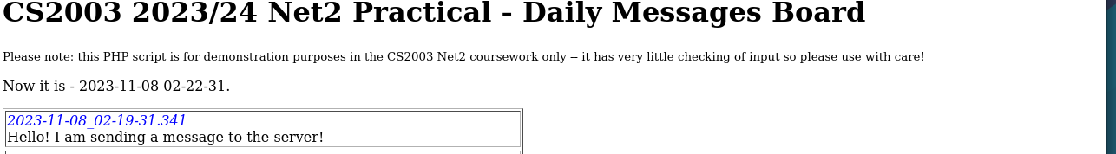

R8
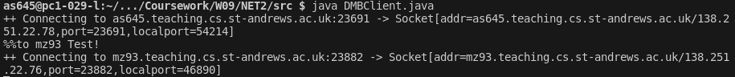
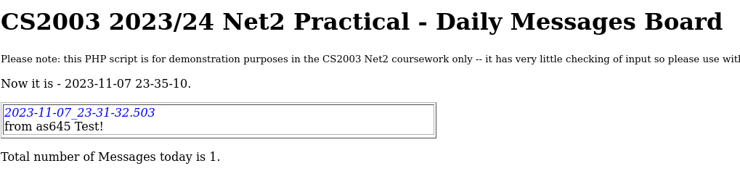

Evaluation
This section should include an evaluation of the success of your submission compared to what you were asked to do.

Conclusion
This section should address:
- what you have achieved
- what you found difficult
- what you would have done if you had more time

Bibliography
Peterson, Larry, and Bruce Davie. 2012. Computer Networks: A Systems Approach. Elsevier. https://github.com/SystemsApproach/book.

