**HakerRank**

**SQL**

**Day 1: 10/01/2025**

Que:

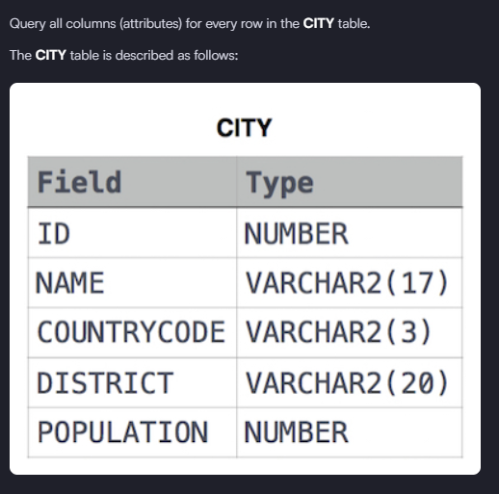

Solution:- Select * from CITY

Que:

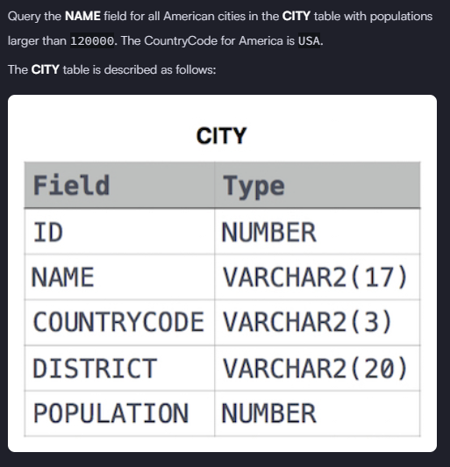

Solution: - select name from city where population > 120000 AND Countrycode = 'USA'

Que

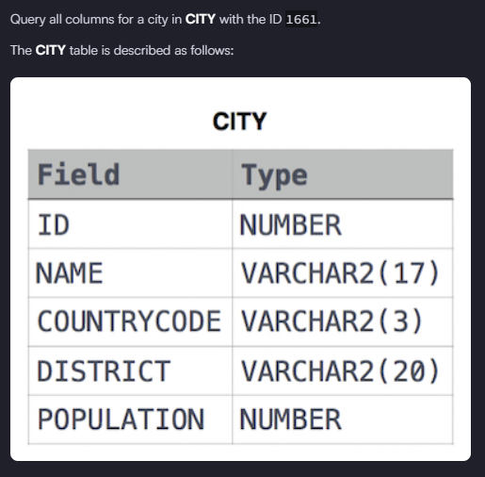

Solution:- select * from city where ID = 1661

Que:

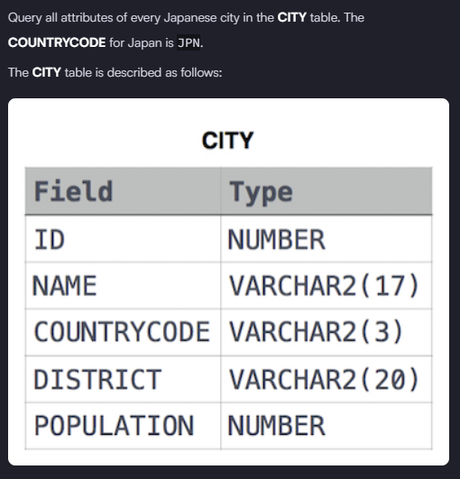

Solution: - select * from city where countrycode = 'JPN'