**HakerRank**

**SQL**

**Day 2: 11/01/2025**

**Que**

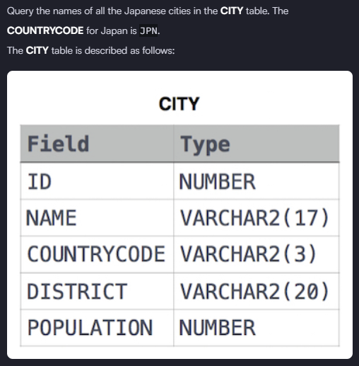

**Solution: -** select name from city where countrycode = 'JPN'

Que:

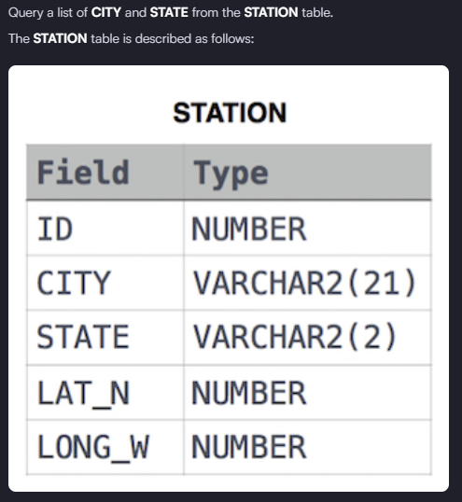

**Solution: -** select city, state from station

Que:

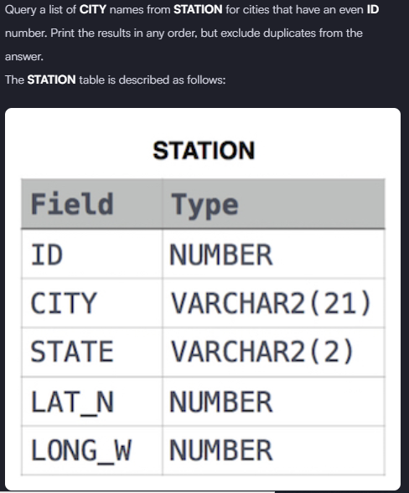

**Solution:** - select distinct city from station where ID%2 = 0

Que:

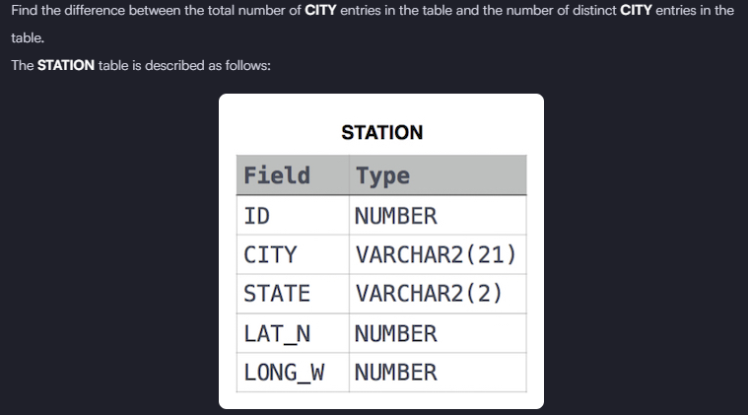

**Solution: -** select count(city)-count(distinct city) from station