**HackerRank**

**SQL**

**DAY 3 – 12/01/2025**

Que:

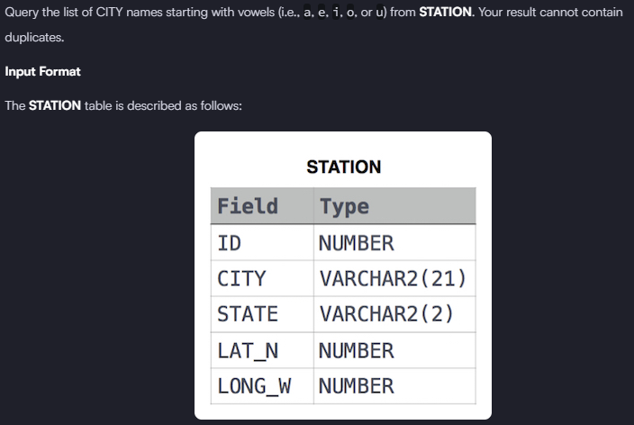

**Solution:** select distinct city from station where city like 'a%' or city like 'e%' or city like 'i%' or city like 'o%' or city like 'u%'

Que

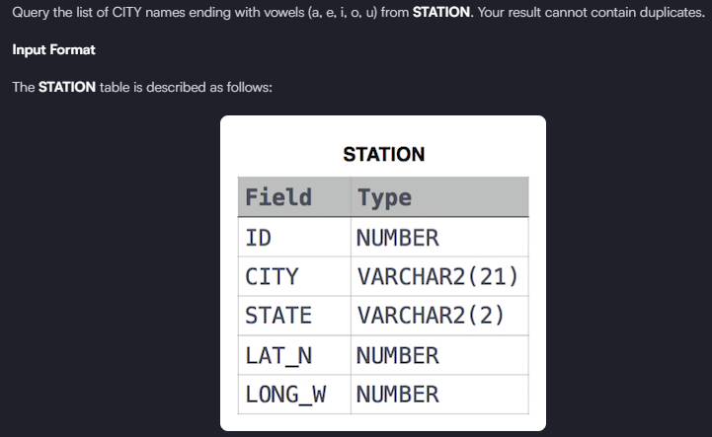

**Solution:** select distinct city from station where city like '%a' or city like '%e' or city like '%i' or city like '%o' or city like '%u'

Que:

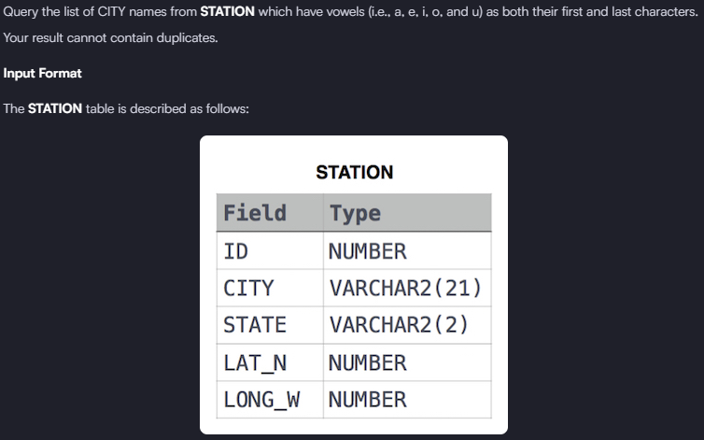

**Solution:** select city from station where left(city,1) IN ('a','e','i','o','u') and right(city,1) IN ('a','e','i','o','u')

Que:

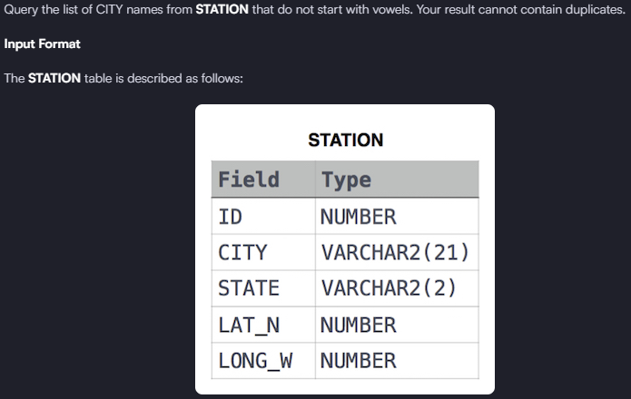

**Solution:** select city from station where left(city,1) Not IN ('a','e','i','o','u') group by city