**HackerRank**

**SQL**

**DAY 4 – 13/01/2025**

**QUE:**

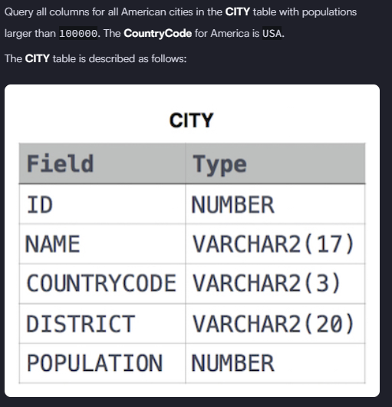

**Solution:-** select * from city where population > 100000 AND Countrycode = 'USA'

**QUE:**

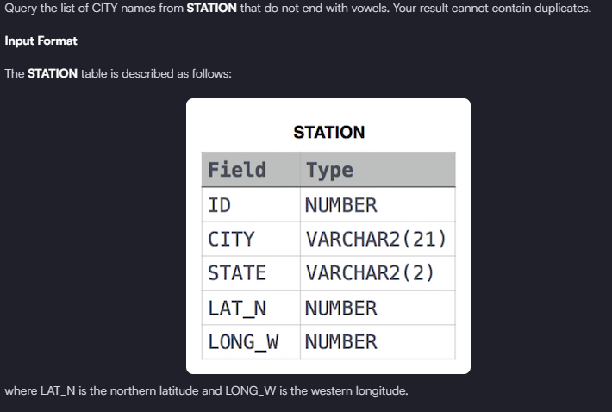

**Solution:-** Select distinct city from Station where city not like '%a' and city not like '%e' and city not like '%i' and city not like '%o' and city not like '%u'

**QUE:**

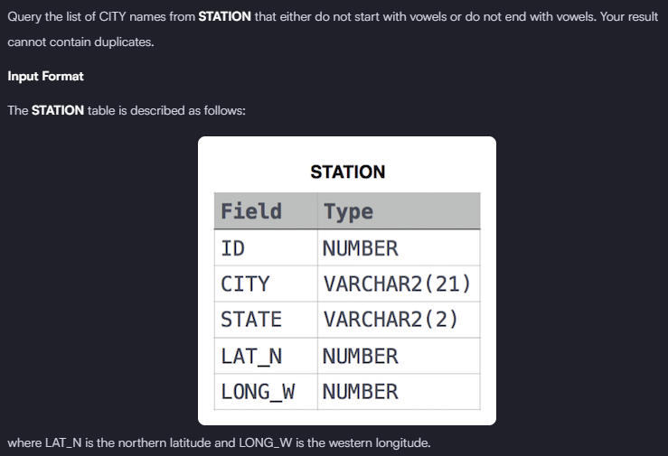

**Solution: -** select distinct city from station where lower(left(city,1)) NOT IN ('a','e','i','o','u') OR lower(Right(city,1)) NOT IN ('a','e','i','o','u')

**QUE:**

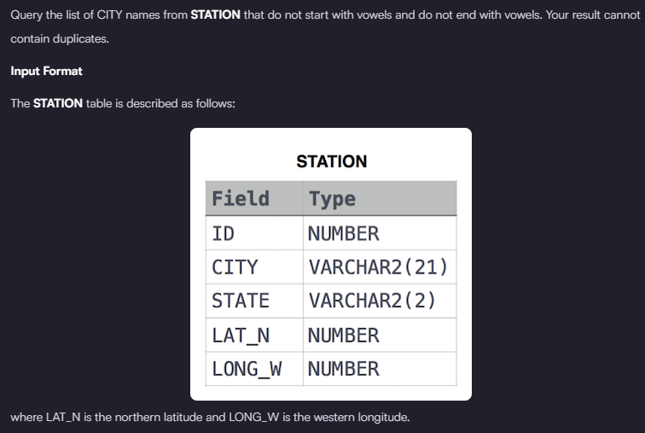

**Solution: -** Select distinct city from station where lower(left(city,1)) NOT IN ('a','e','i','o','u') AND lower(right(city,1)) NOT IN ('a','e','i','o','u')