**HackerRank**

**SQL**

**DAY 5 – 14/01/2025**

**Que:**

Query the Name of any student in STUDENTS who scored higher than Marks. Order your output by the last three characters of each name. If two or more students both have names ending in the same last three characters (i.e.: Bobby, Robby, etc.), secondary sort them by ascending ID.

Input Format

The STUDENTS table is described as follows:

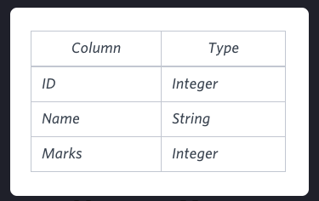 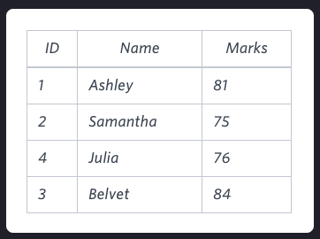

**Solution:-** select name from students where Marks > 75 order by right(name,3), ID ASC

**QUE:**

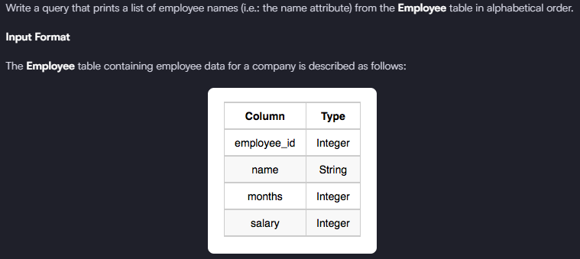

**Solution: -** select name from employee order by name asc

**QUE:**

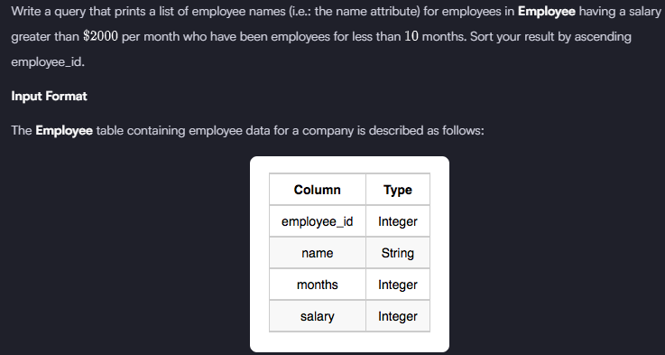

**Solution:-** select name from employee where salary > 2000 and months < 10 order by employee_id asc

**QUE:**

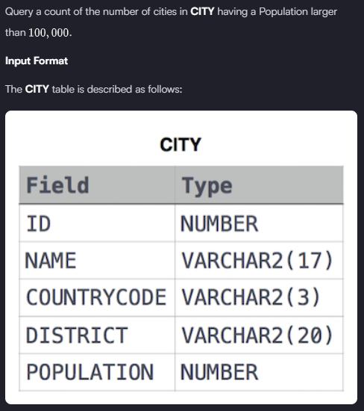

**Solution: -** select count(name) from city where population > 100000