**HackerRank**

**SQL**

**DAY 6 – 15/01/2025**

**Que:**

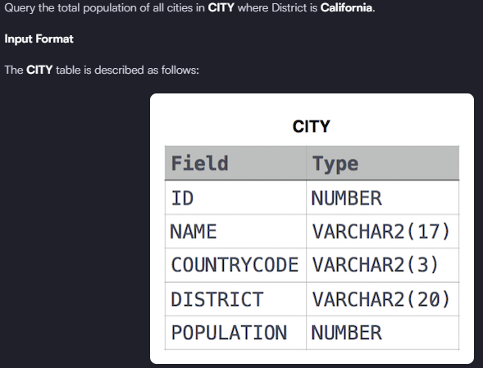

**Solution: -** select sum(population) from city where District = 'California'

**QUE:**

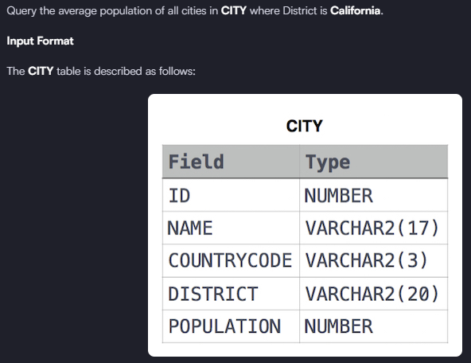

**Solution: -** select avg(population) from city where district = 'California'

**QUE:**

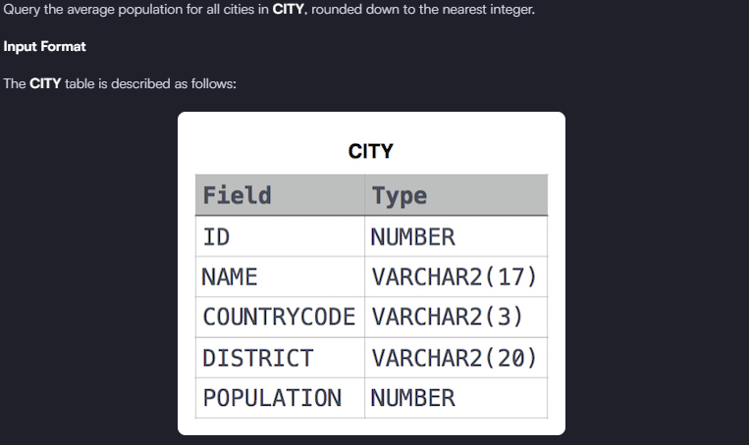

**Solution: -** select floor(avg(population)) from city

**QUE:**

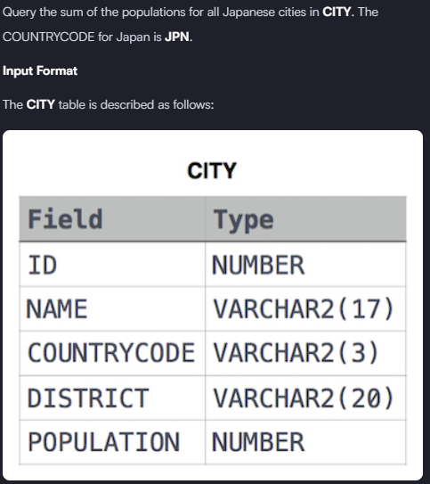

**Solution: -** select sum(population) from city where countrycode = 'JPN'