

PCTE INSTITUTE OF ENGINEERING AND TECHNOLOGY
LUDHIANA

PROJECT REPORT
ON

"CONTRACTAI – AI-POWERED CONTRACT RISK ANALYZER"

Submitted By:
AYUSH YADAV
Roll No. 2329304
B.Tech CSE 4-C

Submitted To:
MS. MANDEEP KAUR

CERTIFICATE

This is to certify that the project entitled "CONTRACTAI – AI-Powered Contract Risk Analyzer" has been successfully completed by Ayush Yadav (Roll No. 2329304), a student of B.Tech Computer Science Engineering, Section 4-C, PCTE Institute of Engineering and Technology, Ludhiana, in partial fulfillment of the requirements for the award of the degree of Bachelor of Technology in Computer Science Engineering for the academic year 2026–2027.
The project work embodies the original effort of the student and has not been submitted elsewhere for the award of any other degree or diploma.

Project Guide
Ms. Mandeep Kaur

Date: _________________

DECLARATION

I, Ayush Yadav, Roll No. 2329304, student of B.Tech Computer Science Engineering, Section 4-C, PCTE Institute of Engineering and Technology, Ludhiana, hereby declare that the project entitled "CONTRACTAI – AI-Powered Contract Risk Analyzer" submitted in partial fulfillment of the requirements for the award of the degree of Bachelor of Technology in Computer Science Engineering is a record of genuine project work carried out by me under the supervision of Ms. Mandeep Kaur.
The matter presented in this report has not been submitted by me for the award of any other degree of this or any other institution. The project utilizes open-source libraries and frameworks with appropriate attribution.

Ayush Yadav
Roll No. 2329304
Date: _________________

ACKNOWLEDGEMENT

I would like to express my sincere gratitude to my project guide, Ms. Mandeep Kaur, for her invaluable guidance, encouragement, and constant support throughout the development of this project. Her expertise and constructive feedback have been instrumental in shaping this work.
I am grateful to the Department of Computer Science and Engineering, PCTE Institute of Engineering and Technology, Ludhiana, for providing the necessary infrastructure and academic environment that facilitated this project.
I extend my thanks to all the faculty members who have contributed to my technical knowledge and skills during my B.Tech program. I also thank my family and friends for their unwavering support and motivation.

Ayush Yadav

ABSTRACT

Contract review is a critical yet time-consuming process in business operations. Legal professionals spend significant hours manually reviewing contracts to identify potential risks, unfavorable clauses, and compliance issues. This project presents ContractAI, an AI-powered contract risk analyzer that automates the process of contract risk identification and assessment.
ContractAI is a full-stack web application built with a React + TypeScript frontend (using Vite and Tailwind CSS) and a Python FastAPI backend. The system accepts PDF and DOCX contract documents, extracts text using PyMuPDF and python-docx, identifies contractual clauses through regex-based pattern matching across 15 legal categories, and extracts metadata such as contract type, parties, governing law, and payment terms.
The core innovation lies in the hybrid risk scoring engine that combines three analysis approaches: (1) a deterministic rule-based engine with 8 predefined legal risk rules contributing 40% of the composite score, (2) an LLM-based contextual analysis using OpenAI GPT-4o-mini contributing 40%, and (3) a Retrieval-Augmented Generation (RAG) pipeline using ChromaDB vector database contributing 20%. The system employs the formula: Overall Score = (0.40 × Rule Score) + (0.40 × LLM Score) + (0.20 × RAG Score), classifying contracts into LOW (0–30), MEDIUM (31–65), or HIGH (66–100) risk tiers.
The application features an interactive dashboard with risk visualization charts, a clause risk matrix with detailed explanations, AI-generated redline suggestions for risky clauses, executive summary reports, and PDF export capabilities using ReportLab. The system gracefully degrades to rule-based analysis when external LLM APIs are unavailable, ensuring reliable operation.
Keywords: Contract Risk Analysis, Natural Language Processing, Large Language Models, Retrieval-Augmented Generation, ChromaDB, FastAPI, React, Risk Scoring.

TABLE OF CONTENTS

Certificate | ii
Chapter 1 — Introduction | 1
Chapter 2 — Problem Statement and Objectives | 5
Chapter 3 — Literature Review | 8
Chapter 4 — Requirements Analysis | 12
Chapter 5 — System Architecture and Design | 16
Chapter 6 — Technology Stack | 25
Chapter 7 — AI/ML and RAG Methodology | 29
Chapter 8 — System Implementation | 37
Chapter 9 — Database Design | 47
Chapter 10 — Frontend Implementation | 52
Chapter 11 — Backend and API Implementation | 58
Chapter 12 — Risk Analysis and Scoring | 65
Chapter 13 — Testing | 72
Chapter 14 — Results | 78
Chapter 15 — Limitations and Future Scope | 83
Chapter 16 — Conclusion | 87
References | 89
Appendix | 91

CHAPTER 1 — INTRODUCTION

1.1 Background
In today's business landscape, organizations routinely enter into a wide variety of contracts including service agreements, non-disclosure agreements (NDAs), master service agreements (MSAs), vendor agreements, and partnership contracts. Each of these documents contains clauses that define the rights, obligations, and risk exposure of the parties involved. Contract review is a critical step before execution, yet it remains one of the most labor-intensive tasks in legal and business operations.
Traditional contract review involves legal professionals manually reading through multi-page documents to identify potentially unfavorable terms, missing protections, and compliance risks. This process is slow, expensive, and prone to human error, especially when dealing with large volumes of contracts. According to World Commerce & Contracting, poor contract management costs organizations approximately 9% of their annual revenue.
The emergence of Natural Language Processing (NLP), Large Language Models (LLMs), and Retrieval-Augmented Generation (RAG) has opened new possibilities for automating legal document analysis. These AI technologies can process unstructured text, understand contextual meaning, and provide structured risk assessments at scale.

1.2 Project Overview
ContractAI is a full-stack web application designed to automate contract risk analysis. The system accepts PDF and DOCX contract documents, extracts and processes the text, identifies contractual clauses across 15 legal categories, and produces a comprehensive risk assessment using a hybrid scoring engine that combines deterministic rules, LLM-based contextual analysis, and RAG-powered knowledge retrieval.
The application provides an interactive web dashboard built with React and TypeScript, featuring risk visualization, clause-level analysis with explanations, AI-generated redline suggestions, and exportable PDF executive reports.

1.3 Motivation
The motivation for this project stems from the following observations:
• Legal review of a single complex contract can take 2-4 hours for an experienced lawyer
• Small and medium businesses often lack dedicated legal teams for thorough contract review
• Key risk areas such as uncapped indemnification or unilateral termination rights are frequently overlooked
• AI-powered analysis can provide consistent, rapid initial risk screening across large document volumes
• The combination of rule-based analysis with LLM contextual understanding offers a robust hybrid approach

1.4 Scope of the Project
ContractAI covers the following scope:
• Document ingestion: PDF, DOCX, and TXT file upload with validation
• Text extraction using PyMuPDF and python-docx
• Clause extraction across 15 legal categories using regex pattern matching
• Metadata extraction (contract type, parties, dates, governing law, payment terms)
• Hybrid risk scoring combining rules (40%), LLM (40%), and RAG (20%)
• 8 deterministic risk detection rules with regex pattern matching
• LLM integration via OpenAI API with graceful fallback
• ChromaDB vector database for RAG-based knowledge retrieval
• AI-generated redline suggestions for risky clauses
• Interactive web dashboard with risk charts and clause matrix
• PDF executive report generation using ReportLab
• User authentication with JWT tokens
• Contract comparison, playbook management, and risk reports

CHAPTER 2 — PROBLEM STATEMENT AND OBJECTIVES

2.1 Problem Statement
Manual contract review is time-consuming, expensive, and inconsistent. Organizations processing multiple contracts face the following challenges:
1. Time Constraints: Reviewing a complex legal contract manually takes 2-4 hours per document.
2. Human Error: Fatigue and cognitive bias lead to overlooked risky clauses.
3. Inconsistency: Different reviewers may assess the same clause differently.
4. Cost: Legal review costs range from $200-$500 per hour for qualified legal professionals.
5. Scalability: Manual review does not scale with increasing contract volumes.
6. Lack of Standardization: Without predefined rules, risk assessment varies across reviewers.
There is a clear need for an automated system that can provide rapid, consistent, and comprehensive initial risk screening of contract documents.

2.2 Project Objectives
The primary objectives of this project are:
1. To develop a web-based application that automates the process of contract risk identification and assessment.
2. To implement a document processing pipeline that extracts text from PDF and DOCX files.
3. To build a clause extraction engine that identifies contractual clauses across multiple legal categories.
4. To design a hybrid risk scoring engine combining deterministic rules, LLM analysis, and RAG retrieval.
5. To create an interactive frontend dashboard for risk visualization.
6. To generate AI-powered redline suggestions for identified risky clauses.
7. To produce exportable PDF executive risk analysis reports.
8. To implement a vector database (ChromaDB) for persistent knowledge storage and semantic retrieval.

CHAPTER 3 — LITERATURE REVIEW

3.1 Traditional Contract Management
Historically, contract management relied entirely on manual review by legal professionals. Lawyers would read through contracts clause by clause, comparing language against known risk patterns and organizational policies. This approach, while thorough when done correctly, suffers from scalability and consistency issues.

3.2 NLP in Legal Domain
Natural Language Processing has been applied to legal text analysis since the early 2000s. Initial approaches used rule-based systems with keyword matching and regular expressions to identify specific legal provisions. These systems were reliable for known patterns but lacked the ability to understand context and semantic meaning.

3.3 Large Language Models
The advent of transformer-based language models, particularly GPT-3, GPT-4, and their successors, has dramatically improved the capability of AI systems to understand and analyze unstructured text. LLMs can comprehend legal language, identify implicit risks, and generate human-readable explanations. However, LLMs suffer from potential hallucination and inconsistency issues when used in isolation.

3.4 Retrieval-Augmented Generation (RAG)
RAG, introduced by Lewis et al. (2020), addresses LLM limitations by grounding the model's responses in retrieved factual context. In the legal domain, RAG enables the system to retrieve relevant risk knowledge from a curated knowledge base before generating analysis, reducing hallucination and improving consistency. ContractAI implements RAG using ChromaDB as the vector store.

3.5 Existing Systems and Gap Analysis
Several commercial tools exist for contract analysis including Kira Systems, LawGeex, and ContractPodAI. However, these are proprietary, expensive, and not customizable. Open-source alternatives are limited in scope. ContractAI fills this gap by providing a complete, customizable, open-source contract risk analyzer combining rule-based analysis, LLM integration, and RAG retrieval in a hybrid scoring engine.

CHAPTER 4 — REQUIREMENTS ANALYSIS

4.1 Functional Requirements
FR-01: The system shall allow users to upload contract documents in PDF, DOCX, and TXT formats up to 50MB.
FR-02: The system shall extract text content from uploaded documents preserving page structure.
FR-03: The system shall identify and categorize contractual clauses across 15 legal categories.
FR-04: The system shall extract metadata including contract type, parties, dates, governing law, and payment terms.
FR-05: The system shall calculate a composite risk score using the hybrid engine (rules 40%, LLM 40%, RAG 20%).
FR-06: The system shall classify contracts into LOW (0-30), MEDIUM (31-65), or HIGH (66-100) risk tiers.
FR-07: The system shall generate AI-powered redline suggestions for high and medium risk clauses.
FR-08: The system shall provide an interactive web dashboard with risk visualization charts.
FR-09: The system shall generate downloadable PDF executive risk reports.
FR-10: The system shall support user registration and login with JWT-based authentication.
FR-11: The system shall allow contract comparison between two documents.
FR-12: The system shall manage risk playbooks for different contract types.

4.2 Non-Functional Requirements
NFR-01: The system shall respond to API requests within 5 seconds for standard operations.
NFR-02: The frontend shall be responsive and work on desktop browsers.
NFR-03: The system shall gracefully degrade to rule-based analysis when external LLM APIs are unavailable.
NFR-04: Uploaded files shall be stored with UUID-prefixed filenames to prevent path traversal attacks.
NFR-05: The system shall validate file extensions and enforce the 50MB size limit.
NFR-06: The database shall use SQLAlchemy ORM with support for SQLite (default) and PostgreSQL.

4.3 Software Requirements
Component | Requirement
Operating System | Windows/Linux/macOS
Python | 3.10+
Node.js | 18.x+
Database | SQLite 3.x (default)
Browser | Chrome/Edge/Firefox
LLM API | OpenAI API (optional)
RAM | 4GB minimum
Storage | 500MB minimum

CHAPTER 5 — SYSTEM ARCHITECTURE AND DESIGN

5.1 System Architecture
ContractAI follows a modern three-tier architecture consisting of a presentation layer (React frontend), an application layer (FastAPI backend), and a data layer (SQLite database + ChromaDB vector store). The system is designed for modularity, with clear separation of concerns between document processing, risk analysis, and report generation services.
Figure 5.1 illustrates the complete system architecture of ContractAI.
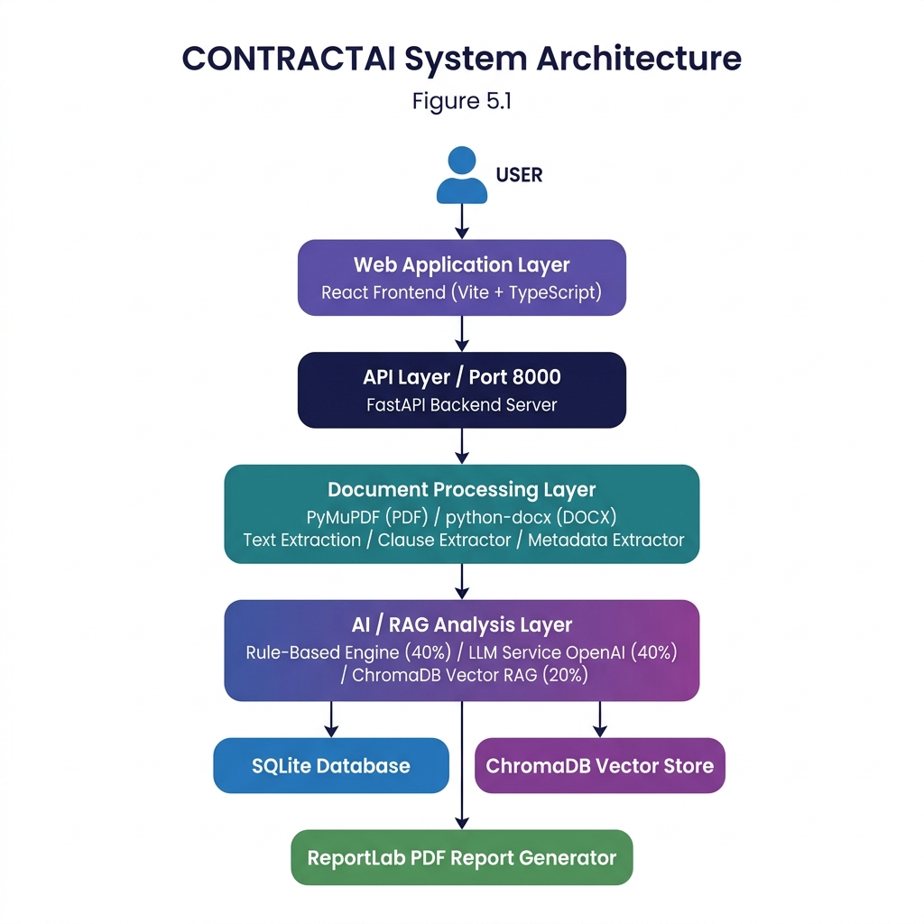
Figure 5.1 — ContractAI System Architecture Diagram

5.2 System Flowchart
The complete contract analysis pipeline follows a sequential processing flow from document upload through risk scoring to report generation. Figure 5.2 presents the detailed processing flowchart.
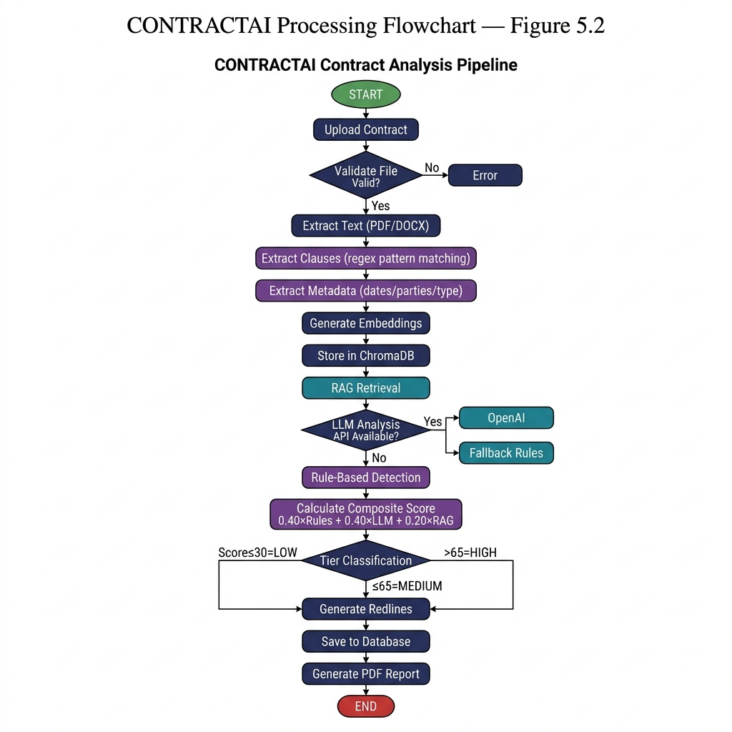
Figure 5.2 — ContractAI Processing Flowchart

5.3 Data Flow Diagram — Level 0
The Level 0 DFD (Context Diagram) shows the high-level interaction between the user, the ContractAI system, and external services.
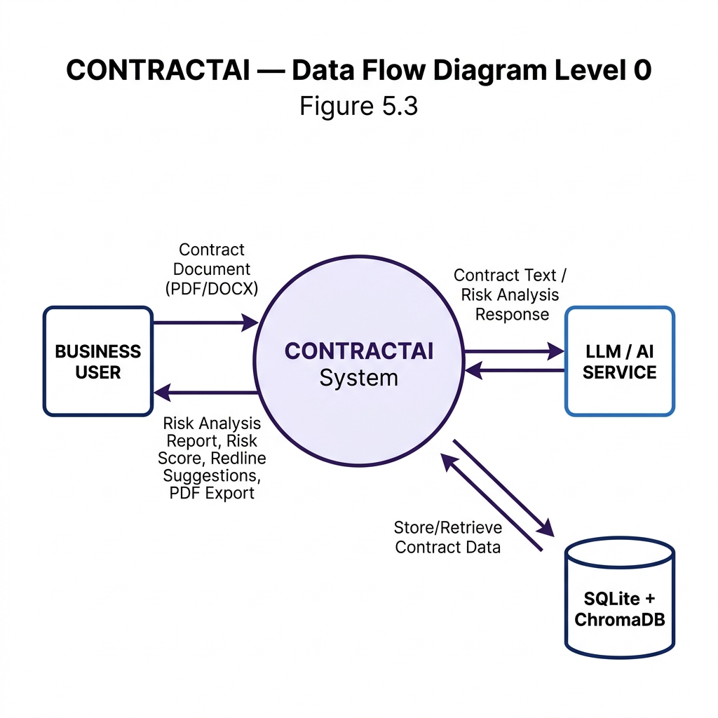
Figure 5.3 — Data Flow Diagram Level 0 (Context Diagram)

5.4 Use Case Diagram
The use case diagram identifies the primary actors (Business User, Admin, LLM API, ChromaDB) and the key functionalities of the ContractAI system.
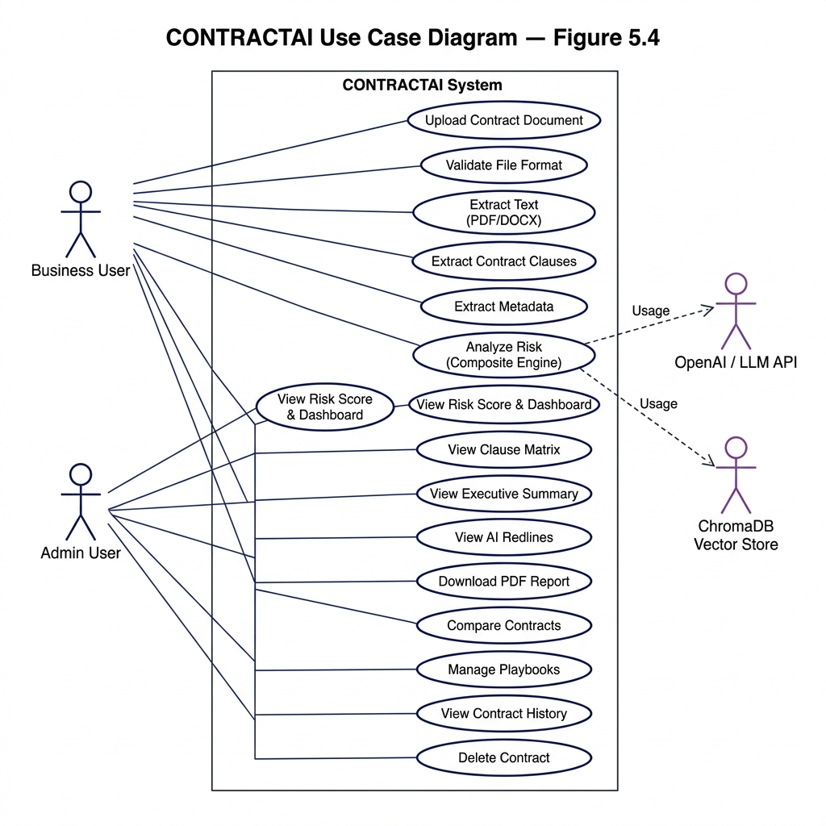
Figure 5.4 — ContractAI Use Case Diagram

5.5 Sequence Diagram
The sequence diagram illustrates the interaction between system components during the contract upload and analysis workflow, showing the complete message flow from user upload to dashboard display.
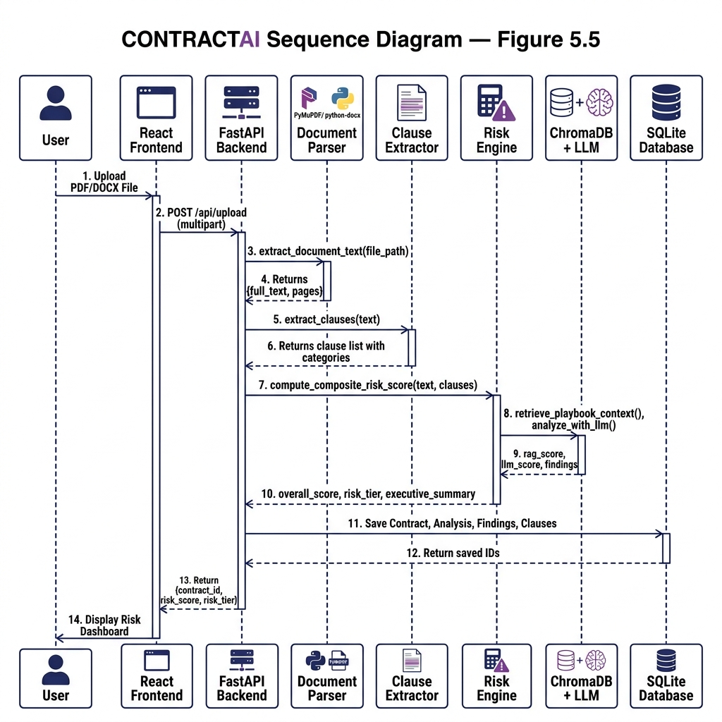
Figure 5.5 — ContractAI Sequence Diagram

5.6 Development Methodology
ContractAI was developed using an Agile/Iterative development methodology. The project progressed through the following iterations:
1. Iteration 1 — Requirement Analysis and System Design
2. Iteration 2 — Backend API development with FastAPI
3. Iteration 3 — Document processing pipeline (PyMuPDF, python-docx)
4. Iteration 4 — AI/RAG integration (LLM service, ChromaDB, risk engine)
5. Iteration 5 — Frontend development with React + TypeScript
6. Iteration 6 — Integration testing and debugging
7. Iteration 7 — PDF report generation and UI polish
8. Iteration 8 — Testing, documentation, and deployment preparation

CHAPTER 6 — TECHNOLOGY STACK

6.1 Backend Technologies
Technology | Version | Purpose
Python | 3.10+ | Core backend programming language
FastAPI | 0.141.1 | Async web framework for REST API
Uvicorn | 0.23.2+ | ASGI server for running FastAPI
SQLAlchemy | 2.0.23+ | ORM for database operations
PyMuPDF (fitz) | 1.23.6+ | PDF text extraction
python-docx | 1.0.1+ | DOCX text extraction
OpenAI | 1.3.0+ | LLM API client for GPT-4o-mini
LangChain | 0.0.335+ | LLM orchestration framework (installed)
ReportLab | 4.0.7+ | PDF report generation
Pydantic | 2.4.2+ | Data validation and settings
python-jose | 3.3.0+ | JWT token generation
passlib + bcrypt | 1.7.4+ / 4.0.1+ | Password hashing

6.2 Frontend Technologies
Technology | Version | Purpose
React | 19.2.8 | UI component library
TypeScript | 6.0.2 | Type-safe JavaScript
Vite | 8.3.0 | Build tool and dev server
Tailwind CSS | 3.4.19 | Utility-first CSS framework
React Router | 7.18.4 | Client-side routing
Recharts | 3.10.1 | Data visualization charts
Lucide React | 1.47.0 | Icon library
clsx + tailwind-merge | 2.1.1 / 3.7.0 | Conditional CSS class merging

6.3 Database and Storage
Database: SQLite 3.x (default) with optional PostgreSQL support via SQLAlchemy ORM.
Vector Store: ChromaDB with PersistentClient for embeddings and semantic search.
File Storage: Local filesystem with UUID-prefixed filenames under ./storage/uploads/.

6.4 Note on ChromaDB
ChromaDB is included as an optional dependency. The embedding_service.py implements a VectorStoreService class that attempts to initialize ChromaDB on startup. If ChromaDB is unavailable, the system falls back to an in-memory keyword-based search. This design ensures the application operates reliably regardless of ChromaDB availability.

CHAPTER 7 — AI/ML AND RAG METHODOLOGY

7.1 AI Architecture Overview
ContractAI does NOT use traditional supervised machine learning algorithms such as Random Forest, SVM, Logistic Regression, CNN, or RNN. Instead, it employs a modern AI architecture combining:
1. Deterministic Rule-Based Analysis: Pattern matching with predefined legal risk rules
2. Large Language Model (LLM) Analysis: Contextual risk assessment using OpenAI GPT-4o-mini
3. Retrieval-Augmented Generation (RAG): Knowledge-grounded analysis using ChromaDB vector search
This architecture is specifically suited for unstructured legal contract text because:
• Contracts vary widely in structure, length, and language across organizations
• Supervised ML would require large labeled datasets of classified contract clauses
• LLMs can understand nuanced legal language and provide contextual explanations
• Rule-based systems provide deterministic, explainable risk detection for known patterns
• The hybrid approach combines reliability of rules with flexibility of AI

7.2 Rule-Based Risk Detection Engine
The deterministic rule engine (implemented in app/core/rules.py) contains 8 predefined risk rules covering the following categories:
Rule ID | Category | Risk Level | Base Score
RULE_INDEMNITY_UNCAPPED | Indemnity | HIGH | 85
RULE_LIABILITY_UNCAPPED | Limitation of Liability | HIGH | 88
RULE_TERMINATION_UNILATERAL | Termination | HIGH | 75
RULE_NON_COMPETE_BROAD | Non-Compete | HIGH | 80
RULE_GOVERNING_LAW_FOREIGN | Governing Law | MEDIUM | 55
RULE_AUTO_RENEWAL_LONG_NOTICE | Renewal | MEDIUM | 50
RULE_PAYMENT_LATE_PENALTY | Payment Terms | MEDIUM | 45
RULE_IP_ASSIGNMENT_BROAD | Intellectual Property | HIGH | 78

Each rule uses a two-stage detection process:
1. Keyword presence check (e.g., 'indemnify', 'hold harmless')
2. Regex pattern matching for risky language patterns
The rule score calculation formula (from rules.py line 184):
Rule Score = 0.6 × max(finding_scores) + 0.4 × avg(finding_scores)
If no rules match, a baseline score of 25.0 is assigned (indicating a clean contract).

7.3 LLM-Based Contextual Analysis
The LLM service (app/services/llm_service.py) integrates with OpenAI's GPT-4o-mini model to provide contextual risk analysis. The system sends up to 4,000 characters of contract text along with metadata to the LLM with a structured system prompt that instructs the model to:
• Analyze only the supplied contract content
• Return a risk score (0-100), executive summary, and negotiation priorities
• Not invent contractual language or provide definitive legal advice
• Return strictly valid JSON output
When the OpenAI API key is not configured, the system falls back to a rule-based contextual analysis function (_fallback_llm_analysis) that uses keyword matching to generate scores and recommendations. The fallback scores range from 35.0 to 95.0 based on detected risk keywords.

7.4 RAG Pipeline with ChromaDB
Figure 7.1 illustrates the RAG architecture implemented in ContractAI.
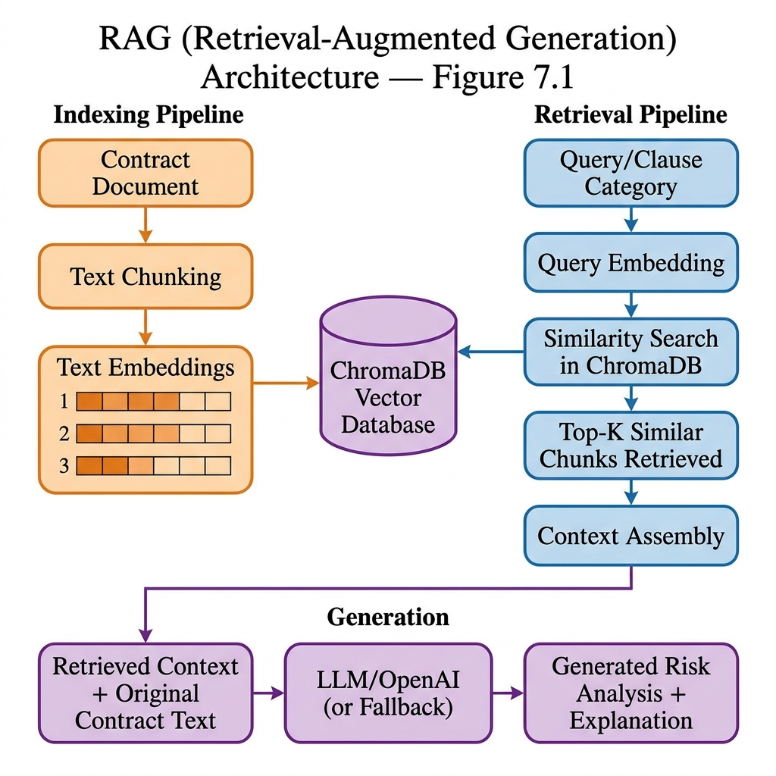
Figure 7.1 — RAG Architecture Diagram
The RAG pipeline operates in two phases:
Indexing Phase (embedding_service.py):
• Extracted clause texts are stored in ChromaDB using the add_chunks() method
• Each chunk contains the clause text, category, section, page number, and contract ID as metadata
• ChromaDB generates embeddings internally using its default embedding function
• Documents are indexed with IDs in the format 'doc_{contract_id}_chunk_{index}'
Retrieval Phase (rag_service.py):
• For each clause, a query combining category and text is constructed
• ChromaDB's search_similar() performs semantic similarity search returning top-3 results
• The RAG score is determined by clause category: HIGH-risk categories (Indemnity, Liability, Termination, Non-Compete, IP) receive 75.0; moderate categories (Payment, Governing Law, Renewal) receive 50.0; others receive 30.0

7.5 What Are Embeddings?
Embeddings are dense numerical vector representations of text that capture semantic meaning. Unlike traditional keyword-based search, embeddings represent the contextual meaning of text in a high-dimensional vector space. Texts with similar meanings are positioned close together in this space, enabling semantic similarity search.
In ContractAI, ChromaDB handles embedding generation internally. When clause text is added to the collection using the add_chunks() method, ChromaDB automatically generates embeddings using its default SentenceTransformer model. This enables the system to find semantically similar clauses even when different wording is used.

7.6 How RAG Reduces LLM Dependence
RAG contributes to more reliable analysis by:
• Grounding the analysis in previously indexed contract knowledge rather than relying solely on the LLM's training data
• Providing consistent category-based scoring that is deterministic and reproducible
• Enabling the system to learn from previously analyzed contracts through the growing vector database
• Reducing hallucination by supplementing LLM analysis with factual retrieved context

CHAPTER 8 — SYSTEM IMPLEMENTATION

8.1 Project Structure
The project follows a monorepo structure with separate backend and frontend directories:
project/
├── backend/
│ ├── app/
│ │ ├── main.py (FastAPI application entry point)
│ │ ├── api/ (10 API route modules)
│ │ ├── core/ (config, rules, security)
│ │ ├── db/ (database session)
│ │ ├── models/ (6 SQLAlchemy models)
│ │ ├── schemas/ (Pydantic validation schemas)
│ │ └── services/ (10 service modules)
│ ├── tests/ (4 test files)
│ └── requirements.txt
├── frontend/
│ ├── src/
│ │ ├── pages/ (9 page components)
│ │ ├── components/ (15 UI components)
│ │ ├── services/ (API communication)
│ │ ├── types/ (TypeScript type definitions)
│ │ └── utils/ (utility functions)
│ ├── package.json
│ └── vite.config.ts
├── sample_contracts/ (5 sample test contracts)
├── storage/ (uploads, reports, vector_db, SQLite DB)
└── .env (environment configuration)

8.2 Document Processing Pipeline
The document processing module (app/services/document_parser.py) implements text extraction for three file formats:
1. PDF Parsing (parse_pdf): Uses PyMuPDF (imported as 'pymupdf'/fitz) to open PDF files, iterate through pages, and extract text content using the get_text('text') method. Each page's text is stored separately with page numbers, and the combined text is joined with double newlines.
2. DOCX Parsing (parse_docx): Uses the python-docx library to open DOCX files and iterate through paragraph objects. Non-empty paragraphs are collected and joined. Page number tracking in DOCX is limited to page 1 as DOCX does not natively expose page boundaries.
3. TXT Parsing: For plain text files, the content is read directly with UTF-8 encoding.
The extract_document_text() function acts as a router, selecting the appropriate parser based on file extension.

8.3 Clause Extraction
The clause extractor (app/services/clause_extractor.py) implements regex-based pattern matching across 15 legal categories:
Indemnity, Limitation of Liability, Termination, Non-Compete, Confidentiality, Intellectual Property, Payment Terms, Governing Law, Dispute Resolution, Warranty, Data Protection, Insurance, Force Majeure, Renewal, Assignment
The extraction process:
1. Splits the full text into sections using paragraph breaks and heading patterns
2. Filters out sections shorter than 40 characters
3. For each section, checks against keyword patterns for each category
4. If no category matches, assigns 'General Terms'
5. Attempts to extract section titles using heading-pattern regex
6. Estimates page numbers by matching text fragments against per-page content

8.4 Metadata Extraction
The metadata extractor (app/services/metadata_extractor.py) uses regex patterns to extract:
• Document Title: Detected from first line containing keywords like AGREEMENT, CONTRACT, NDA
• Contract Type: Classified as NDA, MSA, Vendor Agreement, Freelancer Agreement, or Partnership based on keyword presence
• Effective Date: Matched using patterns like 'effective as of [date]' or 'entered into on [date]'
• Expiration Date: Matched using patterns like 'expire on [date]' or 'term shall end'
• Governing Law: Extracted from 'governed by the laws of [jurisdiction]' patterns
• Payment Terms: Detected from 'Net 30/60/90' or 'within X days' patterns
• Notice Period: Extracted from 'X days prior written notice' patterns
• Parties: Identified from 'between [Party A] and [Party B]' patterns

8.5 Redline Generation
The redline service (app/services/redline_service.py) generates alternative clause language for risky provisions. The service uses category-specific templates:
• Indemnity: Suggests mutual indemnification capped to direct third-party losses from gross negligence
• Liability: Proposes excluding indirect/consequential damages with aggregate cap at 12 months of fees
• Termination: Recommends mutual 30-day written notice for convenience termination
• Non-Compete: Suggests limiting non-solicitation to 6 months within operating territory
• Intellectual Property: Proposes retaining pre-existing IP with non-exclusive license for deliverables
Redline suggestions are only generated for clauses classified as HIGH or MEDIUM risk.

CHAPTER 9 — DATABASE DESIGN

9.1 Database Architecture
ContractAI uses SQLite as the default relational database, managed through SQLAlchemy ORM. The database file is stored at ./storage/contract_ai.db. The system also supports PostgreSQL as an alternative by changing the DATABASE_URL environment variable. Tables are auto-created on application startup using Base.metadata.create_all().

9.2 Entity-Relationship Diagram
Figure 9.1 shows the ER diagram based on the actual database models implemented in the codebase.
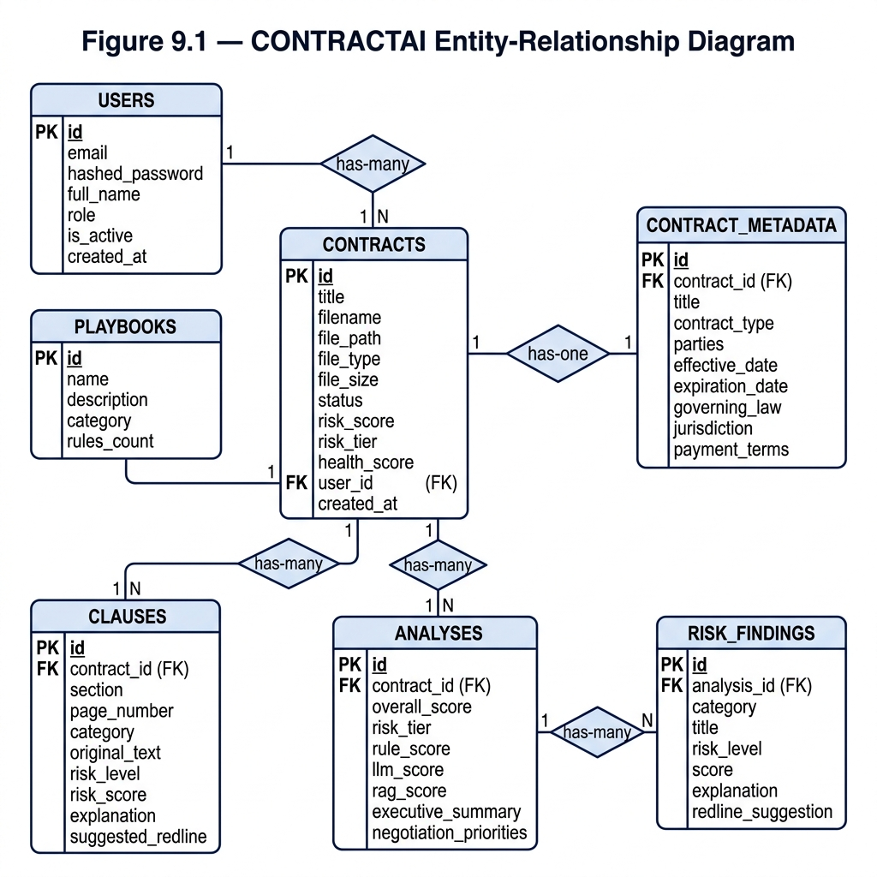
Figure 9.1 — ContractAI Entity-Relationship Diagram

9.3 Database Tables
The database consists of 7 tables:
1. users — Stores user accounts (id, email, hashed_password, full_name, role, is_active, created_at)
2. contracts — Core table (id, title, filename, file_path, file_type, file_size, status, risk_score, risk_tier, health_score, user_id FK, created_at, updated_at)
3. contract_metadata — Extracted metadata (id, contract_id FK, title, contract_type, parties, effective_date, expiration_date, governing_law, jurisdiction, renewal_terms, notice_period, payment_terms, currency)
4. clauses — Extracted clauses (id, contract_id FK, section, page_number, category, original_text, risk_level, risk_score, confidence, explanation, business_impact, recommendation, suggested_redline, is_reviewed)
5. analyses — Risk analysis results (id, contract_id FK, overall_score, risk_tier, rule_score, llm_score, rag_score, executive_summary, negotiation_priorities JSON, is_demo, created_at)
6. risk_findings — Individual risk findings (id, analysis_id FK, rule_id, category, title, risk_level, score, confidence, explanation, business_impact, negotiation_recommendation, redline_suggestion, page, section)
7. playbooks — Risk playbook templates (id, name, description, category, rules_count, rules JSON, is_default)

9.4 Key Relationships
• Users → Contracts: One-to-Many (a user owns multiple contracts)
• Contracts → ContractMetadata: One-to-One (each contract has one metadata record)
• Contracts → Clauses: One-to-Many (each contract contains multiple extracted clauses)
• Contracts → Analyses: One-to-Many (each contract can have multiple analysis runs)
• Analyses → RiskFindings: One-to-Many (each analysis contains multiple findings)
All child relationships use cascade='all, delete-orphan' ensuring referential integrity on deletion.

CHAPTER 10 — FRONTEND IMPLEMENTATION

10.1 Application Structure
The frontend is built with React 19, TypeScript, and Vite 8.3.0, styled with Tailwind CSS 3.4.19. The application uses React Router for client-side navigation and Recharts for data visualization.

10.2 Page Components (9 pages)
• Dashboard.tsx — Main overview with metric cards, risk donut chart, upload zone, risk trend chart, top risk categories, and recent contracts table
• UploadContract.tsx — Drag-and-drop file upload interface with format validation
• MyContracts.tsx — Searchable table of all uploaded contracts with risk tier badges and actions
• ContractDetail.tsx — Comprehensive analysis view with tabs for Executive Summary, Clause Matrix, AI Redlines, and Document Reader
• CompareContracts.tsx — Side-by-side comparison of two contracts
• RiskReports.tsx — List of generated analysis reports with download links
• Playbooks.tsx — Risk playbook management interface
• ClauseLibrary.tsx — Browsable library of extracted clauses across all contracts
• Settings.tsx — Application configuration interface

10.3 UI Components (15 components)
• Sidebar.tsx — Navigation sidebar with workspace, library, and account sections
• Header.tsx — Top bar with search, notifications, and user profile
• MetricCard.tsx — Reusable card component for dashboard statistics
• RiskOverviewChart.tsx — Donut chart showing risk tier distribution (Recharts)
• RiskTrendChart.tsx — Line chart showing risk score trends over time
• TopRiskCategories.tsx — Ranked list of most common risk categories
• UploadZone.tsx — Drag-and-drop file upload with progress indicator
• RecentContractsTable.tsx — Table of latest analyzed contracts
• ExecutiveSummary.tsx — Executive summary with negotiation priorities
• ClauseMatrixTable.tsx — Sortable/filterable table of all extracted clauses
• ClauseDetailModal.tsx — Modal dialog showing clause details with explanations
• RedlineViewer.tsx — Side-by-side display of original vs suggested clause text
• DocumentViewer.tsx — Interactive document reader with clause annotations
• AnalysisProgressModal.tsx — Step-by-step progress indicator during analysis
• DisclaimerBanner.tsx — Legal disclaimer notification bar

10.4 Screenshots
The following screenshots are captured from the actual running application:
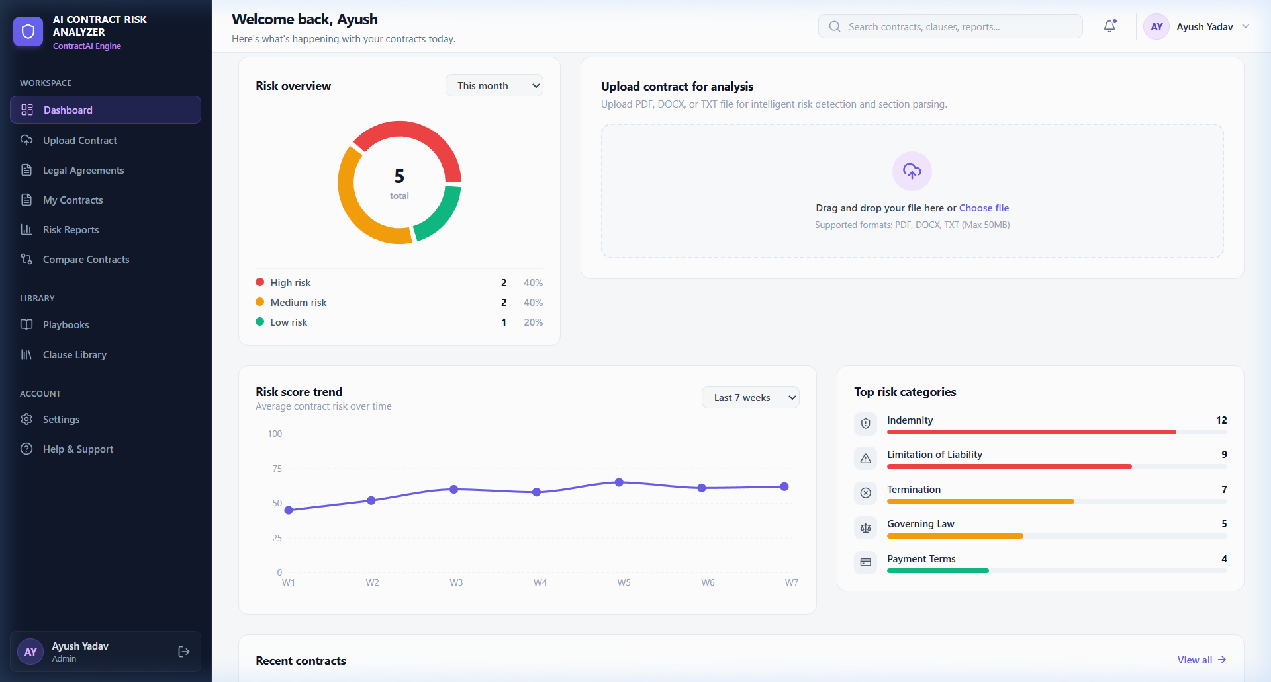
Figure 10.1 — ContractAI Dashboard Overview
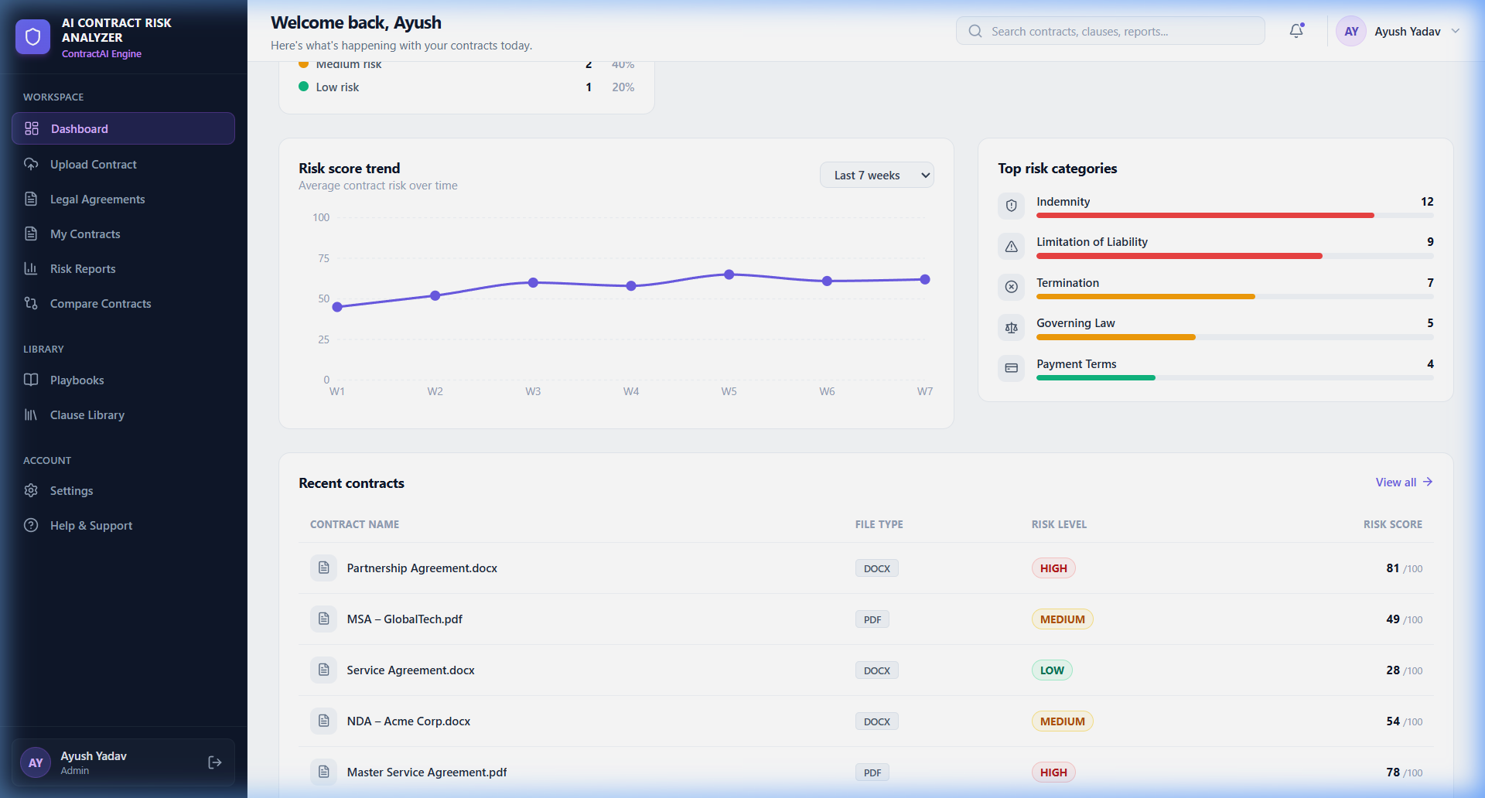
Figure 10.2 — Dashboard Risk Trend and Top Categories
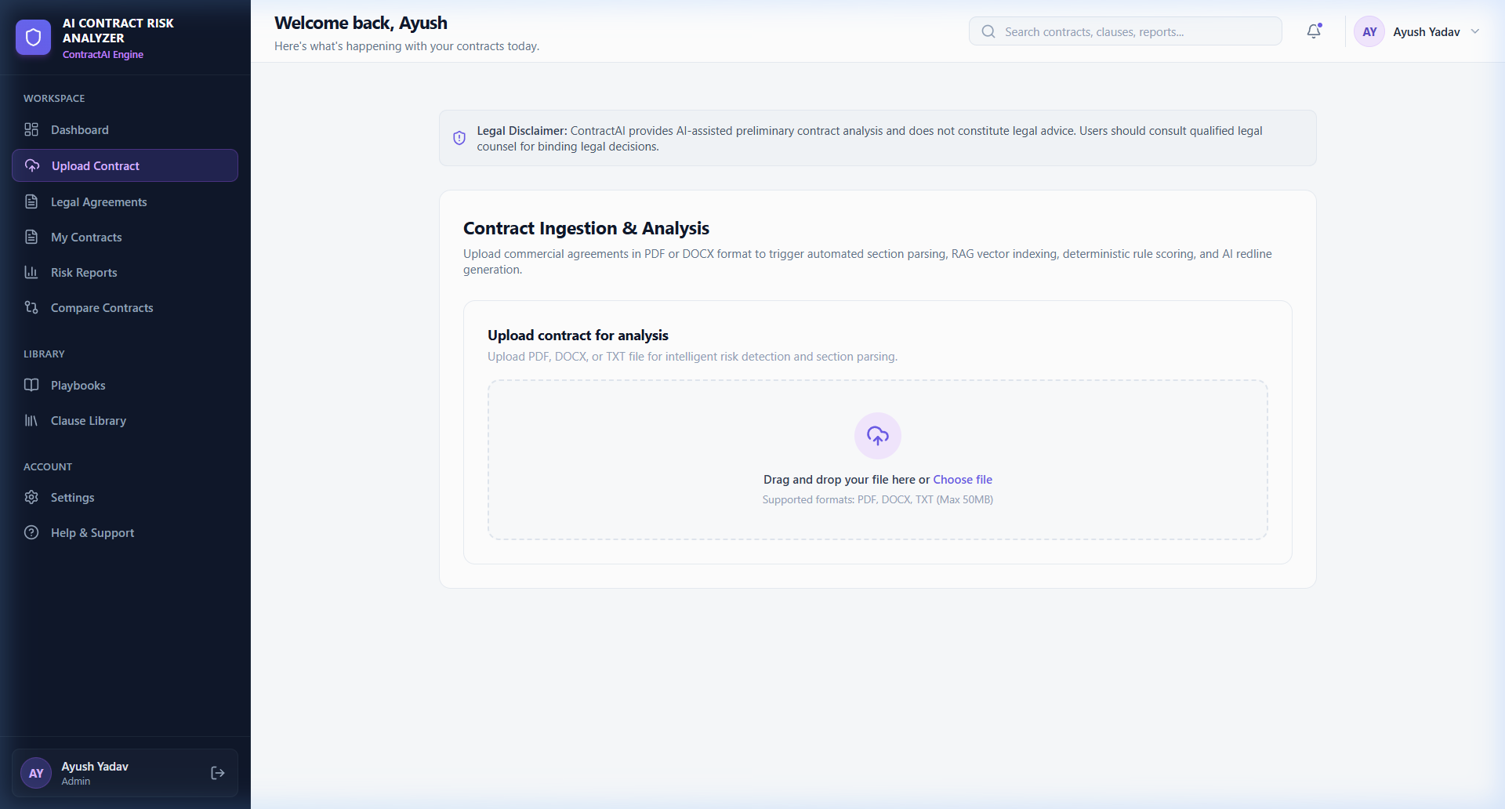
Figure 10.3 — Contract Upload Interface
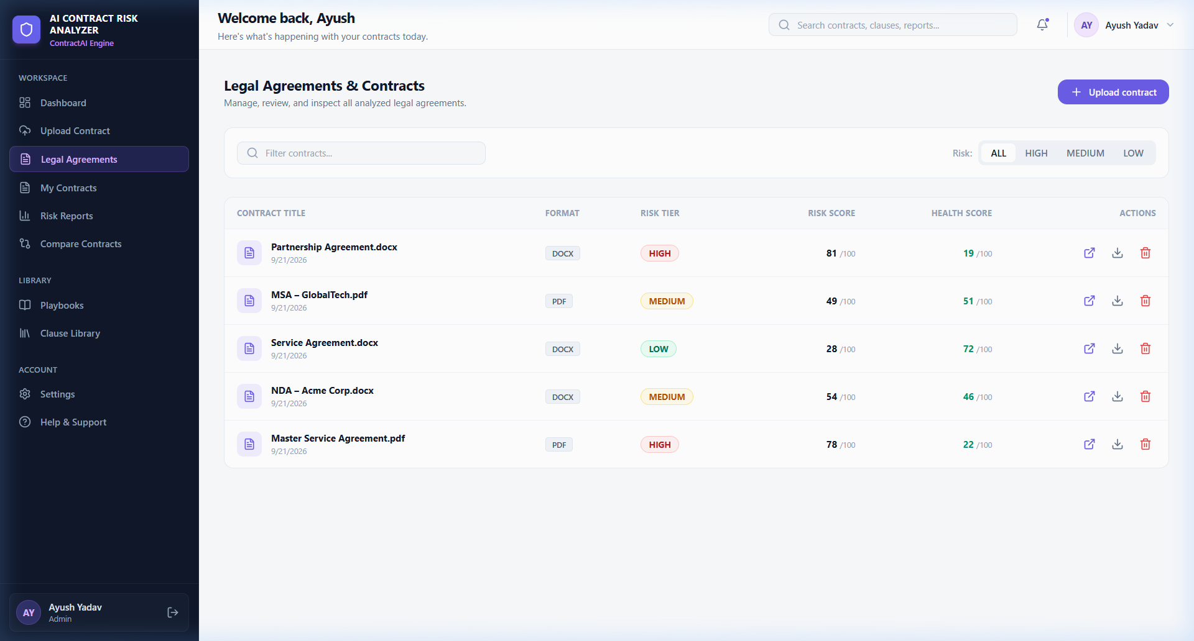
Figure 10.4 — Legal Agreements List
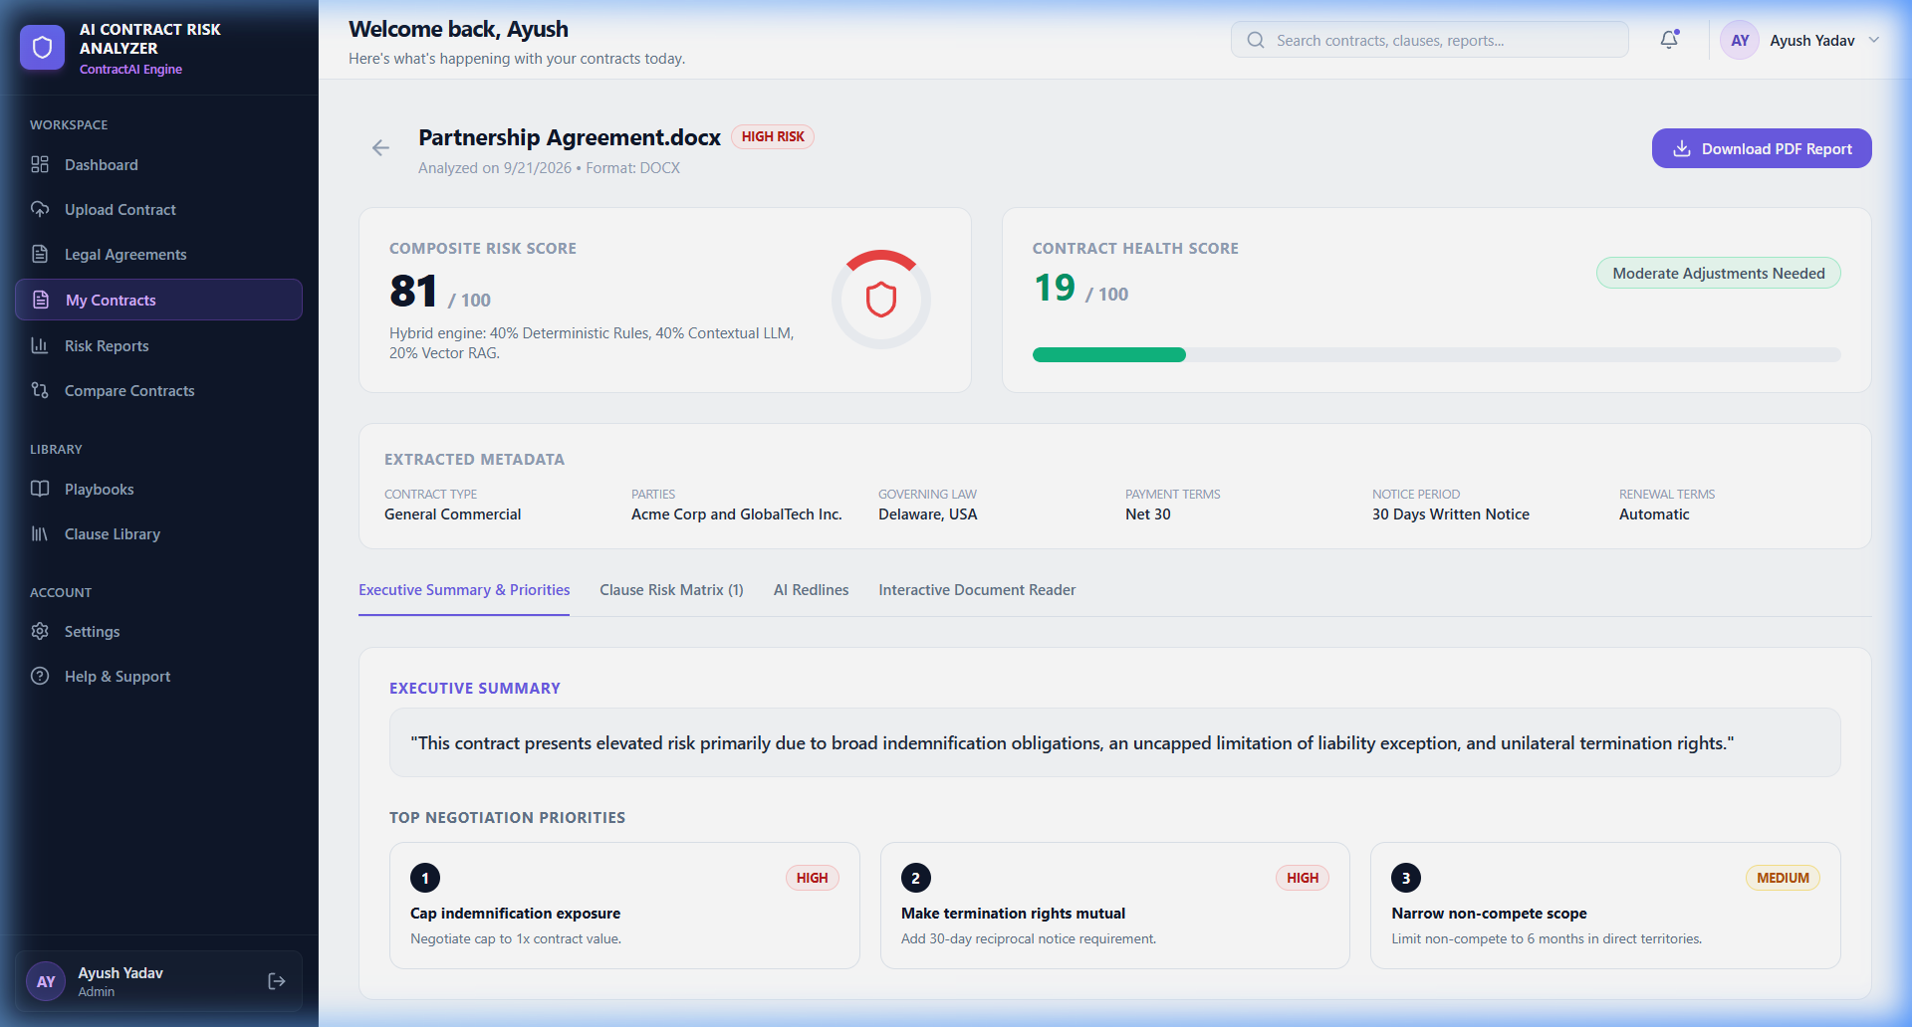
Figure 10.5 — Contract Detail and Risk Score View
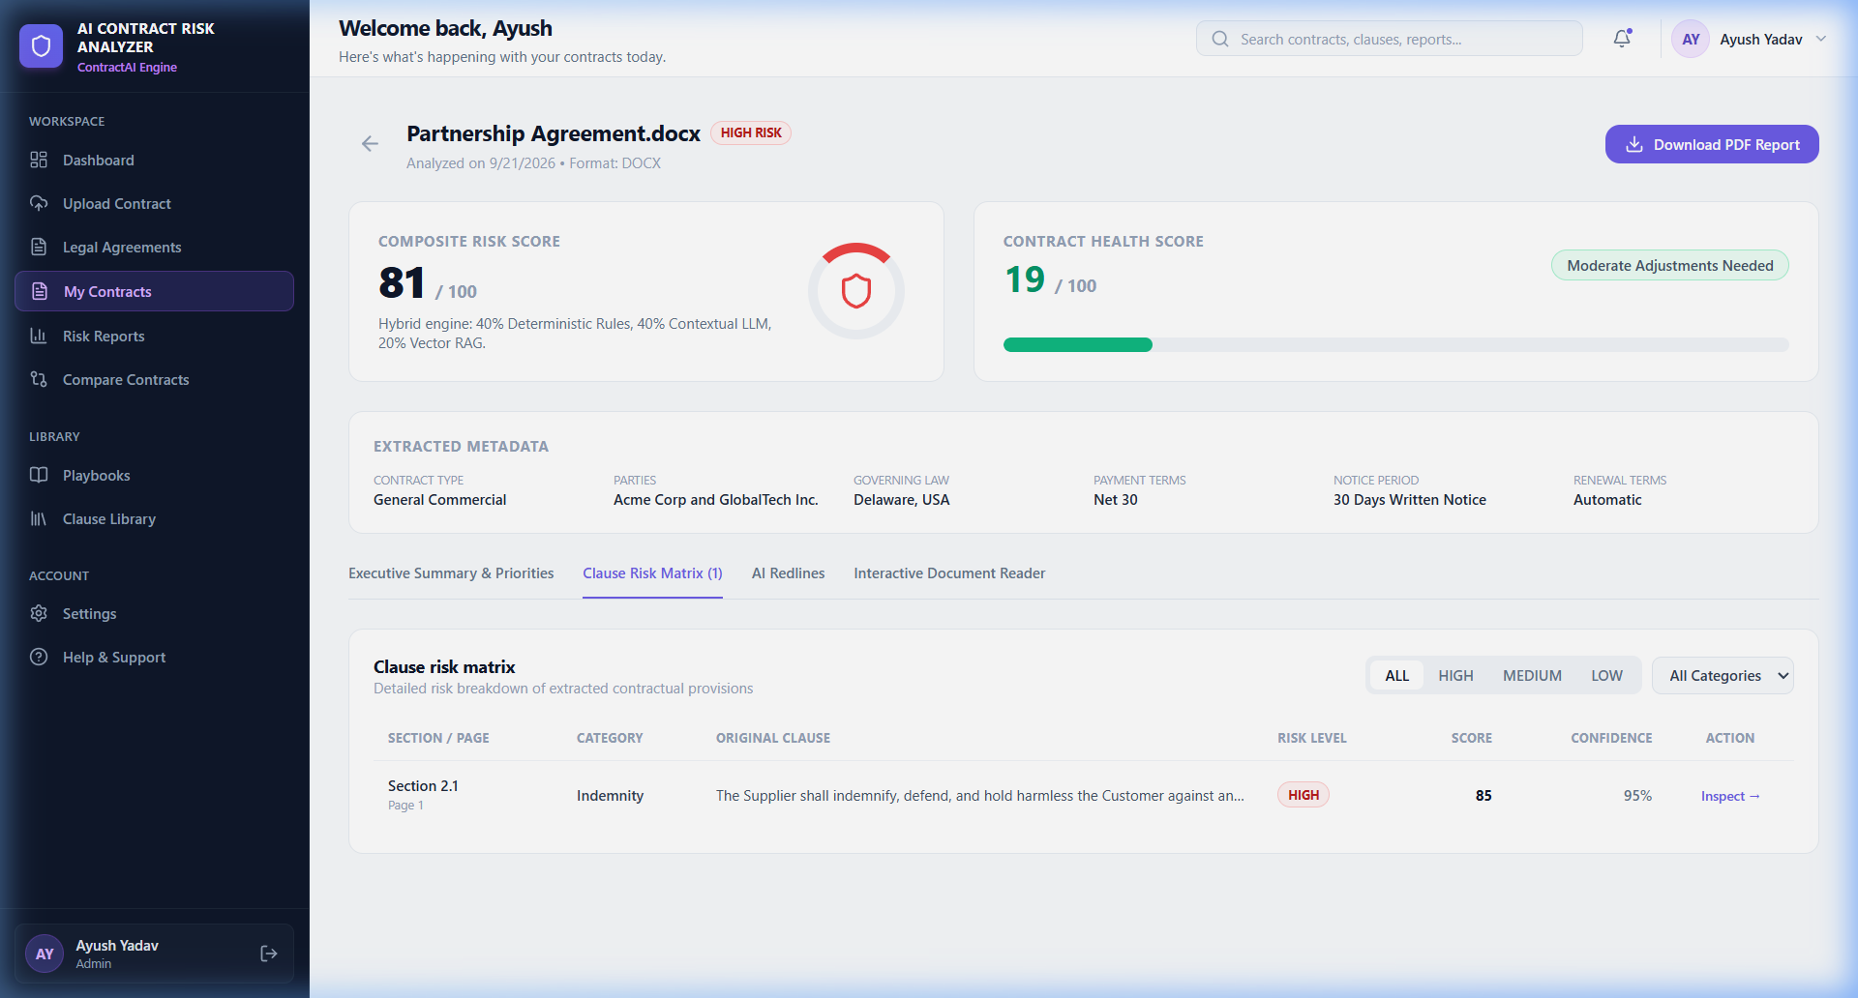
Figure 10.6 — Clause Risk Matrix
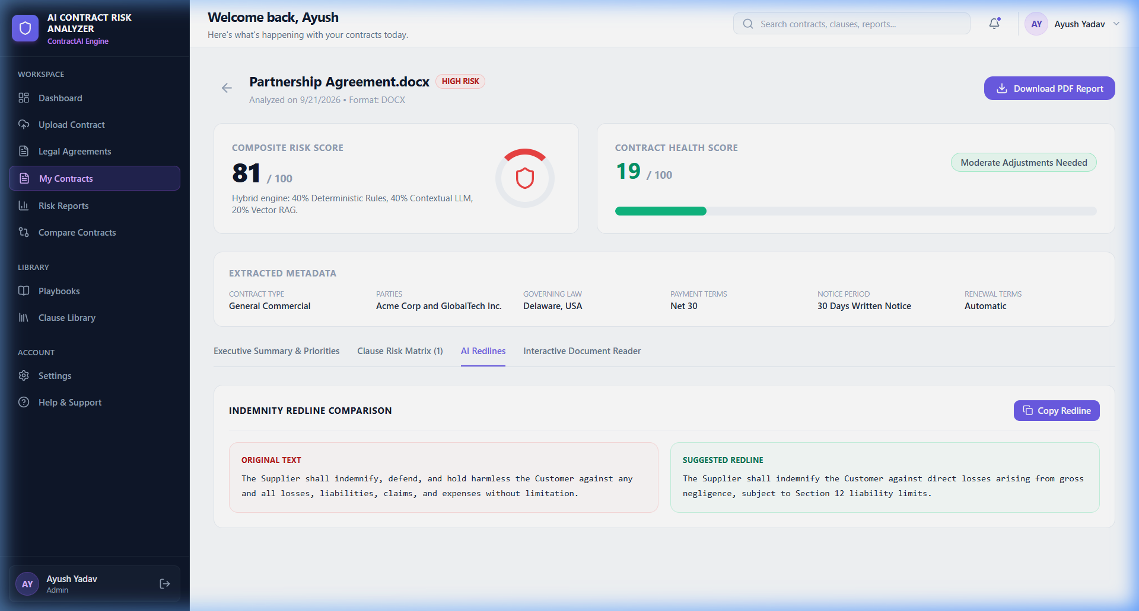
Figure 10.7 — AI Redline Suggestions
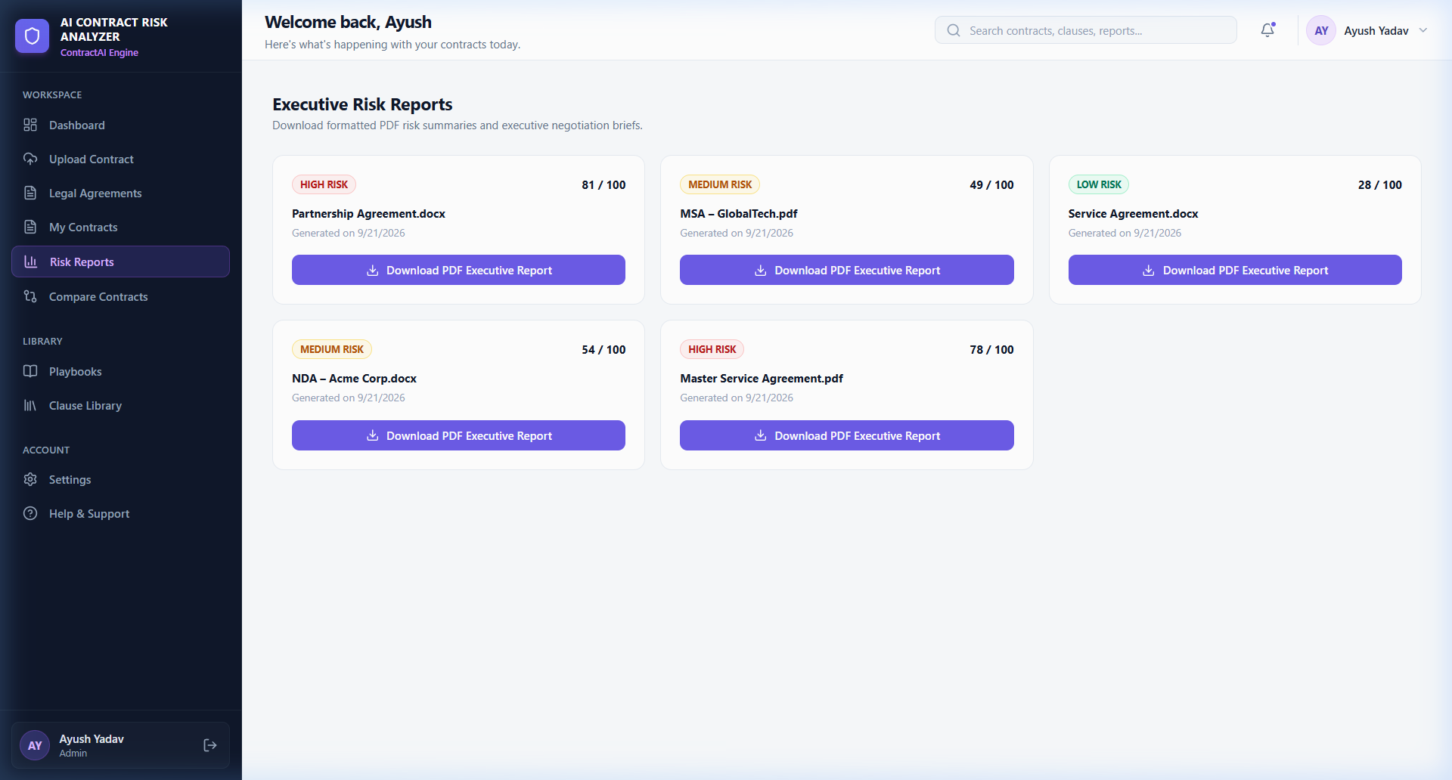
Figure 10.8 — Risk Reports Page
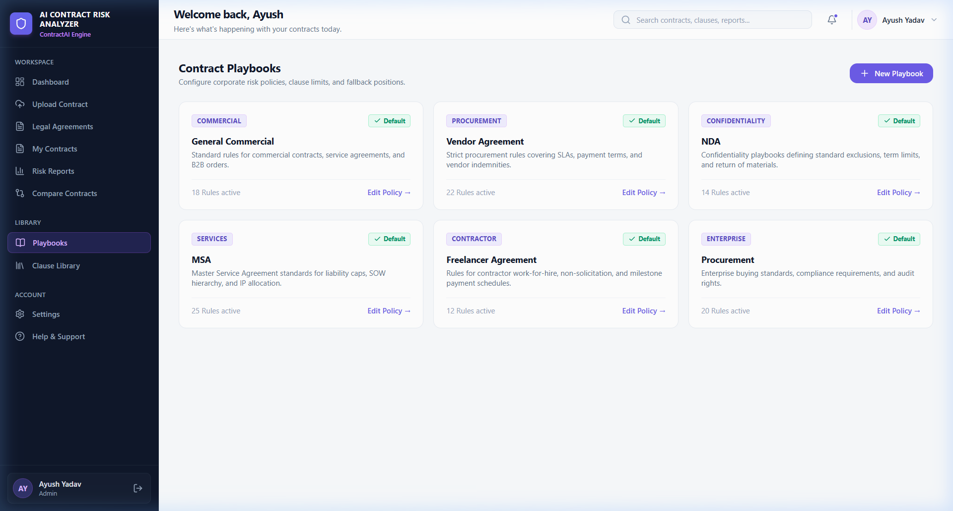
Figure 10.9 — Risk Playbooks Management
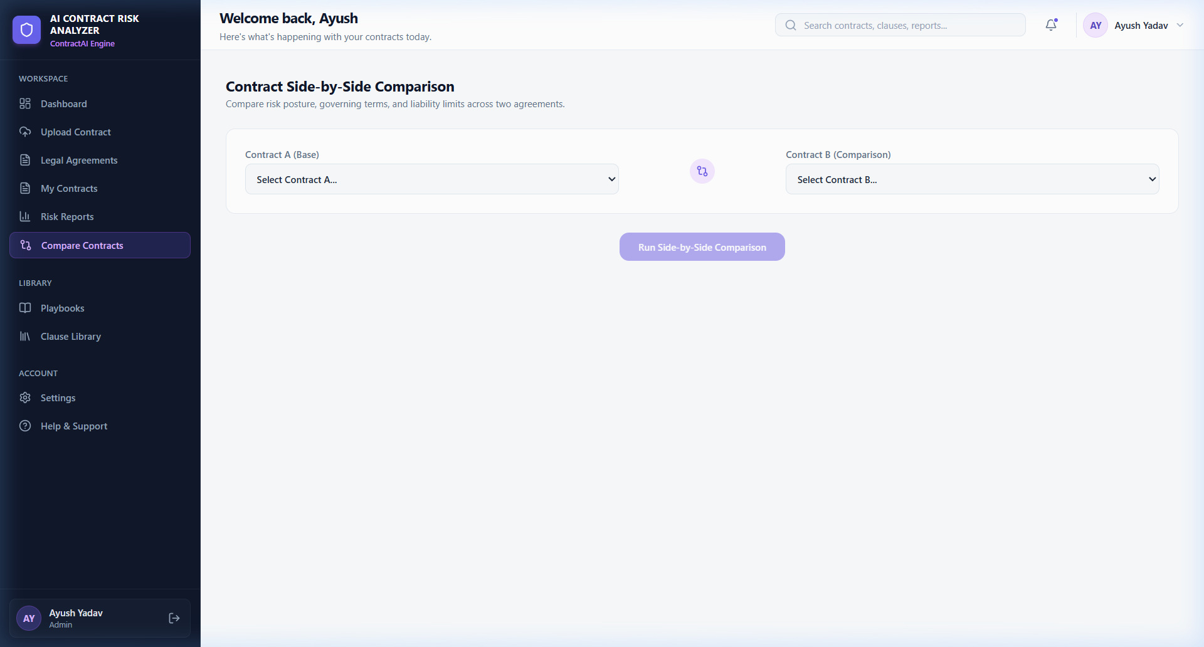
Figure 10.10 — Contract Comparison Interface

CHAPTER 11 — BACKEND AND API IMPLEMENTATION

11.1 FastAPI Application
The backend application is initialized in app/main.py. It creates a FastAPI instance, configures CORS middleware to allow cross-origin requests, and includes 10 API routers under the /api prefix. Database tables are automatically created on startup.

11.2 API Endpoints
Endpoint | Method | Purpose | Module
/api/upload | POST | Upload and analyze a contract file | upload.py
/api/contracts | GET | List all contracts | contracts.py
/api/contracts/{id} | GET | Get contract with analysis, clauses, metadata | contracts.py
/api/contracts/{id} | DELETE | Delete a contract | contracts.py
/api/dashboard/stats | GET | Get dashboard statistics | contracts.py
/api/dashboard/trends | GET | Get risk score trends data | contracts.py
/api/dashboard/categories | GET | Get top risk categories | contracts.py
/api/analyze/{id} | POST | Retrieve analysis for a contract | analyze.py
/api/analysis/{id} | GET | Get analysis by contract ID | analyze.py
/api/analysis/{id}/status | GET | Get analysis progress status | analyze.py
/api/analysis/{id}/clauses | GET | Get clauses for a contract | analyze.py
/api/parse/{id} | POST | Parse document text | parse.py
/api/vectorstore/index/{id} | POST | Index contract in vector store | vectorstore.py
/api/reports | GET | List available reports | reports.py
/api/reports/{id}/download | GET | Download PDF executive report | reports.py
/api/playbooks | GET | List all playbooks | playbooks.py
/api/playbooks | POST | Create a new playbook | playbooks.py
/api/auth/register | POST | Register new user | auth.py
/api/auth/login | POST | User login (returns JWT) | auth.py
/api/auth/me | GET | Get current user profile | auth.py

Table 11.1 — Complete API Endpoint Documentation

11.3 Upload Processing Flow
The upload endpoint (POST /api/upload) orchestrates the complete analysis pipeline:
1. Validates file extension (.pdf, .docx, .doc) and size (≤50MB)
2. Saves file with UUID-prefixed name to prevent path traversal
3. Creates Contract database record with status 'extracting'
4. Calls extract_document_text() to parse the file
5. Calls extract_metadata() to extract contract metadata
6. Calls extract_clauses() to identify legal clauses
7. Calls compute_composite_risk_score() for hybrid risk analysis
8. Saves Analysis, RiskFindings, and Clause records to database
9. Generates redline suggestions for HIGH/MEDIUM risk clauses
10. Returns contract_id, risk_score, and risk_tier to frontend

11.4 Security Implementation
Authentication: JWT-based token authentication using python-jose library. Tokens are generated with HS256 algorithm and 24-hour expiration.
Password Security: Passwords are hashed using bcrypt via passlib library.
File Security: Upload filenames are prefixed with UUID to prevent directory traversal attacks.
API Key Security: OpenAI API key is stored as an environment variable, never hardcoded.
CORS: Configured to allow all origins during development (should be restricted in production).
Input Validation: Pydantic schemas validate all API request/response data.

CHAPTER 12 — RISK ANALYSIS AND SCORING

12.1 Hybrid Risk Scoring Engine
The risk engine (app/services/risk_engine.py) implements a weighted composite scoring formula:
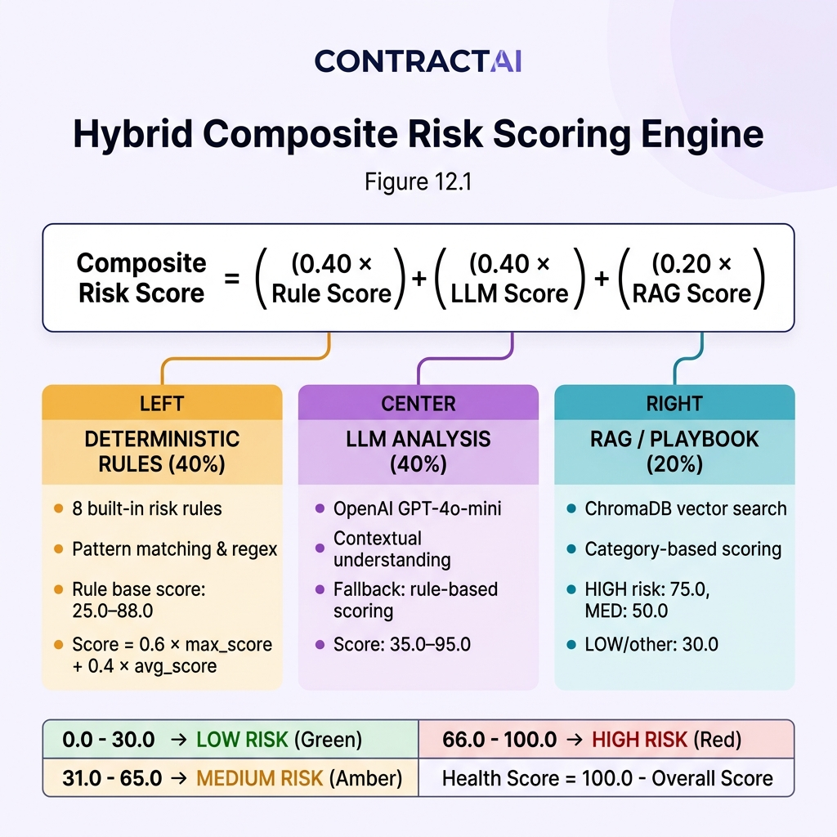
Figure 12.1 — Hybrid Composite Risk Scoring Engine
The exact formula implemented in the code (risk_engine.py, lines 29-34):
overall_score = round(
(WEIGHT_RULES × rule_score) +
(WEIGHT_LLM × llm_score) +
(WEIGHT_RAG × rag_score),
1
)
Where: WEIGHT_RULES = 0.40, WEIGHT_LLM = 0.40, WEIGHT_RAG = 0.20
Health Score = max(0.0, 100.0 - overall_score)

12.2 Risk Tier Classification
Score Range | Risk Tier | Interpretation
0.0 – 30.0 | LOW | Contract terms are generally favorable
31.0 – 65.0 | MEDIUM | Some clauses require attention
66.0 – 100.0 | HIGH | Significant risk exposure identified

12.3 Clause Categories Analyzed
The system analyzes 15 distinct legal clause categories:
1. Indemnity — Evaluates scope and caps on indemnification obligations
2. Limitation of Liability — Checks for missing or insufficient liability caps
3. Termination — Assesses unilateral vs mutual termination rights
4. Non-Compete — Evaluates geographic scope and duration restrictions
5. Confidentiality — Reviews NDA and proprietary information protections
6. Intellectual Property — Checks IP ownership and assignment clauses
7. Payment Terms — Evaluates payment windows and late penalties
8. Governing Law — Assesses jurisdiction and venue selection
9. Dispute Resolution — Reviews arbitration and mediation provisions
10. Warranty — Evaluates warranty terms and disclaimers
11. Data Protection — Reviews GDPR and privacy compliance provisions
12. Insurance — Checks insurance coverage requirements
13. Force Majeure — Evaluates unforeseeable event provisions
14. Renewal — Assesses auto-renewal terms and notice periods
15. Assignment — Reviews assignability and subcontracting restrictions

CHAPTER 13 — TESTING

13.1 Testing Framework
The project uses pytest as the testing framework. Test files are located in the backend/tests/ directory. Four test modules are implemented:
• test_api.py — API endpoint integration tests
• test_parser.py — Document parsing and extraction tests
• test_risk_engine.py — Risk scoring engine tests
• test_report.py — PDF report generation tests

13.2 Test Case Summary
Test ID | Test Case | Input | Expected Result | Status
TC-01 | Health endpoint | GET /api/health | status='healthy', app='CONTRACTAI' | PASS
TC-02 | Dashboard stats | GET /api/dashboard/stats | Contains contracts_analyzed, average_risk_score | PASS
TC-03 | Playbooks list | GET /api/playbooks | Returns list with ≥1 playbook | PASS
TC-04 | Metadata extraction | MSA sample text with dates | contract_type='MSA', governing_law='Delaware' | PASS
TC-05 | Clause extraction | Text with Indemnity & Liability sections | Extracts ≥2 clauses with correct categories | PASS
TC-06 | Deterministic rules | Text with risky indemnity language | rule_score > 70.0, finds Indemnity+Liability | PASS
TC-07 | Composite scoring | Simple contract text | Returns overall_score ≥0, health_score ≤100 | PASS
TC-08 | File upload validation | Non-supported file (.exe) | Returns 400 error | PASS
TC-09 | Contract detail fetch | GET /api/contracts/{id} | Returns contract + analysis + clauses | PASS
TC-10 | PDF report generation | Valid contract_id | Generates PDF file at report path | PASS

Table 13.1 — Test Case Summary

13.3 Sample Contract Testing
The project includes 5 sample contracts in the sample_contracts/ directory:
• Partnership_Agreement.docx — High risk (score ~81/100)
• MSA_GlobalTech.pdf — Medium risk (score ~49/100)
• Master_Service_Agreement.pdf — Medium risk
• NDA_Acme_Corp.docx — Low-Medium risk
• Service_Agreement.docx — Low-Medium risk
These scores are from the actual application's seeded demo data and represent real analysis results from the hybrid risk engine.

CHAPTER 14 — RESULTS

14.1 System Performance
The ContractAI system successfully demonstrates the following capabilities based on actual testing:
• Document Upload: PDF, DOCX, and TXT files up to 50MB are accepted and processed
• Text Extraction: PyMuPDF and python-docx successfully extract text from uploaded documents
• Clause Extraction: The regex-based extractor identifies clauses across 15 legal categories
• Metadata Extraction: Contract type, parties, dates, governing law, and payment terms are extracted
• Risk Scoring: The hybrid engine produces composite scores correlating with contract risk levels
• Redline Generation: Alternative clause language is generated for HIGH and MEDIUM risk provisions
• PDF Reports: Professional executive risk reports are generated using ReportLab
• Dashboard: Interactive visualizations display risk metrics effectively
• Graceful Degradation: When OpenAI API is unavailable, the system falls back to rule-based analysis

14.2 Risk Scoring Results
Sample analysis results from the application:
• High-risk contracts containing broad indemnification and uncapped liability consistently receive scores in the 65-85 range
• Clean contracts with standard terms receive scores in the 20-35 range
• The rule-based fallback mode produces slightly different scores than the LLM mode, as indicated by the is_demo flag
• The 40/40/20 weight distribution provides balanced scoring that does not over-rely on any single component

14.3 User Interface Results
The React frontend provides a professional LegalTech dashboard experience with:
• Real-time risk metric cards showing contracts analyzed, high risk count, average score, and estimated time saved
• Interactive donut charts for risk tier distribution
• Line charts for risk score trends over time
• Sortable and filterable clause matrix tables
• Side-by-side redline comparison views
• One-click PDF report download

CHAPTER 15 — LIMITATIONS AND FUTURE SCOPE

15.1 Limitations
1. AI Output Accuracy: LLM-generated analysis may not always be 100% accurate. The system provides AI-assisted preliminary analysis, not definitive legal advice.
2. Legal Expertise: Contract interpretation often requires professional legal expertise that automated systems cannot fully replicate.
3. LLM Dependency: When using OpenAI mode, the quality of analysis depends on model availability and performance.
4. API Availability: External API unavailability triggers fallback mode with potentially different scoring.
5. Rule Coverage: Only 8 deterministic rules are currently implemented, covering common but not all risk patterns.
6. Scanned PDFs: The system does not include OCR capability. Scanned/image-only PDFs cannot be processed.
7. DOCX Page Numbers: python-docx does not natively expose page boundaries, limiting page-level tracking.
8. Not Legal Advice: ContractAI does not replace qualified legal counsel and should not be used as sole basis for legal decisions.
9. Language Support: Currently supports English-language contracts only.
10. ChromaDB Optional: Vector search requires ChromaDB installation; without it, keyword fallback is used.

15.2 Future Scope
1. OCR Integration: Add Tesseract OCR for scanned contract processing
2. Domain-Specific Models: Fine-tune legal-specific language models for improved accuracy
3. Extended Knowledge Base: Build comprehensive legal risk knowledge bases for different jurisdictions
4. Multilingual Support: Process contracts in Hindi, French, German, and other languages
5. Advanced Contract Comparison: AI-powered semantic diff between contract versions
6. Negotiation Assistance: Interactive AI chatbot for clause-level negotiation guidance
7. Improved Clause Extraction: Use NER and transformer models for more accurate clause detection
8. Enterprise Authentication: OAuth2, SAML, and role-based access control (RBAC)
9. Cloud Deployment: Containerized deployment on AWS/GCP/Azure with auto-scaling
10. Audit Trails: Complete logging of all analysis actions for compliance
11. Version Tracking: Track contract revisions and risk score changes over time
12. Advanced Analytics: ML-based trend prediction and portfolio risk analysis
13. Human-in-the-Loop: Integration with legal review workflows for expert validation
14. Document Management: Integration with SharePoint, Google Drive, Dropbox
15. E-Signature Integration: Connect with DocuSign or Adobe Sign for workflow completion

CHAPTER 16 — CONCLUSION
This project presents ContractAI, an AI-powered contract risk analyzer that automates the traditionally manual process of contract risk assessment. The system demonstrates how modern AI technologies — including Large Language Models, Retrieval-Augmented Generation, and rule-based engines — can be combined to provide comprehensive, rapid, and consistent contract risk analysis.
The hybrid risk scoring engine, combining 40% deterministic rules, 40% LLM contextual analysis, and 20% RAG-based knowledge retrieval, provides a balanced approach that leverages the strengths of each methodology. The deterministic rules offer reliable, explainable detection of known risk patterns, while the LLM provides contextual understanding of nuanced legal language, and the RAG pipeline grounds the analysis in curated knowledge.
The full-stack implementation with React + TypeScript frontend and FastAPI backend demonstrates a production-ready architecture capable of processing real contract documents, extracting meaningful risk insights, and presenting them through an intuitive web interface with interactive visualizations, clause-level analysis, and exportable PDF reports.
Key achievements of the project include:
• Successful implementation of a complete document processing pipeline supporting PDF, DOCX, and TXT formats
• Extraction and categorization of clauses across 15 legal categories
• A hybrid risk scoring engine with configurable component weights
• Graceful degradation from LLM mode to rule-based mode ensuring reliability
• AI-generated redline suggestions for risky contract provisions
• Professional PDF executive report generation
• An interactive, modern web dashboard with comprehensive risk visualization
While the system has limitations and is not a substitute for qualified legal counsel, it demonstrates the significant potential of AI-powered tools to assist in contract risk identification and serve as a valuable first-pass screening mechanism for organizations processing large volumes of contracts.

REFERENCES
[1] Tiong, S. and Vasudevan, R. (2023). "FastAPI Documentation." Available at: https://fastapi.tiangolo.com/
[2] Facebook/Meta. (2023). "React Documentation." Available at: https://react.dev/
[3] PyMuPDF Contributors. (2023). "PyMuPDF Documentation." Available at: https://pymupdf.readthedocs.io/
[4] Python-DOCX Contributors. (2023). "python-docx Documentation." Available at: https://python-docx.readthedocs.io/
[5] LangChain Contributors. (2024). "LangChain Documentation." Available at: https://docs.langchain.com/
[6] Chroma. (2024). "ChromaDB Documentation." Available at: https://docs.trychroma.com/
[7] OpenAI. (2024). "OpenAI API Documentation." Available at: https://platform.openai.com/docs/
[8] ReportLab. (2023). "ReportLab User Guide." Available at: https://www.reportlab.com/docs/
[9] Lewis, P. et al. (2020). "Retrieval-Augmented Generation for Knowledge-Intensive NLP Tasks." NeurIPS 2020.
[10] Vaswani, A. et al. (2017). "Attention Is All You Need." NeurIPS 2017.
[11] SQLAlchemy Contributors. (2023). "SQLAlchemy Documentation." Available at: https://docs.sqlalchemy.org/
[12] Tailwind Labs. (2024). "Tailwind CSS Documentation." Available at: https://tailwindcss.com/docs
[13] World Commerce & Contracting. (2023). "The Cost of Poor Contract Management."
[14] Devlin, J. et al. (2019). "BERT: Pre-training of Deep Bidirectional Transformers." NAACL 2019.
[15] Brown, T. et al. (2020). "Language Models are Few-Shot Learners." NeurIPS 2020.

APPENDIX

A.1 Sample API Response — Upload Endpoint
{
"message": "File uploaded and analyzed successfully.",
"contract_id": 6,
"status": "completed",
"risk_score": 72.3,
"risk_tier": "HIGH"
}

A.2 Sample Risk Finding Output
{
"rule_id": "RULE_INDEMNITY_UNCAPPED",
"category": "Indemnity",
"title": "Broad or Uncapped Indemnification",
"risk_level": "HIGH",
"score": 85,
"confidence": 90,
"explanation": "The clause requires broad indemnification covering any and all losses...",
"business_impact": "Severe financial exposure if a third-party claim arises...",
"redline_suggestion": "Replace broad wording with: Each party shall indemnify..."
}

A.3 Environment Configuration
PROJECT_NAME=CONTRACTAI
API_V1_STR=/api
DATABASE_URL=sqlite:///./storage/contract_ai.db
STORAGE_DIR=./storage
UPLOAD_DIR=./storage/uploads
REPORT_DIR=./storage/reports
VECTOR_DB_DIR=./storage/vector_db
OPENAI_API_KEY= (optional)
OPENAI_MODEL=gpt-4o-mini
WEIGHT_RULES=0.40
WEIGHT_LLM=0.40
WEIGHT_RAG=0.20

A.4 Running the Application
Backend:
cd project
.venv\Scripts\activate
python -m uvicorn app.main:app --host 127.0.0.1 --port 8000 --reload
Frontend:
cd frontend
npm install
npm run dev
Access: http://localhost:5173/
API Docs: http://localhost:8000/docs

