Register



Get Top Users (Get)-

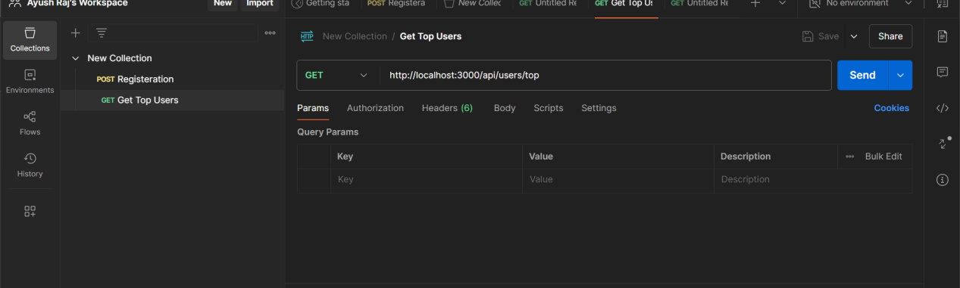

Response -

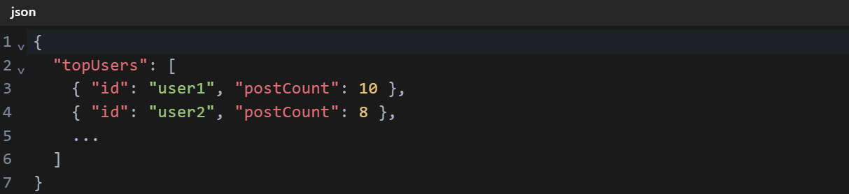

Post-

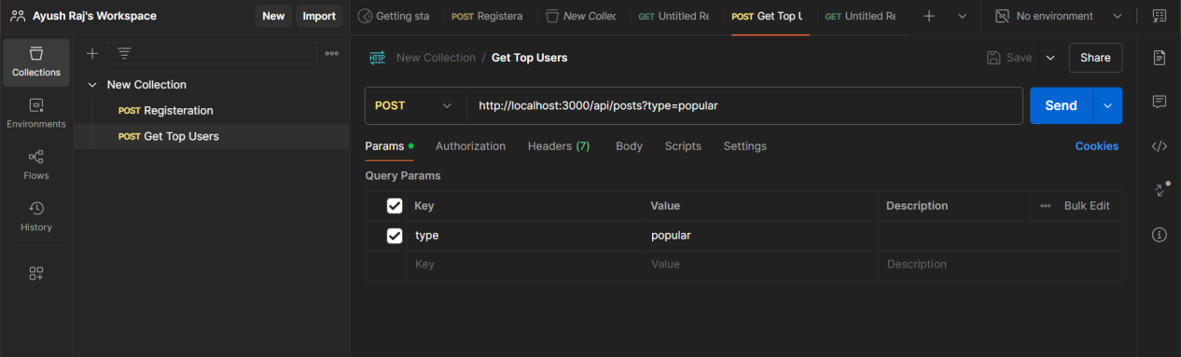

Response-

