https://www.hackerrank.com/challenges/for-loop-in-c/problem
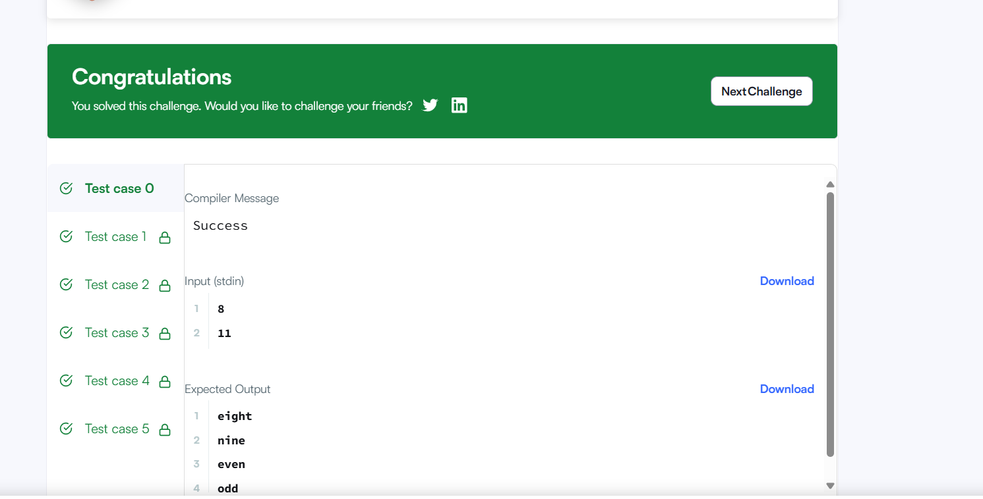
Code
int main()
{
int a, b;
scanf("%d %d", &a, &b);

for(int i = a; i <= b; i++) {

if(i == 1) {
printf("one\n");
}
else if(i == 2) {
printf("two\n");
}
else if(i == 3) {
printf("three\n");
}
else if(i == 4) {
printf("four\n");
}
else if(i == 5) {
printf("five\n");
}
else if(i == 6) {
printf("six\n");
}
else if(i == 7) {
printf("seven\n");
}
else if(i == 8) {
printf("eight\n");
}
else if(i == 9) {
printf("nine\n");
}
else if(i > 9 && i % 2 == 0) {
printf("even\n");
}
else {
printf("odd\n");
}
}

return 0;
}

