https://www.hackerearth.com/practice/basic-programming/input-output/basics-of-input-output/practice-problems/algorithm/count-divisors/
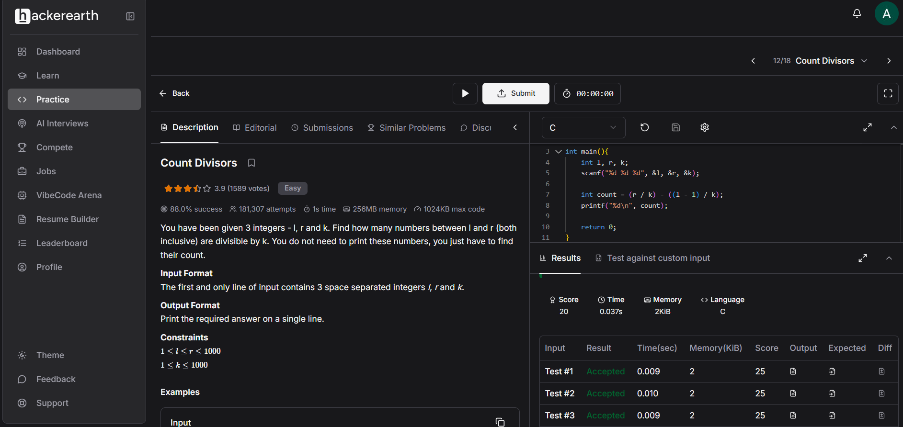
Code
#include <stdio.h>

int main(){
int l, r, k;
scanf("%d %d %d", &l, &r, &k);

int count = (r / k) - ((l - 1) / k);
printf("%d\n", count);

return 0;
}

