https://www.hackerearth.com/problem/algorithm/digit-sum-4/
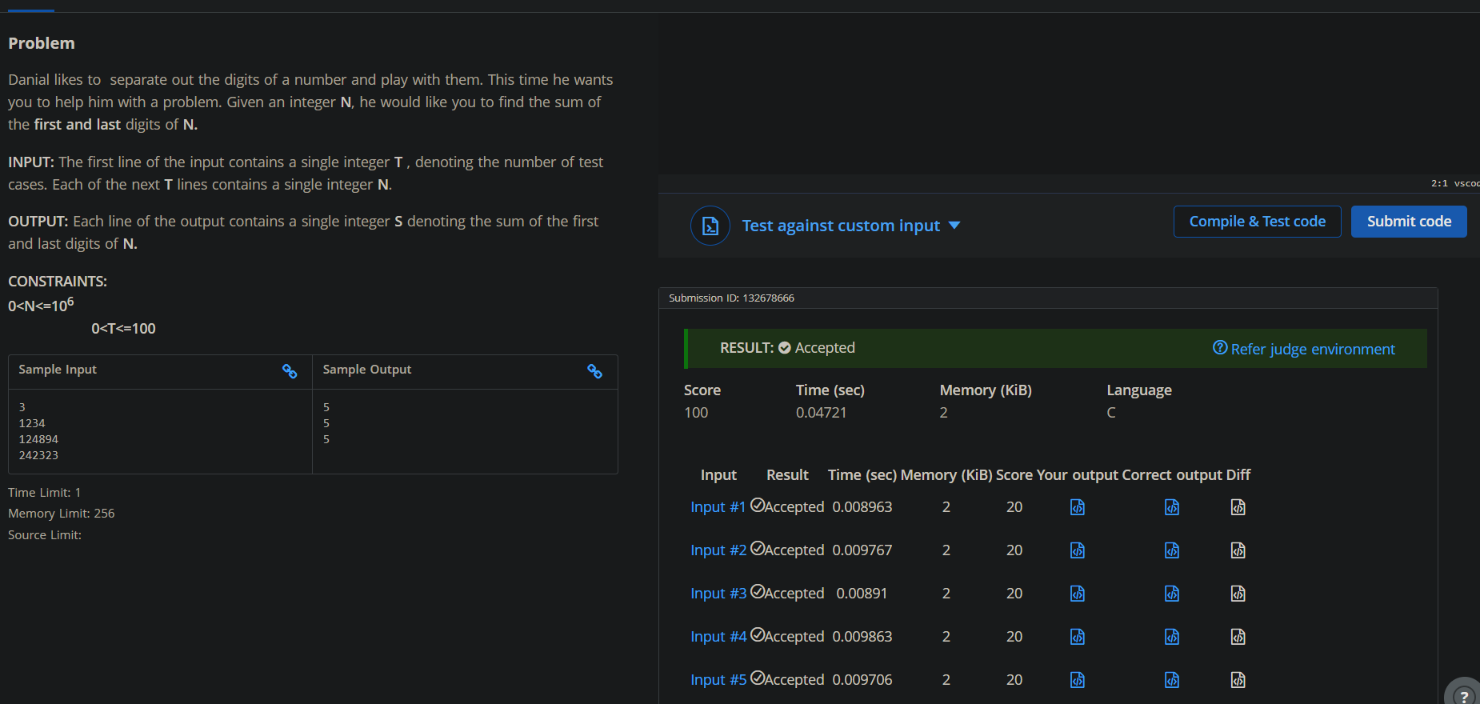
Code
#include <stdio.h>

int main() {
int T;
scanf("%d", &T);

while (T--) {
int N;
scanf("%d", &N);
int last = N % 10;

while (N >= 10) {
N = N / 10;
}
int first = N;
printf("%d\n", first + last);
}
return 0;
}

