https://www.hackerearth.com/practice/basic-programming/input-output/basics-of-input-output/practice-problems/algorithm/io-exercise/
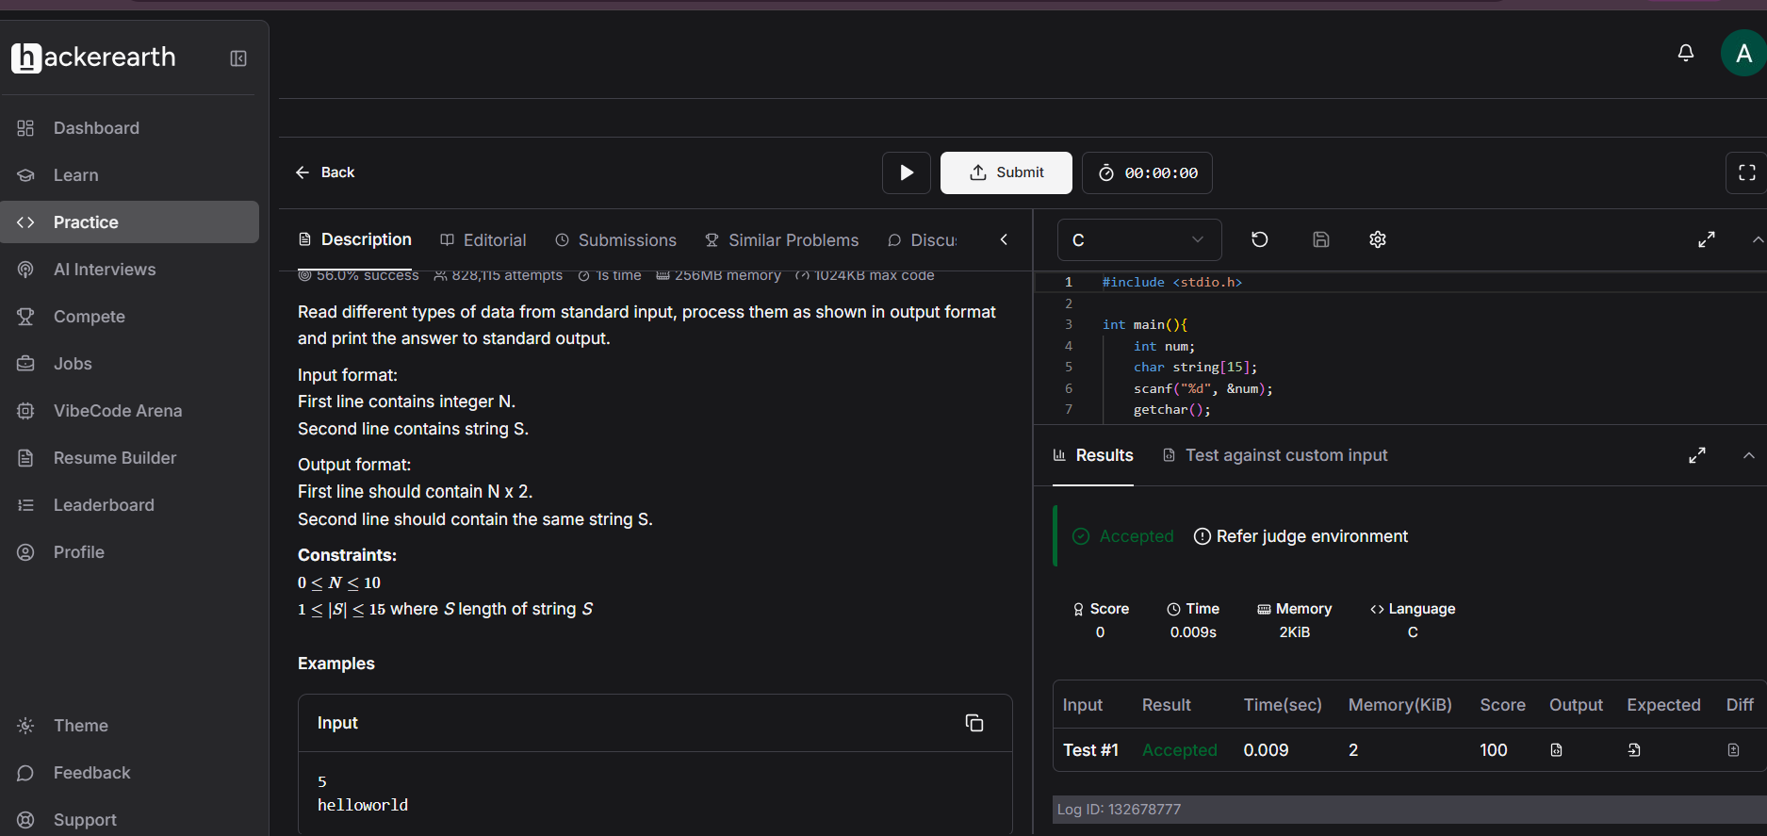
Code
#include <stdio.h>

int main(){
int num;
char string[15];
scanf("%d", &num);
getchar();
fgets(string, 15, stdin);
printf("%d\n", num*2);
printf("%s", string);
}

