https://www.hackerearth.com/practice/basic-programming/input-output/basics-of-input-output/practice-problems/algorithm/roy-and-profile-picture/
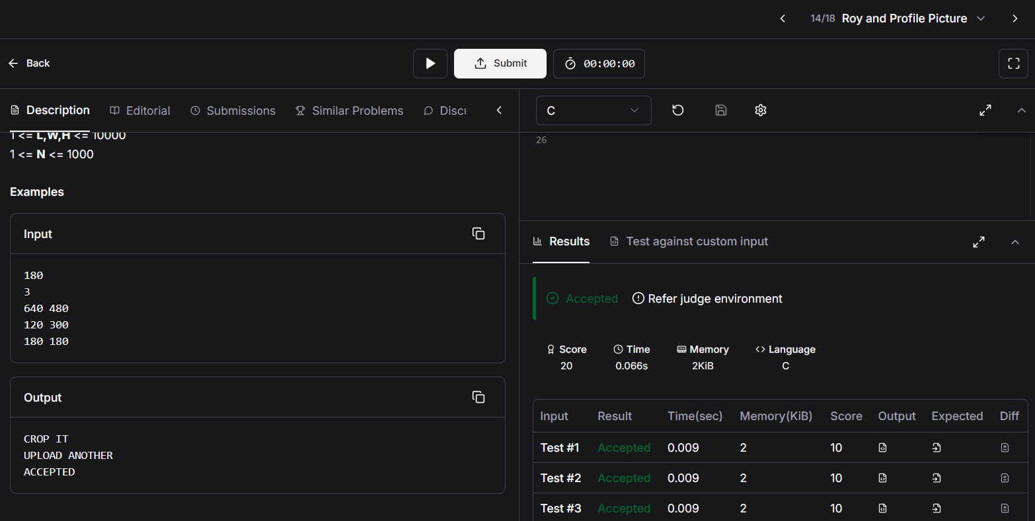
Code
#include <stdio.h>
int main(void){
int length;
int width;
int height;
int num;
scanf("%d", &length);
scanf("%d", &num);

for(int i = 1; i <= num; i++){
scanf("%d %d", &width, &height);

if(width < length || height < length){
printf("UPLOAD ANOTHER\n");
}
else if(width == height){
printf("ACCEPTED\n");
}
else{
printf("CROP IT\n");
}
}
return 0;
}

