https://www.hackerrank.com/challenges/conditional-statements-in-c/problem
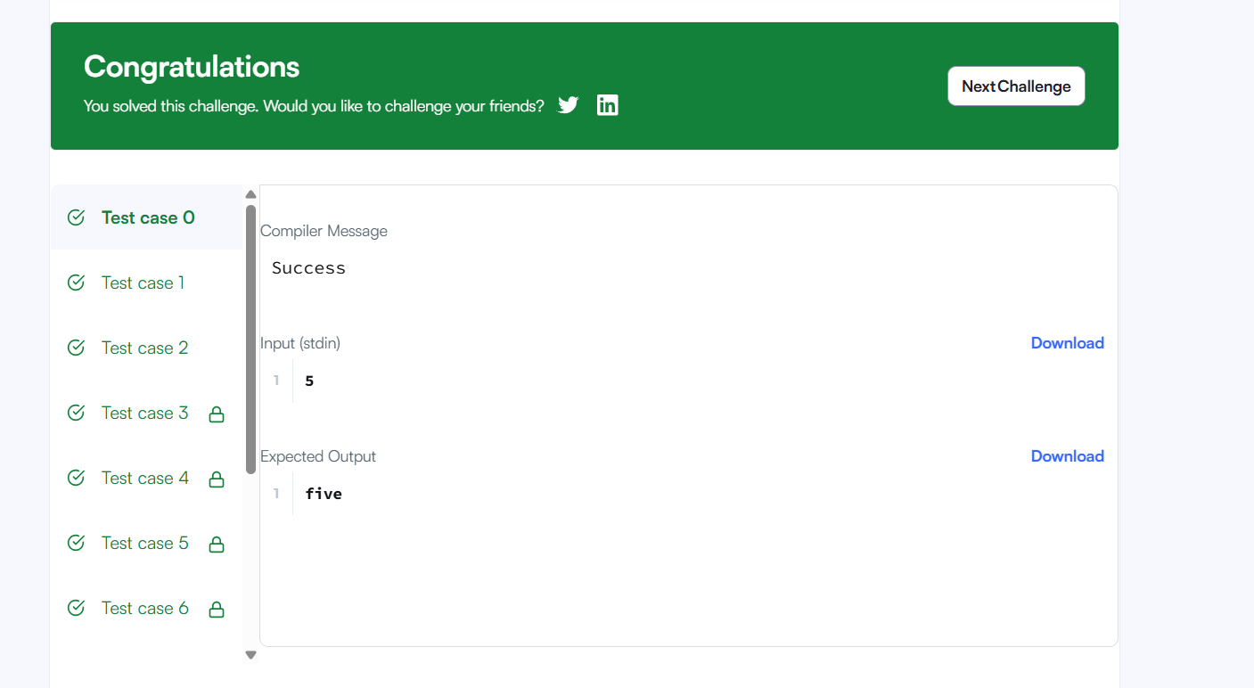
Code
int main()
{
char* n_endptr;
char* n_str = readline();
int n = strtol(n_str, &n_endptr, 10);

if (n_endptr == n_str || *n_endptr != '\0') { exit(EXIT_FAILURE); }

if(n >= 1 && n <= 9){
if(n == 1){
printf("one");
}
if(n == 2){
printf("two");
}
if(n == 3){
printf("three");
}
if(n == 4){
printf("four");
}
if(n == 5){
printf("five");
}
if(n == 6){
printf("six");
}
if(n == 7){
printf("seven");
}
if(n == 8){
printf("eight");
}
if(n == 9){
printf("nine");
}
}
if(n > 9){
printf("Greater than 9");
}

return 0;
}

