https://www.hackerrank.com/challenges/fizzbuzz/problem
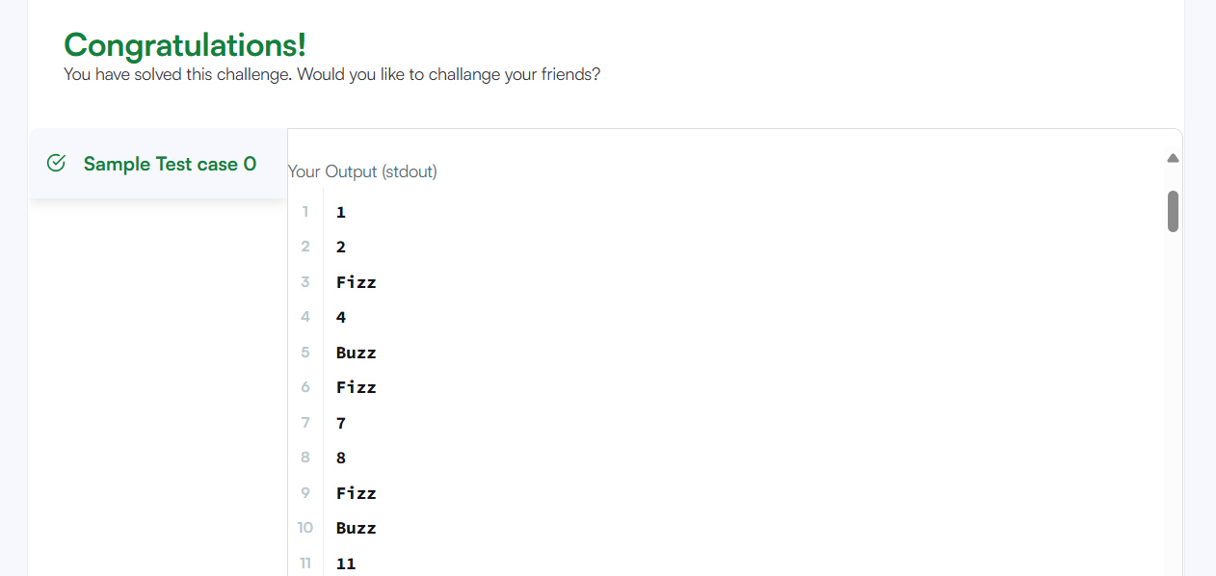
Code
#include<stdio.h>
int main()
{
int i;
for(i=1;i<=100;i++)
{
if(i%3!=0 && i%5!=0){
printf("%d\n", i);
}
if(i%3 == 0 && i%5!=0){
printf("Fizz\n");
}
if(i%5 == 0 && i%3!=0){
printf("Buzz\n");
}
if(i%5 == 0 && i%3==0){
printf("FizzBuzz\n");
}
}
}

