https://www.hackerrank.com/challenges/kangaroo/problem
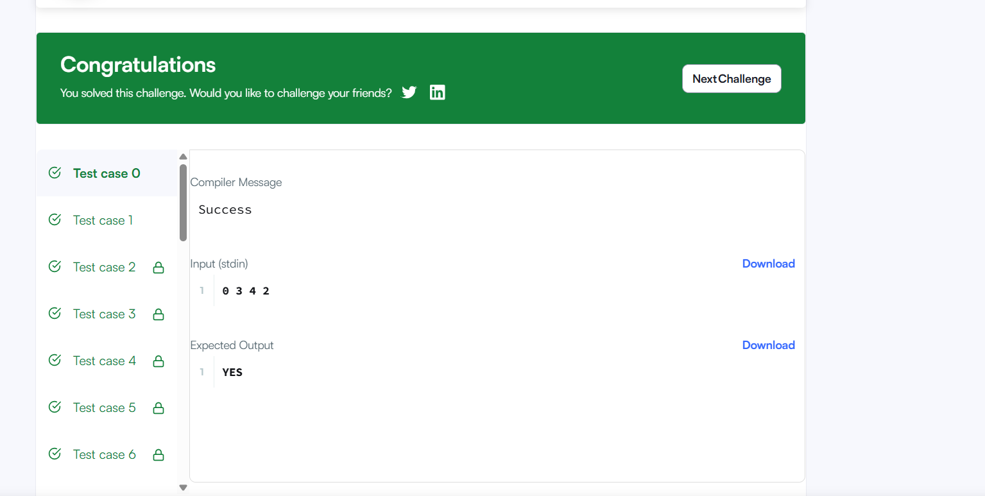
Code
char* kangaroo(int x1, int v1, int x2, int v2) {

if(v1 == v2) {
return (x1 == x2) ? "YES" : "NO";
}

int distance = x2 - x1;
int speed = v1 - v2;

if(distance % speed == 0 && distance / speed >= 0) {
return "YES";
}

return "NO";
}

