https://www.hackerrank.com/challenges/printing-pattern-2/problem
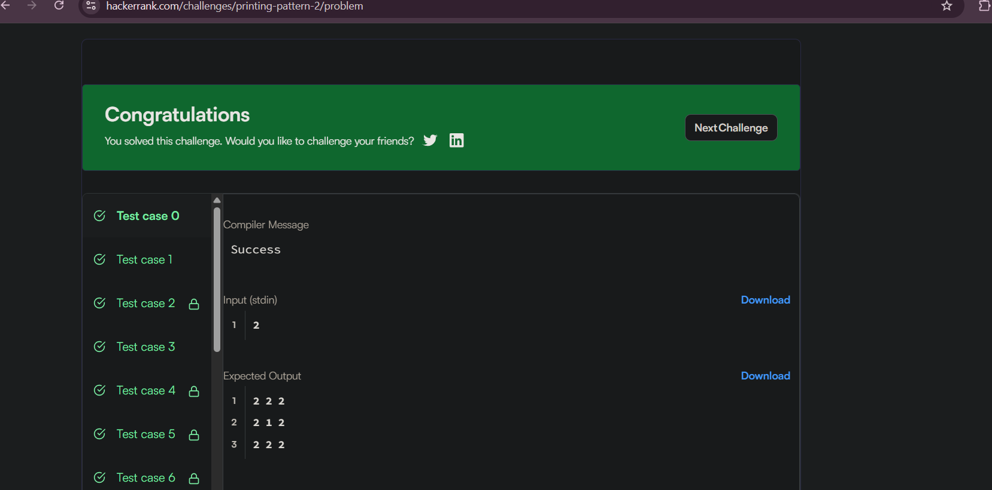
Code
#include <stdio.h>

int main() {
int n;
scanf("%d", &n);

int size = 2 * n - 1;

for (int i = 0; i < size; i++) {
for (int j = 0; j < size; j++) {

int min = i;

if (j < min)
min = j;

if (size - 1 - i < min)
min = size - 1 - i;

if (size - 1 - j < min)
min = size - 1 - j;

printf("%d", n - min);

if (j < size - 1)
printf(" ");
}
printf("\n");
}

return 0;
}

