https://leetcode.com/problems/subtract-the-product-and-sum-of-digits-of-an-integer/
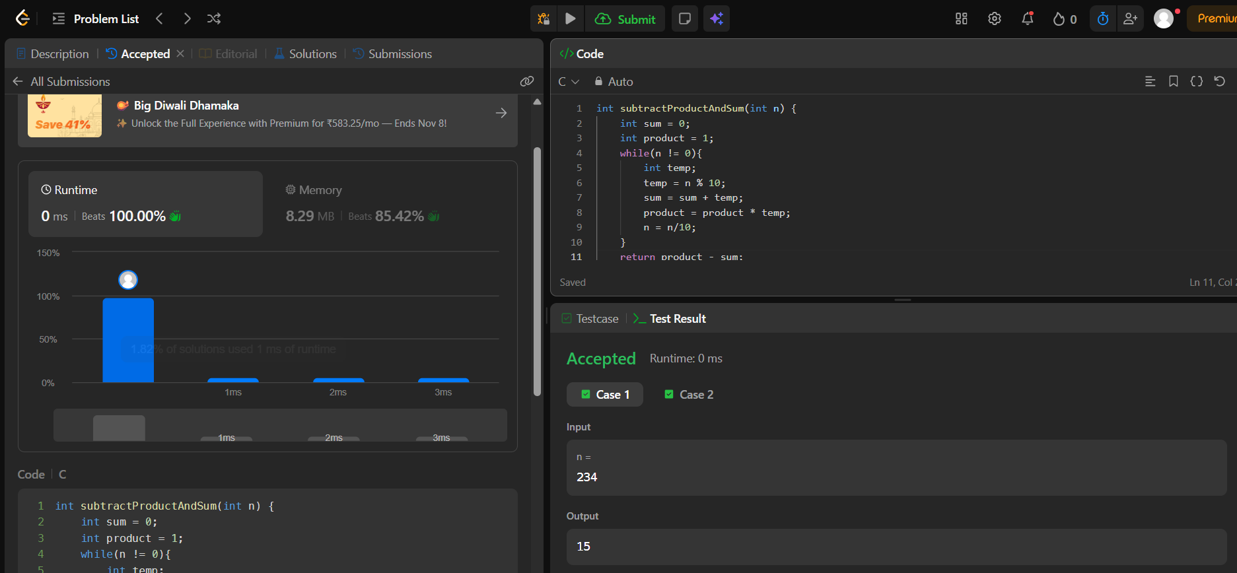
Code
int subtractProductAndSum(int n) {
int sum = 0;
int product = 1;
while(n != 0){
int temp;
temp = n % 10;
sum = sum + temp;
product = product * temp;
n = n/10;
}
return product - sum;
}

