https://leetcode.com/problems/count-operations-to-obtain-zero/
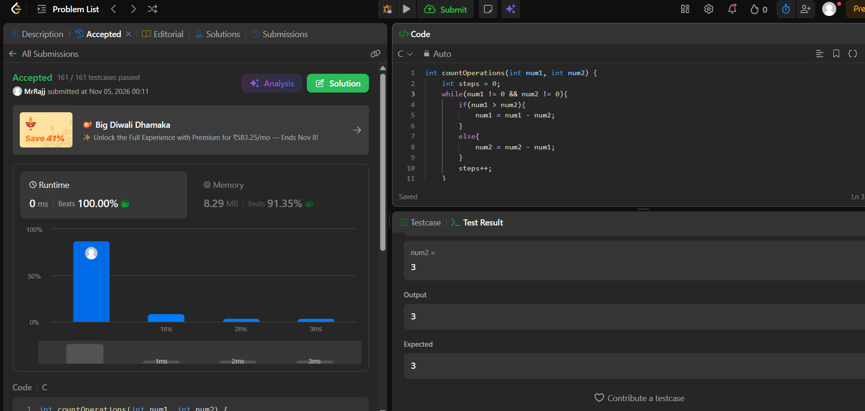
Code
int countOperations(int num1, int num2) {
int steps = 0;
while(num1 != 0 && num2 != 0){
if(num1 > num2){
num1 = num1 - num2;
}
else{
num2 = num2 - num1;
}
steps++;
}
return steps;
}

