https://leetcode.com/problems/count-the-digits-that-divide-a-number/
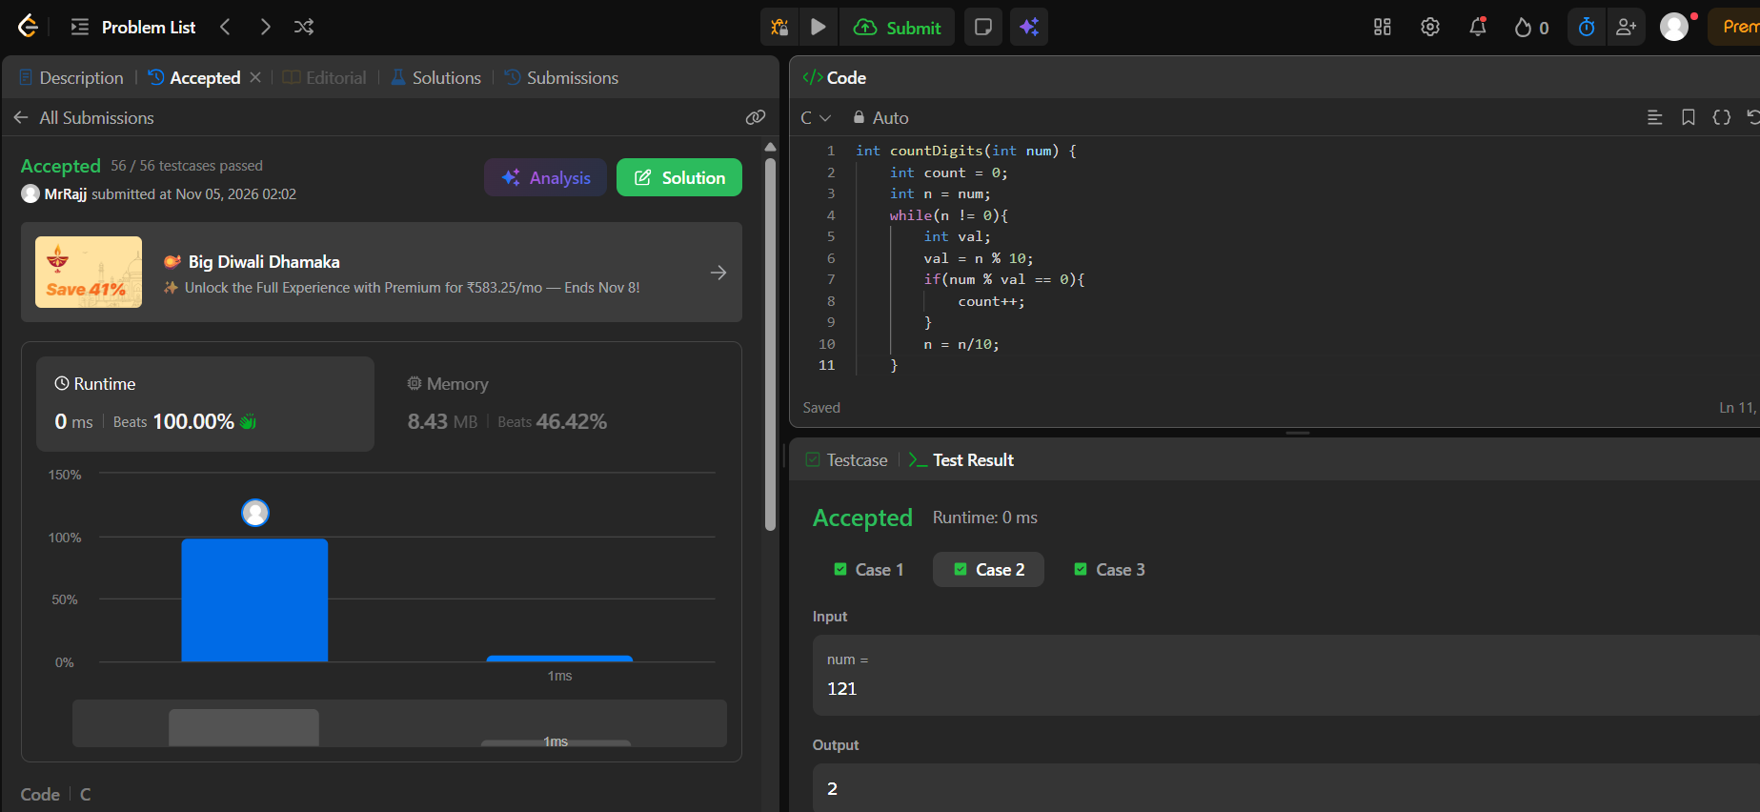
Code
int countDigits(int num) {
int count = 0;
int n = num;
while(n != 0){
int val;
val = n % 10;
if(num % val == 0){
count++;
}
n = n/10;
}
return count;
}

