https://leetcode.com/problems/power-of-three/
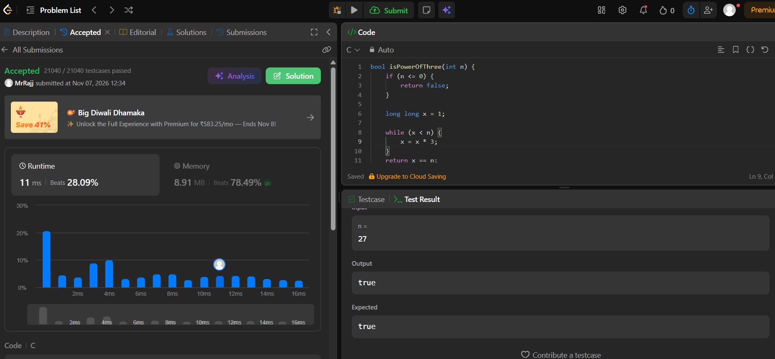
Code
bool isPowerOfThree(int n) {
if (n <= 0) {
return false;
}

long long x = 1;

while (x < n) {
x = x * 3;
}
return x == n;
}

