https://leetcode.com/problems/reverse-integer/
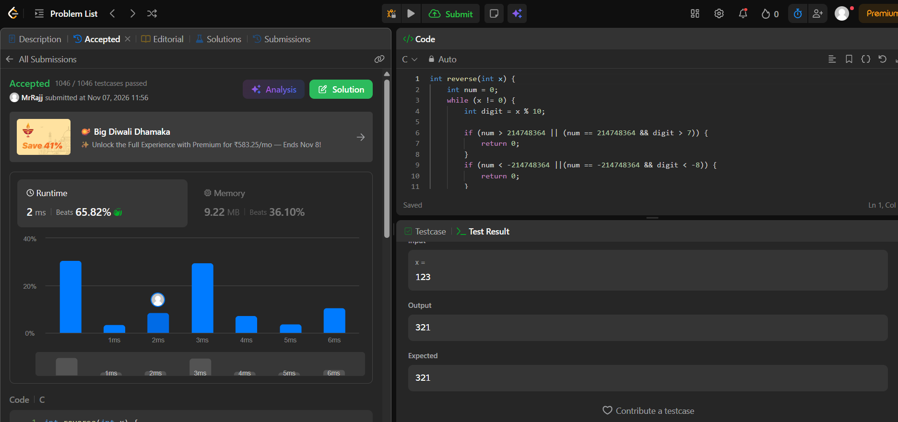
Code
int reverse(int x) {
int num = 0;
while (x != 0) {
int digit = x % 10;

if (num > 214748364 || (num == 214748364 && digit > 7)) {
return 0;
}
if (num < -214748364 ||(num == -214748364 && digit < -8)) {
return 0;
}
num = num * 10 + digit;
x = x / 10;
}
return num;
}

