PHINMA UNIVERSITY OF ILOILO
College of Information Technology Education

CAPSTONE PROJECT PROPOSAL

Design and Development of a Digital Lot Tracking System for Real Estate Lot Status Monitoring

In partial fulfilment of the requirements for Capstone 1 and Research Subject

Bawan, Faith Claire
Bearneza, John Edward
Delos Santos, James Ivan
Pugao, Christine Joy
Santiago, Arian Rashmil

Systems Development Track

Second Semester 2025-26

CHAPTER 1

INTRODUCTION

1.1 Background of the Study
In the real estate industry, accurate and timely monitoring of lot availability is important for efficient operations and proper client service. Real estate companies often manage multiple lots with different statuses, such as available, pending, and sold. Because of this, staff need a reliable way to track and update each lot's status.
At present, the client real estate company uses a manual process in monitoring lot statuses. Staff updates the lot status by manually marking and recoloring printed maps to indicate whether a lot is available, pending, or sold. Although this method may be familiar to the staff, it is repetitive, time-consuming, and prone to human error. Reprinting and manually recoloring maps whenever lot status changes can lead to inconsistencies, delays, and errors in identifying the current status of lots.
Manual systems also make it more difficult to maintain updated records and monitor lot information efficiently. Since the process relies heavily on printed maps and manual color coding, there is a higher risk of inaccurate updates, misplaced records, and slower response when staff need to check the latest lot status. These issues can affect the company’s internal operations and reduce the efficiency of lot monitoring.
To address these problems, a Digital Lot Tracking System is needed that allows staff to monitor and update lot statuses via an interactive digital map. Instead of manually recoloring printed maps, staff can click or select a lot and update its status in the system. The system will automatically apply the appropriate color coding, such as green for available, yellow for pending, and red for sold, to provide a clear and accurate visual representation of lot availability.
Therefore, this study proposes the Design and Development of a Digital Lot Tracking System for Real Estate Lot Status Monitoring. The proposed system aims to improve the current manual process by making lot status updates faster, more organized, and less prone to error. Through digital tracking and automatic color coding, the system is expected to support the client’s internal staff in managing lot status information more effectively.

1.2 Statement of the Problem
The client's real estate company currently uses manually color-coded printed maps to monitor and update lot statuses. This process is repetitive, time-consuming, and prone to human error, leading to delays, inaccurate lot information, and inefficient monitoring.
This study aims to address this problem by developing a Digital Lot Tracking System for Real Estate Lot Status Monitoring.
Specifically, this study seeks to answer the following questions:
- How can a digital system be designed and developed to replace the manual process of updating lot statuses using printed maps?
- How can the proposed system provide an interactive digital map that allows staff to view and update lot statuses easily?
- How can the system automatically apply color coding to lot statuses to improve accuracy and reduce manual recoloring?
- How can the proposed system improve the efficiency and organisation of lot status monitoring for staff users?
- How acceptable is the proposed Digital Lot Tracking System in terms of:
○ functionality,
○ usability,
○ efficiency, and
○ reliability?

1.3 Objectives of the Study

1.3.1 General Objective
The general objective of this study is to design and develop a Digital Lot Tracking System for Real Estate Lot Status Monitoring to improve the current manual process of updating and monitoring lot statuses within the client's real estate company.

1.3.2 Specific Objectives
Specifically, this study aims to:
- Design and develop a digital system to replace the manual use of printed maps for lot status monitoring.
- Create an interactive digital map interface that lets staff easily view and update lot statuses.
- Implement automatic color coding for lot statuses, such as:
○ Green for available,
○ Yellow for pending, and
○ Red for sold.
- Provide a more organised and efficient method for tracking lot availability and status changes.
- Evaluate the proposed system based on:
○ functionality,
○ usability,
○ efficiency, and
○ reliability.

1.4 Scope and Delimitation of the Study
This study focuses on the design and development of a Digital Lot Tracking System for Real Estate Lot Status Monitoring for the client's real estate company.
The proposed system will include the following features:
● A digital map interface for displaying lots
● Lot status updating through user interaction
● Automatic color coding based on lot status
● Storage and retrieval of lot information
● Monitoring of lot availability for internal staff use
The system is intended only for the client's real estate company's staff. It will serve as an internal tool for viewing and updating lot statuses.
The proposed system will be developed as a web-based application, accessible via a web browser within the company's operational setting.
However, the study has the following delimitations:
● The system is intended for staff users only and not for clients or the general public.
● The system will focus only on lot status monitoring and updating.
● The system will not include online reservation, payment processing, or customer account management.
● The system will not include advanced geographic information system (GIS) features beyond the basic interactive digital lot map needed for monitoring.
● The study will focus solely on the design, development, and evaluation of a prototype system.

1.5 Significance of the Study
This study is significant because it aims to improve the client real estate company's current manual process for monitoring and updating lot statuses.
The proposed Digital Lot Tracking System may benefit the following:

Staff
The system will help staff update and monitor lot statuses more quickly and accurately. Instead of manually recoloring printed maps, staff can use the digital map interface to update lot information with less effort and reduced risk of error.

Real Estate Company
The company may benefit from a more organized, efficient method for monitoring lot status. The proposed system can improve internal workflow, reduce repetitive manual work, and support better record management.

Future Researchers and Developers
The study may serve as a reference for future researchers developing similar systems for real estate management, digital mapping, or lot monitoring. It may also provide useful ideas for improving manual monitoring systems through digital solutions.

1.6 Definition of Terms
The following terms are defined conceptually and operationally as used in this study:

Automatic Color Coding
A feature of the system that automatically assigns colors to lots based on their status. In this study, the automatic display shows green for available lots, yellow for pending lots, and red for sold lots.

Digital Lot Tracking System
A web-based system designed to digitally monitor, display, and update the status of real estate lots. In this study, the proposed system is referred to as the system developed for the client real estate company.

Interactive Digital Map
A visual digital representation of lots that allows users to click or select a lot to view or update its status. In this study, it serves as the main interface for lot monitoring.

Lot Status
The current condition or availability of a lot. In this study, lot status refers to whether a lot is available, pending, or sold.

Lot Status Monitoring
The process of checking, tracking, and updating the status of lots. In this study, the term refers to the staff's activity of managing lot availability using the proposed system.

Manual System
A process that relies on physical documents, printed maps, and manual updating methods. In this study, the term refers to the client’s current method of recoloring printed maps to reflect lot status changes.

Prototype
An initial functional version of the system was developed for testing and evaluation. In this study, it refers to the developed version of the Digital Lot Tracking System used during the evaluation phase.

Web-Based Application
A software application that is accessed through a web browser over a network or local environment. In this study, the platform refers to the platform used for the proposed Digital Lot Tracking System.

CHAPTER 2

REVIEW OF RELATED LITERATURE AND STUDIES

2.1 Foreign Studies
Foreign studies show that digital and web-based land information systems are effective in improving the management of land-related records, maps, and monitoring processes. These studies are relevant to the present project because they demonstrate how manual and paper-based systems can be improved through digital platforms.
One related foreign study is the Web-Based Land Information System for Nintavur Divisional Secretariat Division (DSD), Sri Lanka, by Kaleel and Zahir (2016). The study developed a web-based land information system to manage land-related records in a more organized and accessible manner. It emphasised the importance of creating a land information database and using digital tools to improve the acquisition, maintenance, utilisation, and transfer of land-related data. The researchers also explained that the system used a server-side web architecture and incorporated web technologies such as HTML, CSS, JavaScript, PHP, and database tools. This study is related to the present study because both aim to improve land-related record management by replacing manual processes with a digital system. However, the current study is more specific, focusing on lot status monitoring for a real estate company rather than general land administration.
Another related foreign study is Implementation of Web Map Services for Old Cadastral Maps by Verdu-Candela, Femenia-Ribera, Mora-Navarro, and Sierra-Requena (2023). This study focused on the use of digitised cadastral maps and web map services to make land parcel information more accessible and useful. The study showed that digital maps can improve access to land-related information and offer greater usability than traditional paper maps. It also highlighted the value of web-based geographic services in organising and presenting map data. This is relevant to the present study because the proposed system also uses a digital map interface to view and monitor lot information. While the foreign study focused on cadastral mapping and spatial data services, the present study applies a similar approach in a more practical, simplified way for internal lot status tracking.
Another foreign study related to the present project is "Web-Based Village Land Information System Development for Optimising Regional Land Administration" by Sidiq, Junarto, and Wahyuni (2025). The study aimed to develop a web-based land information system to improve regional land administration by providing organised, accessible, and reliable land data. It used a research-and-development approach and found that the developed system improved land information management and user satisfaction. This study is relevant because it supports the idea that land-related information becomes easier to manage when it is moved from manual processes to a structured web-based system. Like the present study, it highlights the usefulness of digital systems for organizing land data. However, the present project is specifically limited to real estate lot status monitoring for staff users only.

2.2 Local Studies
Local studies also support the use of web-based systems in improving real estate and property-related processes in the Philippines. These studies show that digital systems can make record management more organized, efficient, and accessible.
One related local study is the Philippine Web-Based Real Estate Appraisal Information Management System (PWB-REAIM) by Abelon (2014). This study was developed because appraisal forms used by real estate appraisers were not standardised, and there was limited access to software suited to Philippine real estate practices. The developed system provided a web-based platform for personnel to create, store, manage, and edit appraisal forms. It also aimed to automate the creation of appraisal forms. This study is relevant to the present study because it demonstrates how a manual, inconsistent real estate-related process can be improved through a web-based information system. Similar to the current project, it focuses on improving efficiency, organisation, and record handling through digitisation.
Another local study is the Web-Based Real Estate Property Management System by Camago, Degala, Insauriga, and Alquisada (2018) from Central Philippine University. This thesis project developed a web-based system for real estate property management. The study supports the use of digital systems in handling real estate-related operations. This is relevant to the present study because it confirms that web-based solutions are appropriate for real estate-related tasks. However, while that project addressed broader property management, the current study is more specific, focusing only on lot status monitoring and updating via an interactive digital lot map for staff users.

Summary and Comparison of Local Studies
The reviewed local studies show that web-based systems are useful in improving real estate-related operations in the Philippine setting. They help make records more organized, easier to access, and more efficient to manage.
However, the reviewed local studies generally focus on broader real estate functions such as appraisal information management and general property management. In contrast, the present study is more specific and directly addresses the client’s operational problem. The proposed system focuses on internal lot status monitoring, allowing staff to view and update lot statuses through an interactive digital map with automatic color coding. This makes the present study distinct from the reviewed local systems.

2.3 Related Literature

Information Systems
An information system is a system that collects, processes, stores, and distributes information to support organisational operations and decision-making. In business environments, information systems are important because they improve record management and help users access accurate information more efficiently.
In land and property management, information systems are especially useful because they help replace manual, paper-based records with digital, more organized data storage. In a study by Kaleel and Zahir (2016), the researchers emphasised the importance of a web-based land information system for organising land-related data and improving access to land records. This supports the present study because the proposed Digital Lot Tracking System also aims to improve the organisation and accessibility of lot records through a web-based platform.
Another important concept related to the present study is the use of digital cadastral maps. According to Cichocinski (1999), traditional cadastral systems that rely on paper maps and land registers become insufficient as land management becomes more complex. The author explained that a digital cadastral map is a major component of a land information system because it enables better organisation and supports additional layers of information for management purposes. This supports the present study because the proposed system replaces manually color-coded printed maps with a digital lot map that is easier to update and monitor.

Software Development
Software development methodology is important because it provides a structured process for designing, developing, TestingTesting, and improving a system.
The present study uses the Agile Development Model because it supports flexibility, continuous improvement, and gradual refinement of system features. According to Ríos and Pedreira-Souto (2019), agile methodologies are widely used in web-based software development because they support adaptation, responsiveness to user needs, and continuous improvement throughout the development process. This is relevant to the current study because the proposed Digital Lot Tracking System is a web-based application that may need adjustments based on client feedback and testing results.
Similarly, Qumer and Henderson-Sellers (2008) explained that agile methods are useful because they help development teams adopt and improve software development practices while responding to changing requirements. This supports the present study because the researchers may need to revise and improve the system's features during development as they better understand the client's needs.

Technologies Used
The proposed system is a web-based application, which means it relies on technologies used for interface design, server-side processing, and data storage.
Web-based systems are commonly used in land and real estate-related applications because they allow users to access the system through a browser while maintaining centralized data management. In the Sri Lanka land information system study, the researchers used web technologies such as HTML, CSS, JavaScript, PHP, and database tools in developing their land information platform. This supports the present study by showing that web technologies are appropriate for land- and lot-related systems.
Likewise, the Philippine Web-Based Real Estate Appraisal Information Management System demonstrated that web-based technologies can be effectively used in the Philippine real estate setting. The study described a system that allowed users to create, store, and manage appraisal forms online. This supports the current project because both systems aim to improve real estate-related record handling through digital tools.
Another important technological concept related to the present study is the use of a digital map interface. A digital map interface allows users to visually monitor lot information more quickly and clearly compared to printed maps. Through color-coded visual indicators, staff can easily identify whether a lot is available, pending, or sold. This makes the monitoring process more efficient and less prone to human error.

2.4 Synthesis of the Reviewed Literature
Based on the reviewed foreign and local studies, digital and web-based systems are effective in improving land, property, and real estate-related processes. Foreign studies showed that web-based land information systems and digital map services improve the organization, accessibility, and usability of land-related records. Local studies also showed that web-based systems can improve real estate functions such as appraisal information management and property management.
A common finding across the reviewed studies is that manual, paper-based processes often lead to delays, repetitive work, inconsistent records, and difficulty updating information. As a result, many systems were developed to digitize records, centralize data, and improve accessibility. This supports the need for the present study because the client currently uses manually color-coded printed maps to monitor lot statuses, which is repetitive, time-consuming, and prone to human error.
The reviewed studies also reveal a gap. Most foreign studies focus on general land administration, cadastral systems, or access to land information, whereas the reviewed local studies focus on appraisal systems and general property management. There are limited studies that specifically address a staff-only internal system for real-time lot status monitoring using an interactive digital map with automatic color coding.
The present study addresses this gap by proposing a Digital Lot Tracking System for Real Estate Lot Status Monitoring, specifically intended for a real estate company's internal operations. Unlike broader land or property systems, the proposed project focuses on a specific operational need: enabling staff to quickly view and update lot statuses in a centralized digital environment. Through its interactive lot map, automatic color coding, and digital record management, the proposed system directly improves the client's current manual process. It offers a more efficient, accurate, and user-friendly solution.

References
Abelon, M. J. (2014). Philippine web-based real estate appraisal information management system. University of the Philippines Open University. https://repository.upou.edu.ph/items/4e1b7218-f84f-4b38-806e-7014351563bc
Camago, I. P., Degala, A. L., Insauriga, J. B., & Alquisada, C. G. S. (2018). Web-based real estate property management system [Thesis project, Central Philippine University]. Central Philippine University Repository.
Cichocinski, P. (1999). Digital cadastral maps in land information systems. LIBER Quarterly: The Journal of the Association of European Research Libraries, 9(2), 211–221. https://doi.org/10.18352/lq.7535
Kaleel, M. I. M., & Zahir, I. L. M. (2016). Web-based land information system for Nintavur Divisional Secretariat Division (DSD), Sri Lanka. Journal of Geography, Environment and Earth Science International, 5(4), 1–6. https://doi.org/10.9734/JGEESI/2016/20748
Qumer, A., & Henderson-Sellers, B. (2008). A framework to support the evaluation, adoption, and improvement of agile methods in practice. Journal of Systems and Software, 81(11), 1899–1919. https://doi.org/10.1016/j.jss.2007.12.806
Ríos, J. M., & Pedreira-Souto, N. (2019). Approach of agile methodologies in the development of web-based software. Information, 10(10), 314. https://doi.org/10.3390/info10100314
Sidiq, H. H., Junarto, R., & Wahyuni, W. (2025). Web-based village land information system development for optimizing regional land administration. International Journal of Advances in Data and Information Systems, 6(1), 46–61. https://doi.org/10.59395/ijadis.v6i1.1360
Verdu-Candela, A., Femenia-Ribera, C., Mora-Navarro, G., & Sierra-Requena, R. (2023). Implementation of web map services for old cadastral maps. ISPRS International Journal of Geo-Information, 12(10), 413. https://doi.org/10.3390/ijgi12100413

CHAPTER 3

METHODOLOGY

3.1 Research Design
This study will use a developmental research design. Developmental research is appropriate because the study focuses on the design, development, and evaluation of a proposed software application intended to solve an existing operational problem.
The study aims to develop a Digital Lot Tracking System for Real Estate Lot Status Monitoring for the client's real estate company. The system is intended to improve the current manual process of updating lot statuses using printed maps. Using this research design, the researchers will analyze the existing problem, develop a suitable digital solution, and evaluate the system against identified criteria, including functionality, usability, efficiency, and Reliability.
This research design is appropriate because the study's main goal is not only to investigate a problem but also to create a working prototype that addresses the client's identified needs.

3.2 System Development Methodology
The study will use the Agile Development Model as the system development methodology. Agile is appropriate for this study because it supports flexibility, continuous improvement, and frequent revision based on user feedback. Since the proposed system is intended to solve a specific operational problem in the client's real estate company, Agile allows the researchers to refine the system during development gradually.
The Agile Development Model in this study consists of the following phases:

3.2.1 Requirements Analysis
In this phase, the researchers will gather and analyze the requirements of the client's real estate company. This includes identifying current problems in the manual lot-monitoring process, understanding how staff update lot statuses using printed maps, and determining the features needed in the proposed system. Information gathered in this phase will serve as the basis for the design and development of the Digital Lot Tracking System.

3.2.2 System Design
In this phase, the researchers will create the overall design of the proposed system. This includes planning the system structure, designing the user interface, and preparing the layout of the interactive digital lot map. The design phase will also define how lot statuses will be displayed, how automatic color coding will work, and how users will interact with the system.

3.2.3 Development
In this phase, the system's actual coding and implementation will be carried out. The researchers will develop the features of the Digital Lot Tracking System based on the approved design and identified requirements. This includes developing the digital lot map interface, lot status update functions, automatic color coding, and the storage and retrieval of lot information.

3.2.4 Testing
In this phase, the developed system will be tested to verify its intended performance. The researchers will test whether the system can correctly display lot information, update lot statuses, and apply appropriate color coding. Errors, bugs, and usability issues identified during Testing will be corrected and improved.

3.2.5 Deployment (Prototype)
In this phase, the developed prototype of the Digital Lot Tracking System will be presented and deployed for evaluation within the intended environment. The system will be demonstrated to the target users, specifically the staff of the client real estate company, for initial use and assessment. Feedback gathered during this phase will help determine the acceptability and effectiveness of the proposed system.

3.3 System Architecture
The proposed Digital Lot Tracking System will follow a client-server architecture. In this architecture, users access the system via a web browser, while the server processes requests, manages system logic, and handles data storage.
Client-side refers to the interface used by staff. Through this interface, staff will be able to view the interactive digital map, select specific lots, and update their status as available, pending, or sold.
The server-side will process user requests and apply the appropriate system functions. When a staff member updates the status of a lot, the server processes the request, saves the updated information, and returns the result to the user interface. The system will then automatically reflect the updated lot status using the assigned color code.
The database will store a lot of information and status records. It will serve as the centralized repository of data, allowing the system to retrieve and display updated lot information whenever needed.
This architecture is appropriate for the study because it supports centralized data management, easier record updates, and efficient access to large amounts of information for staff users.

3.4 Tools and Technologies Used
Note: The researchers will complete this section based on the final selected technology stack.
The tools and technologies to be used in developing the proposed system will depend on the researchers' final implementation plan. These may include technologies for the front-end interface, back-end development, database management, and development environment.
The selected tools and technologies should be appropriate for building a web-based Digital Lot Tracking System that supports an interactive digital map, lot status updating, automatic color coding, and data storage.

3.5 Data Gathering Techniques
To gather the necessary information for the development of the proposed system, the researchers will use the following data gathering techniques:

3.5.1 Interview
The researchers will conduct interviews with staff or representatives of the client's real estate company to understand the current manual process for monitoring lot status. Through the Interview, the researchers will gather information about how printed maps are currently used, the challenges encountered in updating lot statuses, and the specific features needed in the proposed system.

3.5.2 Observation
The researchers will observe the client's current workflow for lot status monitoring and updating. This will allow the researchers to directly examine how staff use manually color-coded printed maps and identify the inefficiencies, delays, and possible errors in the current process.

3.5.3 Review of Existing Documents and Related Systems
The researchers will review available printed maps, existing lot records, and other related documents used by the client. In addition, the researchers will examine related literature and existing systems to identify useful concepts, features, and best practices that may be applied in the development of the proposed system.
These data-gathering techniques are appropriate because they will provide both direct and supporting information necessary to understand the client's current process and to design a suitable digital solution.

3.6 Testing Procedures
The proposed Digital Lot Tracking System will undergo testing to ensure it functions properly and meets the study's intended objectives. The following testing procedures will be conducted:

3.6.1 Unit Testing
Unit testing will be performed to check individual parts or modules of the system. Each feature, such as the lot selection function, lot status update function, and automatic color-coding function, will be tested separately to ensure it works correctly.

3.6.2 System Testing
System testing will be conducted to evaluate the overall performance of the complete system. This will determine whether all system components work together properly, including the interactions among the user interface, system logic, and the database. The researchers will verify if the system can accurately display lot information, process status updates, and reflect changes on the digital map.

3.6.3 User Acceptance Testing
User Acceptance Testing (UAT) will be conducted with the intended users, specifically the staff of the client real estate company. Users will test the prototype system to evaluate its intended functions and usability. Their feedback will help determine whether the system is acceptable and meets the client's actual needs.

3.7 Evaluation Criteria
The proposed Digital Lot Tracking System will be evaluated based on the following criteria:

3.7.1 Functionality
This refers to the system's ability to perform its intended functions correctly. The system will be evaluated based on whether it can properly display the digital lot map, update lot statuses, apply automatic color coding, and accurately store or retrieve lot information.

3.7.2 Usability
This refers to how easy and convenient the system is for staff users to understand and operate. The system will be evaluated based on the clarity of the interface, ease of navigation, and ease of updating lot statuses.

3.7.3 Efficiency
This refers to how quickly and effectively the system performs compared to the current manual process. The system will be evaluated based on whether it reduces repetitive work, speeds up lot status updates, and improves the overall workflow of lot monitoring.

3.7.4 Reliability
This refers to the system's consistency and dependability in performing its functions. The system will be evaluated based on whether it consistently displays correct lot information and processes updates without errors during use.

SUPPORTING DIAGRAMS (Included within Chapter 3)

Entity Relationship Diagram (ERD)
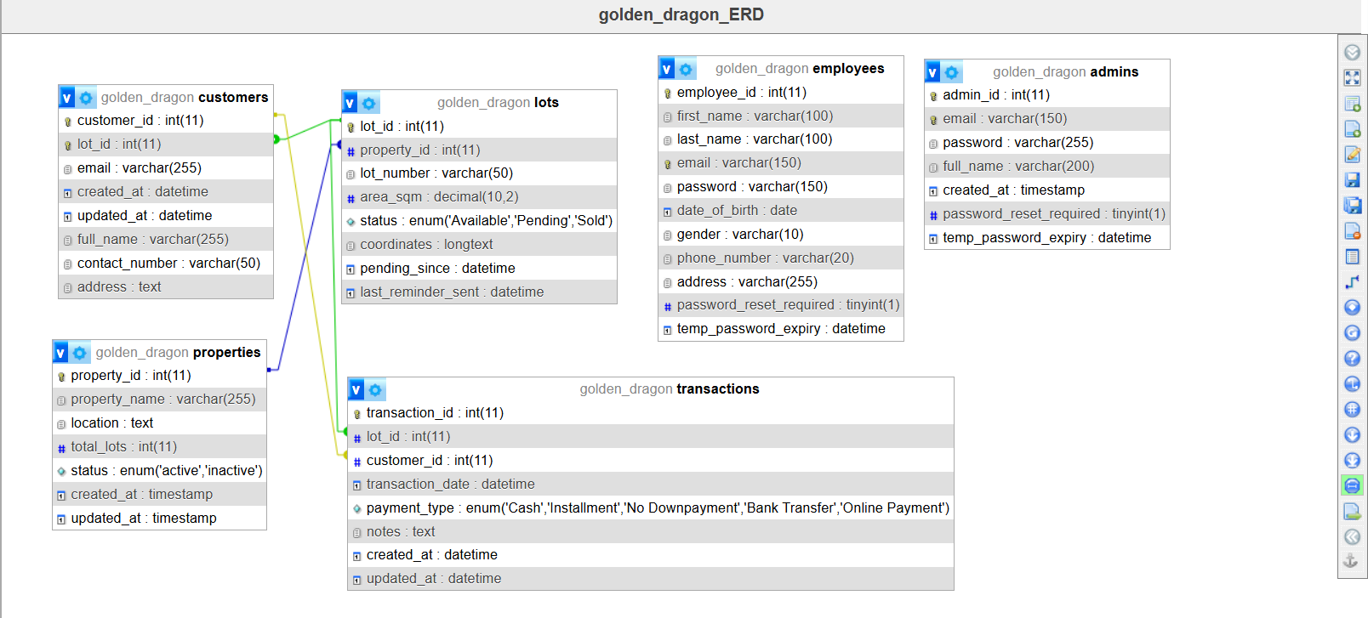

DATA FLOW DIAGRAM (DFD)

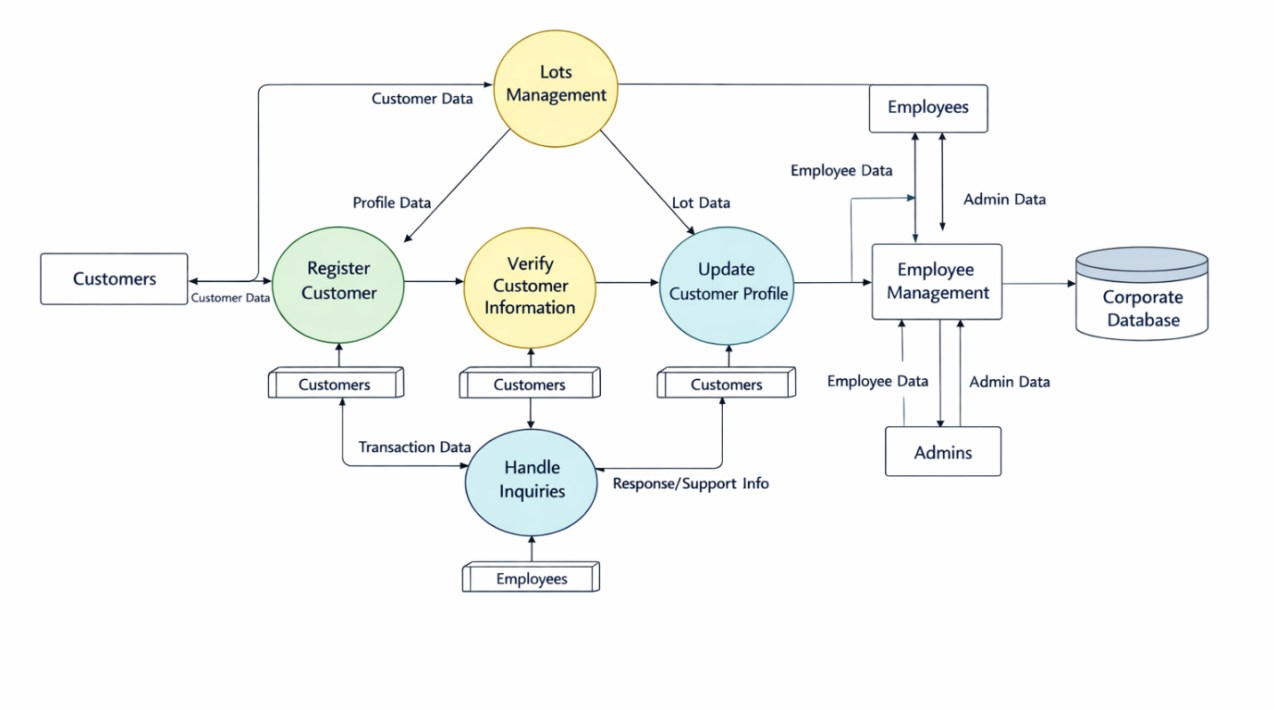

USE CASE DIAGRAM
