A Mini Project Synopsis on
TrustMe AI — Healthcare Misinformation Detection & Clinical Verification Platform

T.E. - I.T Engineering

Submitted By

Ayyan Muqadam | 24104136
Krrish Mukadam | 24104013
Shrikant Panda | 24104046

Under The Guidance Of
Ms. Shafaque Fatma Syed/ Dr. Sonia Aneesh/ Ms. Snehal Mali


DEPARTMENT OF INFORMATION TECHNOLOGY
A.P.SHAH INSTITUTE OF TECHNOLOGY
G.B. Road, Kasarvadavali, Thane (W), Mumbai-400615
UNIVERSITY OF MUMBAI
Academic year: 2026-27

CERTIFICATE

This to certify that the Mini Project report TrustMe AI — Healthcare Misinformation Detection & Clinical Verification Platform has been submitted by Ayyan Muqadam (24104136), Krrish Mukadam (24104013) and Shrikant Panda (24104046) who are a Bonafide students of A. P. Shah Institute of Technology, Thane, Mumbai, as a partial fulfilment of the requirement for the degree in Information Technology, during the academic year 2026-2027 in the satisfactory manner as per the curriculum laid down by
University of Mumbai.

Ms. Shafaque Fatma Syed
Guide

External Examiner
1.

Place: A.P. Shah Institute of Technology, Thane
Date:

ACKNOWLEDGEMENT

This project would not have come to fruition without the invaluable help of our guide Ms. Shafaque Fatma Syed/ Dr. Sonia Aneesh/ Ms. Snehal Mali. Expressing gratitude towards our HoD, Dr. Kiran Deshpande, and the Department of Information Technology for providing us with the opportunity as well as the support required to pursue this project.

TABLE OF CONTENTS
Sr. No. |  | Page  No.
1 | Introduction…………………………………………………………………… | 5
 | 1.1 Purpose……………………………………………………………………. | 6
 | 1.2 Objectives…………………………………………………………………. | 6
 | 1.3 Scope……………………………………………………………….……… | 7
2 | Literature Survey………………………………………………………………. | 8
3 | Problem Definition…………………………………………………….……… | 10
4 | Proposed System………………………………………………………………. | 11
 | 4.1 Algorithm…………………………………………………………………. | 13
5 | Technology Stack……………………………………………………………… | 15
6 | Implementation…………………………………………………………..…….. | 17
7 | Results…………………………………………………………………………. | 21
8 | Conclusion…………………………………………………….………………. | 27
9 | Future Scope………………………………………………….…………..……. | 28
 | References…………………………………………………………………...… | 29

CHAPTER 1

INTRODUCTION
Healthcare misinformation has emerged as a significant public health challenge, particularly with the rapid growth of social media, online news platforms, and digital health information. False medical claims, misleading treatment advice, vaccine-related myths, and unverified health remedies can spread rapidly across digital platforms, influencing people's healthcare decisions and potentially causing serious harm. The widespread availability of online information makes it increasingly difficult for individuals to distinguish scientifically supported medical facts from misleading or fabricated health content.
Traditional fact-checking methods rely heavily on manual verification by healthcare professionals, researchers, and fact-checking organizations. Although these methods are valuable, they can be time-consuming and difficult to scale because of the enormous volume of health-related information published every day. Furthermore, many existing tools focus on identifying false information without clearly explaining why a particular claim may be misleading or providing relevant medical evidence to support their conclusions.
With advancements in Artificial Intelligence (AI), Machine Learning (ML), and Natural Language Processing (NLP), automated systems can analyze textual information, identify linguistic patterns, and classify healthcare news according to its likelihood of being credible or misleading. Explainable AI techniques can further help users understand the factors influencing a model's predictions, improving transparency and interpretability.
This project proposes TrustMe AI — Healthcare Misinformation Detection & Clinical Verification Platform, an AI-powered web application designed to analyze healthcare-related claims, assess news credibility, and support medical fact-checking through machine learning and a curated medical knowledge base. The platform integrates TF-IDF feature extraction, Logistic Regression classification, SHAP-based explainability, and a modern web interface to provide accessible and understandable results. It also incorporates supporting features such as URL-based article analysis, disease-specific fact-checking, and user authentication.
TrustMe AI aims to promote responsible consumption of digital healthcare information by helping users identify potentially misleading claims and understand the importance of verifying medical information against reliable sources. The system is intended as an informational and educational support tool and does not replace professional medical advice, clinical diagnosis, or independent verification by qualified healthcare professionals.

  - Purpose
The purpose of this project is to develop an AI-based healthcare misinformation detection and verification platform that analyzes medical news and health-related claims using machine learning, natural language processing, and a curated medical knowledge base. The system aims to:
Enable preventive healthcare for both individuals and healthcare professionals. Deliver personalized health recommendations based on predicted risk levels
    - Automatically analyze healthcare-related text and classify it as potentially credible or misleading based on learned patterns.
    - Provide explainable predictions by identifying words and textual features that influence the machine learning model's output.
    - Support fact-checking of claims related to COVID-19, cancer, diabetes, and vaccines using a curated collection of medical facts and known myths.
    - Enable users to analyze healthcare articles through text input and URL-based article extraction.
    - Evaluate news credibility using multiple signals, including domain reputation, citations, clickbait patterns, author attribution, and writing style.
    - Improve user awareness of healthcare misinformation through accessible results and understandable explanations.
    - Provide a web-based interface that combines AI analysis, medical information verification, and visualization of results.
    - Encourage users to consult trustworthy medical sources and qualified healthcare professionals before making health-related decisions.
  - Objectives
    - To develop a user-friendly web application using React for the frontend and FastAPI for the backend.
    - To implement a machine learning-based text classification system using TF-IDF vectorization and Logistic Regression for identifying potentially misleading healthcare news.
    - To preprocess textual data using techniques such as lowercasing, URL removal, tokenization, stop-word removal, and lemmatization.
    - To incorporate transformer-based model options, including DistilBERT and BioBERT, for advanced healthcare text classification experiments.
    - To integrate SHAP-based explainable AI techniques to identify important textual features and improve the interpretability of model predictions.
    - To develop a disease-specific fact-checking module that compares users.

1.3 Scope
- Healthcare Misinformation Detection: The system analyzes health-related text and uses a machine learning model to identify patterns associated with potentially misleading or credible healthcare news.
- URL-Based Article Analysis: The platform supports extracting article content from a submitted URL and analyzing the available text to assess its credibility and identify potentially misleading characteristics.
- Explainable Artificial Intelligence: SHAP-based explanations help identify words and textual features that contribute to the machine learning model's predictions, making the classification process more interpretable.
- Multi-Signal Credibility Assessment: The platform evaluates news articles using factors such as domain reputation, citation indicators, clickbait expressions, author attribution, and grammar or writing style. These signals provide supplementary credibility indicators rather than definitive proof of factual accuracy.

CHAPTER 2

Literature Review
Healthcare misinformation detection has gained importance with the increasing availability of medical information through websites, social media platforms, and online news sources. Machine learning and Natural Language Processing (NLP) provide techniques for analyzing textual content and identifying potentially misleading healthcare claims. Research in this area focuses on text classification, dataset development, explainable artificial intelligence, and biomedical language models. These approaches provide a foundation for developing systems such as TrustMe AI, which combines healthcare misinformation classification with explainable predictions and medical information verification.

Research Paper [1] focuses on the use of machine learning and natural language processing techniques for detecting healthcare misinformation. It explores how automated text classification can identify misleading medical claims and fake health-related news. The study highlights the importance of analyzing textual patterns and linguistic features to distinguish reliable healthcare information from potentially false or misleading content. These techniques can help users evaluate health information more efficiently and reduce the spread of medical misinformation.

Research Paper [2] examines the role of machine learning algorithms in fake news detection. It discusses the application of text preprocessing, feature extraction, and classification models such as Logistic Regression and other supervised learning techniques. The research emphasizes that TF-IDF can represent textual information numerically, enabling machine learning models to identify patterns associated with misleading content. This approach provides a practical foundation for developing automated healthcare misinformation detection systems.

Research Paper [3] explores explainable artificial intelligence (XAI) and its application in machine learning-based text classification. It highlights the importance of understanding why a model predicts a particular result rather than relying only on its final classification. Techniques such as SHAP (SHapley Additive exPlanations) help identify words and features that contribute to a prediction. This concept is relevant to TrustMe AI because it aims to provide users with explanations for misinformation detection results, improving transparency and interpretability.

Sr No | Title | Author | Findings
1 | CoAID: COVID-19 Healthcare Misinformation Dataset | Cui and Lee (2020) | Introduced a dataset containing COVID-19-related misinformation and reliable information. It provides a research resource for studying healthcare misinformation detection using machine learning and text analysis.
2 | FakeHealth: A Dataset for Health News and Information Analysis | Dai et al. (2020) | Presented health-related news data that can support research into the identification and analysis of potentially unreliable healthcare information.
3 | A Unified Approach to Interpreting Model Predictions | Scott M. Lundberg and Su-In Lee (2017) | Introduced SHAP, a method for explaining machine learning predictions by estimating the contribution of individual features. It supports the development of more interpretable classification systems.

CHAPTER 3

Problem Definition
Healthcare misinformation has become a major challenge due to the rapid spread of medical claims, misleading health articles, and inaccurate information through social media platforms and websites. People often rely on online sources to understand diseases, treatments, vaccines, and preventive healthcare. However, verifying the accuracy of this information can be difficult without medical expertise or access to reliable sources. Misleading healthcare information may create confusion, influence health-related decisions, and reduce trust in evidence-based medical guidance. The primary challenges include:
- Time-Consuming Manual Verification: Verifying healthcare claims often requires users to consult multiple sources, examine supporting evidence, and compare information with authoritative medical guidance. This process can be time-consuming and difficult for non-experts.
- Limited Medical Knowledge-Based Verification: A healthcare claim may require comparison with established medical information before it can be assessed. General text classification alone cannot determine whether every medical statement is factually correct.
- Difficulty in Assessing Source Credibility: Users may struggle to evaluate the reliability of health-related websites and articles. Indicators such as domain reputation, citations, author information, clickbait expressions, and writing style may require systematic analysis.
- Challenges in Processing Healthcare Text: Medical content may contain specialized terminology, complex sentence structures, and disease-specific claims. Effective analysis requires appropriate text preprocessing, feature extraction, and classification techniques.
- Rapid Spread of Healthcare Misinformation: Misleading medical claims and inaccurate health-related articles can spread quickly through social media, websites, and online communities, making it difficult for users to identify reliable information.
This project seeks to address these challenges by developing TrustMe AI — Healthcare Misinformation Detection & Explainable Verification Platform, an AI-powered web application that:
- Analyzes healthcare claims, submitted text, and accessible health-related article content to identify potentially misleading information.
- Uses Natural Language Processing (NLP), TF-IDF feature extraction, and Logistic Regression for machine learning-based text classification.
- Provides SHAP-based explanations to help users understand the textual features influencing the model's predictions
- Presents classification results, credibility information, and analysis history through an interactive dashboard.
CHAPTER 4
PROPOSED SYSTEM
The proposed system, TrustMe AI — Healthcare Misinformation Detection & Explainable Verification Platform, aims to identify, classify, and explain potentially misleading healthcare information using Artificial Intelligence (AI), Machine Learning (ML), and Natural Language Processing (NLP). The system is designed to help users evaluate the reliability of healthcare claims, medical news, and online health-related articles by combining text classification, explainable AI, medical knowledge-based verification, and credibility assessment.
The platform uses a TF-IDF and Logistic Regression-based classification pipeline to analyze textual content. SHAP-based explanations help identify the textual features influencing the model's predictions. A curated medical knowledge base supports the comparison of selected claims with available healthcare information. The system also incorporates credibility scoring, secure user authentication, biometric face verification, and an interactive dashboard to present analysis results.
System Architecture
The system follows a modular architecture comprising the following components:
- Data Input Layer: Provides a user interface through which users can submit healthcare claims, text, or article URLs for analysis.
- Text Preprocessing Layer: Processes submitted text through cleaning, tokenization, and stop-word removal to prepare the content for feature extraction and classification.
- Feature Extraction Layer: Uses Term Frequency–Inverse Document Frequency (TF-IDF) to convert textual content into numerical features that can be processed by the machine learning model.
- Prediction Layer: Produces a classification result indicating whether the submitted content is predicted to be potentially misleading or reliable according to the trained model. The output depends on the model's training data and classification performance.
- Explainability Layer: Uses SHAP to identify textual features that contribute to the model's prediction, helping users understand the basis of the classification.
- Medical Fact-Checking Layer: Compares selected healthcare claims with information stored in a curated medical knowledge base covering COVID-19, cancer, diabetes, and vaccines. The results provide preliminary guidance and may require further verification against authoritative sources.
- Authentication and Security Layer: Supports user registration and login through JWT-based authentication and secure password storage. The project also includes biometric face verification functionality.
- Database Layer: Uses MySQL with SQL Alchemy for database interaction and management of application data.
- Visualization Layer: Presents classification results, SHAP explanations, credibility information, verification findings, and relevant statistics through an interactive React-based dashboard.
- History and Results Layer: Supports the display of previous analysis results and related history where this functionality is implemented and stored by the application.

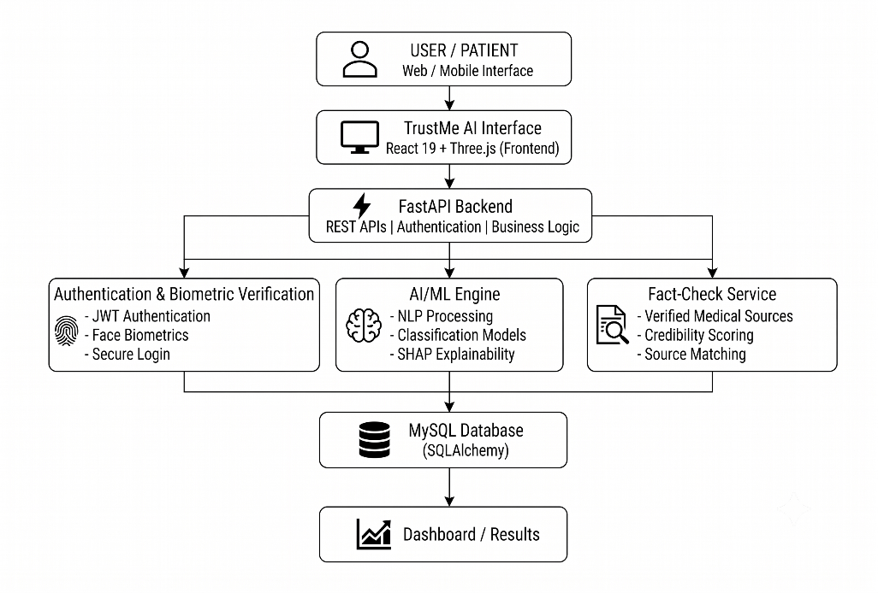
System Architecture
Key Features
- Healthcare Misinformation Detection: Analyzes healthcare-related text using machine learning techniques to identify content that may contain misleading information.
- Text and URL Analysis: Allows users to submit text directly or provide healthcare article URLs for analysis, subject to successful content extraction.
- Explainable AI: Uses SHAP-based feature attribution to highlight words or textual features that influence the model's prediction.
- Medical Fact-Checking: Compares selected healthcare claims with a curated knowledge base containing medical facts and common myths related to specific health topics.
- Credibility Scoring: Evaluates multiple indicators of content credibility to help users determine whether further verification may be necessary.
- Interactive Dashboard: Displays analysis results, credibility scores, explanations, and relevant information through a user-friendly interface.
- Secure Authentication: Provides user registration and login functionality using JWT-based authentication and secure password storage.
- Biometric Face Verification: Includes face verification functionality as an additional authentication feature.
4.1 Algorithm
TF-IDF and Logistic Regression Algorithm
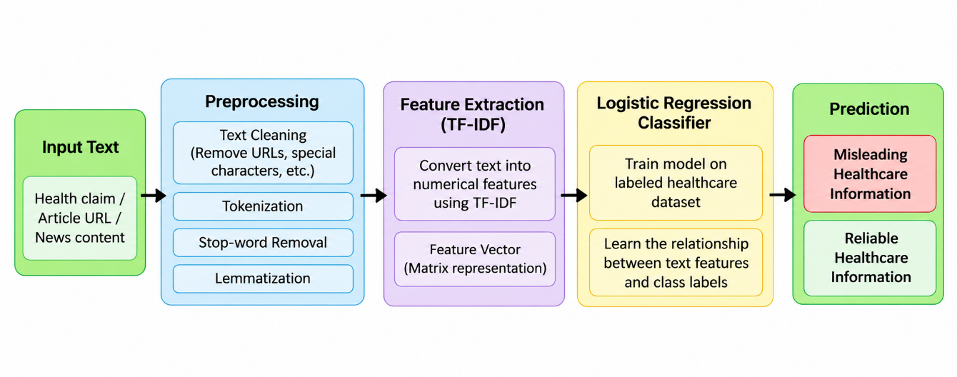
Figure 4.1. TF-IDF and Logistic Regression Algorithm
TrustMe AI uses a machine learning pipeline based on Term Frequency–Inverse Document Frequency (TF-IDF) and Logistic Regression to detect potentially misleading healthcare information. The algorithm processes healthcare claims, news articles, and available article text to classify the submitted content based on patterns learned from a labeled dataset.
The process begins with the input text submitted by the user. The text is preprocessed to remove unwanted elements, tokenize the content, and remove stop words. The cleaned text is then converted into numerical features using TF-IDF. These features are passed to a Logistic Regression classifier trained on labeled healthcare information. The classifier generates a prediction indicating whether the content is classified as potentially misleading or reliable according to the model.
Working of the Algorithm
Step 1: Input Text
The user submits a healthcare claim, medical news text, or an article URL. If a URL is provided, the system attempts to extract the available article content for analysis.
Step 2: Text Preprocessing
The submitted text is cleaned before classification. Preprocessing may include removing unwanted URLs and special characters, tokenizing text into individual words, removing common stop words, and applying lemmatization where configured.

Step 3: TF-IDF Feature Extraction
Term Frequency–Inverse Document Frequency converts the processed text into numerical feature vectors. It estimates the importance of words in a document relative to their occurrence across the dataset. These numerical features allow the machine learning model to process textual information.
Step 4: Logistic Regression Classification
The extracted feature vectors are supplied to a Logistic Regression classifier trained using labeled healthcare text. The model learns relationships between textual features and class labels during training.
Step 5: Prediction
The trained classifier predicts the category of the submitted content. Depending on the model's learned patterns, the result may indicate potentially misleading healthcare information or content classified as reliable.
Step 6: Explainability
TrustMe AI uses SHAP-based feature attribution to help explain which textual features influenced the classification. This provides additional insight into the model's prediction.
Reasons for Selecting TF-IDF and Logistic Regression
- Effective Text Representation: TF-IDF converts text into numerical features and gives greater weight to words that are informative within the dataset.
- Suitable for Text Classification: Logistic Regression is a supervised machine learning algorithm suitable for classifying text into predefined categories.
- Computational Efficiency: TF-IDF and Logistic Regression are relatively lightweight compared with many transformer-based approaches, making them practical for a web-based application.
- Interpretability: Logistic Regression learns feature weights that can help explain the influence of words on its predictions.
- Compatibility with Explainable AI: SHAP can be used to estimate the contribution of input features to model predictions, supporting the explainability component of TrustMe AI.
- Evaluation of Performance: The model can be evaluated using accuracy, precision, recall, F1-score, and ROC-AUC to assess its classification performance.

CHAPTER 5

Technical Specification
TrustMe AI is developed using a combination of frontend technologies, backend services, machine learning libraries, database management tools, and security components. These technologies work together to analyze healthcare information, classify potentially misleading content, explain model predictions, and present results through an interactive web application.
1. Backend (FastAPI and ML Integration)
- FastAPI (Python-based web framework): Manages backend routing, API endpoints, authentication, and communication between the frontend and machine learning components.
- Uvicorn: Acts as the ASGI server used to run the FastAPI application and handle incoming requests.
- Scikit-learn (Machine Learning Library): Implements the TF-IDF vectorization and Logistic Regression classification pipeline for analyzing healthcare text.
- Pydantic Settings: Supports application configuration and management of environment-based settings.
- SQLAlchemy: Provides database interaction and object-relational mapping between the backend application and the MySQL database.
2. AI, NLP, and Data Processing
- NLTK (Natural Language Toolkit): Supports natural language processing operations such as tokenization and stop-word removal.
- TF-IDF: Converts processed healthcare text into numerical feature vectors for machine learning classification.
- Logistic Regression: Classifies submitted healthcare information using patterns learned from labeled training data.
- SHAP (Explainable AI): Estimates the contribution of textual features to model predictions, helping users understand the classification results.
- NumPy and Pandas: Support numerical operations, dataset manipulation, and data preprocessing.
- DistilBERT and BioBERT: Represent additional transformer-based approaches for contextual and biomedical text analysis, where implemented and evaluated.
3. Database and Storage
- MySQL: Stores application data and relevant records required by the platform.
- SQLAlchemy: Manages database operations and connects backend application components with MySQL.
- Model and Dataset Storage: Stores the healthcare dataset and trained machine learning artifacts required for prediction, according to the project's implementation.
- Analysis History: Supports storing or retrieving previous analysis results where the corresponding functionality is implemented
4. Frontend (Interactive Web Interface)
- React: Builds the user interface and provides reusable components for user interaction and results presentation.
- Vite: Supports frontend development and application build processes.
- JavaScript: Implements interactive functionality and communication between the frontend and backend.
- Tailwind CSS: Provides styling utilities for developing a consistent and responsive interface.
- Three.js: Supports interactive 3D visual elements within the application.
- Framer Motion: Provides animations and transitions for interface components.
- Recharts: Displays charts and graphical representations of available analysis results and statistics.
- Axios: Sends HTTP requests from the frontend to the FastAPI backend.
5. Security and Authentication
- JSON Web Token (JWT): Supports authenticated access to protected application endpoints.
- bcrypt: Provides password hashing for secure password storage.
- Google OAuth 2.0: Supports Google-based authentication where configured in the application.
- Biometric Face Verification: Provides an additional user verification mechanism based on face-related biometric features.
- Environment Configuration: Supports secure management of application settings and sensitive configuration values.

CHAPTER 6

IMPLEMENTATION
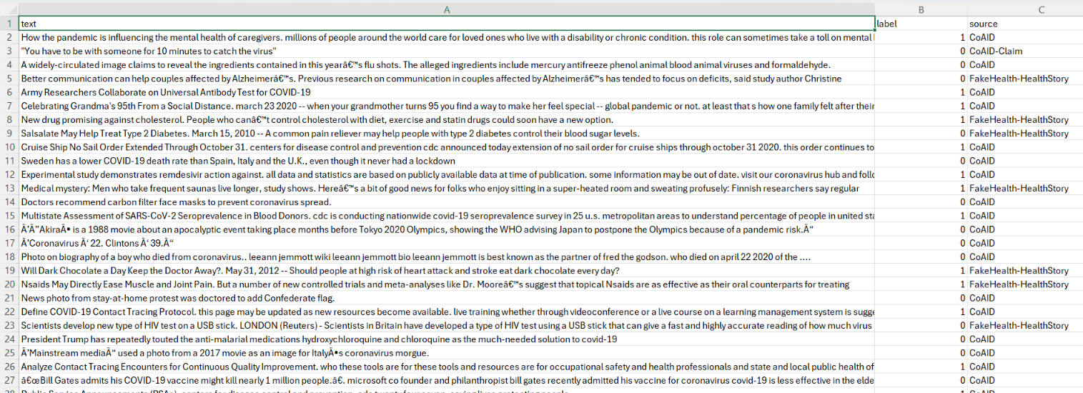
Figure 6.1 Dataset Preparation
The healthcare text dataset was inspected to identify the input text and corresponding classification labels. Sample records and label distributions were examined before preparing the data for model development.
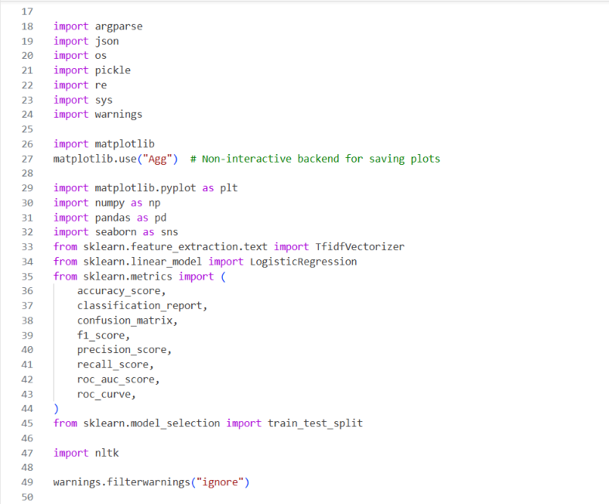
Figure 6.2 Data Preprocessing
The input text was processed using the preprocessing steps implemented in the project. The screenshot shows how the original text is transformed into a cleaned representation before feature extraction.
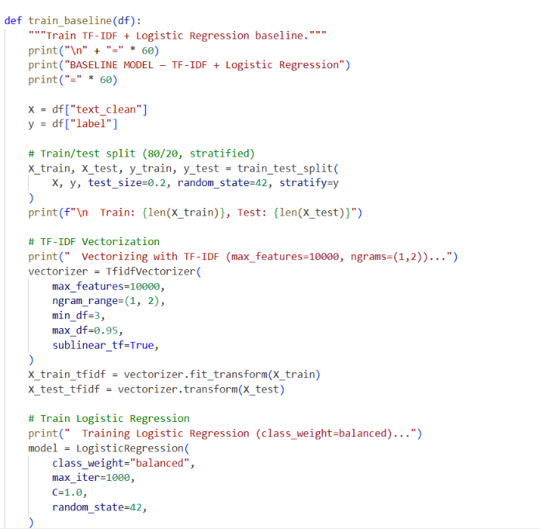
Figure 6.3 Feature Extraction Using TF-IDF
TF-IDF converts the processed text into numerical feature vectors. It assigns weights to terms based on their frequency within a document and across the training corpus. These vectors are used as input to the classification model.

Figure 6.4 Model Training
The dataset was divided into training and testing subsets. A Logistic Regression classifier was trained using TF-IDF features to learn textual patterns associated with the dataset labels. The testing subset was used to evaluate the trained model.
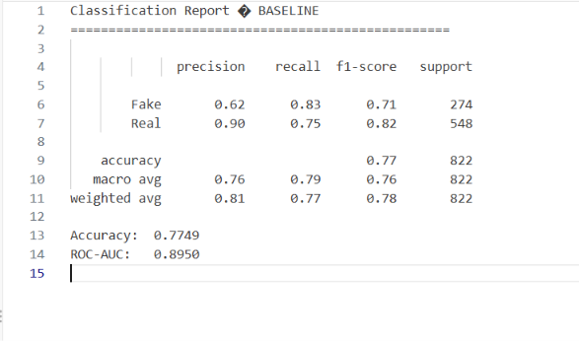
Figure 6.5 Model Evaluation
The classifier was evaluated using predictions on the testing subset. The displayed metrics and confusion matrix summarize correct predictions and classification errors. These results describe the performance of the text classifier and do not establish the accuracy of the separate medical evidence verification module.
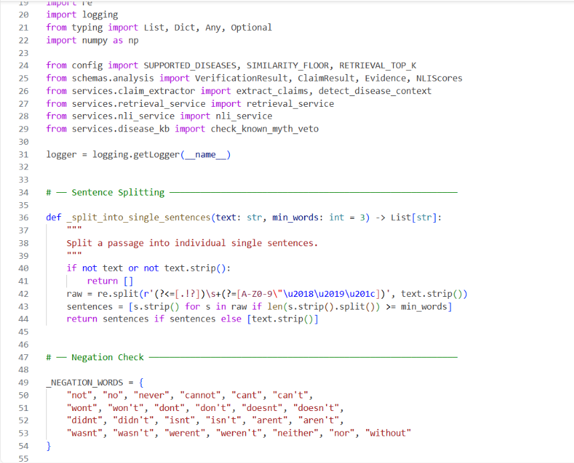
Figure 6.6 Medical Evidence Verification
The verification module retrieves relevant passages from the healthcare evidence corpus for a submitted claim. It compares the claim with the retrieved evidence and presents the resulting verdict alongside the source passage and reference link. Claims with insufficient evidence are marked accordingly.
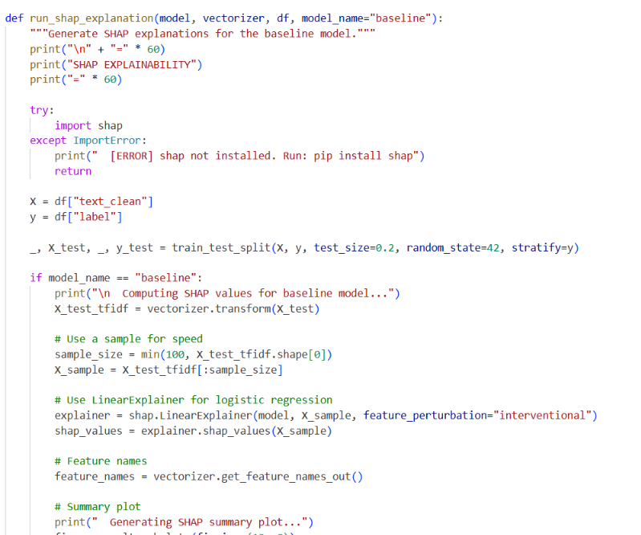

Figure 6.7 Explainability Using SHAP
SHAP is used to identify textual features that influence the classifier’s prediction. The explanation displays words contributing toward the predicted class, helping users interpret the model’s behaviour. These contributions explain the classification decision rather than proving the medical accuracy of a claim.
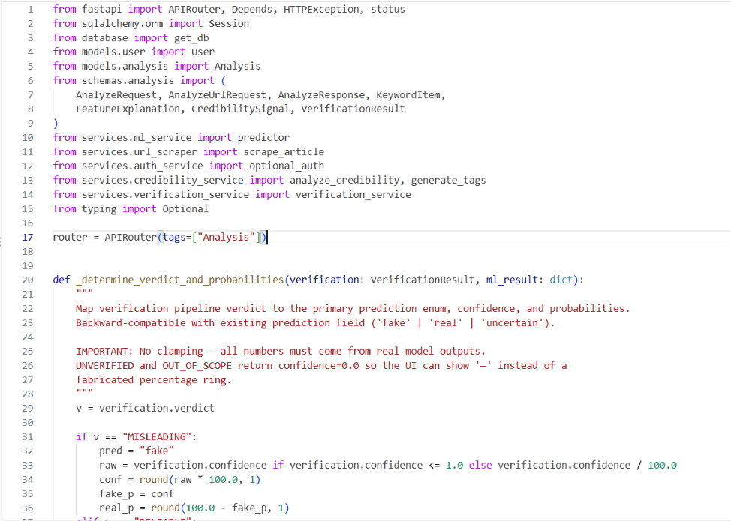

Figure 6.8 Backend and Database Integration
The FastAPI backend connects the user interface with the analysis components through API endpoints. The database supports storage of application records, including user information and analysis history where implemented. The screenshots show the available endpoints and database structure.

CHAPTER 7

RESULT
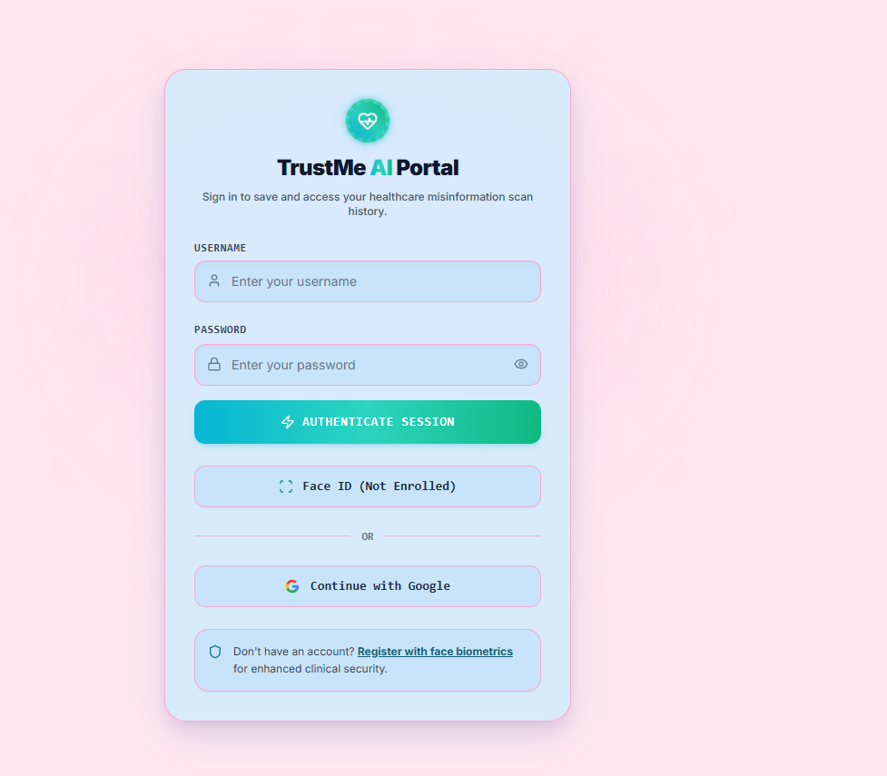
Figure 7.1 Login Page
TrustMe AI Login Page: This page allows registered users to sign in using their username and password, with additional Google sign-in and optional face authentication options.

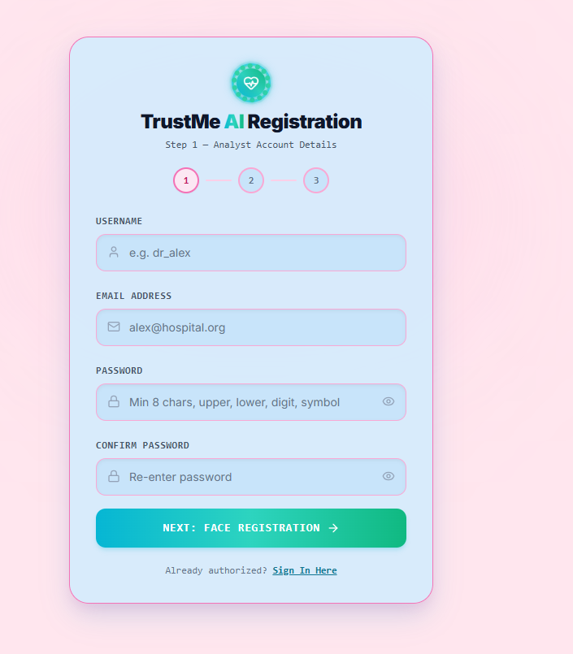
Figure 7.2 Sign up
TrustMe AI Registration – Account Details: This page collects the user’s username, email address, and password to create an account before proceeding to the optional biometric registration step.
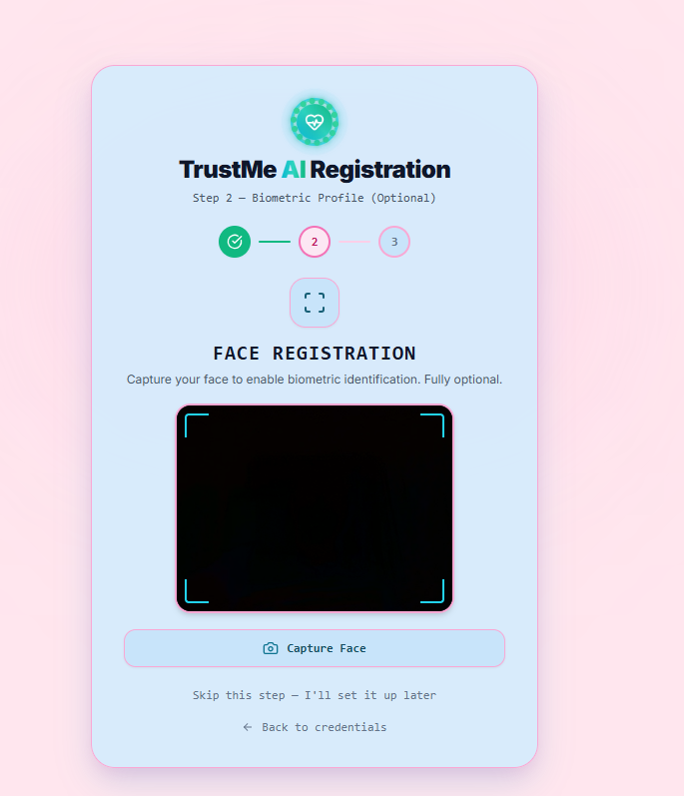
Figure 7.3 Face Registration
TrustMe AI Registration – Face Authentication: This page provides an optional face-registration interface intended to support biometric identification and enhanced account authentication.
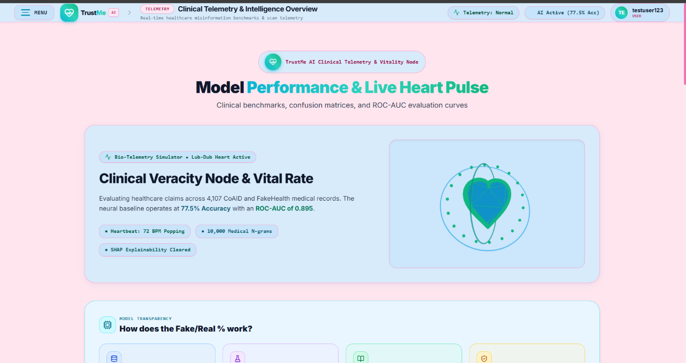
Figure 7.4 Dashboard
Clinical Telemetry & Intelligence Overview: This dashboard displays TrustMe AI’s model performance, including the dataset size, accuracy, ROC-AUC score, and healthcare misinformation analysis status.
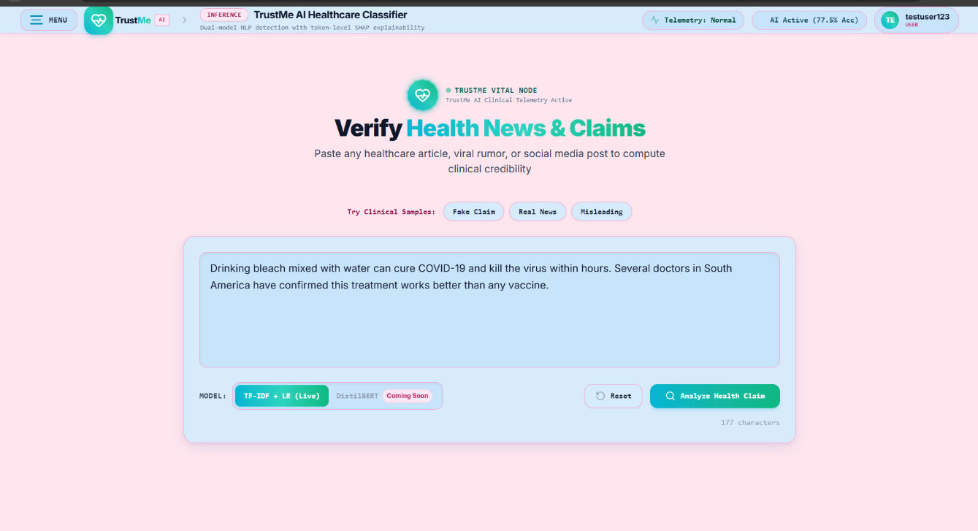
Figure 7.5 Healthcare Misinformation Classifier
Healthcare Misinformation Classifier: This page allows users to submit healthcare-related text for AI classification as likely real or fake, with the system displaying prediction confidence and word-level SHAP explanations.
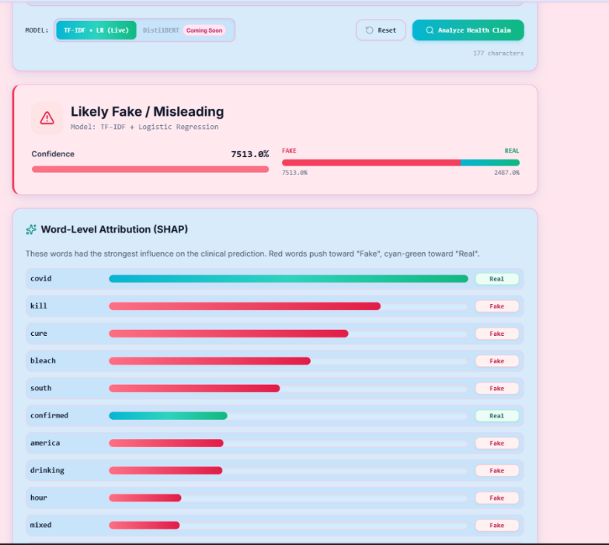
Figure 7.6 Prediction Results & SHAP Analysis
Prediction Results & SHAP Analysis: This section presents the model’s classification result and highlights words that influence the prediction, helping users understand why a claim may be identified as misleading.
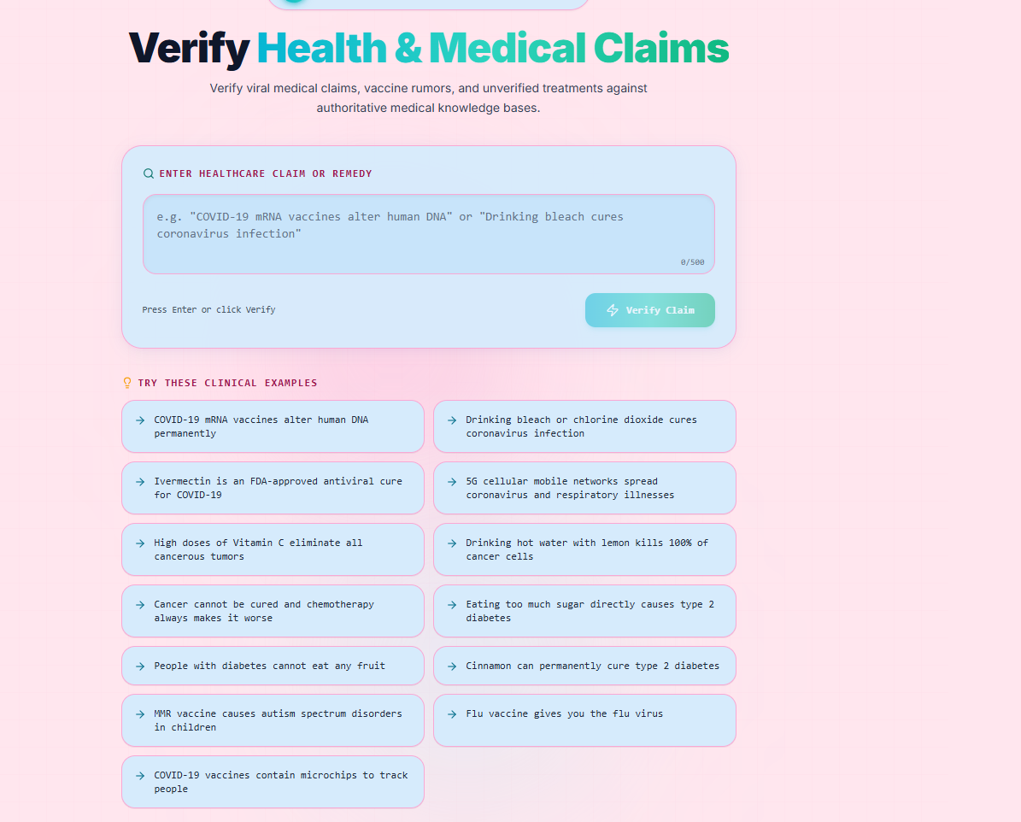
Figure 7.7 Medical Fact-Checking
Medical Fact-Checking: This page allows users to verify medical claims against a curated healthcare knowledge base covering topics such as COVID-19, vaccines, cancer, and diabetes.
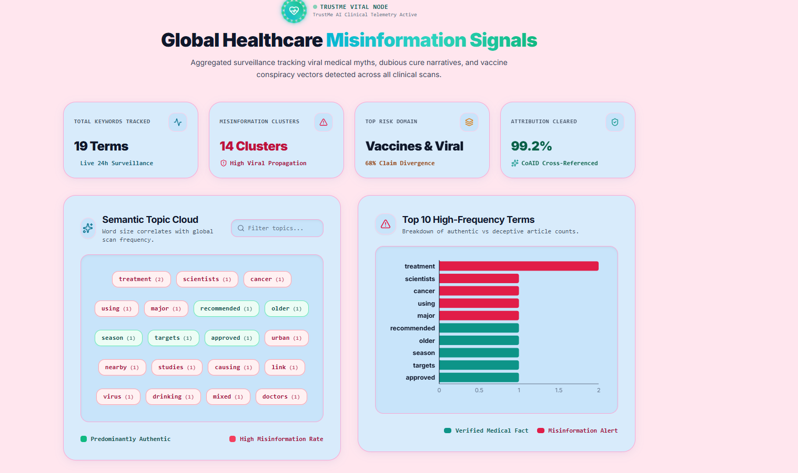
Figure 7.8 Global Healthcare Misinformation Signals
Global Healthcare Misinformation Signals: This dashboard summarizes frequently detected misinformation terms, topic clusters, and trends to help users explore patterns in healthcare-related claims.
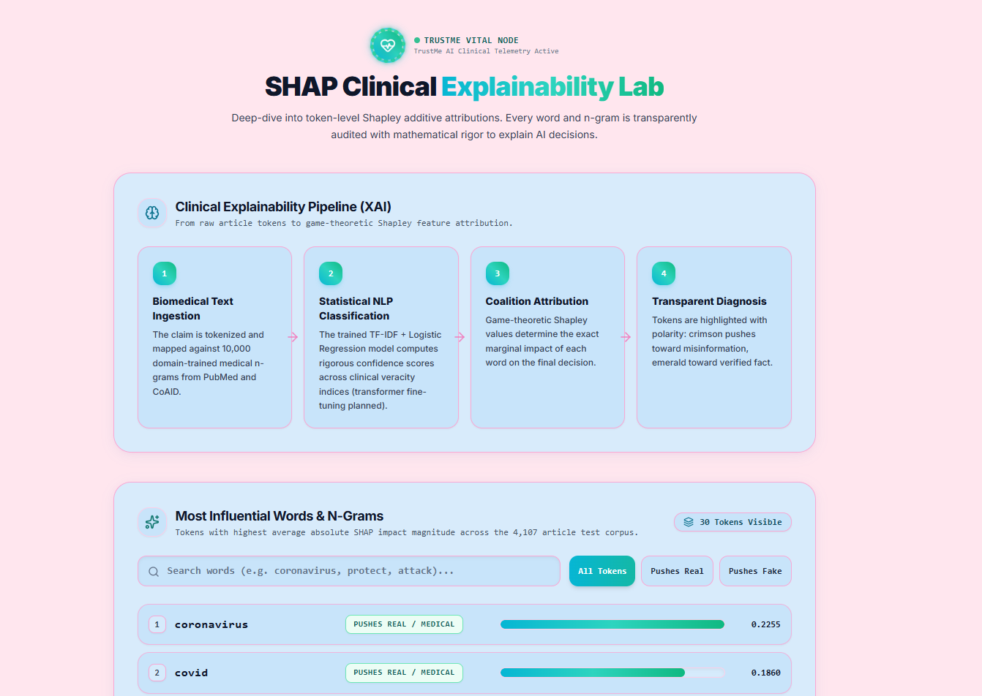
Figure 7.9 SHAP Clinical Explainability Lab
SHAP Clinical Explainability Lab: This page explains the AI model’s decision-making process by displaying influential words and their contributions toward real or fake classifications.
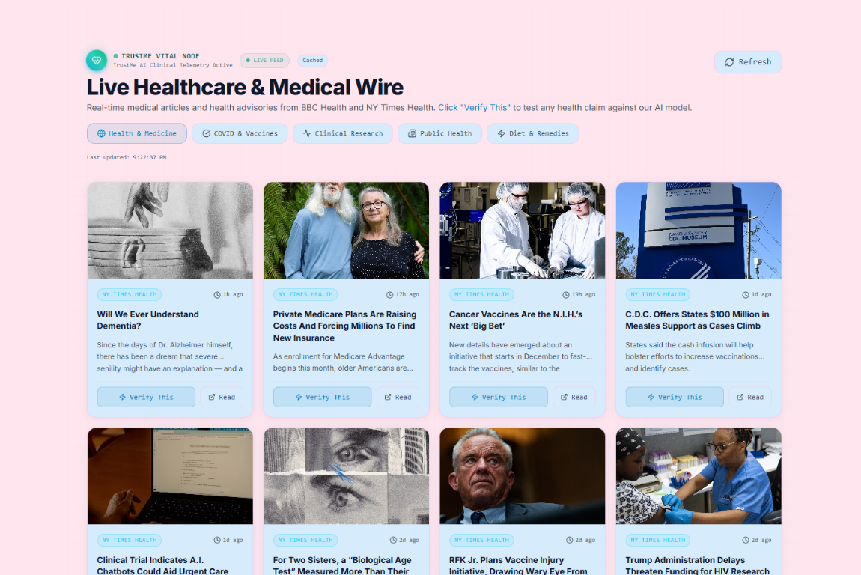
Figure 7.10 Live Healthcare & Medical News Wire
Live Healthcare & Medical News Wire: This page displays health-related news articles from available sources and allows users to submit claims for AI-based verification.
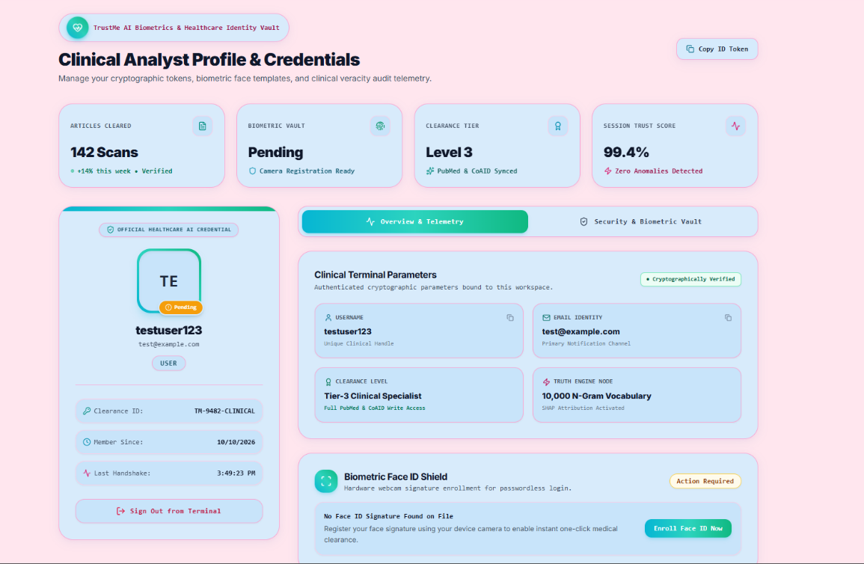
Figure 7.11 Clinical Analyst Profile & Credentials
Clinical Analyst Profile & Credentials: This page displays the user’s account information, security status, profile details, and biometric registration options.

CHAPTER 8

CONCLUSION
TrustMe AI represents a significant step forward in the application of artificial intelligence and natural language processing to healthcare misinformation detection. By combining TF-IDF feature extraction with Logistic Regression, the project demonstrates how machine learning can classify healthcare-related articles and claims as likely real or fake. Using a dataset of approximately 4,107 healthcare news records, the baseline model achieved an accuracy of 77.49% and an ROC-AUC score of 0.895, providing a foundation for identifying potentially misleading medical information.
Beyond its technical performance, the project’s key strength lies in its user-friendly interface and explainable AI capabilities. Through SHAP-based word-level explanations, users can identify which words influence the model’s predictions. The medical fact-checking module further supports claim assessment by comparing healthcare statements against a curated knowledge base covering topics such as COVID-19, cancer, diabetes, and vaccines. Additional features, including article scanning, credibility assessment, health news browsing, and misinformation trend visualization, make the platform a comprehensive tool for exploring healthcare information.
Ultimately, TrustMe AI serves as a bridge between AI-powered information analysis and public health awareness. It helps users critically evaluate online medical claims and recognize potentially misleading content before accepting or sharing it. Although the system cannot independently establish medical truth or replace professional medical advice and authoritative fact-checking, it provides a useful first step toward responsible health information verification. With future improvements such as fine-tuned biomedical language models, multilingual support, and integration with external fact-checking services, TrustMe AI has the potential to become a more accurate, accessible, and scalable platform for combating healthcare misinformation and promoting informed health decisions.

CHAPTER 9

FUTURE SCOPE
1. Integration with External Fact-Checking APIs: Connect TrustMe AI with trusted healthcare fact-checking services and authoritative medical databases to improve claim verification.
2. Advanced AI Models: Implement and fine-tune transformer-based models such as BioBERT and DistilBERT to improve the detection and classification of healthcare misinformation.
3. Multilingual Support: Extend the platform to support multiple languages so users from different regions can verify medical claims in their preferred language.
4. Mobile Application Development: Develop dedicated Android and iOS applications to make healthcare misinformation detection accessible anytime and anywhere.
5. Browser Extension: Create a browser extension that automatically identifies potentially misleading medical claims while users browse websites and read online articles.
6. Social Media Integration: Integrate with social media platforms to help identify and analyze misleading health information circulating through posts, comments, and shared content.
7. Enhanced Explainable AI: Improve SHAP-based explanations to provide clearer insights into which words and phrases influence the model's predictions.
8. Expansion of the Medical Knowledge Base: Include more diseases, treatments, medicines, vaccines, and preventive healthcare topics using verified sources such as WHO, CDC, and NIH.
9. Improved Credibility Assessment: Enhance website and article credibility analysis by incorporating source reputation, author information, scientific references, publication dates, and supporting evidence.

REFRENCES
[1] Cui, L. and Lee, D. [2020]: CoAID: COVID-19 Healthcare Misinformation Dataset — A Dataset for COVID-19 Related Healthcare Misinformation Research.
[2] MySQL Documentation: Relational Database Management System. https://dev.mysql.com/doc/
[3] Lundberg, S. M. and Lee, S.-I. [2017]: A Unified Approach to Interpreting Model Predictions. Advances in Neural Information Processing Systems (NeurIPS).
[4] Sanh, V., Debut, L., Chaumond, J. and Wolf, T. [2019]: DistilBERT, a Distilled Version of BERT: Smaller, Faster, Cheaper and Lighter.
[5] Lee, J. et al. [2020]: BioBERT: A Pre-trained Biomedical Language Representation Model for Biomedical Text Mining.
[6] Scikit-learn Documentation: TF-IDF Vectorization and Logistic Regression for Text Classification. https://scikit-learn.org/stable/
[7] SHAP Documentation: Explainable AI and Shapley Additive Explanations. https://shap.readthedocs.io/
[8] FastAPI Documentation: Python Framework for Building APIs. https://fastapi.tiangolo.com/
[9] React Documentation: JavaScript Library for Building User Interfaces. https://react.dev/
[10] Three.js Documentation: JavaScript 3D Graphics Library. https://threejs.org/docs/

