ARTIFICIAL INTELLIGENCE LAB — WEEK 5
Lab 5: Adversarial Search — Minimax & Alpha-Beta Pruning

Name: M.Ayyan Khan
Roll No: 042
Section: BSAI-3A

Objective
Implement Minimax and Alpha-Beta Pruning for a fixed-depth game tree, count evaluated leaf nodes, compare the results, and observe how branch ordering affects pruning while preserving the Minimax value.

Task 1 — Trace the supplied tree using Minimax
Given leaf scores: [3, 5, 2, 9, 0, 7]. The supplied code pads this list with zeros to form a complete binary tree.
Padded leaf scores: [3, 5, 2, 9, 0, 7, 0, 0]
Tree depth = ceil(log₂(6)) = 3.
Node | Children / Leaf Values | Player | Computed Value
A | 3, 5 | MIN | min(3, 5) = 3
B | 2, 9 | MIN | min(2, 9) = 2
C | 0, 7 | MIN | min(0, 7) = 0
D | 0, 0 | MIN | min(0, 0) = 0
E | A=3, B=2 | MAX | max(3, 2) = 3
F | C=0, D=0 | MAX | max(0, 0) = 0
Root | E=3, F=0 | MAX | max(3, 0) = 3
Answer: The optimal Minimax root value is 3. MAX selects the left subtree because its value (3) is greater than the right subtree value (0).

Task 1 — Working Minimax code with leaf counter
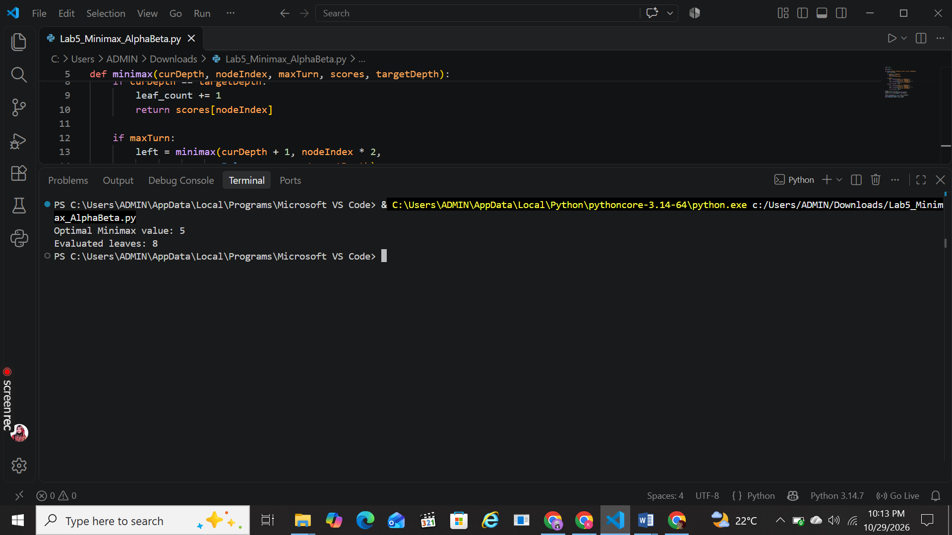

Task 2 — Add leaf-evaluation counters to both algorithms
The terminal-node/base case increments the counter only when a leaf score is actually evaluated. Reset the counter before each algorithm so the counts are independent.
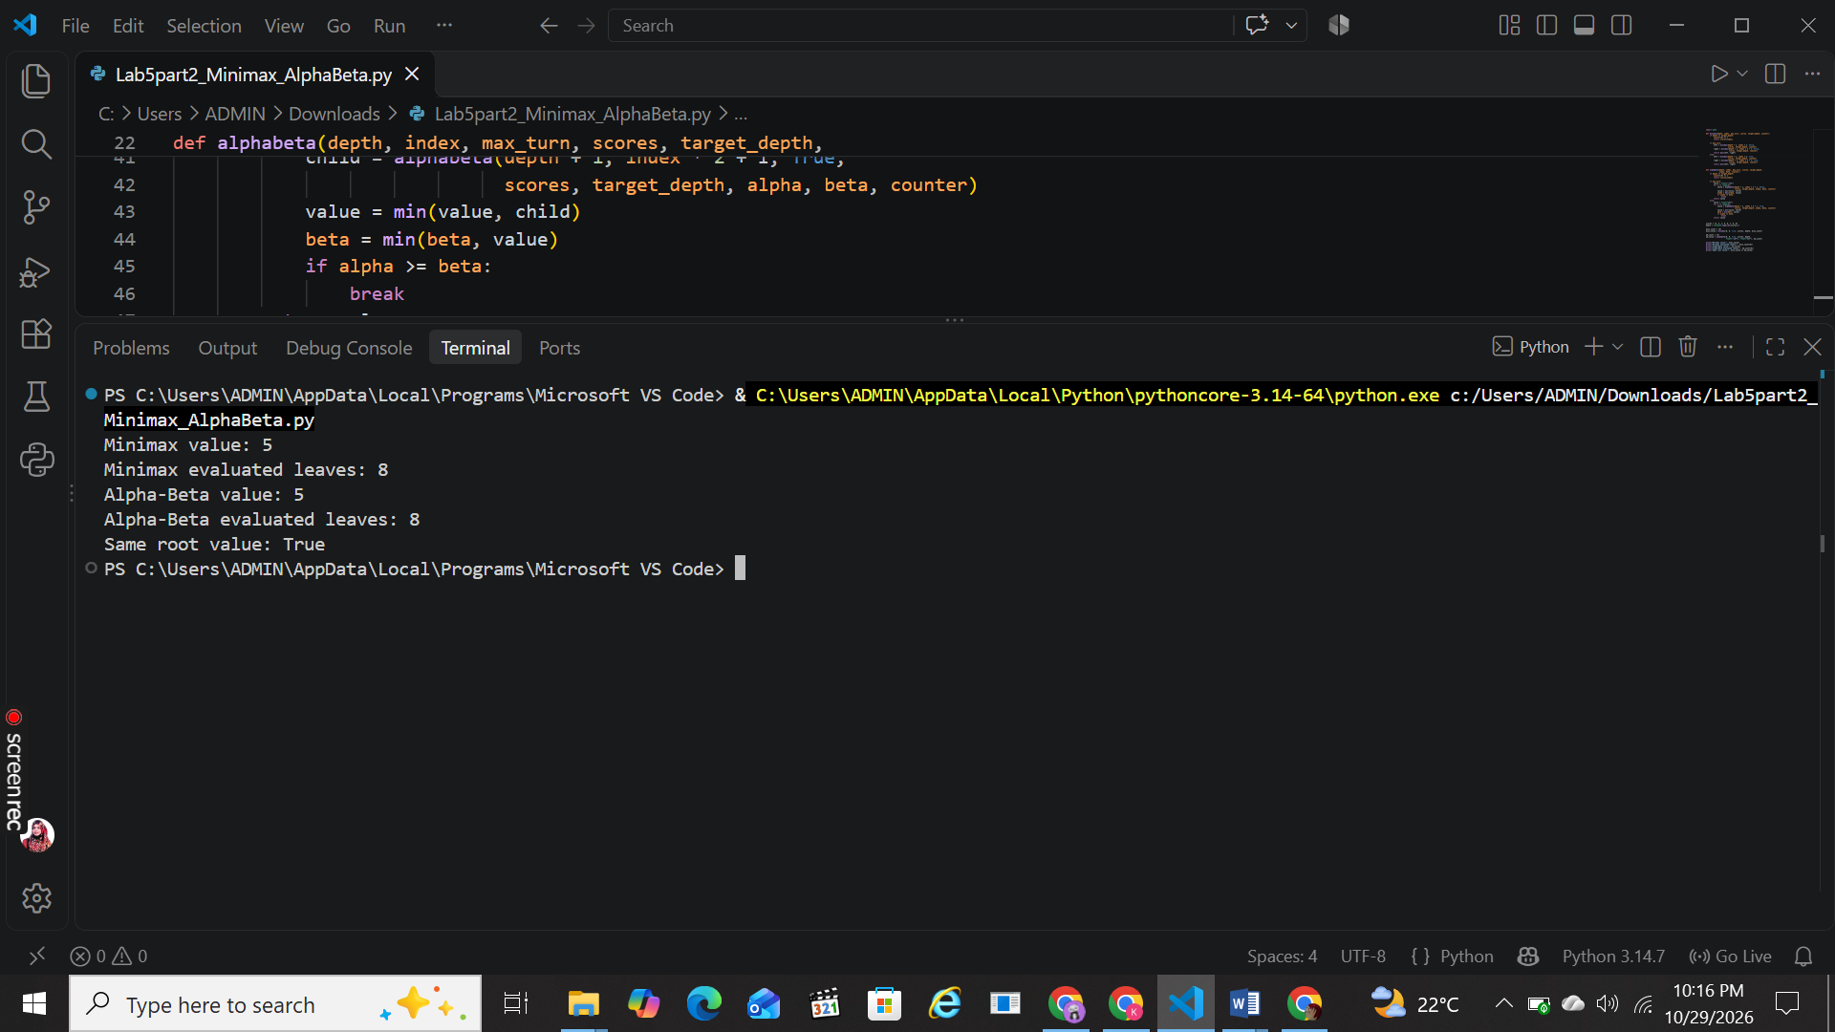

Task 3 — Reorder branches and observe pruning
To test ordering fairly, swap the two children inside each pair while preserving the same tree structure. The helper below reverses the left/right order at every internal node. Run both algorithms again with the reordered leaves.
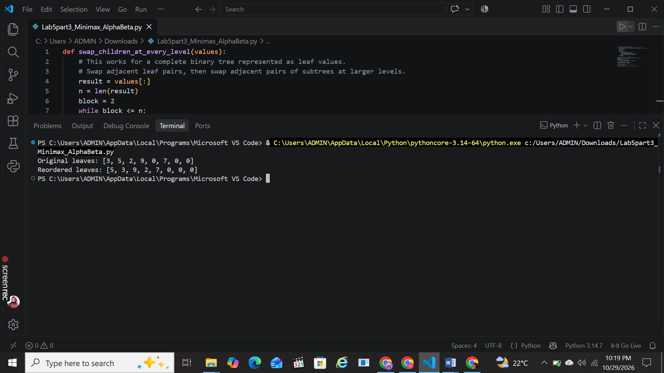

Expected observation: the root Minimax value stays the same when only sibling subtrees are reordered. Alpha-Beta’s evaluated-leaf count may change because it encounters useful bounds earlier or later. Plain Minimax still evaluates every leaf.

Comparison table
Test | Minimax value | Alpha-Beta value | Leaf-count observation
Original order | 3 | 3 | 8 vs 7 leaves
Reordered branches | Same as original | Same as original | Alpha-Beta count may change

Short explanation / conclusion
Minimax selects the best move for MAX while assuming MIN also plays optimally. It evaluates all terminal leaves and propagates values upward using maximum and minimum operations. Alpha-Beta Pruning maintains alpha, the best value found for MAX, and beta, the best value found for MIN. When alpha is greater than or equal to beta, the remaining children of that node can be skipped because they cannot improve the final decision. In the supplied example, both methods return root value 3, while Alpha-Beta evaluates 7 leaves compared with 8 for Minimax. Branch ordering can improve or reduce pruning efficiency, but it does not change the Minimax result when the same game tree and utilities are preserved.

