Serverless AQI Predictor
Hyderabad AQI Forecasting System
Internship Project Report | 72-hour AQI Forecasting
Open-Meteo | Hopsworks | GitHub Actions | FastAPI | Streamlit

Item | Value
Prepared by | Ayyan Afzal
Report type | Internship project report
City | Hyderabad, Pakistan
Forecast horizon | 72 hours / 3 days
Final model | XGBoost
Feature count | 19 forecast-compatible features
Report date | 5 June 2026

Project Scope
This report documents the complete AQI prediction system: data ingestion, feature engineering, historical backfill, model training, automation, API deployment, dashboard design, evaluation, explainability, and deployment validation.

Contents
Sections | Sections
1. Executive Summary | 8. Automation, Deployment, and Application Layers
2. Project Background and Objectives | 9. EDA, Drift Analysis, and Explainability
3. System Architecture Overview | 10. Validation Results
4. Data Sources and Dataset Overview | 11. Development Challenges and Key Engineering Decisions
5. Feature Engineering and Feature Selection Rationale | 12. Limitations and Future Improvements
6. Historical Backfill and Live Feature Pipeline | 13. Conclusion
7. Model Training, Comparison, and Final Selection | Appendices

1. Executive Summary
This report presents the design, implementation, and validation of a serverless air quality forecasting system for Hyderabad, Pakistan. The project predicts hourly Air Quality Index (AQI) values for the next 72 hours by combining Open-Meteo forecast data with a machine learning pipeline built around Hopsworks, GitHub Actions, FastAPI, and Streamlit.
The central engineering decision in this project was to train the model only on features that are genuinely available at prediction time. This constraint led to the removal of AQI lag features, observed-data rolling averages, future AQI forecast values as input features, and month-based seasonal indicators that could not be justified by the available training window. The final production model uses 19 forecast-compatible pollutant, weather, and time-based features and achieves a test R² of 0.9619.
The deployed system refreshes forecast features every hour, retrains the model daily, serves predictions through a FastAPI backend, and presents results through a Streamlit dashboard. End-to-end validation confirmed that the deployed pipeline returns a complete 72-hour prediction payload with consistent summary statistics and Moderate AQI classifications during the final test window.
Metric | Value
Final deployed model | XGBoost
Forecast horizon | 72 hours / 3 days
Feature count | 19
Best test R² | 0.9619
Best test RMSE | 3.9196
Backend | FastAPI on Hugging Face Spaces
Dashboard | Streamlit Cloud

2. Project Background and Objectives
Air quality forecasting is a practical time-series prediction problem with direct public-health relevance. However, building a reliable forecasting system requires more than selecting a strong model. It requires a feature pipeline that is consistent between historical training and live inference, careful avoidance of leakage, and an operational design that supports automated retraining and repeatable deployment.
The objective of this internship project was to build a complete AQI forecasting system for Hyderabad, Pakistan that can:
- Collect historical and forecast weather and pollutant data from Open-Meteo.
- Engineer prediction-ready features for both training and inference.
- Train and compare multiple regression models.
- Register the best model in Hopsworks.
- Automate feature refresh and retraining through GitHub Actions.
- Serve 72-hour AQI forecasts through a deployed API and dashboard.

3. System Architecture Overview
The project is organized as a set of separate but connected components rather than a single monolithic script. This design improves maintainability, simplifies debugging, and reduces coupling between data preparation, training, inference, and presentation.
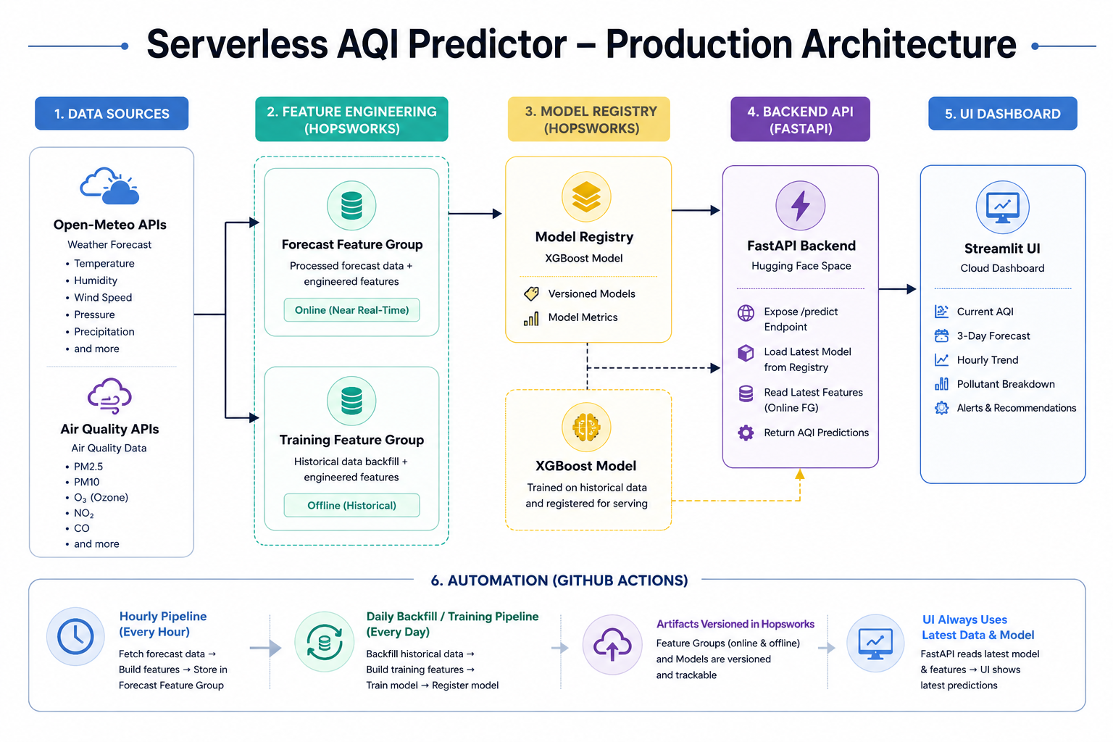
Figure 1. Production architecture for the AQI forecasting system.
Layer | Responsibility | Output
Open-Meteo APIs | Provide historical and forecast weather and pollutant data. | Raw hourly input data
Feature Engineering | Convert raw variables into forecast-compatible model features. | Training and forecast feature tables
Hopsworks | Store feature groups and manage model registry. | Versioned features and model artifacts
Training Pipeline | Train, evaluate, and select the best model. | Registered XGBoost model
FastAPI Backend | Load model and latest forecast features, then serve predictions. | JSON prediction payload
Streamlit Dashboard | Visualize current AQI, 3-day forecast, trends, and alerts. | Interactive user dashboard

4. Data Sources and Dataset Overview
Open-Meteo was selected because the project required both historical and forecast data from a source with consistent variable names and compatible units. This reduced engineering overhead and helped keep feature logic consistent between historical training and live inference.
Dataset Item | Details
City | Hyderabad, Pakistan
Data source | Open-Meteo Weather API and Air Quality API
Data type | Hourly weather, pollutant, and AQI records
Historical period | 1 December 2025 to 29 May 2026
Approximate duration | 180 days / around 6 months
Approximate row count | About 4,320 hourly records before training
Target variable | us_aqi
Forecast horizon | Next 72 hours / 3 days

Because the dataset covers only about six months, the model has limited exposure to full annual seasonal variation. This limitation influenced the final feature selection strategy, especially the decision to exclude month-based seasonality features.

5. Feature Engineering and Feature Selection Rationale

5.1 Final Feature Set
The final deployed model uses 19 features grouped into three categories. These features were retained because they are both predictive and available for future timestamps during live inference.
Feature Category | Columns
Pollutant features | pm25_24h, pm10_24h, o3_8h_ppb, co_8h_ppm, no2_1h_ppb
Weather features | temperature_2m, relative_humidity_2m, precipitation, windspeed_10m, surface_pressure, shortwave_radiation, et0_fao_evapotranspiration
Time features | hour, day_of_week, is_weekend, hour_sin, hour_cos, day_of_week_sin, day_of_week_cos

5.2 Pollutant Unit Conversion and AQI-Aligned Windows
The pollutant features were engineered to align better with AQI-relevant interpretation while preserving consistency between training and deployment. PM2.5 and PM10 were kept in µg/m³ and summarized with 24-hour rolling averages. Ozone and nitrogen dioxide were converted from µg/m³ to ppb, carbon monoxide was converted from µg/m³ to ppm, ozone and carbon monoxide were represented with 8-hour rolling averages, and nitrogen dioxide was retained as a 1-hour feature.
Pollutant | Raw Unit | Engineering Applied | Final Feature
PM2.5 | µg/m³ | 24-hour rolling average | pm25_24h
PM10 | µg/m³ | 24-hour rolling average | pm10_24h
O₃ | µg/m³ → ppb | ppb = (µg/m³ × 24.45) / 48.00; 8-hour rolling average | o3_8h_ppb
CO | µg/m³ → ppm | ppm = (µg/m³ × 24.45) / (28.01 × 1000); 8-hour rolling average | co_8h_ppm
NO₂ | µg/m³ → ppb | ppb = (µg/m³ × 24.45) / 46.0055; 1-hour feature | no2_1h_ppb

These transformations were not used to manually recalculate AQI. The target variable remained Open-Meteo’s us_aqi value. The conversions improved the interpretability and physical relevance of the model inputs while keeping the same definitions in the backfill and live forecast pipelines.

5.3 Removed Features and Leakage Prevention
The most important feature-engineering decision was the removal of variables that would not be available when predicting future timestamps. The production model does not use previous observed AQI values, rolling averages computed from observed AQI readings, future Open-Meteo AQI forecasts as input features, or month-based seasonal features.
Removed / Excluded Input | Reason
AQI lag features | Observed AQI values do not exist for future timestamps and would cause leakage.
Observed rolling AQI averages | They depend on future unavailable observations during live forecasting.
Future Open-Meteo AQI as model input | This would create proxy target leakage by giving the model another AQI forecast while asking it to predict AQI.
Month features | The 180-day dataset does not cover a complete annual cycle, so month features could learn unreliable seasonality.

6. Historical Backfill and Live Feature Pipeline
The project uses two closely aligned pipelines. The backfill pipeline generates the historical training dataset and includes the target variable us_aqi. The feature pipeline generates the next 72 hours of forecast features for live inference. Maintaining the same transformation logic across both pipelines prevents train-serve skew.
Pipeline / Resource | Role
pipelines/backfill_pipeline.py | Builds historical training rows with features and target values.
pipelines/feature_pipeline.py | Builds 72-hour future forecast features for live inference.
aqi_openmeteo_19f_training_fg v1 | Hopsworks training feature group.
aqi_openmeteo_19f_forecast_fg v1 | Hopsworks forecast feature group.
aqi_openmeteo_19f_best_model v1 | Hopsworks model registry entry used by the API.

7. Model Training, Comparison, and Final Selection
The training pipeline reads historical features from Hopsworks, trains three candidate models, evaluates them on holdout regression metrics, and registers the best-performing model. A chronological time-based train-test split was used so that older records form the training set and newer records form the test set, matching the real forecasting scenario.
Model | Train MAE | Train RMSE | Train R² | Test MAE | Test RMSE | Test R²
XGBoost | 1.1049 | 1.5423 | 0.9973 | 2.0749 | 3.9196 | 0.9619
Random Forest | 0.8088 | 1.4747 | 0.9975 | 2.0045 | 4.3100 | 0.9539
Ridge Regression | 5.7771 | 8.7000 | 0.9144 | 5.3275 | 7.6916 | 0.8532

XGBoost was selected for deployment because it achieved the best overall balance of low test error and high explained variance. Although Random Forest produced a slightly lower test MAE, XGBoost achieved the lowest test RMSE and highest test R², making it the stronger production choice for this forecasting context.

7.1 Model Card Summary
Item | Value
Final deployed model | XGBoost
Target variable | us_aqi
Feature count | 19
Training rows | About 4,320
Intended use | Academic demonstration and short-term AQI awareness for Hyderabad, Pakistan
Not intended use | Official regulatory forecasting or critical health decision-making without external validation

8. Automation, Deployment, and Application Layers
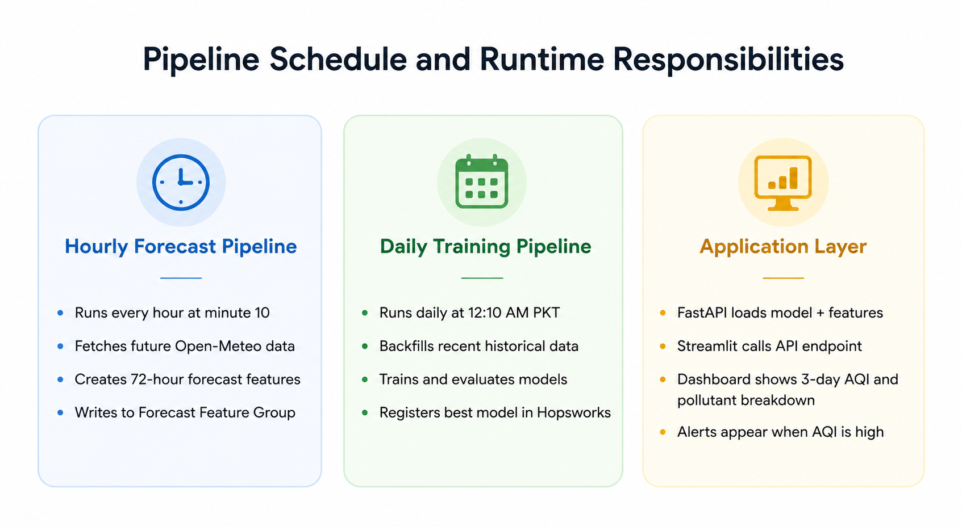
Figure 2. Pipeline schedule and runtime responsibilities.
GitHub Actions manages the operational cycle of the system. The inference and presentation layers were intentionally separated so that FastAPI handles prediction logic and Streamlit handles only visualization.
Component | Schedule / Endpoint | Responsibility
Hourly feature workflow | 10 * * * * | Runs every hour at minute 10 UTC to refresh forecast features.
Daily training workflow | 10 19 * * * | Runs at 19:10 UTC, equivalent to 12:10 AM Pakistan time.Retrain The Models And upload the best on the Hopswork.
FastAPI /health | Public API endpoint | Confirms the API container and configuration are running.
FastAPI /predictions?hours=72 | Public API endpoint | Returns location, summary, daily forecasts, hourly predictions, and pollutant summaries.
Streamlit dashboard | Streamlit Cloud | Displays AQI cards, hourly trend charts, pollutant summaries, and alerts.

9. EDA, Drift Analysis, and Explainability
Exploratory data analysis was used to inspect feature distributions, assess data quality, and verify that relationships between predictors and us_aqi were physically reasonable before finalizing the training setup.
Analysis | Purpose | Main Finding
Bivariate analysis | Compare pollutants and weather variables against AQI. | PM2.5, ozone, and PM10 showed the clearest AQI relationships.
Feature drift | Compare first and second halves of the dataset. | Weather variables shifted noticeably, supporting daily retraining.
SHAP explainability | Interpret the XGBoost model’s decisions. | pm25_24h was the strongest driver, followed by ozone and PM10-related features.

10. Validation Results
The deployed FastAPI service was validated through the public production endpoint rather than through a local mock response. This confirmed that the live system was able to load the latest model and forecast features, produce a complete prediction payload, and return it successfully under real deployment conditions.
Validation Item | Value | Interpretation
Current forecast AQI | 75.1 | Moderate
72-hour average AQI | 73.4 | Moderate
Peak AQI across forecast window | 77.5 | Moderate
Returned forecast hours | 72 | Three-day prediction window
Returned model | XGBoost | 19-feature deployed model

11. Development Challenges and Key Engineering Decisions
The most important development challenges were related to production realism rather than code implementation alone. Candidate features were screened not only for predictive performance but also for whether they would exist at future prediction time.
Challenge | Resolution
Open-Meteo provides future AQI values, which initially looked useful as inputs. | Future AQI values were excluded to avoid proxy target leakage. They were used only as a reference for comparison and validation.
AQI lag features improved notebook results but were not available for future timestamps. | AQI lag variables and observed rolling AQI averages were removed from the production model.
Recursive 72-hour forecasting could compound errors across the prediction window. | Each future hour is predicted independently using forecast variables for that timestamp.
Month features could capture seasonality but the training window was incomplete. | Month features were excluded; hour and day-of-week cyclic encodings were retained.
Streamlit initially handled model loading, Hopsworks access, and inference. | Prediction logic was moved into FastAPI, leaving Streamlit as a clean UI client.

12. Limitations and Future Improvements

12.1 Limitations
Limitation | Impact
Dependence on Open-Meteo forecast quality | If the input forecast is inaccurate, the AQI prediction will also be affected.
Six-month training window | Long-term seasonal generalization is limited.
Hyderabad-only deployment | City-level retraining would be needed for other locations.
No deep learning deployment | Dataset size and serverless latency constraints made deep learning impractical at this stage.
Hugging Face free Space cold starts | First request after inactivity can be slower.

12.2 Future Improvements
- Extend the system to multiple cities using city-specific feature groups and retraining workflows.
- Increase the historical training window to include multi-year seasonality.
- Evaluate predictions against ground-truth monitoring data.
- Add real-time alerting and notification support.
- Build a dedicated drift-monitoring dashboard.
- Experiment with temporal deep learning models once more training data becomes available.

13. Conclusion
This internship project demonstrates that a useful AQI forecasting system depends as much on engineering discipline as on model choice. The strongest decision in the project was to remove every feature that relied on information unavailable at future prediction time, even when doing so reduced the temptation to optimize only for training metrics.
The final system combines automated data ingestion, consistent feature engineering, Hopsworks-based feature and model management, scheduled retraining, a FastAPI inference service, and a Streamlit visualization layer. The resulting architecture is maintainable, explainable, and suitable for an end-to-end project demonstration. Within its documented limitations, the system successfully forecasts Hyderabad’s air quality for the next 72 hours without manual intervention.

Appendix A: Project Components
Component | Purpose
pipelines/feature_pipeline.py | Hourly forecast feature generation for the next 72 hours.
pipelines/backfill_pipeline.py | Historical data collection and training feature generation.
pipelines/training_pipeline.py | Model training, evaluation, artifact creation, and Hopsworks registration.
api/main.py | FastAPI backend for loading the model and returning predictions.
app/app.py | Streamlit frontend for visualizing API results.
.github/workflows/ | Scheduled automation for hourly refresh and daily retraining.
Dockerfile | Deployment definition for the FastAPI backend.

Appendix B: Operational Resources and Artifacts
Resource / Artifact | Description
FastAPI health endpoint | Used to verify that the backend container is running.
FastAPI prediction endpoint | Returns the full 72-hour forecast payload.
Streamlit dashboard | User-facing AQI forecast dashboard.
Model metrics report | Stores candidate model performance metrics.
SHAP analysis outputs | Explainability artifacts for the XGBoost model.
Feature drift summaries | EDA artifacts showing changes in feature distributions.
Latest 72-hour forecast reports | Forecast output saved by the feature/inference pipeline.

References
- Open-Meteo Weather Forecast API and Air Quality API documentation.
- Hopsworks Feature Store and Model Registry documentation.
- GitHub Actions workflow scheduling documentation.
- FastAPI documentation.
- Streamlit documentation.
- Hugging Face Spaces Docker documentation.
- Scikit-learn, XGBoost, and SHAP documentation.

