SYSTEM DESIGN & ARCHITECTURE

Architecture Explanation (3-Tier System Design)
This system follows a 3-tier architecture, which separates the application into three independent layers: Presentation, Logic, and Data. This separation improves scalability, maintainability, and security.

1. Presentation Tier (Frontend)
The Presentation Layer consists of a single-page application built using React.js or Vue.js.

Responsibilities:
- Provides the user interface for the system
- Handles user interactions (login, task creation, file upload, etc.)
- Sends and receives data from backend via REST APIs
- Displays real-time updates to the user

Key Component:
- UI (React/Vue SPA): Acts as the client-side application that communicates with the backend

2. Logic Tier (Backend)
The Logic Layer is implemented using a backend framework such as Node.js or Django. It contains the core business logic of the system.

Responsibilities:
- Processes all client requests
- Handles authentication and authorization using JWT
- Manages task operations (create, update, delete, assign)
- Coordinates file handling and storage operations
- Acts as an intermediary between frontend and database

Key Components:
- API Gateway
  - Entry point for all frontend requests
  - Routes requests to appropriate services
- Auth Controller
  - Handles login/register logic
  - Verifies JWT tokens for secure access
- Task Service
  - Implements business logic for task management
  - Communicates with database for CRUD operations
- File Middleware (Multer)
  - Processes file uploads before storing them
  - Validates and prepares files for storage

3. Data Tier (Database & Storage)
The Data Layer is responsible for persistent data storage and file management.

Responsibilities:
- Stores application data (users, tasks, teams)
- Manages file storage (documents, images, attachments)
- Ensures data integrity and persistence

Key Components:
- Database (MySQL / MongoDB)
  - Stores structured or semi-structured data
  - Handles queries from backend services
- Storage (Cloudinary / Local File System)
  - Stores uploaded files
  - Returns file URLs for frontend access

Data Flow Explanation
- User interacts with the Frontend (UI)
- UI sends a REST API request (JSON) to the backend
- Request reaches the API Gateway
- Gateway routes request to:
  - Auth Controller (for login/verification)
  - Task Service (for task operations)
- Task Service interacts with:
  - Database for data storage/retrieval
  - File middleware for uploads
- Files are stored in Cloud storage or local filesystem
- Response is sent back to frontend and displayed to user

Why This Architecture is Effective
- Separation of concerns → each layer has a clear responsibility
- Scalability → backend and frontend can scale independently
- Maintainability → easier debugging and updates
- Flexibility → supports different databases and storage systems

Security Considerations
- JWT-based authentication ensures secure access control
- API Gateway acts as a security checkpoint
- Backend validates all requests before processing
- File uploads are handled securely via middleware
- Database access is restricted to backend services only

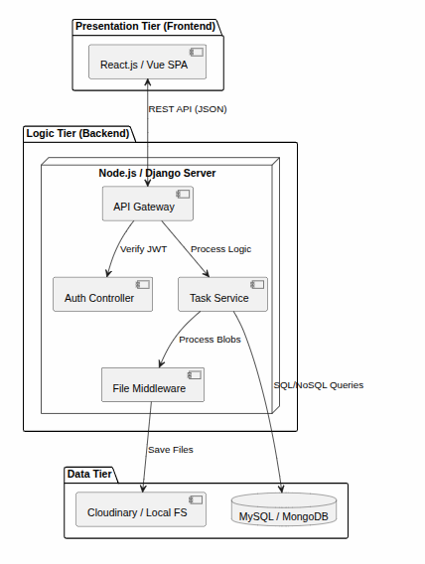

UML DIAGRAMS

1. Use Case Diagram
The Use Case diagram defines the functional scope and user boundaries of SmartTasker.
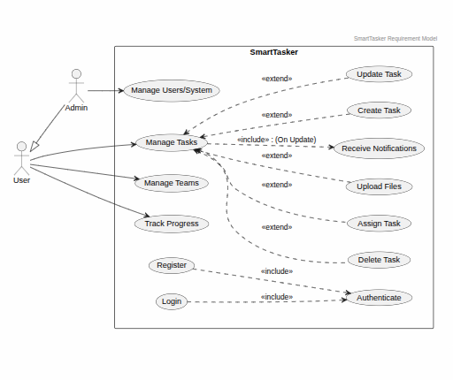
1. Actor Hierarchy (Inheritance)
The diagram employs Generalization Admin → User. The Admin inherits all functions of the User (Task CRUD, Team collaboration) while maintaining exclusive access to System/User Management. This reduces redundancy and reflects the system's Role-Based Access Control (RBAC).
2. Authentication Module (Include)
The Authenticate (UC3) use case is an <<include>> for both Login and Register. This signifies that identity verification is a mandatory, non-optional step within the authentication flow, ensuring system security.
3. Task Management Framework (Extend)
Manage Tasks (UC4) serves as the primary gateway. Specific actions—Create, Update, Delete, Assign, and Upload—are modeled as <<extend>>. This indicates that these features are optional branches available to the user only after they have accessed the task management module.
4. Event-Based Notifications
The system triggers Receive Notifications (UC11) as an <<include>> during task modifications. This demonstrates an automated business rule where the system ensures stakeholders stay informed of progress changes.

2. Class Diagram :
The Class Diagram serves as the Blueprint for the Data Layer, defining how the system stores information and how objects interact within the backend.
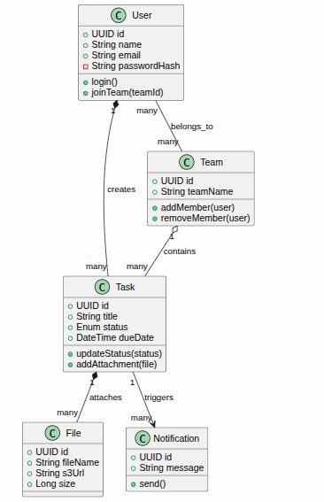

1. Encapsulation & Security Logic
- Private Data Masking (Red Icon): The passwordHash is encapsulated as Private. Technically, this ensures the system follows the Principle of Least Privilege, preventing sensitive credentials from being exposed during object serialization or API responses.
- Public Interface (Green Icon): Methods like updateStatus() and login() define the Public API of the class. This forces all state changes through validated logic, ensuring a task cannot reach an invalid state (e.g., jumping from "Created" to "Archived" without review).

2. Relationship & Lifecycle Logic
- Strong Ownership (Composition ◆): Used for Task ⮕ File. In a Task Manager, if a task is deleted, its attachments are no longer relevant. This relationship ensures Cascading Deletes in the database, preventing storage bloat from "orphan" files.
- Weak Association (Aggregation ◇): Used for Team ⮕ Task. This allows for Resource Reassignment. If a team is deleted, the tasks can remain in the system for archival or be moved to a different team, preserving historical work data.
- Many-to-Many Association: Between User ⮕ Team. This supports the collaborative requirement where users participate in multiple projects and teams consist of various members.

3. Sequence Diagram
This sequence diagram illustrates the end-to-end process of creating a task in the SmartTasker system. It shows how different system components interact in a step-by-step manner, starting from user input to final task confirmation.

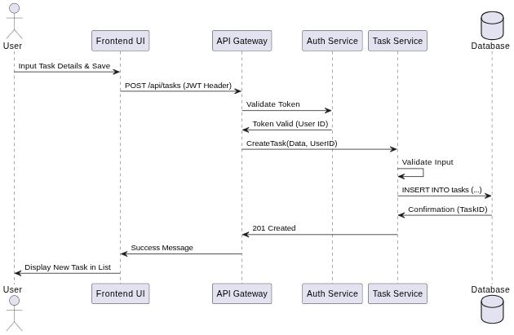

1. User Interaction
The process begins when the User enters task details in the frontend interface.
The frontend collects the input and prepares it for submission.
- The Frontend sends a POST request (/tasks) to the backend
- The request includes a JWT token for authentication

2. Backend Request Handling
Once the request reaches the backend:
- The Backend forwards the token to AuthService
- AuthService validates whether the user is authenticated

Authentication Check

Case 1: Invalid Token
- AuthService rejects the token
- Backend returns a 401 Unauthorized error
- Frontend displays an error message to the user

Case 2: Valid Token
- AuthService confirms authentication
- Backend proceeds to business logic processing

3. Task Processing (Business Logic Layer)
After successful authentication:
- Backend sends the request to TaskService
- TaskService validates the input data

Case1: Validation Failure
- TaskService detects invalid input
- Returns error to backend
- Backend sends validation error to frontend
- User is prompted to correct input

Case2: Validation Success
- TaskService processes the request successfully

4. Database Operation
If validation is successful:
- TaskService sends a request to the Database
- A new task record is inserted
- Database confirms successful storage

5. Notification System
After task creation:
- TaskService triggers the NotificationService
- Notification system sends alerts to relevant team members
- Confirmation is returned after successful delivery

6. Response to User
Finally:
- TaskService confirms task creation to backend
- Backend sends a success response to frontend
- Frontend displays a success message to the user

4. Activity Diagram
This activity diagram represents the complete lifecycle of a task in the SmartTasker system, from creation to completion. It illustrates workflow steps, decision points, parallel processes, and iterative updates.

1. Task Creation Phase
The process begins when a User creates a task.
- The task is then assigned to a team member
- The system checks whether the task has been properly assigned

Decision: Team Assigned?
- Yes → Workflow continues normally
- No → Task is reassigned until a valid assignment is made

2. Parallel Execution Phase
Once a task is successfully assigned, two processes occur in parallel:

A. Upload Attachments
- Users can upload supporting files (documents, images, etc.)
- These files are linked to the task

B. Send Notifications
- The system notifies relevant team members
- Ensures collaboration and awareness
These two activities run simultaneously to improve efficiency.

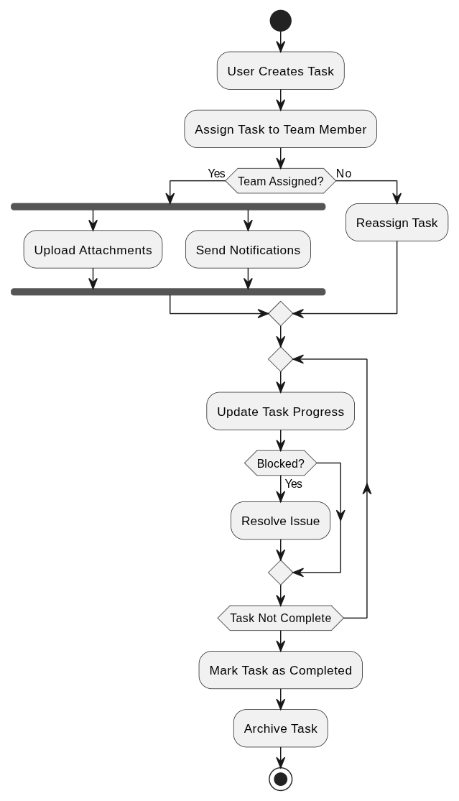

3. Task Progress Update Phase
After initial setup:
- The task enters the progress tracking stage
- Users continuously update task status

Decision: Blocked?
- Yes →
  - The system triggers issue resolution
  - Problems are addressed before continuing
- No →
  - Task continues normal progress flow

4. Completion Check Loop
The system repeatedly checks:
- Whether the task is completed or still in progress

Decision: Task Not Complete?
- If not complete → return to progress update loop
- If complete → proceed to final steps

5. Task Completion Phase
Once all work is finished:
- Task is marked as completed
- System updates final status

6. Archiving Phase
- Completed tasks are moved to archive storage
- This ensures:
  - Clean active workspace
  - Historical record maintenance

7. End of Process
The workflow terminates after archiving the task.

