Experiment No. 1
Comparative Study of Low-Code Development versus Traditional Application Development Approaches

1. Aim
To study and conduct a comparative analysis between the Traditional Application Development approach and the Low-Code Application Development approach, understanding their respective stages, advantages, limitations, and suitability for different types of software projects.

2. Introduction to Traditional Approach
Traditional application development refers to the conventional method of building software applications through manual, hand-written source code using programming languages such as Java, Python, C#, or C++. This approach typically follows a structured Software Development Life Cycle (SDLC), such as the Waterfall or Agile model, where each phase — requirement analysis, design, coding, testing, deployment, and maintenance — is carried out sequentially or iteratively by skilled developers.
This approach offers maximum flexibility and control over the application's architecture, performance, and security, making it suitable for large-scale, complex, and highly customized enterprise systems. However, it demands significant time, skilled human resources, and cost, since every functional component is built from scratch and thoroughly tested before release.

3. Introduction to Low-Code Development
Low-code development is a modern software development approach that enables developers — and even non-technical 'citizen developers' — to build applications using visual interfaces, drag-and-drop components, pre-built templates, and configuration instead of writing extensive lines of code. Popular platforms include OutSystems, Mendix, Microsoft Power Apps, and Appian.
The primary goal of low-code development is to accelerate the delivery of applications by abstracting away repetitive coding tasks, allowing teams to focus on business logic and user experience. While it significantly reduces development time and cost, it may introduce limitations in customization, scalability, and dependency on the vendor's platform capabilities.

4. Diagram: Stages in Traditional Approach
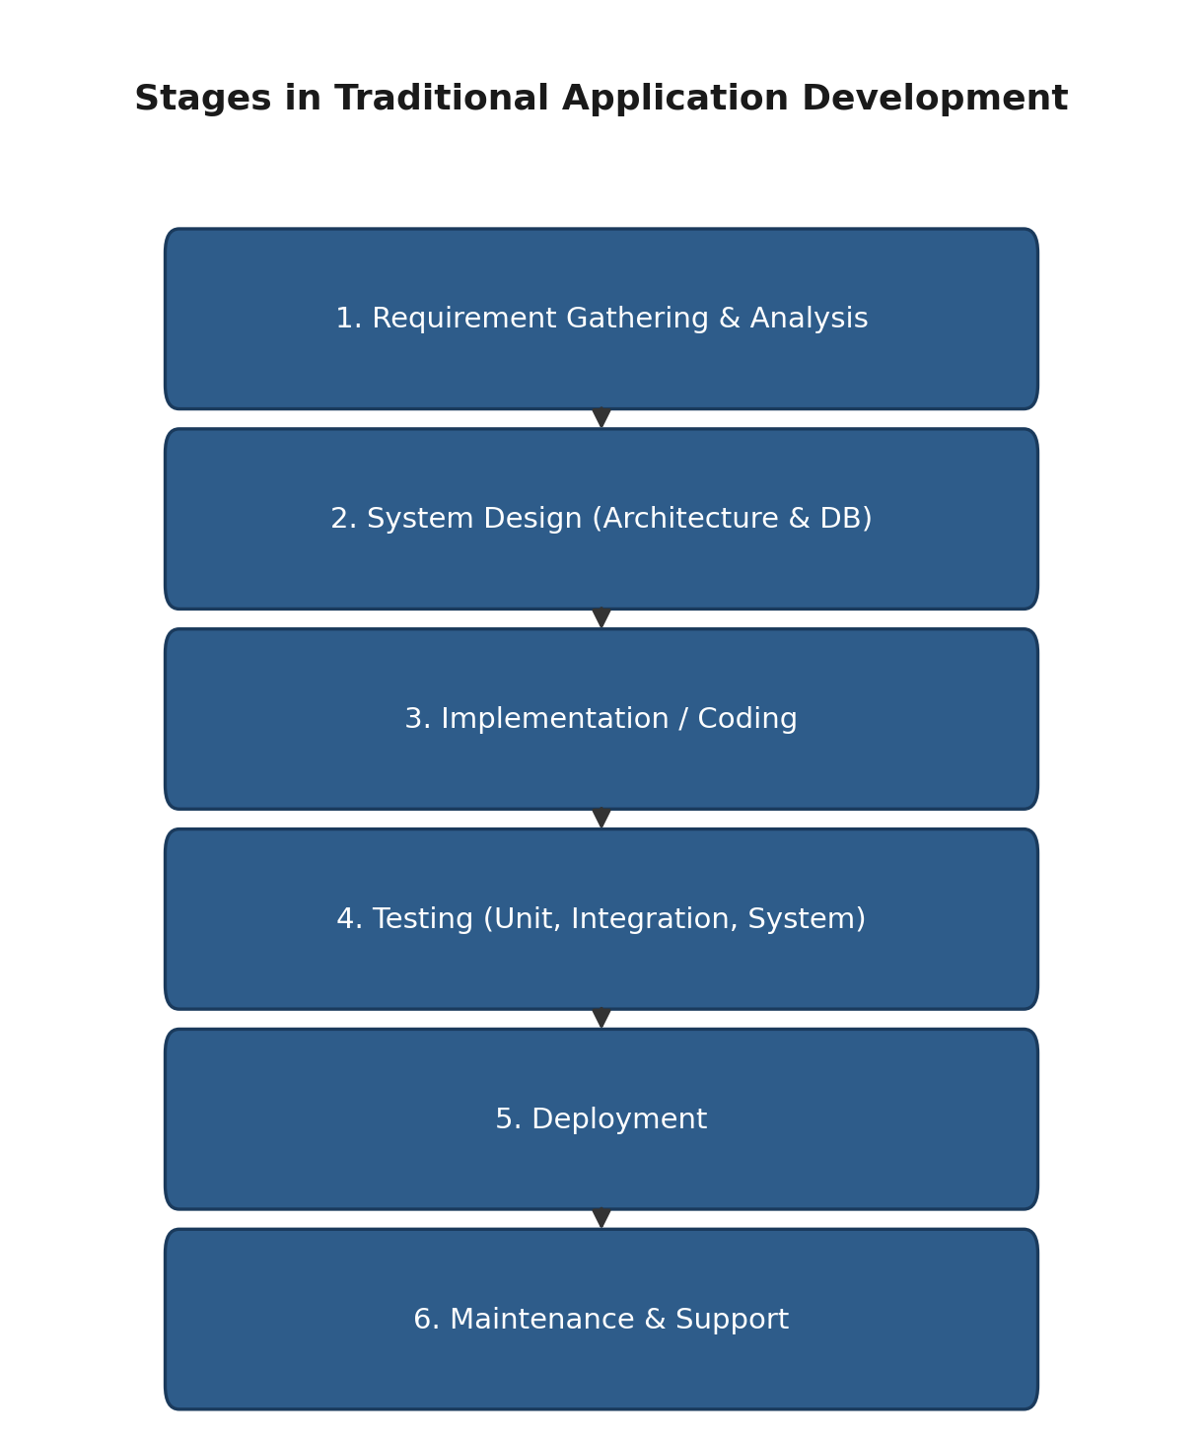

5. Diagram: Steps in Low-Code Development
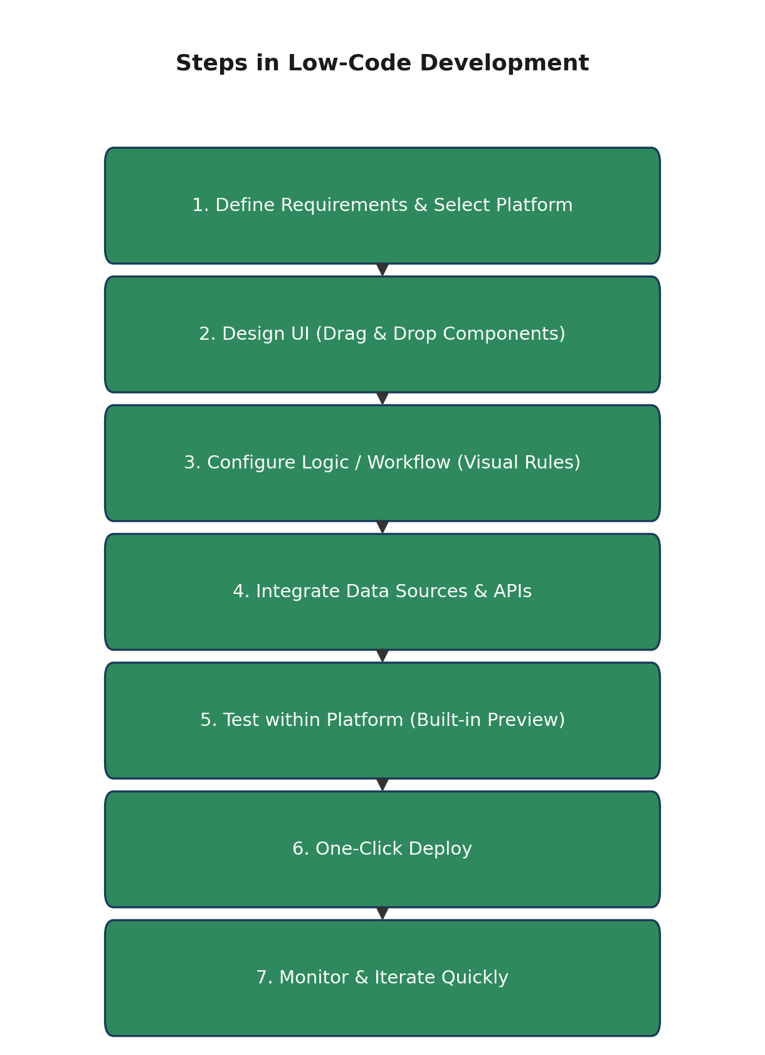

6. Comparative Analysis (Traditional vs Low-Code)
Parameter | Traditional Development | Low-Code Development
Development Speed | Slow; every module hand-coded | Fast; drag-and-drop + reusable components
Coding Skill Required | High; trained developers needed | Low to moderate; business users (citizen developers) can build apps
Cost | High (skilled manpower, long timelines) | Lower upfront cost; subscription/licensing fees apply
Customization & Flexibility | Very high; no platform limitations | Limited by platform capabilities and templates
Scalability | Fully scalable, architecture designed as needed | Depends on platform; may hit vendor limits at large scale
Maintenance | Requires ongoing developer effort | Easier; platform handles updates, but vendor lock-in risk
Testing & QA | Manual + automated testing frameworks | Built-in/simplified testing tools within platform
Security Control | Full control over security implementation | Depends on vendor's security standards
Integration with Legacy Systems | Easily integrated via custom code | May require connectors/APIs; not always seamless
Best Suited For | Complex, large-scale, highly customized enterprise systems | Rapid prototyping, internal tools, small-to-medium business apps
Vendor Dependency | None; code is owned by the organization | High; tied to the low-code vendor/platform

7. Result
The comparative study was successfully carried out, and the key stages of both the Traditional and Low-Code development approaches were understood and represented diagrammatically. It was observed that:
- Traditional development offers greater flexibility, control, and scalability but requires more time, cost, and skilled manpower.
- Low-code development significantly speeds up application delivery and lowers the barrier to entry for non-programmers, but comes with platform dependency and limited customization.
- The choice between the two approaches depends on project complexity, budget, timeline, required customization, and long-term scalability needs.
Thus, the experiment concludes that both approaches have their own merits, and organizations should choose the appropriate methodology based on the specific requirements of the project — traditional development for complex, mission-critical systems, and low-code development for rapid prototyping, internal tools, and smaller-scale applications.

