Installation Guide

1. Setup the lab and launch a windows instance.
2. Inside the instance install JDK, Maven, Git
3. JDK installation process

Navigate to JDK installation page (<https://www.oracle.com/java/technologies/javase/jdk11-archive-downloads.html>)

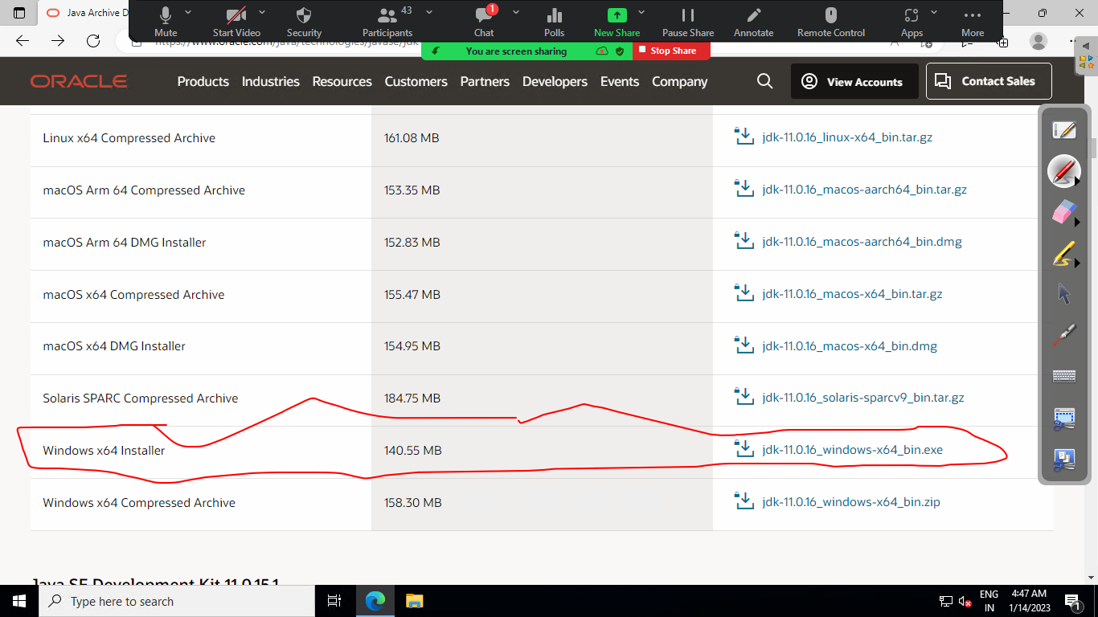

Install JDK and set the environment variable

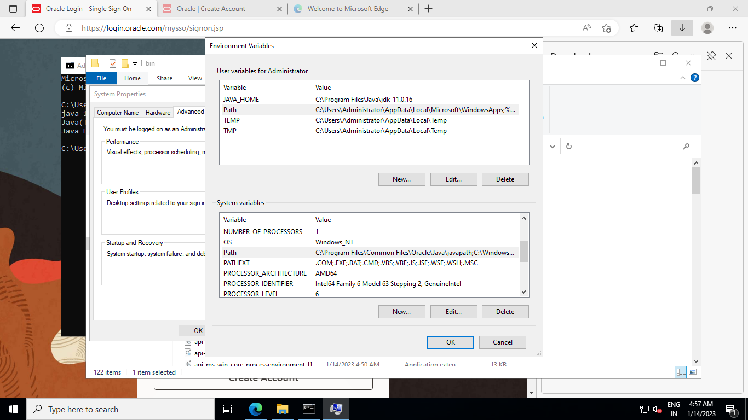

Maven Installation:

Navigate to the link and Download Manven package

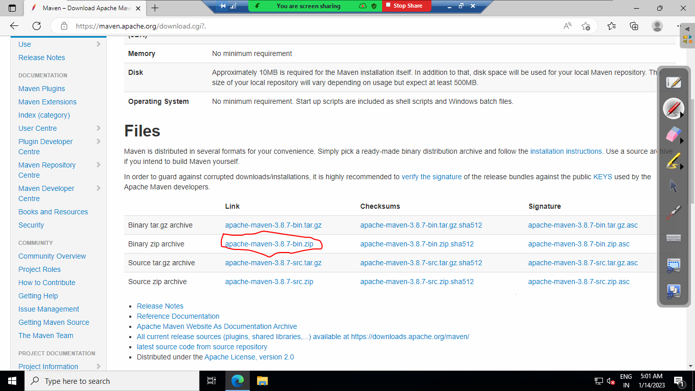

After download unzip the file and copy the maven folder inside c disk

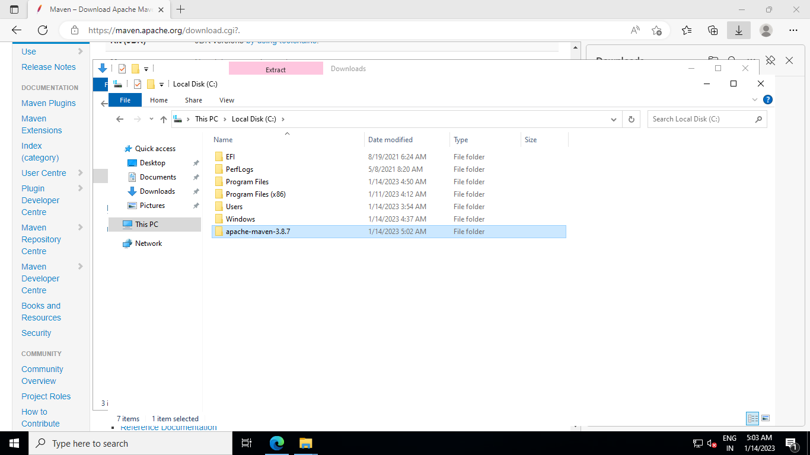

Setup environment variable for maven.

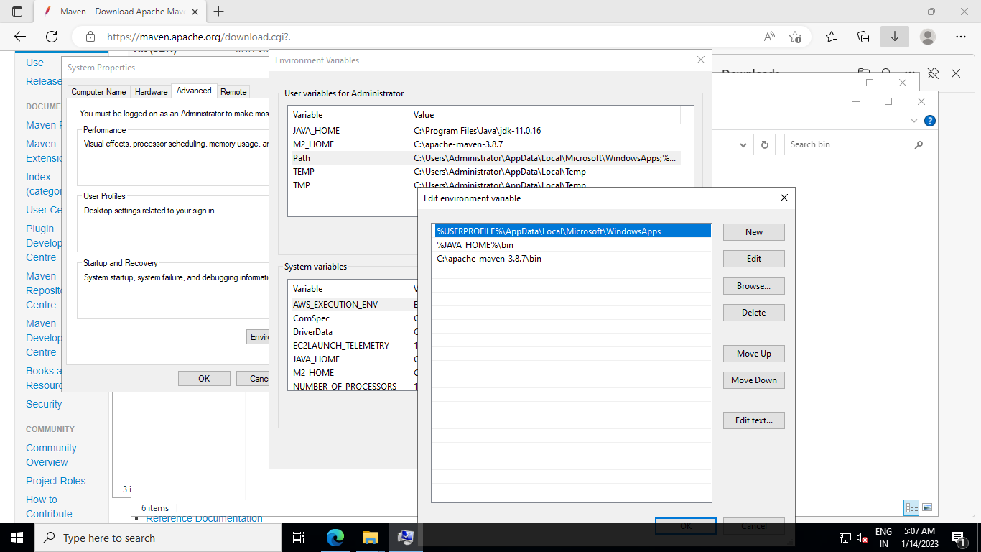

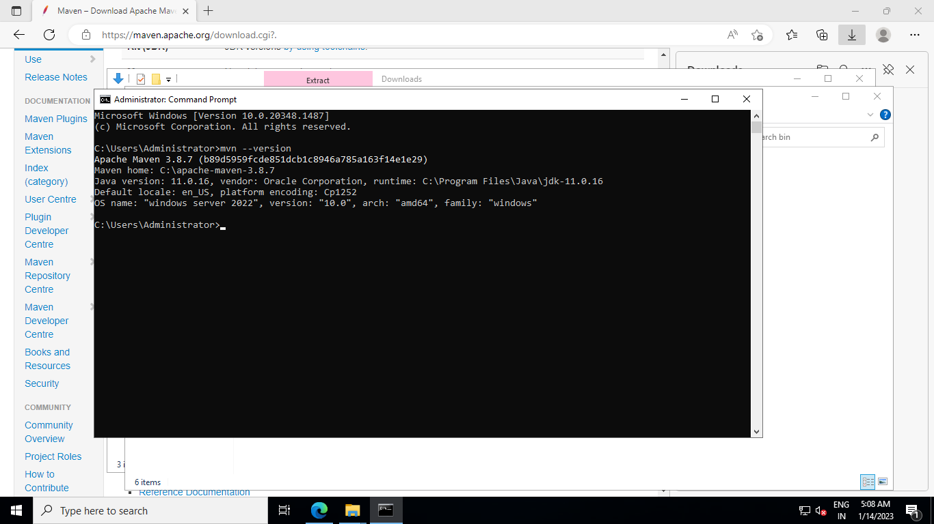

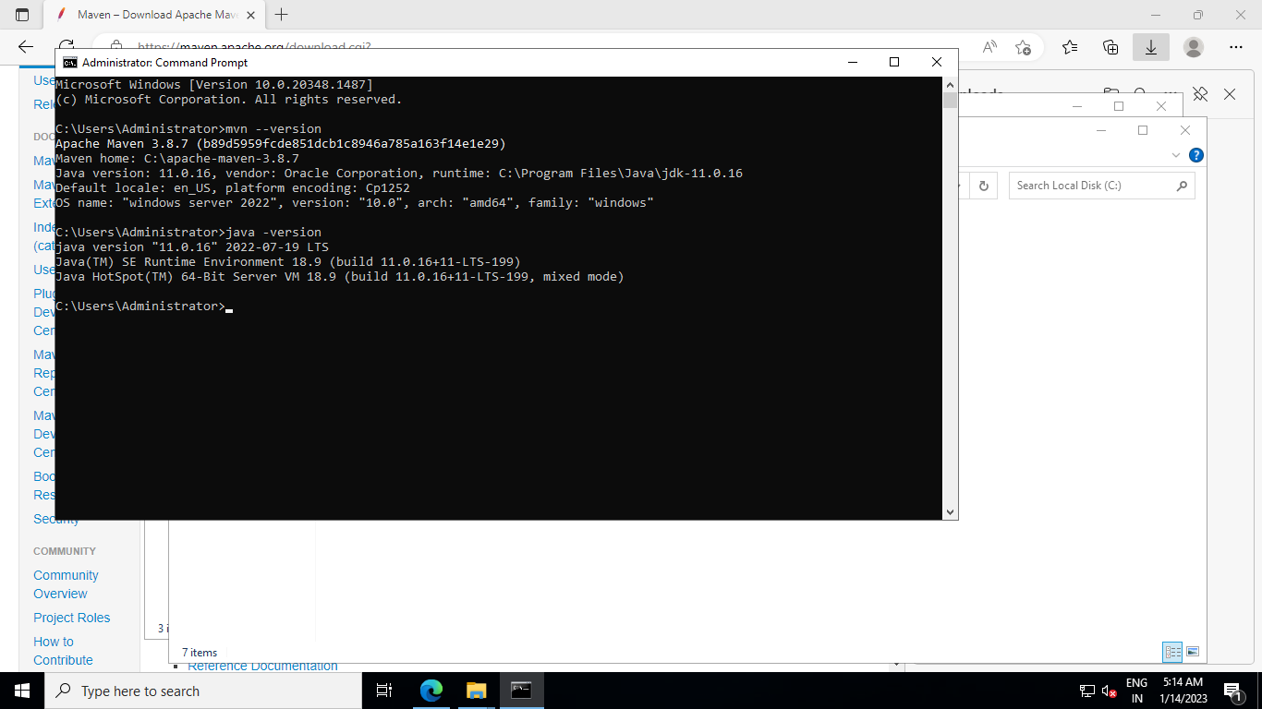

Download Jenkis (<https://www.jenkins.io/download/>)

Install Jenkins and Open the NSG inbound port tcp 8080

After installation navigate to Jenkins url: localhost:8080 or <server public ip>:8080

First time it will ask for the initial password and you can get the same by navigating the path mentioned.

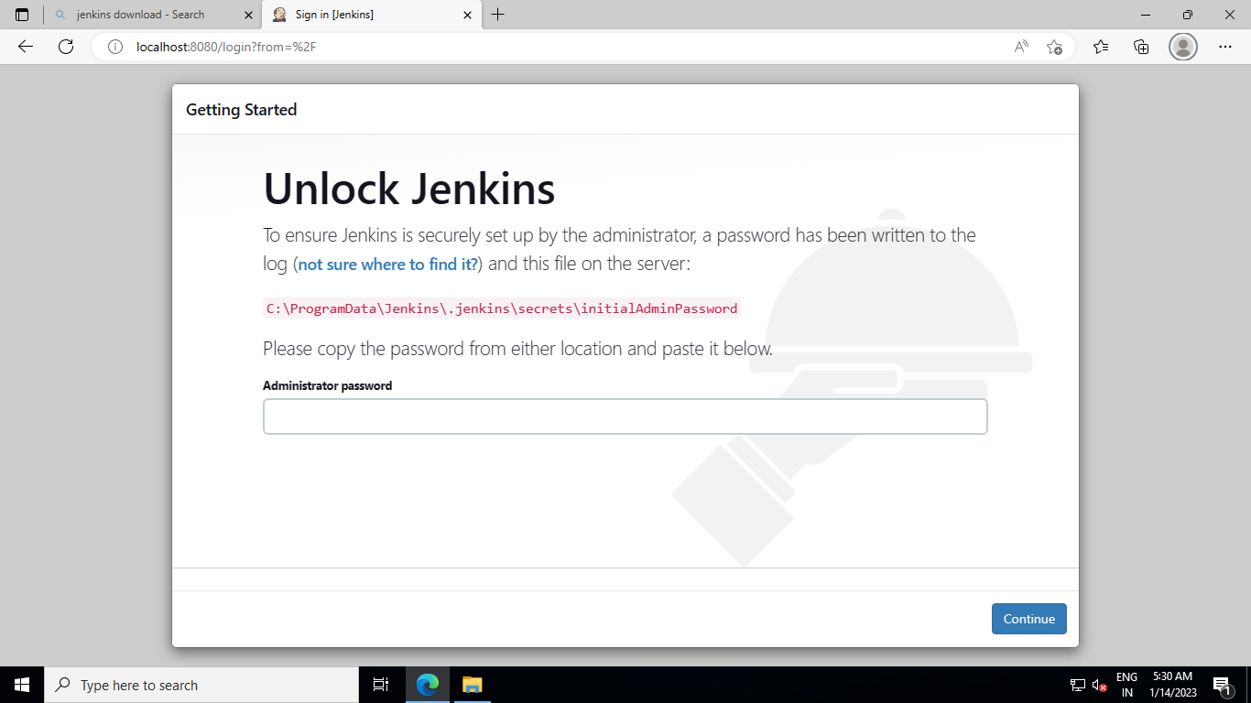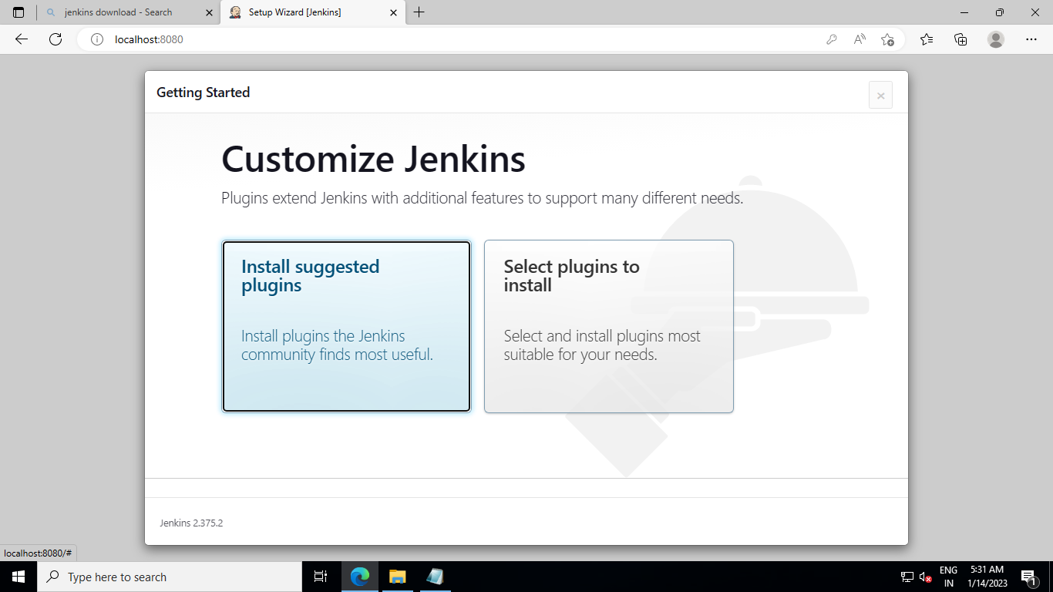

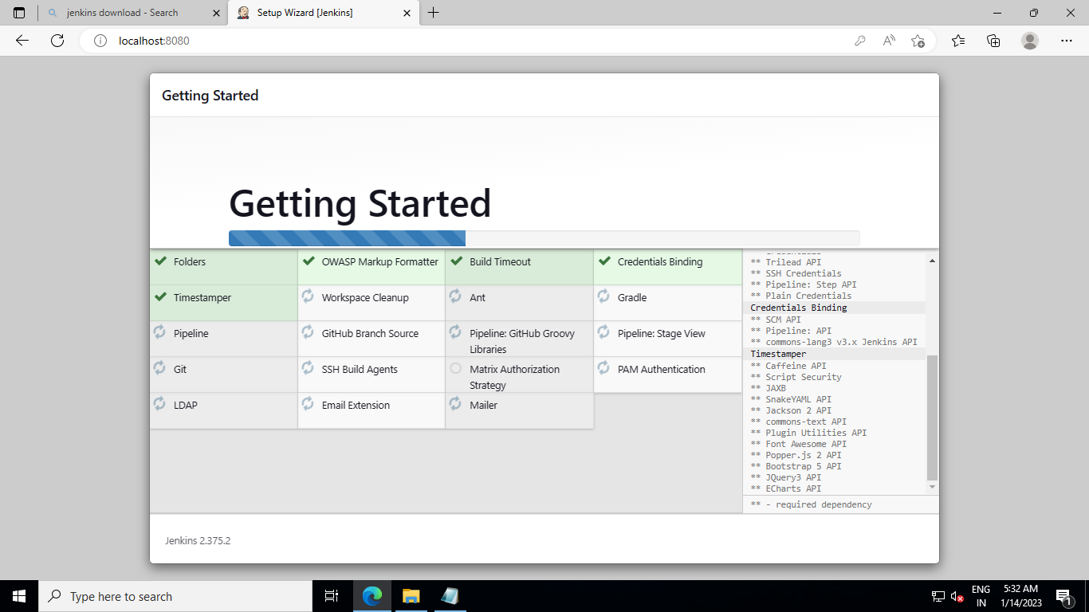

We have navigated to a page where you need to setup your admin account

Username: admin

Password : <password>

Full name: Niladri Mondal

Email id: [niladrimondal.mondal@gmail.com](mailto:niladrimondal.mondal@gmail.com)

#note: if you are not able to access the Jenkins url from your local browser. <publicip>:8080 means the server is blocking the same. To make it work you need to disable firewall of the server where Jenkins has installed.

