**Experiment -1 Simulate the communication using e-mail applications:**

i) Create a topology with two e-mail clients and email server.

ii) Configure email clients and email server (use your reg. number).

iii) Demonstrate for sending and receiving the mails.

First we need to create the topology with two clients and email web server. Open cisco packet tracer then go to end devices select generic PC and place over there then again go to end devices select web server and click and drop the generic web server. So for connecting those two clients and web server connect the generic switches in between the two clients and web server. After placing connect the wire between the two client and web server. Here we have the topology for communicating email applications.

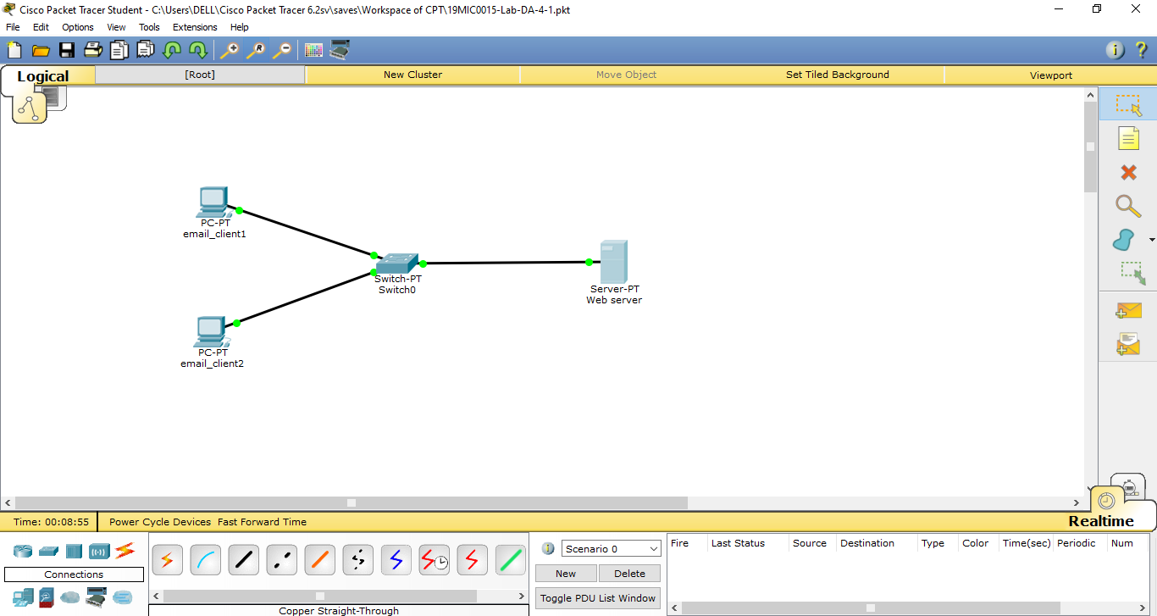

Now click on web server and go to services select the email service and check whether the SMTP & POP3 service are ON mode for configuring the email application(Client 1 username & password).

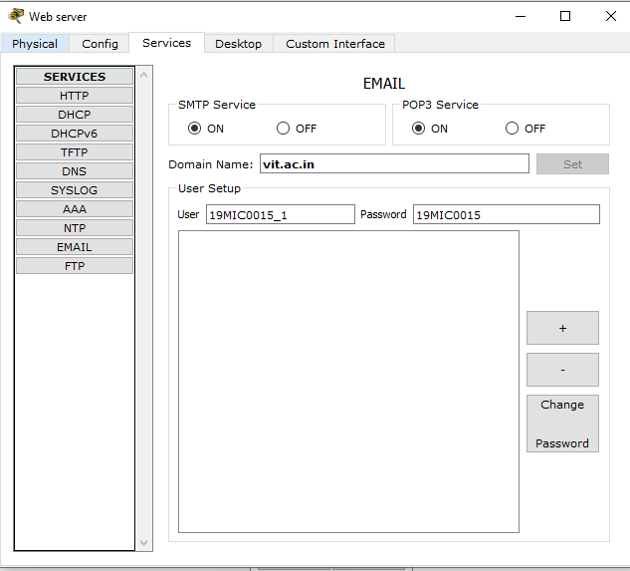

Then give the domain name as vit.ac.in and assign the two username and password for configuring the two email clients. After entering the domain, username, password then click set and click + symbol to add this function to it (Client 2 username & password and then the 2 client added details).

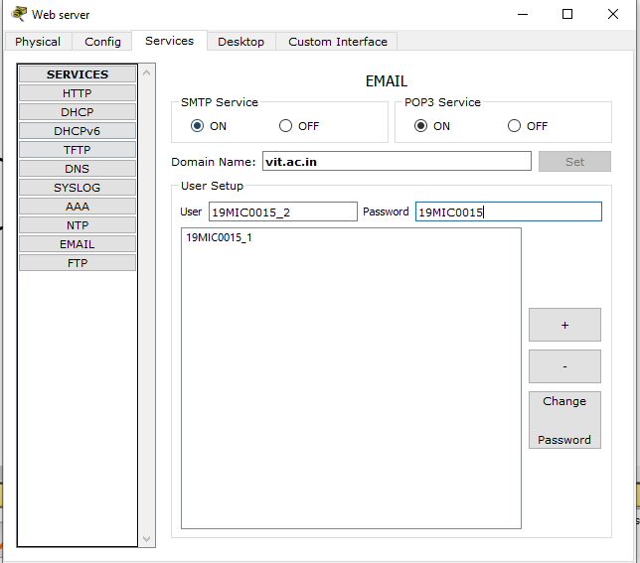

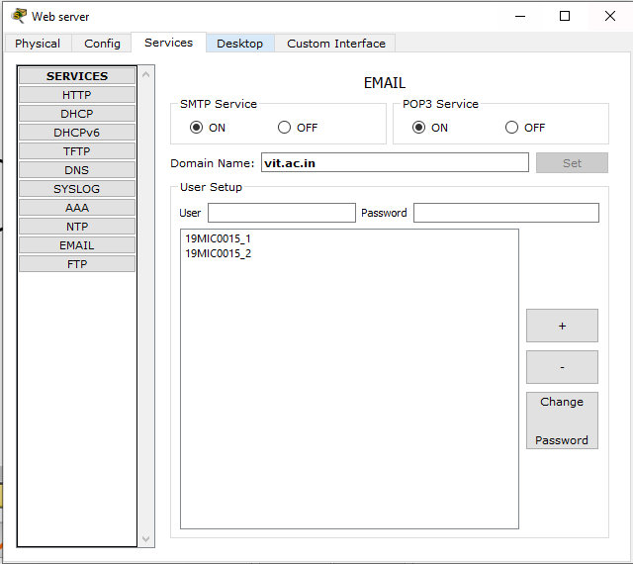

After this go to Desktop option in web server itself we need to configure the ip address for configuring the email applications.

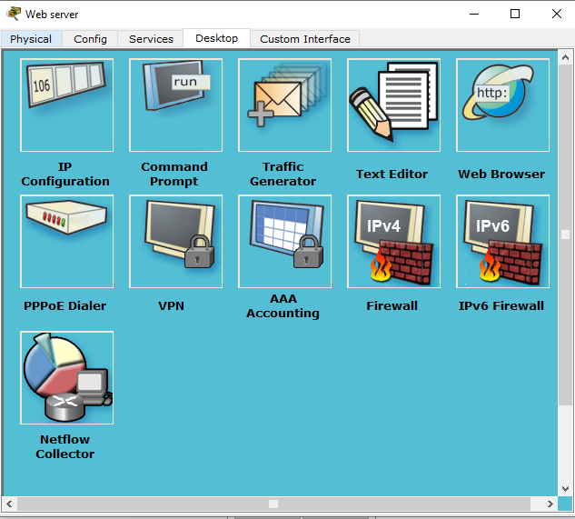

In this IP configuration give IP address as 192.168.1.1 and subnet is default.

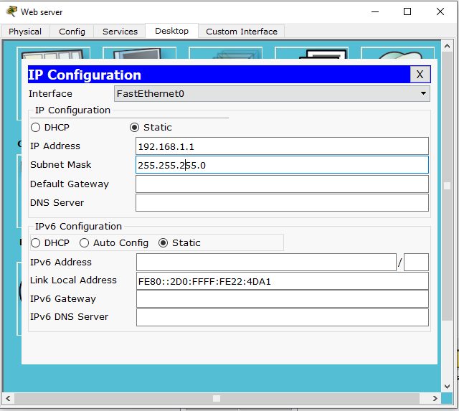

Now we need to configure on 2 clients so go to the 1st client select desktop option and click IP configuration(email_client1).

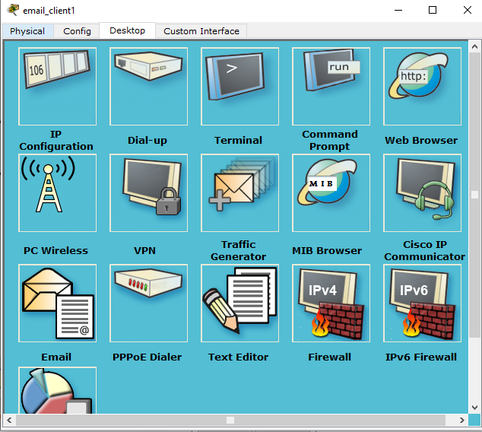

Here the IP address for email_client1 is 192.168.1.2 and subnet is default.

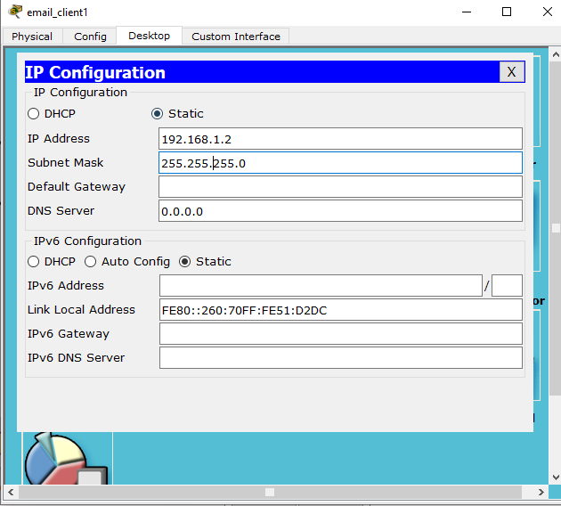

Then close the IP configuration and select email option in email_client1 itself.



Here we need to give our name and email address which we have given in the email services in the web server. Then sever information as incoming and outgoing as same IP address and finally give the respective username and password and click save option.

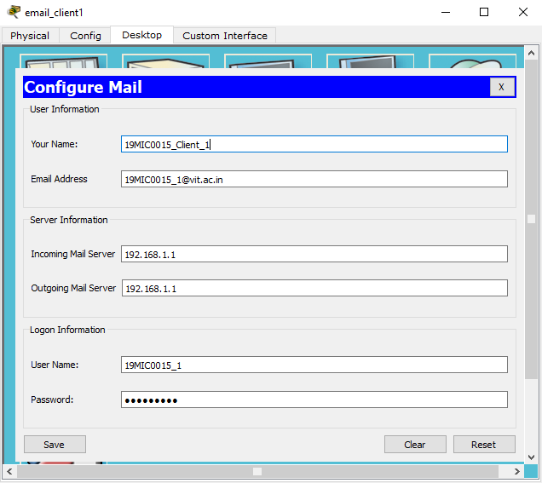

Then same procedure is repeated for email_client2 also, select the email_client2 click on IP configuration (email_client2).

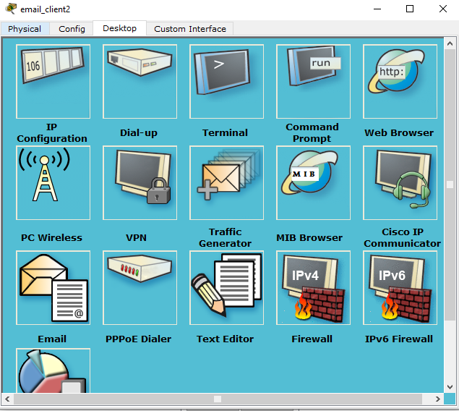

Here the IP address for client2 is 192.168.1.3 & subnet is default.

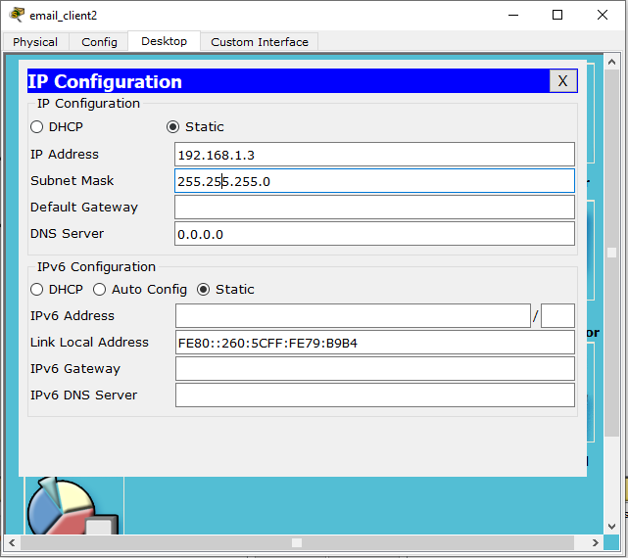

Then close the IP configuration and select email option in email_client2 itself.



Here we need to give our name and email address which we have given in the email services in the web server. Then sever information as incoming and outgoing as same IP address and finally give the respective username and password and click save option.

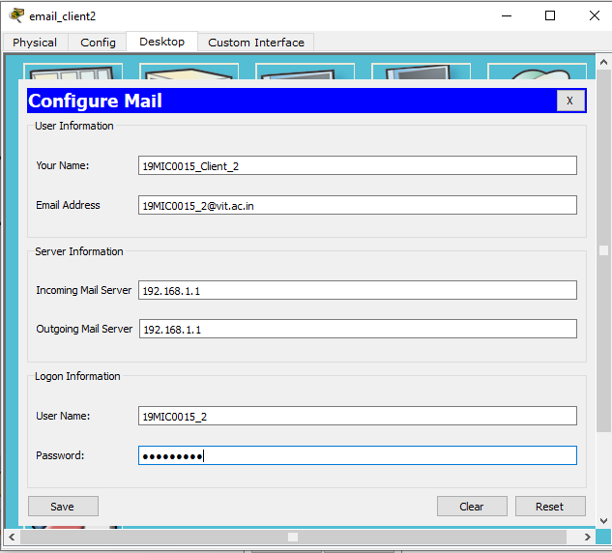

Then we need to check the whether the package is transferring or not. For that select email_client1 and select the command prompt type ping 192.168.1.1.

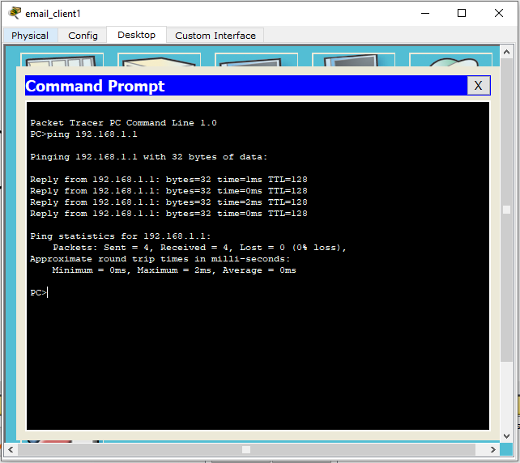

Now we can communicate the message using email applications. Select email_client1 then go to desktop option select email option.

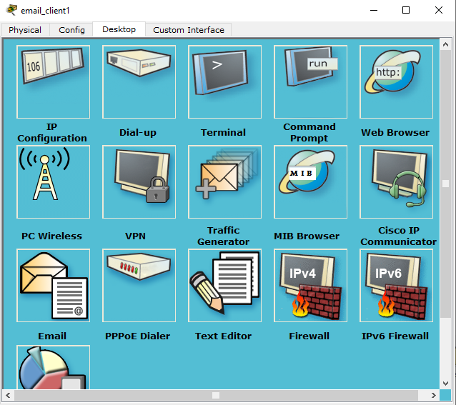

Click on compose to compose the mail.

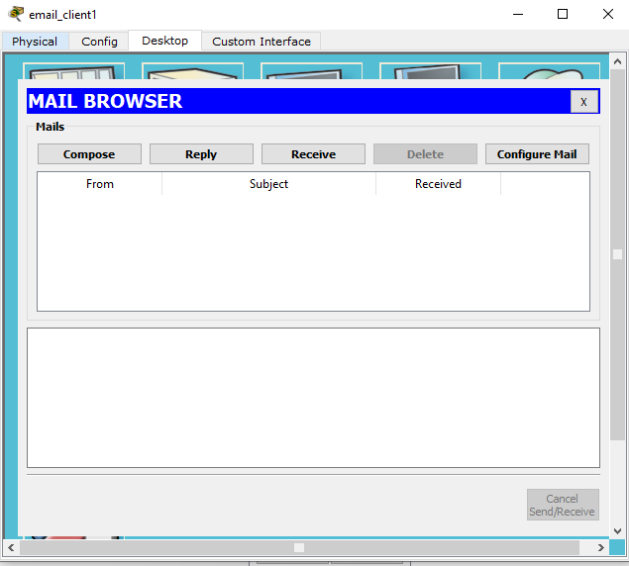

Now enter the To address of the email and subject that need to communicate that email enter those details and click send option.

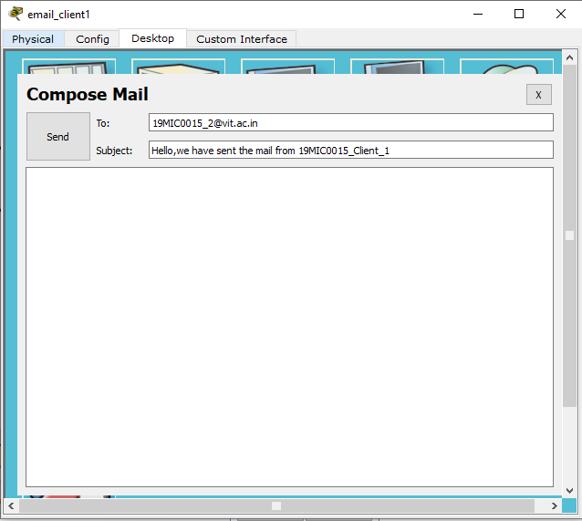

As we can see the email message is successfully sent to the client2 side. So here To mail, subject, Mail server IP address can be displayed here.

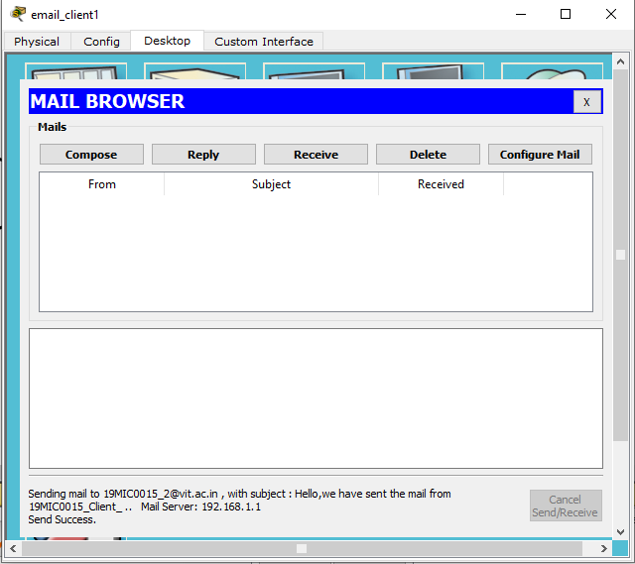

Then close this and go to email_client2 select desktop option click on email option there.

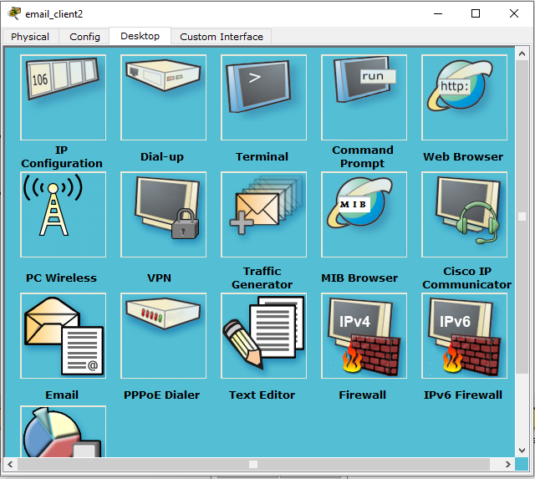

Here click on receive option to see the message which has came from email_client1 mail in it.

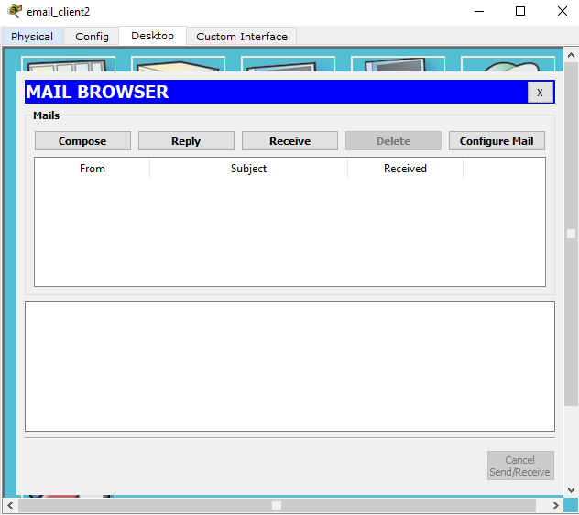

So here the received message, we have received the mail successfully from client1 and shows the mail id of sent person, message, mail server IP address in it.

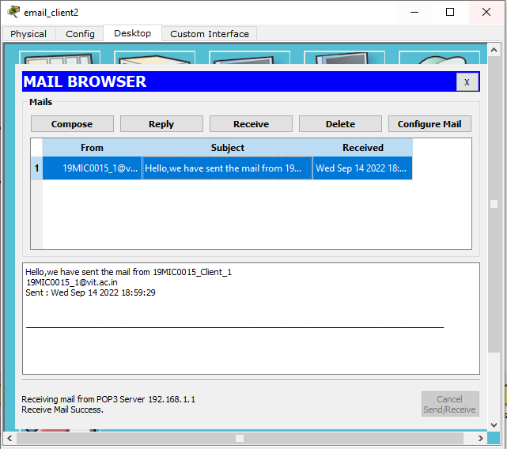

So we can send and receive any number of mail from any client in it. Now we are sending the message from client2 to client1 click on compose option.

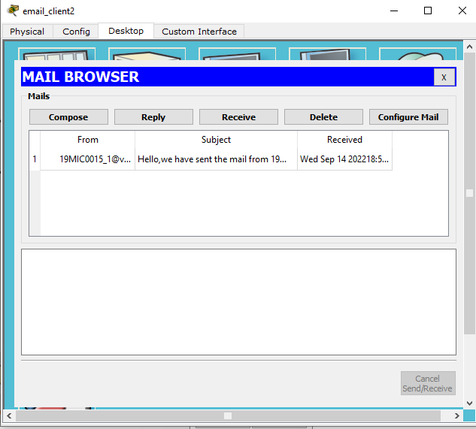

Here enter the client1 mail id and subject to it and click send option.

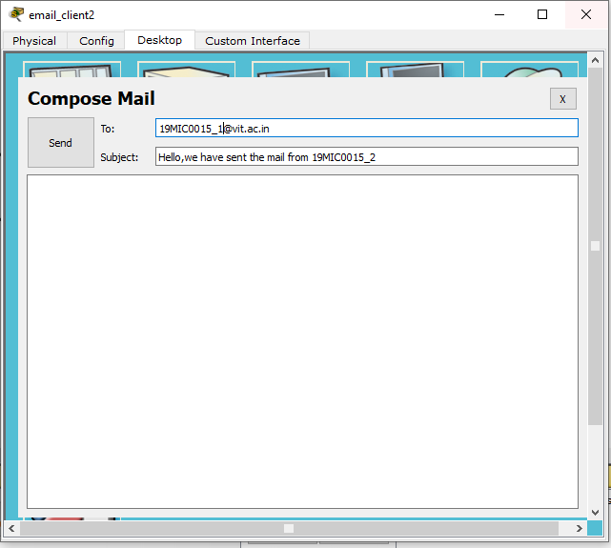

Now we can see the message is successfully sent to the client2 to client1. And then close it.

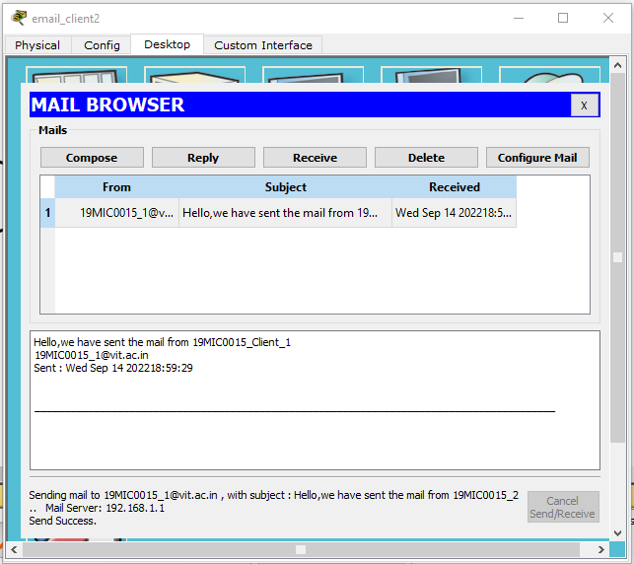

Now got to client1 and select desktop option and click on email option.

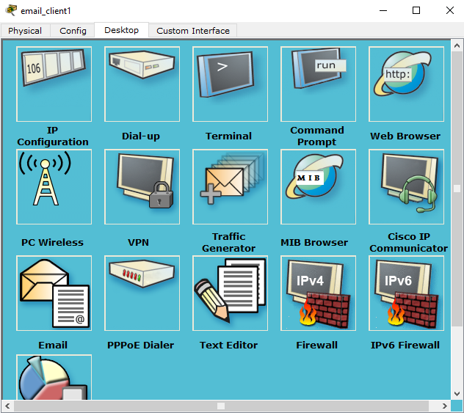

Click on receive option to view the message.

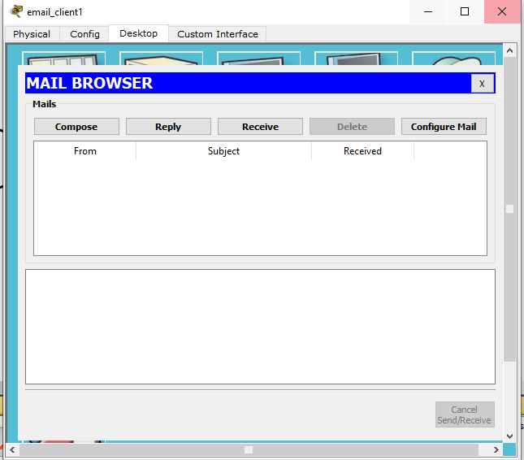

Hence we have received the message successfully from the client 2 to client 1.

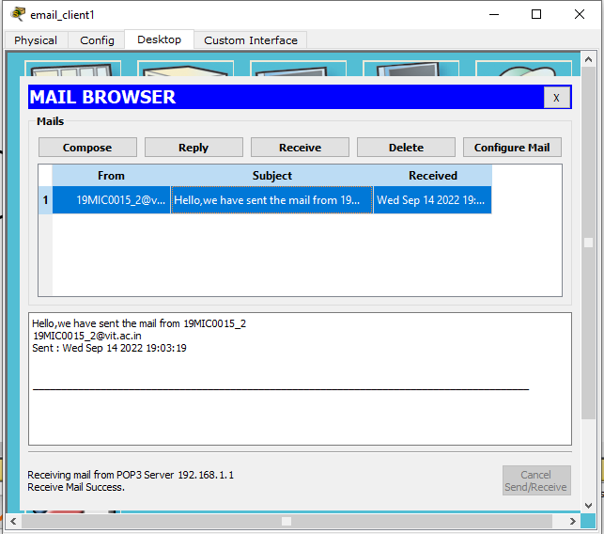

Here I have done another example for sending and receiving the mail from client1 to cleint2 and client2 to client1.

Email_client1 to Email_client2

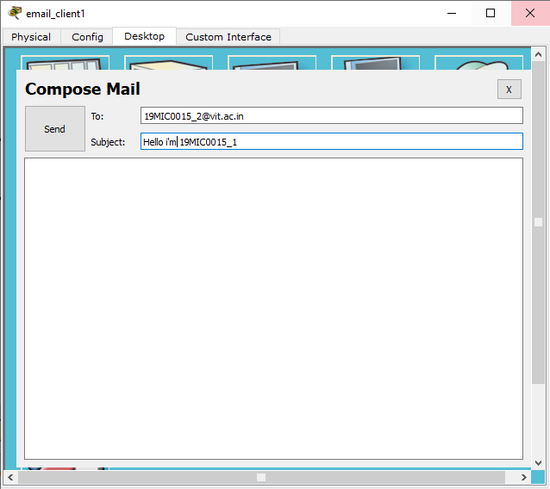

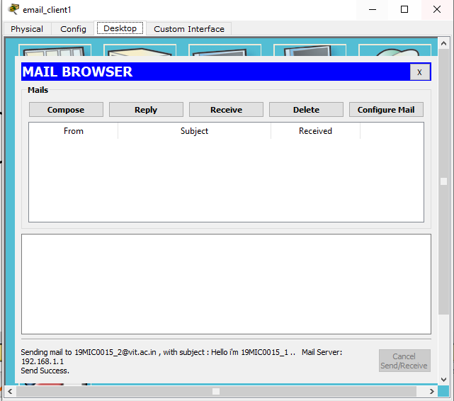

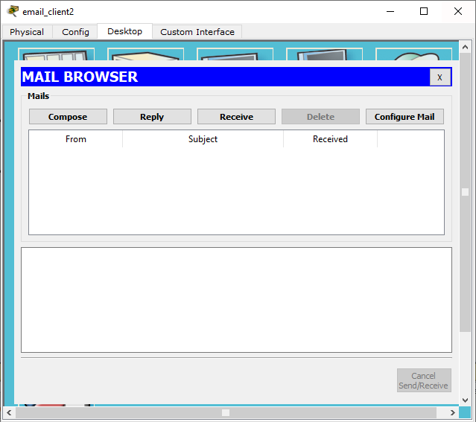

Here we have received the message from client 1 to client 2 successfully.

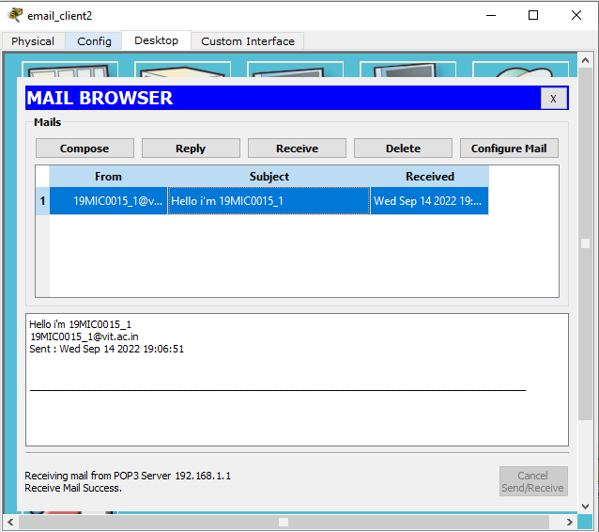

Email_client2 to Email_client1

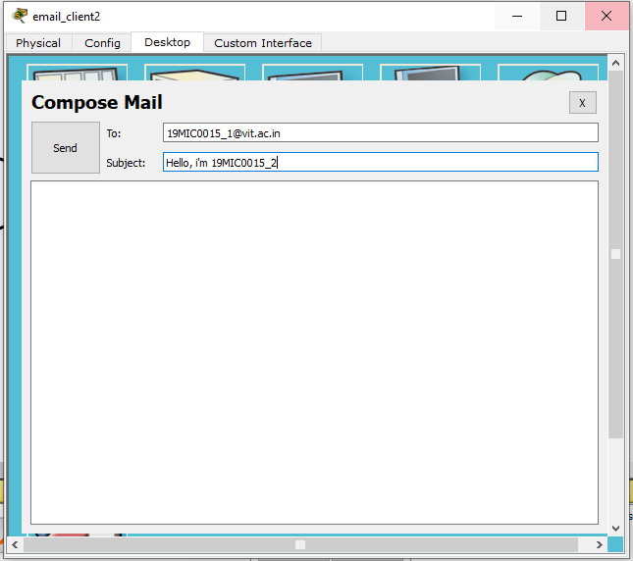

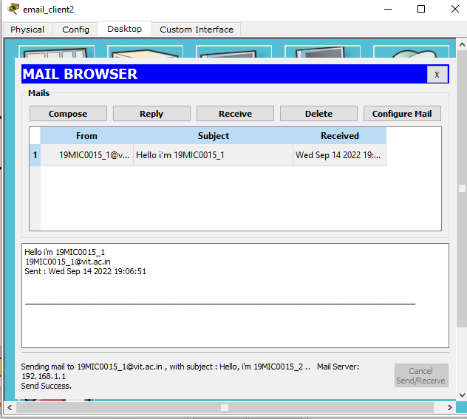

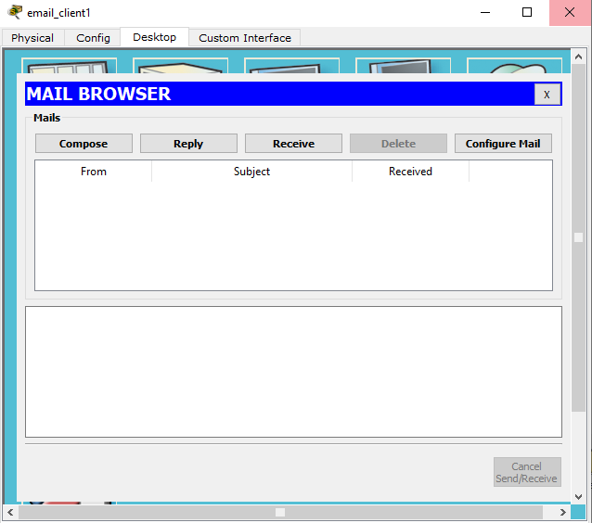

Here we have received the message from client 2 to client 1 successfully.

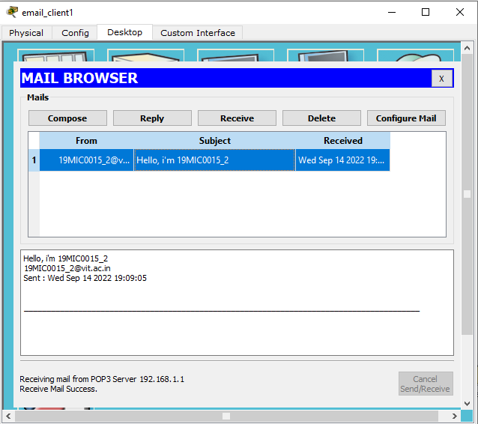

Topology :-

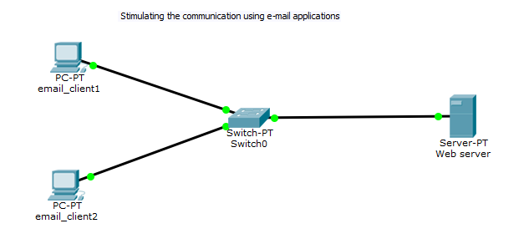

**Experiment -2 Simulate the communication using web applications:**

i) Create a topology with two web clients and web server:.

ii) Configure web clients and web server and DNS server.

iii) Demonstrate for giving the web request. Ensure that the page should display your register number.

First we need to create the topology with two clients and web server. Open cisco packet tracer then go to end devices select generic PC and place over there then again go to end devices select web server and click and drop the generic web server. So for connecting those two clients and web server connect the generic switches in between the two clients and web server. After placing connect the wire between the two client and web server. Here we have the topology for communicating email applications.

After creating the topology we need to configure the 2 clients and webserver for communicating using the web applications.

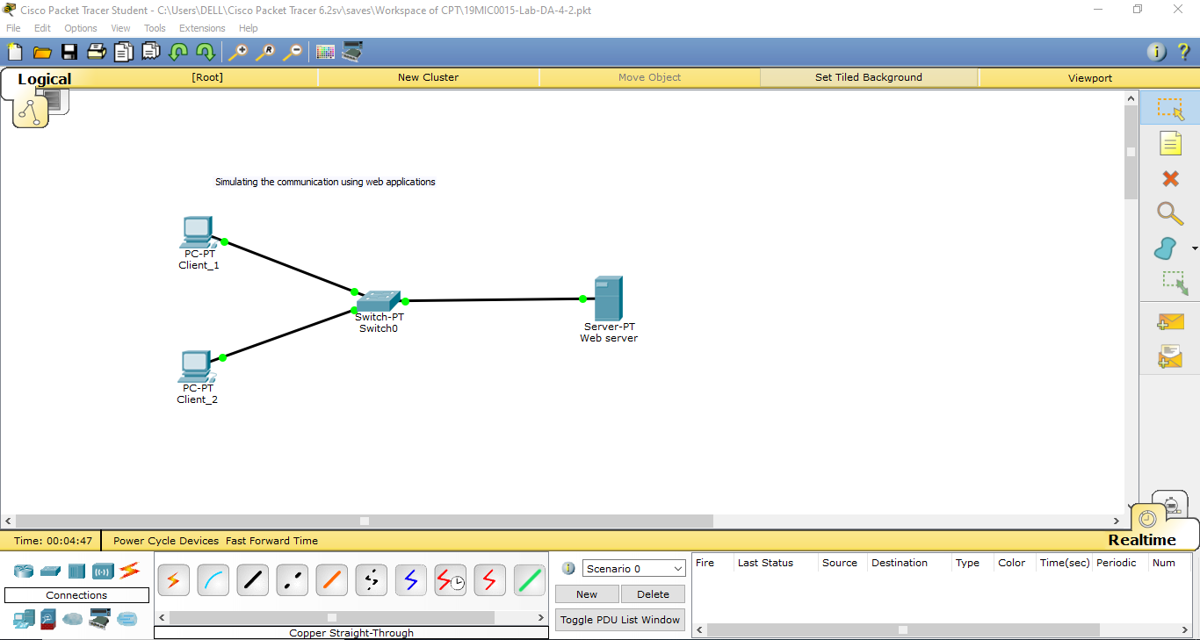

After creating the topology go to web server then select the config option in that gateway type the address as 192.168.1.254 and DNS server as 192.168.1.1.

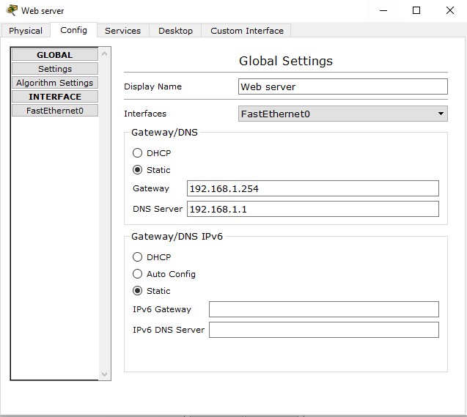

Then select the services option in same web server itself and click on DNS option in services. Check DNS service is ON and type the name as [www.google.com](http://www.google.com) and address as 192.168.1.1 and click on add option.

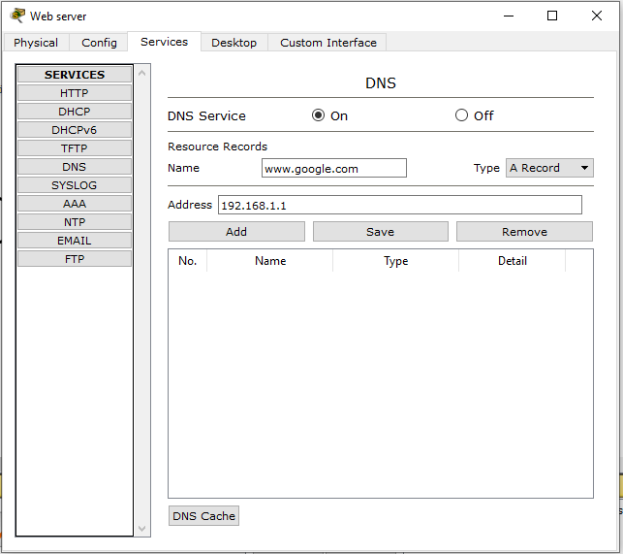

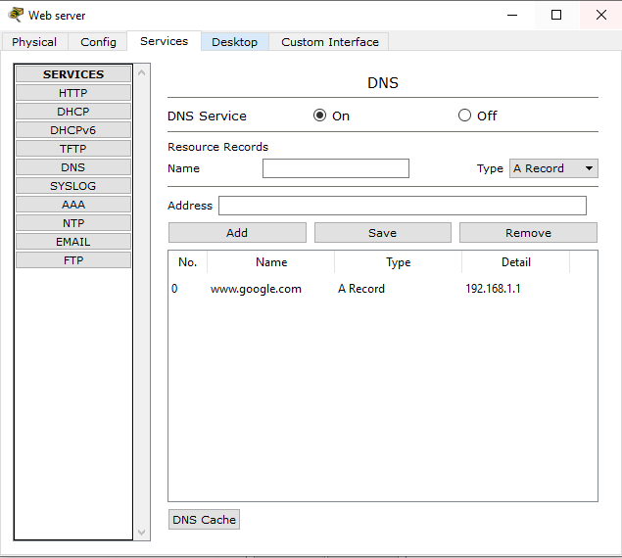

Then same in web server select the option as services in this click on HTTP option then check whether the HTTP & HTTPS are ON mode then select on index.html file to edit the web application.

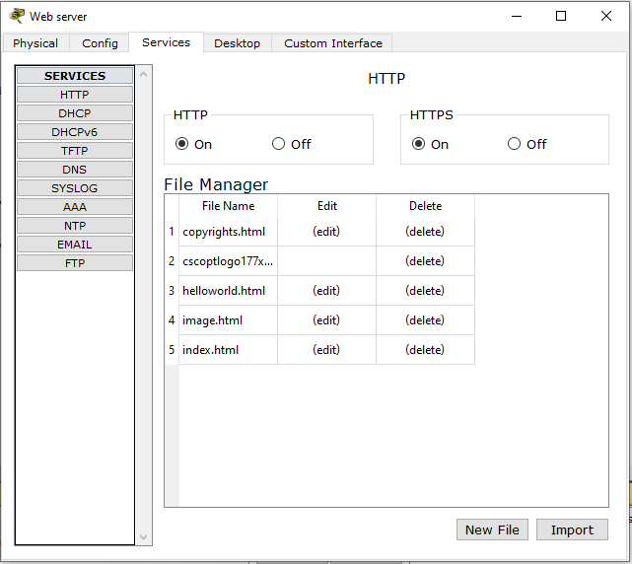

Default code for that web application.

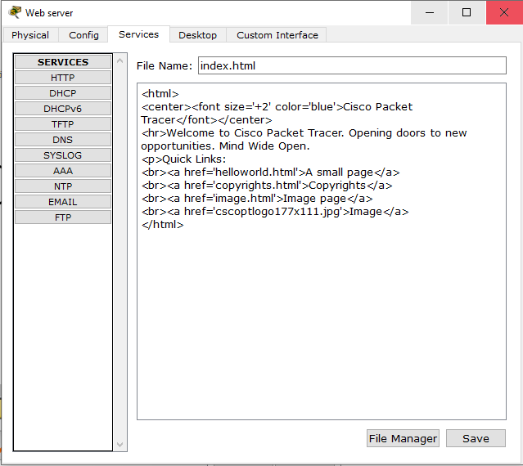

Now whatever the editing we need we can edit the html page here itself.

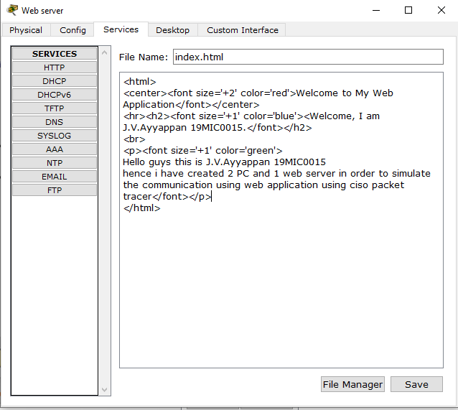

After editing of our web application is over click on save option.

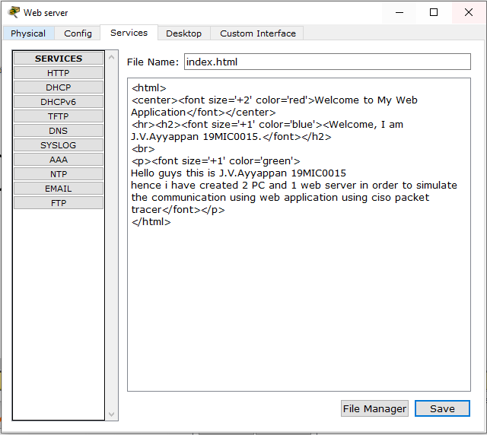

Now select on desktop option for IP configuration on web server.

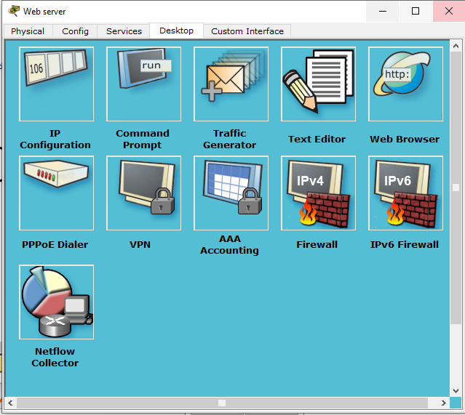

Here enter the IP configuration for web server IP as 192.168.1.1, subnet default, default gateway as 192.168.1.254 & DNS as 192.168.1.1.

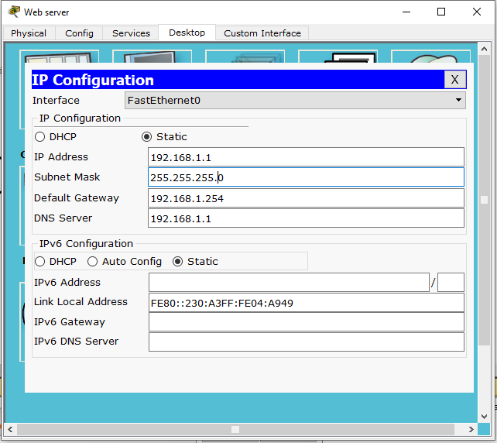

After then close the web server now click on client1 and select the config option enter the gateway address as 192.168.1.254 & DNS as 192.168.1.1

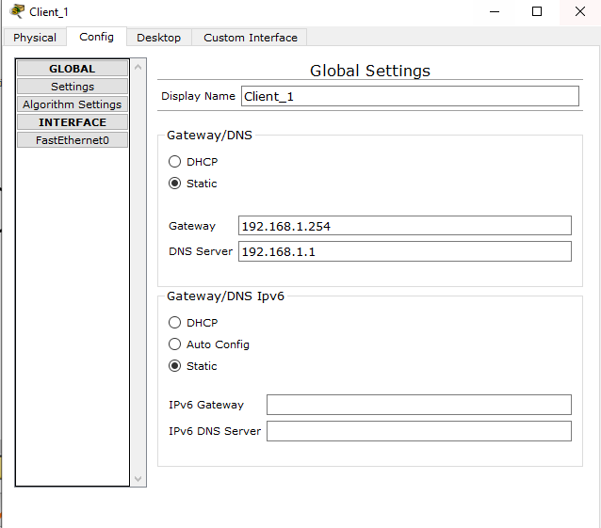

Then select the option as desktop as in client1 and click on IP configuration.

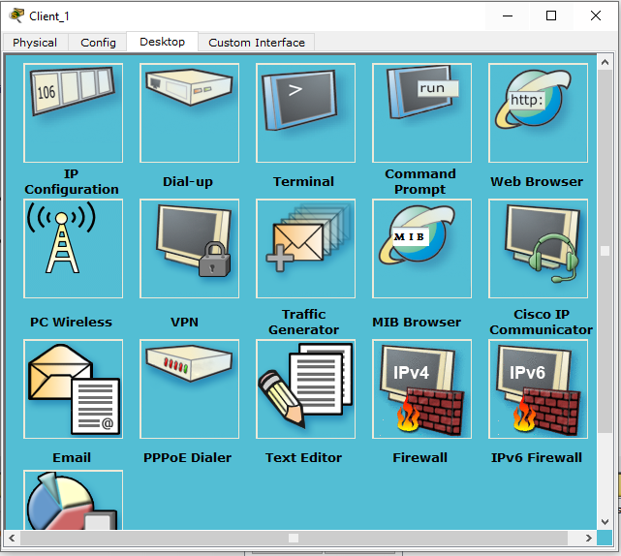

Here the IP configuration for client1. Give IP 192.168.1.2 , default subnet, gateway as 192.168.1.254 & DNS as 192.168.1.1.

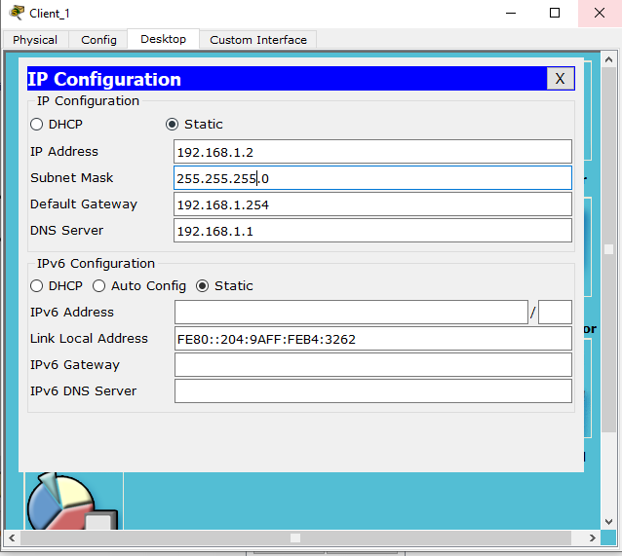

Now go to client 2 config and do the configuration for client2 side.Give DNS as 192.168.1.1.

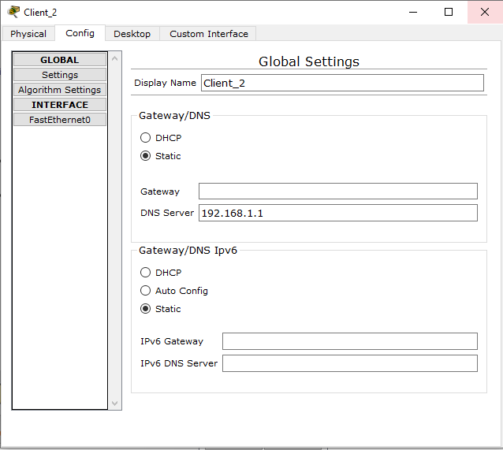

Now select the option as desktop and click on IP configuration in client2.

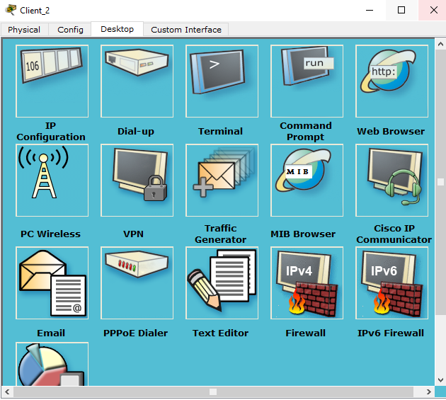

Here we have IP configuration for client2 as IP as 192.168.1.3, subnet as default and DNS as 192.168.1.1

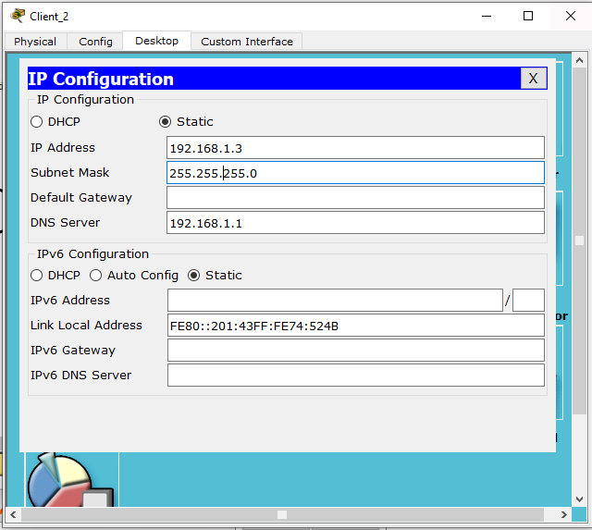

Now go to client 1 select the desktop option and click on command prompt to check whether the package is transferring from client to webserver.

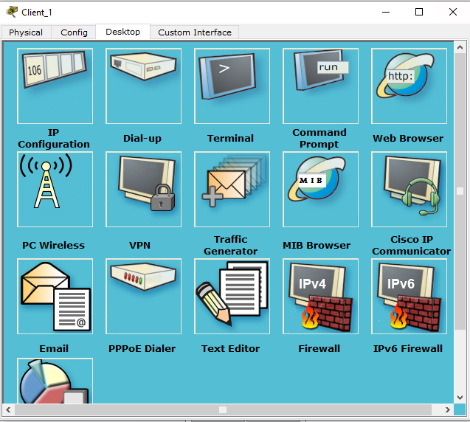

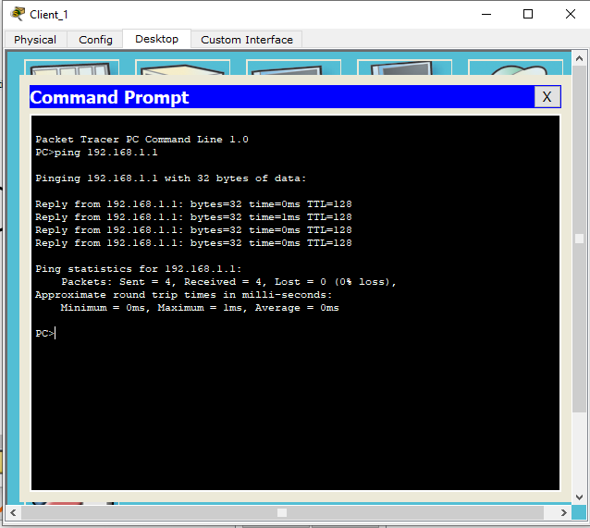

Now we can execute our web application go to client1 and select the desktop option click on web browser.

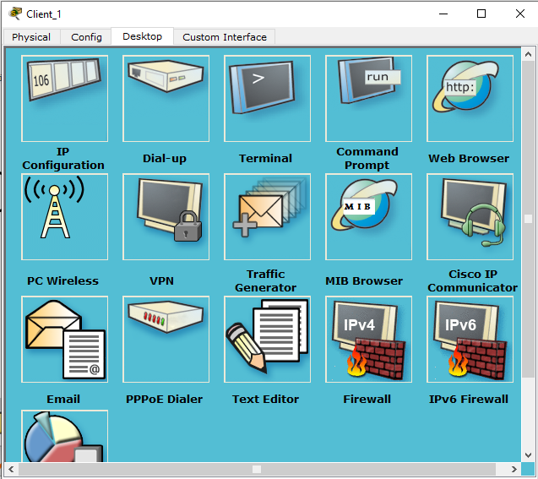

Here type the URL as [www.google.com](http://www.google.com) and click as go

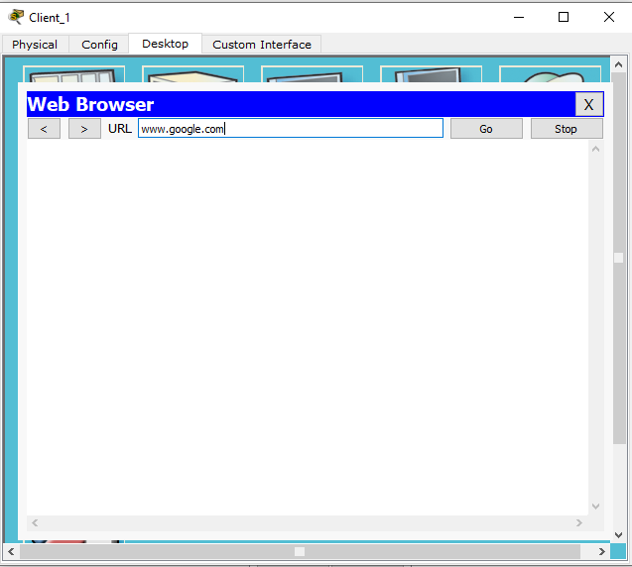

Here comes our edited web application.

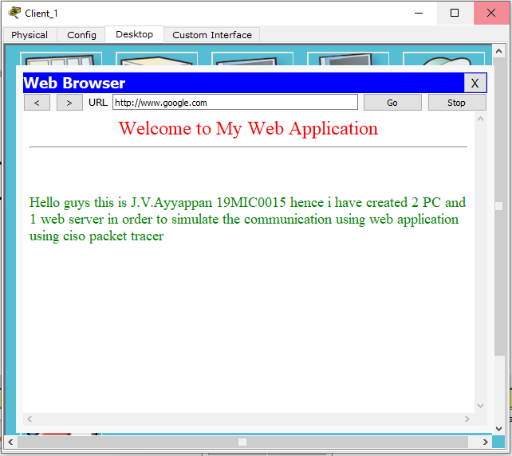

Here again I have edited the web page with some changes. Go to web browser and services click on HTTP select the index.html edit it.

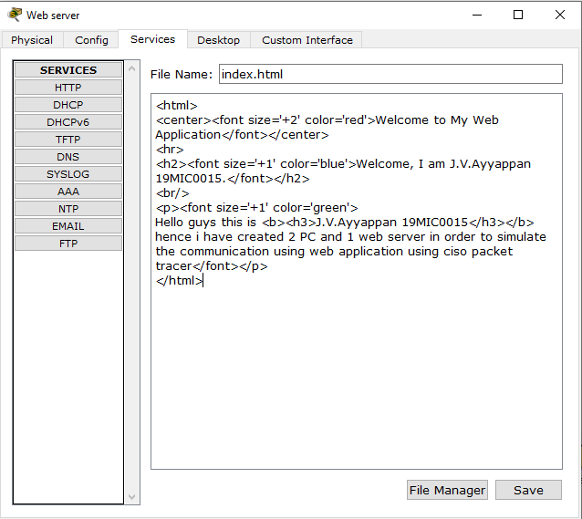

So again go to client 1 -> desktop and select the web browser and type as [www.google.com](http://www.google.com) and click go

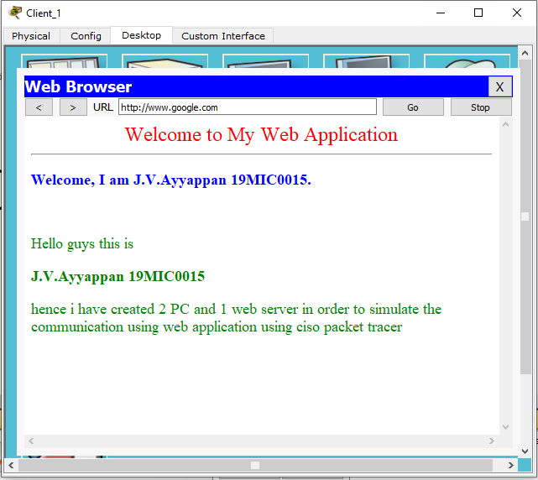

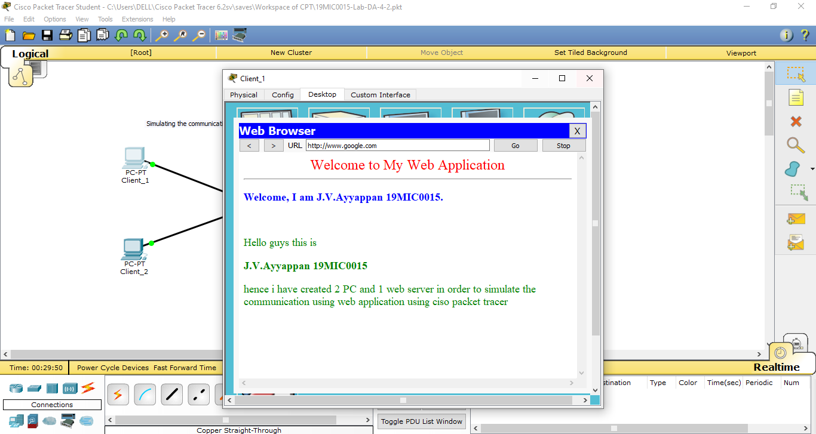

Topology :

