1.Create a maven project and deploy in Jenkins.

Plugin manager -> install maven integration.

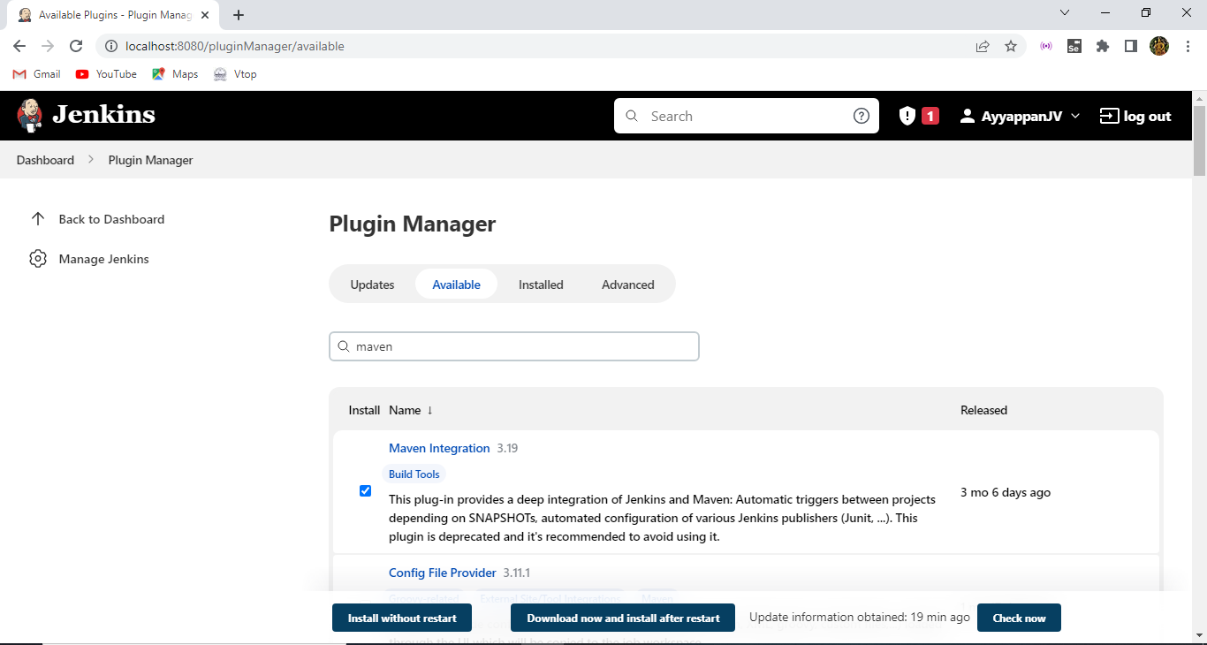

Click create a job option to create the Jenkins workspace.

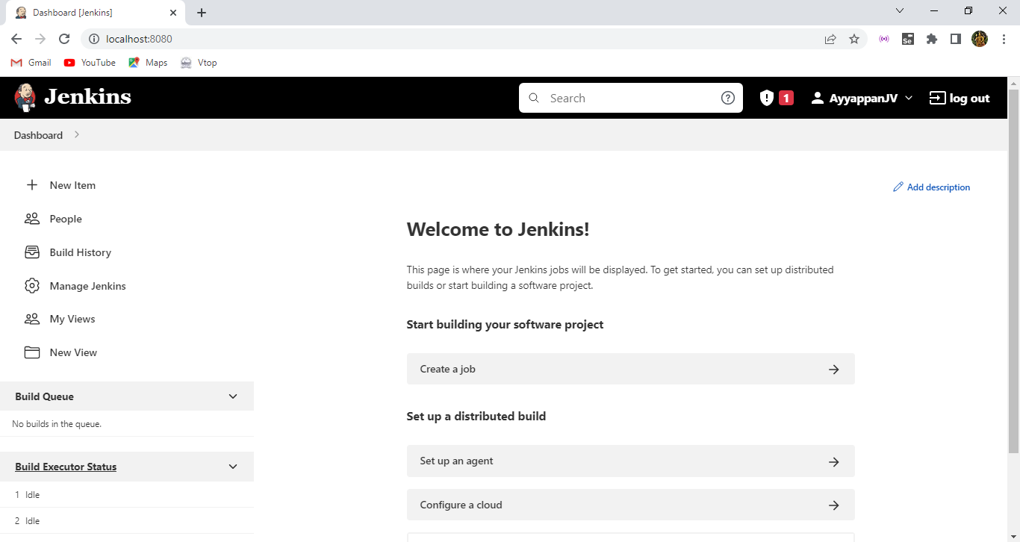

Here before creating the workspace we need to configure our JDK, maven into the global tool configuration. Because we need to access java project on maven using Jenkins.

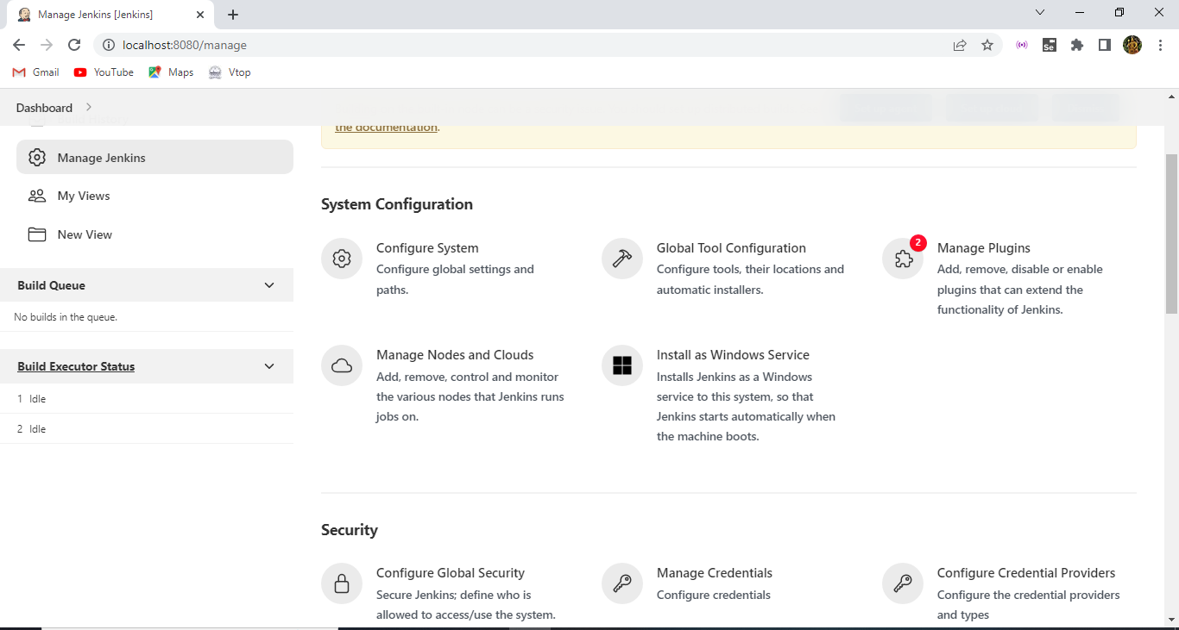

After configuring type some name for your job and select the maven project and then click OK.

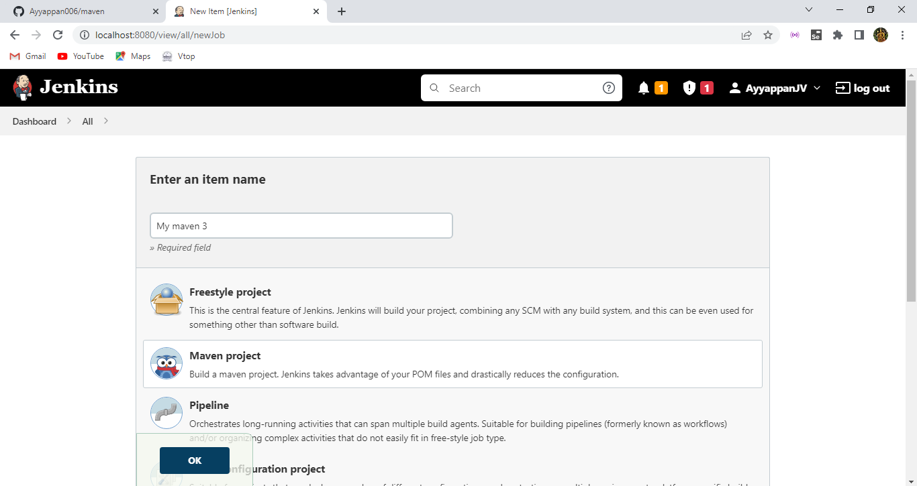

Here in description add some lines and click on github project copy paste the url of your project.

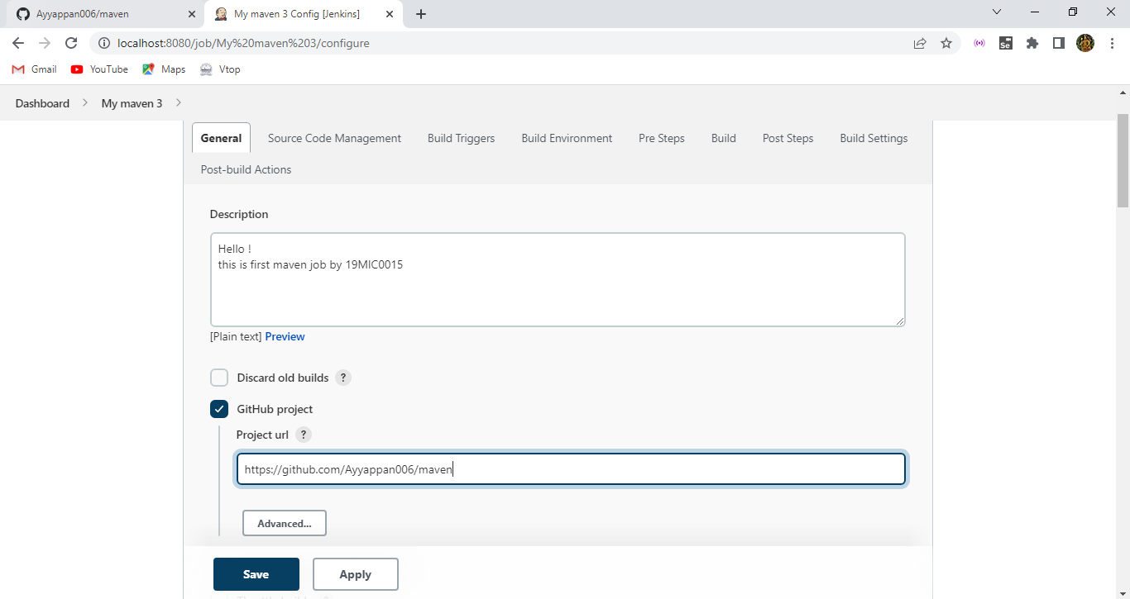

Then copy paste your github repository link into git.

Here add some credentials like username password id and description for provider to Jenkins and select those credintials.

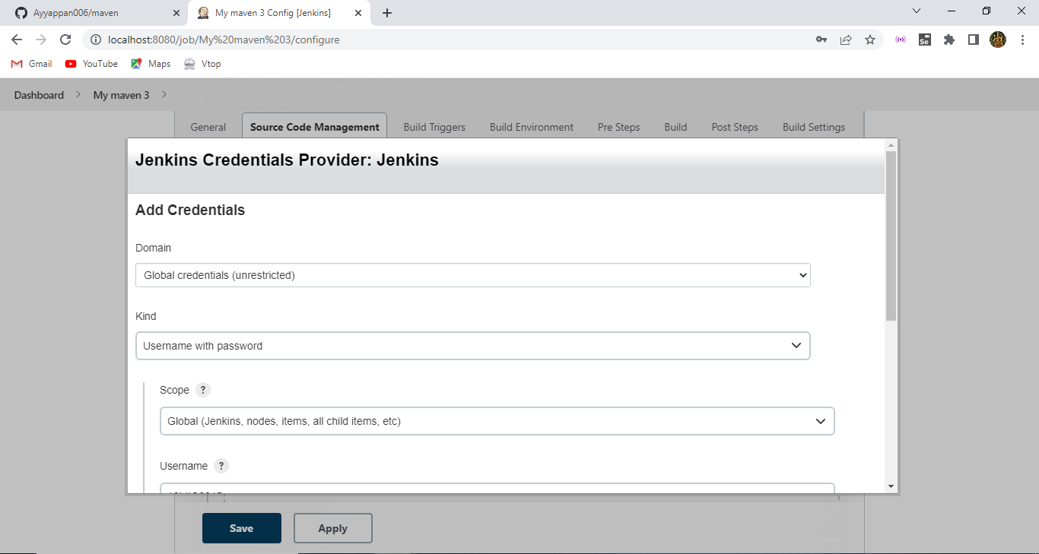

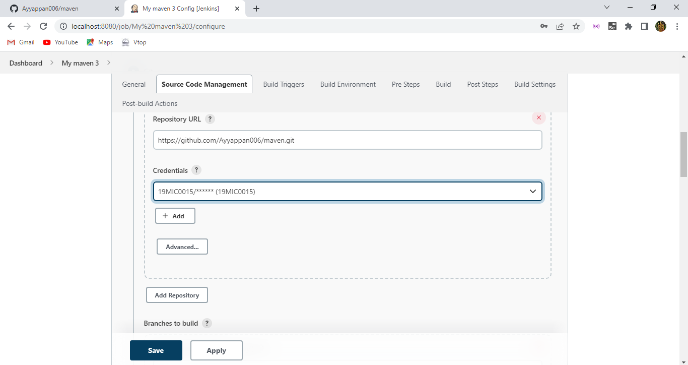

After then type as main because we are using github so the main function will point out to respective code segment to open it.

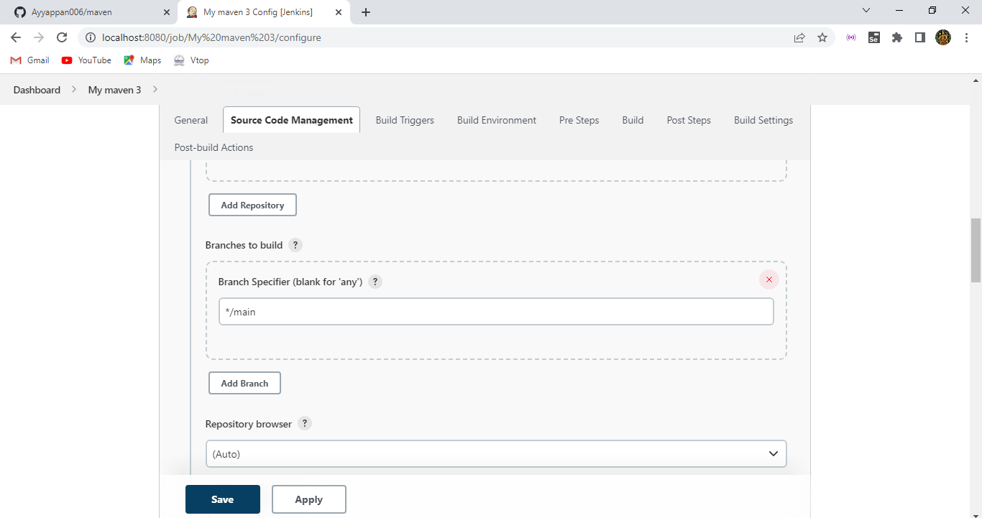

Select those options.

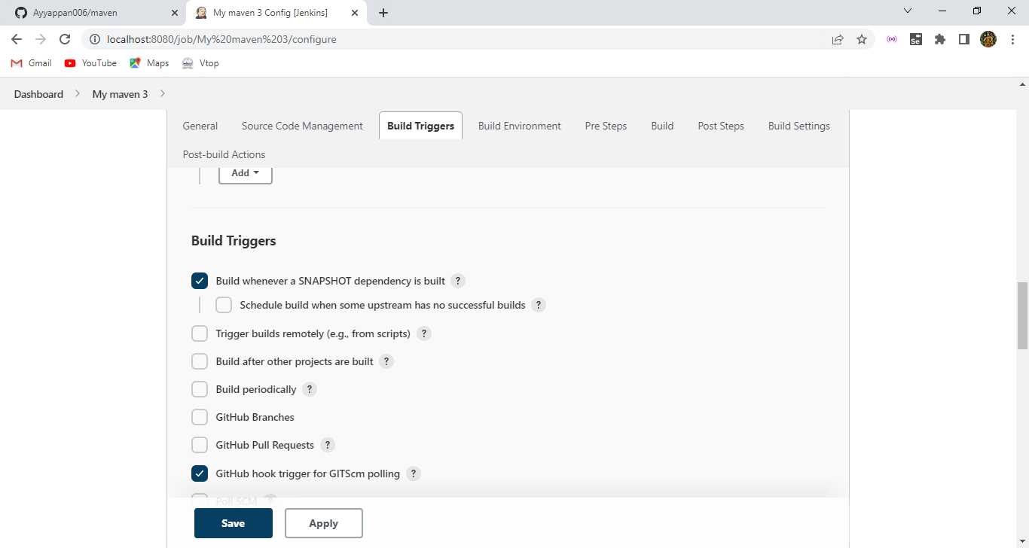

Here also select those options respectively.

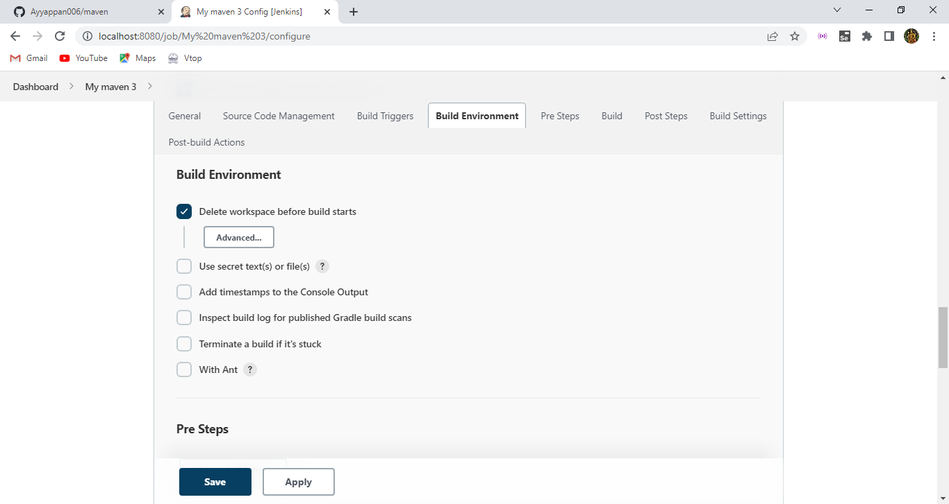

Here type as clean package and give save option.

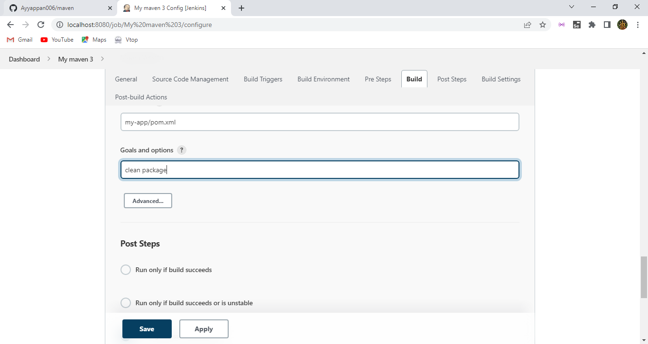

Here this is the maven project we have created in Jenkins now we need to deploy in it.

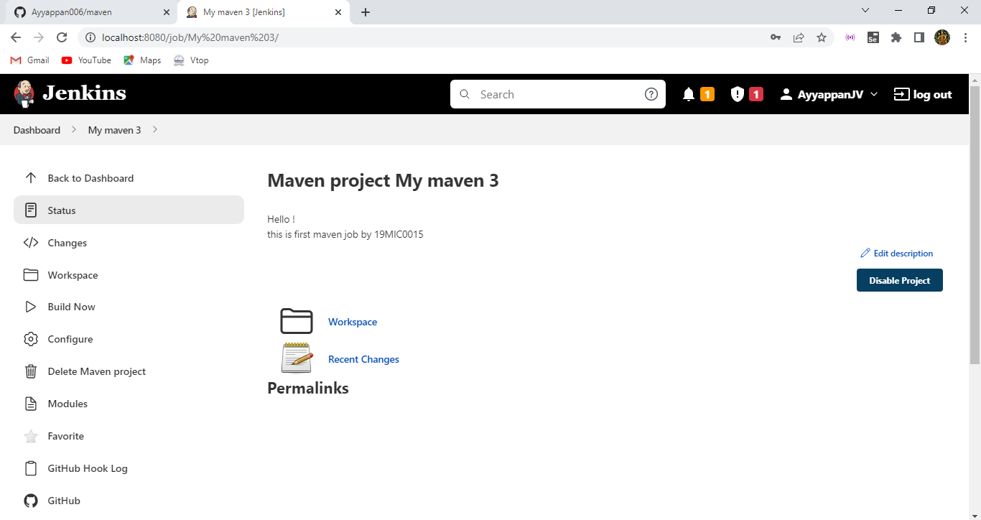

To deploy click on build now option it will take you to build the website in the Jenkins and our results will be shown in build history.

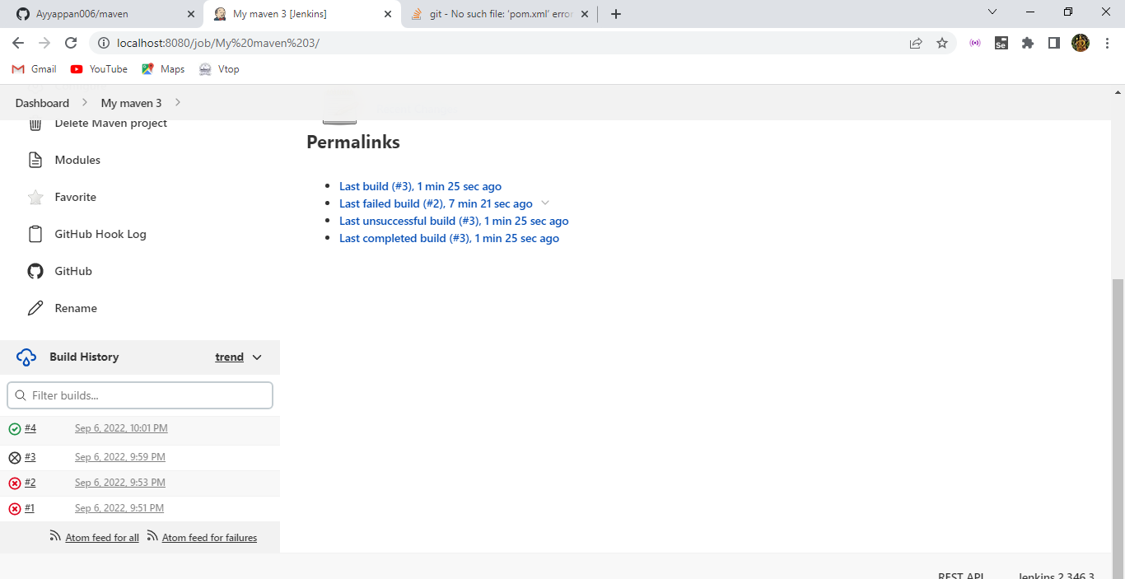

Here the output of the console of our project.

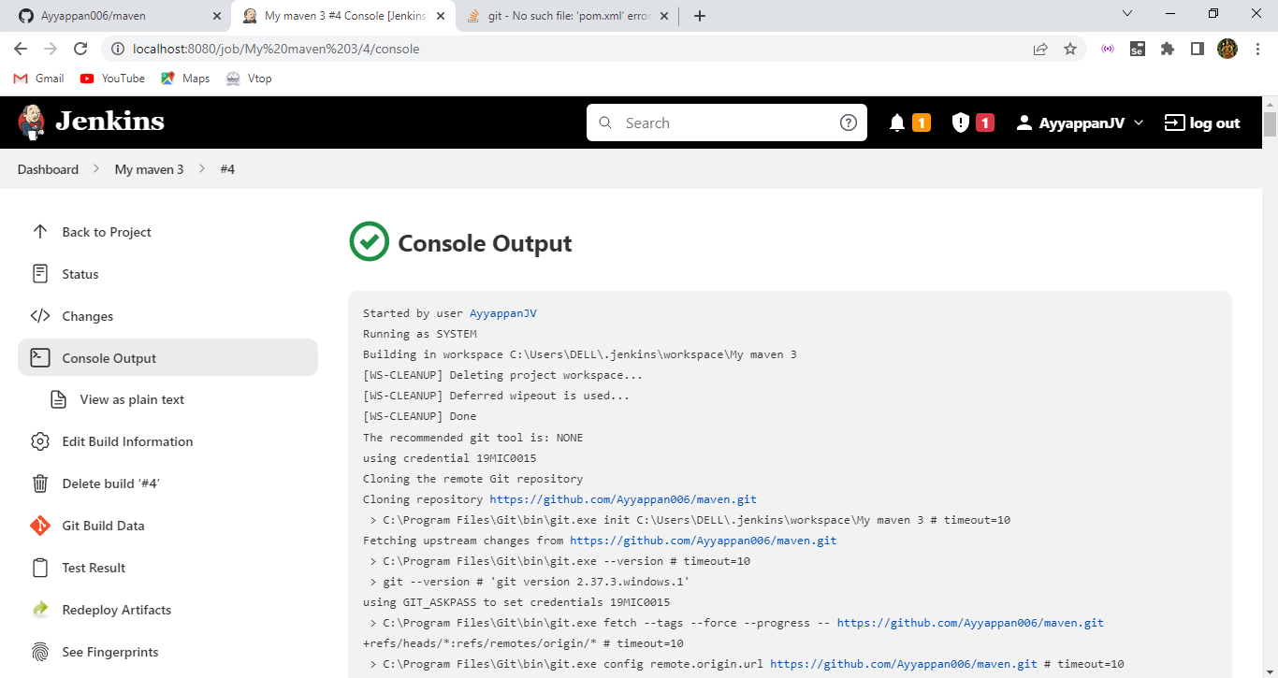

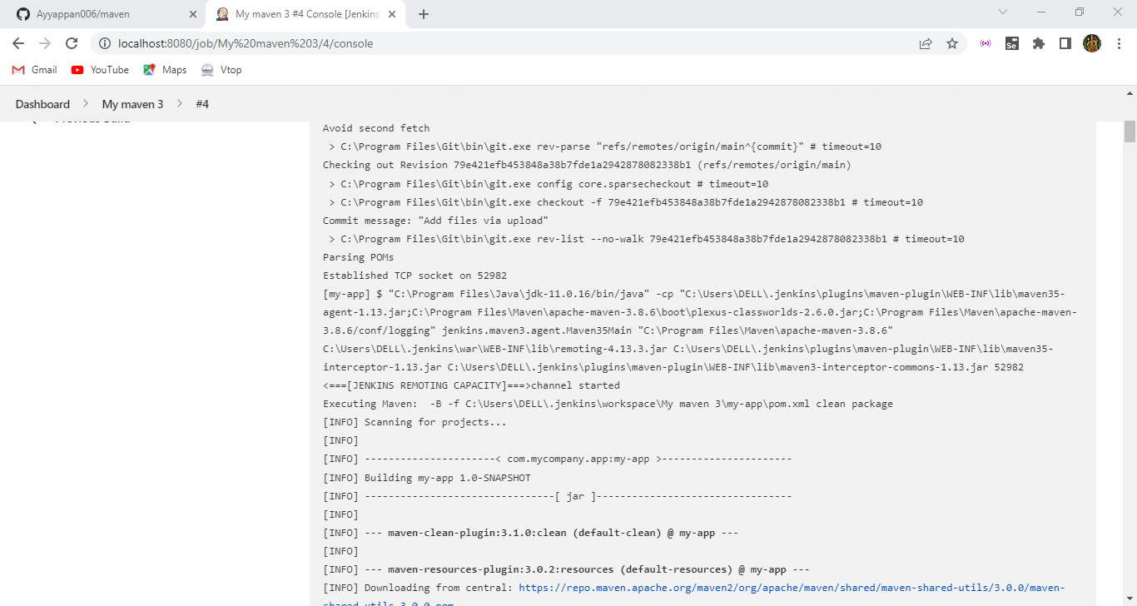

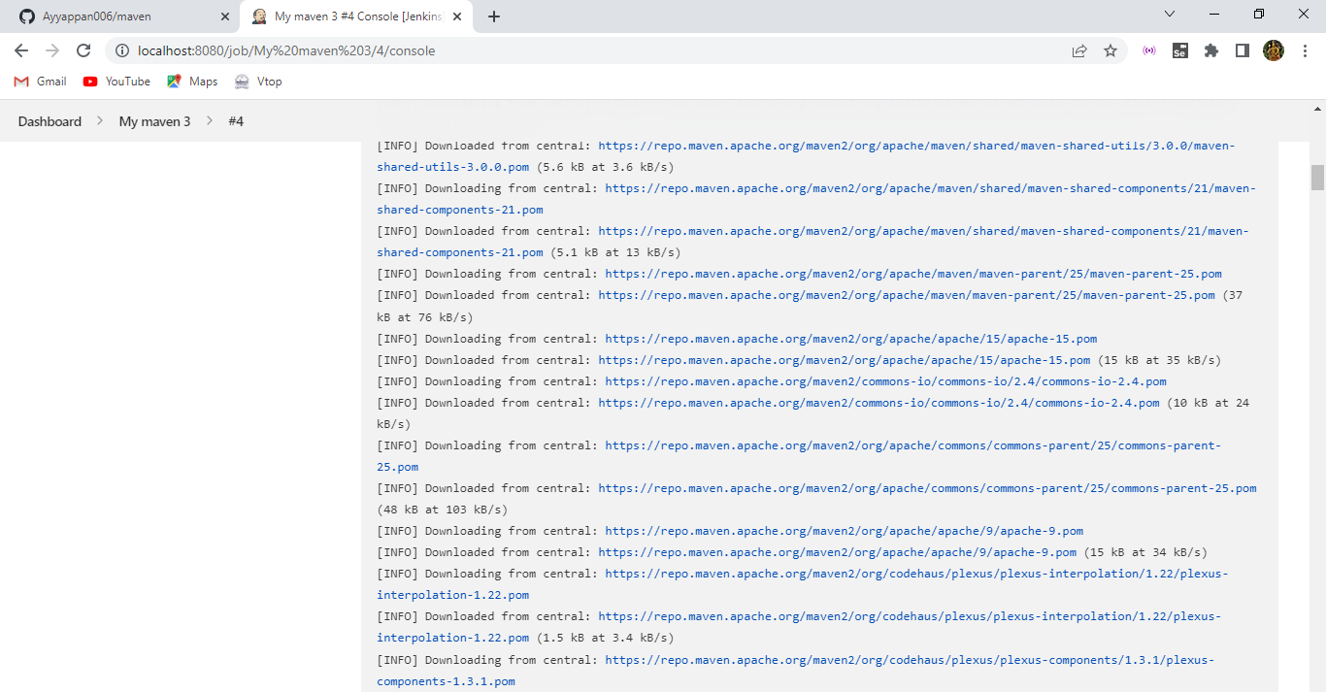

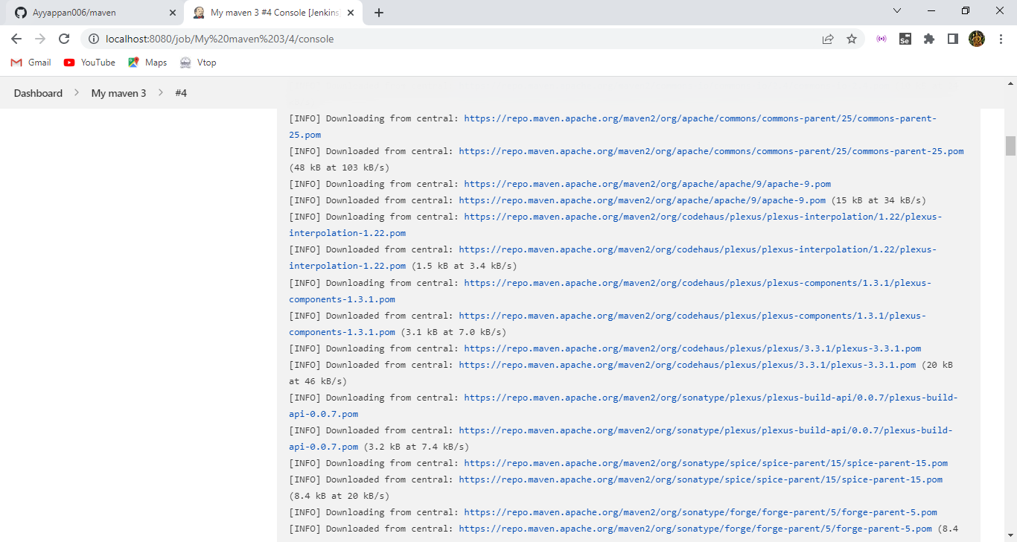

Here the test cases of our project.

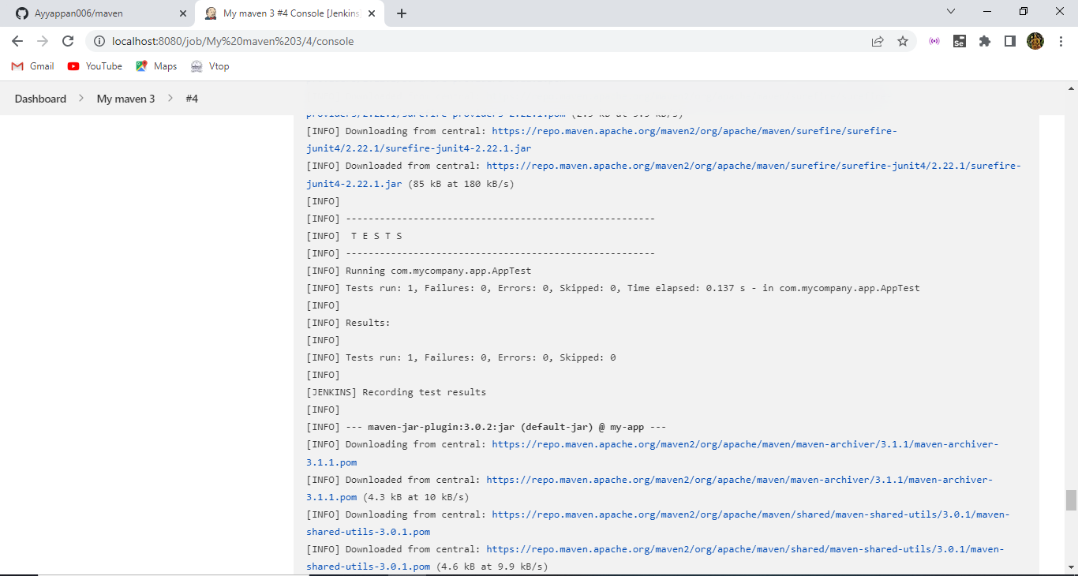

Here the build successfully configuration message , so hence we have deployed the maven project / job within the Jenkins.

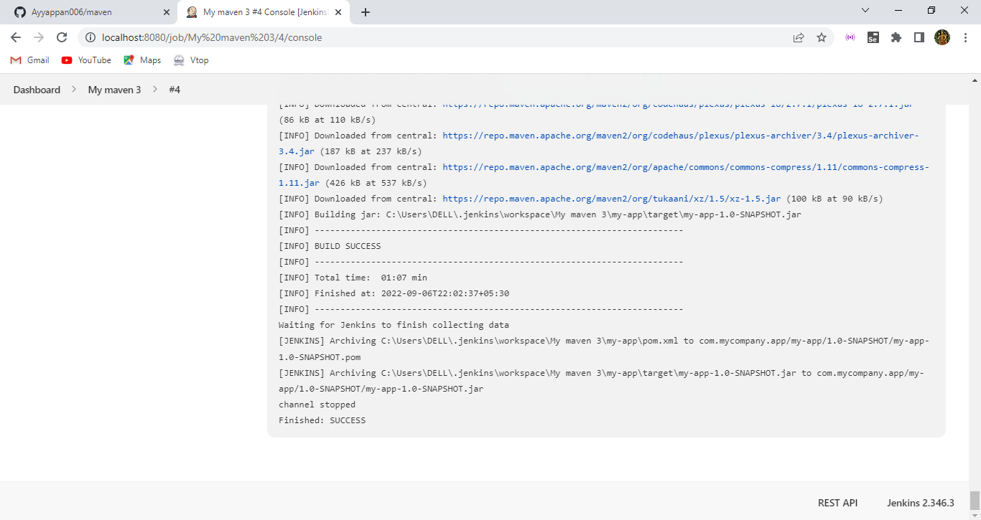

Here the pass tets cases available here.

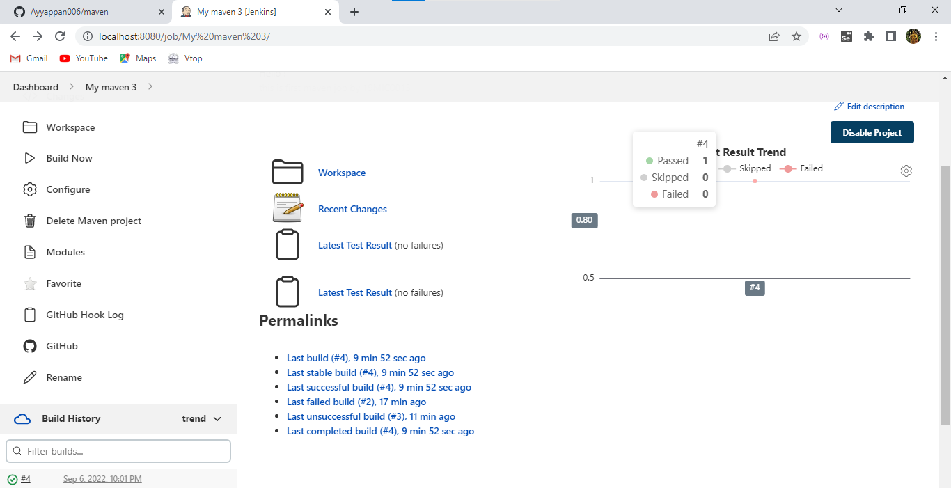

Here the build cases and repository are available.

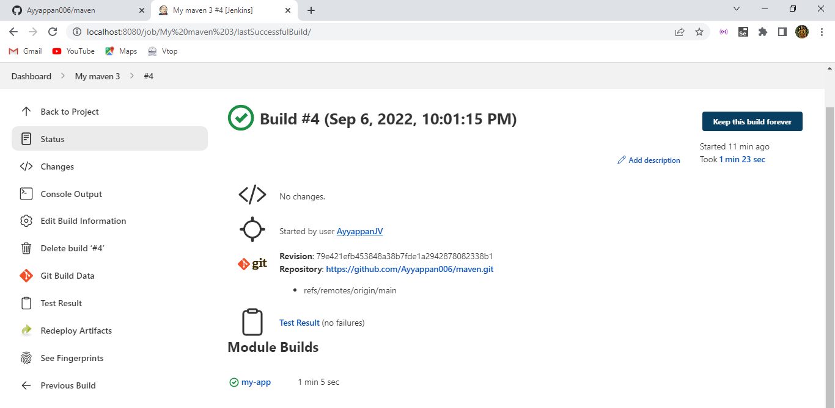

After then here we can see the deployed workspace from our Jenkins successfully.

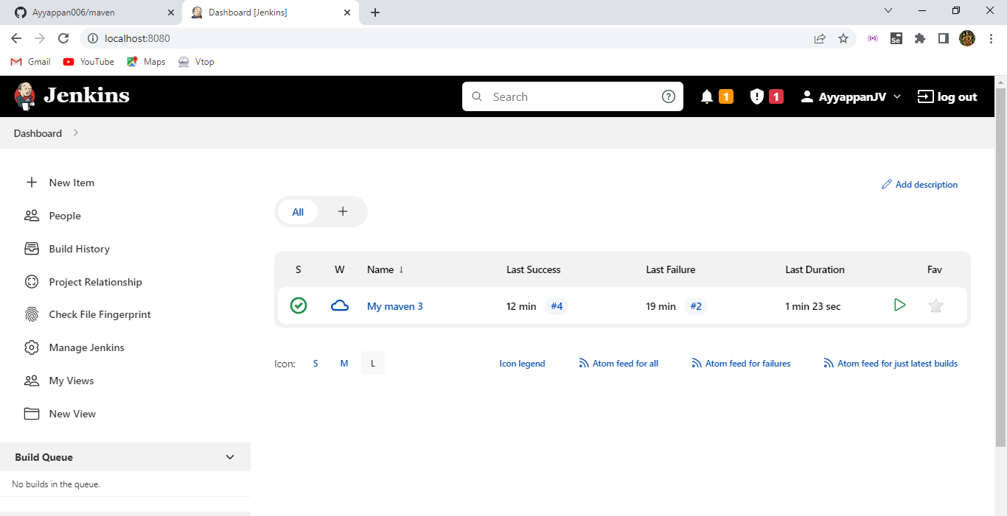

Here the github page is used for deploying the project in Jenkins.

