**Invoice API Service**

Solution Description

* This solution uses Spring Boot framework to expose the invoice services
* The services exposed
  + POST requests – to create invoices
  + GET requests – to query/get invoices using criteria
* The file structure

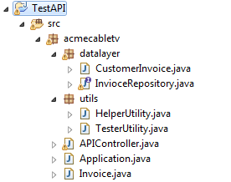

* Reason for using Spring Boot: For the sake of simplicity and faster development I have chosen Spring Boot framework.
  + Spring uses the Jackson JSON library to automatically marshal instances of type invoices into JSON.
  + Spring Data JPA to automatically creates an implementation of InvoiceRepository when the application is run.
  + Also this web application is 100% pure Java without any XML configuration.
* Application.java is the trigger which contains the main method.
* I have also added a test method in this file
* APIController.java is the request mapper. The HTTP requests GET and POST are mapped to different methods based on the type and request parameters.
* These methods in turn invoke the database interface methods.
* A sequence diagram can be found below

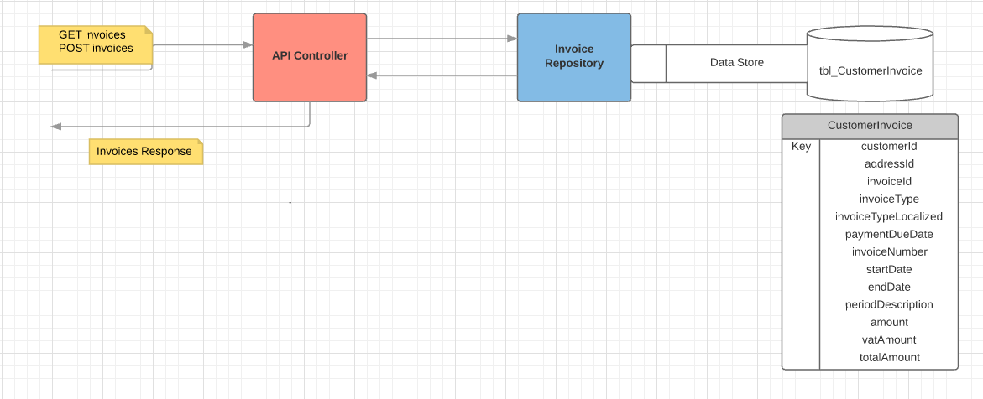

**Note**: Please refer the folder lib_ref that contains all dependencies.