RESEARCH AND PLANNING FOR
E-GOVERNANCE DATA INITIATIVES
A Data Analysis Strategy for Innovative Decision-Making in the Public Sector
Week 1 Task — Research and Planning
Data Analysis Internship / Assignment Submission
Date: September 16, 2026
Companion GitHub repository: see Section 9 for the README / repository description

Table of Contents
1. Executive Summary
2. Introduction and Task Objective
3. Research Methodology
4. Literature Review: Global and National Trends in E-Governance Data
4.1 Global Trends — UN E-Government Survey 2024
4.2 Digital Public Infrastructure (DPI) as a Global Paradigm
4.3 India-Specific Context
4.4 The Rise of AI and Predictive Analytics in Government
5. Key Challenges and Gaps Identified
6. Proposed Data Analysis Plan
6.1 Objectives
6.2 Data Sources and Collection Methods
6.3 Key Metrics and Indicators
6.4 Analytical Techniques
6.5 Governance Architecture (Conceptual Diagram)
7. Implementation Timeline
8. Risk Assessment and Mitigation
9. Deliverables Summary and GitHub Repository Description
10. Conclusion
11. References

1. Executive Summary
Governments worldwide are undergoing a fundamental shift from paper-based administration to data-driven, citizen-centric digital service delivery. This report synthesizes current research on e-governance and Digital Public Infrastructure (DPI), identifies the principal gaps that limit the effectiveness of public-sector data use, and proposes a structured data analysis plan that a government department, digital-governance unit, or civic-technology team could adopt to convert raw administrative and citizen-interaction data into actionable policy insight.
Global evidence — most notably the United Nations E-Government Survey 2024 and the OECD Digital Government Outlook 2026 — shows that while the foundational layers of e-governance (portals, digital identity, online services) have matured rapidly, the analytical layer that turns collected data into decisions remains underdeveloped. Countries have built the pipes for data collection but have not yet built the engines that turn that data into foresight. This is precisely the gap the proposed plan addresses.
The proposed strategy is organized around a five-layer analytics architecture (data sources → integration and governance → analytics engine → insight delivery → stakeholder outcomes), a set of ten priority Key Performance Indicators (KPIs), four categories of analytical technique (descriptive, diagnostic, predictive, and prescriptive), and an eight-month phased implementation roadmap. The plan is designed to be technology-agnostic and applicable at the national, state, or municipal level, with explicit attention to data privacy, interoperability, and inclusion — the three risk areas that recur most frequently across the literature reviewed.

2. Introduction and Task Objective
This task forms Week 1 of a broader assignment on data analysis in the field of E-Governance and Digital Services. The objective is twofold: first, to research current trends, policies, and challenges in the domain of government digital transformation using publicly available governmental reports, academic journals, and reputable online sources; and second, to translate that research into a concrete, implementable data analysis plan capable of supporting innovative, evidence-based decision-making in the public sector.
E-governance is understood here in the broad sense used by the United Nations and OECD: the use of information and communication technologies (ICT) by government institutions to improve the efficiency, transparency, accessibility, and accountability of public administration and service delivery to citizens, businesses, and other government agencies. Within this broad field, this report focuses specifically on the data and analytics dimension — how governments collect, integrate, govern, and analyze data to identify service gaps, forecast demand, detect risk, and measure the impact of policy interventions.

3. Research Methodology
The research underlying this report was conducted through a structured desk-review of publicly available materials, following four steps aligned with the task's key-steps guidance:
- Literature scan: Review of flagship international reports (UN E-Government Survey 2024, OECD Digital Government Outlook 2026, World Bank and IDB publications on Digital Public Infrastructure), peer-reviewed and policy journal articles (e.g., Economic and Political Weekly, academic DPI governance literature), and industry analyses of AI and predictive analytics adoption in government.
- Thematic coding: Findings were grouped into recurring themes — infrastructure maturity, data governance and interoperability, privacy and trust, analytics capability, and inclusion/equity — to identify convergent conclusions across sources.
- Gap analysis: Cross-referencing global best practice against commonly reported implementation challenges to isolate the specific gaps a data analysis plan should target.
- Strategy synthesis: Translating the identified gaps into a concrete, phased data analysis plan with defined objectives, data sources, metrics, analytical techniques, a governance architecture, and a timeline.
This is a secondary-research and planning exercise; no primary data collection or proprietary government datasets were accessed. All figures cited from external sources are attributed in Section 11 (References).

4. Literature Review: Global and National Trends in E-Governance Data

4.1 Global Trends — UN E-Government Survey 2024
The United Nations E-Government Survey 2024, the thirteenth edition of the biennial assessment covering all 193 Member States, reports a significant upward trend in digital government development worldwide, driven by increased investment in resilient infrastructure and emerging technologies. The share of the world's population living in countries with low E-Government Development Index (EGDI) scores fell sharply, from 45.0 percent in 2022 to 22.4 percent in 2024, while the global average EGDI value rose from 0.6102 to 0.6382 over the same period.
The Survey identifies several converging global megatrends: the rapid digitalization of public services, the growth of remote and hybrid public-service delivery, the integration of artificial intelligence into government operations, a sharpened emphasis on digital identity and data management, and the increasing use of data and emerging technologies directly in policymaking. Asia was highlighted as the fastest-improving region (a 7.7 percent rise in average EGDI), while Europe retained the highest regional average. Despite this progress, the Survey cautions that EGDI averages for Africa, Least Developed Countries, and Small Island Developing States remain below the global average, and that a persistent gap exists between national e-government performance and local (city-level) performance as measured by the Local Online Services Index (LOSI).
A particularly relevant finding for this report is the Survey's introduction of a Digital Government Model Framework intended to help countries plan, execute, and assess digital government initiatives in a structured way — an explicit acknowledgment that many governments now need less "digitization" and more strategic frameworks for managing the data and services they have already digitized.

4.2 Digital Public Infrastructure (DPI) as a Global Paradigm
Digital Public Infrastructure — shared, secure, and interoperable digital systems such as digital identity, real-time payments, and data-exchange platforms that underpin the delivery of public and private services — has emerged as the dominant organizing paradigm for e-governance since 2023. The OECD's Digital Government Outlook 2026 finds that while national strategies and data-governance frameworks are now common, governments continue to lag in data-quality management, data reuse at scale, interoperability across agencies and borders, and the measurement of real-world impact. The Outlook frames the present period as a shift "from foundations to transformational impact": most countries have built the basic digital rails, but few have converted that infrastructure into measurable gains in service quality or policy effectiveness.
Multilateral development banks echo this diagnosis. The Inter-American Development Bank notes that because DPI is inherently cross-cutting, it strains government structures that were designed around siloed institutions, producing duplication of effort, unclear authority, weak incentives to share data, and fragmented decision-making. Analyses of DPI governance further emphasize that inclusion and rights protection cannot be assumed as automatic by-products of scale; without a governance-first approach, DPI systems can be exclusionary, as seen in real-world cases of authentication failure, market concentration among private intermediaries, and unresolved privacy concerns.

4.3 India-Specific Context
India offers one of the most extensively documented DPI ecosystems globally, anchored in the "JAM trinity" of Jan Dhan bank accounts, Aadhaar digital identity, and mobile connectivity. As of 2026, India's digital economy is estimated to contribute roughly 12–14 percent of GDP, with projections toward 20 percent within a decade, and the country is now ranked as the world's fifth-largest digitalized economy. Flagship platforms illustrate the range of DPI components relevant to a data analysis strategy: the Public Financial Management System (PFMS) enables end-to-end monitoring of government funds and has been used to detect and remove duplicate or fraudulent welfare beneficiaries; the Unified Payments Interface (UPI) processes billions of transactions monthly and now accounts for a large share of global real-time payments; DigiLocker provides a secure digital document repository; and the Open Network for Digital Commerce (ONDC) applies interoperability principles to digital commerce.
At the same time, commentary in outlets such as the Economic and Political Weekly cautions that India's DPI architecture demonstrates how large-scale digital systems can still be exclusionary in practice — citing authentication failures, market concentration effects, and unresolved privacy questions — and argues that DPI outcomes ultimately depend on legal safeguards, grievance redressal capacity, and citizen accountability mechanisms rather than technology scale alone. Persistent challenges specific to the Indian context include language and accessibility barriers on digital platforms, a continuing citizen trust deficit linked to data-misuse and fraud concerns, and slow grievance-redressal mechanisms that undermine confidence in digital systems.

4.4 The Rise of AI and Predictive Analytics in Government
Across jurisdictions, predictive and prescriptive analytics are increasingly positioned as the next frontier of e-governance, moving public administration from reactive, retrospective reporting toward proactive, forward-looking decision support. Reported use cases include forecasting demand for social services, detecting fraud in benefit disbursement, optimizing resource allocation for public safety and infrastructure maintenance, and simulating the likely impact of proposed legislation before enactment.
However, the literature is consistent in flagging that technology adoption alone does not guarantee value. Commonly cited barriers include incomplete, outdated, or siloed source data; the absence of pre-implementation baselines against which to measure AI or analytics impact; organizational and cultural resistance to data-driven workflows; and a persistent implementation gap — one widely cited survey finding that only around one-third of public-sector leaders currently use data insights in their daily decision-making. Researchers categorize the barriers to public-sector AI and analytics adoption into social, economic, data-related, organizational, technological, political/legal, and ethical dimensions, underscoring that a successful data analysis plan must address organizational readiness and governance alongside the technical pipeline.

5. Key Challenges and Gaps Identified
Synthesizing the literature reviewed in Section 4, the following recurring gaps define the problem space that the proposed data analysis plan is designed to address:
- Data fragmentation and siloing: Citizen and administrative data are frequently scattered across departments and legacy systems with limited interoperability, preventing a unified view of service delivery or citizen need.
- Weak data quality and standardization: Incomplete, outdated, duplicate, or inconsistently formatted records undermine the reliability of any downstream analysis, especially predictive modelling.
- Underdeveloped analytics capability: Most e-governance investment to date has targeted front-end digitization (portals, apps, online forms) rather than the back-end analytical capability needed to convert collected data into insight.
- Privacy, security, and trust deficits: Citizens' concerns about data misuse, surveillance, and fraud reduce willingness to engage with digital systems and constrain the legal and ethical scope for data reuse.
- Digital and linguistic exclusion: Persistent authentication failures, language barriers, and accessibility gaps mean that data generated through digital channels may under-represent vulnerable or rural populations, biasing analysis if not corrected for.
- Fragmented governance and unclear ownership: Because DPI and data initiatives cut across institutional boundaries, there are frequently unclear mandates for who owns, maintains, and is accountable for shared datasets.
- Absence of baseline metrics: Without pre-defined Key Performance Indicators (KPIs) established before implementation, it is difficult to measure whether a given data or AI initiative actually improved outcomes.
- Weak grievance redressal and feedback loops: Citizen feedback on service failures is often not systematically captured or fed back into the analytics process, limiting continuous improvement.

6. Proposed Data Analysis Plan
The plan below is deliberately structured to respond point-for-point to the gaps identified in Section 5. It is intended to be adaptable to a national ministry, a state department, or a municipal e-governance unit.

6.1 Objectives
- Establish a unified, interoperable view of citizen-facing and administrative data across participating departments to eliminate fragmentation.
- Implement data quality, standardization, and privacy-by-design protocols consistent with applicable data-protection law (e.g., India's Digital Personal Data Protection (DPDP) Act, 2023) before any analytical work begins.
- Deploy a tiered analytics capability — descriptive, diagnostic, predictive, and prescriptive — to move decision-making from retrospective reporting to proactive planning.
- Identify service-delivery gaps and underserved populations (geographic, linguistic, or demographic) using disaggregated data analysis.
- Forecast demand for key public services (welfare disbursement, healthcare, utilities, grievance volumes) to support proactive resource allocation.
- Build transparent, citizen-facing open-data dashboards to strengthen public trust and enable civil-society oversight.
- Create a continuous feedback loop between citizen grievance data, monitoring dashboards, and policy revision (see Figure 1).
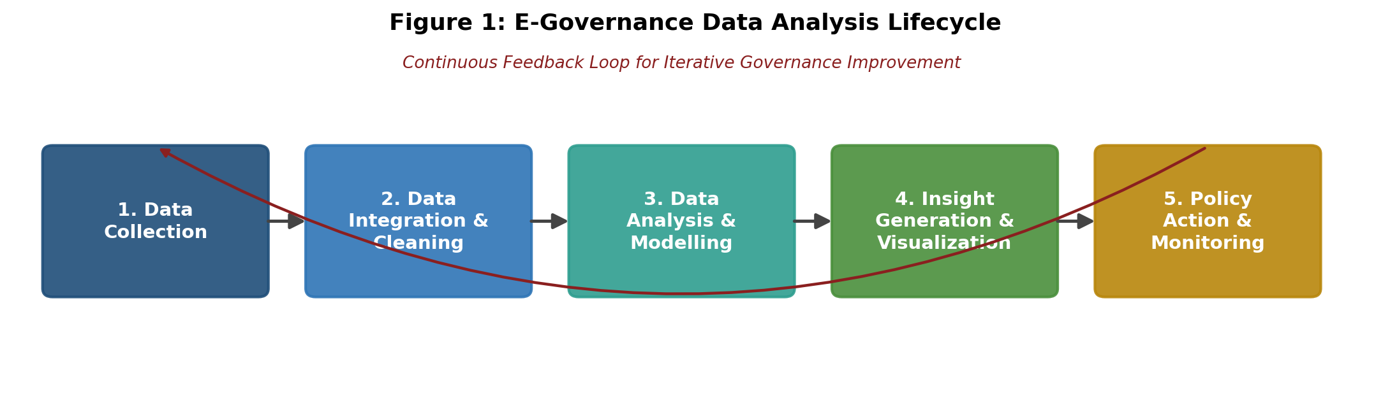
Figure 1: The five-stage E-Governance Data Analysis Lifecycle, closed by a continuous feedback loop from policy action back to data collection.

6.2 Data Sources and Collection Methods
Data Source | Examples | Collection Method
Citizen service portals & mobile apps | Service applications, transaction logs, session analytics | API integration, web/app analytics tools, log aggregation
Administrative & registry records | Aadhaar-linked welfare records, land records, tax filings, PFMS fund-flow data | Secure government data-exchange APIs / interoperable registries
Grievance & feedback systems | Helpline logs, CPGRAMS-type grievance portals, satisfaction surveys | Structured form capture, call-center CRM export, periodic surveys
Geospatial & IoT data | Infrastructure sensors, utility meters, satellite/GIS layers | IoT telemetry ingestion, GIS data feeds
Open government data portals | Budget data, sector-specific SDG-linked datasets | Bulk download / open API from national/state open-data portals
Social media & public sentiment | Public posts referencing government services (aggregated, anonymized) | Licensed social-listening APIs with strict anonymization
Table 1: Proposed data sources and collection methods.

6.3 Key Metrics and Indicators
Category | Indicator | Purpose
Service Efficiency | Average service completion time | Track processing speed against SLA targets
Service Efficiency | Digital adoption / online-service uptake rate | Measure channel shift from offline to digital
Equity & Inclusion | Service access rate by district / language / income group | Detect and address exclusion patterns
Equity & Inclusion | Authentication / transaction failure rate | Identify friction points affecting vulnerable users
Data Quality | Record completeness & duplication rate | Ensure data reliability for downstream modelling
Trust & Satisfaction | Grievance redressal turnaround time | Monitor responsiveness of feedback mechanisms
Trust & Satisfaction | Citizen satisfaction score (survey-based) | Gauge perceived service quality and trust
Financial Integrity | Leakage / duplicate-beneficiary detection rate | Quantify fraud and error reduction (as with PFMS)
Predictive Performance | Forecast accuracy (e.g., MAPE) for demand models | Validate reliability of predictive analytics outputs
Policy Impact | Pre/post intervention outcome change | Measure real-world effect of data-informed policy action
Table 2: Ten priority KPIs spanning efficiency, equity, quality, trust, integrity, and impact.

6.4 Analytical Techniques

Descriptive Analytics
Dashboards and standardized reporting that summarize current-state service usage, processing times, and demographic reach — the baseline layer every subsequent technique depends on.

Diagnostic Analytics
Root-cause analysis (e.g., correlation and drill-down analysis) to explain why specific districts, services, or population segments show poor performance — for example, isolating whether low service uptake stems from connectivity gaps, language barriers, or awareness deficits.

Predictive Analytics
Statistical and machine-learning forecasting models (e.g., time-series forecasting, classification models) to anticipate service demand, grievance volume spikes, or fraud risk before they materialize, enabling proactive resource planning.

Prescriptive Analytics
Optimization and simulation models that recommend specific resource-allocation or policy actions — for instance, optimal placement of service centers, or simulated impact of a proposed subsidy change prior to rollout.

6.5 Governance Architecture (Conceptual Diagram)
Figure 2 below illustrates how the data sources, governance layer, analytics engine, and stakeholder outputs described above interconnect within a single conceptual architecture.
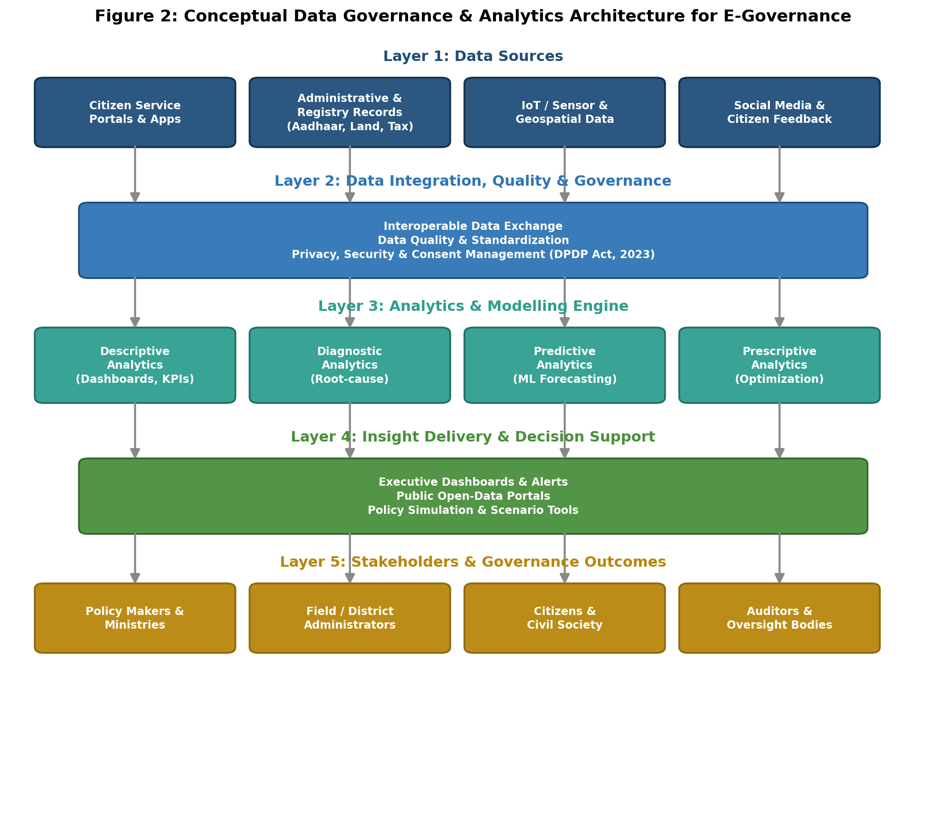
Figure 2: Conceptual five-layer data governance and analytics architecture, from raw data sources through to stakeholder outcomes.

7. Implementation Timeline
The plan is designed for phased delivery over an eight-month horizon, allowing governance and data-quality foundations (Phases 1–3) to be firmly established before analytical modelling (Phases 4–5) and pilot deployment (Phases 6–7) begin. This sequencing directly reflects the literature's repeated finding that analytics initiatives fail when they are layered onto poor-quality, ungoverned data.
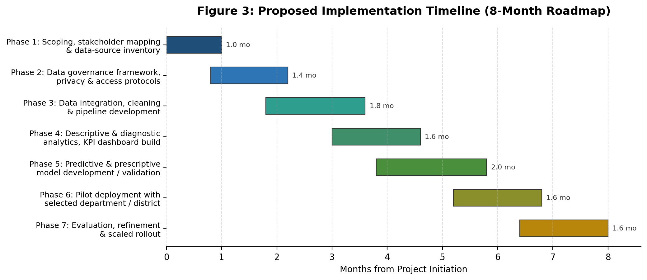
Figure 3: Proposed eight-month, seven-phase implementation roadmap.

8. Risk Assessment and Mitigation
Risk | Likelihood | Mitigation
Data privacy breach or non-compliance | Medium | Privacy-by-design architecture; DPDP Act-aligned consent management; role-based access control
Poor data quality undermining models | High | Dedicated data-quality phase (Phase 3) with validation rules before any modelling begins
Low interoperability between departments | High | Adopt open, standardized APIs and a shared data-exchange layer (Layer 2 of Figure 2)
Exclusion of low-digital-literacy populations | Medium | Disaggregated equity metrics (Table 2); multilingual and assisted-access channels
Stakeholder / organizational resistance | Medium | Early stakeholder mapping (Phase 1); change-management and training track alongside technical rollout
Model drift or forecast inaccuracy over time | Medium | Continuous monitoring of forecast-accuracy KPI; scheduled model retraining
Table 3: Principal implementation risks and corresponding mitigation measures.

9. Deliverables Summary and GitHub Repository Description
In line with the task's expected deliverables, this submission comprises: (1) this detailed research and planning document; (2) the data analysis plan outline embedded in Section 6, covering objectives, data-collection methods, and analytical techniques; and (3) the three conceptual diagrams (Figures 1–3) illustrating the analytics lifecycle, governance architecture, and implementation timeline.
If this project is hosted in a GitHub repository (for example, to share the report, diagram-generation scripts, and any future analysis code with reviewers or collaborators), the following description and README structure are recommended:

Suggested GitHub Repository Name
e-governance-data-analysis-plan

Suggested Short Description (for the repository's "About" field)
Week 1 research and planning deliverable proposing a data analysis strategy — objectives, data sources, KPIs, analytical techniques, and an 8-month roadmap — for evidence-based decision-making in e-governance and digital public services.

Suggested README.md Outline
- Project title and one-line summary
- Objective (mirrors Section 2 of this report)
- Key findings from the literature review (mirrors Section 4)
- The proposed data analysis plan: objectives, data sources, KPIs, analytical techniques (mirrors Section 6)
- Diagrams: embed Figures 1–3 as images in the /diagrams folder
- Implementation roadmap (mirrors Section 7)
- Repository structure: /report (this document), /diagrams (Figures 1–3 and generation scripts), /references
- License and contact / author information
This structure allows the repository to serve as a living companion to the static DOC report — the README gives reviewers an immediate summary, while the full document and diagram source files remain available for detailed review or reuse.

10. Conclusion
The evidence reviewed points to a consistent global pattern: governments have made substantial progress in digitizing service delivery and building the infrastructural foundations of e-governance, but the analytical layer that converts collected data into proactive, evidence-based decisions remains comparatively immature. The proposed data analysis plan directly targets this gap through a phased approach that sequences data governance and quality work ahead of predictive and prescriptive modelling, embeds equity and privacy considerations throughout rather than as an afterthought, and closes the loop between citizen feedback and policy revision. If implemented as outlined, this plan would give a public-sector body the capability not only to report on what has happened, but to anticipate service demand, detect risk early, and measure the real-world impact of its own policy decisions.

11. References
United Nations Department of Economic and Social Affairs (2024). United Nations E-Government Survey 2024: Accelerating Digital Transformation for Sustainable Development. UN DESA / DPIDG.
OECD (2026). Digital Government Outlook 2026: From Foundations to Transformational Impact. OECD Publishing, Paris.
Inter-American Development Bank (2026). Strengthening the Governance of Digital Public Infrastructure and Digital Public Goods.
Economic and Political Weekly (2026). "Digital Public Infrastructure Needs a Governance Reset," Vol. 61, Issue 29.
AfricLaw (2026). "Digital Public Infrastructure Through an Open Government Lens."
NextIAS (2026). "Digital Infrastructure in India: DPI, Initiatives & Challenges," citing the State of India's Digital Economy Report 2026.
IASPOINT (2026). "India's Digital Public Infrastructure Transforming Governance."
Rutgers New Jersey State Policy Lab (2025). "Predictive Algorithms in the Public Sector," citing van Noordt & Misuraca (2020) and Dwivedi et al. (2021).
Elastic (2026). "Understanding AI in Government: Applications, Use Cases, and Implementation."
Snowflake (2026). "Public Sector Industry Predictions for 2026."
StateTech Magazine (2025). "Transforming Public Sector With AI: Opportunities and Challenges."
Strategy.com / MicroStrategy (2026). "Harnessing the Power of Predictive Analytics for Data-Driven Decision-Making in the Public Sector."

