
GoldCare MEDICAL CLINIC – DOCUMENTATION

Outline
This project is a small web application called GoldCare Medical Clinic. It simulates a campus health clinic for Goldsmiths, University of London, where students and staff can register as patients, book appointments and send contact messages. Reception staff can log in to see a list of patients, appointments, messages and an audit log of login attempts. The app is built with Node.js and Express using EJS templates, and it uses a MySQL database called health to store all data. The design is simple with a blue, green and white theme and a shared navbar on every page so navigation is easy. Security is improved with input sanitising, login audit logging and a basic lockout after repeated failed logins. The idea is to be realistic enough for a small clinic, but still easy enough to understand as a student project.
Architecture
The application has a basic two‑tier architecture: a web application tier and a database tier. The application tier runs on Node.js with Express, serving EJS views and static CSS/images. It handles routing, session‑based authentication for receptionists, and validation/sanitising of form inputs. The data tier is a MySQL database called health, accessed via the mysql2 connection pool, with configuration coming from environment variables loaded by dotenv.
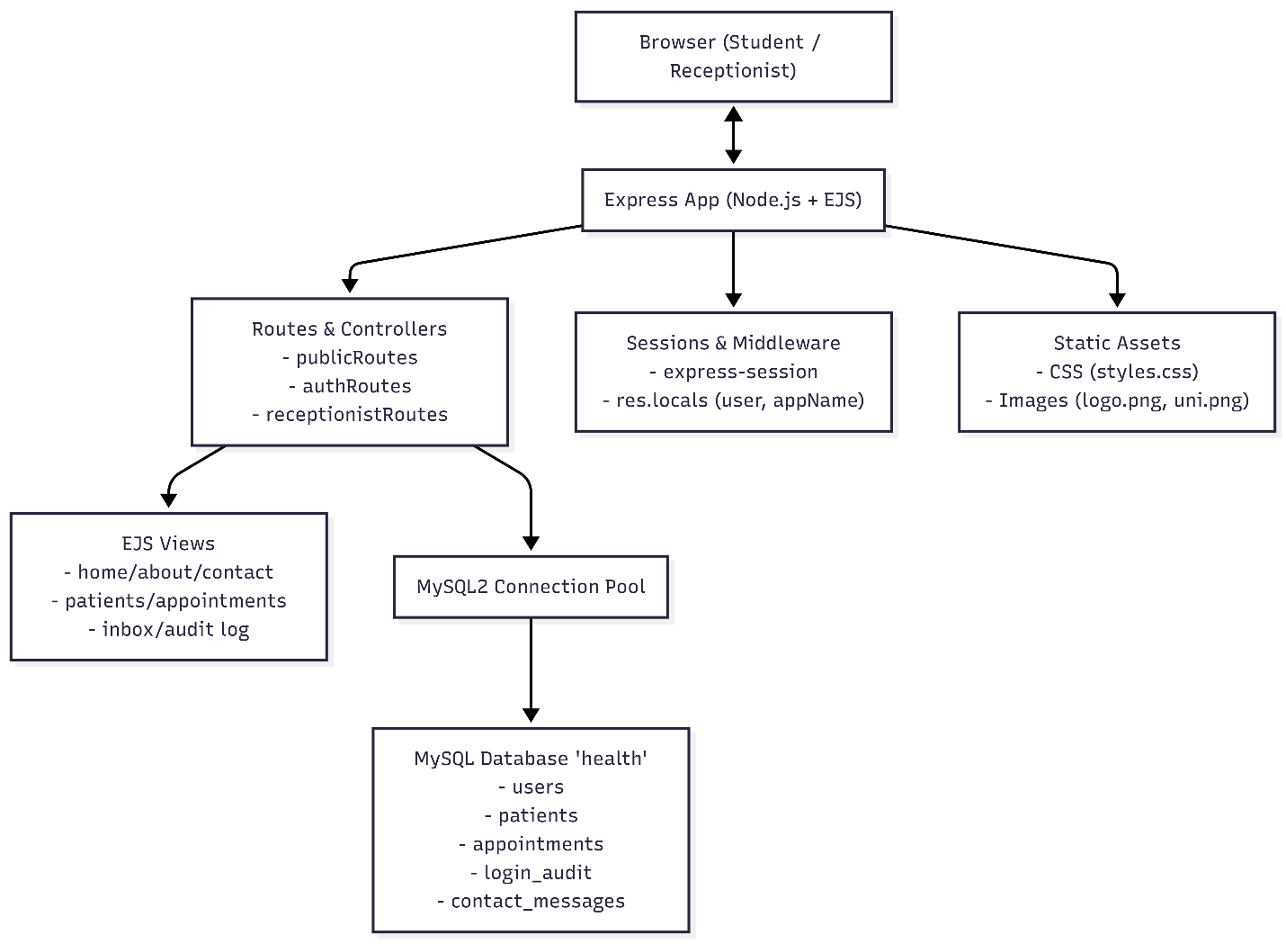
Data Model
The data model is centred around five tables in the health database. users stores receptionist login accounts (id, username, password_hash, role). patients holds registered patient details like name, date of birth, email, phone, student_id and notes. appointments records booked appointments with patient_name, email, phone, appointment_date, appointment_time, reason and status. login_audit stores every login attempt with username, success flag and attempt_time for security monitoring. contact_messages keeps contact form messages with name, email, message and created_at.
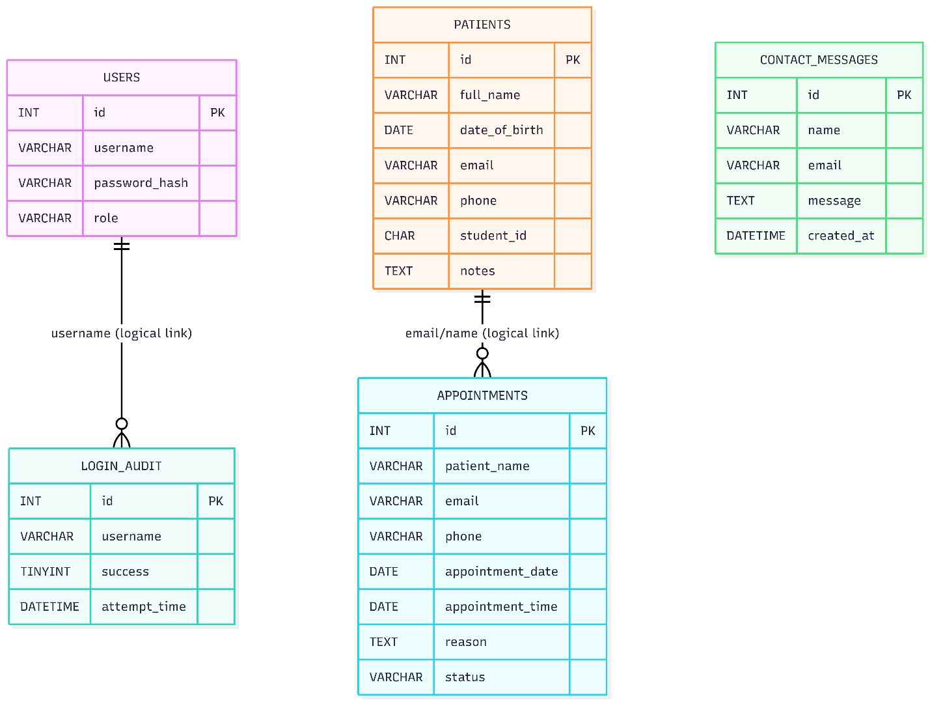
User Functionality
Public pages
Home (/)
Shows the GoldCare logo and the university logo, with a short introduction explaining that the clinic supports Goldsmiths students and staff. There are two main buttons: “Book an appointment” (links to /appointments/book) and “Register as a patient” (links to /patients/register). This page is meant to be a friendly landing page with the blue‑green colour theme and a hero layout.​
About (/about)
Describes the mission of GoldCare (accessible campus healthcare), who it supports (students and staff, including international students) and how it works with other wellbeing and support services. It is laid out in two columns explaining mission, who we support, how we work and the clinic values such as confidentiality and inclusivity.​
Contact (/contact)
Shows example clinic address on campus, phone number, email and opening hours for term time and vacation. It also contains a contact form with three fields: name, Goldsmiths email and message. When a user submits this form, their message is stored in the contact_messages table and they see either an error or success message at the top of the page.​
Student / public actions
Register as a patient (/patients/register)
This page lets a new student or staff member register with the clinic. The form collects full name, date of birth, email, phone, optional student ID and optional notes. Inputs are trimmed and simple characters like < and $ are removed as a basic sanitiser. If required fields are missing, the page shows an error. When the form is valid, the data is inserted into the patients table and the user is redirected or informed that registration is complete.​
Book an appointment (/appointments/book)
Here the user can request a routine appointment. They enter their name, email, phone, preferred date, time and the reason for the appointment. After validation, a new row is added to the appointments table with status like “Scheduled”. Reception staff will later see this booking in their appointments list. This page is accessible without login because it is aimed at patients.​
Receptionist‑only features
To access the following pages, the receptionist must log in first.
Login / Logout (/login, /logout)
The login page accepts username and password for a receptionist defined in the users table. The input is sanitised and then the app checks how many failed attempts exist for this username in the last 15 minutes using the login_audit table. If there are 3 or more, the login is blocked temporarily and another audit record is added. If not locked, the app checks the credentials; every success or failure is written to login_audit with a timestamp. On success, a session is created and the user is redirected to /patients. /logout destroys the session and returns to the public view.​
Patients list (/patients)
Shows a table of all registered patients ordered by name. Columns include full name, date of birth, email, phone, student ID and notes. There is also a delete button so reception staff can remove a patient row. At the top of the page a short paragraph explains that this is used by reception to quickly look up and manage patient records.​
Appointments list (/appointments)
Displays a table of all appointments with patient_name, email, phone, appointment_date, appointment_time, reason and status. A small search form allows filtering by patient name and date using query parameters. This helps reception plan daily clinics, see upcoming bookings and avoid double bookings. A short introduction paragraph explains the purpose of the page.​
Messages inbox (/inbox)
This looks like a simple inbox for contact messages. It lists all rows from contact_messages ordered by created_at descending, with columns for received time, sender name, sender email and the message text. It gives the receptionist a central place to check non‑urgent queries coming from the Contact page.​
Login audit log (/audit-log)
Shows the contents of login_audit so staff can see when and how often login attempts happen. The table shows attempt_time, username, whether it was a success and the IP/agent if recorded. This is mostly for security and transparency, to show that login activity is being monitored.​
All receptionist pages share the same navbar with extra links (Patients, Appointments, Messages, Login Audit) plus a label “Logged in as [username]” and a Logout button.
Advanced Techniques
Central shared navbar and app name
Instead of repeating the navbar HTML and the application name in every EJS file, the app uses an Express middleware plus a partial. In index.js a middleware sets shared locals:
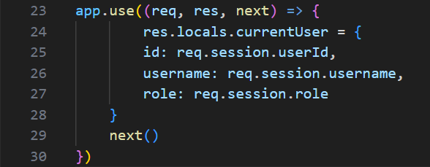
Then in views/partials/header.ejs the navbar uses <%= appData.appName %> and checks currentUser to show the correct links. All pages just call <%- include('partials/header') %>. This makes it easier to change the clinic name or add new links later without editing every template.
Environment‑based configuration with dotenv
The app uses dotenv to keep database credentials out of the source code. The .env file contains: (.env)
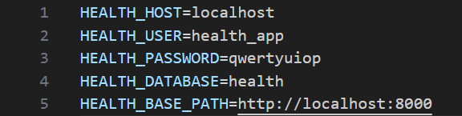
At the top of index.js:
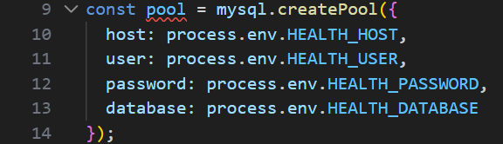
Basic input sanitising
For forms like login, patient registration, appointment booking and contact messages, the code does small sanitising and validation. For example, in the login route: (authRoutes.js)
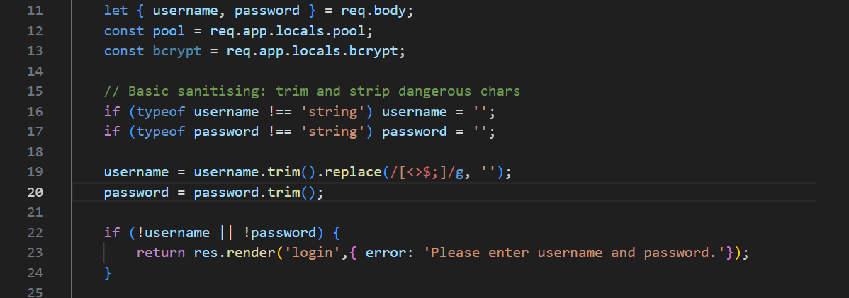
This is combined with parameterised SQL queries everywhere, so there is protection against SQL injection and also less risk of storing obvious XSS payloads. It is a simple approach but suitable for a learning project.

AI Declaration
AI tools were used in this assignment mainly as a tutor. They explained Node/Express concepts, MySQL queries and security ideas like login audit logs and lockout, so that I could understand and then write my own code. AI was also used to help fix bugs, for example by reading error messages (like unknown column names or EJS problems) and suggesting what line to change in my routes or views. It was slightly used to organise the documentation, helping to structure sections and improve wording, which I then edited to match the assignment and my own style. Because of lack of time, I also asked AI to generate Mermaid code for the architecture and data model diagrams, which I then pasted into a Mermaid editor to render the diagrams. The final design decisions, code integration and testing were done by me, and AI was used as a learning and productivity aid.

