pMIC Prediction Pipeline v3
Methods and Results Report
Canonical SMILES · Duplicate collapse · Butina/Tanimoto split ·
Classification (pMIC ≥ 6) · Regression · Applicability Domain · External Validation
Modeling set after canonicalization: n = 19,183 unique molecules | Activity cutoff: pMIC ≥ 6.0 | Seed = 42

1. Overview
This report documents a scaffold-aware quantitative structure–activity relationship (QSAR) pipeline for antimycobacterial potency (pMIC). SMILES strings were converted to RDKit canonical form and duplicate molecules were collapsed before fingerprint construction, so that one chemical entity could not enter the model under two different SMILES writings. The workflow then combined multi-fingerprint molecular representation, Butina clustering with Tanimoto similarity for train/test partitioning and GroupKFold cross-validation, multi-model ensembles, SHAP-based fingerprint highlighting, classification cutoff selection between pMIC 5.5 and 6.0, Williams applicability-domain (AD) analysis with percent coverage of external and screening libraries, labeled external validation, and virtual screening of approved drugs, 4FDN natural products, CyanoMetDB, and COCONUT.

1.1 Objectives
- Standardize SMILES and remove intra-set molecular duplicates before featurization.
- Predict continuous pMIC (regression) under chemically rigorous splits.
- Classify Active vs Inactive at an evidence-based cutoff (pMIC ≥ 6.0).
- Avoid chemical leakage via Butina/Tanimoto cluster assignment.
- Quantify whether test, external, and screening libraries fall inside the AD, as percentages.
- Interpret influential Morgan/MACCS bits and map them onto molecules.
- Validate externally and screen approved drugs, 4FDN NPs, CyanoMetDB, and COCONUT.

2. Methods

2.1 Datasets and endpoint
Modeling data (Smiles.xlsx) originally comprised 35,948 rows with experimental pMIC. pMIC is −log₁₀(MIC [M]). An independent labeled set (Cleaned_External_Validation.xlsx, 122 rows) was used only for final evaluation. Unlabeled libraries: approved DrugBank compounds, 4FDN natural-product docking set, CyanoMetDB V03 2024, and COCONUT (July 2026 dump).

2.2 Canonical SMILES and duplicate removal
Before any fingerprint or descriptor was computed, each SMILES string was parsed with RDKit and rewritten as Chem.MolToSmiles(..., canonical=True). Invalid structures and molecules with zero heavy atoms were dropped. Rows sharing the same canonical SMILES were collapsed to one molecule: pMIC was averaged and remaining columns kept the first occurrence. This prevents the same compound, written with two different SMILES strings, from entering the model as two independent training points. Salt stripping and charge neutralization were not applied. The same canonicalize-and-mean protocol was used on the labeled external set.
After canonicalization the modeling table contained 19,183 unique molecules (16,765 duplicate rows removed; 4,204 groups had conflicting experimental pMIC and were averaged). pMIC ranged from 2.17 to 9.00. The external set collapsed from 122 to 92 unique molecules (30 duplicates; 3 conflicting-pMIC groups).

2.3 Molecular representation
- Morgan fingerprints (radius 2, 2048 bits)
- MACCS keys (167 bits)
- Atom-pair fingerprints (2048 bits)
- RDKit path fingerprints (2048 bits)
- 216 RDKit descriptors (Ipc excluded) → 6,527 features in total
Invalid SMILES remaining after canonicalization and zero-heavy-atom structures were dropped during featurization (none remained in the modeling set). Descriptors were sanitized (NaN/Inf → 0; clipped).

2.4 Feature selection
- VarianceThreshold (0.01)
- Pearson correlation filter (|r| > 0.95)
- Mutual-information SelectKBest: top 1000 (regression) / top 300 (classification)
- Selectors fit on training data only and stored in a picklable FeatureTransformer

2.5 Butina cluster split (scaffold-aware)
Molecules were clustered with the Butina algorithm on Morgan fingerprints (radius 2, 1024 bits) using Tanimoto distance cutoff 0.4 (similarity ≥ 0.6). Entire clusters were assigned to train or test (~80/20) with size-balanced allocation. Within-train CV used GroupKFold by cluster ID (5 folds), preventing cluster leakage.
Partition after unique-molecule modeling: 4,470 clusters (2,164 singletons); Train n = 15,346 (2,585 clusters); Test n = 3,837 (1,885 clusters). Each molecule was labeled in preprocessed_data.xlsx with Split, CV_fold / Dataset_role, and Butina_cluster.

2.6 Models
Regression candidates:
- RandomForest, ExtraTrees, HistGradientBoosting, Ridge, LinearSVR
- XGBoost, LightGBM
- StackingRegressor of top-3 trees → Ridge
Classification candidates:
- Calibrated LinearSVC, LogisticRegression (balanced)
- RandomForest, ExtraTrees, HistGradientBoosting (balanced)
- XGBoost, LightGBM; StackingClassifier → LogisticRegression
- Decision threshold optimized on train probabilities (balanced accuracy)
- Gray-zone exclusion: |pMIC − cutoff| < 0.5 removed from classification training

2.7 Classification cutoff selection
Binary Active labels were compared at pMIC ≥ 5.5 and ≥ 6.0 (cutoff 7 was discarded a priori because of extreme imbalance). Selection used GroupKFold random-forest probes and preferred 6.0 when it was best among near-AUC candidates.

2.8 Cascade: classify then active-only regress
The global regressor ranks the full potency range but can miscalibrate among strong actives. A cascade was therefore fit on the unique-molecule Butina split with no test leakage:
- Stage A: reuse the train-only classifier (pMIC ≥ 6); decision threshold from balanced accuracy on train probabilities.
- Stage B: fit a new regressor only on train ∩ true actives (n = 2,258); feature selection refit on that subset; GroupKFold by Butina cluster among actives.
- Test metrics reported separately as: (i) Oracle — active-regressor on true test actives; (ii) Pipeline — active-regressor on classifier-predicted actives; (iii) Baseline — global regressor for reference; (iv) true-positive subset.

2.9 Applicability domain
Williams plots were computed in the selected feature space after StandardScaler and PCA (≤50 components) fitted on training data only. Leverage used the hat matrix in that PCA space with warning leverage h* = 3(p+1)/n_train. Standardized residuals used the training residual standard deviation. For labeled sets (Train, Test, External) a compound was in-AD if h ≤ h* and |standardized residual| ≤ 3. Unlabeled screening libraries have no experimental pMIC, so in-AD was leverage-only (h ≤ h*). Coverage was reported as a percentage of valid molecules. Williams scatter shows Train, Test, and External only; library coverage is summarized as bars (COCONUT is too large to scatter).

2.10 Interpretability
TreeSHAP attributions on the regression LightGBM surrogate ranked Morgan/MACCS bits. Top bits were mapped to atoms and highlighted on the five test compounds with highest predicted pMIC and on reference TB drugs (SMILES for mapping.xlsx).

2.11 External validation and screening
Saved models were applied to the canonicalized external set and to three screening libraries (approved, 4FDN, CyanoMetDB). Original columns were retained; predictions were written to new *_pmic files. COCONUT was scored for AD coverage (738,820 valid structures); a prior full pMIC screen of the same dump remains available as CSV.

2.12 Software
- Python 3.13; RDKit; scikit-learn; XGBoost; LightGBM; SHAP; NumPy; Pandas; Matplotlib
- Key scripts: pmic_prediction.py, pmic_extras.py, cascade_cls_then_reg.py, plot_ad_coverage.py, predict_forxlsx.py

3. Results

3.1 Dataset after canonical SMILES
Set | Raw rows | Invalid SMILES | Unique molecules | Duplicates removed | Conflicting pMIC groups
Modeling (Smiles.xlsx) | 35,948 | 0 | 19,183 | 16,765 | 4,204
External validation | 122 | 0 | 92 | 30 | 3

Table 1. Canonical SMILES duplicate collapse (mean pMIC within each unique molecule).
Without this step the same chemical could have been treated as two compounds. The unique-molecule modeling set (n = 19,183) is the basis of all subsequent results.

3.2 Cutoff comparison (5.5 vs 6.0)
Cutoff | Train active % | CV ROC-AUC | CV BalAcc | CV F1 | CV MCC | Ext. actives (unique)
5.5 | 28.0% | 0.828 | 0.704 | 0.577 | 0.487 | 25/92 (27.2%)
6.0 (selected) | 14.7% | 0.858 | 0.686 | 0.510 | 0.474 | 7/92 (7.6%)

Table 2. Classification cutoff comparison on the unique-molecule train set (GroupKFold RF probes). Cutoff 6.0 was selected for higher CV AUC.
A three-class probe (Inactive < 5 / Moderate 5–6 / Active ≥ 6) gave CV macro-F1 = 0.585 and Test macro-F1 = 0.568; binary classification at pMIC ≥ 6 remained the primary task.

3.3 Regression (global model, Butina split)
After variance (4,949 features), correlation (4,896), and mutual-information selection (top 1,000), Stacking of LightGBM + XGBoost + ExtraTrees → Ridge was best by CV R². LightGBM was the strongest base learner on Test R². Train pMIC mean = 5.00 (SD 0.95; range 2.17–9.00).
Set | R² | RMSE | MAE
Train | 0.920 | 0.270 | 0.201
CV (OOF) | 0.431 | 0.719 | 0.551
Test | 0.432 | 0.714 | 0.532

Table 3. Global regression metrics — Stacking (selected by CV R²).
Model | CV R² | Test R² | CV RMSE | Test RMSE
RandomForest | 0.383 | 0.384 | 0.748 | 0.744
ExtraTrees | 0.396 | 0.396 | 0.740 | 0.736
HistGradBoost | 0.396 | 0.374 | 0.740 | 0.750
Ridge | 0.156 | 0.131 | 0.875 | 0.883
LinearSVR | 0.097 | 0.077 | 0.905 | 0.910
XGBoost | 0.407 | 0.396 | 0.733 | 0.736
LightGBM | 0.423 | 0.429 | 0.724 | 0.716
Stacking (selected) | 0.431 | 0.432 | 0.719 | 0.714

Table 4. Global regression model comparison on the unique-molecule Butina split.
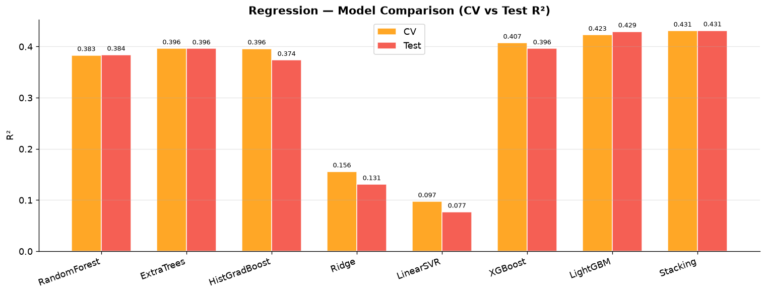
Figure 1. Regression model comparison (CV vs Test R²).
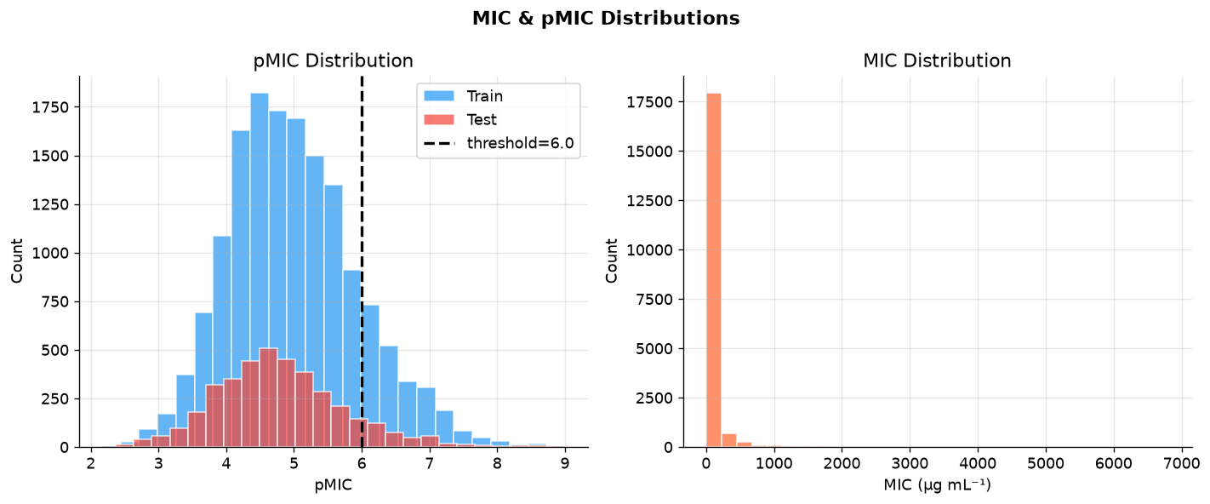
Figure 2. pMIC / MIC distributions.
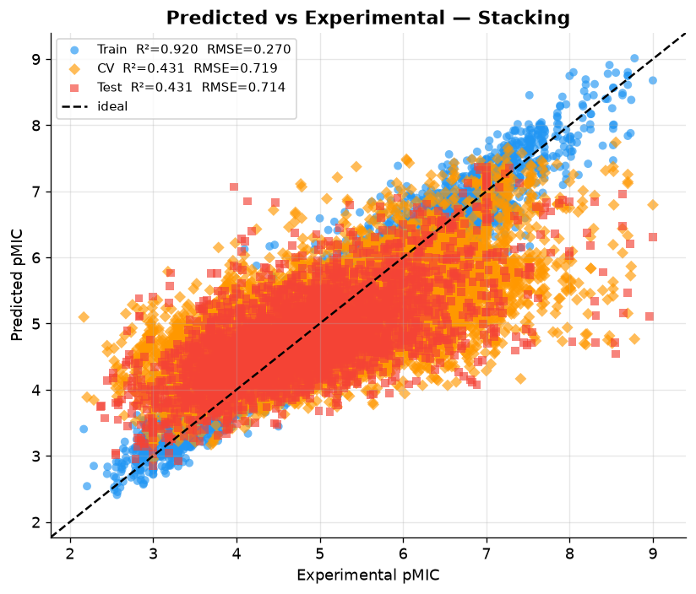
Figure 3. Predicted vs experimental pMIC.
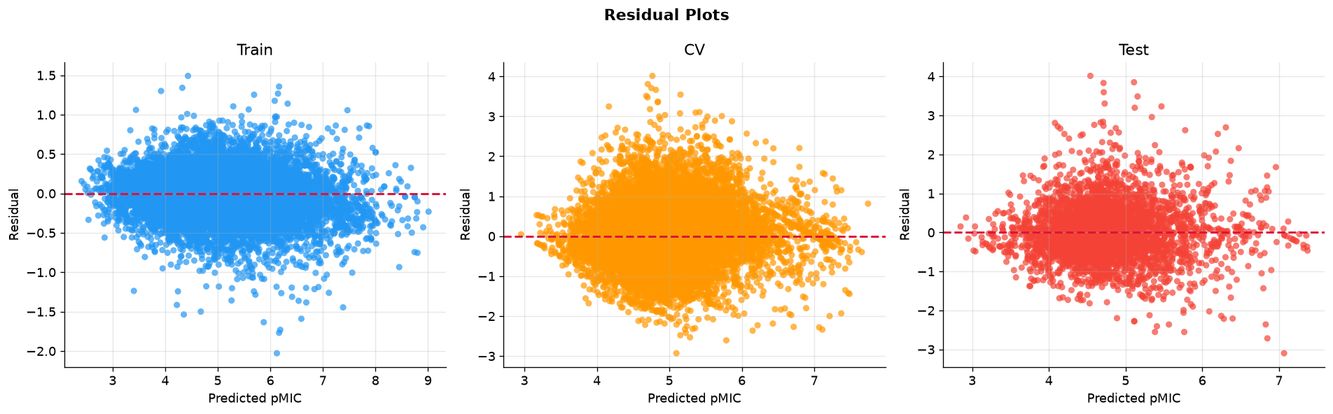
Figure 4. Residual plots.
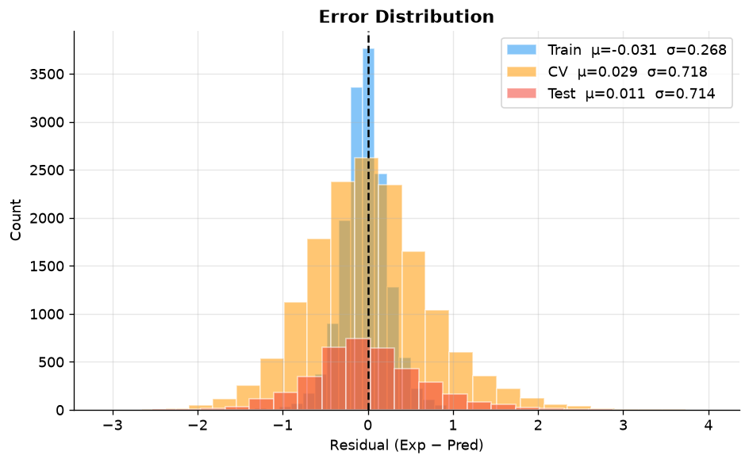
Figure 5. Error distributions.
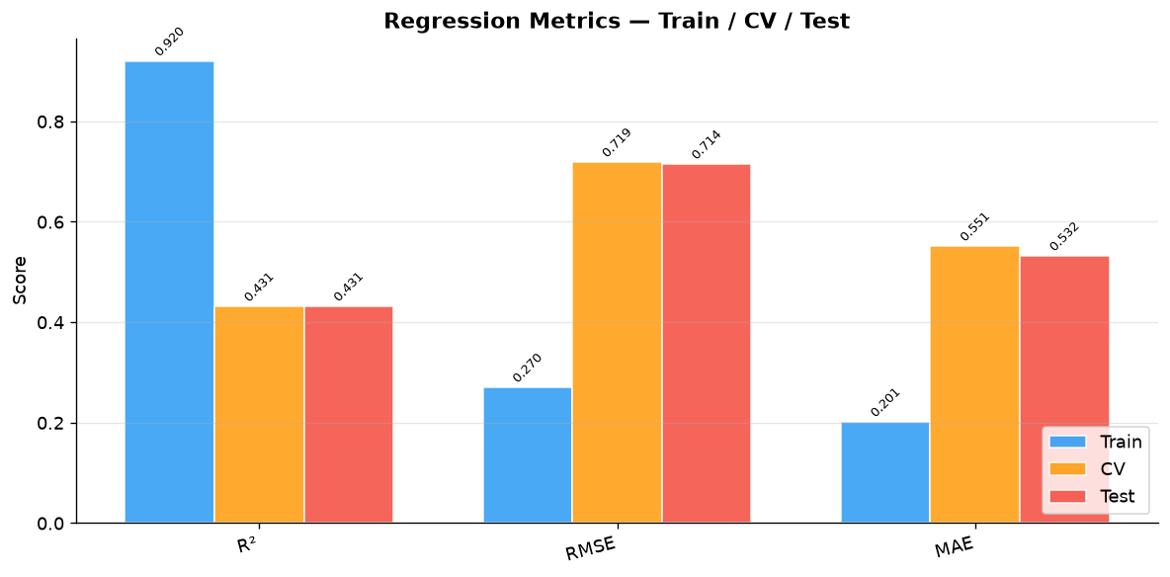
Figure 6. Regression metrics summary.
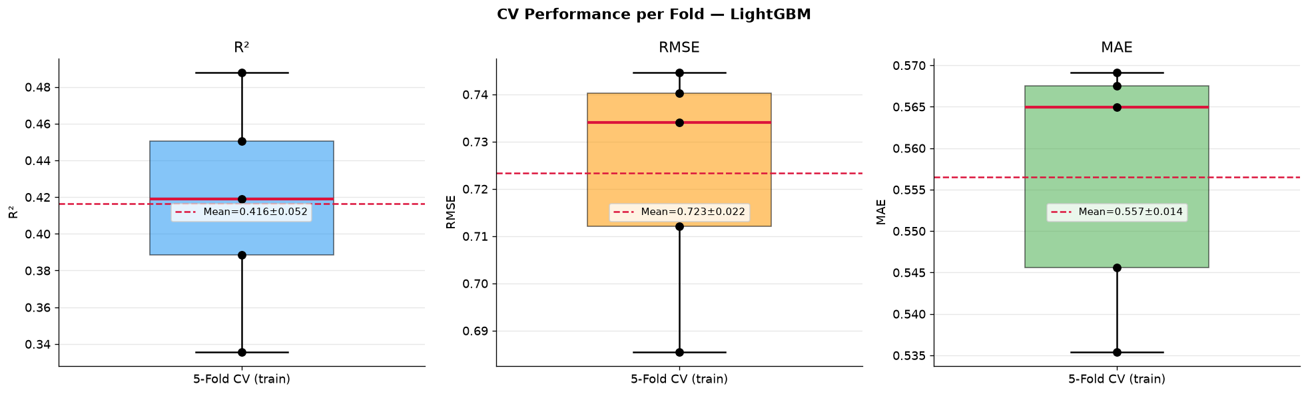
Figure 7. Per-fold CV regression metrics.
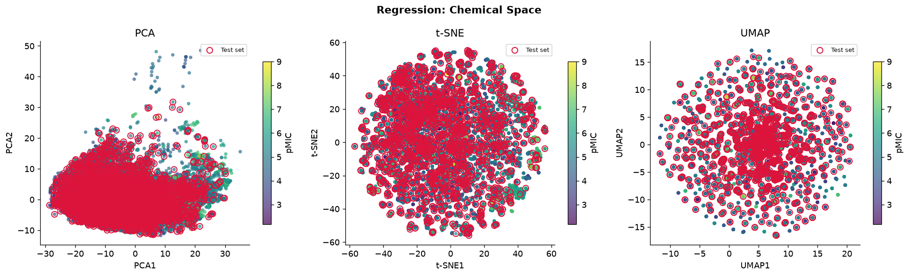
Figure 8. Chemical-space embeddings (regression).
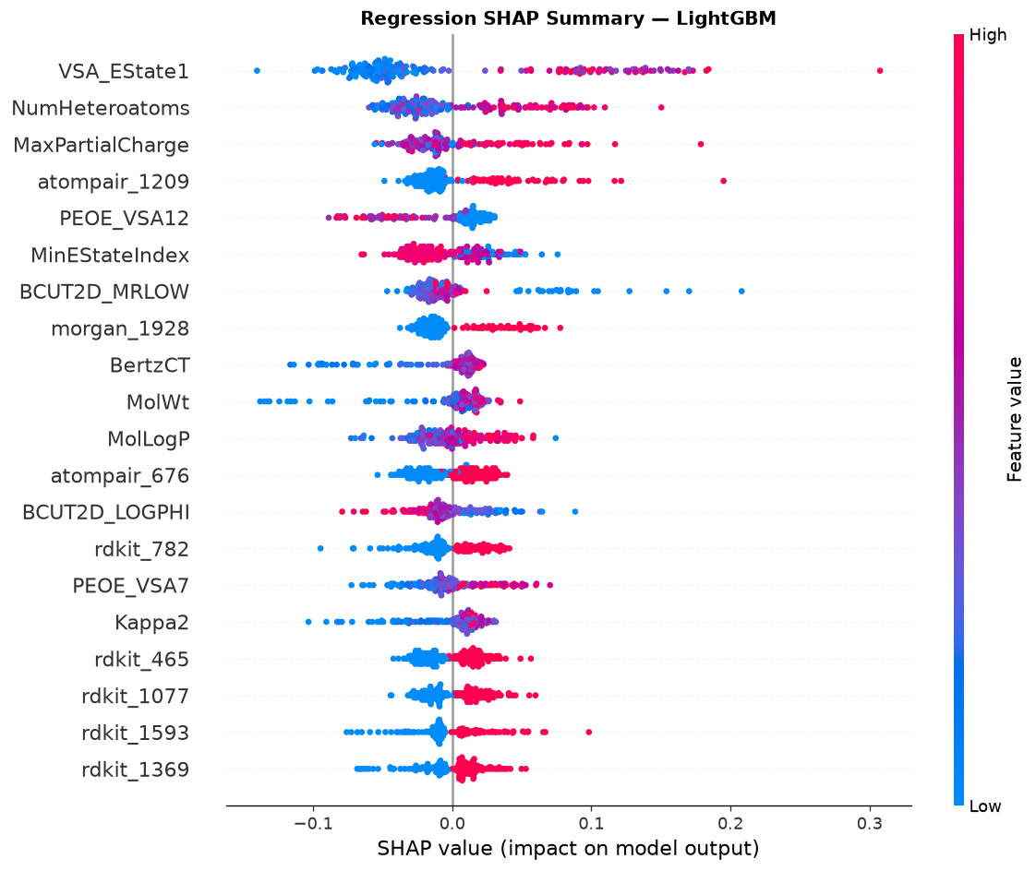
Figure 9. Regression SHAP summary.
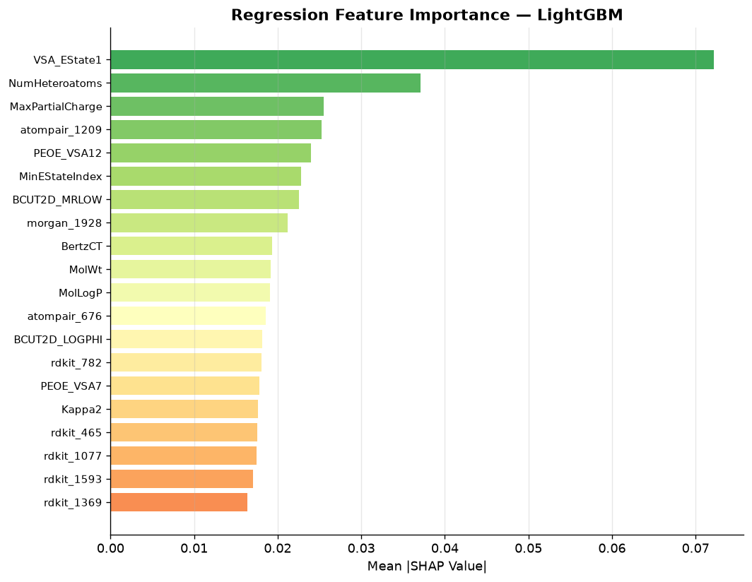
Figure 10. Regression feature importance.
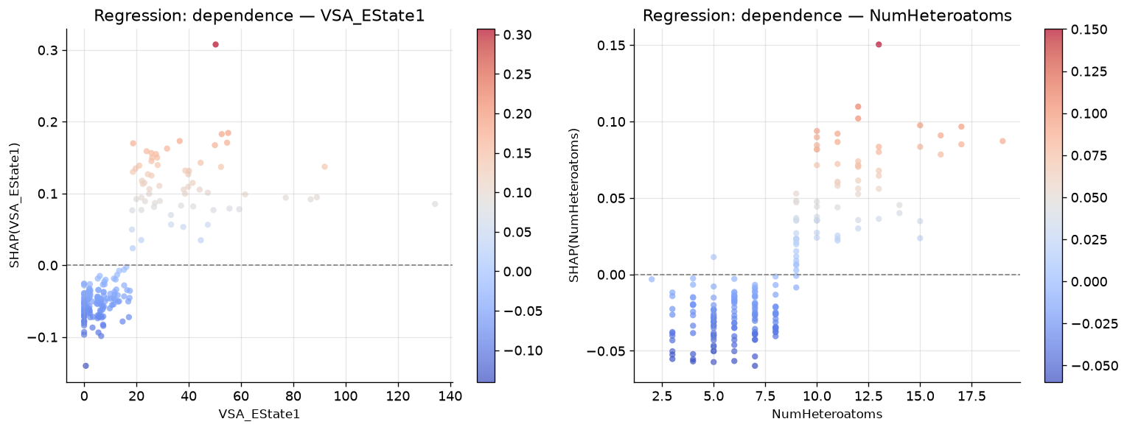
Figure 11. Regression SHAP dependence.
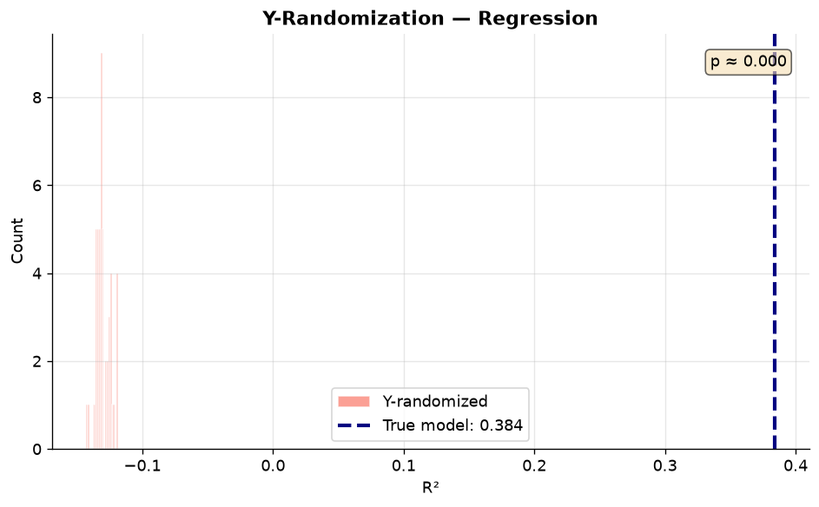
Figure 12. Y-randomization (regression).
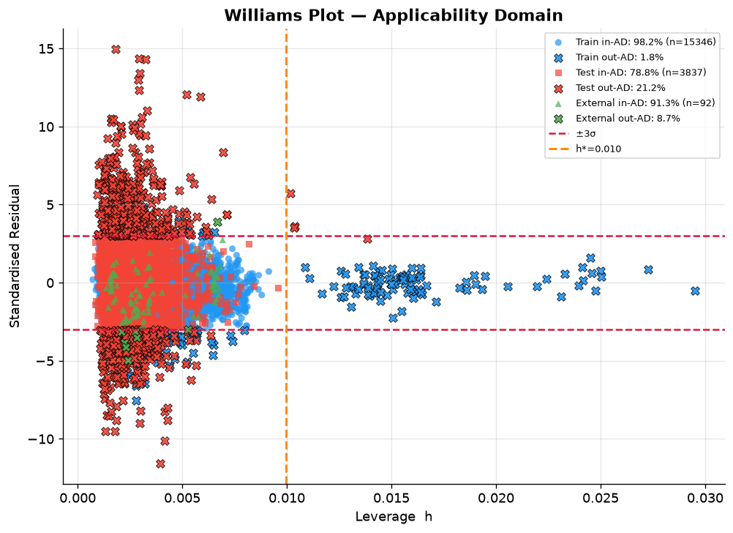
Figure 13. Williams plot (regression AD) with Train, Test, and External; legend shows in-AD %.
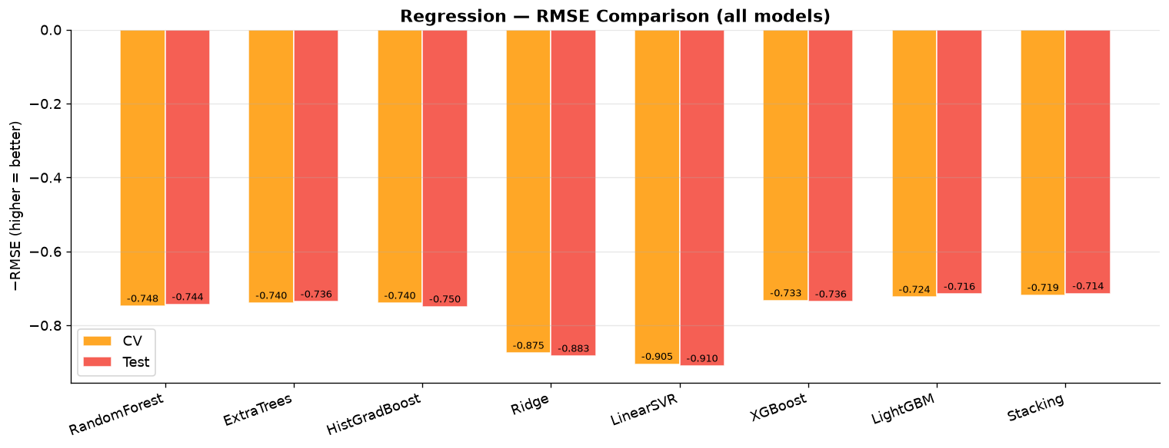
Figure 14. RMSE comparison across regressors.

3.4 Classification (pMIC ≥ 6.0)
Gray-zone exclusion removed 3,169 train compounds with |pMIC − 6| < 0.5. Classification training then used 12,177 compounds (1,125 active, 9.2%); the test set retained 3,837 (405 active, 10.6%). Feature selection reduced the space to 300 mutual-information features. Stacking (ExtraTrees + RandomForest + LightGBM → LogisticRegression) achieved the best CV ROC-AUC (0.915). The saved decision threshold (balanced accuracy on train probabilities) was 0.28. ExtraTrees was used as the SHAP surrogate.
Model | CV AUC | Test AUC | CV F1 | Test F1
LinearSVM | 0.828 | 0.711 | 0.380 | 0.321
LogisticReg | 0.828 | 0.709 | 0.399 | 0.322
RandomForest | 0.913 | 0.811 | 0.521 | 0.440
ExtraTrees | 0.915 | 0.813 | 0.578 | 0.460
HistGradBoost | 0.897 | 0.780 | 0.521 | 0.336
XGBoost | 0.906 | 0.782 | 0.555 | 0.438
LightGBM | 0.909 | 0.792 | 0.624 | 0.468
Stacking (saved) | 0.915 | 0.816 | 0.528 | 0.407

Table 5. Classification comparison at pMIC ≥ 6 on the unique-molecule split.
Set | Accuracy | Bal. Acc. | ROC-AUC | F1 | MCC
Train | 0.949 | 0.972 | 1.000 | 0.782 | 0.779
CV (OOF) | 0.861 | 0.853 | 0.915 | 0.528 | 0.508
Test | 0.796 | 0.737 | 0.816 | 0.407 | 0.342

Table 6. Detailed Stacking metrics at the balanced-accuracy threshold (0.28). For screening, Active_probability ranking (AUC) is the primary quality metric.
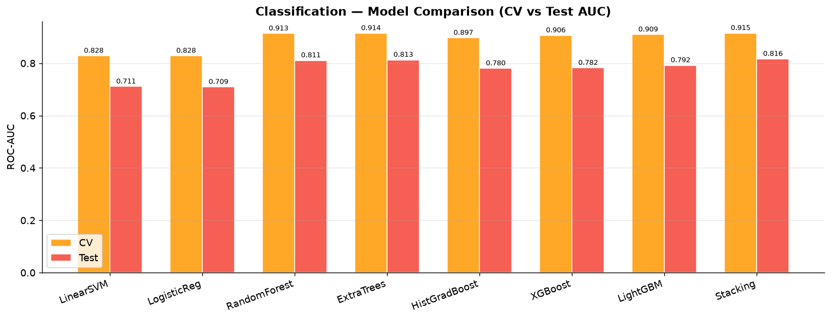
Figure 15. Classification model comparison.
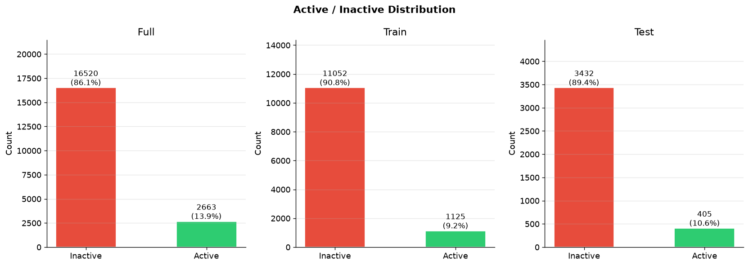
Figure 16. Active/Inactive distributions.
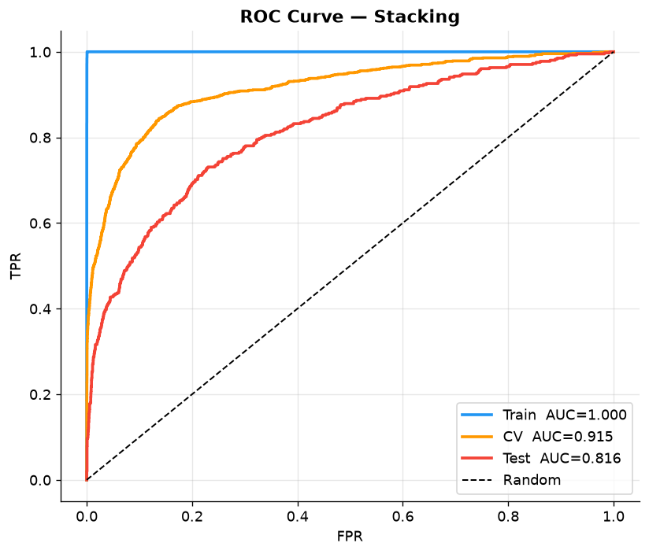
Figure 17. ROC curves.
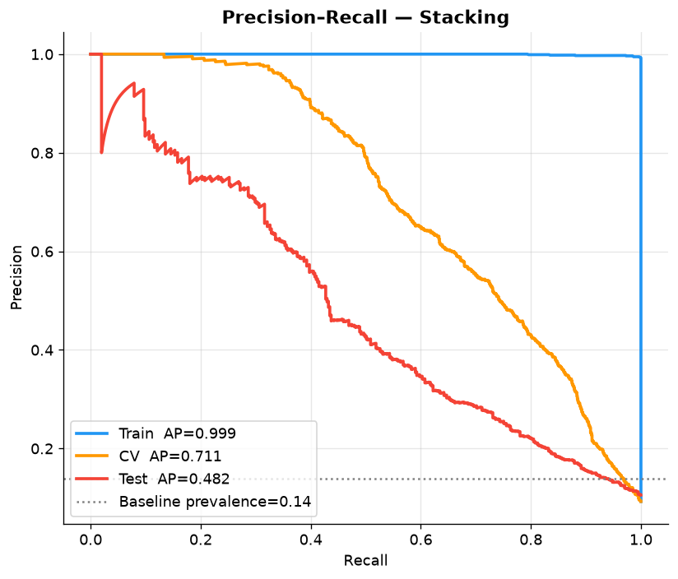
Figure 18. Precision–Recall curves.
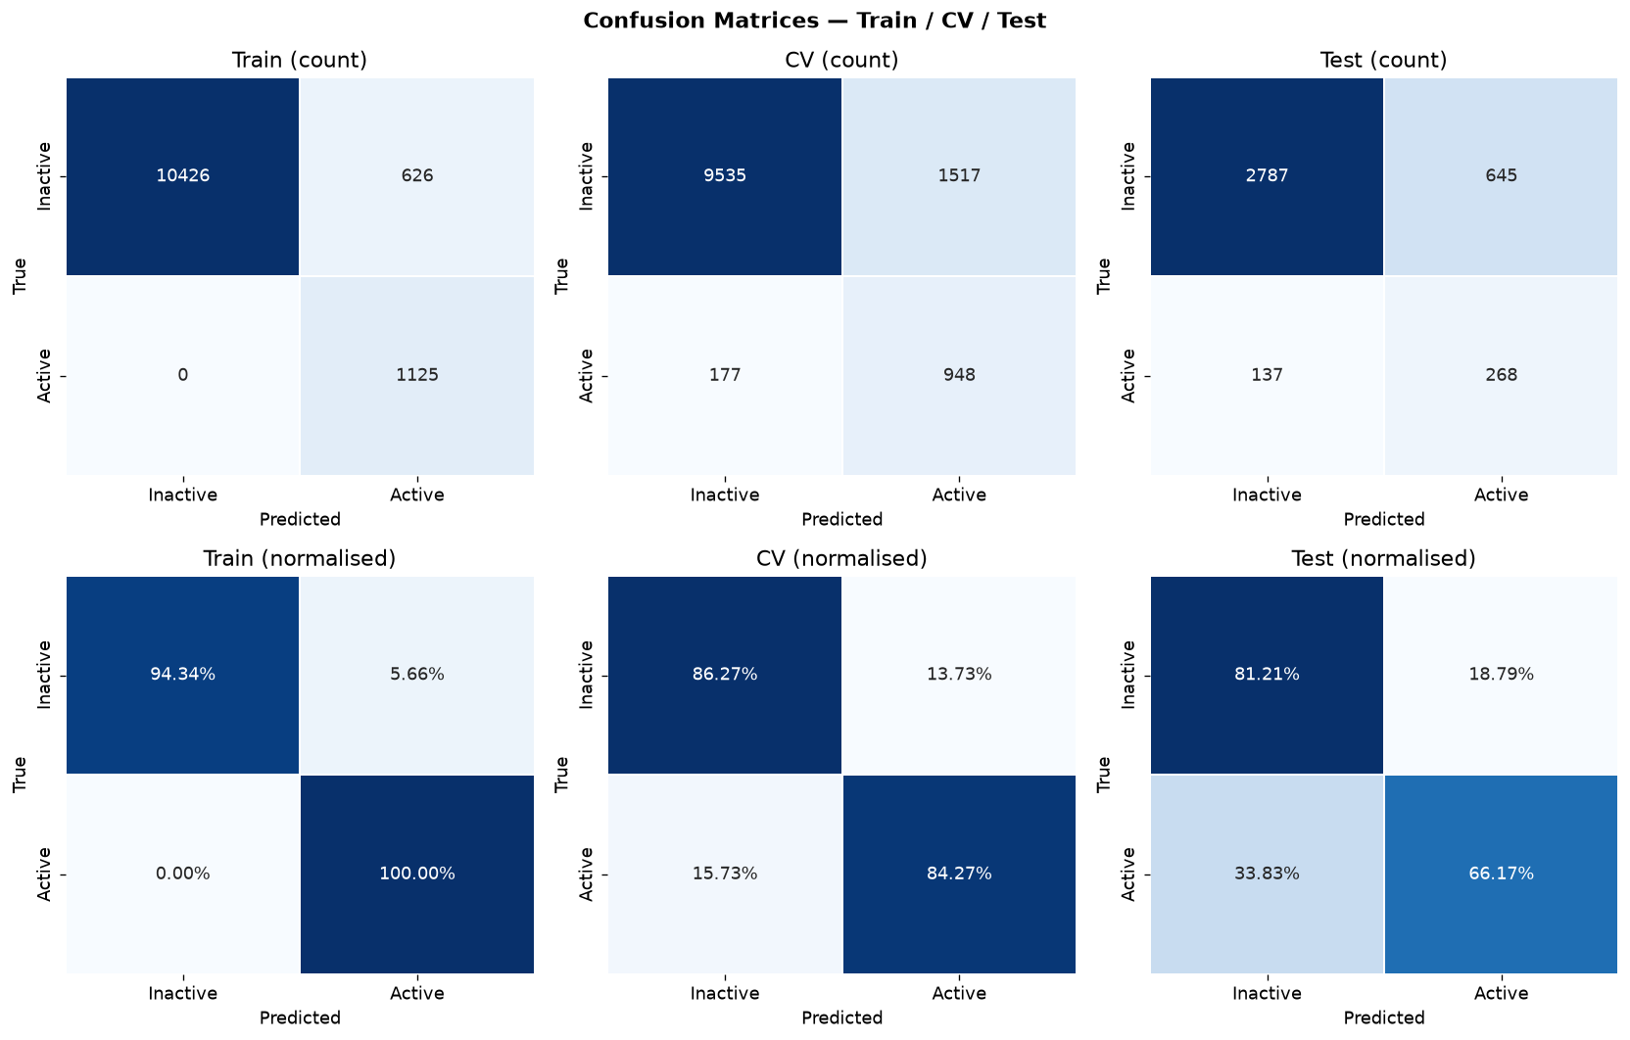
Figure 19. Confusion matrices.
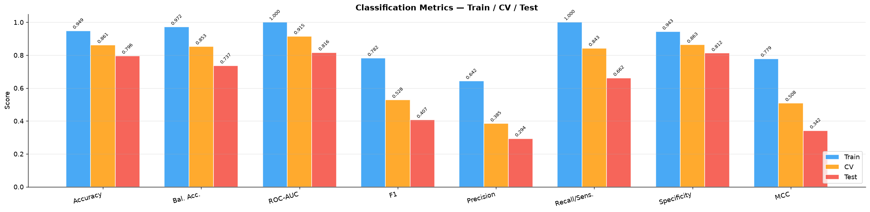
Figure 20. Classification metrics summary.
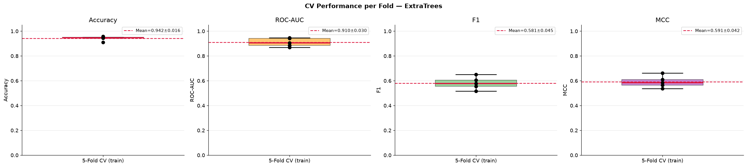
Figure 21. Per-fold CV classification metrics.
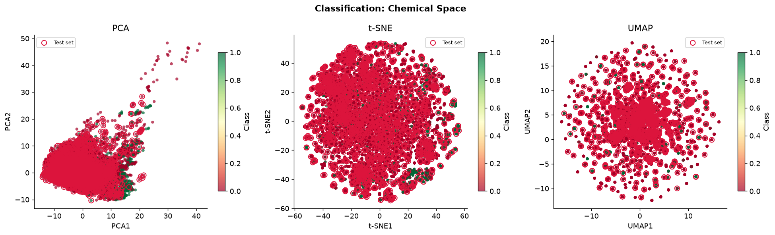
Figure 22. Chemical-space embeddings (classification).
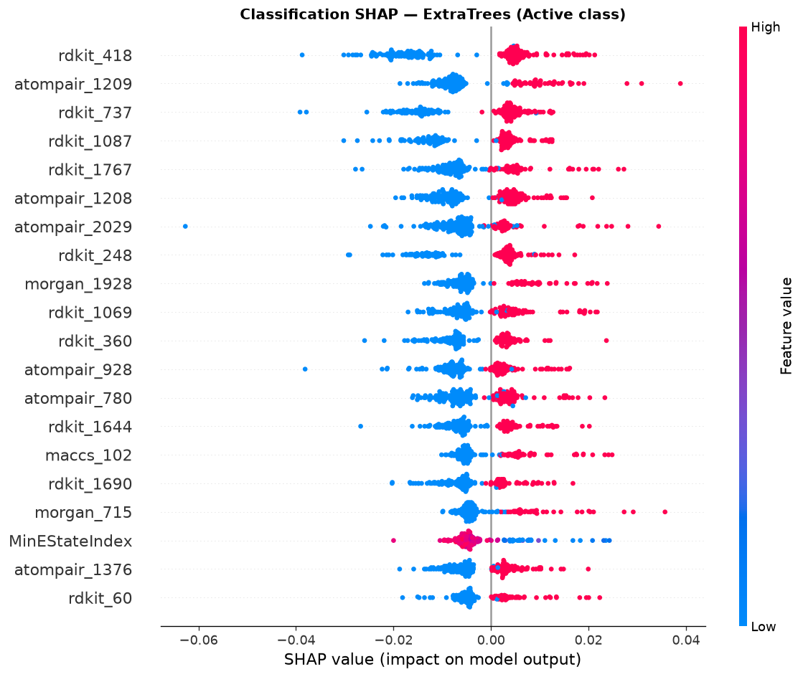
Figure 23. Classification SHAP summary.
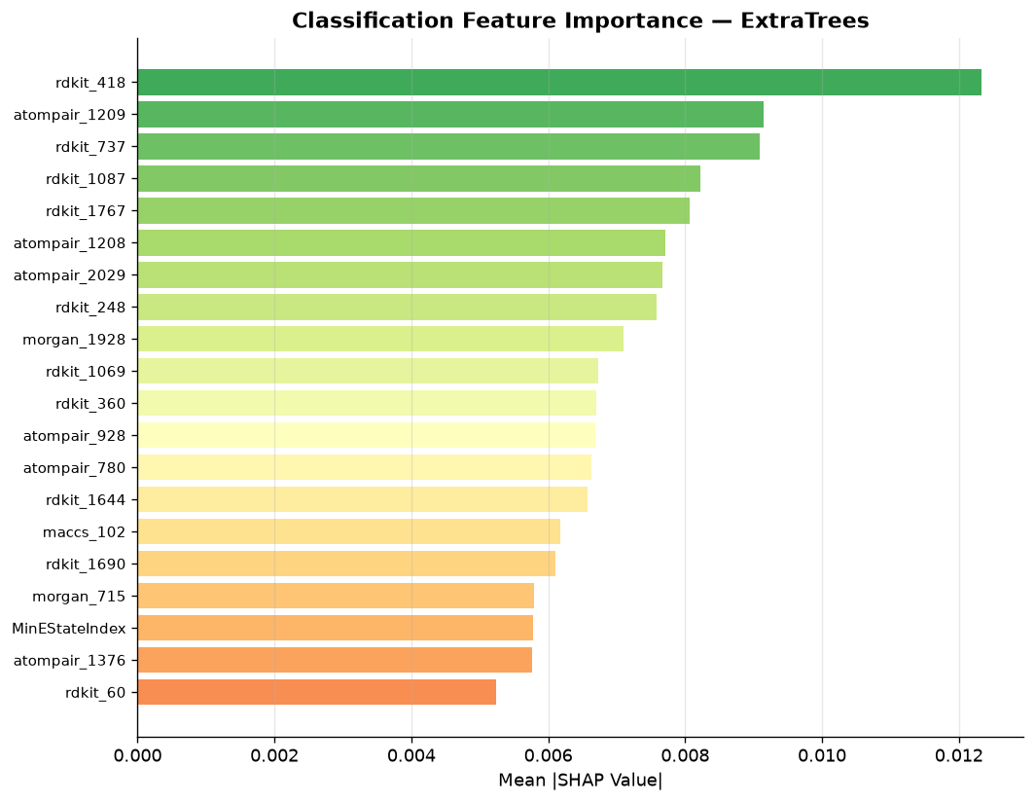
Figure 24. Classification feature importance.
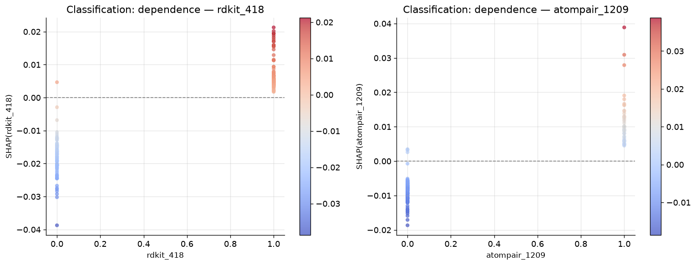
Figure 25. Classification SHAP dependence.
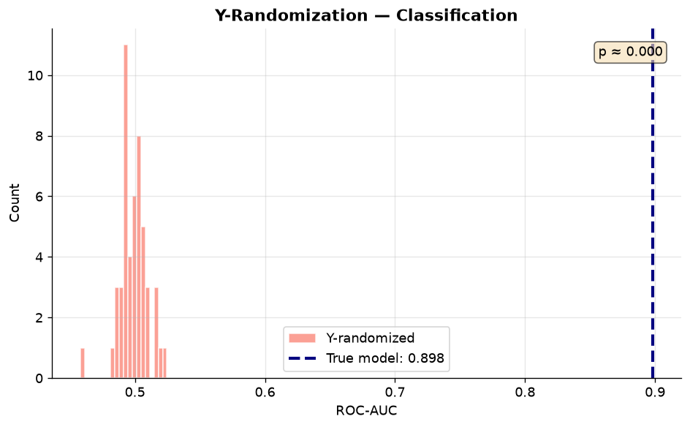
Figure 26. Y-randomization (classification).
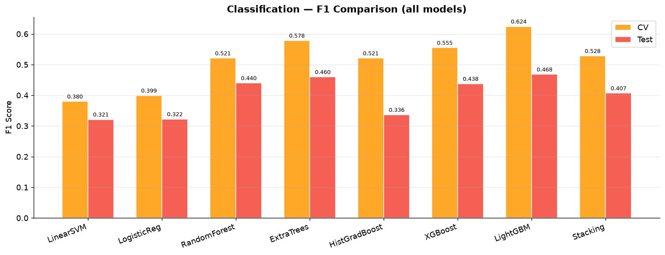
Figure 27. F1 comparison across classifiers.
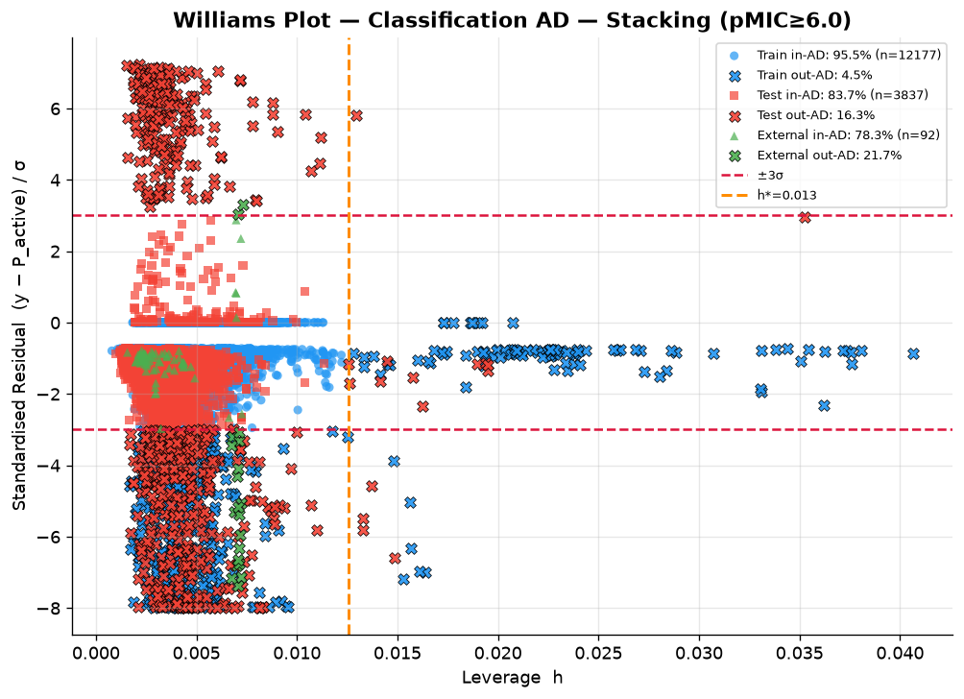
Figure 28. Williams plot (classification AD) with Train, Test, and External; legend shows in-AD %.

3.5 Applicability domain coverage
Williams AD was evaluated for Train, Test, External, and four screening libraries. Labeled sets used leverage plus residual; unlabeled libraries used leverage only. Regression feature-space h* = 0.010; classification h* = 0.013.
Dataset | n valid | Reg. in-AD % | Reg. criterion | Cls. in-AD % | Cls. criterion
Train | 15,346 / 12,177* | 98.2 | leverage+residual | 95.5 | leverage+residual
Test | 3,837 | 78.8 | leverage+residual | 83.7 | leverage+residual
External | 92 | 91.3 | leverage+residual | 78.3 | leverage+residual
Approved | 14,596 | 98.7 | leverage | 95.2 | leverage
4FDN | 799 | 100.0 | leverage | 99.8 | leverage
CyanoMetDB | 3,026 | 96.5 | leverage | 94.8 | leverage
COCONUT | 738,820 | 98.6 | leverage | 92.5 | leverage

Table 7. Percent of molecules inside the applicability domain. *Classification train n is after gray-zone exclusion. Full numbers are in ad_coverage_summary.csv.
Most screening compounds lie inside the leverage AD of the unique-molecule training set. Test coverage is lower than train (78.8% regression / 83.7% classification), as expected for a Butina split that holds out dissimilar clusters. External coverage is high in regression space (91.3%) and moderate in classification space (78.3%).
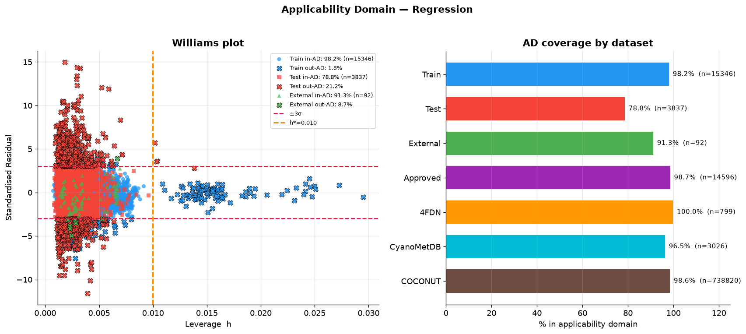
Figure 29. Regression AD: Williams scatter (Train/Test/External) and % in-AD bars for all datasets including COCONUT.
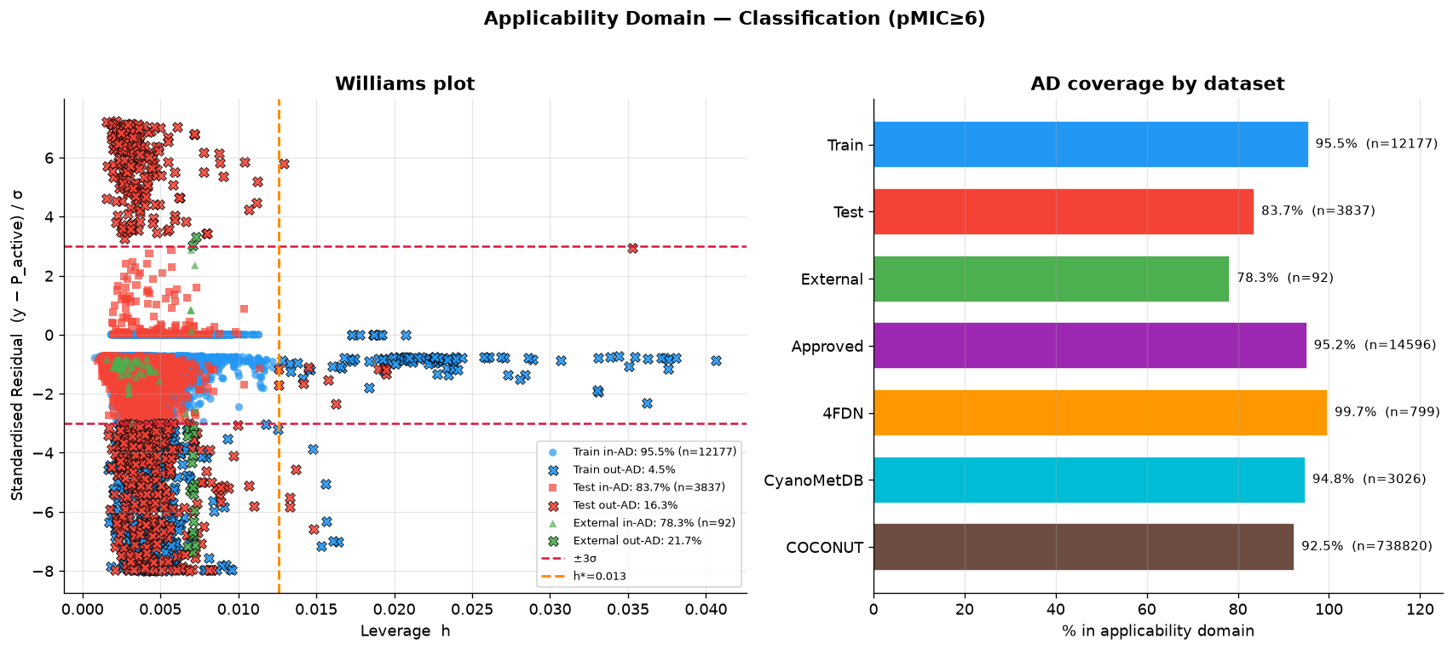
Figure 30. Classification AD: Williams scatter and % in-AD bars for all datasets.

3.6 Fingerprint highlights
Top SHAP fingerprint bits from the regression LightGBM surrogate were led by morgan_1928, maccs_86, and maccs_107. These bits were highlighted on the five test molecules with highest predicted pMIC and on reference antimycobacterials.
Rank | Feature | Type | Mean |SHAP|
1 | morgan_1928 | Morgan | 0.0212
2 | maccs_86 | MACCS | 0.0133
3 | maccs_107 | MACCS | 0.0125
4 | morgan_80 | Morgan | 0.0050
5 | maccs_113 | MACCS | 0.0025
6 | maccs_119 | MACCS | 0.0025
7 | morgan_715 | Morgan | 0.0024
8 | maccs_89 | MACCS | 0.0023

Table 8. Top regression SHAP fingerprint features.
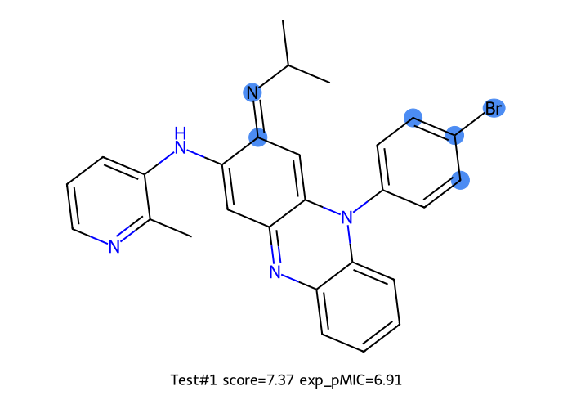
Figure 31. Test top-1 by predicted pMIC — FP highlights.
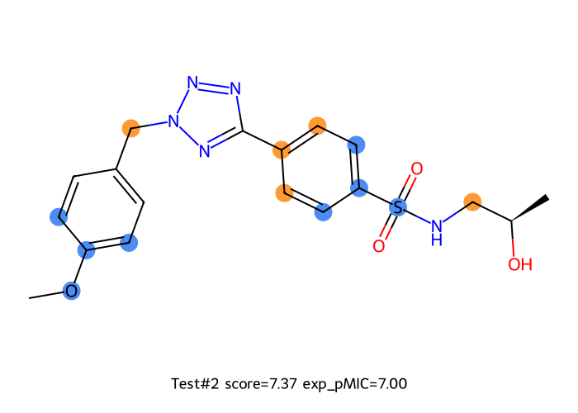
Figure 32. Test top-2 — FP highlights.
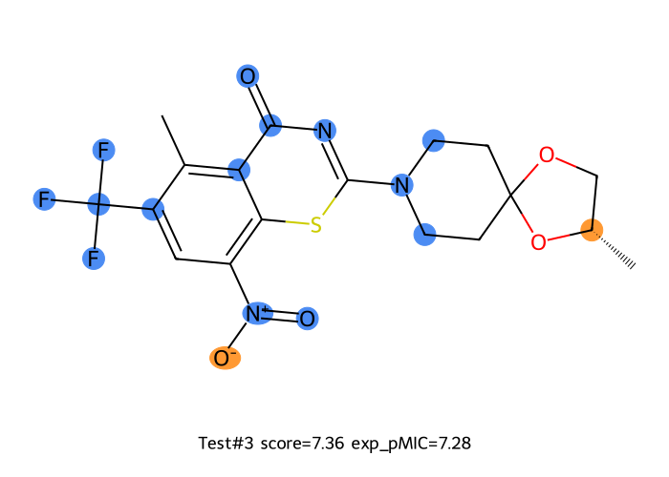
Figure 33. Test top-3 — FP highlights.
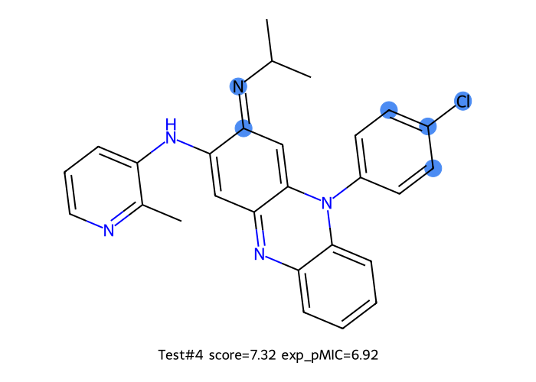
Figure 34. Test top-4 — FP highlights.
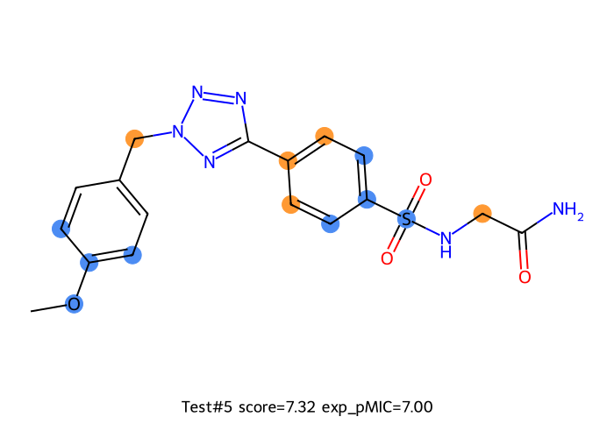
Figure 35. Test top-5 — FP highlights.
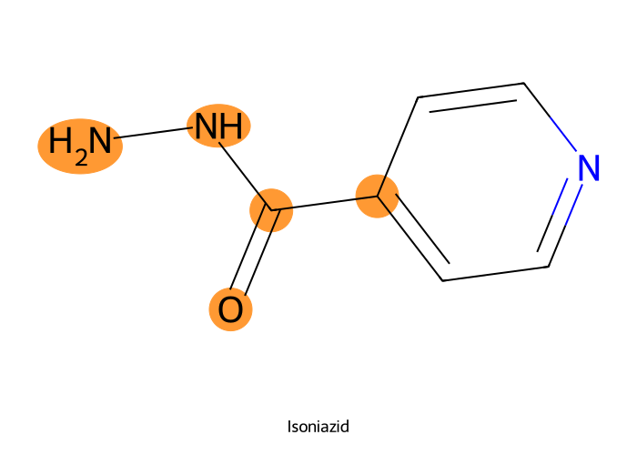
Figure 36. Isoniazid — FP highlights.
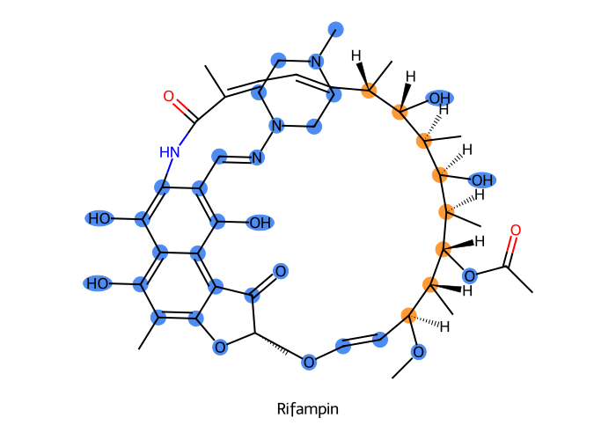
Figure 37. Rifampin — FP highlights.
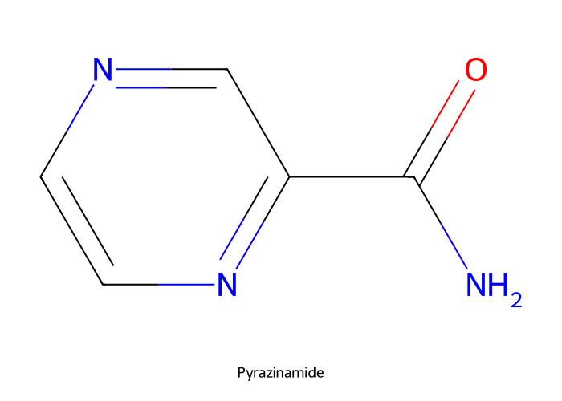
Figure 38. Pyrazinamide — FP highlights.
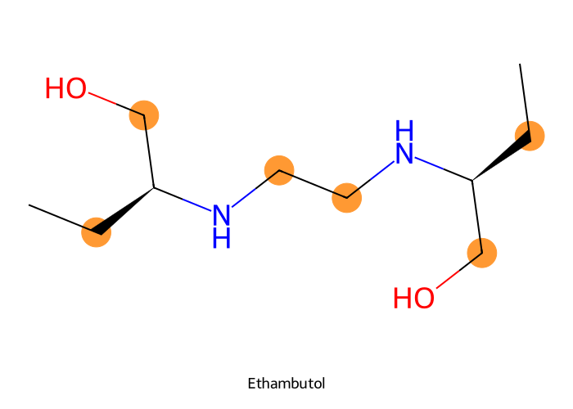
Figure 39. Ethambutol — FP highlights.
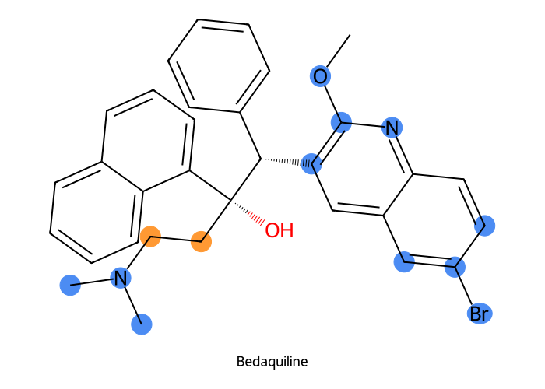
Figure 40. Bedaquiline — FP highlights.
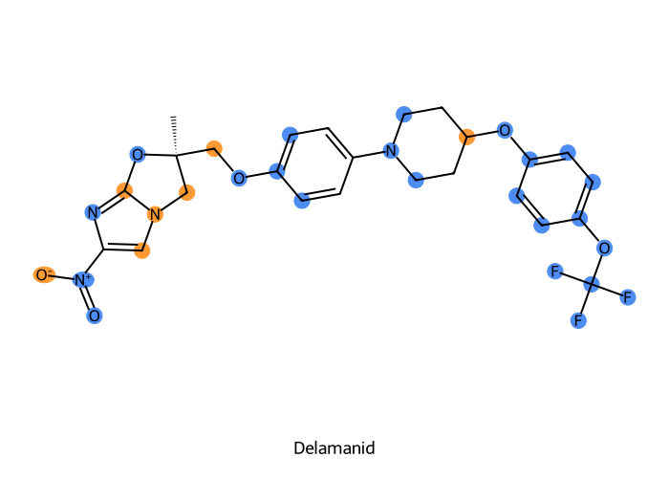
Figure 41. Delamanid — FP highlights.
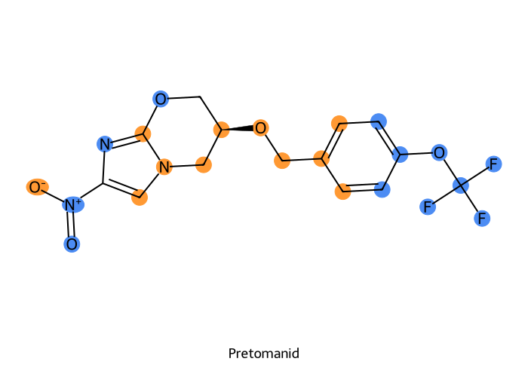
Figure 42. Pretomanid — FP highlights.
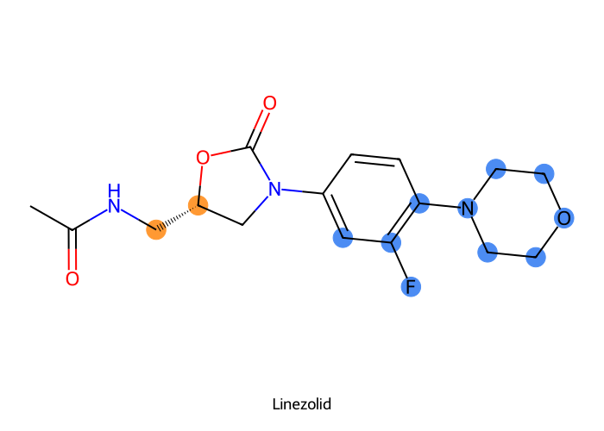
Figure 43. Linezolid — FP highlights.

3.7 External validation
On the canonicalized external set (n = 92 unique molecules; 7 actives at pMIC ≥ 6) the global regressor achieved R² = 0.718, RMSE = 0.455, MAE = 0.358. Classification at cutoff 6.0 yielded ROC-AUC = 0.923, balanced accuracy = 0.918, F1 = 0.500, and MCC = 0.528. These metrics are consistent with the high regression AD coverage of this set (91.3%).
Task | Metric | Value
Regression (global) | n / R² / RMSE / MAE | 92 / 0.718 / 0.455 / 0.358
Classification (T=6) | AUC / BalAcc / F1 / MCC | 0.923 / 0.918 / 0.500 / 0.528
External actives at T=6 | n (%) | 7 / 92 (7.6%)
Regression AD coverage | in-AD % | 91.3
Classification AD coverage | in-AD % | 78.3

Table 9. External validation summary after canonical SMILES deduplication.
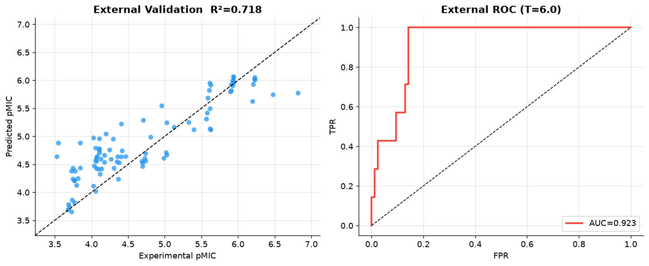
Figure 44. External validation — predicted vs experimental pMIC (n = 92 unique molecules).

3.8 Cascade classification → active-only regression
The cascade was re-fit on the unique-molecule split. Stage A reused the saved classifier (Test AUC = 0.816; 981 predicted actives vs 405 true actives). Stage B trained an active-only regressor on 2,258 train actives (mean pMIC = 6.62). XGBoost was best by CV R² (0.223). The global regressor still ranked the full test set (R² = 0.432) but failed among true actives (R² = −3.85, RMSE = 1.32). The active-only model recovered usable potency on true test actives (Oracle R² = 0.181, RMSE = 0.543). Pipeline metrics on predicted-actives are degraded by false positives, as expected; among true positives (n = 282) R² = 0.200.
Scenario | n | R² | RMSE | MAE
Baseline full-reg, all test | 3837 | 0.432 | 0.714 | 0.532
Baseline full-reg, true actives | 405 | −3.853 | 1.322 | 1.074
Oracle active-reg (XGBoost), true actives | 405 | 0.181 | 0.543 | 0.380
Pipeline active-reg, pred. actives | 981 | −1.072 | 1.529 | 1.277
Pipeline true positives only | 282 | 0.200 | 0.554 | 0.397
Hybrid (inactive→5.5) all test | 3837 | −0.895 | 1.304 | 1.093

Table 10. Cascade vs baseline regression on the unique-molecule Butina test set.
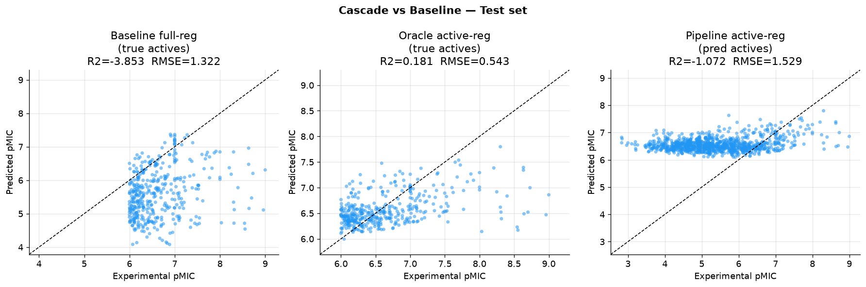
Figure 45. Cascade vs baseline — predicted vs experimental pMIC (test).
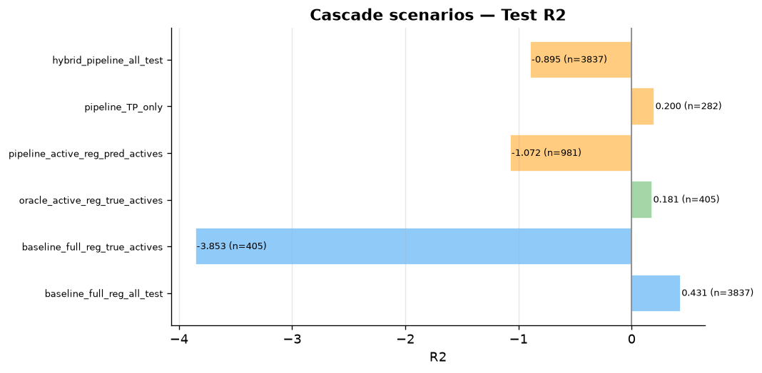
Figure 46. Cascade scenario R² comparison.
On the unique external set, the global regressor on all 92 molecules remained strong (R² = 0.718), but among the 7 true actives it failed (R² = −5.77, RMSE = 0.559). Oracle active-only regression reduced RMSE to 0.214 (R² ≈ 0.01; n = 7 is too small for a stable R²). Pipeline evaluation on 28 predicted actives was again limited by false positives (R² = −1.67).
External scenario | n | R² | RMSE
Baseline full-reg, all | 92 | 0.718 | 0.455
Baseline full-reg, true actives | 7 | −5.773 | 0.559
Oracle active-reg, true actives | 7 | 0.009 | 0.214
Pipeline active-reg, pred. actives | 28 | −1.675 | 0.880

Table 11. Cascade external validation (canonical unique molecules).

3.9 Library screens
Library | Output | Predicted | Notes
Approved drugs | approved_pmic.xlsx | 14,605 | 875 skipped; 98.7% in regression AD
4FDN natural products | 4FDN-Natural-products-dock_pmic.xlsx | 1,923 | 5 skipped; 100% unique mols in regression AD (n=799 unique)
CyanoMetDB V03 2024 | CyanoMetDB_V03_2024_pmic.xlsx | 3,059 | 184 skipped; 96.5% in regression AD
COCONUT 07-2026 | coconut_csv-07-2026_pmic.csv | 738,820 | AD scored in this run (98.6% in-AD); pMIC CSV from the prior screen

Table 12. Virtual screening outputs. AD percentages refer to unique valid structures in Table 7.

4. Discussion and limitations
- Canonical SMILES duplicate collapse halved the apparent sample (35,948 → 19,183) and is a prerequisite for claiming that each training point is a distinct molecule. Mean pMIC was used where replicate measurements disagreed (4,204 groups).
- Butina/Tanimoto splitting is substantially harder than random split and better reflects generalization to unseen chemotypes. After unique-molecule modeling, Test R² rose to 0.43 versus ~0.32 on the previous non-deduplicated table.
- Cutoff 6.0 is preferred over 5.5 for classification claims because of higher CV AUC, despite fewer external actives (7 of 92).
- Most screening compounds are inside the leverage AD, so domain shift is not the main caveat for those libraries; Test and classification-space External coverage are the stricter checks.
- SHAP fingerprint highlights are correlative attributions, not causal proofs.
- Classification Test F1 remains modest because of class imbalance; use probability ranking (AUC 0.816 test / 0.923 external) for prioritization.
- Global regression is useful for overall ranking but miscalibrates among strong actives; cascade active-only regression (XGBoost) improves potency RMSE on true actives (Oracle) and should be applied after classification in screening workflows. Pipeline cascade metrics are sensitive to false positives—report Oracle and Pipeline separately.

5. Key deliverables
- cache_features_butina_canonical.joblib (unique-molecule features and Butina split)
- best_reg_model.joblib / best_cls_model.joblib (T = 6)
- best_reg_active_only_model.joblib / cascade_cls_reg_model.joblib
- cascade_cls_reg_metrics.csv / cascade_test_predictions.xlsx / cascade_external_*
- preprocessed_data.xlsx (n = 19,183; Split, roles, Butina_cluster)
- plots/ including Williams overlays and ad_dataset_coverage.png / cls_ad_dataset_coverage.png
- ad_coverage_summary.csv
- external_validation_predictions.xlsx (n = 92)
- approved_pmic.xlsx, 4FDN-Natural-products-dock_pmic.xlsx, CyanoMetDB_V03_2024_pmic.xlsx
- coconut_csv-07-2026_pmic.csv (prior screen; AD coverage computed in this run)

6. Conclusions
A scaffold-aware multi-fingerprint pipeline was established for antimycobacterial pMIC modeling after canonical SMILES standardization and duplicate collapse (n = 19,183 unique molecules). Under Butina splits, stacking regression reached Test R² = 0.43 and classification at pMIC ≥ 6 achieved Test ROC-AUC = 0.82 with strong external validation (R² = 0.72; AUC = 0.92 on 92 unique external molecules). Williams AD analysis showed 91% of the external set and >92% of screening libraries (including COCONUT) inside the leverage domain of the training chemistry, while the held-out Butina test set was more challenging (79–84% in-AD). Cascade active-only regression (XGBoost) improved potency RMSE among true test actives relative to the global regressor (Oracle RMSE 0.54 vs 1.32) and is recommended as a second stage after activity filtering. Fingerprint highlights and library screens provide hypotheses for drug-repurposing prioritization.
— End of report —
Generated from pipeline v3 after canonical SMILES deduplication, cascade retrain on the unique-molecule split, Williams AD coverage (including COCONUT), and library screens.

