COMP 1234

Assignment 1

Testing

Pat Doe

A00000000

Feb 30th, 2020

**Tests 4**

Test 1 4

Test 2 5

Test 3 5

Test 4 6

Test 5 6

Test 6 7

Test 7 7

Test 8 8

Test 9 8

Test 10 9

Test 11 9

Test 12 10

Test 13 10

| **Test** | **Expected** | **Actual** | **Screenshot** |
| --- | --- | --- | --- |
| No arguments | fail | fail | Test 1 |
| -h | pass | pass | Test 2 |
| -x | fail | fail | Test 3 |
| Empty message | fail | fail | Test 4 |
| Empty count | fail | fail | Test 5 |
| Non-integer count | fail | fail | Test 6 |
| Negative count | fail | fail | Test 7 |
| Count of 0 | fail | fail | Test 8 |
| Too many arguments | fail | fail | Test 9 |
| Message, no count | pass | pass | Test 10 |
| Message, 1 | pass | pass | Test 11 |
| Message, 2 | pass | pass | Test 12 |
| Message, 10 | pass | pass | Test 13 |

# Tests

## Test 1

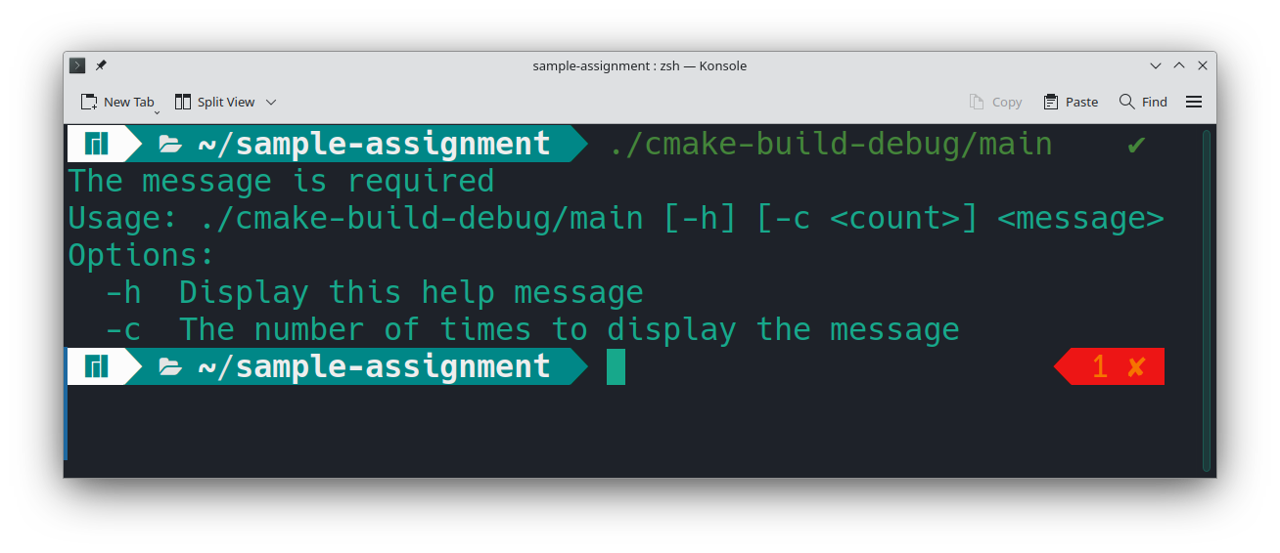

## Test 2

## Test 3

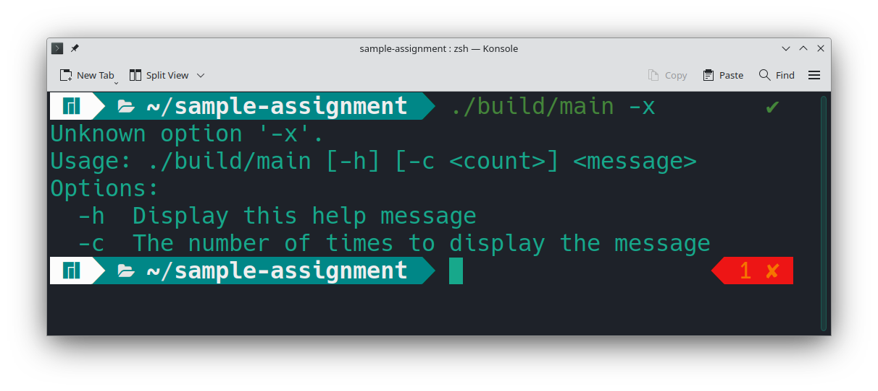

## Test 4

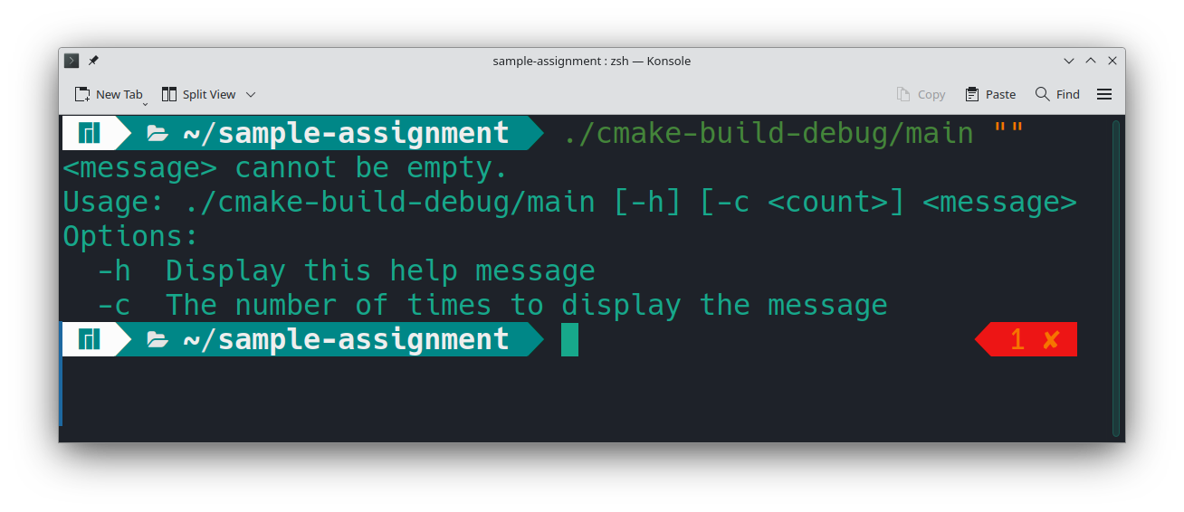

## Test 5

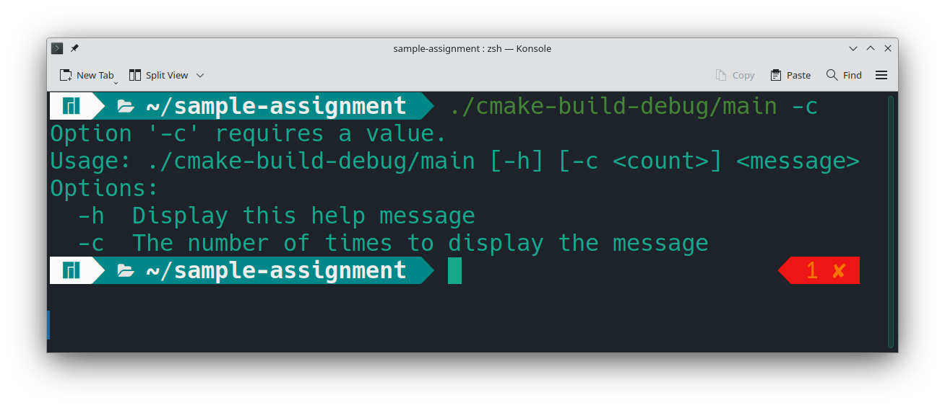

## Test 6

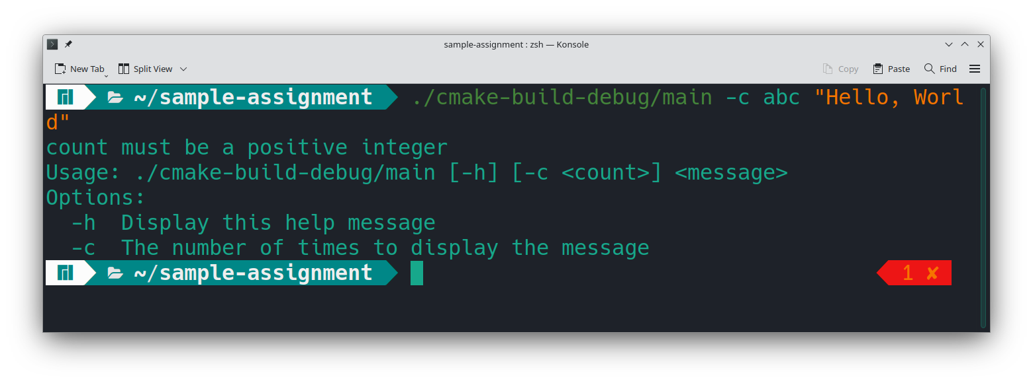

## Test 7

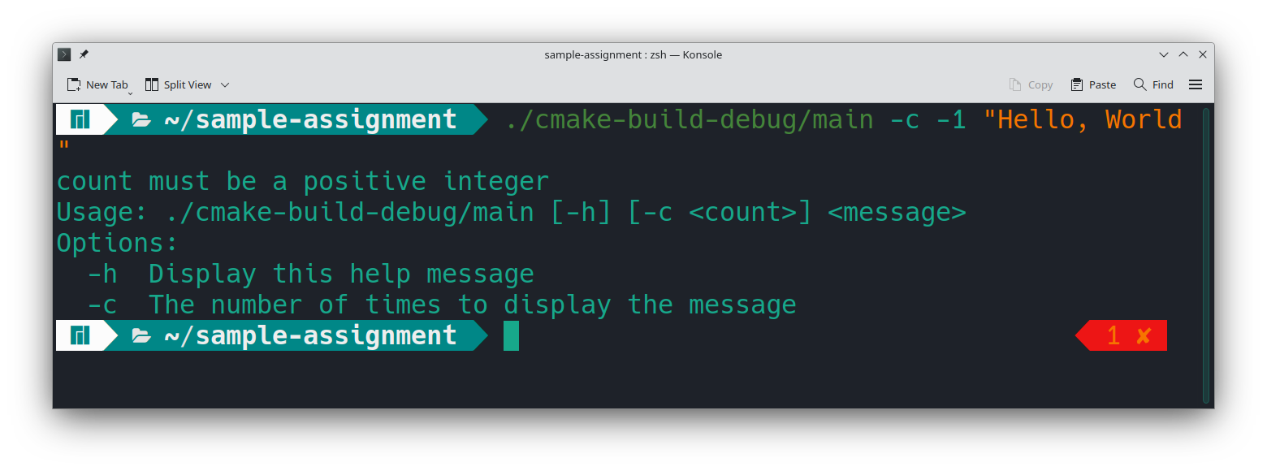

## Test 8

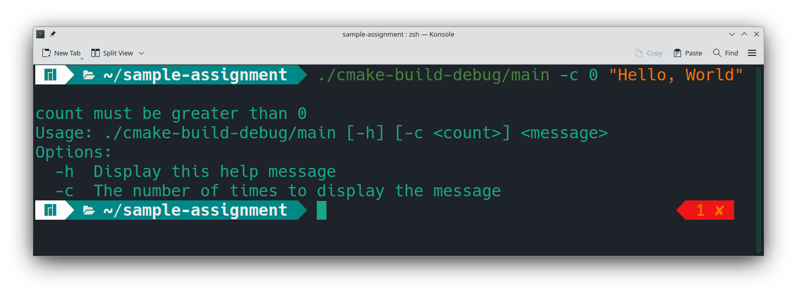

## Test 9

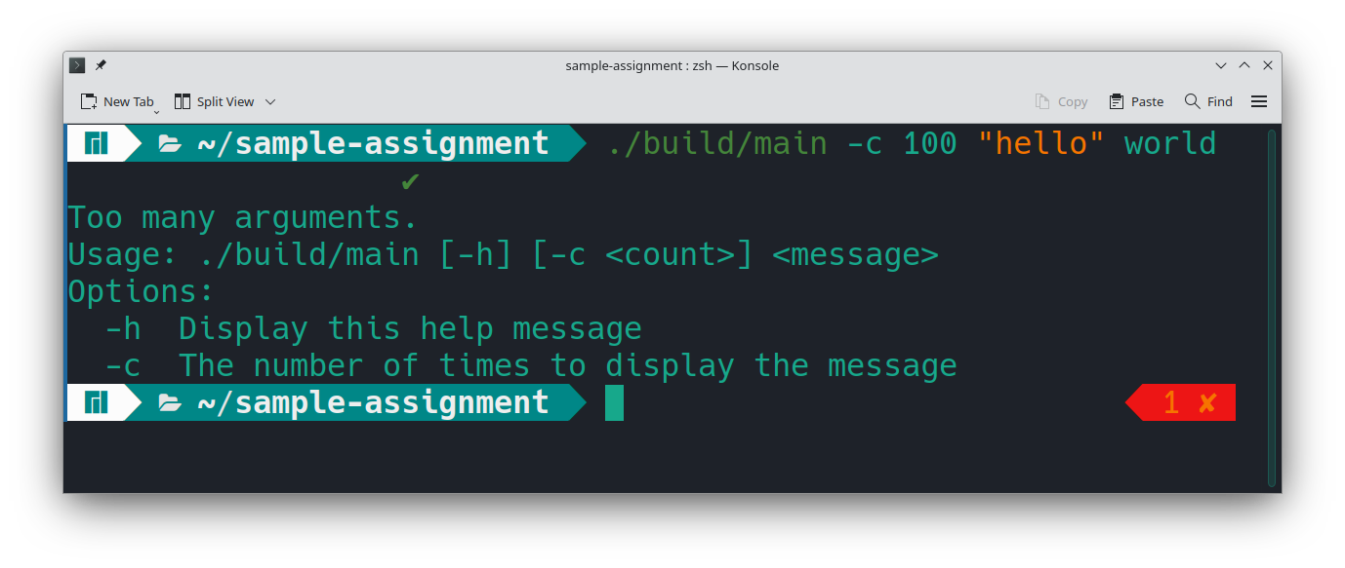

## Test 10

## Test 11

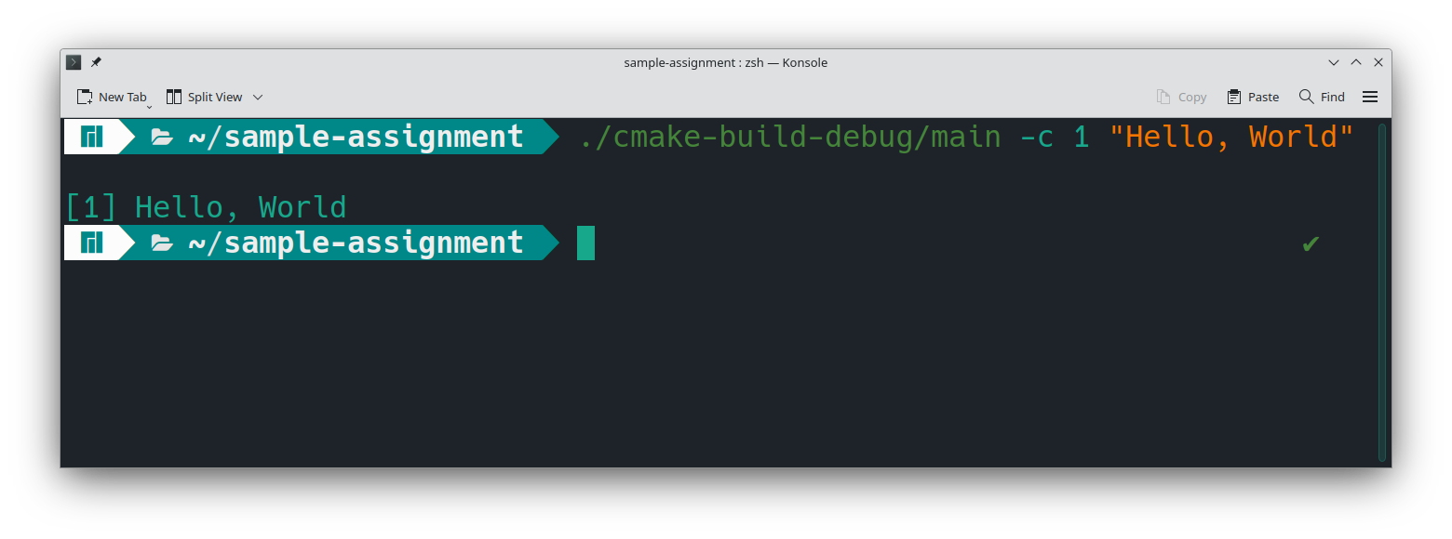

## Test 12

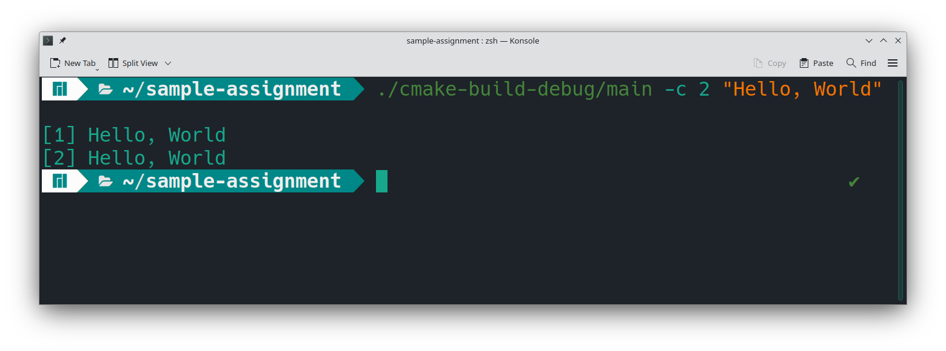

## Test 13

