LOCO Anomaly Inspector
Logical and Structural Anomaly Detection on MVTec LOCO AD
Data Analytics Lab | Final Project Report | June 2026

Abstract. This project detects industrial product defects using only normal training images. Frozen DINOv2-small features support three anomaly detectors, while a lightweight global proxy provides an additional baseline. The system compares seven scoring configurations and presents the results in Power BI and an offline HTML dashboard. Mean fusion achieved 0.761 overall AUROC, with stronger performance on structural anomalies than logical anomalies.

1. Introduction
Industrial inspection systems must find uncommon defects before products reach customers. In practice, defective examples are limited and expensive to label. Anomaly detection addresses this problem by learning the appearance of normal products and assigning a higher score to unusual test images.
- Structural anomalies: local visual defects such as damage, contamination, or deformation.
- Logical anomalies: missing, extra, misplaced, or incorrectly counted parts that may still look normal.
The study uses all five MVTec LOCO AD categories: breakfast box, juice bottle, pushpins, screw bag, and splicing connectors. The audited data contains 3,651 images across normal training, normal validation, and held-out test splits.

2. Objective of the Product
The objective is to build a clear anomaly-detection product that can:
- Detect: rank normal and abnormal images without training on defects.
- Compare: report logical, structural, overall AUROC, and F1.
- Explain: show scores, thresholds, ground truth, and model heatmaps separately.
- Support review: place the useful EDA and model evidence in one dashboard.
0.761  Overall AUROC | 0.731  Logical AUROC | 0.804  Structural AUROC | 5  Product categories

3. Product Features
The product is available as a Power BI dashboard and as a self-contained HTML dashboard. Both versions focus on evidence needed to understand the model.
- Overview and leaderboard: show the best method and all seven scoring configurations.
- Relevant EDA: show split counts, sample images, mask overlays, and category-level patterns.
- Explainability and drill-down: show per-image decisions, category results, thresholds, and heatmaps.
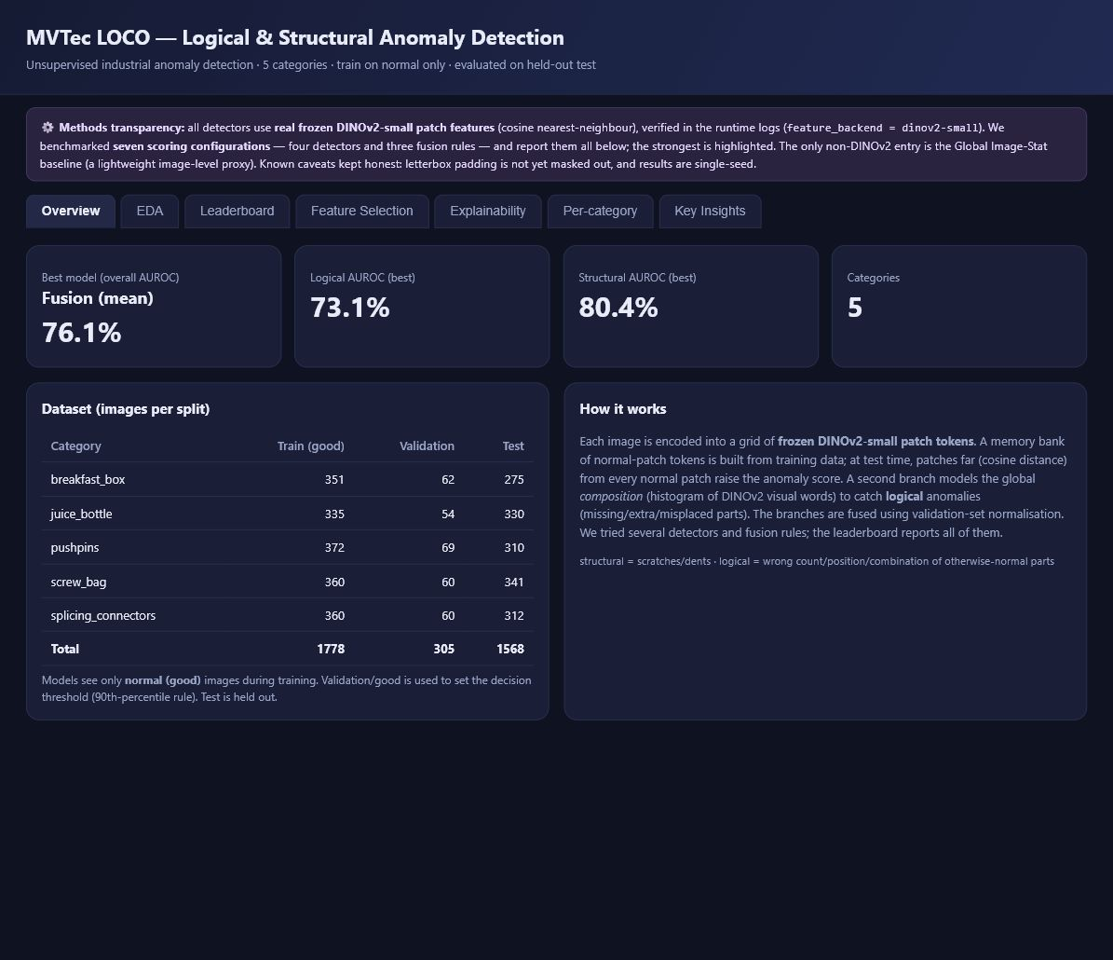
Figure 1. Dashboard overview showing the headline metrics, dataset split, and method transparency statement.

4. User Guidelines
- Open the dashboard. Use the Power BI file or open 09_dashboard/dashboard.html.
- Read the overview. Check overall, logical, and structural AUROC.
- Use a detailed tab. Select the leaderboard, explainability, or per-category view.
- Interpret a decision. A score at or above the saved validation threshold is flagged as anomalous.

5. Implementation and Methodology
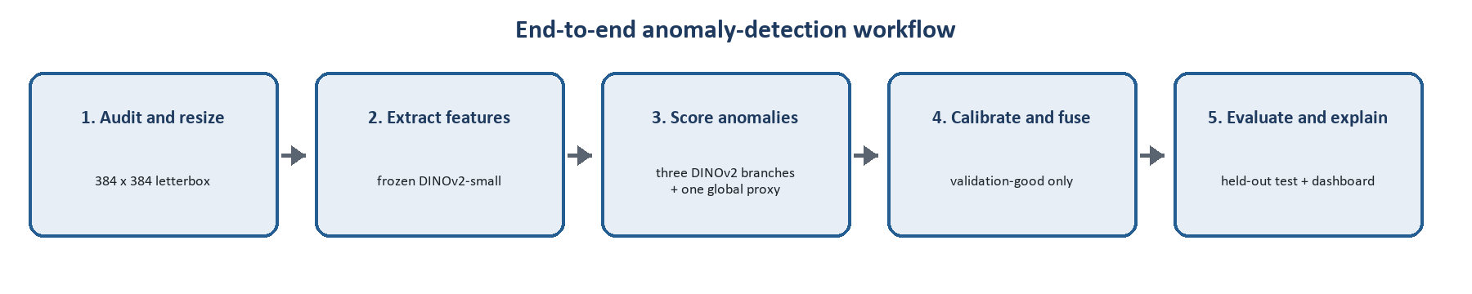
Figure 2. End-to-end workflow from data preparation to dashboard reporting.

5.1 Data Preparation
Images are placed on a 384 x 384 canvas using aspect-ratio-preserving letterboxing. Product images use bilinear interpolation. Ground-truth masks use nearest-neighbour interpolation and remain binary. Only normal images are used to fit the anomaly detectors.

5.2 Model Methods
Detector branch | Purpose | Feature source
Patch Memory | Find local patches unlike the normal memory bank. | DINOv2-small
Region-Aware Memory | Compare appearance while keeping rough image position. | DINOv2-small
Composition Histogram | Measure changes in the global mix of visual words. | DINOv2-small
Global Image-Stat proxy | Provide a fast whole-image difference score. | Non-DINOv2 proxy
Table 1. Detector branches used in the reported comparison.
The three DINOv2 branches use real frozen DINOv2-small patch features. The Global Image-Stat detector is a lightweight non-DINOv2 proxy. Mean, maximum, and rank-average fusion combine the branch scores. This report does not claim an official EfficientAD or PatchCore implementation.

5.3 Evaluation Protocol
- Training: fit normal memories using train/good images.
- Calibration: use validation/good scores for normalization and the 90th-percentile threshold.
- Testing: use the held-out test split only for the final reported evaluation.
- Metrics: report image-level AUROC and F1; AUROC is the main comparison metric.

6. Results and Feature Selection
Method | Logical | Structural | Overall | F1
Fusion (mean) | 0.731 | 0.804 | 0.761 | 0.626
Region-Aware Memory | 0.730 | 0.784 | 0.750 | 0.626
Patch Memory | 0.697 | 0.765 | 0.724 | 0.612
Fusion (rank average) | 0.727 | 0.720 | 0.720 | 0.573
Fusion (max) | 0.692 | 0.741 | 0.714 | 0.551
Global Image-Stat proxy | 0.634 | 0.683 | 0.655 | 0.474
Composition Histogram | 0.644 | 0.498 | 0.576 | 0.396
Table 2. Corrected image-level results. AUROC is threshold-free; F1 uses a validation-good operating threshold.
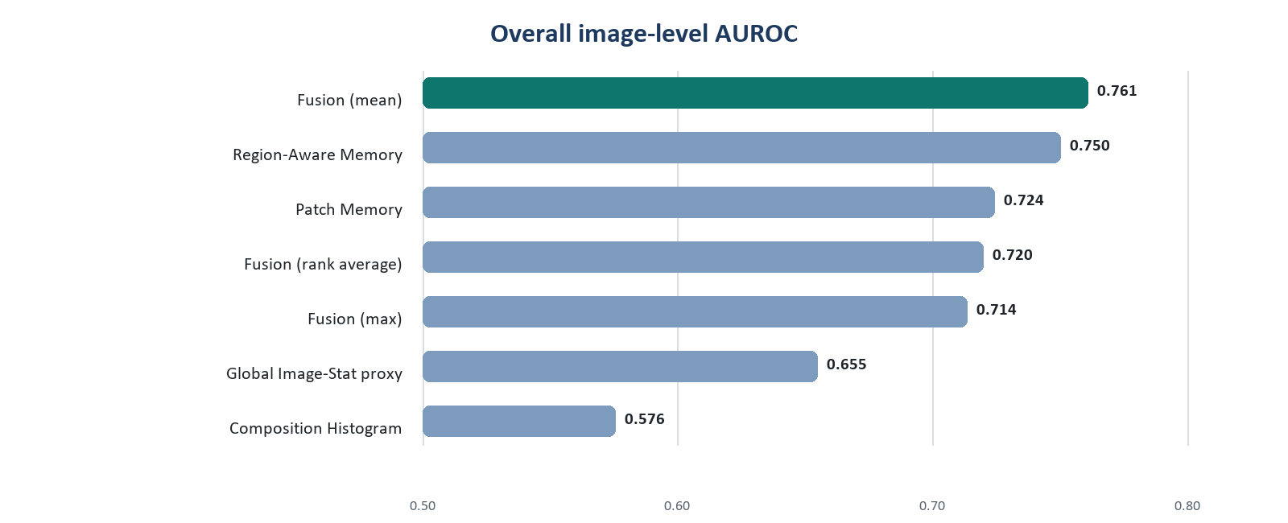
Figure 3. Corrected overall AUROC for all reported methods and fusion rules.
- Best pre-specified result: mean fusion reached 0.761 overall AUROC.
- Best single detector: Region-Aware Memory reached 0.750 overall AUROC.
- Main pattern: structural AUROC (0.804) was higher than logical AUROC (0.731).
Feature-selection analysis. Removing a duplicate Patch Memory entry and the weak Composition Histogram branch produced a three-branch score of 0.764 overall AUROC and 0.826 structural AUROC. This analysis used held-out test labels, so it is reported as a later diagnostic result. Mean fusion remains the headline result.

7. Explainability and Limitations
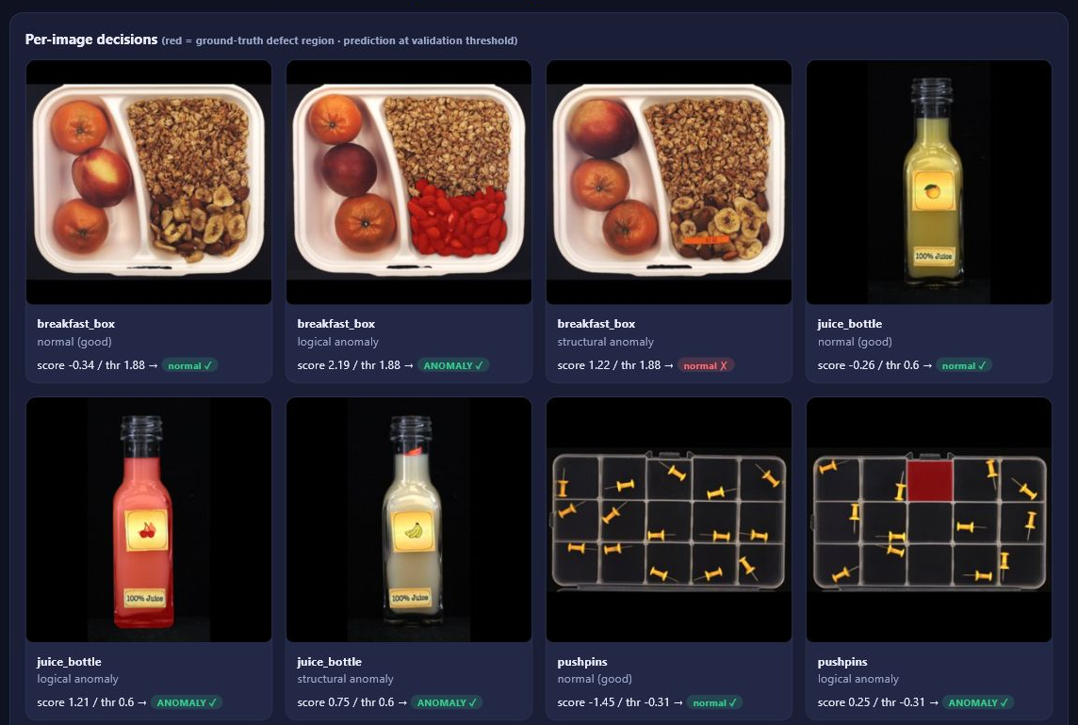
Figure 4. Per-image dashboard decisions with the anomaly score, validation threshold, predicted class, and ground-truth defect region.
The red region is the dataset annotation, while the score and prediction are model outputs. Keeping them separate prevents the ground truth from being mistaken for a generated explanation.
- Single run: the headline experiment has not been repeated across several random seeds.
- Padding: letterbox padding is not fully removed from patch modelling and scoring.
- Logical reasoning: nearest-neighbour features do not explicitly count parts or model long-range relations.
- Localization: the final comparison does not yet include complete pixel AUROC and AUPRO results.

8. Conclusion
The LOCO Anomaly Inspector meets the project requirements by combining unsupervised anomaly detection, method comparison, useful EDA, and an interactive dashboard. Mean fusion achieved 0.761 overall AUROC, and the Region-Aware branch was the strongest single detector. The results also show that logical anomalies remain harder than visible structural defects.

References
[1] Bergmann et al., MVTec LOCO AD and GCAD, International Journal of Computer Vision, 2022.
[2] Oquab et al., DINOv2: Learning Robust Visual Features without Supervision, TMLR, 2024.
[3] MVTec LOCO AD dataset documentation and project experiment outputs.

