LOCO Anomaly Inspector
Logical and Structural Anomaly Detection on MVTec LOCO AD
0.761  Overall AUROC | 0.731  Logical AUROC | 0.804  Structural AUROC

1. Introduction
Factories need to find defective products before they reach customers. This is difficult because real defects are rare and expensive to label. The LOCO Anomaly Inspector learns only from normal images and gives each test image an anomaly score.
- Structural anomalies: visible local defects such as damage, contamination, or deformation.
- Logical anomalies: missing, extra, misplaced, or incorrectly counted parts. The parts may look normal by themselves, so these cases are harder.
The project uses all five MVTec LOCO AD categories: breakfast box, juice bottle, pushpins, screw bag, and splicing connectors. The audited dataset contains 3,651 product images and 1,246 ground-truth masks.

2. Objective of the Product
The product combines a reproducible machine-learning pipeline with a HTML dashboard. Its main goals are:
- Detect defects: rank good and abnormal test images using normal training data.
- Explain results: show scores, thresholds, masks, and anomaly heatmaps.
- Compare methods: show logical, structural, overall AUROC, and F1.
- Support review: present only EDA and model outputs that help explain decisions.
Main result: Mean fusion achieved 0.761 overall AUROC. Region-Aware Memory was the strongest individual detector at 0.750 overall AUROC.

3. Features Description with Relevant Snapshots
The dashboard is available in an HTML file. It brings the dataset summary, model comparison, category results, threshold metrics, feature selection, EDA, and explanation examples into one place.
- Overview and leaderboard: show the best method and compare all seven scoring configurations.
- Category analysis: filters results by product category and anomaly type.
- Relevant EDA only: keeps sample images, mask overlays, normal mean/variance, and separate category heatmaps because these views help explain the modelling choices.
- Explainability: keeps ground-truth masks separate from model heatmaps and displays the model score against a validation-derived threshold.
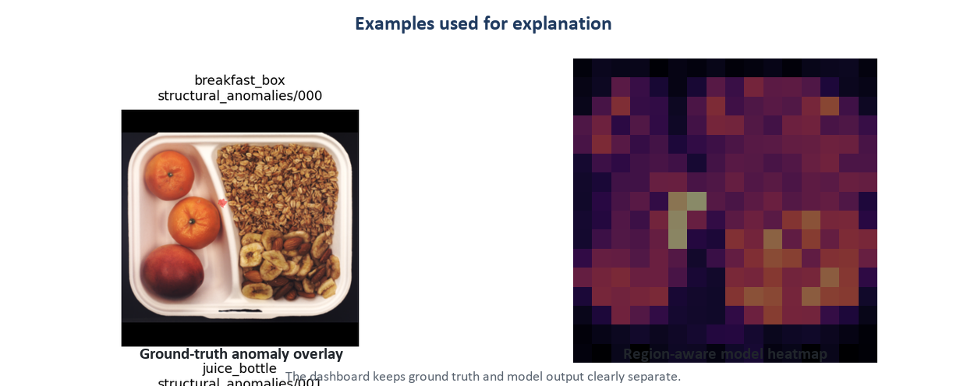
Figure 1. Relevant explanation views: a ground-truth overlay and a model anomaly heatmap. They are different objects and are labelled separately.
Important reading rule: The red overlay is the dataset annotation. The heatmap is the model output. Neither should be described as the other.

4. User Guidelines
- Open the dashboard. Use the dashboard.html in a browser.
- Start with the overview. Check the best overall AUROC and the logical-versus-structural difference.
- Use filters. Choose a method, category, and anomaly type to inspect detailed results.
- Read a decision. A score at or above the saved validation threshold is flagged as anomalous.
- Check the explanation. Compare the original image, ground truth, and model heatmap before drawing a conclusion.

5. Implementation Details
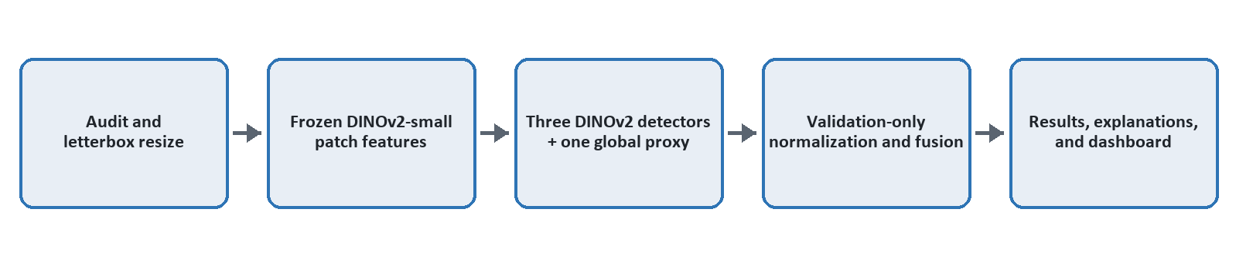
Figure 2. The corrected end-to-end workflow.
Images are resized to a 384 x 384 canvas with aspect-ratio-preserving letterboxing. Product images use bilinear interpolation; masks use nearest-neighbour interpolation and remain binary. Train/good images fit the normal models. Validation/good scores set normalization and thresholds. The test split is used only for final evaluation.
Branch | What it checks | Feature source
Patch Memory | Local patch appearance compared with normal memory. | DINOv2-small
Region-Aware Memory | Patch appearance plus approximate image position. | DINOv2-small
Composition Histogram | The global mix of visual words in the image. | DINOv2-small
Global Image-Stat Proxy | A fast global image-level difference score. | Non-DINOv2 proxy
Table 2. The four detector branches used in the comparison.
The three DINOv2 branches use real frozen DINOv2-small patch features. The Global Image-Stat Detector is a lightweight non-DINOv2 proxy. Scores are combined with mean, maximum, and rank-average fusion.

5. Implementation Details - Results
Method | Logical | Structural | Overall | F1
Fusion (mean) | 0.731 | 0.804 | 0.761 | 0.626
DINOv2 Region-Aware Memory | 0.730 | 0.784 | 0.750 | 0.626
DINOv2 Patch Memory (NN) | 0.697 | 0.765 | 0.724 | 0.612
Fusion (rank-avg) | 0.727 | 0.720 | 0.720 | 0.573
Fusion (max) | 0.692 | 0.741 | 0.714 | 0.551
Global Image-Stat Detector (proxy) | 0.634 | 0.683 | 0.655 | 0.474
DINOv2 Composition Histogram (BoVW) | 0.644 | 0.498 | 0.576 | 0.396
Table 1. Corrected image-level results. Mean fusion is the best pre-specified method.
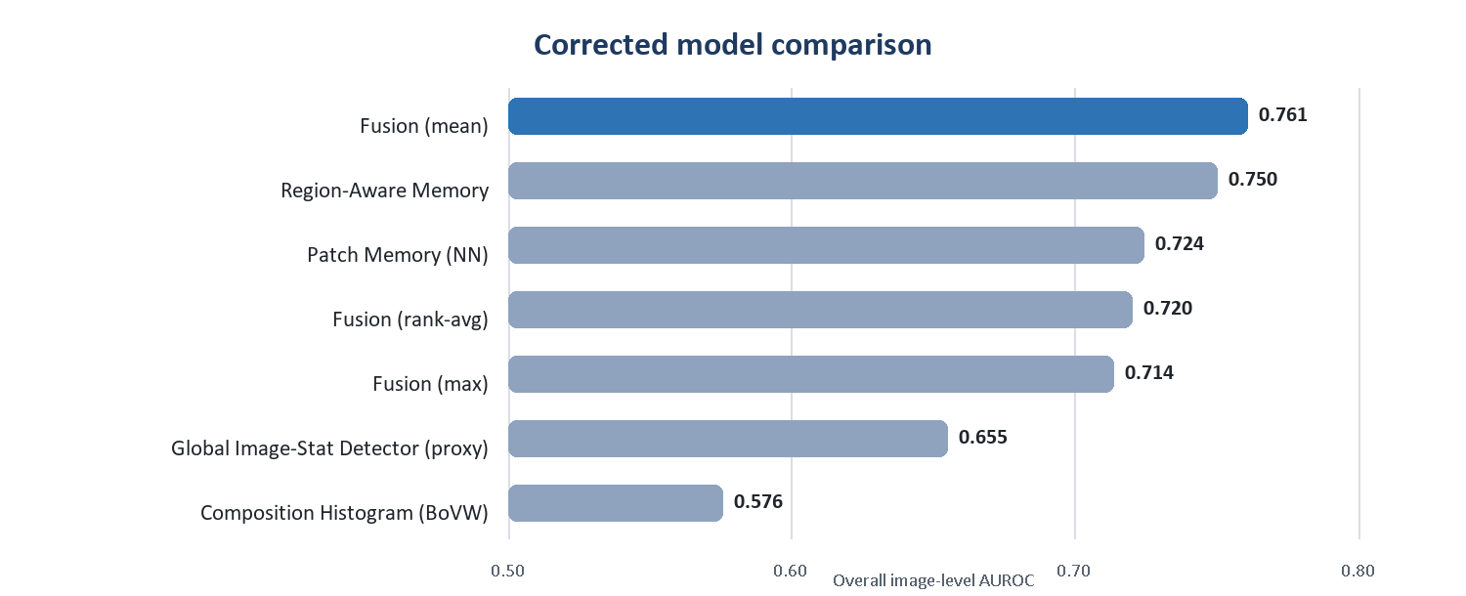
Figure 3. Corrected overall AUROC values from corrected_main_results.csv.
Feature selection: The Composition Histogram reduced fusion quality, and one Patch Memory entry was a duplicate. Removing both produced a smaller three-branch configuration with 0.764 overall AUROC and 0.826 structural AUROC. Because this analysis used held-out test labels, the pre-specified mean fusion remains the headline result.

Structural anomalies were easier than logical anomalies. Local damage changes patch appearance directly, while a wrong number or arrangement of normal-looking parts requires stronger relational reasoning.

Current Limitations
- Single seed: the headline experiment has not yet been repeated across several random seeds.
- Letterbox padding: padded regions are not fully removed from patch modelling and scoring.
- Logical reasoning: nearest-neighbour patch matching does not explicitly count parts or model long-range relationships.
- Localization metrics: the final tables do not yet include the complete pixel AUROC and AUPRO evaluation.
- Method scope: the global baseline is a proxy, and the patch-memory baseline is PatchCore-style rather than a full official reproduction.

6. Conclusion
The LOCO Anomaly Inspector meets the main project goal: it trains on normal images, detects both logical and structural anomalies, compares multiple ML/DL scoring methods, and explains results through dashboards and visual evidence.
Mean fusion achieved the best pre-specified overall result at 0.761 AUROC. Region-Aware Memory was the strongest single detector. The work also shows that keeping every feature is not always helpful: the reduced three-branch model was slightly better, although it is reported as analysis rather than the headline model.
The next priorities are to mask padded regions, repeat experiments across multiple seeds, add complete localization metrics, and test stronger relational methods for counting and arrangement errors.
Final assessment: The project delivers a clear, reproducible, and honest anomaly-detection product. Its strongest contribution is the combination of real DINOv2 features, leakage-aware evaluation, model comparison, feature selection, and simple visual explanation.

References
[1] Bergmann et al. MVTec LOCO AD and GCAD. IJCV, 2022.
[2] Batzner et al. EfficientAD. WACV, 2024.
[3] Damm et al. AnomalyDINO. WACV, 2025.
[4] Hsieh et al. CSAD. BMVC, 2024.

