LOCO Anomaly Inspector
Defense-Ready Technical Documentation Manual
Logical and Structural Anomaly Detection on MVTec LOCO AD

Repository | Az-main/Data-Analytics-Lab-Project
Inspected local snapshot | main @ f934edc
Core engine | 01_notebooks/loco_project_utils.py
Primary deliverables | 09_dashboard/dashboard.html, 07_paper_draft reports and slides
Truthful method stance | Lightweight, training-free DINOv2-based baseline; EfficientAD is a proxy; PatchCore row is PatchCore-style and duplicate of DINOv2 PatchMemory in current outputs.
Viva positioning: The defensible claim is not that this project reproduces every heavyweight SOTA baseline. The defensible claim is that it builds a transparent, reproducible, DINOv2-based anomaly scoring pipeline with local memory, region awareness, composition histograms, validation-only fusion, an offline dashboard, and explicit limitation analysis.

1. Executive Summary and Global System Architecture
The project builds an unsupervised visual anomaly detection system for MVTec LOCO AD. The key difficulty is that the test set contains both structural defects, which are local appearance changes, and logical defects, where each local component can look normal but the global composition is wrong. The system therefore avoids a single black-box classifier and uses a set of complementary anomaly scorers trained only on defect-free images.
Core research claim: A lightweight, training-free baseline can be made defensible if it is honest about its scope: frozen DINOv2 patch features provide semantic local descriptors; patch-memory scoring detects local novelty; region-aware memory adds positional structure; composition histograms summarize global part distribution; and validation-only fusion combines heterogeneous evidence without using test labels for calibration.

High-Level Objective
- Detect anomalies using only normal training images; no labelled defects are used for model fitting.
- Report logical and structural anomaly performance separately, because LOCO was designed to test both.
- Make the pipeline auditable: saved preprocessing metadata, hash-based leakage audit, fixed seeds, configs, score CSVs, and dashboard-ready artifacts.
- Deliver an offline explainability dashboard and short report, rather than only notebook outputs.

End-to-End Data and Model Flow
RAW MVTec LOCO AD ("Phase 1", read-only)
-> dataset audit: counts, corrupted files, image metadata
-> MD5 + perceptual hash leakage check across splits
-> deterministic letterbox resize to 384 x 384
-> cleaned products and masks under 03_cleaned_data/loco_cleaned_letterbox_384
-> EDA: sample grids, masks, spatial heatmaps, edge density, mask-area distribution
-> feature extraction:
DINOv2-small patch tokens for main DINOv2 methods
fallback patch statistics only when auto backend cannot load DINOv2
global image statistics for the EfficientAD proxy row
-> scorers:
PatchCore-style DINOv2 patch memory
DINOv2 patch memory baseline
GridAware DINOv2 region-conditioned memory
DINOv2 composition histogram / bag-of-visual-words
Global Image-Stat detector proxy
-> validation-good score normalization:
z_m(x) = (s_m(x) - mu_val_good_m) / sigma_val_good_m
-> fusion:
mean, max, rank-average, nominal weighted average
-> evaluation:
image AUROC, logical/structural split, corrected dashboard F1 at validation threshold
-> deliverables:
dashboard.html, report DOCX/PDF, PPTX slides, final tables, figures, result ZIP

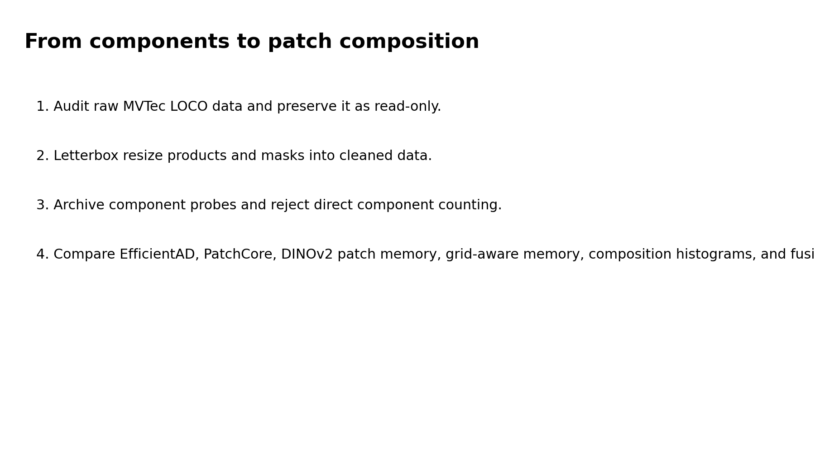
Figure 1. Existing project pipeline overview exported by Notebook 12.

Architecture Truth Table
Component | Implemented status | Defense interpretation
DINOv2-small feature backend | Implemented for current DINOv2 methods | Runtime CSVs confirm feature_backend = dinov2-small for PatchCore-style, PatchMemory, GridAware, and CompositionHistogram.
Real EfficientAD | Not implemented | Stage 04 is a deterministic global image-stat proxy. It should be defended as a lightweight baseline, not official EfficientAD.
Real PatchCore | PatchCore-style only | The current PatchCore score file is byte-identical to DINOv2 PatchMemory. It uses the same DINOv2 nearest-neighbor memory code path.
Greedy PatchCore coreset | Not implemented | The repo caps memory with random sampling to 50,000 patches. Greedy coreset is a future improvement.
Pixel-level PRO/sPRO | Not implemented in final tables | Pixel masks exist and heatmaps are produced, but official LOCO localization metrics are future work.
Dashboard and report | Implemented | dashboard.html is self-contained; product report and slide deck are current deliverables.

2. Notebook-by-Notebook Architectural Breakdown
The notebooks are deliberately thin orchestration layers. Most computation is centralized in loco_project_utils.py, which avoids logic drift between notebooks. Each notebook sets LAB_ROOT, imports exactly one stage function, runs it, prints saved outputs, and performs acceptance checks.
Notebook | Cells | Primary stage call
01_preprocessing_reproducibility.ipynb | 12 | from loco_project_utils import run_stage01_preprocessing; result = run_stage01_preprocessing(lab_root=LAB_ROOT, target_size=384)
02_eda_cleaned_letterbox.ipynb | 12 | from loco_project_utils import run_stage02_eda; result = run_stage02_eda(lab_root=LAB_ROOT)
03_dinov2_component_probe_archive.ipynb | 13 | from loco_project_utils import run_stage03_component_probe; result = run_stage03_component_probe(lab_root=LAB_ROOT, backend=FEATURE_BACKEND)
04_baseline_efficientad.ipynb | 12 | from loco_project_utils import run_stage04_efficientad; result = run_stage04_efficientad(lab_root=LAB_ROOT)
05_baseline_patchcore.ipynb | 13 | from loco_project_utils import run_stage05_patchcore; result = run_stage05_patchcore(lab_root=LAB_ROOT, backend=FEATURE_BACKEND)
06_dinov2_patch_memory_baseline.ipynb | 13 | from loco_project_utils import run_stage06_dinov2_patchmemory; result = run_stage06_dinov2_patchmemory(lab_root=LAB_ROOT, backend=FEATURE_BACKEND)
07_grid_aware_patch_composition.ipynb | 13 | from loco_project_utils import run_stage07_gridaware; result = run_stage07_gridaware(lab_root=LAB_ROOT, backend=FEATURE_BACKEND, region_size=6)
08_composition_histogram_method.ipynb | 13 | from loco_project_utils import run_stage08_composition_histogram; result = run_stage08_composition_histogram(lab_root=LAB_ROOT, backend=FEATURE_BACKEND, k_selected=32)
09_fusion_experiments.ipynb | 12 | from loco_project_utils import run_stage09_fusion; result = run_stage09_fusion(lab_root=LAB_ROOT)
10_full_evaluation_tables.ipynb | 12 | from loco_project_utils import run_stage10_final_tables; result = run_stage10_final_tables(lab_root=LAB_ROOT)
11_qualitative_failure_analysis.ipynb | 12 | from loco_project_utils import run_stage11_qualitative; result = run_stage11_qualitative(lab_root=LAB_ROOT)
12_paper_figures_export.ipynb | 12 | from loco_project_utils import run_stage12_paper_exports; result = run_stage12_paper_exports(lab_root=LAB_ROOT)
Run_DINOv2_Colab.ipynb | 30 | res = L.run_stage01_preprocessing(lab_root=LAB_ROOT); t = time.time(); L.run_stage04_efficientad(lab_root=LAB_ROOT); print(f"stage04 done in {time.time()-t:.0f}s")

01_preprocessing_reproducibility.ipynb
Notebook Name and Core Objective: Build a deterministic, auditable cleaned dataset.
Architectural Design Choices: It appears first because every later EDA, model, heatmap, and mask lookup assumes the cleaned letterbox tree exists. The design separates raw data policy from modeling so that the raw MVTec data remains read-only.
Code and Logic Breakdown: Calls run_stage01_preprocessing. This resolves LAB_ROOT, creates project folders, audits PNG files, computes hash records, checks duplicates/leakage, letterbox-resizes product images and masks to 384 x 384, verifies output size and binary masks, and writes preprocessing config/protocol files.
Inputs, Transformations, Outputs: Outputs: dataset_audit_full.csv, product/mask summaries, image_hashes.csv, duplicate_leakage_candidates.csv, resize_letterbox_metadata.csv, cleaned_letterbox_verify.csv, config_preprocessing.json, preprocessing_protocol.txt, environment_versions.csv, requirements_freeze.txt.

02_eda_cleaned_letterbox.ipynb
Notebook Name and Core Objective: Generate decision-relevant EDA on the cleaned dataset.
Architectural Design Choices: EDA is run after preprocessing so plots match exactly what the models see. It is not used to tune on test labels; it is descriptive and supports architectural choices such as region-aware scoring.
Code and Logic Breakdown: Calls run_stage02_eda. It gathers product and mask records, creates image grids, overlays masks on products, computes normal mean/variance maps, mask area distribution, spatial anomaly frequency heatmap, and edge-density statistics.
Inputs, Transformations, Outputs: Outputs: EDA PNGs in 04_probe_results plus eda_summary_table.csv, eda_edge_density_stats.csv, eda_conclusion.txt.

03_dinov2_component_probe_archive.ipynb
Notebook Name and Core Objective: Probe whether frozen features can support explicit component counting.
Architectural Design Choices: The notebook is archived rather than promoted to the final method. It exists to show that an alternative was tested and rejected for reliability reasons.
Code and Logic Breakdown: Calls run_stage03_component_probe with FEATURE_BACKEND. It extracts patch features for representative anomalous images, applies PCA and KMeans, visualizes pseudo-components, and summarizes component-count instability.
Inputs, Transformations, Outputs: Outputs: probe_kmeans_segmentation.png, probe_pca_rgb.png, improved_pca_component_probe_visual.png, raw/summary CSVs, component_probe_conclusion.txt.

04_baseline_efficientad.ipynb
Notebook Name and Core Objective: Create a fast global baseline, historically named EfficientAD.
Architectural Design Choices: This stage provides a lightweight non-DINOv2 reference point and keeps the pipeline executable without training a neural network. The name is legacy; the implementation is a proxy.
Code and Logic Breakdown: Calls run_stage04_efficientad. For each category, it computes image_level_features on train/good, estimates mean and standard deviation, scores validation/test images by RMS z-distance, and saves simple map overlays.
Inputs, Transformations, Outputs: Outputs: efficientad_scores.csv, efficientad_results_per_category.csv, efficientad_results_summary.csv, efficientad_runtime_memory.csv, efficientad_config.yaml, efficientad_logs.txt, anomaly maps.

05_baseline_patchcore.ipynb
Notebook Name and Core Objective: Run a PatchCore-style patch nearest-neighbor memory baseline.
Architectural Design Choices: It uses the shared patch-memory family to model the distribution of normal patches. In the current run this is not official WideResNet PatchCore; it is a DINOv2 nearest-neighbor memory row.
Code and Logic Breakdown: Calls run_stage05_patchcore with FEATURE_BACKEND. It builds a memory bank from train/good patch embeddings, optionally caps it at 50,000 patches, scores validation/test patches by nearest-neighbor distance, and aggregates the top 5 percent patch scores.
Inputs, Transformations, Outputs: Outputs: patchcore_scores.csv, per-category/summary/runtime CSVs, patchcore_config.json/yaml, logs, patchcore_anomaly_maps.

06_dinov2_patch_memory_baseline.ipynb
Notebook Name and Core Objective: Run the explicitly named DINOv2 PatchMemory baseline.
Architectural Design Choices: This is the clean name for what the patch-memory code actually does under the DINOv2 backend: frozen DINOv2 token extraction plus memory-bank distance scoring.
Code and Logic Breakdown: Calls run_stage06_dinov2_patchmemory. The code path is identical to Notebook 05 except output folder and method name, which is why the current PatchCore and PatchMemory rows match exactly.
Inputs, Transformations, Outputs: Outputs: dinov2_patchmemory_scores.csv, result tables, runtime/config CSV/JSON, dinov2_patchmemory_anomaly_maps.

07_grid_aware_patch_composition.ipynb
Notebook Name and Core Objective: Add spatial conditioning to patch-memory anomaly scoring.
Architectural Design Choices: Logical anomalies often depend on where an object part appears, not only what the local patch texture looks like. Region conditioning gives the memory bank coarse layout awareness.
Code and Logic Breakdown: Calls run_stage07_gridaware with region_size=6. It builds memory banks indexed by category and region_id. Each test patch is compared to the normal memory from its region, falling back to category-level memory if needed.
Inputs, Transformations, Outputs: Outputs: gridaware_scores.csv, per-category/summary/runtime CSVs, gridaware_config.json, top-k and region-size ablation metadata, gridaware_anomaly_maps.

08_composition_histogram_method.ipynb
Notebook Name and Core Objective: Model global composition as a bag of DINOv2 visual words.
Architectural Design Choices: Nearest-neighbor patch memory is local. This notebook adds an image-level distributional representation intended to capture whether the normal mixture of parts has changed.
Code and Logic Breakdown: Calls run_stage08_composition_histogram with k_selected=32. It samples train/good patches, fits MiniBatchKMeans, converts each image into a normalized visual-word histogram, estimates normal histogram mean/covariance, and scores by Mahalanobis distance.
Inputs, Transformations, Outputs: Outputs: composition_hist_scores.csv, per-category/summary/runtime CSVs, config, k-ablation metadata, per-category histogram visualizations.

09_fusion_experiments.ipynb
Notebook Name and Core Objective: Combine heterogeneous scorers after validation-good normalization.
Architectural Design Choices: Scores from different methods have incompatible scales, so fusion first z-normalizes each scorer using validation/good only. This prevents test-label leakage during score calibration.
Code and Logic Breakdown: Calls run_stage09_fusion. It loads all method score CSVs, aligns by image_id, computes mean, max, rank-average, and nominal weighted average fusion scores, then writes fusion score/result tables.
Inputs, Transformations, Outputs: Outputs: fusion_scores.csv, fusion_results_per_category.csv, fusion_results_summary.csv, fusion_ablation.csv, fusion_config.json.

10_full_evaluation_tables.ipynb
Notebook Name and Core Objective: Consolidate all method and fusion scores into final evaluation tables.
Architectural Design Choices: This notebook is the reporting layer for scores and runtime metadata. It creates the tables consumed by report/dashboard builders.
Code and Logic Breakdown: Calls run_stage10_final_tables. It concatenates score files, recomputes per-category metrics, pivots method x anomaly-type AUROC/F1 tables, gathers runtime files, and merges ablation metadata.
Inputs, Transformations, Outputs: Outputs: main_results_table.csv, per_category_results_table.csv, ablation_table.csv, efficiency_table.csv, final_scores_all_methods.csv.

11_qualitative_failure_analysis.ipynb
Notebook Name and Core Objective: Generate qualitative success/failure grids and score-overlap summaries.
Architectural Design Choices: Numerical metrics do not explain failure modes. This notebook creates visual cases for defense discussion and dashboard explainability.
Code and Logic Breakdown: Calls run_stage11_qualitative. It selects cases from final scores, builds image/mask/score grids, and writes descriptive score statistics by category/defect.
Inputs, Transformations, Outputs: Outputs: qualitative_success_cases.png, qualitative_failure_cases.png, method_comparison_maps.png, category_failure_analysis.csv, failure_case_notes.txt.

12_paper_figures_export.ipynb
Notebook Name and Core Objective: Export paper/report figures from pipeline outputs.
Architectural Design Choices: This is a reproducible presentation layer. It prevents manual screenshot-based figures and keeps report visuals linked to current results.
Code and Logic Breakdown: Calls run_stage12_paper_exports. It creates pipeline, dataset example, component-probe, method-comparison, failure-case, speed-accuracy, and feature-selection figures.
Inputs, Transformations, Outputs: Outputs: figure_1_pipeline_overview.png through figure_6_speed_accuracy_tradeoff.png plus figure_feature_selection.png.

Run_DINOv2_Colab.ipynb
Notebook Name and Core Objective: Run the real DINOv2 feature backend on a GPU and export refreshed results.
Architectural Design Choices: The local notebooks use FEATURE_BACKEND='auto' for convenience. The Colab notebook forces a real DINOv2 extractor so results cannot silently fall back to handcrafted patch statistics.
Code and Logic Breakdown: It checks GPU availability, installs/imports transformers, mounts Drive, locates the Phase 1 dataset, copies data to local Colab disk, clones the repo, monkey-patches extract_patch_features with a DINOv2-only normalized extractor, runs stages 01/04/05/06/07/08/09/10, verifies feature_backend, and zips result folders.
Inputs, Transformations, Outputs: Outputs: refreshed 05_baselines and 06_method_results contents, loco_dinov2_results.zip, runtime CSVs with feature_backend = dinov2-small for DINOv2 methods.

3. Methodological Deep-Dive and Algorithmic Intuition

3.1 Dataset, Splits, and Preprocessing Logic
The system obeys a strict unsupervised anomaly-detection protocol. Train/good images define normality. Validation/good images calibrate thresholds and normalization. Test images, which contain good, logical, and structural samples, are held out for final evaluation. Ground-truth masks are used for descriptive EDA and qualitative interpretation, not for training the anomaly scorers.
Category | Split | Defect type | Images
breakfast_box | test | good | 102
breakfast_box | test | logical_anomalies | 83
breakfast_box | test | structural_anomalies | 90
breakfast_box | train | good | 351
breakfast_box | validation | good | 62
juice_bottle | test | good | 94
juice_bottle | test | logical_anomalies | 142
juice_bottle | test | structural_anomalies | 94
juice_bottle | train | good | 335
juice_bottle | validation | good | 54
pushpins | test | good | 138
pushpins | test | logical_anomalies | 91
pushpins | test | structural_anomalies | 81
pushpins | train | good | 372
pushpins | validation | good | 69
screw_bag | test | good | 122
screw_bag | test | logical_anomalies | 137
screw_bag | test | structural_anomalies | 82
screw_bag | train | good | 360
screw_bag | validation | good | 60
splicing_connectors | test | good | 119
splicing_connectors | test | logical_anomalies | 108
splicing_connectors | test | structural_anomalies | 85
splicing_connectors | train | good | 360
splicing_connectors | validation | good | 60

The preprocessing function letterbox_resize_pil preserves aspect ratio and pads to a fixed 384 x 384 canvas. For product images it uses bilinear interpolation; for masks it uses nearest-neighbor interpolation and re-binarizes nonzero pixels to 255. This matters because anomaly masks must remain categorical labels, not blurred grayscale regions.

3.2 DINOv2 Feature Extraction
DINOv2 is a self-supervised Vision Transformer representation. It is useful here because industrial anomaly detection has few or no labelled defects; a supervised classifier would learn the labels available during training, while DINOv2 provides general visual features without requiring defect labels. In this project, DINOv2-small produces 384-dimensional patch tokens. A patch token is not a class prediction. It is a vector summarizing the visual content of a local image region after transformer self-attention.
Patch token vs global embedding: A global embedding compresses the whole image into one vector and is useful for image-level similarity. A patch embedding keeps spatial granularity: every token corresponds to a local region, so abnormal regions can be localized by assigning anomaly scores to tokens and reshaping them back into a grid.

Under the hood, try_dinov2_patch_features loads facebook/dinov2-small through AutoImageProcessor and AutoModel. It discards the CLS token and keeps the remaining patch tokens. The grid shape is inferred as sqrt(number of tokens). For the Colab real-DINOv2 run, the monkey-patched extractor L2-normalizes tokens so Euclidean nearest neighbor distance becomes equivalent to cosine distance by the identity:
For normalized u and v: ||u - v||_2^2 = 2 - 2 cos(u, v)

3.3 PatchCore-Style Memory Bank
PatchCore's central idea is simple but powerful: store representative normal patch features, then score a new patch by how far it lies from the nearest normal patch. If a test patch has no close neighbor in normal memory, it is considered anomalous. The repo implements this paradigm in build_patch_memory and score_records_patch_memory.
Fit:
M = union of f_i(x) for every train/good image x and patch i
If |M| > 50000, randomly sample 50000 features in the current implementation.

Score patch:
d_i(x) = min_{m in M} || f_i(x) - m ||_2

Score image:
S(x) = mean(top 5 percent of {d_i(x)})

The top-percent aggregation is important. A pure max score can be noisy because one bad patch dominates. A full mean can dilute a small scratch because most patches are normal. The top 5 percent mean is a compromise: it emphasizes suspicious regions while remaining more stable than a single maximum.

3.4 Neighborhood Aggregation and Coreset Sampling
Canonical PatchCore uses neighborhood-aware patch features and greedy coreset selection. The coreset objective is to keep a small subset C of the normal memory M such that every original memory vector has a nearby representative in C. This reduces inference cost because nearest-neighbor search runs against |C| rather than |M|.
Greedy k-center coreset intuition:
Start C with one seed point.
Repeatedly add the point in M whose distance to its nearest point in C is largest.
Stop when C reaches the target size.
Result: preserve coverage of normal feature space while reducing memory.

Current implementation distinction: This repo does not implement greedy coreset selection. It uses a reproducible random cap of 50,000 patch features. In viva, say: 'We implemented a PatchCore-style memory baseline, not full official PatchCore. Greedy coreset is listed as a future optimization because it reduces latency while preserving coverage.'

3.5 Anomaly Scoring and Localization
Each patch receives a scalar nearest-neighbor distance. The vector of patch scores is reshaped into the token grid and overlaid on the image using a magma heatmap. High-intensity areas mean the local DINOv2 descriptor is far from the normal memory. The image-level score is the top-5-percent mean of these patch distances.
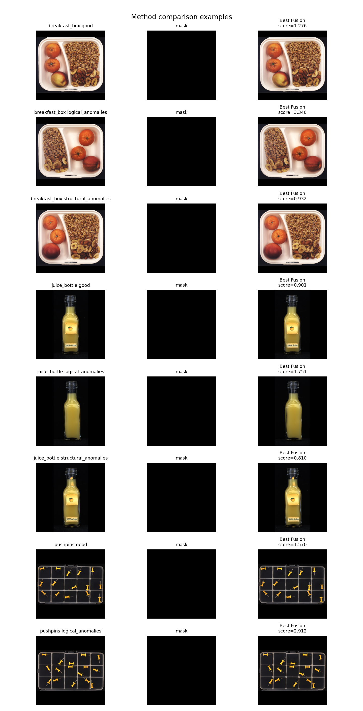
Figure 2. Qualitative method comparison examples generated by Notebook 11.

3.6 GridAware DINOv2 Region-Conditioned Memory
GridAware DINOv2 modifies nearest-neighbor memory by conditioning it on coarse spatial region. Instead of one global memory bank per category, it stores normal patches by (category, region_id). A patch in the upper-left region is compared primarily against normal upper-left patches, not all normal patches. This helps logical/layout anomalies because a part can be visually normal but spatially misplaced.
region_id(i, j, H, W, R, C):
r = floor(i / H * R)
c = floor(j / W * C)
return r * C + c

For this run: region_size = 6, so R = C = 6 per image grid.
Runtime file: 180 region memories, 455168 stored features.

3.7 Composition Histogram / Bag-of-Visual-Words
Patch memory is local. CompositionHistogram adds a global distributional view. It clusters normal DINOv2 patches into k visual words using MiniBatchKMeans, then represents each image as a normalized histogram over those words. If the object composition changes, the histogram can deviate even when individual patches look plausible.
KMeans:
Train visual words on sampled train/good patch features.
Current k_selected = 32.

Image histogram:
h_j(x) = count(patches assigned to word j) / total patches

Mahalanobis score:
S(x) = sqrt((h(x) - mu)^T Sigma^{-1} (h(x) - mu))

Why it underperformed: The live score is Mahalanobis distance. The code also computes cosine-to-mean and IsolationForest scores but does not use them in the final score. Current results show CompositionHistogram is logical-leaning in concept but harmful to full fusion on this run, which the feature-selection analysis correctly exposes.

3.8 Global Image-Stat Detector Proxy
Stage 04 computes a 39-dimensional global descriptor: RGB mean, RGB standard deviation, average grayscale edge gradient, and a 32-bin grayscale histogram. For each category, train/good features define a normal mean and standard deviation. A test image score is the root-mean-square z-distance from that normal profile. This is fast and interpretable, but it is not official EfficientAD.
S(x) = sqrt(mean(((g(x) - mu_train_good) / sigma_train_good)^2))

3.9 Fusion and Feature Selection
Fusion is required because each branch captures a different abnormality signal. Before fusion, scores are normalized using validation/good only, not test labels. The main fusion is the mean of z-normalized method scores. The dashboard also reports max and rank-average fusion. The nominal weighted average in the utility code currently uses equal weights, so it is equivalent to mean and should not be defended as a distinct learned weighting scheme.
For method m:
z_m(x) = (s_m(x) - mean_val_good_m) / (std_val_good_m + epsilon)

Mean fusion:
S_fusion(x) = (1/M) sum_m z_m(x)

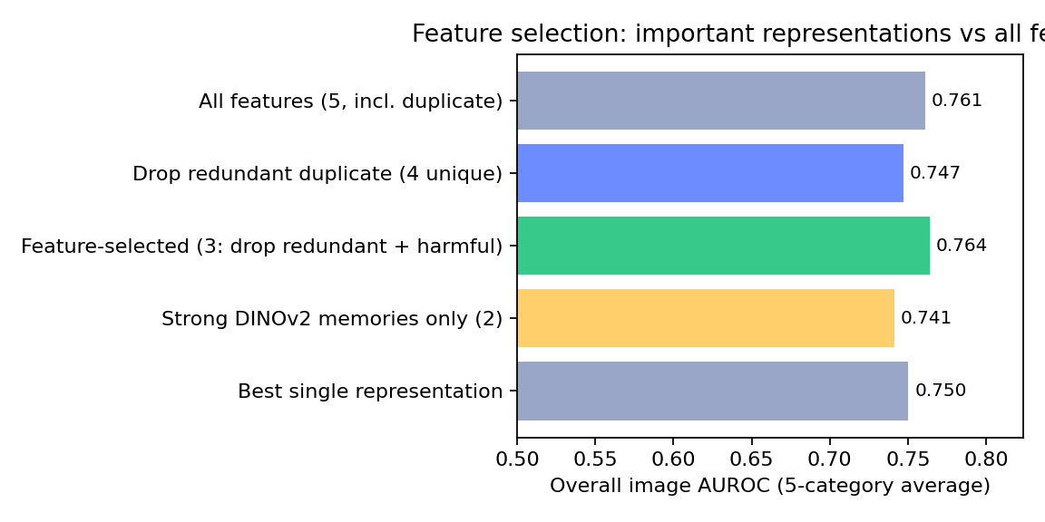
Figure 3. Existing feature-selection figure from the project report artifacts.

4. Completed Alternatives and Defensibility: Why X and Not Y?
The strongest defense is to separate project purpose from benchmark reproduction. Heavyweight methods are valuable as related work and future baselines, but the project deliberately emphasizes a lightweight, auditable baseline that can be explained in a dashboard and defended from the code.
Design decision | Alternative | Reason for final choice | Defense caveat
Frozen DINOv2-small tokens | Train a supervised CNN/ViT | No defect labels are available for training; DINOv2 gives strong semantic features without supervised defect labels. | DINOv2-base may improve accuracy but increases compute.
Patch-memory nearest neighbor | Autoencoder reconstruction | Memory scoring does not require learning to reconstruct anomalies; reconstruction models can generalize too well and reconstruct defects. | Memory bank can be large and needs approximate NN or coreset for deployment.
Region-aware memory | Global memory only | Spatial conditioning detects misplaced normal-looking parts, which is central to logical anomalies. | Region size is a hyperparameter; current metadata records candidates but not a full measured ablation table.
Composition histogram | Explicit component counter | KMeans visual words are lightweight and do not require segmentation labels or SAM/Grounding-DINO setup. | The component probe showed unstable counts; a stronger component method is future work.
Validation-only fusion | Train a supervised meta-classifier | No labelled validation anomalies should be used for training; validation-good normalization is leakage-safer. | Fusion weights are not learned in the current code.
EfficientAD proxy | Official EfficientAD | The proxy keeps a fast baseline in the project and avoids merely reproducing an already established method. | Never claim it as real EfficientAD.
PatchCore-style row | Official Anomalib PatchCore | The local row tests the memory-bank idea with DINOv2 features. | It is duplicate with DINOv2 PatchMemory in current outputs; merge or relabel in defense.

DINOv2 vs ResNet and Conventional ViTs
A supervised ResNet trained on ImageNet is optimized to separate ImageNet classes. It can still be a strong feature extractor, but its representation is shaped by class-discriminative supervision. DINOv2 is self-supervised and tends to preserve richer object-part and texture correspondences, useful when the anomaly class is unknown. Conventional ViTs trained supervised can be brittle under out-of-distribution industrial layouts because their global classification objective is not aligned with patch-level novelty detection.

Memory Bank vs Reconstruction, GANs, and Flows
Family | Mechanism | Why not primary here | When it would be useful
Autoencoders | Reconstruct input and use reconstruction error. | Can reconstruct anomalies too well; blurry reconstructions make localization ambiguous; training adds instability. | When a compact normal manifold is easy to learn and pixel-level reconstruction error is reliable.
GANs | Learn normal image distribution with generator/discriminator. | Harder to train, mode collapse risk, and less transparent for a course defense. | When high-fidelity synthesis is central to the research question.
Normalizing flows | Learn invertible density model over features. | Good flows need careful backbone and density calibration; likelihood can be misleading OOD. | When exact likelihood over deep features is the main benchmark target.
Student-teacher | Compare teacher and student feature responses. | EfficientAD already covers this strongly; reproducing it is less novel for this project. | As an external baseline or deployment-speed benchmark.
Patch memory | Nearest normal patch in feature space. | Memory-heavy but transparent, training-free, and localizable. | Best fit for lightweight unsupervised industrial baseline.

5. Experimental Analysis and Output Interpretation

5.1 Expected Output Artifacts
Artifact | Location | Meaning
Preprocessing audit | 02_audit_reproducibility | Counts, hashes, leakage candidates, resize metadata, environment capture.
EDA figures | 04_probe_results | Dataset inspection, mask overlays, normal mean/variance, spatial anomaly heatmaps, edge/mask distributions.
Score CSVs | 05_baselines, 06_method_results | One row per validation/test image with method score, label, split, category, and metadata.
Anomaly maps | method anomaly_map folders | Patch-level score grids overlaid on images; high intensity means far from normal memory.
Final tables | 06_method_results/Final_Evaluation | Consolidated image-level AUROC/F1/runtime tables.
Corrected dashboard tables | 09_dashboard | Dashboard uses validation-good 90th percentile thresholds for F1-style decisions.
Dashboard | 09_dashboard/dashboard.html | Self-contained interactive deliverable with results, EDA, examples, and insights.
Reports/slides | 07_paper_draft | Human-facing project report, product report, PPTX, and exported figures.

5.2 Interpreting Pixel-Level Anomaly Maps
The heatmap is not a probability map. It is a spatial visualization of patch anomaly scores. A brighter region means the patch descriptor has a larger nearest-neighbor distance from normal training memory. In structural anomalies this often aligns with a scratch or damage region. In logical anomalies the map can be diffuse or misleading because the error may be global composition rather than a single abnormal texture.
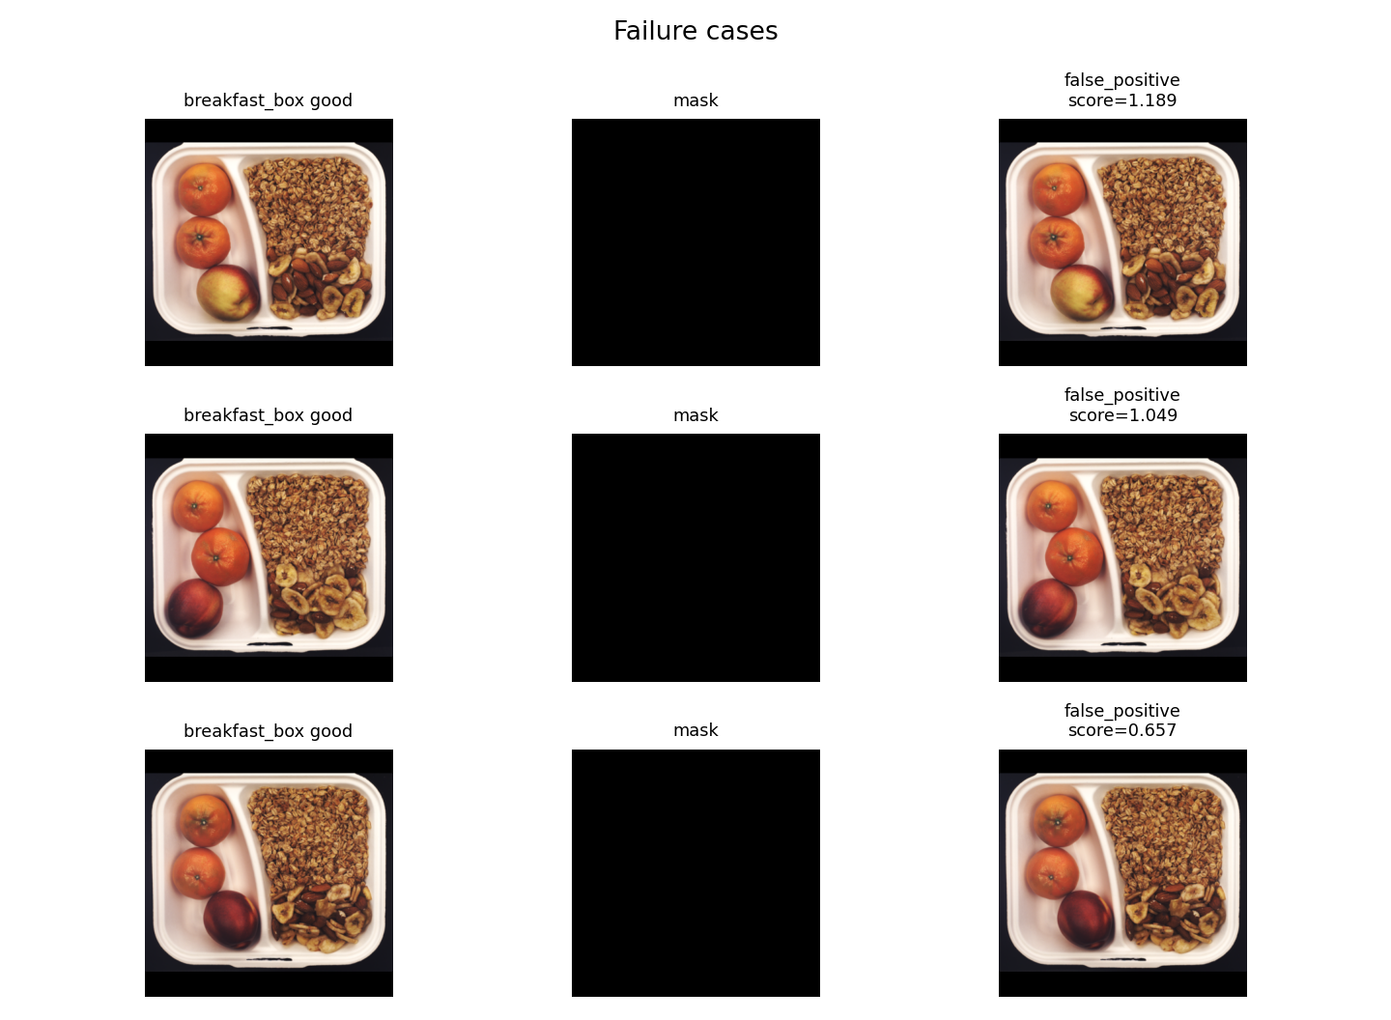
Figure 4. Existing failure-case figure used for qualitative interpretation.

5.3 Evaluation Metrics
Image-level AUROC:
TPR(t) = TP(t) / (TP(t) + FN(t))
FPR(t) = FP(t) / (FP(t) + TN(t))
AUROC = integral_0^1 TPR(FPR) dFPR

AUROC measures ranking quality over all thresholds. A value of 1.0 means every anomalous image scores above every normal image. A value of 0.5 is random ranking. It does not require choosing a threshold, which is why it is the most reliable current headline metric in this repo.
Pixel-level AUROC ranks pixels by anomaly heatmap intensity and compares them to ground-truth mask pixels. It is stricter than image AUROC because a method must place high scores on the defective region, not merely flag the whole image. The current project has masks and maps but does not compute pixel AUROC in the final tables.
PRO and sPRO: Per-Region Overlap measures how well predicted anomaly regions overlap each connected ground-truth defect region across thresholds. It prevents large defects from dominating tiny defects. sPRO is the saturated variant emphasized by LOCO-style localization evaluation. This is important future work because LOCO is not only an image-classification benchmark; it also evaluates localization quality.
Inference time and memory utilization: time_ms_per_image measures scoring latency after model setup. Memory bank size controls both RAM usage and nearest-neighbor search cost. Patch memory has strong localization but scales roughly with number of stored normal patches; composition histograms are much lighter because each image becomes a 32-bin histogram.

5.4 Current Main Results
Method | Logical AUROC | Structural AUROC | Overall AUROC | F1 overall
Fusion (mean) | 0.731 | 0.804 | 0.761 | 0.626
DINOv2 Region-Aware Memory | 0.730 | 0.784 | 0.750 | 0.626
DINOv2 Patch Memory (NN) | 0.697 | 0.765 | 0.724 | 0.612
Fusion (rank-avg) | 0.727 | 0.720 | 0.720 | 0.573
Fusion (max) | 0.692 | 0.741 | 0.714 | 0.551
Global Image-Stat Detector (proxy) | 0.634 | 0.683 | 0.655 | 0.474
DINOv2 Composition Histogram (BoVW) | 0.644 | 0.498 | 0.576 | 0.396


Figure 5. Existing method-comparison figure from the project artifacts.
Result interpretation: Fusion mean is the best pre-specified current method at 0.761 overall AUROC. GridAware DINOv2 is the strongest single branch at 0.750. DINOv2 Patch Memory is useful but duplicated by the current PatchCore-style row. Composition Histogram is conceptually important but empirically weak in the current run, especially on structural anomalies.

5.5 Runtime and Memory Tradeoffs
Method | Runtime | Memory | Interpretation
Global Image-Stat proxy | 18.5-22.7 ms/image | 0 | Fast global baseline, no patch memory.
PatchCore-style DINOv2 memory | 370.8 ms/image | 50,000 | Transparent but memory-heavy nearest-neighbor search.
DINOv2 PatchMemory | 367.3 ms/image | 50,000 | Duplicate score distribution with PatchCore-style row.
GridAware DINOv2 | 154.2 ms/image | 455,168 | Many region memories; faster measured average but larger stored bank.
CompositionHistogram | 27.8 ms/image | 1,778 image histograms | Very light scoring after KMeans fit.

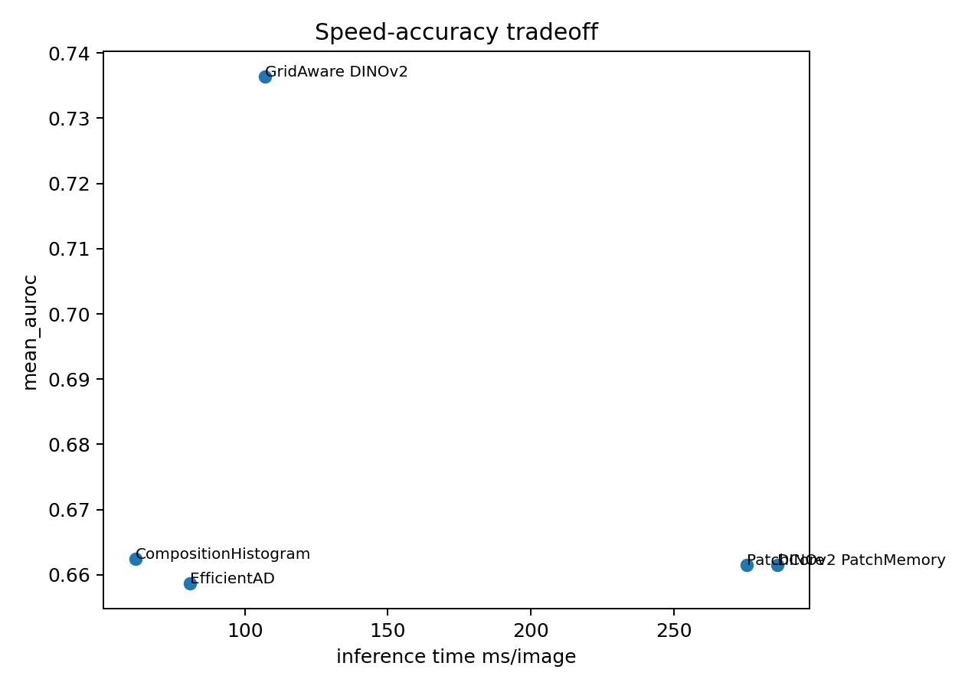
Figure 6. Existing speed-accuracy tradeoff figure.

6. Dashboard Architecture and Defense Explanation
The dashboard is the project's examiner-facing product layer. It is not a separate ML model; it is a self-contained interactive HTML report that integrates the outputs of preprocessing, EDA, scoring, evaluation, feature selection, qualitative examples, and key insights. This matters for the course criteria because the dashboard demonstrates that the project is not only a notebook experiment but a usable analytical artifact.
Important defense line: The requirement allows Power BI or any other dashboarding tool. This project uses a custom offline HTML dashboard because the artifact needs to embed images, heatmaps, per-category ML metrics, feature-selection outputs, and qualitative examples without requiring a server, database, internet connection, or Power BI runtime.

6.1 Dashboard Build Pipeline
The dashboard is generated in two steps from the result CSVs and figures. First, build_dashboard.py recomputes corrected metrics and constructs dashboard_data.json. Second, generate_html.py converts that JSON payload into dashboard.html by embedding data and images directly into the HTML file.
Method score CSVs + EDA figures + qualitative figures + feature_selection.json
-> 09_dashboard/build_dashboard.py
- reads method score files
- computes validation-threshold metrics
- converts selected images to base64
- writes corrected_main_results.csv
- writes corrected_per_category.csv
- writes dashboard_data.json
-> 09_dashboard/generate_html.py
- reads dashboard_data.json
- writes one self-contained dashboard.html file
- all charts/tables/images are available offline

File | Role in dashboard | Defense meaning
build_dashboard.py | Data assembly and corrected metric computation. | Shows the dashboard is generated reproducibly, not manually edited.
dashboard_data.json | Single structured payload containing metrics, EDA images, galleries, heatmaps, counts, insights, and feature-selection results. | Separates data preparation from visual rendering.
generate_html.py | HTML/CSS/JavaScript renderer for tabs, tables, charts, and embedded images. | Creates the final offline dashboard artifact.
dashboard.html | Final user-facing dashboard. | Can be opened directly in a browser; no server or internet is required.
corrected_main_results.csv | Main dashboard leaderboard table. | Uses validation-good thresholds for F1-style decisions and AUROC for ranking.
corrected_per_category.csv | Detailed category/anomaly-type metrics. | Supports drill-down questions during viva.

6.2 Why a Self-Contained HTML Dashboard?
A normal BI dashboard is excellent for tabular business analytics, but this project needs computer-vision outputs: anomaly maps, mask overlays, image galleries, and base64-embedded figures. A self-contained HTML dashboard is therefore technically appropriate because the visual evidence and the metric tables can travel together as one file.
- Offline portability: dashboard.html opens in any browser without Python, notebook execution, or internet.
- Reproducibility: every displayed metric is generated from saved CSVs rather than typed manually.
- Visual explainability: image examples, masks, and heatmaps are integrated beside numerical scores.
- Defense usability: tabs let the examiner move from overview to EDA, leaderboard, feature selection, and failure analysis quickly.
- No deployment dependency: avoids requiring Streamlit/Gradio server setup during presentation.

6.3 Dashboard Data Model
The dashboard_data.json file acts like the dashboard's internal database. It contains structured lists and dictionaries that the JavaScript renderer turns into cards, tables, galleries, and charts. The important keys are shown below.
JSON key | Contents | How to explain it in defense
main | Seven method/fusion rows with logical, structural, overall AUROC and F1 values. | This drives the leaderboard and headline result.
per | 105 rows: method x category x anomaly type metrics. | This supports per-category drill-down and shows no category is hidden.
eda | Base64 EDA figures such as sample grid, mask overlay, spatial heatmap, edge density, and mask-area plot. | This satisfies the relevant-EDA dashboard criterion.
gallery | Representative normal, logical, and structural examples for all five categories. | This makes individual decisions inspectable.
heatmaps | Example anomaly map images, mainly from GridAware outputs. | Shows where the model assigned high anomaly evidence.
quals | Success and failure case figures. | Supports honest qualitative analysis.
feature_selection | Variants, leave-one-out importance, dropped branches, harmful branch list. | Satisfies feature-selection and model-comparison criteria.
insights | Five consolidated project takeaways. | Turns raw metrics into examiner-readable conclusions.
counts | Dataset count summary by category/split. | Connects the dashboard back to the audited dataset.

6.4 Tab-by-Tab Dashboard Explanation
Dashboard tab | What it shows | Why it exists | What to say in viva
Overview | Dataset summary, headline metric, method-transparency banner, and high-level project framing. | Gives the examiner immediate orientation. | This page states the problem, the anomaly types, and the best current result before going into details.
EDA | Only decision-relevant EDA figures: samples, masks, normal mean/variance, spatial heatmap, mask-area distribution, edge density. | Meets the requirement to keep only relevant EDA in the dashboard. | I did not include decorative charts; each EDA view motivates preprocessing, region awareness, or anomaly interpretation.
Leaderboard | Method comparison table with logical, structural, and overall AUROC plus F1 values. | Shows quantitative comparison across detectors and fusion rules. | Fusion mean is best overall; GridAware is the strongest single branch; CompositionHistogram is conceptually useful but empirically weak in this run.
Feature Selection | All-feature fusion, duplicate-removal variants, three-representation model, leave-one-out importance, dropped/harmful branches. | Directly satisfies the feature-selection criterion. | The analysis shows we identified redundancy and a harmful branch rather than blindly keeping every feature.
Explainability | Representative examples, scores, thresholds, predictions, masks, and/or heatmaps. | Makes the model's decision auditable. | A high score alone is not enough; this tab lets us inspect what visual evidence produced the decision.
Per-category | Category-wise logical/structural/overall performance. | Shows that average performance is not hiding weak categories. | Industrial anomaly detection is category-dependent; juice_bottle is strong, while pushpins logical anomalies remain difficult.
Insights | Final key findings and limitations. | Converts model outputs into a concise project story. | This tab is where I explicitly discuss real DINOv2 use, feature-selection findings, and remaining limitations such as padding and single-seed results.

6.5 Dashboard Metric Logic
The dashboard intentionally uses corrected metric files rather than only the older final evaluation tables. The distinction matters for defense: AUROC is threshold-free, but F1 requires a threshold. In the dashboard, the threshold is derived from validation/good scores using the 90th percentile. This is more defensible than choosing the threshold that maximizes F1 on the test set.
For each category and method:
validation_scores = scores where split == validation and defect_type == good
threshold = quantile(validation_scores, 0.90)
prediction(test image) = anomaly if score >= threshold

AUROC:
computed from ranking normal vs anomalous test images

F1:
computed from validation-derived threshold, not test-optimized threshold

6.6 How to Demonstrate the Dashboard Live
- Open 09_dashboard/dashboard.html directly in a browser and mention that it is fully offline.
- Start with Overview to define logical versus structural anomaly detection and state the best result.
- Move to EDA and explain why each plot is relevant to modeling.
- Open Leaderboard and compare Fusion mean, GridAware DINOv2, Patch Memory, CompositionHistogram, and the proxy baseline.
- Open Feature Selection and explain the duplicate PatchCore/PatchMemory issue honestly.
- Open Explainability and show how heatmaps/masks/scores support individual decisions.
- Finish with Per-category or Insights to discuss limitations and future improvements.

6.7 Dashboard Limitations and Honest Answers
Potential examiner challenge | Best answer
Why not Power BI? | Power BI is allowed but not required. This project needs embedded computer-vision artifacts; a self-contained HTML dashboard is more portable and better suited to heatmaps and image examples.
Is the dashboard doing live inference? | No. It is an offline analytical dashboard over saved results. That is appropriate for defense and reproducibility. A live upload predictor is future deployment work.
Are all dashboard metrics manually typed? | No. build_dashboard.py reads saved score CSVs and generates corrected_main_results.csv, corrected_per_category.csv, and dashboard_data.json.
Does the dashboard hide weak results? | No. It includes per-category metrics and explicitly discusses weak logical cases such as pushpins.
Why show ground-truth masks? | Masks are used for explanation and qualitative inspection, not model fitting. They help humans verify whether heatmaps align with true defect regions.
Is F1 test-leaked? | The dashboard-corrected F1 uses a validation-good percentile threshold. Older f1_max tables should be treated as diagnostic upper bounds, not the deployment threshold.

7. Viva / Project Defense Simulator

1. Are you claiming that you implemented real EfficientAD?
No. The repo contains a deterministic Global Image-Stat proxy in Stage 04. It uses global RGB statistics, edge density, and grayscale histograms scored by z-distance from train/good. I use it as a lightweight baseline, not as official EfficientAD. Official EfficientAD would require a trained student-teacher and autoencoder pipeline, for example via Anomalib.

2. Is your PatchCore row real PatchCore?
It is PatchCore-style, not full official PatchCore. It implements the core memory-bank nearest-neighbor idea using DINOv2 features, but it does not use the official WideResNet feature stack or greedy coreset. In the current outputs it is byte-identical to DINOv2 PatchMemory, so I would merge or relabel it in a strict paper version.

3. Why use DINOv2 instead of training a classifier?
Because the training protocol is unsupervised: only normal images are available for fitting. A classifier would need labelled anomaly classes. DINOv2 provides strong self-supervised patch descriptors without defect labels, and patch tokens preserve spatial locality for heatmaps.

4. What exactly is a patch token?
A patch token is a vector representation of a local image region after Vision Transformer processing. The CLS token summarizes the image globally, but patch tokens keep a grid of local descriptors. I discard CLS and score each patch token against normal memory.

5. Why not use only global image embeddings?
Global embeddings can detect large distribution shifts but lose localization. Structural defects may occupy a tiny region. Patch tokens allow each local region to receive a score, which produces anomaly heatmaps and makes the decision explainable.

6. Why is logical anomaly detection harder than structural anomaly detection?
A structural anomaly is often a local texture or appearance deviation. A logical anomaly can consist of normal-looking parts in the wrong count or position. Local nearest-neighbor scoring may see every patch as normal; the abnormality lives in composition or layout.

7. What does GridAware add over vanilla patch memory?
It conditions normal memory on coarse spatial region. A patch is compared to normal patches from the same approximate location. This makes the model sensitive to misplaced normal-looking components and not only abnormal textures.

8. Why did CompositionHistogram underperform if logical anomalies need composition?
The idea is defensible, but the implementation is lightweight: KMeans visual words plus Mahalanobis distance. It may not capture true semantic components, and the code computes cosine/IsolationForest alternatives without using them. Feature selection showed it reduced full fusion in this run.

9. Did you use test labels to tune the model?
The intended protocol is no: train/good fits normality and validation/good normalizes scores/sets thresholds. AUROC is threshold-free. The dashboard corrected F1 uses validation-good 90th percentile thresholds. Older final_tables f1_max sweeps test thresholds, so I would avoid defending those older F1 values as final deployment metrics.

10. What does an anomaly heatmap intensity mean?
It is the local patch anomaly score, usually nearest-neighbor distance from normal memory. High intensity means that local descriptor is far from known normal descriptors. It is not a calibrated probability.

11. How does memory-bank scaling affect deployment?
Nearest-neighbor search cost grows with memory size and feature dimension. The current memory cap is 50,000 features for the patch-memory family, but GridAware stores more region-conditioned features. Deployment would benefit from greedy coreset, FAISS/approximate NN, quantization, or cached features.

12. Why did you not implement greedy coreset sampling?
For the course deliverable the priority was a reproducible end-to-end pipeline, dashboard, report, and real DINOv2 features. Greedy coreset is an optimization that preserves memory coverage, but it adds implementation complexity. I document it as a future improvement and do not claim official PatchCore.

13. What are the biggest limitations?
No official EfficientAD or official PatchCore baseline, no sPRO/pixel PRO in final tables, single-seed results, letterbox padding is not masked out, and PatchCore/PatchMemory duplication should be cleaned before publication.

14. How do you know there is no data leakage?
Stage 01 audits counts and writes MD5/perceptual hash records. duplicate_leakage_candidates.csv is empty. The split policy is explicit: fit on train/good, use validation/good for calibration, evaluate on test.

15. If you had one week more, what would you do first?
I would mask letterbox padding in feature extraction/scoring, collapse the duplicate PatchCore/PatchMemory row, add official Anomalib PatchCore and EfficientAD as external baselines, compute pixel PRO/sPRO from the cleaned masks, and run at least three seeds.

8. Appendix: Repository Map, Functions, and References

Repository Structure
00_project_planning/ Roadmap, peer review, submission guide, demo script, context
01_notebooks/ 12 stage notebooks + loco_project_utils.py
02_audit_reproducibility/ Preprocessing audit, hashes, environment, resize metadata
04_probe_results/ EDA figures and component-probe outputs
05_baselines/ EfficientAD proxy and PatchCore-style score outputs
06_method_results/ DINOv2 methods, Fusion, Final_Evaluation, Qualitative outputs
07_paper_draft/ Reports, slide deck, figures, builder scripts
09_dashboard/ Offline dashboard, dashboard data, corrected metrics
Run_DINOv2_Colab.ipynb GPU notebook for real DINOv2 result generation

Core Utility Function Groups
Function group | Representative functions | Purpose
Pathing and reproducibility | resolve_lab_root, get_project_paths, set_reproducible_seed, save_environment | Create deterministic project context.
Audit/preprocessing | audit_png, save_hashes, letterbox_resize_pil, create_clean_letterbox_dataset | Prepare and verify cleaned data.
EDA | product_records, mask_records, save_image_grid, overlay_image_mask, run_stage02_eda | Generate visual/data summaries.
Features | simple_patch_features, try_dinov2_patch_features, extract_patch_features, image_level_features | Compute patch or global descriptors.
Patch memory | build_patch_memory, score_records_patch_memory, run_patch_memory_family | Nearest-neighbor memory scoring.
Methods | run_stage04_efficientad, run_stage07_gridaware, run_stage08_composition_histogram | Specific anomaly scorers.
Evaluation/fusion | per_category_metrics, summary_metrics, z_normalize_scores, run_stage09_fusion | Metrics and score fusion.
Deliverables | run_stage10_final_tables, run_stage11_qualitative, run_stage12_paper_exports | Tables, qualitative figures, report figures.

Selected References and Related Repositories
- MVTec LOCO AD dataset: https://www.mvtec.com/research-teaching/datasets/mvtec-loco-ad
- Bergmann et al., Beyond Dents and Scratches / GCAD, IJCV 2022.
- PatchCore official repository: https://github.com/amazon-science/patchcore-inspection
- Anomalib PatchCore and EfficientAD implementations: https://github.com/openvinotoolkit/anomalib
- EfficientAD, WACV 2024: Accurate Visual Anomaly Detection at Millisecond-Level Latencies.
- AnomalyDINO repository: https://github.com/dammsi/AnomalyDINO
- CSAD repository: https://github.com/Tokichan/CSAD
- SALAD repository: https://github.com/MaticFuc/SALAD
- M-3LAB industrial anomaly detection paper list: https://github.com/m-3lab/awesome-industrial-anomaly-detection

