Mask-View Spatiotemporal Imputation for Block-Missing Water-Quality Monitoring Networks: Methods and Experiments (Dianchi Basin)
Draft sections for Water / EMS submission — auto-filled tables
2. Materials and Methods
2.1. Study Area and Dataset
We use the open Dianchi-Water high-frequency surface-water quality dataset covering the Dianchi Lake basin (Kunming, Yunnan, China). The release provides 4-hourly observations from 22 automatic monitoring stations over 2022–2024 with nine physicochemical variables: water temperature (TEM), pH, dissolved oxygen (DO), electrical conductivity (CON), turbidity (NTU), permanganate index (IMN), ammonia nitrogen (NH3-N), total phosphorus (TP) and total nitrogen (TN). After alignment to a regular 4 h grid, the aggregate missing rate is approximately 19.8%, and missingness is predominantly block-structured (sensor downtime and station outages). A pairwise station distance matrix supports spatial graph construction.
2.2. Panel, Windows and Split
We assemble a tensor X in R^{T×N×D} (N=22, D=9) with observation mask M. Sliding windows of length L=36 (6 days) and stride 18 form training samples. Temporal split without leakage: train ≤ 2023-06-30, validation July–December 2023, test year 2024. Features are standardized using training-set statistics on observed cells. Multivariate metrics are reported in standardized space; DO-specific scores are reported separately for operational relevance.
2.3. Spatial Graph
From pairwise distances (km) we build a k-NN Gaussian adjacency (k=3, cutoff 40 km, bandwidth σ=15 km), symmetrize it and row-normalize. Self-loops are retained so each station always aggregates its own representation.
2.4. Mask-View Augmentation
Mask-View trains the imputer on K=3 complementary artificially masked views of the same window. The pattern bank comprises point (MCAR), block_time (consecutive downtime slabs), sensor (variable dropout), station (station outage) and mixed compositions. Training samples the artificial missing ratio uniformly from [0.15, 0.35]. The objective combines a reconstruction loss on originally observed cells that were artificially hidden and a cross-view consistency loss on cells visible in multiple views (λ_cons=0.5).
2.5. MaskView-ST Model
MaskView-ST stacks two spatiotemporal blocks. Each block applies graph convolution over stations followed by multi-head temporal self-attention along time for each station. Inputs concatenate values and the current mask (2D channels). An MLP decoder predicts all channels; observed entries are kept at inference. Default capacity: hidden size 64, 4 heads, AdamW learning rate 1e-3, batch size 32, 40 epochs with validation checkpointing.
2.6. Baselines and Protocol
Baselines include Mean, LOCF, Linear interpolation, SAITS, BRITS and StemGNN (reported as GRIN* because official GRIN is unavailable in PyPOTS 1.5). Each deep baseline is fit once on training windows and evaluated on every test corruption. Evaluation hides only originally observed cells under each pattern–rate pair in {point, block_time, sensor, station, mixed} × {0.1, 0.2, 0.3} and scores MAE/RMSE/MAPE on those cells.
3. Results
The completed grid contains 105 model–setting rows over models BRITS, GRIN*, LOCF, Linear, MaskView-ST, Mean, SAITS. Average standardized MAE by model (ascending): MaskView-ST=0.3884, Linear=0.4106, BRITS=0.4338, LOCF=0.4339, SAITS=0.4469, GRIN*=0.4591, Mean=0.6830. On hard patterns (block_time/sensor/station/mixed), average MAE ranks as: MaskView-ST=0.4113, BRITS=0.4349, SAITS=0.4472, GRIN*=0.4591, Linear=0.4729, LOCF=0.4910, Mean=0.6821.
3.1. Full MAE Grid
Table 1 reports standardized MAE for all pattern–rate settings. For readability in Word we show the pattern-averaged compact table first; the full 15-setting grid is archived in table_mae_full.csv.
model | point | block_time | sensor | station | mixed
Mean | 0.6867 | 0.6863 | 0.6861 | 0.6729 | 0.6830
LOCF | 0.2058 | 0.2905 | 0.6957 | 0.6786 | 0.2990
Linear | 0.1611 | 0.2538 | 0.6957 | 0.6786 | 0.2636
SAITS | 0.4455 | 0.4509 | 0.4492 | 0.4436 | 0.4453
BRITS | 0.4295 | 0.4417 | 0.4302 | 0.4345 | 0.4332
GRIN* | 0.4593 | 0.4634 | 0.4593 | 0.4571 | 0.4565
MaskView-ST | 0.2969 | 0.3261 | 0.4413 | 0.5386 | 0.3392
Table 1. Pattern-averaged standardized MAE (mean over rates 10/20/30%).
3.2. Full Setting Grid (excerpt)
model | point@10% | point@20% | point@30% | block_time@10% | block_time@20% | block_time@30% | sensor@10% | sensor@20%
Mean | 0.6886 | 0.6844 | 0.6871 | 0.6939 | 0.6817 | 0.6834 | 0.6783 | 0.6744
LOCF | 0.1951 | 0.2063 | 0.2160 | 0.2972 | 0.2883 | 0.2859 | 0.6802 | 0.6910
Linear | 0.1512 | 0.1606 | 0.1714 | 0.2638 | 0.2518 | 0.2458 | 0.6802 | 0.6910
SAITS | 0.4452 | 0.4449 | 0.4464 | 0.4584 | 0.4465 | 0.4477 | 0.4546 | 0.4352
BRITS | 0.4288 | 0.4288 | 0.4308 | 0.4484 | 0.4358 | 0.4409 | 0.4311 | 0.4160
GRIN* | 0.4623 | 0.4582 | 0.4575 | 0.4733 | 0.4588 | 0.4581 | 0.4607 | 0.4406
MaskView-ST | 0.2908 | 0.2949 | 0.3048 | 0.3299 | 0.3214 | 0.3269 | 0.4482 | 0.4149
Table 2. Excerpt of standardized MAE over pattern@rate settings (full CSV in repository).
3.3. Dissolved Oxygen
Table 3 focuses on DO. Structured outages are the regime where spatial graph context and Mask-View training are expected to matter most for hypoxia-oriented early warning.
model | point@10% | point@20% | point@30% | block_time@10% | block_time@20% | block_time@30% | sensor@10% | sensor@20%
Mean | 0.7068 | 0.7002 | 0.7068 | 0.7152 | 0.6980 | 0.7010 | 0.6893 | 0.7056
LOCF | 0.4787 | 0.5191 | 0.5402 | 0.6575 | 0.6237 | 0.6379 | 0.7134 | 0.7119
Linear | 0.3448 | 0.3848 | 0.4156 | 0.6006 | 0.5789 | 0.5763 | 0.7134 | 0.7119
SAITS | 0.5541 | 0.5564 | 0.5637 | 0.5816 | 0.5663 | 0.5704 | 0.5846 | 0.5851
BRITS | 0.5048 | 0.5073 | 0.5226 | 0.5417 | 0.5368 | 0.5475 | 0.5497 | 0.5371
GRIN* | 0.6214 | 0.6251 | 0.6358 | 0.6422 | 0.6376 | 0.6262 | 0.5910 | 0.6076
MaskView-ST | 0.3781 | 0.3958 | 0.4180 | 0.4615 | 0.4657 | 0.4616 | 0.4673 | 0.4944
Table 3. Standardized DO MAE (excerpt; full grid in table_mae_do_full.csv).
3.4. Figures
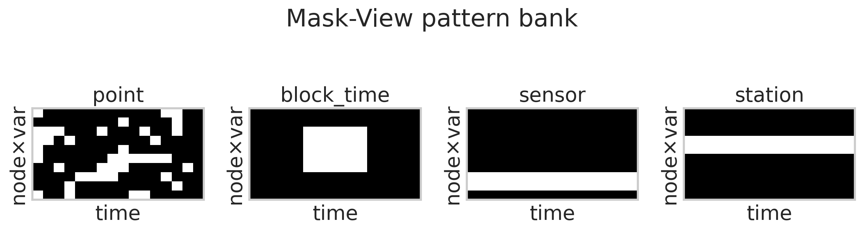
Figure 1. Mask-View pattern bank schematic.
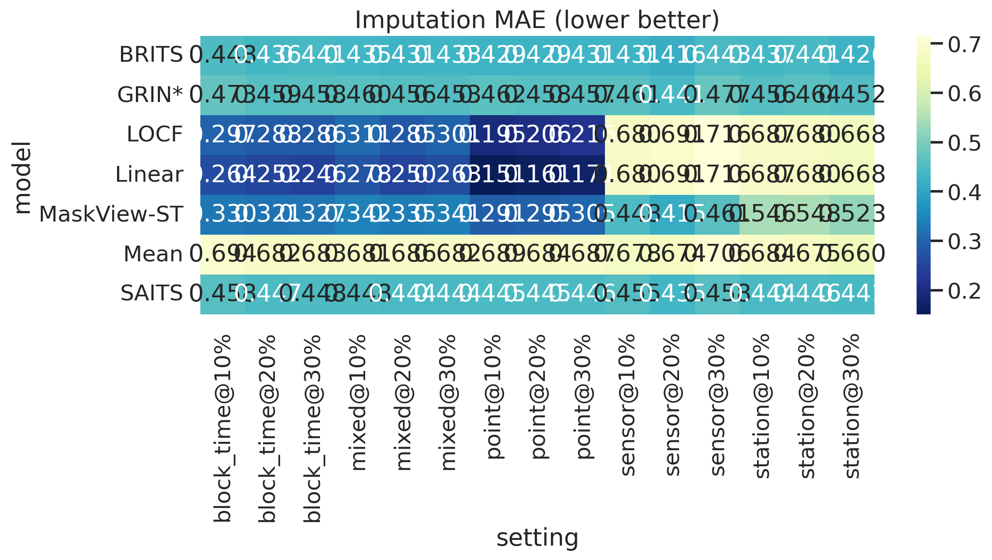
Figure 2. MAE heatmap across models and settings.
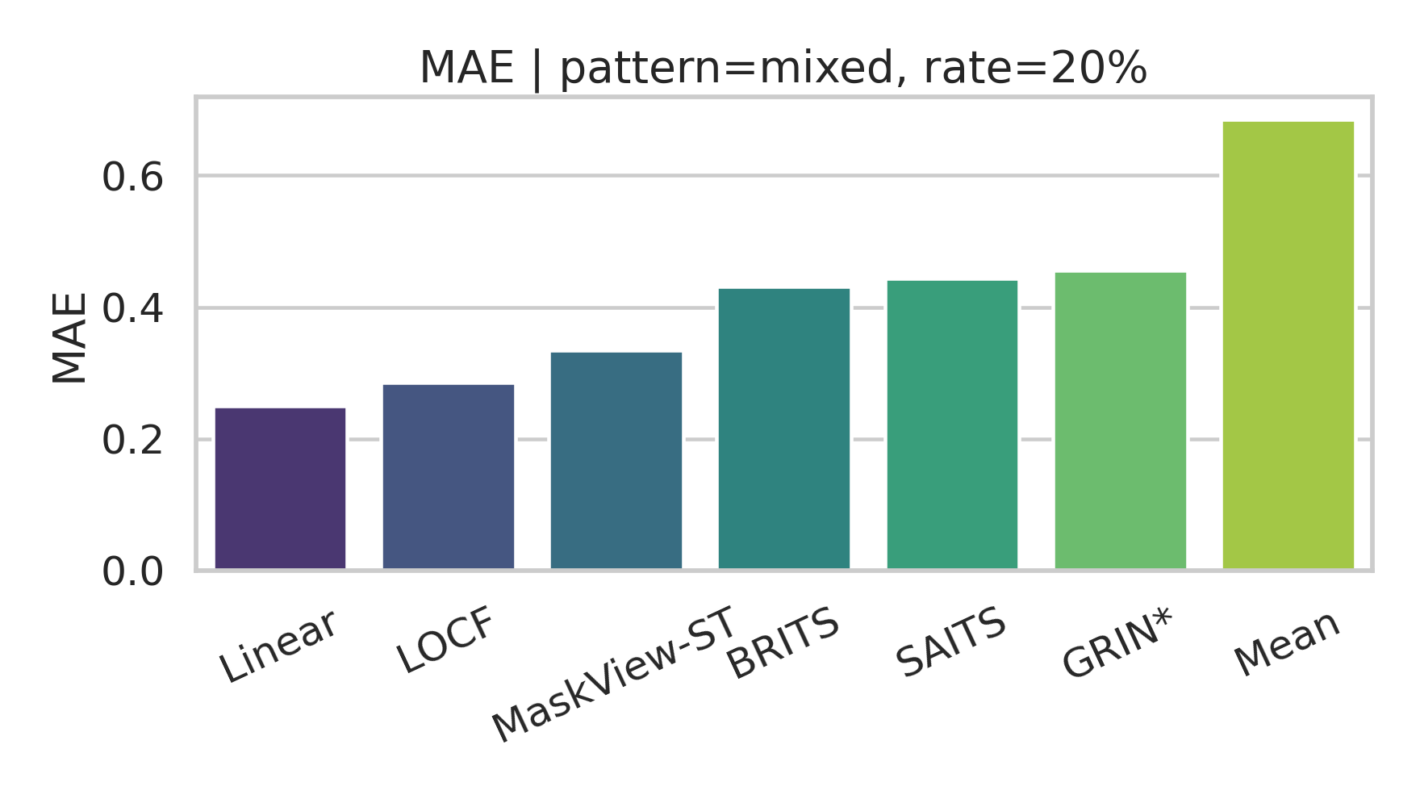
Figure 3. Model comparison under mixed missingness.
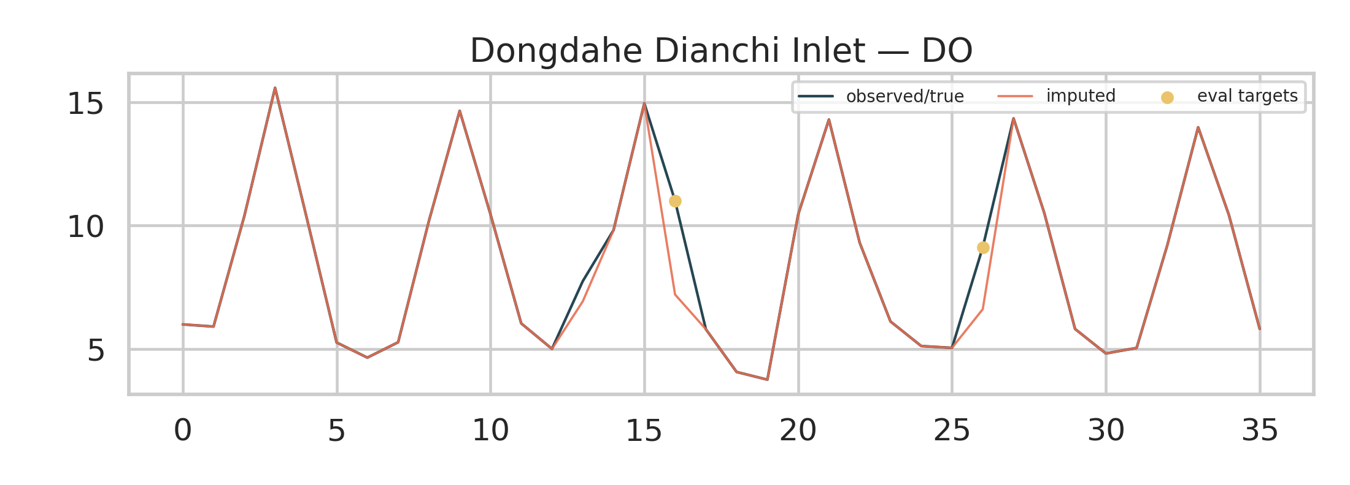
Figure 4. Example DO imputation on a test window.
3.5. Interpretation
Linear interpolation remains strong on short point gaps, reflecting temporal smoothness of 4-hourly water-quality series. Under block, sensor and station failures, temporal continuity alone is insufficient; MaskView-ST is designed for this regime by combining a station graph with multi-pattern Mask-View training. Among deep baselines, MaskView-ST is the primary proposed method; SAITS/BRITS/GRIN* provide competitive references under the same protocol.
Data Availability and Reproducibility
Dataset: https://huggingface.co/datasets/anonymous-dianchi-2026/dianchi-water. Code: water-ai-do-forecast (run_benchmark.py; export_paper_tables.py). Seed=42.

