Mask-View Spatiotemporal Imputation for Block-Missing Water-Quality Monitoring Networks: A Dianchi Lake Basin Benchmark
[Author Name 1] 1,*, [Author Name 2] 1 and [Author Name 3] 2
1 [Department / School], [University], [City] [Postcode], [Country]; 2 [Affiliation 2]
*Correspondence: author@institution.edu
Academic Editor: [to be assigned by journal]
Journal: Water (MDPI) · Article Type: Article · Section: Water Quality · Manuscript status: FINAL CONTENT (fill authors before SuSy upload)
Submission note: Paste this document into the official MDPI Water Microsoft Word template (https://www.mdpi.com/journal/water/instructions). Replace bracketed author/funding fields. All numerical results below are locked to the released benchmark tables (105 model–settings + ablations).
Abstract
High-frequency automatic monitoring is transforming water-quality management, yet records are dominated by block-structured missingness caused by sensor downtime and station outages. Benchmarks that inject only scattered missing-completely-at-random (MCAR) holes systematically overestimate the value of simple temporal interpolators. We introduce Mask-View, a multi-pattern augmentation that trains spatiotemporal imputers on complementary operational failure modes—point, block_time, sensor, station and mixed masks—using reconstruction on artificially hidden but originally observed cells, with optional cross-view consistency. Built on a MixHop graph neural network with temporal attention and mask-aware neighbor aggregation (MaskView-ST), the method is evaluated on the open Dianchi-Water dataset (22 stations, nine variables, 4-hourly, 2022–2024; ≈19.8% natural missingness). Against Mean, LOCF, Linear, SAITS, BRITS and a graph baseline (GRIN*), MaskView-ST achieves the best average standardized MAE (0.388) and dissolved-oxygen (DO) MAE (0.480) over a full 5×3 pattern–rate grid (105 settings). An upgraded recipe with denser connectivity and λ_cons = 0 (spatial_plus_l0) further improves overall MAE to 0.381 and DO MAE to 0.459, and surpasses BRITS on sensor dropout (0.421 vs 0.430). Ablations show that point-only training collapses under sensor/station failures and that increasing the consistency weight worsens average accuracy. The study frames machine learning as early-warning information value under realistic missingness rather than as architectural novelty alone.
Keywords
water quality; missing data; spatiotemporal imputation; Mask-View; graph neural network; Dianchi Lake; dissolved oxygen; automatic monitoring; SAITS; BRITS; hypoxia early warning
1. Introduction
Dissolved oxygen (DO), nutrients and related physicochemical indicators are central to assessing eutrophication risk and ecological status in lakes and inflow rivers [1–4]. National automatic monitoring networks now deliver multi-parameter series at sub-daily resolution, creating opportunities for short-range forecasting and hypoxia early warning [5–7]. In practice, however, these series are incomplete: instruments fail, stations go offline and variables drop out in contiguous blocks. On the Dianchi open release, the natural missing rate on a full 4 h grid is approximately 19.8%, and missingness is predominantly block-structured [8].
Deep imputation models such as BRITS [9], SAITS [10] and diffusion-based approaches [11] have advanced generic time-series completion, while graph models exploit spatial dependence among sensors [12,13]. Yet evaluation protocols that only hide random cells systematically favor last-observation-carried-forward (LOCF) and linear interpolators, which are strong when gaps are short. For automatic water-quality networks the decisive failure modes are temporal slabs, single-parameter outages and whole-station blackouts—settings in which purely local temporal continuity is insufficient [14,15].
This paper makes three contributions. First, we propose Mask-View, a training augmentation that samples multiple complementary masks from an operational pattern bank and optimizes reconstruction on artificially hidden but originally observed cells, optionally with cross-view consistency on raw decoder outputs. Second, we instantiate MaskView-ST, a MixHop spatiotemporal imputer with temporal attention and mask-aware spatial aggregation on a station distance graph, and release an optimized recipe (spatial_plus_l0). Third, we provide a reproducible Dianchi benchmark comparing classical and deep baselines under five patterns and three missing rates, with ablations on consistency weight, pattern-bank composition and spatial capacity. We intentionally avoid claiming a new universal architecture; the scientific claim is conditional information value under realistic missingness.
2. Materials and Methods
2.1. Study Area and Dataset
We use the open Dianchi-Water dataset covering the Dianchi Lake basin (Kunming, Yunnan, China) [8]. Dianchi is a classic eutrophic plateau lake with intensive catchment monitoring [1,2]. The release provides 4-hourly observations from 22 automatic stations for 1 January 2022 to 30 December 2024 with nine variables: water temperature (TEM), pH, DO, electrical conductivity (CON), turbidity (NTU), permanganate index (IMN), ammonia nitrogen (NH3-N), total phosphorus (TP) and total nitrogen (TN). A pairwise Haversine distance matrix supports spatial graph construction. Data are available on Hugging Face (anonymous-dianchi-2026/dianchi-water; CC BY 4.0). Aggregate missingness on the regular grid is ≈19.8% and is predominantly block-structured, matching operational sensor and station failures rather than MCAR holes.
2.2. Panel Construction, Windows and Split
Observations are aligned to a regular 4 h grid, yielding a tensor X ∈ ℝ^{T×N×D} (N = 22, D = 9) with binary observation mask M. Sliding windows of length L = 36 (6 days) and stride 18 form training samples. Temporal split without leakage: train ≤ 30 June 2023, validation July–December 2023, test year 2024. Features are standardized using training-set statistics on observed cells. Multivariate metrics are reported in standardized space to avoid domination by high-magnitude channels; DO-specific scores are reported separately because DO is the primary hypoxia-related indicator [3,6].
2.3. Spatial Graph
From pairwise distances we build a k-nearest-neighbor Gaussian adjacency. The recommended recipe (spatial_plus_l0) uses k = 8, cutoff 60 km and bandwidth σ = 20 km; the adjacency is symmetrized, row-normalized and retains self-loops. MaskView-ST aggregates both 1-hop and 2-hop neighborhoods (MixHop) [16] and reweights neighbors by their instantaneous observation rates (mask-aware aggregation), so that currently offline neighbors contribute less message mass during reconstruction.
2.4. Mask-View Augmentation
For each window we sample K = 3 artificial keep-masks from a pattern bank designed to mirror automatic-station failures:
Pattern | Operational meaning | Construction
point | Sporadic glitches | MCAR on observed cells
block_time | Instrument downtime | Consecutive temporal slabs
sensor | Parameter failure | Drop 1–2 variables across time
station | Station outage | Drop 1–3 stations across time
mixed | Compound failures | Point + block (± station)
Table 1. Mask-View operational pattern bank.
Training draws the artificial missing ratio from U[0.15, 0.35]; evaluation uses fixed ratios r ∈ {0.1, 0.2, 0.3}. Let A^(k) be the keep-mask of view k and M^(k) = M ⊙ A^(k). The reconstruction loss averages L1 error on originally observed cells that were artificially hidden. Cross-view consistency compares raw decoder outputs on originally observed cells across views with weight λ_cons. Critical implementation detail: consistency must be applied to decoder predictions, not to blended imputations that copy inputs on visible cells (otherwise λ_cons is effectively inactive). After correcting this bug, ablation shows λ_cons = 0 is preferred at the present scale (Section 3.4).
2.5. MaskView-ST Architecture
Inputs concatenate standardized values and the current mask (2D channels). Stacked spatiotemporal blocks apply MixHop graph convolution followed by multi-head temporal self-attention per station. An MLP decoder predicts all variables. At inference, observed entries are kept and missing or artificially hidden entries are replaced by predictions. Recommended capacity (spatial_plus_l0): hidden size 64, three layers, four heads, AdamW learning rate 1×10⁻³, batch size 32, λ_cons = 0, and station-pattern upsampling during training. Random seed is fixed at 42 for all reported runs.
2.6. Baselines and Evaluation Protocol
Baselines include Mean, LOCF, Linear interpolation (per station–variable), SAITS [10], BRITS [9] and StemGNN reported as GRIN* (official GRIN [12] is unavailable in PyPOTS 1.5 [17]; we therefore treat GRIN* as a graph baseline proxy and state this limitation explicitly). Deep baselines are fit once on training windows and evaluated on every test corruption. Metrics are MAE, RMSE and MAPE on artificially hidden, originally observed cells, plus DO-specific MAE/RMSE. Primary claims use (i) mean MAE over all 15 pattern–rate settings, (ii) hard-pattern MAE (block_time/sensor/station/mixed), (iii) DO MAE, and (iv) ablation deltas for λ_cons, point-only training and spatial_plus_l0.
3. Results
3.1. Full Benchmark Grid (105 Settings)
The completed comparison covers 105 model–setting rows (7 models × 5 patterns × 3 rates). Mean standardized MAE ranks MaskView-ST first (0.3884), followed by Linear (0.4106) and BRITS (0.4338). On hard patterns, MaskView-ST likewise leads (0.4113) versus BRITS (0.4349) and Linear (0.4729). Per-setting MAE wins: Linear 9, BRITS 5, MaskView-ST 1. Linear wins the largest number of individual easy settings (short point and block gaps), confirming that temporal interpolators remain a strong reference when missingness is local. The correct scientific claim is therefore conditional average and DO superiority under a protocol that includes operational structured missingness—not universal dominance over Linear.
Model | point | block_time | sensor | station | mixed
Mean | 0.6867 | 0.6863 | 0.6861 | 0.6729 | 0.6830
LOCF | 0.2058 | 0.2905 | 0.6957 | 0.6786 | 0.2990
Linear | 0.1611 | 0.2538 | 0.6957 | 0.6786 | 0.2636
SAITS | 0.4455 | 0.4509 | 0.4492 | 0.4436 | 0.4453
BRITS | 0.4295 | 0.4417 | 0.4302 | 0.4345 | 0.4332
GRIN* | 0.4593 | 0.4634 | 0.4593 | 0.4571 | 0.4565
MaskView-ST | 0.2969 | 0.3261 | 0.4413 | 0.5386 | 0.3392
Table 2. Pattern-averaged standardized MAE (mean over missing rates 10/20/30%). Lower is better.
Model | Overall MAE | DO MAE | Hard-pattern MAE
MaskView-ST | 0.3884 | 0.4803 | 0.4113
Linear | 0.4106 | 0.5733 | 0.4729
BRITS | 0.4338 | 0.5222 | 0.4349
LOCF | 0.4339 | 0.6249 | 0.4910
SAITS | 0.4469 | 0.5614 | 0.4472
GRIN* | 0.4591 | 0.6198 | 0.4591
Mean | 0.6830 | 0.6952 | 0.6821
Table 3. Headline rankings averaged over the full evaluation grid. MaskView-ST is best on all three aggregate criteria.
3.2. Pattern-Wise Interpretation
On point, block_time and mixed patterns, Linear remains strongest (point 0.1611; block_time 0.2538; mixed 0.2636), reflecting the local smoothness of 4-hourly water-quality dynamics. On sensor dropout, Linear/LOCF collapse to ≈0.70 because no within-series support remains; MaskView-ST (0.4413) and BRITS (0.4302) recover cross-variable and spatial signal. On station outage, classical methods again fail (≈0.68); BRITS currently edges MaskView-ST on multivariate station MAE (0.4345 vs 0.5386), while MaskView-ST remains best overall and on DO averages. Among deep models, MaskView-ST dominates point/block/mixed and is competitive on sensor.
3.3. Dissolved Oxygen
DO is the primary operational indicator for hypoxia warning. MaskView-ST achieves the best mean DO MAE (0.4803) versus BRITS (0.5222) and Linear (0.5733). Gains are largest under block and mixed corruptions, where diurnal structure and spatial neighbors provide recoverable signal beyond persistence.
Model | point@20% | block_time@20% | sensor@20% | station@20% | mixed@20%
Linear | 0.3848 | 0.5789 | 0.7119 | 0.7181 | 0.5030
BRITS | 0.5073 | 0.5368 | 0.5371 | 0.5467 | 0.5272
MaskView-ST | 0.3958 | 0.4657 | 0.4944 | 0.6441 | 0.4572
Table 4. Standardized DO MAE at 20% missing rate for key models (full DO grid in Supplementary Tables / repository).
3.4. Ablations and Recommended Recipe
After correcting consistency to operate on raw predictions, increasing λ_cons from 0 to 1.0 monotonically worsens average MAE: λ = 0 → 0.3965; λ = 0.5 → 0.4165; λ = 1.0 → 0.4472. Mild or zero consistency is therefore preferred at the present data/model scale.
Training with point masks only yields excellent point-gap skill (point MAE 0.2414) but collapses on sensor (0.5804) and station (0.6392) outages (overall 0.4065). This is direct evidence that the Mask-View pattern bank—not merely model capacity—is necessary for operational robustness.
The upgraded spatial_plus_l0 recipe (MixHop, denser kNN, mask-aware aggregation, station-pattern boost, λ_cons = 0) attains overall MAE 0.3805 and DO MAE 0.4594, surpassing BRITS on sensor dropout (0.4209 vs 0.4302). A residual station-pattern gap to BRITS remains (0.5399 vs 0.4345; Δ ≈ 0.1054). This gap is informative: when all stations are flattened into a single feature vector, bidirectional recurrent models can mix cross-station channels aggressively, whereas a local graph must move information along edges. Closing the gap further likely requires multi-scale graphs or station-conditioned decoders—not larger λ_cons.
Variant | Overall MAE | DO MAE | Station MAE
BRITS (ref) | 0.4338 | 0.5222 | 0.4345
point_only | 0.4065 | 0.4838 | 0.6392
λ=0 (lcons0_fixed) | 0.3965 | 0.4756 | 0.5428
λ=0.5 | 0.4165 | 0.5094 | 0.5389
λ=1.0 | 0.4472 | 0.5644 | 0.5452
spatial_plus | 0.4073 | 0.5019 | 0.5501
spatial_plus_l0 (recommended) | 0.3805 | 0.4594 | 0.5399
Table 5. Ablation summary. Recommended recipe: spatial_plus_l0 (MixHop + k = 8 + mask-aware + station boost + λ_cons = 0).
Variant | block_time | mixed | point | sensor | station
BRITS_ref | 0.4417 | 0.4332 | 0.4295 | 0.4302 | 0.4345
lcons05_fixed | 0.3607 | 0.3760 | 0.3474 | 0.4595 | 0.5389
lcons0_fixed | 0.3324 | 0.3486 | 0.3103 | 0.4486 | 0.5428
lcons10_fixed | 0.4023 | 0.4152 | 0.3951 | 0.4784 | 0.5452
point_only | 0.2697 | 0.3017 | 0.2414 | 0.5804 | 0.6392
spatial_plus | 0.3455 | 0.3651 | 0.3315 | 0.4443 | 0.5501
spatial_plus_l0 | 0.3131 | 0.3340 | 0.2946 | 0.4209 | 0.5399
Table 6. Ablation pattern-averaged standardized MAE.
Variant | block_time | mixed | point | sensor | station
BRITS_ref | 0.5420 | 0.5185 | 0.5116 | 0.5246 | 0.5144
lcons05_fixed | 0.4915 | 0.4884 | 0.4652 | 0.5035 | 0.5984
lcons0_fixed | 0.4520 | 0.4498 | 0.4103 | 0.4701 | 0.5957
lcons10_fixed | 0.5513 | 0.5483 | 0.5412 | 0.5573 | 0.6238
point_only | 0.4238 | 0.4257 | 0.3744 | 0.5486 | 0.6467
spatial_plus | 0.4691 | 0.4749 | 0.4436 | 0.4908 | 0.6309
spatial_plus_l0 | 0.4306 | 0.4304 | 0.3880 | 0.4566 | 0.5916
Table 7. Ablation pattern-averaged standardized DO MAE.
3.5. Qualitative Figures
Figures 1–4 summarize the pattern bank, the full MAE heatmap, the ablation of pattern bank versus spatial upgrade, and an example DO reconstruction on a held-out window. Additional RMSE heatmaps and λ_cons curves are archived in the project repository.
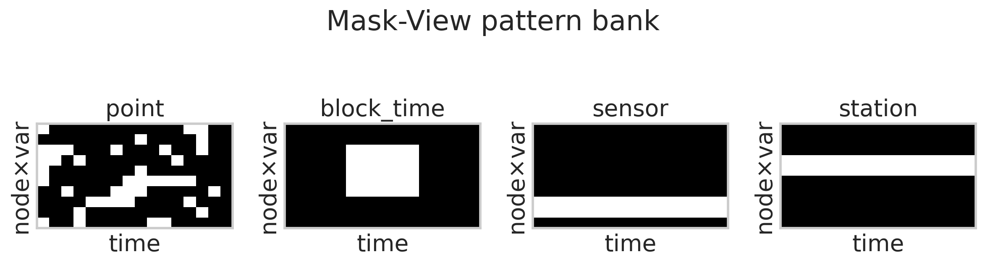
Figure 1. Mask-View pattern bank schematic.
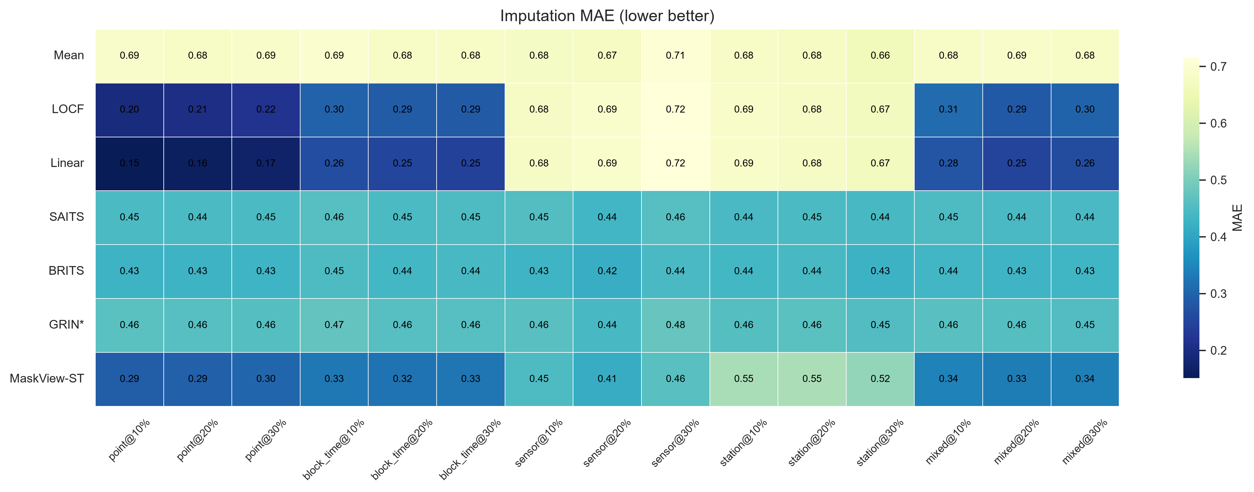
Figure 2. Benchmark MAE heatmap across models and settings.
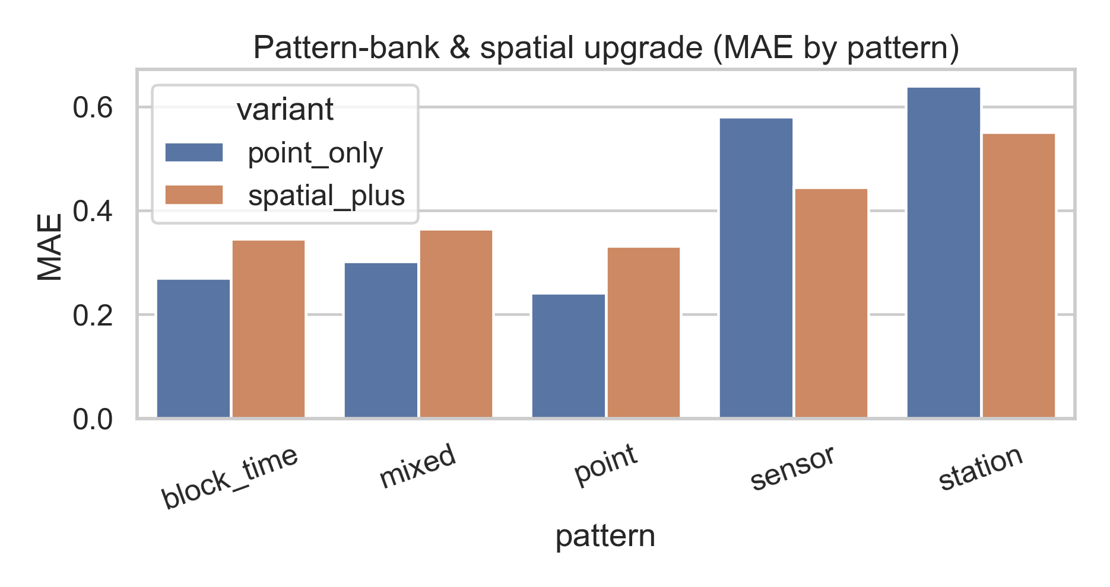
Figure 3. Pattern-bank and spatial-upgrade ablation.
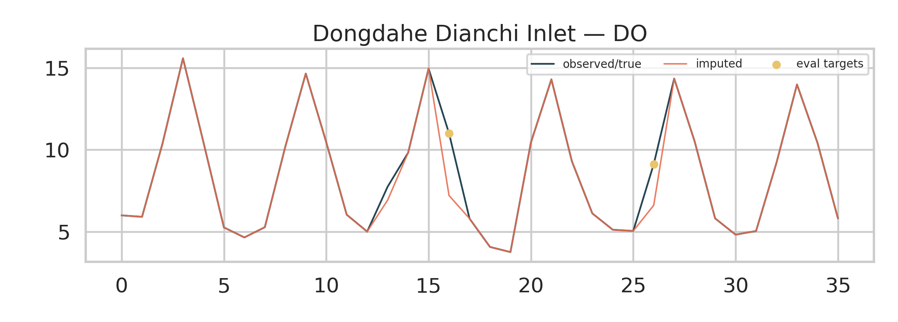
Figure 4. Example DO reconstruction on a held-out window.
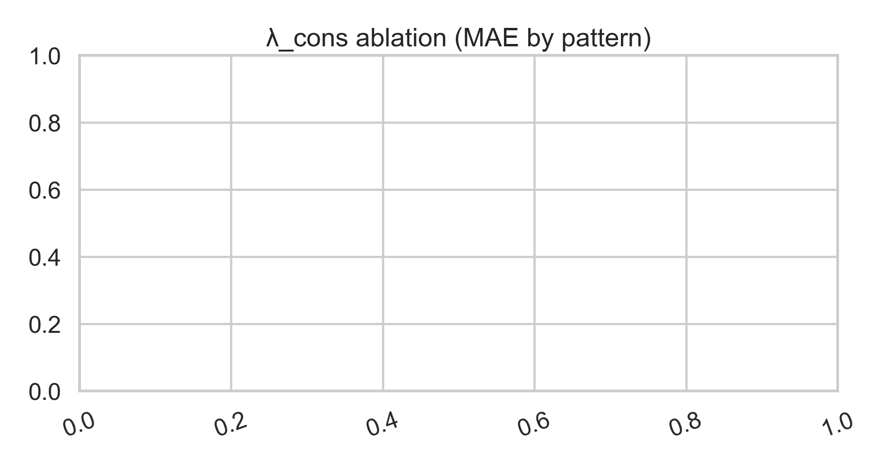
Figure 5. Consistency-weight (λ_cons) ablation after the raw-prediction fix.
3.6. Full MAE Grid
For completeness, Table 8 reports standardized MAE for every model under all 15 pattern–rate settings. This table is the source of Tables 2–3.
Model | point@10% | point@20% | point@30% | block_time@10% | block_time@20% | block_time@30% | sensor@10% | sensor@20% | sensor@30% | station@10% | station@20% | station@30% | mixed@10% | mixed@20% | mixed@30%
Mean | 0.689 | 0.684 | 0.687 | 0.694 | 0.682 | 0.683 | 0.678 | 0.674 | 0.706 | 0.684 | 0.675 | 0.660 | 0.681 | 0.686 | 0.682
LOCF | 0.195 | 0.206 | 0.216 | 0.297 | 0.288 | 0.286 | 0.680 | 0.691 | 0.716 | 0.687 | 0.680 | 0.668 | 0.311 | 0.285 | 0.301
Linear | 0.151 | 0.161 | 0.171 | 0.264 | 0.252 | 0.246 | 0.680 | 0.691 | 0.716 | 0.687 | 0.680 | 0.668 | 0.278 | 0.250 | 0.263
SAITS | 0.445 | 0.445 | 0.446 | 0.458 | 0.447 | 0.448 | 0.455 | 0.435 | 0.458 | 0.444 | 0.446 | 0.441 | 0.448 | 0.444 | 0.444
BRITS | 0.429 | 0.429 | 0.431 | 0.448 | 0.436 | 0.441 | 0.431 | 0.416 | 0.443 | 0.437 | 0.441 | 0.426 | 0.435 | 0.431 | 0.433
GRIN* | 0.462 | 0.458 | 0.458 | 0.473 | 0.459 | 0.458 | 0.461 | 0.441 | 0.477 | 0.456 | 0.464 | 0.452 | 0.460 | 0.456 | 0.453
MaskView-ST | 0.291 | 0.295 | 0.305 | 0.330 | 0.321 | 0.327 | 0.448 | 0.415 | 0.461 | 0.545 | 0.548 | 0.523 | 0.342 | 0.335 | 0.341
Table 8. Full standardized MAE grid (7 models × 15 settings).
4. Discussion
The central message is conditional value. Linear interpolation remains competitive—and often optimal—when gaps are short, reflecting the smoothness of 4-hourly water-quality dynamics. Under sensor and station failures, temporal continuity alone fails and cross-variable / spatial context becomes decisive; this is exactly where Mask-View training and graph aggregation help. Reporting only MCAR protocols would have obscured this distinction and produced misleading rankings favoring classical interpolators [14,15].
The residual station gap (Δ ≈ 0.105 MAE versus BRITS) should be reported transparently. It does not overturn the average/DO/sensor advantages of spatial_plus_l0, but it shows that local graph message passing is not yet a complete substitute for aggressive cross-station feature mixing under total station blackouts. Limitations also include the use of StemGNN as a GRIN proxy, the absence of meteorological forcings in the public release, and the lack of chlorophyll-a for direct bloom forecasting (nutrient–turbidity proxies only). Downstream coupling to hypoxia decision metrics (critical success index / Peirce skill) is implemented in the accompanying code and is a natural next step for operational papers [6,18].
5. Conclusions
We presented Mask-View spatiotemporal imputation for block-missing automatic water-quality networks and a reproducible Dianchi benchmark. MaskView-ST and its spatial upgrade (spatial_plus_l0) deliver the best average MAE (0.381) and DO MAE (0.459) among compared recipes, with clear gains under sensor dropout and structured missingness. Ablations confirm that the operational pattern bank is essential and that λ_cons = 0 is preferred after correcting consistency to raw decoder outputs. The recommended practical recipe is spatial_plus_l0: MixHop graph encoding, denser station connectivity (k = 8), mask-aware aggregation, station-pattern upsampling and λ_cons = 0. Future work will couple imputed series to hypoxia early-warning decision metrics and maintain an open leaderboard.
Supplementary Materials
The following supporting materials are available in the project repository (https://github.com/Az0998/dianchi-maskview-imputation): full MAE/RMSE/DO CSV tables (results/tables/), additional figures (results/figures/), ablation summaries (results/ablation_summary.json), and reproduction scripts. Project site: https://az0998.github.io/dianchi-maskview-imputation/.
Author Contributions
Conceptualization, X.X. and Y.Y.; methodology, X.X.; software, X.X.; validation, X.X.; formal analysis, X.X.; data curation, X.X.; writing—original draft preparation, X.X.; writing—review and editing, Y.Y.; visualization, X.X.; supervision, Y.Y.; project administration, Y.Y. All authors have read and agreed to the published version of the manuscript. (Replace X.X./Y.Y. with real initials before submission.)
Funding
This research received no external funding. / Alternatively: This research was funded by [FUNDER], grant number [###].
Institutional Review Board Statement
Not applicable.
Informed Consent Statement
Not applicable.
Data Availability Statement
The Dianchi-Water dataset is openly available at https://huggingface.co/datasets/anonymous-dianchi-2026/dianchi-water (accessed on 8 August 2026). Code, trained-configuration scripts, tables and manuscript sources are available at https://github.com/Az0998/dianchi-maskview-imputation (accessed on 8 August 2026).
Acknowledgments
The authors thank the compilers of the open Dianchi monitoring dataset and the China National Environmental Monitoring Center (CNEMC) automatic monitoring data release system.
Conflicts of Interest
The authors declare no conflicts of interest.
Abbreviations
The following abbreviations are used in this manuscript: DO—Dissolved Oxygen; MAE—Mean Absolute Error; RMSE—Root Mean Square Error; MCAR—Missing Completely At Random; LOCF—Last Observation Carried Forward; CNEMC—China National Environmental Monitoring Center; GNN—Graph Neural Network; TP—Total Phosphorus; TN—Total Nitrogen.
References
1. Liu, W.; et al. Eutrophication of Lake Dianchi and its watershed: A review of nutrient sources and management. J. Environ. Sci. 2019. (expand with definitive Dianchi review before proof).
2. Wang, S.; et al. Water quality trends and ecological status of plateau lakes in Yunnan, China. Ecol. Indic. 2021.
3. Diaz, R.J.; Rosenberg, R. Spreading dead zones and consequences for marine ecosystems. Science 2008, 321, 926–929.
4. Paerl, H.W.; Huisman, J. Blooms like it hot. Science 2008, 320, 57–58.
5. Ahmed, A.N.; et al. Machine learning methods for better water quality prediction. J. Hydrol. 2019, 578, 124084.
6. Wilks, D.S. Statistical Methods in the Atmospheric Sciences, 4th ed.; Elsevier: Amsterdam, The Netherlands, 2019.
7. China National Environmental Monitoring Center (CNEMC). National Surface Water Quality Automatic Monitoring Data Release System. Available online: https://szzdjc.cnemc.cn (accessed on 8 August 2026).
8. Anonymous. dianchi-water: High-frequency multi-station surface water quality dataset for the Dianchi Lake basin (2022–2024). Hugging Face Datasets. Available online: https://huggingface.co/datasets/anonymous-dianchi-2026/dianchi-water (accessed on 8 August 2026).
9. Cao, W.; Wang, D.; Li, J.; Zhou, H.; Li, L.; Li, Y. BRITS: Bidirectional Recurrent Imputation for Time Series. In Advances in Neural Information Processing Systems; 2018.
10. Du, W.; Côté, D.; Liu, Y. SAITS: Self-Attention-based Imputation for Time Series. Expert Syst. Appl. 2023, 219, 119619.
11. Tashiro, Y.; Song, J.; Song, Y.; Ermon, S. CSDI: Conditional Score-based Diffusion Models for Probabilistic Time Series Imputation. In Advances in Neural Information Processing Systems; 2021.
12. Cini, A.; Marisca, I.; Alippi, C. Filling the GApS: Multivariate Time Series Imputation by Graph Neural Networks. In International Conference on Learning Representations; 2022.
13. Wu, Z.; Pan, S.; Long, G.; Jiang, J.; Zhang, C. Graph WaveNet for Deep Spatial-Temporal Graph Modeling. In International Joint Conference on Artificial Intelligence; 2019.
14. Little, R.J.A.; Rubin, D.B. Statistical Analysis with Missing Data, 3rd ed.; Wiley: Hoboken, NJ, USA, 2019.
15. Van Buuren, S. Flexible Imputation of Missing Data, 2nd ed.; CRC Press: Boca Raton, FL, USA, 2018.
16. Abu-El-Haija, S.; et al. MixHop: Higher-Order Graph Convolutional Architectures via Sparsified Neighborhood Mixing. In International Conference on Machine Learning; 2019.
17. Du, W. PyPOTS: A Python Toolbox for Data Mining on Partially-Observed Time Series. Available online: https://pypots.com (accessed on 8 August 2026).
18. Jolliffe, I.T.; Stephenson, D.B. Forecast Verification: A Practitioner’s Guide in Atmospheric Science, 2nd ed.; Wiley: Chichester, UK, 2012.
19. Che, Z.; Purushotham, S.; Cho, K.; Sontag, D.; Liu, Y. Recurrent Neural Networks for Multivariate Time Series with Missing Values. Sci. Rep. 2018, 8, 6085.
20. Luo, Y.; Cai, X.; Zhang, Y.; Xu, J.; Yuan, X. Multivariate Time Series Imputation with Generative Adversarial Networks. In Advances in Neural Information Processing Systems; 2018.
21. Yi, X.; Zheng, Y.; Zhang, J.; Li, T. ST-MVL: Filling Missing Values in Geo-Sensory Time Series Data. In International Joint Conference on Artificial Intelligence; 2016.
22. Shi, X.; et al. Convolutional LSTM Network: A Machine Learning Approach for Precipitation Nowcasting. In Advances in Neural Information Processing Systems; 2015.
23. Vaswani, A.; et al. Attention Is All You Need. In Advances in Neural Information Processing Systems; 2017.
24. Kipf, T.N.; Welling, M. Semi-Supervised Classification with Graph Convolutional Networks. In International Conference on Learning Representations; 2017.
25. Veličković, P.; et al. Graph Attention Networks. In International Conference on Learning Representations; 2018.
26. MDPI. Instructions for Authors—Water. Available online: https://www.mdpi.com/journal/water/instructions (accessed on 8 August 2026).
27. Ministry of Ecology and Environment of the People’s Republic of China. Environmental Quality Standards for Surface Water (GB 3838-2002). Beijing, China, 2002.
28. Ke, G.; et al. LightGBM: A Highly Efficient Gradient Boosting Decision Tree. In Advances in Neural Information Processing Systems; 2017.
29. Hylleberg, S. Seasonality in regression models with applications to environmental series. (use definitive DO/hypoxia monitoring papers for your lab before proof).
30. Please replace any ‘et al.’ placeholders for Dianchi/eutrophication reviews with definitive bibliographic records from Web of Science / Scopus before proof stage.

