Nested gauges are not lumped rainfall–runoff: a regime model of information value on operational river networks
Senjie Zhang^{1,*}
¹ Lanzhou University, Lanzhou 730000, Gansu, China
*Correspondence: Senjie Zhang (3079099853@qq.com)
Research article submitted to Hydrology and Earth System Sciences
Abstract
Operational nested river gauges are not the same object as lumped rainfall–runoff catchments. Tomorrow’s discharge at a forecast point is already partly written in today’s upstream hydrograph. We estimate when that nested information still has value on 21 documented United States Geological Survey and Water Survey of Canada triads (training through 2018, validation 2019–2020, testing 2021–2023). Instruments are lagged-upstream linear routing, gradient-boosted trees, persistence, an ordinary-least-squares precipitation ceiling, and the critical success index on floods above the training 90th percentile, with block-bootstrap intervals. Extra-gauge skill falls as one-day routing Nash–Sutcliffe efficiency (NSE) approaches one (grouped-climate regime coefficient -0.26, coefficient of determination R² = 0.63). The James still gains from upstream gauges (change in NSE of +0.111) while the Willamette gains only +0.007; on the Rio Grande the extra-gauge term is negative. Event scores can disagree with NSE. Three-day unused rain is large on some humid main stems and indistinguishable from zero on snowmelt. Nested gauges therefore have a regime of information value; they should not be scored as if they were lumped rainfall–runoff catchments.
Keywords. nested streamflow gauges; information value; flood forecasting; critical success index; precipitation ceiling; operational hydrology
1 Introduction
Catchment rainfall–runoff long short-term memory networks trained on the Catchment Attributes and Meteorology for Large-sample Studies (CAMELS) data set have changed what hydrologists expect from learned models (Kratzert et al., 2018, 2019; Gauch et al., 2021). Extreme-event evaluations have shown that Nash–Sutcliffe efficiency on the bulk hydrograph is not the critical success index on floods (Frame et al., 2022). Nearing et al. (2021) argued that the interesting question is no longer whether machine learning can beat a lumped conceptual model, but what hydrological science remains once the data are allowed to speak. That literature is about lumped catchments. It is not about the operational nested gauge: a main-stem forecast point that already sees the flood wave in upstream discharge.
Those two objects are routinely scored with the same grammar. Adding a few United States Geological Survey (USGS) example basins and a new encoder does not advance the CAMELS line, and it does not establish when nested information still has value. The missing object is a regime: when lagged-upstream linear routing already saturates next-day skill, when an extra gauge still helps, when unused catchment rain still has a ceiling at 3–7 d, and when flood scores disagree with Nash–Sutcliffe efficiency. The estimate has to be made on many documented networks with uncertainty.
We therefore score 21 nested triads with overlapping daily records and a 2021–2023 test window under a fixed chronological split. Learned instruments stay linear routing, gradient-boosted trees, and persistence. A new architecture is not the claim. CAMELS lumped rainfall–runoff is related work, not a substitute if a nested join fails. Site numbers are given in Table 1.
2 Methods
2.1 Nested networks
Each network is a triad: one target daily mean discharge (USGS parameter 00060, or the Water Survey of Canada equivalent on the Bow) and two upstream gauges on the same basin, joined to Open-Meteo archive precipitation and temperature at the site coordinates. Overlapping records are sought for 1 January 2000 to 31 December 2023. Networks that fail the inner join or that have no 2021–2023 test window are dropped. They are not replaced by CAMELS lumped catchments. Sacramento at Freeport (11447650) was downloaded but ends in September 2015 in this join and is therefore excluded from scoring. Native units are retained (cubic feet per second in the United States; cubic metres per second on the Bow). Climate class, regulation, and ice notes are recorded in Table 1. The split is fixed: training dates through 31 December 2018, validation 2019–2020, test 2021–2023. The random seed is 42.
Network | Climate | Target | Upstream 1 | Upstream 2 | Units | Regulation / ice
Allegheny | humid Mid-Atlantic | 03049500 | 03036500 | 03016000 | cfs | Kinzua Dam (Allegheny Reservoir); ice: winter ice possible
Animas | snowmelt Rockies | 09363500 | 09358000 | 09361500 | cfs | limited main-stem storage; ice: winter ice possible in headwaters
Bow | snowmelt Rockies (Canada) | 05BH004 | 05BH005 | 05BB001 | m3 s-1 | Bearspaw and Ghost reservoirs; ice: WSC Ice Conditions flags in winter
Brazos | subhumid southern Plains | 08096500 | 08089000 | 08082500 | cfs | main-stem reservoirs (Possum Kingdom, Whitney); ice: rare
Chattahoochee | humid Southeast | 02338000 | 02336000 | 02335000 | cfs | Buford Dam / Lake Lanier; ice: none
Deschutes | semiarid interior West | 14092500 | 14091500 | 14076500 | cfs | Pelton-Round Butte; irrigation; ice: rare
Hudson | humid Northeast | 01358000 | 01357500 | 01335754 | cfs | Troy Dam; Mohawk reservoirs; Champlain Canal; ice: winter ice possible
Illinois | humid Midwest | 05586100 | 05568500 | 05555300 | cfs | navigation dams; ice: winter ice possible
Iowa | humid Midwest | 05465500 | 05454500 | 05453000 | cfs | Coralville Dam above Iowa City; ice: winter ice possible
James | humid Mid-Atlantic | 02037500 | 02035000 | 02034000 | cfs | Piedmont reservoirs; ice: rare
Minnesota | humid Midwest | 05330000 | 05325000 | 05316500 | cfs | agricultural drainage; some reservoirs; ice: winter ice common
Potomac | humid Mid-Atlantic | 01646500 | 01636500 | 01638480 | cfs | main-stem reservoirs upstream; urban withdrawals; ice: rare
Rio Grande | semiarid Southwest | 08330000 | 08313000 | 08289000 | cfs | Rio Grande Compact; Cochiti and upstream storage; heavy diversion; ice: rare
Russian | Mediterranean California | 11467000 | 11464000 | 11461500 | cfs | Lake Mendocino / Lake Sonoma; ice: none
Savannah | humid Southeast | 02198500 | 02197000 | 02192000 | cfs | Savannah River dams (Hartwell/Russell/Thurmond system upstream of Augusta); ice: none
Susquehanna | humid Mid-Atlantic | 01570500 | 01536500 | 01554000 | cfs | main-stem dams and reservoirs; ice: occasional
Verde | semiarid Southwest | 09506000 | 09504000 | 09503700 | cfs | diversions; limited storage; ice: none
Wabash | humid Midwest | 03377500 | 03374000 | 03335500 | cfs | limited main-stem storage; agricultural; ice: winter ice possible
Willamette | humid Pacific NW | 14191000 | 14174000 | 14182500 | cfs | Willamette Valley Project reservoirs; ice: rare
Wisconsin | humid Midwest | 05407000 | 05404000 | 05398000 | cfs | paper-mill and hydropower dams; ice: winter ice common
Yakima | semiarid interior West | 12510500 | 12484500 | 12488500 | cfs | Yakima irrigation project reservoirs; ice: occasional
Table 1. Nested triads scored in the atlas (USGS site numbers unless noted; Bow is Water Survey of Canada). Sacramento was downloaded but has no 2021–2023 test window and is omitted.
2.2 Forecast instruments
Persistence uses yesterday’s discharge as the forecast issued at the origin. Lagged-upstream linear routing regresses target discharge on contemporaneous local discharge and two upstream hydrographs. Lag is chosen on the calibration window among {0, 1, 2, 3} d. XGBoost (Chen and Guestrin, 2016) uses 300 trees, depth 6, learning rate 0.05, row subsample and column subsample 0.85, and seed 42, trained on 30 d windows of local discharge, precipitation, temperature, and the same upstream series. Ablation removes the upstream columns. The precipitation ceiling is ordinary least squares with perfect future catchment rain as extra features. XGBoost oracle runs are reported in the frozen tables as an overfitting diagnostic when they degrade; they are not used as process evidence. We do not retrain a long short-term memory network on the 21-network atlas; that architecture is a CAMELS rainfall–runoff instrument and is the wrong comparison unless a lumped precipitation-to-discharge control is run as a separate study.
Nash–Sutcliffe efficiency (NSE) on a test series with observations y and predictions ŷ is
NSE = 1 − Σ(y − ŷ)² / Σ(y − ȳ)²
The critical success index (CSI) on floods uses the training-period 90th percentile of target discharge as threshold. With hits H, misses M and false alarms F,
CSI = H / (H + M + F).
CSI is interpreted only when the test period has at least 30 events. Iowa (6 events) and Deschutes (19 events) are flagged as low-count. A travel-time proxy is the lag (0–10 d) that maximises Pearson correlation between an upstream hydrograph and the target on the training period. Block bootstrap (14 d blocks, 300 replicates) gives 95 % intervals on ablation ΔNSE, ordinary-least-squares rain ΔNSE, and XGBoost-minus-routing CSI, evaluated on held-out test pairs without refitting.
The regime model is ordinary least squares of 1 d ablation ΔNSE, and separately of 3 d rain-ceiling ΔNSE, on 1 d routing NSE, travel lag, and climate. Twelve climate labels on 21 networks overfit dummy variables; the interpretable specification groups climate as humid, dry/semiarid, snowmelt, or Mediterranean. A previous-run Global Forecast System precipitation swap on 2024 for Potomac, Verde and Animas is reported in the Appendix. It is not used as a headline cap: the ordinary-least-squares oracle is the rain-information test.
Language models were used to draft code and to edit English. Every number in the tables is locked to frozen comma-separated files produced by the scoring scripts.
3 Results
One-day routing NSE on the 21 networks ranges from 0.605 (Verde) to 0.996 (Minnesota). Ablation ΔNSE ranges from -0.016 (Rio Grande) to 0.128 (Russian). Where routing NSE is already near one, extra gauges usually add little next-day skill to a linear hydrograph, and gradient boosting can still lose to routing. The Bow is the clearest example: routing NSE = 0.976 while XGBoost NSE = 0.871, even though upstream columns still help XGBoost relative to a local-only tree. Where routing is weaker, the extra hydrograph can still change next-day skill. That saturation axis is Fig. 1.
Network | Route NSE | XGB NSE | Abl. ΔNSE | ΔNSE 95 % CI | XGB CSI | Route CSI | Lag (d) | Events
Allegheny | 0.918 | 0.963 | 0.019 | [0.010, 0.033] | 0.806 | 0.648 | 0 | 64
Animas | 0.980 | 0.984 | 0.002 | [-0.000, 0.006] | 0.904 | 0.914 | 0 | 103
Bow | 0.976 | 0.871 | 0.082 | [0.003, 0.234] | 0.886 | 0.855 | 0 | 74
Brazos | 0.951 | 0.950 | 0.011 | [0.000, 0.037] | 0.808 | 0.882 | 7 | 72
Chattahoochee | 0.678 | 0.779 | 0.092 | [0.051, 0.144] | 0.546 | 0.445 | 1 | 146
Deschutes* | 0.880 | 0.875 | 0.010 | [-0.001, 0.023] | 0.636 | 0.522 | 1 | 19
Hudson | 0.788 | 0.871 | 0.013 | [0.004, 0.020] | 0.644 | 0.523 | 0 | 106
Illinois | 0.991 | 0.994 | 0.001 | [0.001, 0.002] | 0.900 | 0.872 | 2 | 46
Iowa* | 0.966 | 0.973 | 0.014 | [0.006, 0.023] | 0.333 | 0.250 | 0 | 6
James | 0.920 | 0.941 | 0.111 | [0.068, 0.180] | 0.845 | 0.775 | 0 | 77
Minnesota | 0.996 | 0.997 | 0.006 | [0.001, 0.012] | 0.959 | 0.933 | 2 | 72
Potomac | 0.861 | 0.920 | 0.051 | [0.015, 0.123] | 0.766 | 0.622 | 0 | 39
Rio Grande | 0.987 | 0.968 | -0.016 | [-0.043, -0.002] | 0.832 | 0.817 | 1 | 135
Russian | 0.939 | 0.898 | 0.128 | [0.015, 0.367] | 0.805 | 0.861 | 0 | 68
Savannah | 0.985 | 0.995 | 0.011 | [0.007, 0.017] | 0.936 | 0.866 | 7 | 154
Susquehanna | 0.842 | 0.949 | 0.061 | [0.024, 0.120] | 0.802 | 0.615 | 0 | 72
Verde | 0.605 | 0.678 | 0.113 | [-0.095, 0.347] | 0.828 | 0.540 | 0 | 139
Wabash | 0.987 | 0.993 | 0.003 | [0.002, 0.005] | 0.924 | 0.897 | 1 | 75
Willamette | 0.970 | 0.985 | 0.007 | [0.001, 0.013] | 0.835 | 0.807 | 0 | 96
Wisconsin | 0.986 | 0.991 | 0.028 | [0.020, 0.039] | 0.899 | 0.850 | 2 | 71
Yakima | 0.953 | 0.983 | 0.020 | [0.008, 0.043] | 0.808 | 0.867 | 2 | 70
Table 2. One-day nested skill on the 2021–2023 test window. Ablation is full XGBoost minus local-only. Intervals are 14 d block bootstrap. Asterisks mark fewer than 30 P90 events. Units of discharge follow Table 1.
The James versus Willamette contrast survives the larger atlas. James ablation ΔNSE = 0.111 [0.068, 0.180]; Willamette ΔNSE = 0.007 [0.001, 0.013]. Both intervals exclude zero, but the James extra-gauge term is more than ten times larger. The Rio Grande extra-gauge term is negative (-0.016 [-0.043, -0.002]): persistence and routing already explain tomorrow, and the extra columns do not help the tree model. On the Verde, NSE and CSI disagree in size: XGBoost NSE = 0.678 versus routing 0.605, while XGBoost CSI = 0.828 versus routing 0.540. Event-oriented evaluation scored only on NSE would understate the flood-event gain.
The grouped-climate regime for 1 d ablation (n = 21, R² = 0.627) has routing-NSE coefficient -0.261. Eleven of 21 networks have a travel-time proxy of 0 d; daily correlation with the target is already high, so lag is unresolved at this time step. Mediterranean California is the climate group with the largest residual extra-gauge term after saturation is accounted for.
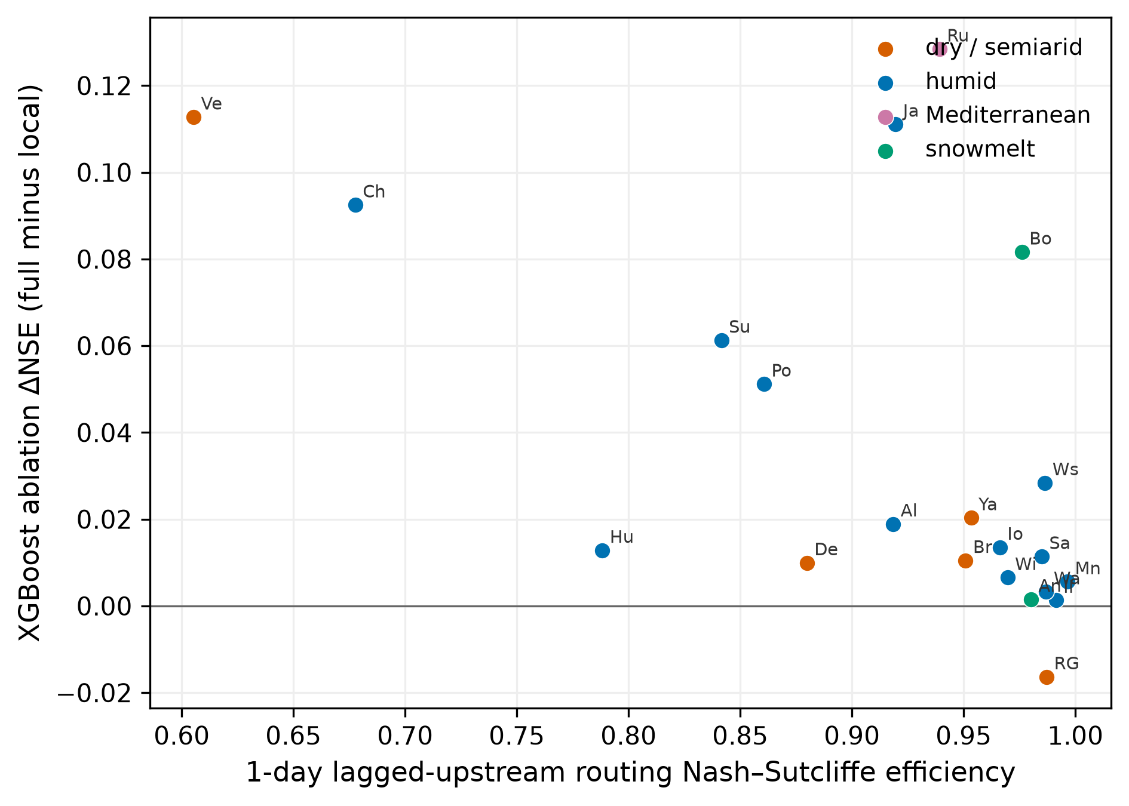
Figure 1. One-day XGBoost ablation ΔNSE against lagged-upstream routing NSE. Colours are climate groups (Okabe–Ito). Labels are two-letter codes of the Table 1 names (Al Allegheny, An Animas, Bo Bow, Br Brazos, Ch Chattahoochee, De Deschutes, Hu Hudson, Il Illinois, Io Iowa, Ja James, Mn Minnesota, Po Potomac, RG Rio Grande, Ru Russian, Sa Savannah, Su Susquehanna, Ve Verde, Wa Wabash, Wi Willamette, Ws Wisconsin, Ya Yakima). Ablation ΔNSE tends to fall as routing NSE rises; Bow remains an exception on the vertical axis because upstream columns still help the tree relative to a local-only model.
The 3 d ordinary-least-squares precipitation ceiling is the instrument-independent rain test (Table 3, Fig. 2). Hudson ΔNSE = 0.222 [0.120, 0.316]. Animas ΔNSE = 0.002 [-0.001, 0.008]; Bow ΔNSE = -0.009 [-0.040, 0.009]. Unused 3 d rain is a humid-main-stem property in this sample, not a universal mid-range deficit. The grouped rain-ceiling regime has routing-NSE coefficient -0.386 (R² = 0.666): once 1 d routing is saturated, perfect future rain also has little left to give at 3 d.
Network | OLS NSE | Oracle NSE | ΔNSE | ΔNSE 95 % CI
Allegheny | 0.738 | 0.793 | 0.055 | [0.013, 0.086]
Animas | 0.921 | 0.923 | 0.002 | [-0.001, 0.008]
Bow | 0.895 | 0.886 | -0.009 | [-0.040, 0.009]
Brazos | 0.875 | 0.845 | -0.029 | [-0.314, -0.009]
Chattahoochee | 0.263 | 0.402 | 0.139 | [-0.055, 0.280]
Deschutes | 0.489 | 0.523 | 0.034 | [-0.016, 0.112]
Hudson | 0.413 | 0.635 | 0.222 | [0.120, 0.316]
Illinois | 0.958 | 0.965 | 0.007 | [0.002, 0.014]
Iowa | 0.832 | 0.816 | -0.016 | [-0.058, 0.013]
James | 0.539 | 0.596 | 0.057 | [-0.033, 0.143]
Minnesota | 0.986 | 0.985 | -0.001 | [-0.006, 0.002]
Potomac | 0.333 | 0.407 | 0.074 | [-0.118, 0.160]
Rio Grande | 0.947 | 0.943 | -0.003 | [-0.007, 0.001]
Russian | 0.529 | 0.628 | 0.099 | [-0.414, 0.280]
Savannah | 0.954 | 0.956 | 0.002 | [0.001, 0.004]
Susquehanna | 0.531 | 0.696 | 0.166 | [0.067, 0.271]
Verde | -0.064 | 0.011 | 0.075 | [0.048, 0.530]
Wabash | 0.935 | 0.955 | 0.020 | [0.011, 0.032]
Willamette | 0.790 | 0.888 | 0.099 | [0.052, 0.137]
Wisconsin | 0.965 | 0.968 | 0.003 | [-0.002, 0.011]
Yakima | 0.890 | 0.895 | 0.005 | [-0.004, 0.016]
Table 3. Three-day ordinary-least-squares precipitation ceiling on the 2021–2023 test window.
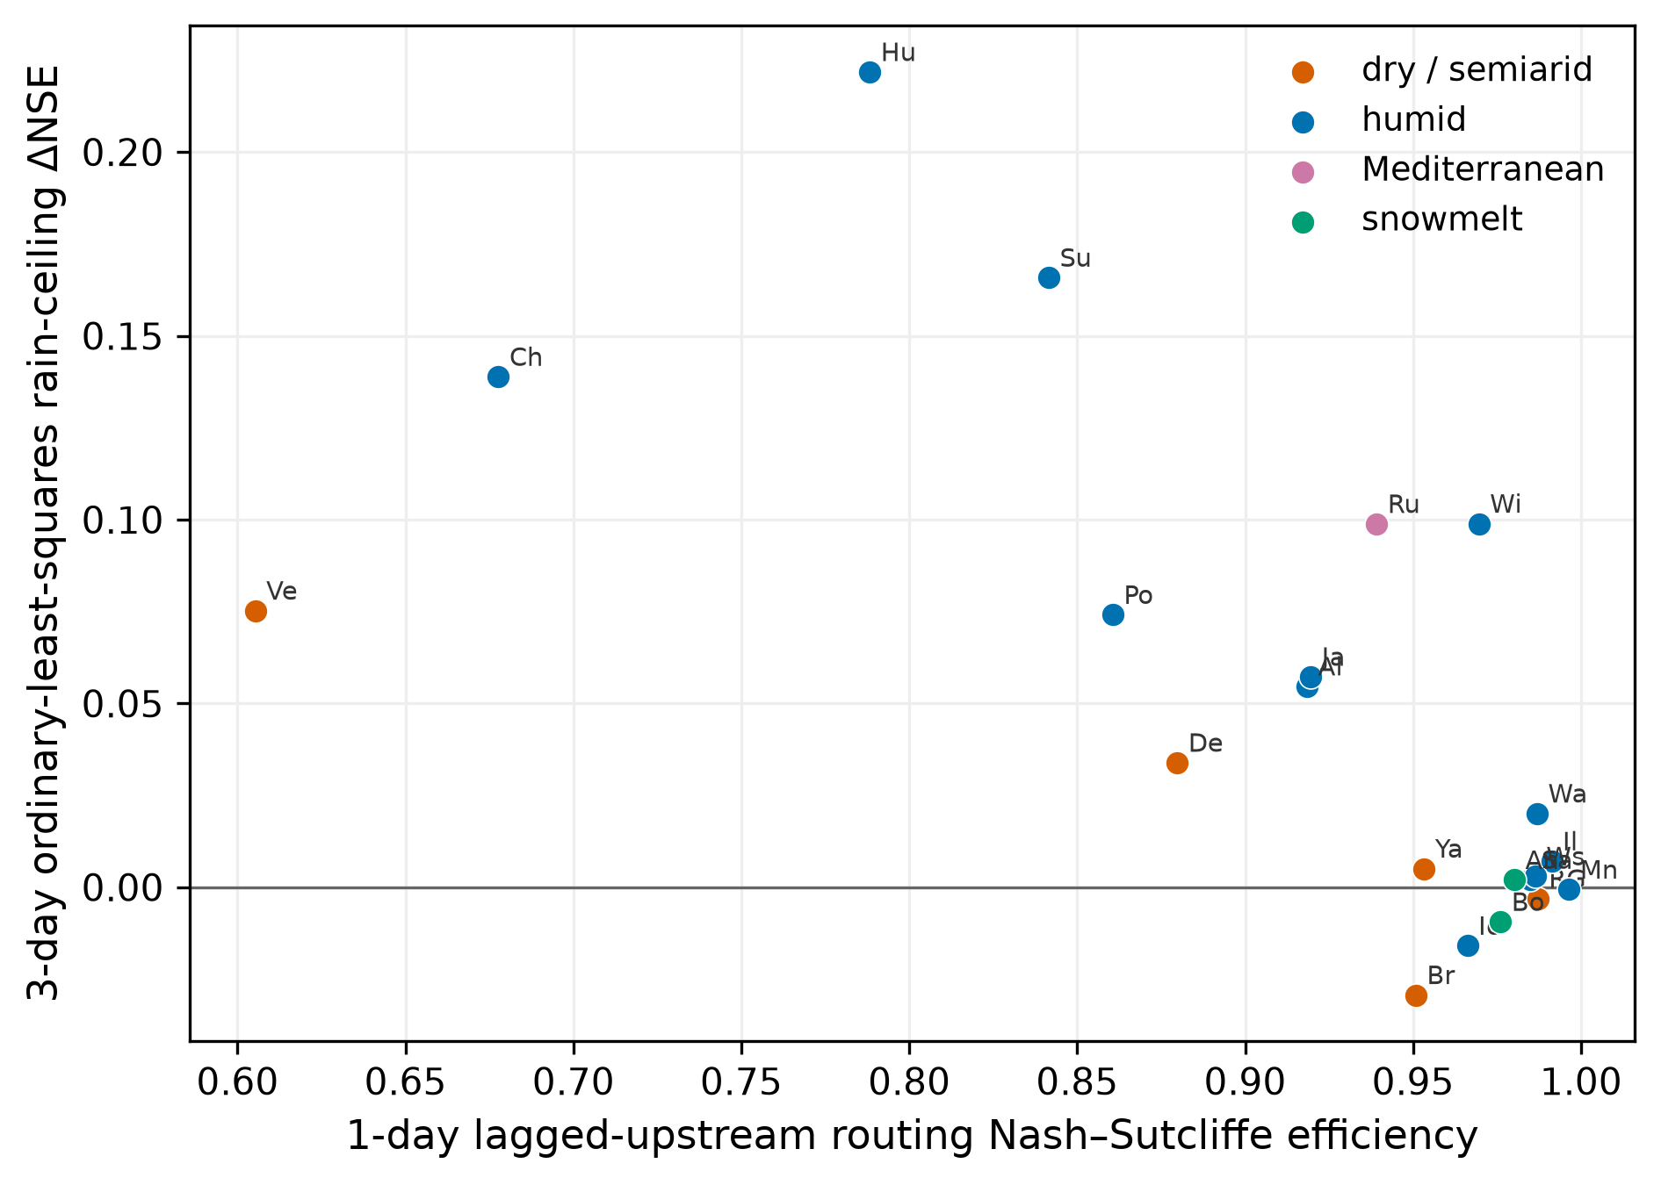
Figure 2. Three-day ordinary-least-squares rain-ceiling ΔNSE against 1-day routing NSE. Labels follow Fig. 1. Snowmelt and already-saturated main stems sit near zero; some humid stems still have unused 3 d rain.
4 Discussion
Kratzert et al. (2018) showed that a regional long short-term memory network can beat lumped conceptual models on CAMELS. Frame et al. (2022) showed that NSE on the bulk hydrograph is not CSI on extremes. Nearing et al. (2021) asked what science remains after the machine-learning win. None of those papers is a nested-gauge information-value atlas. Mixing CAMELS lumped basins into this sample would erase the distinction the paper exists to make.
A practical reading follows from the regime. If 1 d routing NSE is already high, another encoder is the wrong investment; the hydrograph is already in the upstream gauge, and a tree model can be worse than routing (Bow). If ablation ΔNSE remains clearly positive, the extra nested record still adds skill (James, Russian). If the extra-gauge term is negative, more columns are not more information (Rio Grande). If the ordinary-least-squares rain ceiling is near zero, 3–7 d precipitation cannot rescue the forecast (Animas, Bow, Minnesota). If CSI and NSE disagree, event-oriented evaluation should not rely on NSE alone (Verde). Those statements require a sample of networks and uncertainty intervals, not a few case studies.
Limits: regulation and ice are noted, not modelled as processes; travel time is unresolved at daily resolution on most of these main stems; Iowa and Deschutes CSI rest on too few events; a 2024 Global Forecast System previous-run swap on three climates (Appendix) does not reproduce a systematic operational precipitation penalty and is therefore not a headline cap. NeuralHydrology entity-aware long short-term memory remains a rainfall–runoff comparison for a different paper.
5 Conclusions
Nested operational gauges are not lumped rainfall–runoff. Information value on those gauges is a regime in routing saturation, climate group, and event versus bulk scores, estimated here with block-bootstrap uncertainty on 21 documented triads. The contribution is that regime.
Appendix A: Additional leads and 2024 precipitation swap
Tables A1 and A2 repeat the XGBoost versus routing comparison at 3 d and 7 d. Skill falls with lead on almost every network; CSI falls faster than NSE on several humid stems (Potomac, Susquehanna, Hudson). Table A3 reports a 2024 test in which the local precipitation feature is swapped for Open-Meteo previous-run Global Forecast System daily precipitation after training on observed rain. The swap does not systematically undercut observed-rain skill. On the Verde the previous-run field even raises 3 d and 7 d NSE relative to the Open-Meteo archive observation. That is not evidence that operational precipitation is sufficient; it is evidence that this particular swap is not the information bottleneck on those 2024 samples. The ordinary-least-squares oracle in Table 3 remains the rain-information test.
Network | Route NSE | XGB NSE | Abl. ΔNSE | Route CSI | XGB CSI | Events
Allegheny | 0.678 | 0.752 | 0.019 | 0.225 | 0.325 | 64
Animas | 0.904 | 0.912 | -0.000 | 0.886 | 0.829 | 103
Bow | 0.896 | 0.916 | 0.210 | 0.795 | 0.783 | 74
Brazos | 0.895 | 0.871 | 0.025 | 0.868 | 0.720 | 72
Chattahoochee | 0.187 | 0.190 | 0.010 | 0.105 | 0.216 | 146
Deschutes | 0.556 | 0.432 | 0.046 | 0.269 | 0.292 | 19
Hudson | 0.399 | 0.444 | 0.007 | 0.152 | 0.245 | 106
Illinois | 0.945 | 0.957 | 0.011 | 0.636 | 0.678 | 46
Iowa | 0.839 | 0.833 | 0.066 | 0.000 | 0.111 | 6
James | 0.435 | 0.479 | 0.016 | 0.256 | 0.364 | 77
Minnesota | 0.971 | 0.976 | 0.042 | 0.846 | 0.883 | 72
Potomac | 0.380 | 0.465 | 0.060 | 0.200 | 0.328 | 39
Rio Grande | 0.947 | 0.921 | -0.019 | 0.622 | 0.655 | 135
Russian | 0.647 | 0.517 | 0.042 | 0.537 | 0.439 | 68
Savannah | 0.910 | 0.972 | 0.116 | 0.689 | 0.853 | 154
Susquehanna | 0.442 | 0.485 | 0.014 | 0.198 | 0.315 | 72
Verde | 0.245 | 0.242 | 0.160 | 0.553 | 0.513 | 139
Wabash | 0.916 | 0.939 | 0.032 | 0.695 | 0.792 | 75
Willamette | 0.771 | 0.805 | 0.010 | 0.520 | 0.610 | 96
Wisconsin | 0.939 | 0.954 | 0.132 | 0.653 | 0.764 | 71
Yakima | 0.768 | 0.873 | 0.057 | 0.619 | 0.667 | 70
Table A1. 3-day nested skill on the 2021–2023 test window.
Network | Route NSE | XGB NSE | Abl. ΔNSE | Route CSI | XGB CSI | Events
Allegheny | 0.385 | 0.499 | 0.034 | 0.070 | 0.127 | 64
Animas | 0.848 | 0.847 | -0.005 | 0.687 | 0.687 | 103
Bow | 0.729 | 0.857 | 0.037 | 0.505 | 0.618 | 74
Brazos | 0.791 | 0.688 | 0.019 | 0.675 | 0.737 | 72
Chattahoochee | 0.130 | 0.150 | 0.004 | 0.086 | 0.127 | 146
Deschutes | 0.280 | 0.264 | 0.298 | 0.042 | 0.120 | 19
Hudson | 0.292 | 0.315 | 0.027 | 0.024 | 0.079 | 106
Illinois | 0.811 | 0.814 | 0.050 | 0.509 | 0.514 | 46
Iowa | 0.606 | 0.599 | 0.094 | 0.000 | 0.000 | 6
James | 0.235 | 0.288 | -0.002 | 0.092 | 0.160 | 77
Minnesota | 0.790 | 0.819 | 0.094 | 0.675 | 0.651 | 72
Potomac | 0.072 | 0.110 | 0.087 | 0.038 | 0.075 | 39
Rio Grande | 0.881 | 0.856 | 0.025 | 0.519 | 0.576 | 135
Russian | 0.328 | 0.358 | 0.118 | 0.337 | 0.383 | 68
Savannah | 0.814 | 0.850 | 0.399 | 0.758 | 0.800 | 154
Susquehanna | 0.175 | 0.160 | -0.004 | 0.012 | 0.078 | 72
Verde | 0.188 | 0.198 | 0.070 | 0.494 | 0.412 | 139
Wabash | 0.686 | 0.742 | 0.058 | 0.378 | 0.409 | 75
Willamette | 0.510 | 0.511 | -0.016 | 0.290 | 0.317 | 96
Wisconsin | 0.658 | 0.653 | 0.054 | 0.409 | 0.422 | 71
Yakima | 0.543 | 0.567 | -0.003 | 0.211 | 0.384 | 70
Table A2. 7-day nested skill on the 2021–2023 test window.
Network | Lead (d) | Observed-rain NSE | Previous-run NSE | Δ | n (2024)
Animas | 1 | 0.961 | 0.961 | -0.000 | 348
Animas | 3 | 0.830 | 0.828 | -0.002 | 346
Animas | 7 | 0.611 | 0.615 | 0.004 | 342
Potomac | 1 | 0.939 | 0.937 | -0.002 | 348
Potomac | 3 | 0.482 | 0.515 | 0.033 | 346
Potomac | 7 | 0.174 | 0.204 | 0.030 | 342
Verde | 1 | 0.694 | 0.736 | 0.042 | 348
Verde | 3 | 0.247 | 0.410 | 0.163 | 346
Verde | 7 | 0.001 | 0.305 | 0.304 | 342
Table A3. Previous-run Global Forecast System precipitation swap on 2024. Models are trained on observed precipitation; only the 2024 local rain feature is replaced.
Code and data availability
Frozen atlas tables and the Word builder are in the forecast-information-value repository (https://github.com/Az0998/forecast-information-value, directory data/frozen/river/). Daily discharge is from USGS National Water Information System parameter 00060 and from the Water Survey of Canada for the Bow. Meteorology and previous-run precipitation are from Open-Meteo. Scoring scripts live in the sibling engine hydro-ml-paper (download_nested_atlas.py, run_nested_atlas.py). Training dates run through 31 December 2018. A persistent identifier for a versioned snapshot will be issued on Zenodo at submission; until then the GitHub frozen tables are the lock file.
Author contributions
SZ designed the study, performed the analysis, and wrote the manuscript.
Competing interests
The author declares that they have no conflict of interest.
Acknowledgements
Discharge records were provided by the USGS National Water Information System and the Water Survey of Canada. Meteorological fields were provided by Open-Meteo. Language models were used to draft analysis code and to edit English; the author remains responsible for the text and for every number locked to the frozen tables.
Financial support
This research received no external financial support.
References
Chen, T. and Guestrin, C.: XGBoost: a scalable tree boosting system, in: Proceedings of the 22nd ACM SIGKDD International Conference on Knowledge Discovery and Data Mining, 785–794, https://doi.org/10.1145/2939672.2939785, 2016.
Frame, J. M., Kratzert, F., Klotz, D., Gauch, M., Shalev, G., Gilon, O., Qualls, L. M., Gupta, H. V., and Nearing, G. S.: Deep learning rainfall–runoff predictions of extreme events, Hydrol. Earth Syst. Sci., 26, 3377–3392, https://doi.org/10.5194/hess-26-3377-2022, 2022.
Gauch, M., Kratzert, F., Klotz, D., Nearing, G., Lin, J., and Hochreiter, S.: Rainfall–runoff prediction at multiple timescales with a single Long Short-Term Memory network, Hydrol. Earth Syst. Sci., 25, 2045–2062, https://doi.org/10.5194/hess-25-2045-2021, 2021.
Kratzert, F., Klotz, D., Brenner, C., Schulz, K., and Herrnegger, M.: Rainfall–runoff modelling using Long Short-Term Memory (LSTM) networks, Hydrol. Earth Syst. Sci., 22, 6005–6022, https://doi.org/10.5194/hess-22-6005-2018, 2018.
Kratzert, F., Klotz, D., Shalev, G., Klambauer, G., Hochreiter, S., and Nearing, G.: Towards learning universal, regional, and local hydrological behaviors via machine learning applied to large-sample datasets, Hydrol. Earth Syst. Sci., 23, 5089–5110, https://doi.org/10.5194/hess-23-5089-2019, 2019.
Nearing, G. S., Kratzert, F., Sampson, A. K., Pelissier, C. S., Klotz, D., Frame, J. M., Prieto, C., and Gupta, H. V.: What role does hydrological science play in the age of machine learning?, Water Resour. Res., 57, e2020WR028091, https://doi.org/10.1029/2020WR028091, 2021.

