Information value of upstream gauges and precipitation foresight for multi-horizon streamflow forecasting: Potomac–James mid-Atlantic evidence
Senjie Zhang¹
Lanzhou University
E-mail:3079099853@qq.com | ORCID:0009-0001-8346-3603:
Research Article | Journal: Hydrological Sciences Journal
Highlights
• ML gains are judged against lagged-upstream routing, not persistence alone.
• James River replication confirms protocol transfer in the mid-Atlantic.
• Oracle precip lifts 3–7d NSE; raw GFS QPF needs careful use at longer leads.
• P90 flood CSI is useful at 1 day but weak for weekly observation-only alerts.
• Upstream ablation shows basin-dependent gauge value for next-day outlooks.
Abstract
Whether upstream gauges improve downstream forecasts is no longer a novel claim. The operational question is how forecast information is partitioned among routing memory, nonlinear learning, and precipitation foresight, and whether that partition transfers across neighboring basins. We address this for two mid-Atlantic outlets—the Potomac River at Washington, D.C. (USGS 01646500) and the James River near Richmond, VA (02037500)—using public USGS discharge and Open-Meteo meteorology (2000–2023 test window) plus GFS previous-run quantitative precipitation forecasts (QPF) for 2024. Models are scored against persistence and a lagged-upstream linear routing baseline; upstream value is tested by ablation; flood utility uses P90 exceedance CSI/POD/FAR; and precip foresight is compared as observation-only, precipitation persistence, real GFS QPF, and perfect-foresight oracle. On the Potomac, 1-day LSTM-Attention NSE = 0.930 exceeds routing (0.861); James replication shows even stronger routing (0.920) with a large upstream-ablation gain (ΔNSE = 0.129). Oracle precip raises longer-lead skill, while raw GFS QPF improves 1-day 2024 NSE relative to observation-only inputs but can degrade uncorrected 3-day forecasts. Flood CSI is useful next day (~0.75) yet weak weekly. The transferable message is conditional gauge-network and QPF design guidance for mid-Atlantic short-range forecasting.
Keywords: streamflow forecasting; information value; upstream gauges; QPF; flood warning; Potomac River; James River; LSTM
1. Introduction
Upstream discharge is a physically expected predictor of downstream short-range streamflow. Repeating that fact for a single humid basin, framed as a scenario simulation of upstream forcing, does not constitute a sufficient contribution for an international hydrology readership. What remains useful is a sharper information-value question: relative to a simple hydrologic routing reference, how large is the residual gain from machine learning; at which leads does skill become limited by missing future rainfall rather than by gauge density; do bulk NSE gains translate into flood-threshold alert skill; and do these patterns transfer to a neighboring mid-Atlantic basin (Kratzert et al., 2019; Frame et al., 2022; Nearing et al., 2021).
Deep learning and gradient boosting provide strong benchmarks when dense archives exist (Kratzert et al., 2018; Chen and Guestrin, 2016; Shen, 2018). Architecture novelty is secondary unless paired with hydrological insight about information pathways. Here we deliberately avoid claiming a new universal network. Instead we quantify an information partition for the Potomac outlet and test protocol transfer on the James River.
Objectives are to (i) measure multi-horizon skill against persistence and lagged-upstream linear routing, (ii) quantify upstream-gauge value by ablation on both basins, (iii) compare observation-only forecasts with precipitation persistence, real GFS QPF and an oracle precipitation ceiling, and (iv) report P90 flood-threshold CSI/POD/FAR.
2. Study areas and data
Potomac network: target USGS 01646500 (Washington, D.C.) with upstream 01636500 (Shenandoah at Millville) and 01638480 (Potomac at Harpers Ferry). James network: target 02037500 (near Richmond) with upstream 02035000 (Cartersville) and 02034000 (Rivanna at Palmyra). Both are humid subtropical mid-Atlantic corridors with strong societal exposure. Daily discharge (USGS NWIS) and Open-Meteo precipitation/temperature span 2000–2024. Real QPF uses Open-Meteo GFS previous-run hourly precipitation aggregated to daily sums for lead times 1, 3 and 7 days in 2024 (Fig. 1).
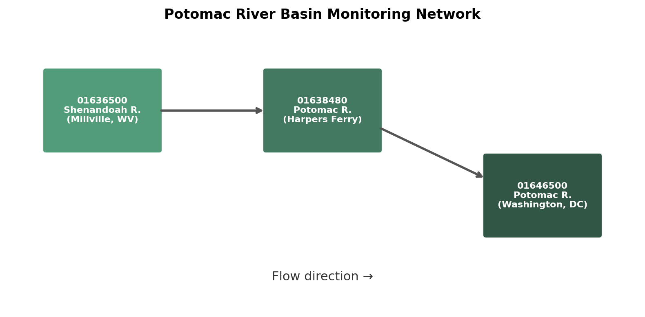
Fig. 1. Potomac gauge schematic used in the primary experiments (James network analogous).
Table 1. Gauge networks.
Basin | Site ID | Name | Role
Potomac | 01646500 | Potomac at Washington, DC | Target
Potomac | 01636500 | Shenandoah at Millville, WV | Upstream
Potomac | 01638480 | Potomac at Harpers Ferry, WV | Upstream
James | 02037500 | James near Richmond, VA | Target
James | 02035000 | James at Cartersville, VA | Upstream
James | 02034000 | Rivanna at Palmyra, VA | Upstream
3. Methods
3.1 Forecast task
Predict Q_target(t+h), h ∈ {1, 3, 7}, from 30-day sequences of local discharge, precipitation and temperature plus upstream discharge and precipitation. Chronological split for basin experiments: train ≤2018, validation 2019–2020, test 2021–2023. QPF experiments use train ≤2022, validation 2023, test 2024 because the previous-run archive used here begins in 2024. Pre-2024 foresight features for the QPF-trained model use precipitation persistence fill; 2024 test uses real GFS QPF.
3.2 Models and baselines
Persistence; lagged-upstream linear regression with lag L ∈ {0–3} selected on train+validation; XGBoost; LSTM-Attention (2×64, dropout 0.2). Upstream ablation retrains Attention on local-only inputs.
3.3 Precipitation foresight ladder
Four Attention configurations on Potomac 2024: (1) observation-only; (2) precipitation persistence foresight; (3) real GFS QPF foresight; (4) perfect-foresight oracle precipitation. Separately, oracle-versus-observation ceilings on the 2021–2023 Potomac window quantify the information gap without QPF archive constraints.
3.4 Evaluation
NSE/KGE/RMSE/MAE/PBIAS; P90 flood threshold from training discharge (Potomac P90 ≈ 26200 cfs) with POD/FAR/CSI; GFS QPF verified against observed daily precipitation (correlation and RMSE).
4. Results
4.1 Potomac skill against routing
At 1 day, routing already reaches NSE = 0.861, while Attention reaches 0.930 and XGBoost 0.911 (Figs. 2–3; Table 2). The ML residual over routing is finite (~0.070 NSE). At 3–7 days, observation-driven skill collapses for all methods, with Attention retaining a larger 7-day residual (0.218) than routing (0.072). Hydrograph excerpts (Figs. 4–6) illustrate progressive loss of amplitude and timing fidelity with lead time.
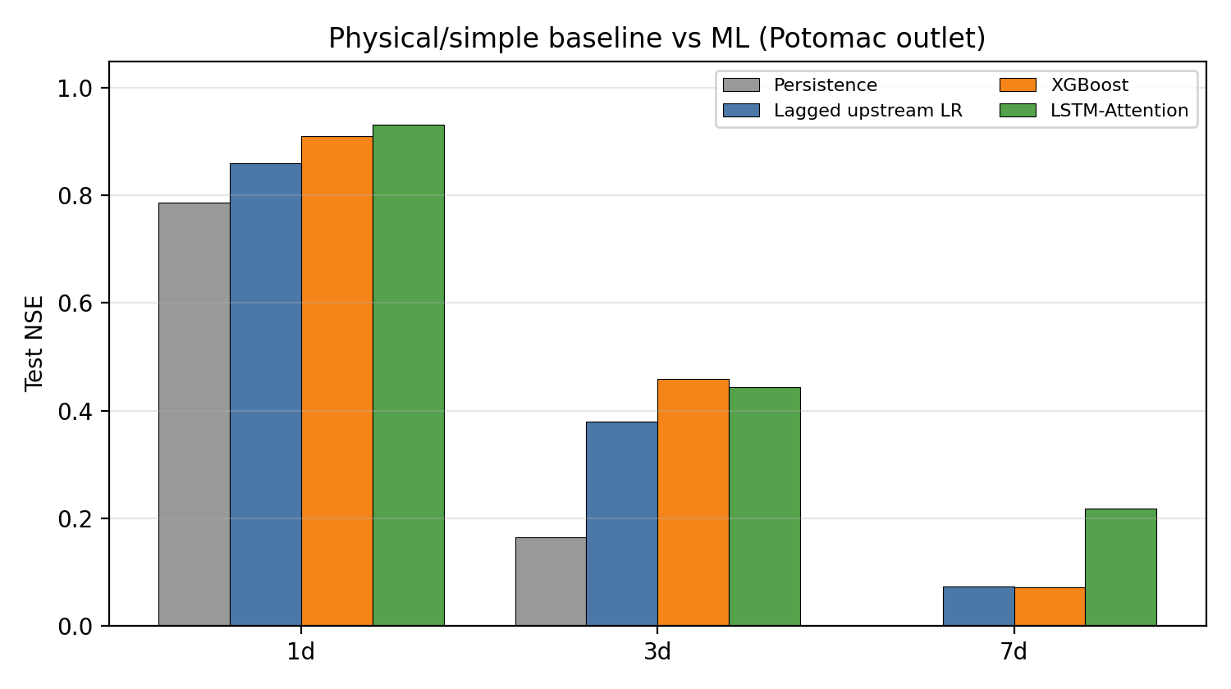
Fig. 2. Potomac test NSE versus persistence and lagged-upstream linear routing.
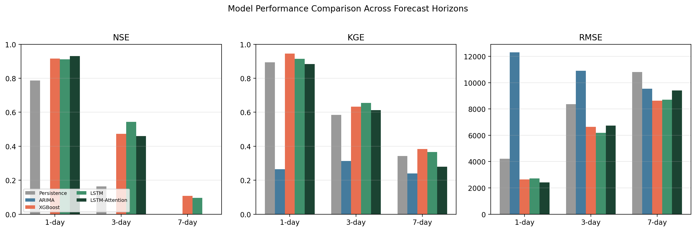
Fig. 3. Bulk NSE/KGE/RMSE comparison across 1-, 3- and 7-day horizons (Potomac).
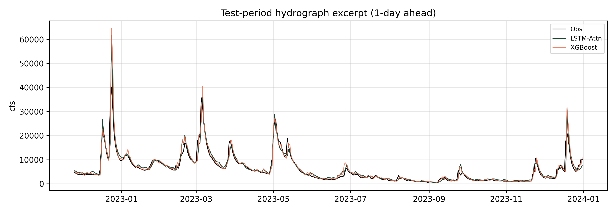
Fig. 4. Potomac test hydrograph excerpt (1-day ahead).
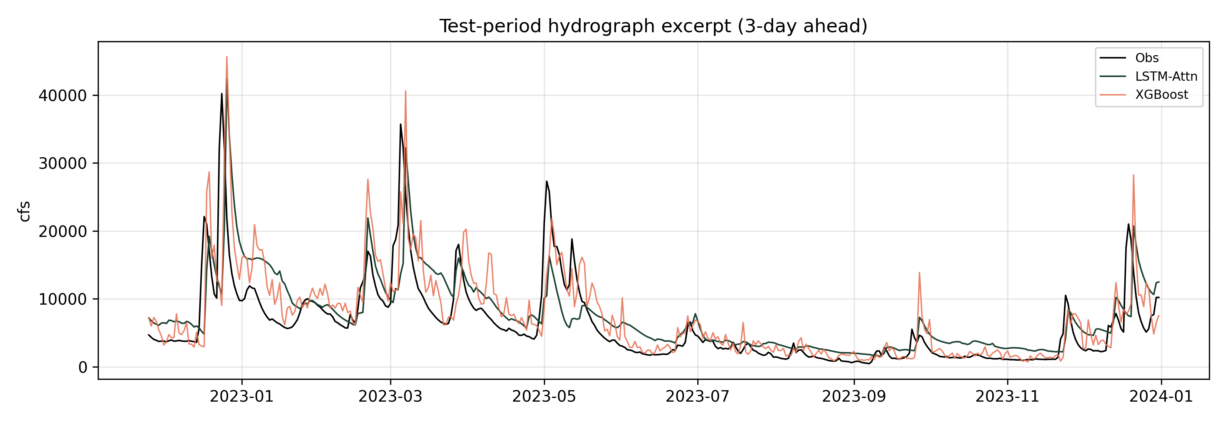
Fig. 5. Potomac test hydrograph excerpt (3-day ahead).
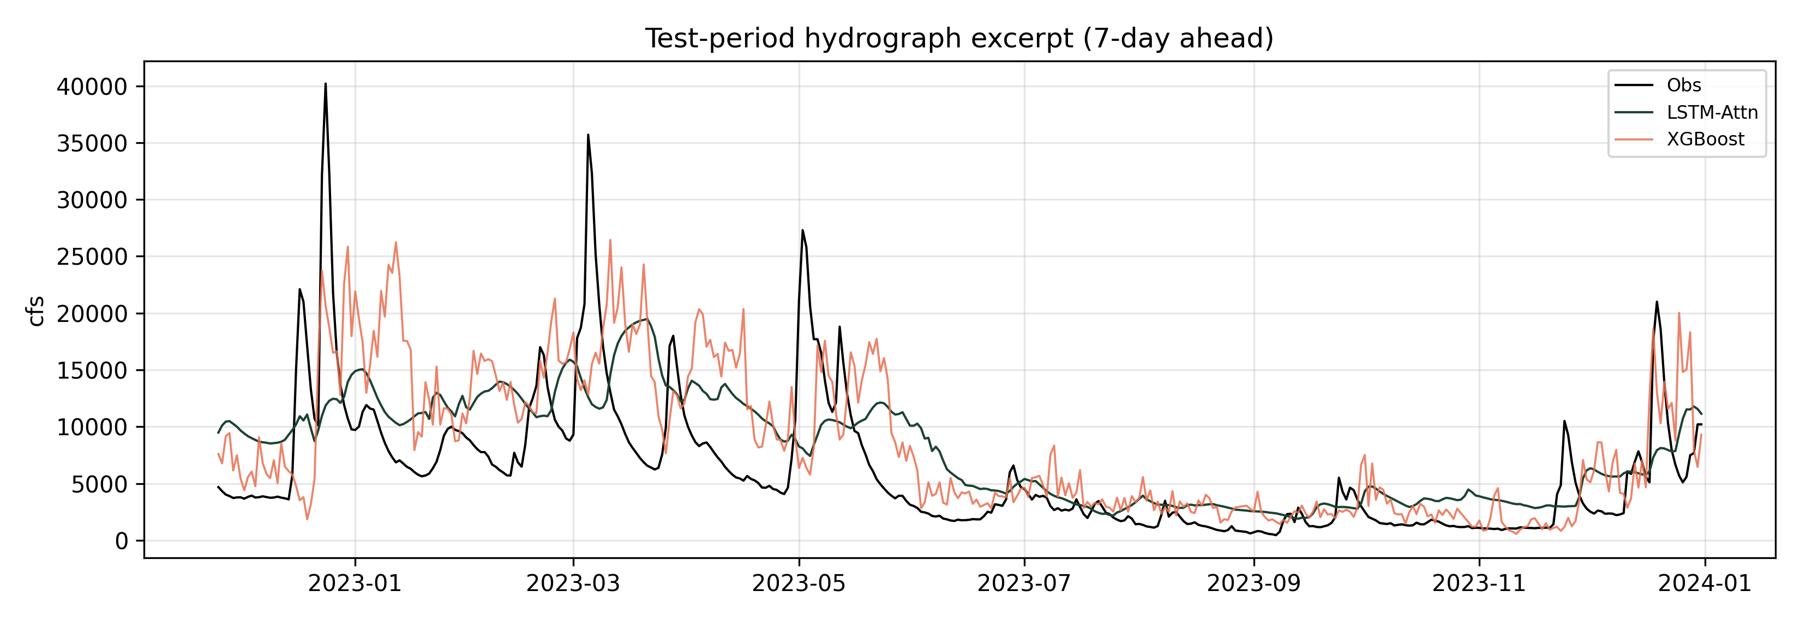
Fig. 6. Potomac test hydrograph excerpt (7-day ahead).
4.2 Transfer to the James River
The same protocol on the James outlet yields 1-day routing NSE = 0.920 and XGBoost/Attention ≈ 0.939/0.933 (Fig. 7; Table 2). Upstream ablation ΔNSE at 1 day is 0.129 on James versus 0.020 on Potomac, indicating stronger near-term dependence on upstream gauges for the Richmond target. Patterns of horizon-dependent skill decay are shared across basins.
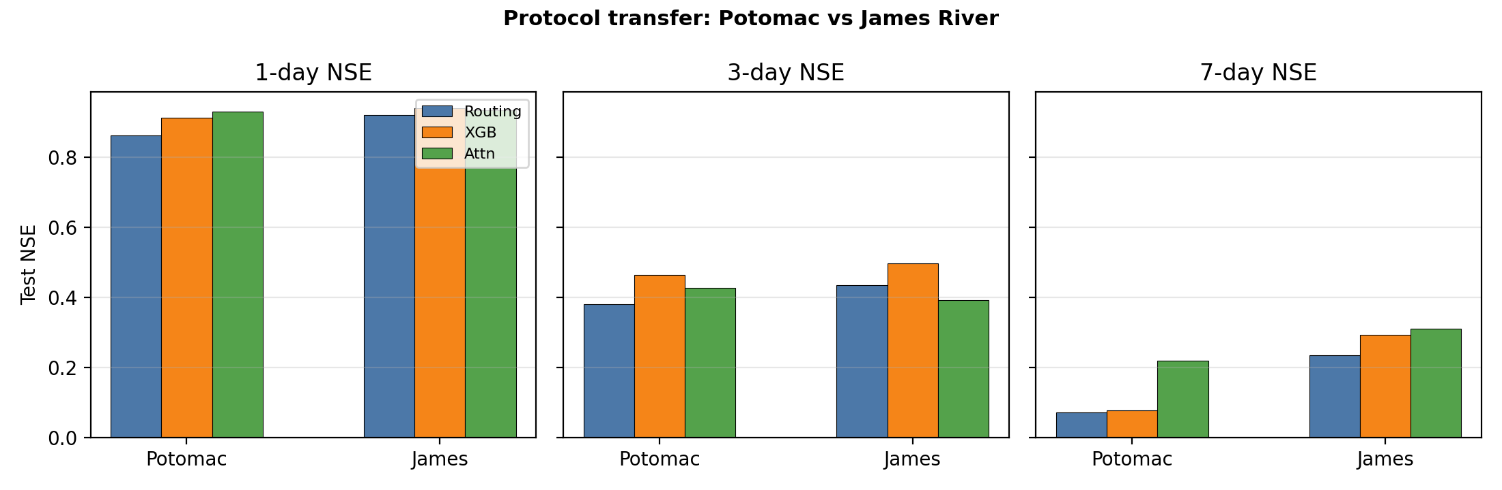
Fig. 7. Protocol transfer: Potomac versus James River test NSE.
Table 2. Test NSE by basin and horizon.
Basin | h (d) | Pers. | Routing | XGB | Attn
Potomac | 1 | 0.787 | 0.861 | 0.911 | 0.930
Potomac | 3 | 0.164 | 0.380 | 0.463 | 0.426
Potomac | 7 | -0.393 | 0.072 | 0.077 | 0.218
James | 1 | 0.773 | 0.920 | 0.939 | 0.933
James | 3 | 0.293 | 0.435 | 0.496 | 0.392
James | 7 | -0.052 | 0.235 | 0.292 | 0.309
Table 3. Upstream ablation ΔNSE for LSTM-Attention (full minus local-only).
Basin | h (d) | Full NSE | ΔNSE (full−local)
Potomac | 1 | 0.926 | 0.020
Potomac | 3 | 0.426 | 0.091
Potomac | 7 | 0.218 | 0.285
James | 1 | 0.933 | 0.129
James | 3 | 0.392 | 0.090
James | 7 | 0.309 | 0.011
4.3 Precipitation foresight: oracle ceiling and real GFS QPF
On the 2021–2023 Potomac window, perfect-foresight precipitation leaves 1-day NSE nearly unchanged (ΔNSE ≈ -0.001) but raises 3-day and 7-day NSE by 0.121 and 0.196, respectively (Fig. 8). Thus weekly observation-only forecasts are information-limited.
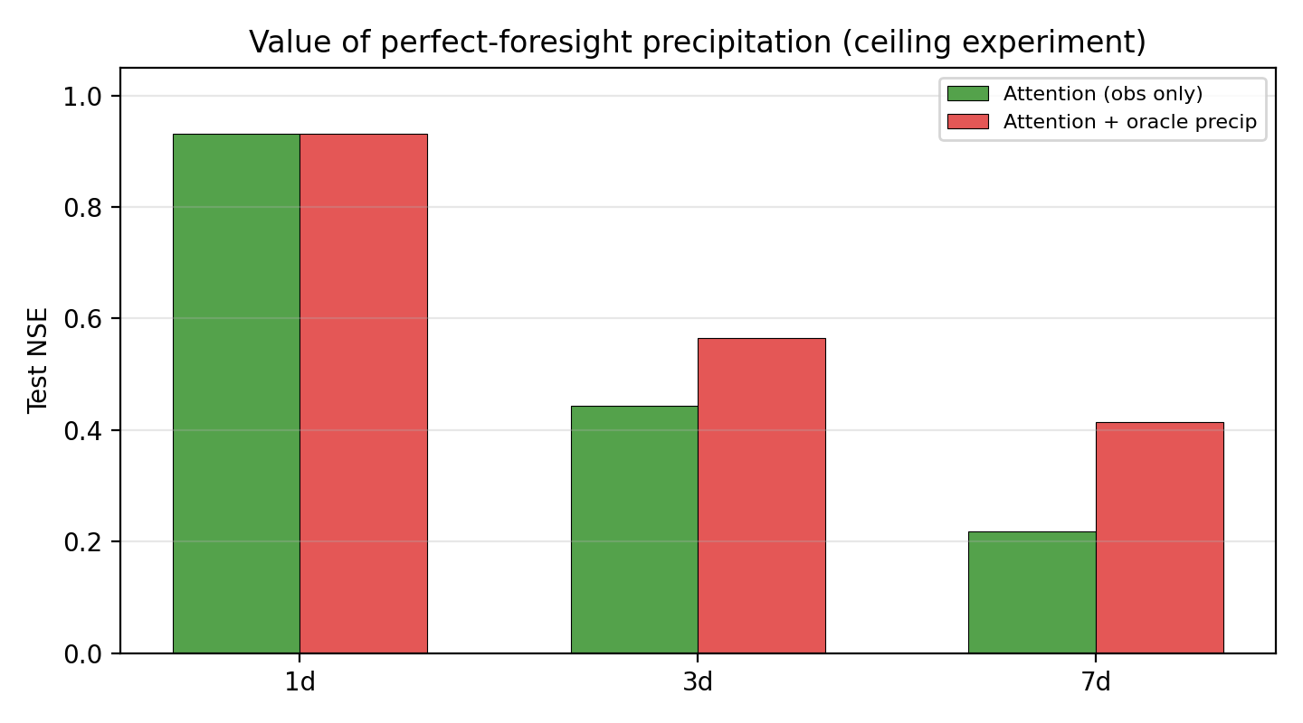
Fig. 8. Oracle precipitation ceiling for Potomac LSTM-Attention (2021–2023 test).
For 2024, GFS previous-run daily precip correlates with observations at r = 0.49 (1-day lead) and r = 0.60 (3-day lead). In streamflow mode, real QPF raises 1-day Attention NSE from 0.893 (obs-only) to 0.923, approaching the oracle (0.926). At 3 days, however, uncorrected QPF ingestion can degrade skill (-0.035) relative to obs-only (0.406), while oracle remains highest (0.577) (Fig. 9; Table 4). This cautions against treating raw QPF as a drop-in feature without bias-aware training.
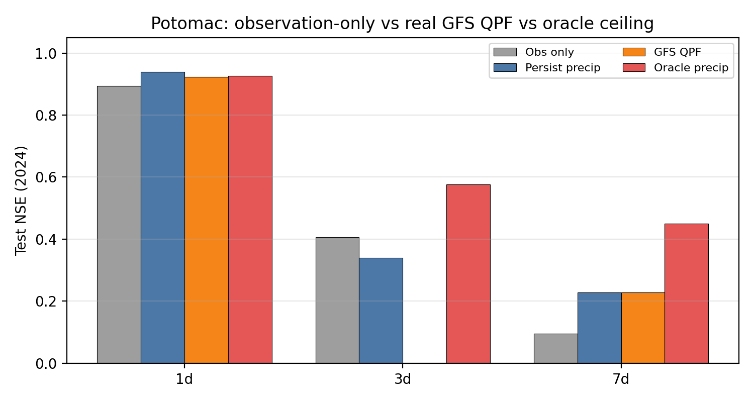
Fig. 9. Potomac 2024 NSE ladder: obs-only, precip persistence, real GFS QPF, oracle.
Table 4. Potomac 2024 Attention NSE under precip foresight options.
h (d) | Obs-only | Persist P | GFS QPF | Oracle
1 | 0.893 | 0.939 | 0.923 | 0.926
3 | 0.406 | 0.340 | -0.035 | 0.577
7 | 0.094 | 0.228 | 0.228 | 0.450
4.4 Flood-threshold, seasonal skill, uncertainty and interpretability
Using Potomac training P90, 1-day Attention CSI = 0.75 (POD = 0.85, FAR = 0.13), exceeding routing CSI = 0.62 (Fig. 10; Table 5). CSI collapses at weekly lead times under observation-only forcing. Seasonal NSE panels (Figs. 11–13), multi-seed uncertainty bands (Figs. 14–15), permutation importance (Fig. 16) and the weekly scatter plot (Fig. 17) provide supporting diagnostics.
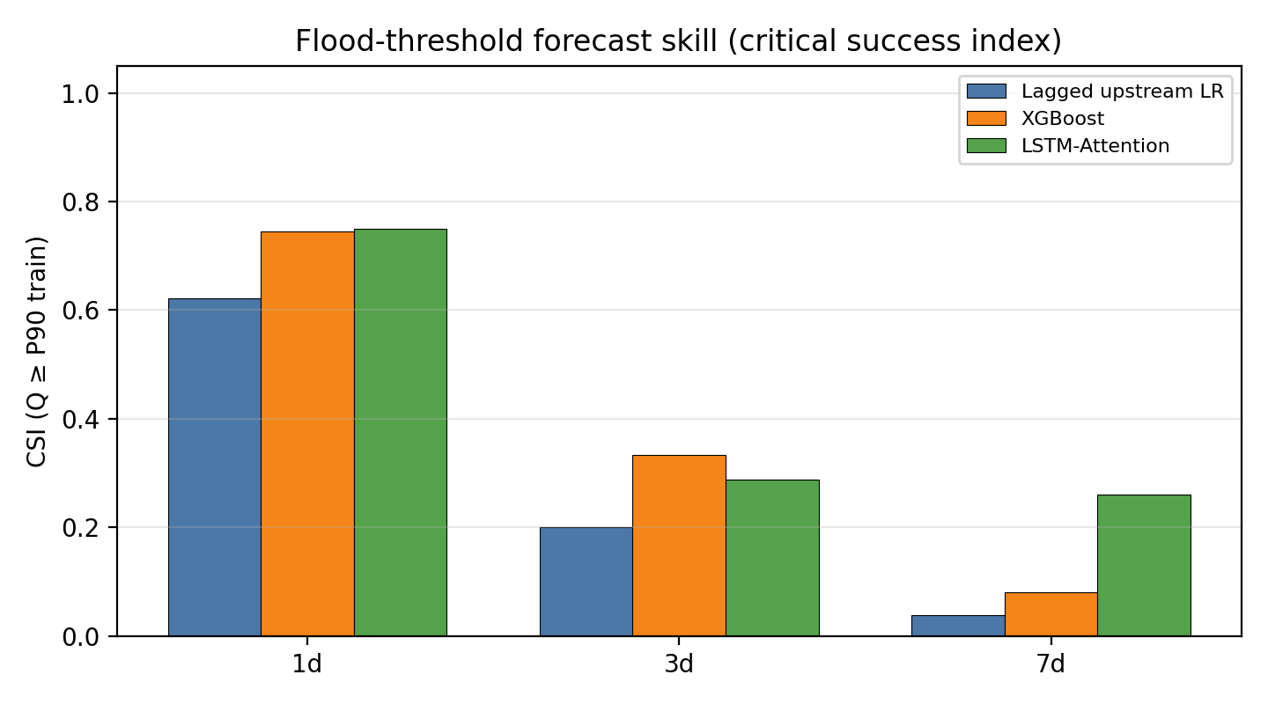
Fig. 10. Potomac P90 flood-threshold critical success index.
Table 5. Potomac P90 flood-threshold CSI.
h (d) | Routing CSI | XGB CSI | Attn CSI
1 | 0.62 | 0.74 | 0.75
3 | 0.20 | 0.33 | 0.29
7 | 0.04 | 0.08 | 0.26
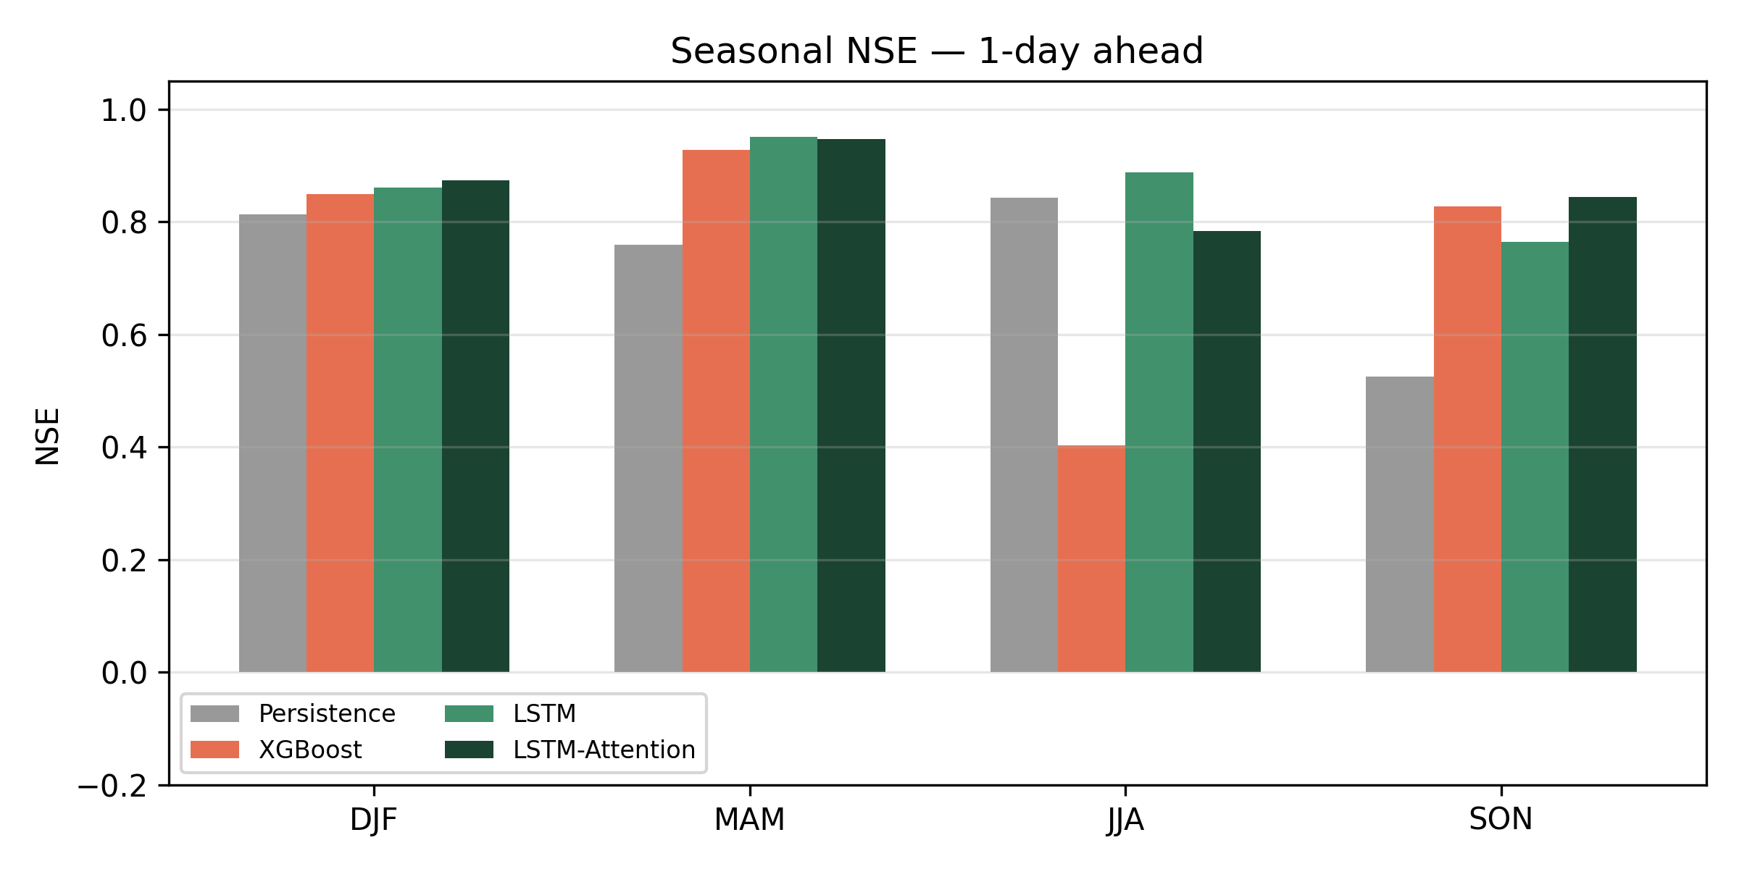
Fig. 11. Seasonal NSE at the 1-day horizon (Potomac).
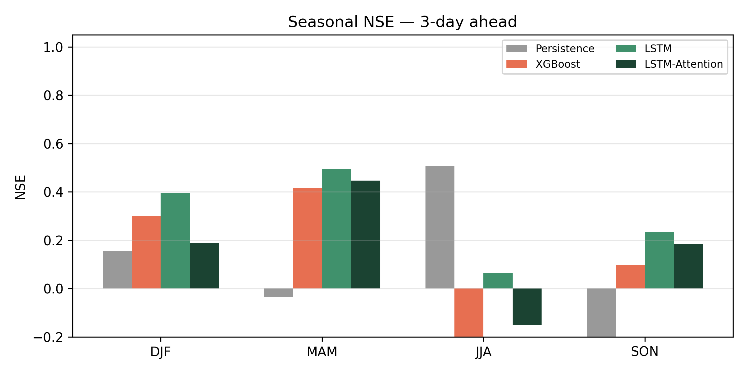
Fig. 12. Seasonal NSE at the 3-day horizon (Potomac).
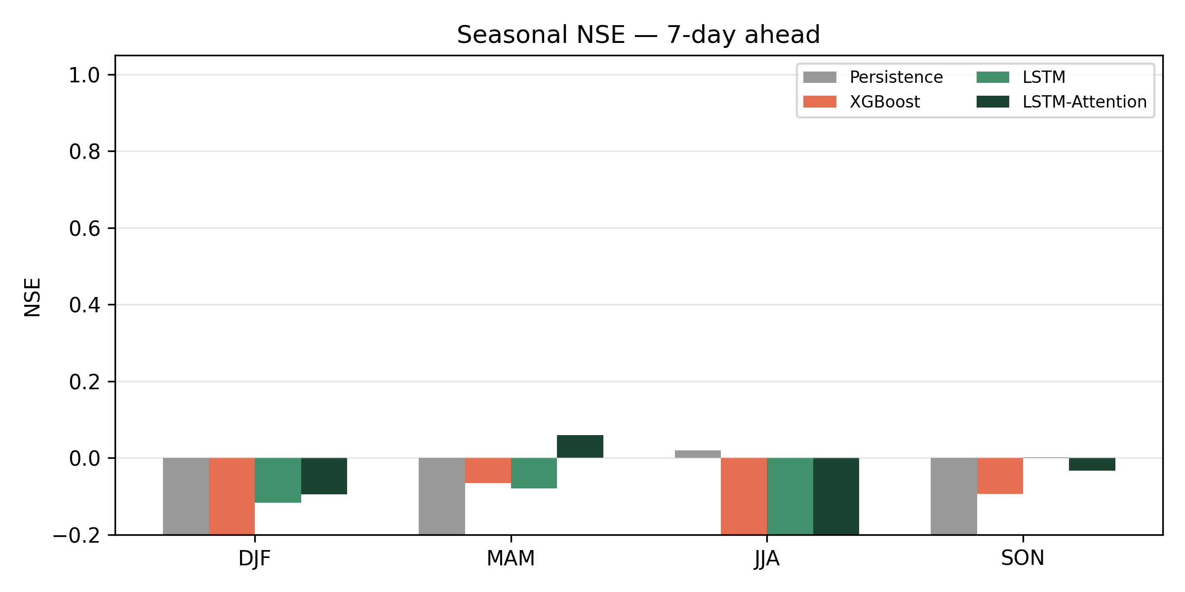
Fig. 13. Seasonal NSE at the 7-day horizon (Potomac).
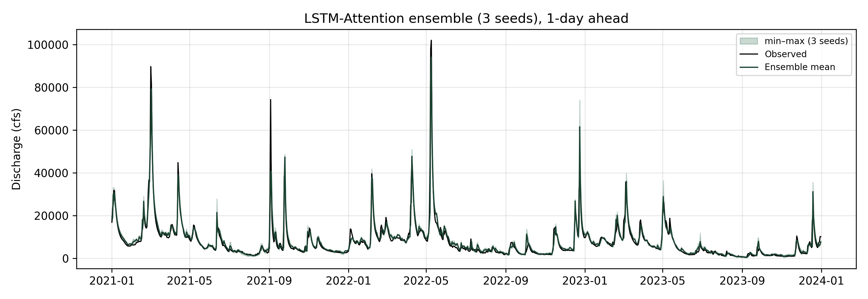
Fig. 14. Multi-seed uncertainty band for LSTM-Attention (1-day).
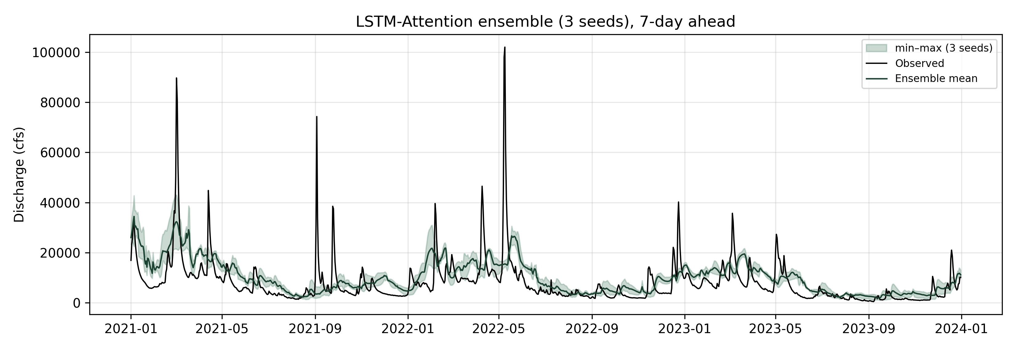
Fig. 15. Multi-seed uncertainty band for LSTM-Attention (7-day).
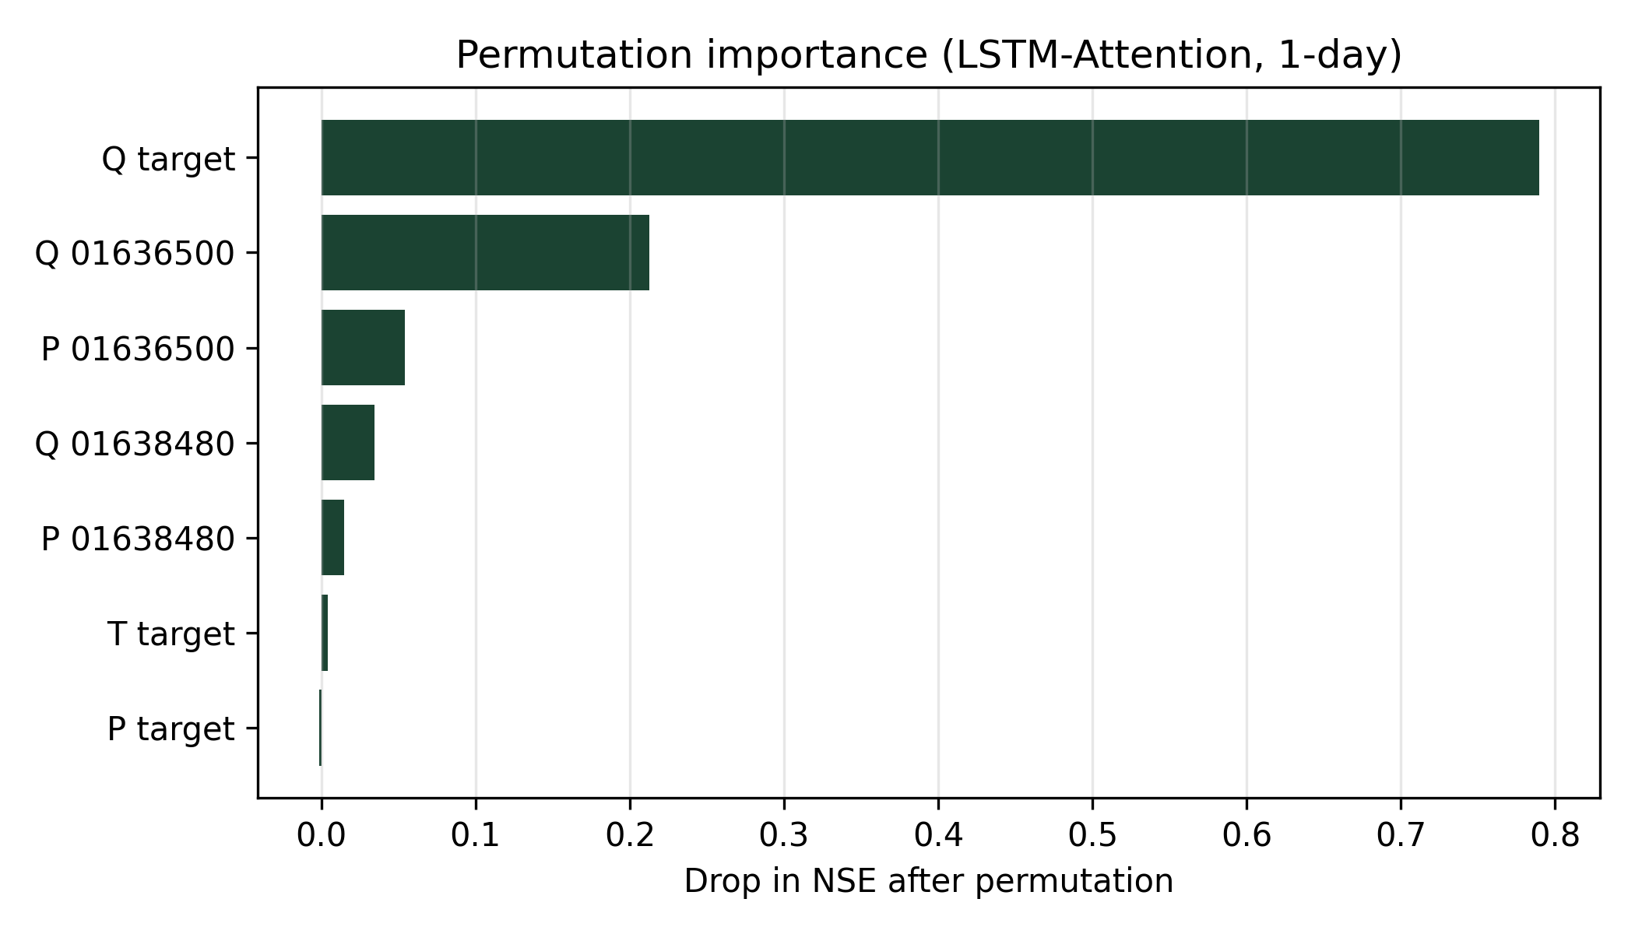
Fig. 16. Permutation importance for Potomac 1-day Attention.
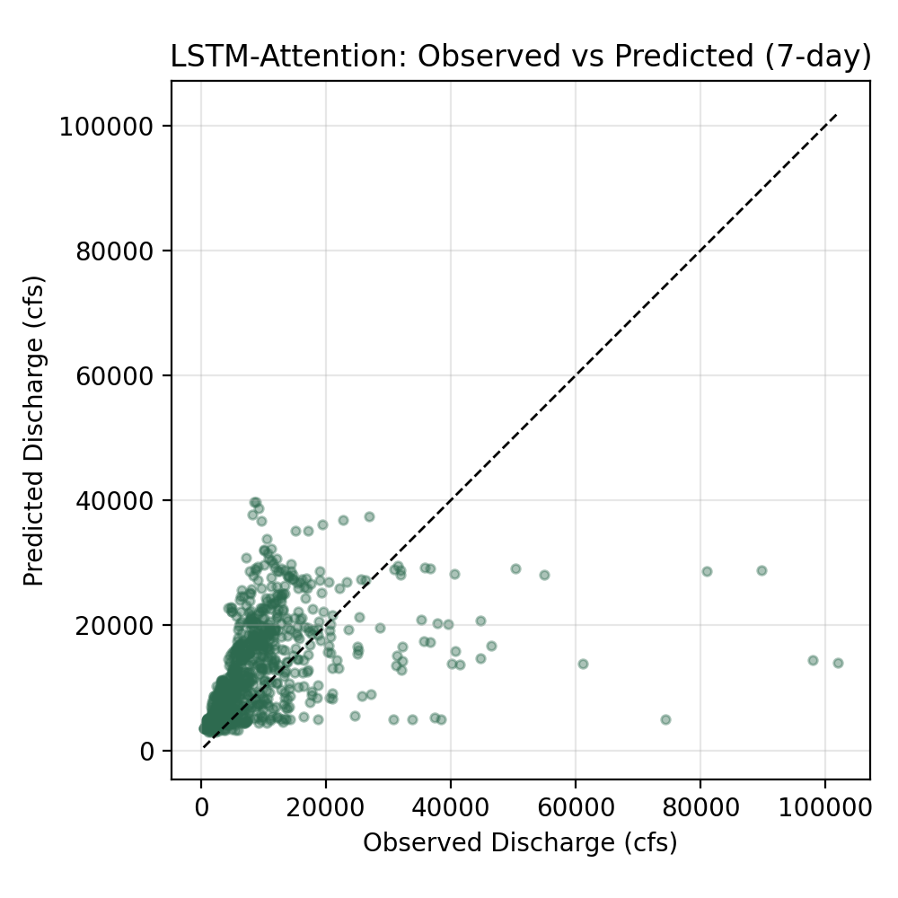
Fig. 17. Observed versus predicted discharge at the weekly horizon.
5. Discussion
The contribution is not that upstream flow matters, but that mid-Atlantic short-range forecast skill is routing-dominated at 1 day, with a basin-dependent upstream-ablation signal (stronger on James), a finite ML residual over linear routing, and a clear precipitation-foresight bottleneck beyond about three days. Real GFS QPF can help next-day products yet is not a substitute for bias-aware integration at longer leads, even though oracle experiments show substantial unused skill.
These findings align with broader LSTM rainfall–runoff evidence and caution against overstating weekly deterministic skill without precipitation foresight (Kratzert et al., 2018, 2019; Frame et al., 2022; Nearing et al., 2021). Limitations include reanalysis meteorology for non-QPF inputs, a single year of previous-run QPF, omitted regulation/tidal effects, and two-basin rather than continental scope.
6. Conclusions
Main findings. Across Potomac and James outlets, next-day forecasts are largely explained by lagged upstream routing plus local memory; ML adds a finite residual. Precipitation foresight, not additional architecture complexity, is the binding constraint for 3–7-day deterministic skill.
Broader impacts. Mid-Atlantic forecasting design should protect upstream telemetry for 1-day flood-threshold alerts and couple weekly products to QPF with explicit bias handling.
Outlook. Extending previous-run QPF archives, testing bias-corrected QPF predictors, and adding further Atlantic-coast basins would strengthen transfer claims.
Data availability
USGS NWIS discharge (https://waterservices.usgs.gov/) and Open-Meteo archive / previous-run APIs (https://open-meteo.com/) are public. Processed tables and scripts are available from the corresponding author upon reasonable request.
Disclosure statement
The authors report there are no competing interests to declare.
Funding
This research received no specific grant from any funding agency in the public, commercial, or not-for-profit sectors.
Acknowledgments
The authors thank USGS and Open-Meteo for open data services.
References
Chen, T. and Guestrin, C., 2016. XGBoost: A scalable tree boosting system. In: Proceedings of the 22nd ACM SIGKDD International Conference on Knowledge Discovery and Data Mining. ACM, 785–794.
Frame, J.M., et al., 2022. Deep learning rainfall–runoff predictions of extreme events. Hydrology and Earth System Sciences, 26, 3377–3392.
Gupta, H.V., Kling, H., Yilmaz, K.K. and Martinez, G.F., 2009. Decomposition of the mean squared error and NSE performance criteria. Journal of Hydrology, 377, 80–91.
Kratzert, F., et al., 2018. Rainfall–runoff modelling using Long Short-Term Memory (LSTM) networks. Hydrology and Earth System Sciences, 22, 6005–6022.
Kratzert, F., et al., 2019. Towards learning universal, regional, and local hydrological behaviors via machine learning applied to large-sample datasets. Hydrology and Earth System Sciences, 23, 5089–5110.
Nash, J.E. and Sutcliffe, J.V., 1970. River flow forecasting through conceptual models part I — A discussion of principles. Journal of Hydrology, 10, 282–290.
Nearing, G.S., et al., 2021. What role does hydrological science play in the age of machine learning? Water Resources Research, 57, e2020WR028091.
Shen, C., 2018. A transdisciplinary review of deep learning research and its relevance for water resources scientists. Water Resources Research, 54, 8558–8593.
U.S. Geological Survey, 2024. National Water Information System. https://waterdata.usgs.gov/nwis.

