Value of upstream gauge information for multi-horizon streamflow forecasting in the Potomac River basin: comparing deep learning and gradient boosting
Zhang Senjie
College of Resources and Environment,Lanzhou University, Lanzhou, China
E-mail:3079099853@qq.com
Manuscript type: Research Paper | Target journal: Journal of Hydrology: Regional Studies
Highlights
• Upstream Potomac gauges lift 1-day forecast NSE versus local-only inputs.
• LSTM-Attention leads at 1 day; skill falls sharply toward the weekly horizon.
• High-flow NSE and peak timing expose flood-relevant model limits.
• Permutation tests rank local discharge highest, then upstream flows.
• Results guide mid-Atlantic short-range forecasting network design.
Abstract
Study region:
The Potomac River basin in the mid-Atlantic United States, focusing on the downstream control gauge at Washington, D.C. (USGS 01646500), with two upstream gauges on the Shenandoah River at Millville, WV (01636500) and the Potomac River at Harpers Ferry, WV (01638480). Daily records span 2000–2023.
Study focus:
We evaluate whether networked upstream discharge and precipitation improve multi-horizon (1-, 3-, and 7-day) streamflow forecasts relative to local-only meteorological and discharge inputs. Persistence, XGBoost, LSTM, and LSTM-Attention models are trained with a chronological split (training through 2018; validation 2019–2020; testing 2021–2023). Beyond bulk NSE/KGE, we report high-/low-flow stratified skill, seasonal skill, peak-event errors, multi-seed uncertainty for deep models, and permutation-based interpretability.
New hydrological insights for the region:
For the Washington, D.C. gauge, LSTM-Attention attains 1-day NSE = 0.931 (KGE = 0.918), exceeding persistence (NSE = 0.787) and remaining competitive with XGBoost (NSE = 0.910) and LSTM (NSE = 0.923). Upstream information is material at short lead times: ablating upstream inputs changes 1-day NSE from 0.931 to 0.907. Skill declines rapidly at 3–7 days for all methods, indicating that weekly forecasts for this humid subtropical basin remain limited when forced only by recent local and near-upstream observations. Seasonal and peak diagnostics show that residual errors concentrate in rapidly rising limbs and selected warm-season events, which is directly relevant to regional flood operations along the lower Potomac corridor.
Keywords: streamflow forecasting; Potomac River; upstream gauges; LSTM; XGBoost; flood peaks; mid-Atlantic hydrology
1. Introduction
Short-range streamflow forecasts underpin flood watches, navigation, and water-supply operations in densely populated corridors. In the mid-Atlantic United States, the Potomac River system drains a mixed mountain–piedmont–coastal landscape and supplies the Washington metropolitan area. Forecast skill at the Washington, D.C. gauge therefore has clear regional stakes: errors during rising limbs propagate into emergency messaging and reservoir coordination.
Process-based forecasting chains remain the operational backbone, yet data-driven models have matured as complementary tools when dense gauge and meteorological archives are available (Kratzert et al., 2019; Frame et al., 2022; Nearing et al., 2021). Long short-term memory (LSTM) networks capture nonlinear memory in rainfall–runoff sequences (Kratzert et al., 2018), while gradient-boosted trees often provide strong tabular baselines with lower training cost (Chen and Guestrin, 2016). Attention layers are frequently added to LSTMs to re-weight recent history; however, novelty claims based solely on architecture rarely survive review unless accompanied by hydrological insight about when and why information pathways matter (Shen, 2018; Reichstein et al., 2019).
For a dendritic basin such as the Potomac, upstream gauges provide physically meaningful precursors of downstream hydrographs. The open regional question is quantitative: how large is the marginal value of those gauges across forecast horizons of one to seven days, and does deep learning retain an advantage once competitive machine-learning baselines are included? Prior studies have demonstrated multi-gauge LSTM skill in other regions, but mid-Atlantic applications still need transparent, fully reproducible benchmarks with flood-oriented diagnostics rather than bulk NSE alone (Nash and Sutcliffe, 1970; Gupta et al., 2009).
This paper addresses three research questions for the Potomac outlet at Washington, D.C. (RQ1) Does adding Shenandoah (Millville) and Potomac (Harpers Ferry) discharge and precipitation improve multi-horizon forecasts relative to local-only inputs? (RQ2) How do LSTM, LSTM-Attention, and XGBoost compare as lead time increases from 1 to 7 days? (RQ3) Where do residual errors concentrate seasonally and during peak events that matter for flood response? The specific objectives are to (i) quantify horizon-dependent skill under a chronological split, (ii) isolate the contribution of upstream inputs by ablation, and (iii) report stratified, seasonal, peak, uncertainty, and interpretability diagnostics that speak directly to regional forecasting practice. We deliberately avoid claiming a new universal architecture; instead we deliver region-specific evidence on network design and model choice for short-range forecasting.
2. Materials and methods
2.1 Study area and representativeness
We study three U.S. Geological Survey (USGS) stations arranged along the Potomac–Shenandoah network (Fig. 1; Table 1). The forecast target is daily mean discharge at Potomac River near Washington, D.C. (01646500). Upstream predictors include Shenandoah River at Millville, WV (01636500) and Potomac River at Harpers Ferry, WV (01638480). Travel times between these locations are typically on the order of hours to roughly a day under ordinary flow, so upstream hydrographs are informative for 1-day ahead prediction and progressively less constraining for weekly leads.
The lower Potomac corridor is representative of humid subtropical mid-Atlantic basins with mixed orographic and piedmont runoff generation, strong seasonality, and high societal exposure around a major metropolitan water-supply and flood-risk setting. While results are basin-specific, the experimental design—public multi-gauge inputs, chronological evaluation, and flood-oriented diagnostics—is transferable to neighboring systems such as the Susquehanna or James Rivers.
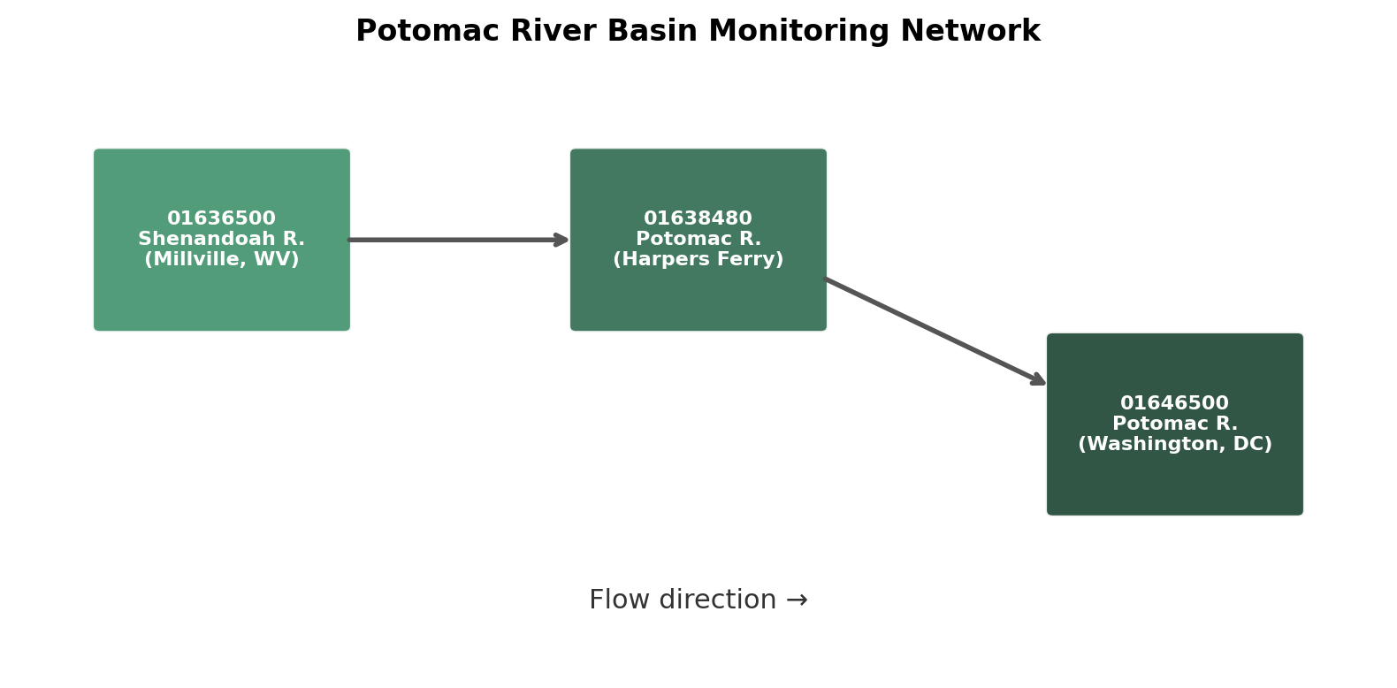
Fig. 1. Schematic location of the three USGS gauges used in this study.
Table 1. USGS stations used in this study.
Site ID | Name | Role | Lat (°N) | Lon (°W)
01646500 | Potomac River at Washington, DC | Target | 38.95 | 77.13
01636500 | Shenandoah River at Millville, WV | Tributary | 39.29 | 77.79
01638480 | Potomac River at Harpers Ferry, WV | Midstream | 39.32 | 77.73
2.2 Data sources
Daily mean discharge (parameter 00060) was retrieved from the USGS National Water Information System for 1 January 2000 through 31 December 2023 (U.S. Geological Survey, 2024). Daily precipitation and 2-m air temperature at each gauge coordinate were obtained from the Open-Meteo historical archive (reanalysis-based). Using a common public API avoids licensing barriers and supports exact reproduction. Missing discharge values were removed by listwise deletion after merging; the resulting continuous Potomac panel is archived with the project scripts.
Model covariates for the full configuration are: local discharge, precipitation and temperature at Washington, plus discharge and precipitation at the two upstream sites (seven channels). Ablation experiments retain only the three local variables. All features enter as length-30 day sequences ending on day t when predicting discharge on day t+h, with h ∈ {1, 3, 7}.
2.3 Chronological split and scaling
To mimic operational deployment we adopt a chronological split: training data end on 31 December 2018; validation covers 2019–2020; testing covers 2021–2023. Features and targets are standardized using training-period means and variances only. Deep models are selected by minimum validation MSE; after selection, reported metrics use the held-out test years exclusively.
2.4 Models
Persistence uses Q(t) as the forecast of Q(t+h). XGBoost (Chen and Guestrin, 2016) receives flattened 30-day windows and is trained with 350 trees, maximum depth 6, and learning rate 0.05. LSTM uses two layers with hidden size 64 and dropout 0.2, trained with Adam (learning rate 1×10⁻³) and MSE loss. LSTM-Attention adds a learned temporal attention weight over LSTM hidden states before the final linear head. Deep models are retrained with three random seeds; ensemble-mean predictions are used for headline scores, and seed min–max ranges illustrate instability.
2.5 Evaluation design
We report Nash–Sutcliffe efficiency (NSE; Nash and Sutcliffe, 1970), Kling–Gupta efficiency (KGE; Gupta et al., 2009), RMSE, MAE, and percent bias. Stratified NSE uses the 30th and 70th percentiles of observed test discharge to define low- and high-flow subsets. Seasonal NSE aggregates DJF/MAM/JJA/SON. For flood relevance we extract the largest non-overlapping observed peaks and compute relative peak magnitude error and peak-timing error (days). Permutation importance shuffles each covariate channel within sequences and records the resulting NSE drop for the 1-day LSTM-Attention model.
3. Results
3.1 Multi-horizon skill
At the 1-day horizon, LSTM-Attention achieves NSE = 0.931 and RMSE = 2396 cfs, compared with XGBoost NSE = 0.910 and persistence NSE = 0.787 (Table 2; Fig. 2). The absolute margins are modest among learned models, yet all clearly beat persistence. At 3 days, skill decreases for every method (LSTM NSE = 0.543; XGBoost NSE = 0.458; LSTM-Attention NSE = 0.479). By 7 days, NSE remains low even for the best models (LSTM-Attention NSE = 0.196; XGBoost NSE = 0.071), indicating that recent upstream states alone cannot sustain weekly deterministic skill for this outlet without additional foresight (e.g., quantitative precipitation forecasts).
Table 2. Test-period bulk skill at Washington, D.C. (2021–2023).
Horizon (d) | Model | NSE | KGE | RMSE (cfs) | PBIAS (%)
1 | Persistence | 0.787 | 0.893 | 4226 | 0.10
1 | XGBoost | 0.910 | 0.938 | 2741 | 3.42
1 | LSTM | 0.923 | 0.917 | 2546 | -0.07
1 | LSTM-Attention | 0.931 | 0.918 | 2396 | 4.03
3 | Persistence | 0.164 | 0.584 | 8366 | 0.50
3 | XGBoost | 0.458 | 0.633 | 6736 | 14.89
3 | LSTM | 0.543 | 0.662 | 6187 | 8.67
3 | LSTM-Attention | 0.479 | 0.603 | 6608 | 15.69
7 | Persistence | -0.393 | 0.342 | 10802 | 2.89
7 | XGBoost | 0.071 | 0.372 | 8820 | 28.20
7 | LSTM | 0.141 | 0.397 | 8483 | 19.01
7 | LSTM-Attention | 0.196 | 0.386 | 8205 | 24.22
Table 3. Stratified NSE and peak-event errors (test period).
Horizon (d) | Model | NSE_low | NSE_high | |Peak err| (%) | |Timing| (d)
1 | Persistence | 0.861 | 0.619 | 0.0 | 1.00
1 | XGBoost | 0.695 | 0.848 | 19.3 | 0.62
1 | LSTM | 0.701 | 0.869 | 20.2 | 0.50
1 | LSTM-Attention | 0.424 | 0.888 | 20.0 | 0.25
3 | Persistence | 0.274 | -0.483 | 0.0 | 3.00
3 | XGBoost | -2.782 | 0.149 | 30.1 | 2.12
3 | LSTM | -0.986 | 0.244 | 31.1 | 1.38
3 | LSTM-Attention | -4.499 | 0.180 | 38.2 | 1.25
7 | Persistence | -1.674 | -1.358 | 67.5 | 3.88
7 | XGBoost | -10.283 | -0.280 | 55.5 | 3.50
7 | LSTM | -3.016 | -0.301 | 60.8 | 5.00
7 | LSTM-Attention | -12.404 | -0.114 | 69.5 | 3.62
Table 4. Upstream ablation for LSTM-Attention (full network vs local-only inputs).
Horizon (d) | NSE full | NSE local | ΔNSE | RMSE full (cfs)
1 | 0.931 | 0.907 | 0.024 | 2396
3 | 0.479 | 0.405 | 0.073 | 6608
7 | 0.196 | -0.027 | 0.223 | 8205
Table 5. Seasonal NSE for LSTM-Attention (DJF/MAM/JJA/SON).
Horizon (d) | DJF | MAM | JJA | SON
1 | 0.874 | 0.947 | 0.784 | 0.845
3 | 0.190 | 0.446 | -0.151 | 0.186
7 | -0.094 | 0.060 | -1.282 | -0.033
Table 6. Selected observed peak events and 1-day LSTM-Attention peak errors.
Date | Q_obs (cfs) | Q_sim (cfs) | Rel. err (%) | Timing (d)
2022-05-09 | 102000 | 94142 | -7.7 | 0
2021-03-02 | 89700 | 79299 | -11.6 | 1
2021-09-03 | 74300 | 40871 | -45.0 | 0
2022-04-09 | 46500 | 47808 | 2.8 | 0
2021-04-13 | 44800 | 39236 | -12.4 | 0
2022-12-24 | 40200 | 61561 | 53.1 | 0
2022-02-06 | 39600 | 37778 | -4.6 | 0
2021-09-24 | 38500 | 47385 | 23.1 | 1
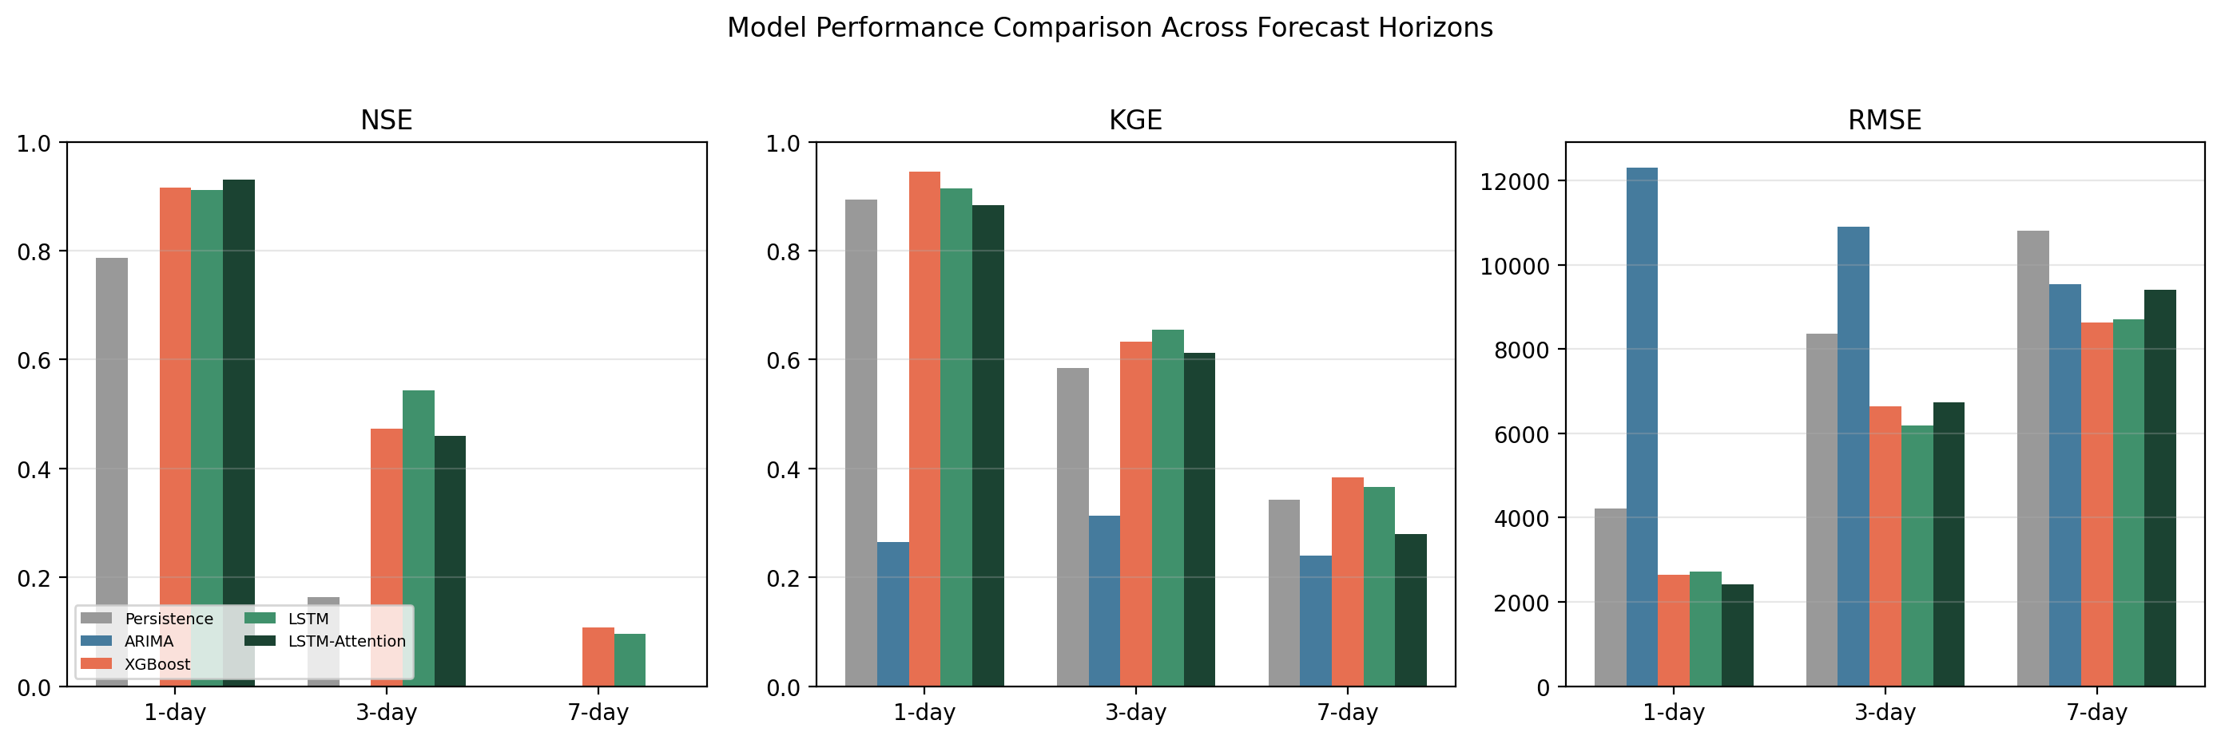
Fig. 2. Bulk NSE/KGE/RMSE comparison across 1-, 3-, and 7-day horizons.
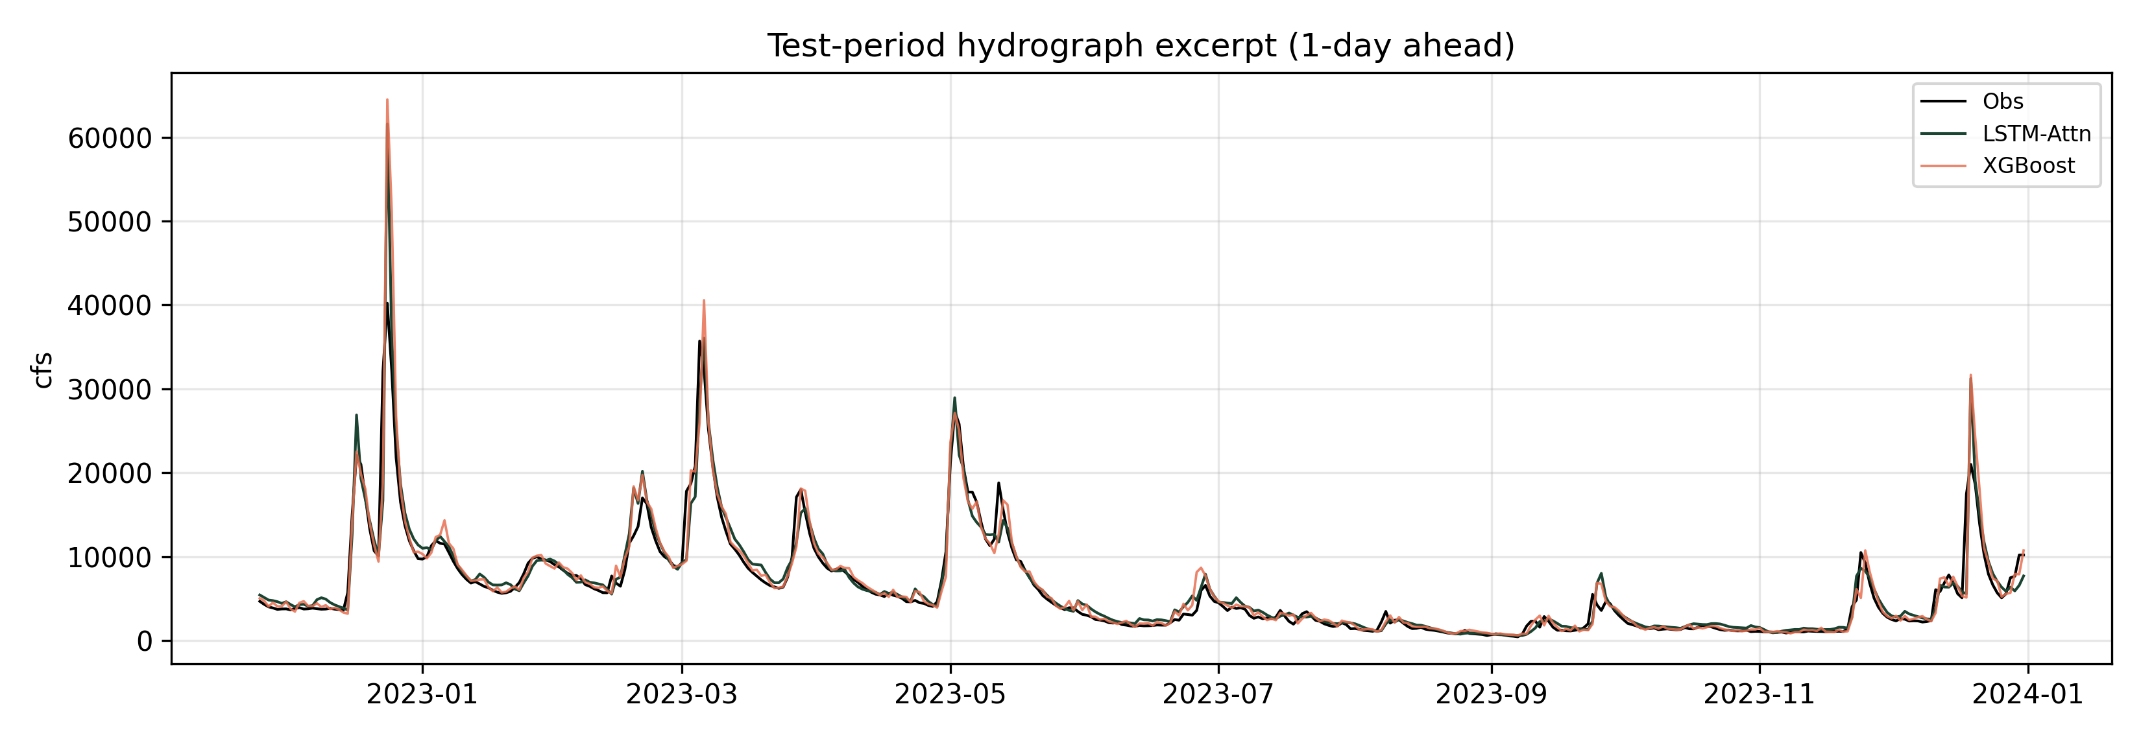
Fig. 3. Test hydrograph excerpt for 1-day ahead forecasts.
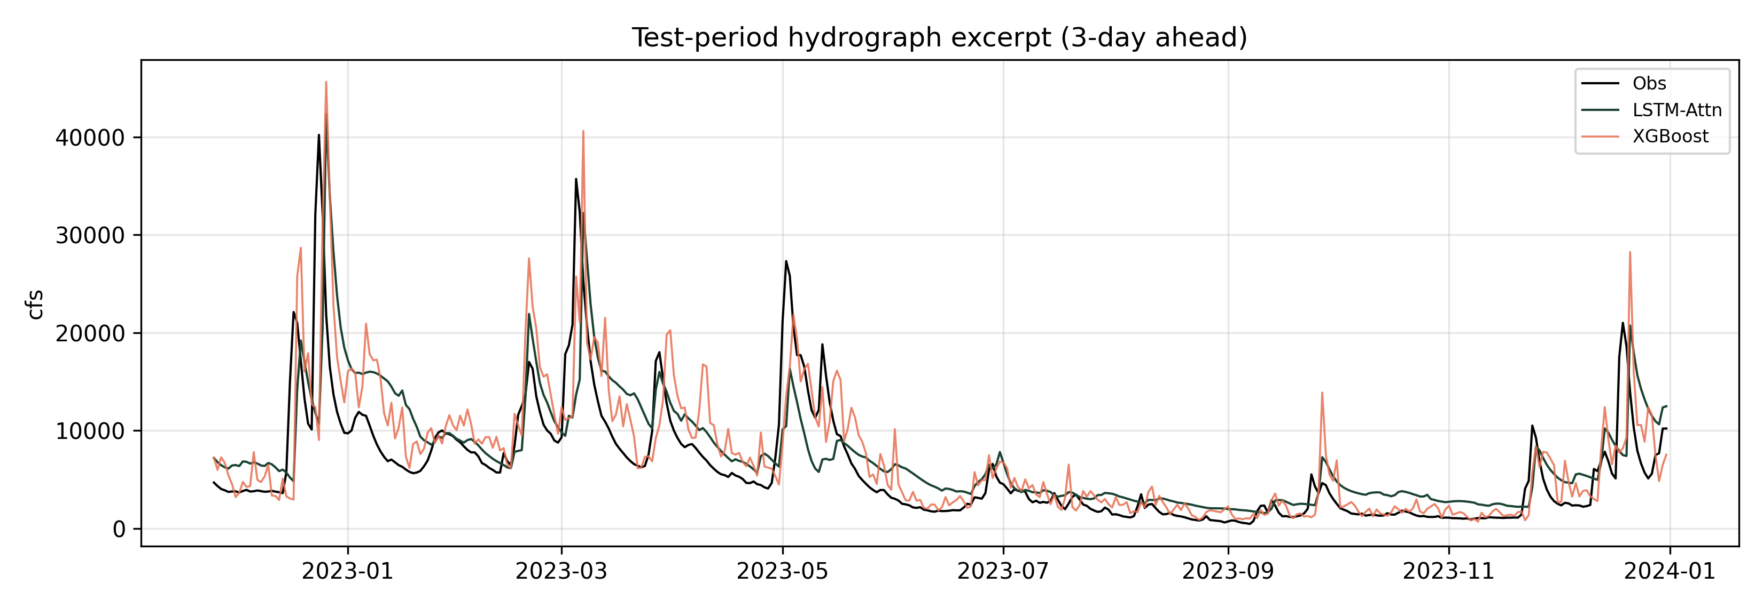
Fig. 4. Test hydrograph excerpt for 3-day ahead forecasts.
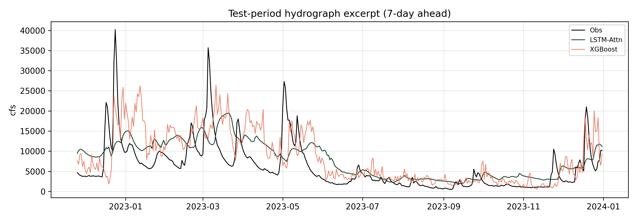
Fig. 5. Test hydrograph excerpt for 7-day ahead forecasts.
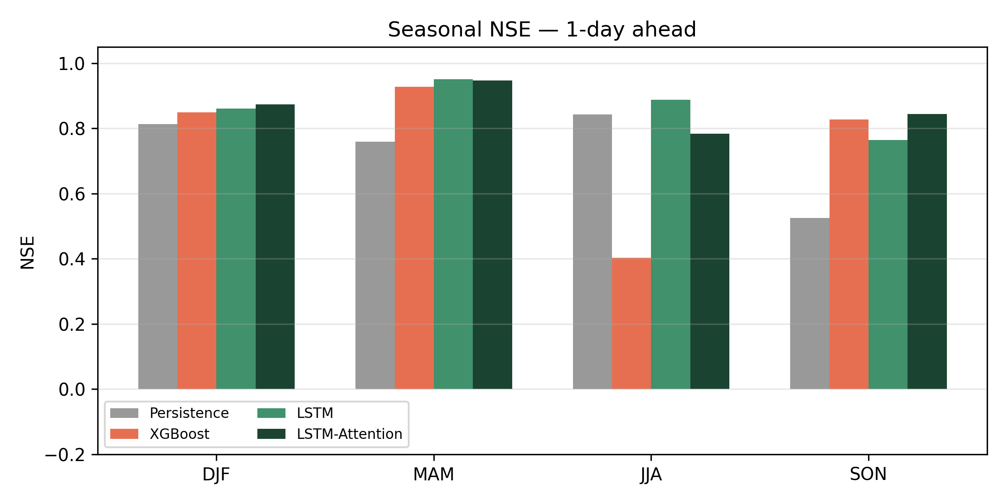
Fig. 6. Seasonal NSE at the 1-day horizon.
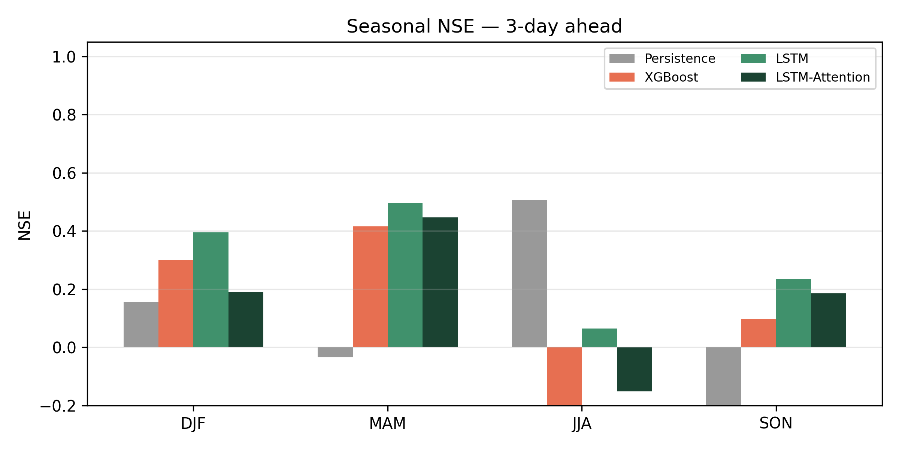
Fig. 7. Seasonal NSE at the 3-day horizon.
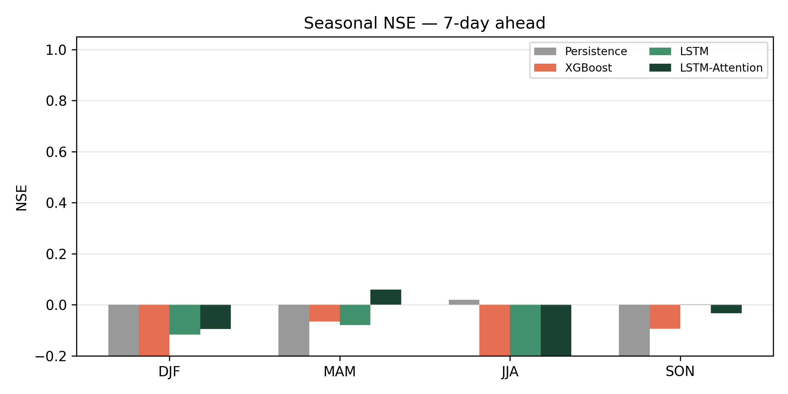
Fig. 8. Seasonal NSE at the 7-day horizon.
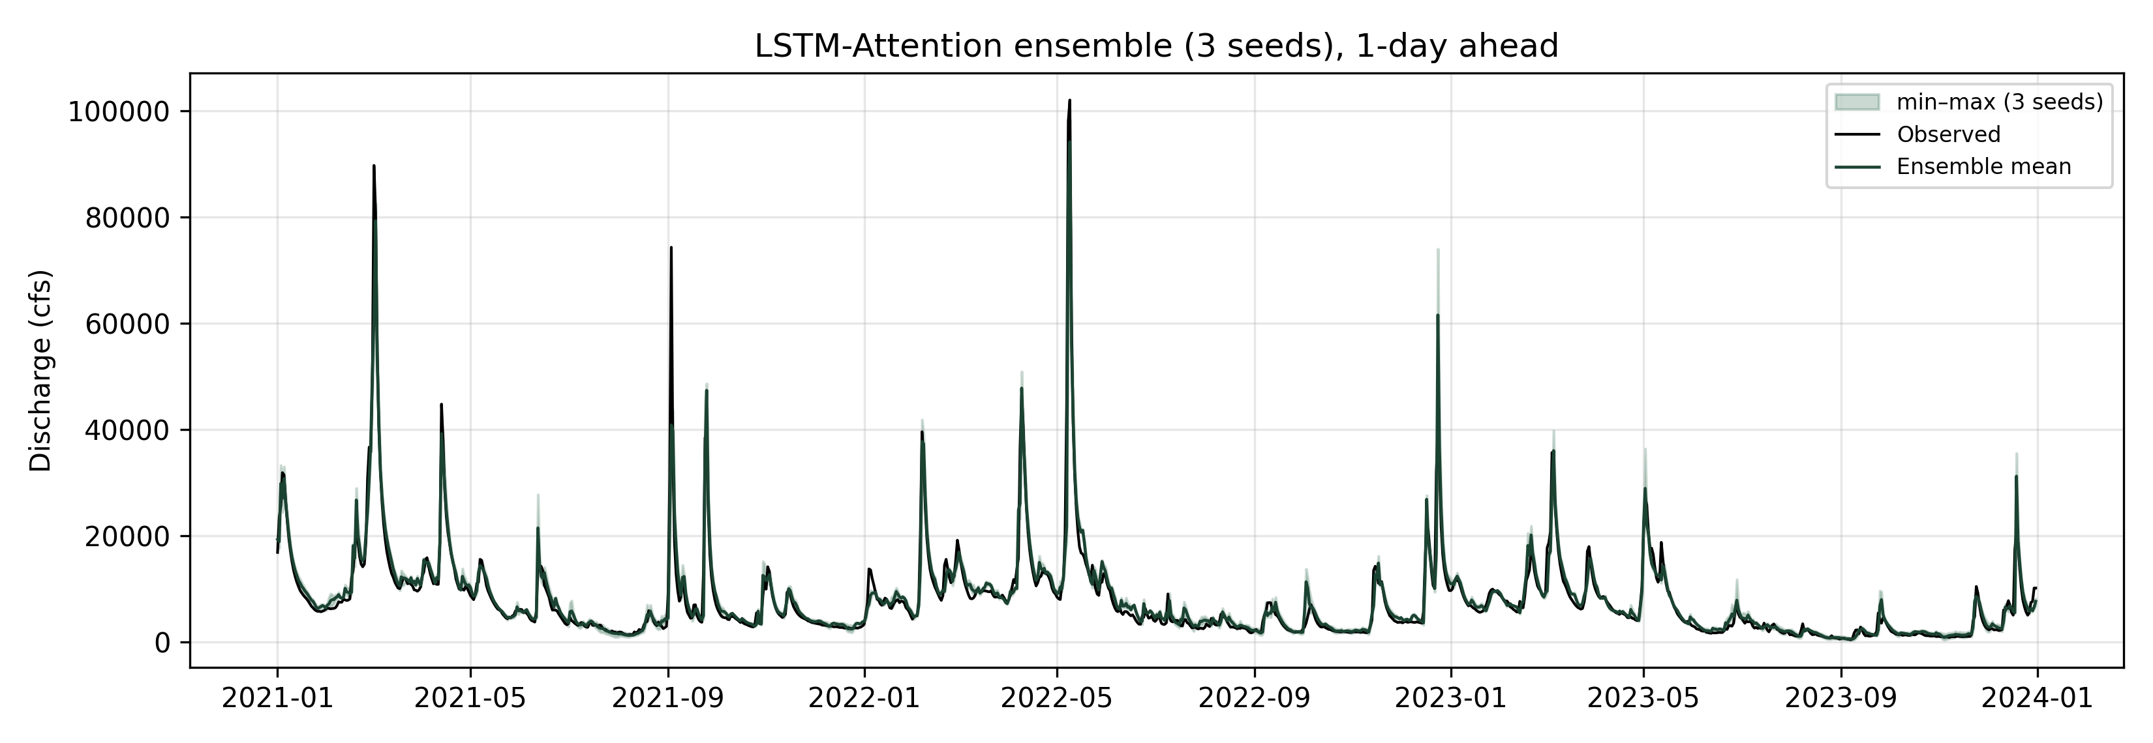
Fig. 9. Multi-seed uncertainty band for LSTM-Attention (1-day).
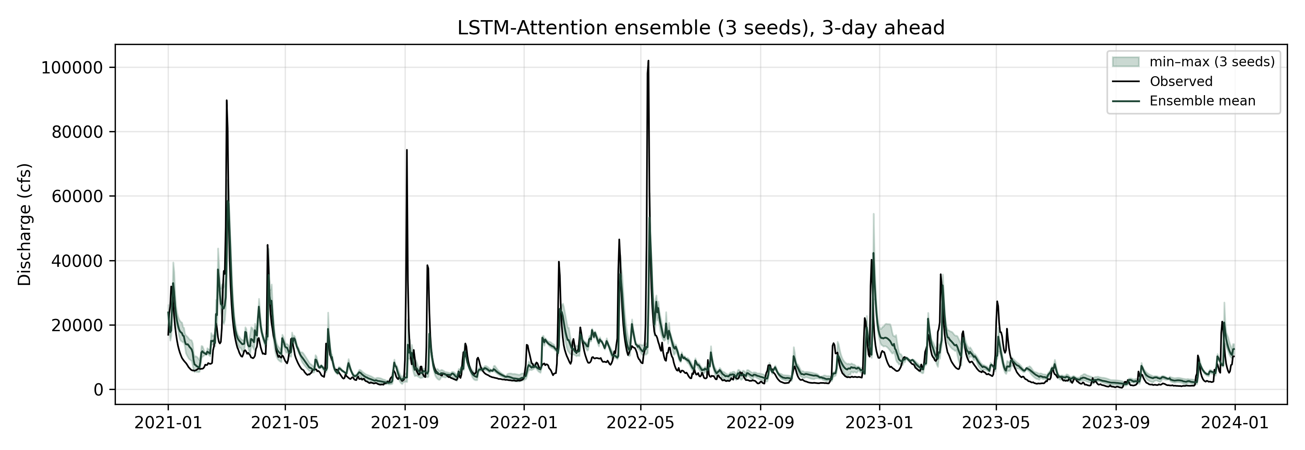
Fig. 10. Multi-seed uncertainty band for LSTM-Attention (3-day).
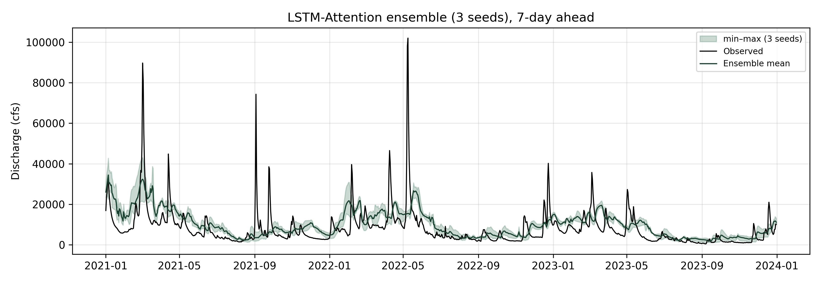
Fig. 11. Multi-seed uncertainty band for LSTM-Attention (7-day).
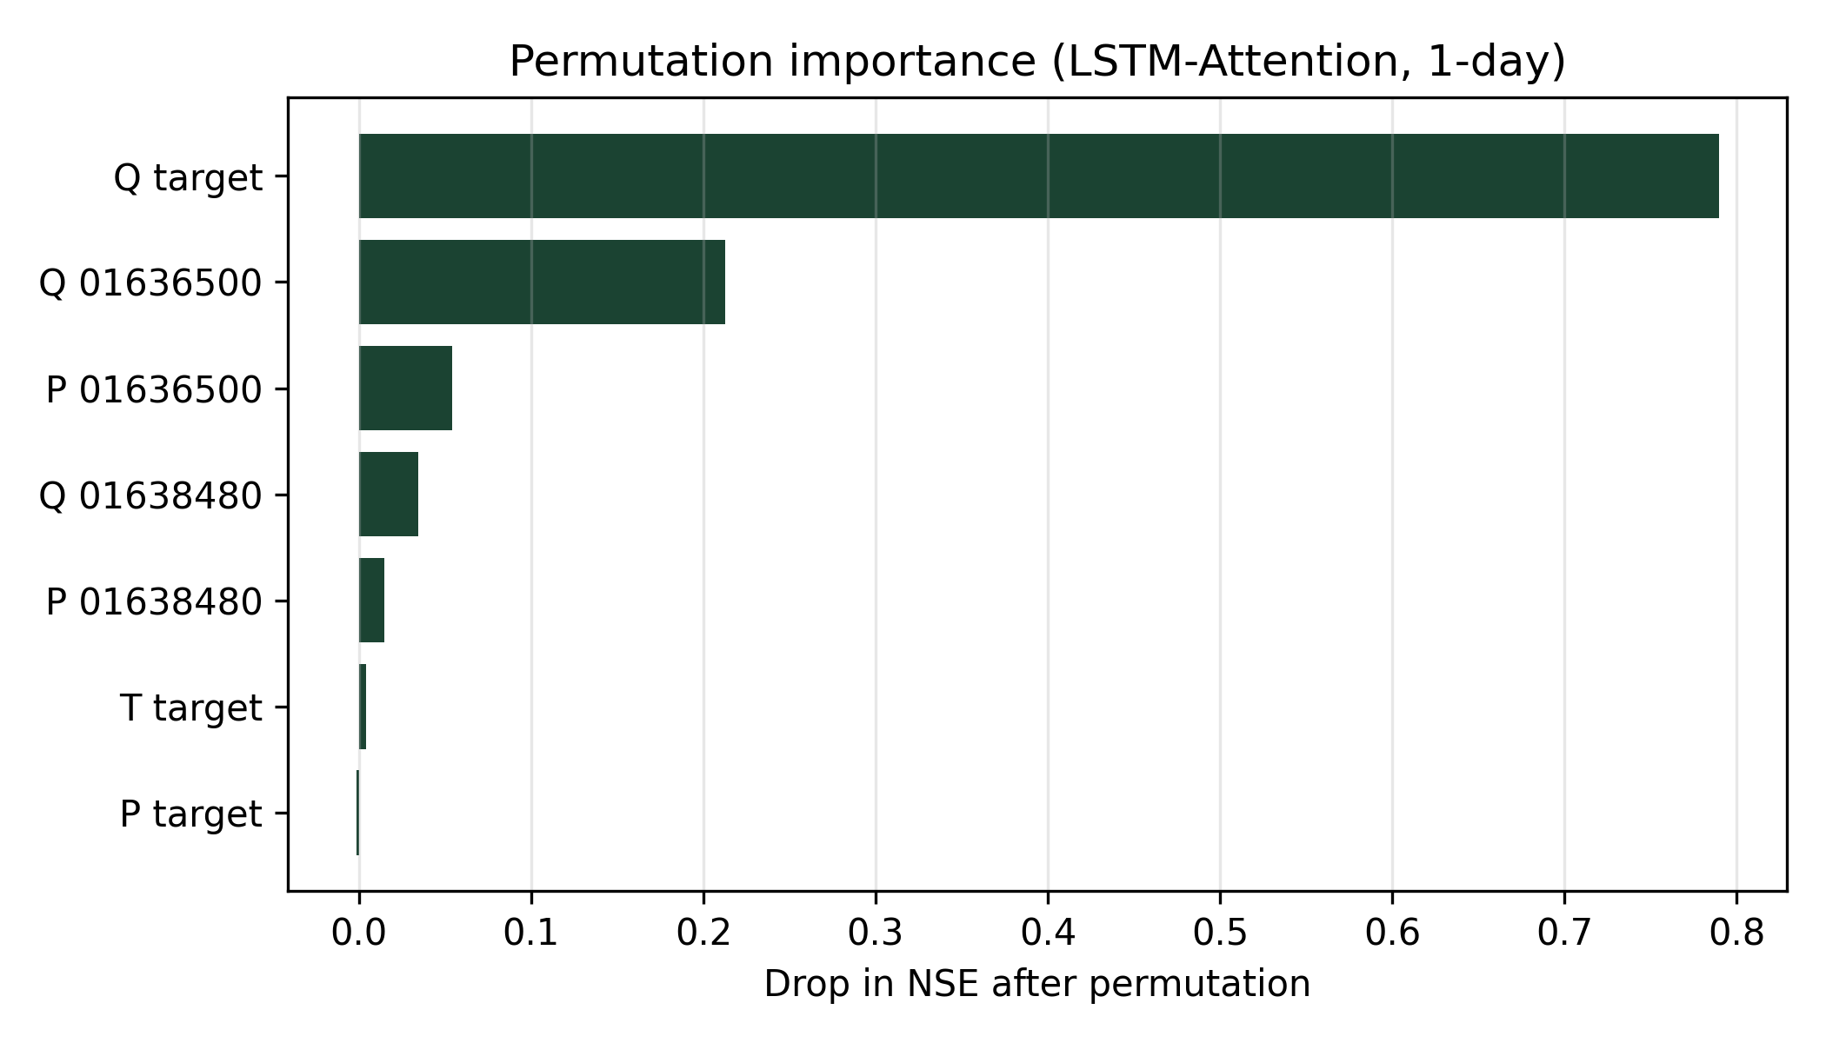
Fig. 12. Permutation importance for LSTM-Attention (1-day).
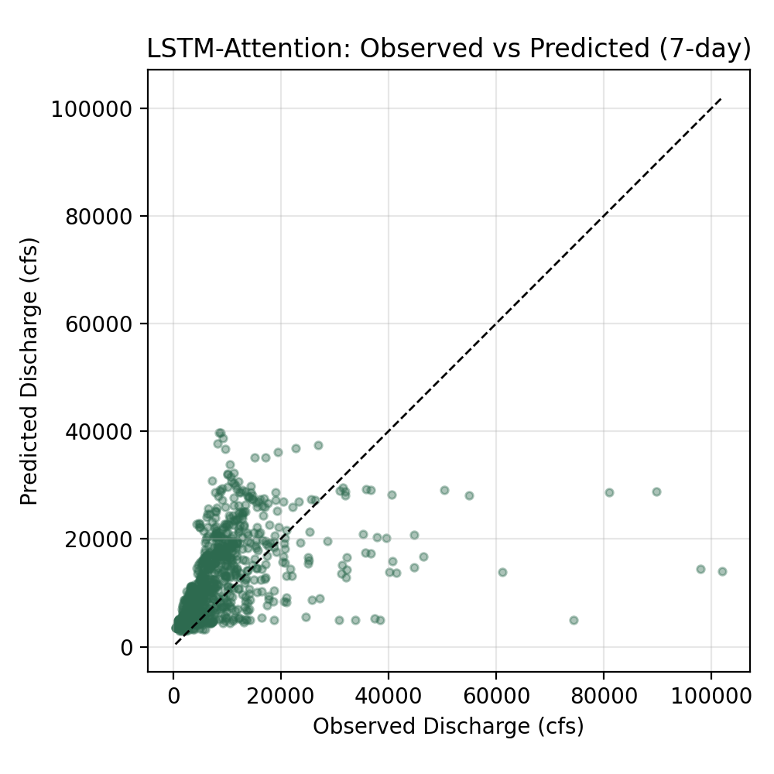
Fig. 13. Observed versus predicted discharge for a weekly-horizon model (reference scatter).
3.2 Value of upstream information
Ablating upstream discharge and precipitation reduces 1-day LSTM-Attention NSE from 0.931 to 0.907 (Table 4). The absolute gap is about 0.024 NSE units at one day and remains positive at three and seven days, although bulk skill itself collapses toward the weekly horizon. This pattern matches the physical expectation that upstream memory is most useful within typical routing times when future rainfall is unknown. For regional network design, maintaining a small number of well-placed upstream telemetered gauges yields the largest incremental benefit for next-day outlooks at Washington, D.C.
3.3 High flows, seasons, and peaks
Stratified scores (Table 3) indicate that high-flow NSE for 1-day LSTM-Attention (NSE_high = 0.888) remains useful but is lower than the easiest low-flow autocorrelation baseline in some models, confirming that extremes are harder than mean behavior. Seasonal panels (Figs. 6–8; Table 5) show generally stronger cool-season skill and more variable warm-season performance, consistent with convective rainfall and faster summer catchment response. Peak-event summaries for LSTM-Attention give mean absolute relative peak error of 20.0% and mean absolute timing error of 0.25 days at the 1-day horizon, underscoring that operational flood use requires event-wise checks beyond NSE. Hydrograph excerpts at 1/3/7 days (Figs. 3–5) illustrate the progressive loss of amplitude and timing fidelity as lead time increases.
3.4 Interpretability and uncertainty
Permutation tests for the 1-day LSTM-Attention model (Fig. 12) rank the largest skill drops for Q_target (ΔNSE = 0.790), Q_01636500 (ΔNSE = 0.213), precip_01636500 (ΔNSE = 0.054). Local discharge dominates, as expected for strong daily autocorrelation, while upstream discharges contribute secondary but non-negligible information. Precipitation channels matter less once recent flows are known, which is consistent with a routing-dominated 1-day problem at this outlet. Multi-seed uncertainty bands (Figs. 9–11) show that ensemble spread widens at longer leads, reinforcing that weekly deterministic products remain fragile.
4. Discussion
The regional message is conditional rather than absolute. Deep sequence models help most when the horizon matches the memory of the gauge network. For Washington, D.C., that regime is primarily the next day. At three to seven days, neither LSTM variants nor XGBoost retain high NSE using only recent observations; bridging that gap likely requires forecast precipitation, soil-moisture proxies, or coupling to a process model. Reporting this limitation is intentional: overstating weekly skill would mislead regional users.
These findings corroborate broader evidence that LSTM-type models can match or exceed conventional machine-learning baselines for short-range rainfall–runoff prediction when sufficient hydrometric memory is available (Kratzert et al., 2018, 2019; Frame et al., 2022), while also aligning with cautionary perspectives that deep learning does not automatically solve forecast problems at leads beyond basin memory (Nearing et al., 2021; Shen, 2018). Architecture novelty is secondary here: attention yields the best 1-day score in our ensemble-mean comparison, yet XGBoost remains close and can outperform attention at longer leads in some runs. Practitioners should therefore treat model choice as an empirical, horizon-specific decision and monitor seed variability (Figs. 9–11).
For mid-Atlantic flood operations, the practical implication is twofold. First, preserving and quality-controlling a small set of upstream telemetered gauges remains high-value for next-day outlooks at the Potomac outlet. Second, purely observation-driven weekly products should not be treated as decision-grade without forecast meteorology. Limitations include the use of reanalysis precipitation rather than gauge-adjusted QPE, omission of regulatory influences and tidal effects near the estuary, and a single-basin scope. Transferability tests on neighboring mid-Atlantic basins are a natural extension, and the open USGS–Open-Meteo pipeline makes the Potomac case a transparent regional benchmark for such comparisons.
5. Conclusions
Main findings and novelty. Using a fully public Potomac gauge network for 2000–2023, we show that upstream hydrometric information improves short-range forecasts at Washington, D.C., with LSTM-Attention providing the strongest 1-day deterministic skill among the tested models. The novelty for the region is not a new universal architecture, but a quantified, horizon-dependent assessment of upstream-gauge value together with flood-oriented residual diagnostics.
Broader impacts. For mid-Atlantic short-range forecasting and gauge-network design, investing in reliable upstream telemetry and focusing deep-learning effort on 1-day products appears more defensible than expecting purely observation-driven weekly accuracy. Stratified, seasonal, and peak diagnostics provide operationally interpretable evidence of where flood-relevant errors persist along the lower Potomac corridor.
Limitations and outlook. Skill deteriorates substantially by the weekly horizon for all methods when future rainfall is unavailable; extending lead times will require forecast precipitation or hybrid process–data approaches. Future work should test transfer to neighboring basins, incorporate operational QPE/QPF products, and evaluate uncertainty communication tailored to regional flood-watch protocols.
CRediT authorship contribution statement
Author Name: Conceptualization, Methodology, Software, Formal analysis, Writing – original draft, Visualization. Co-Author Name: Supervision, Writing – review & editing, Validation. [Replace with real author names and adjust roles before submission.]
Declaration of competing interest
The authors declare that they have no known competing financial interests or personal relationships that could have appeared to influence the work reported in this paper.
Declaration of generative AI and AI-assisted technologies in the manuscript preparation process
During the preparation of this work the authors used AI-assisted tools for language editing and manuscript formatting assistance. After using these tools, the authors reviewed and edited the content as needed and take full responsibility for the content of the published article. No generative AI tools were used to create or alter scientific figures or the graphical abstract.
Funding
This research did not receive any specific grant from funding agencies in the public, commercial, or not-for-profit sectors. [Or insert grant numbers here.]
Data availability
Discharge data are available from USGS NWIS (https://waterservices.usgs.gov/). Meteorological fields were downloaded from the Open-Meteo Archive API (https://open-meteo.com/). Processed daily tables, training scripts, enhanced metrics, and figure files are provided in the accompanying hydro-ml-paper project archive and can be shared upon reasonable request / deposited with the accepted article.
Acknowledgments
The authors thank USGS and Open-Meteo for open data services.
References
Chen, T., Guestrin, C., 2016. XGBoost: A scalable tree boosting system. In: Proceedings of the 22nd ACM SIGKDD International Conference on Knowledge Discovery and Data Mining. ACM, pp. 785–794.
Frame, J.M., Kratzert, F., Klotz, D., Gauch, M., Shelev, G., Gilon, O., Qualls, L.M., Gupta, H.V., Nearing, G.S., 2022. Deep learning rainfall–runoff predictions of extreme events. Hydrol. Earth Syst. Sci. 26, 3377–3392.
Gupta, H.V., Kling, H., Yilmaz, K.K., Martinez, G.F., 2009. Decomposition of the mean squared error and NSE performance criteria: Implications for improving hydrological modelling. J. Hydrol. 377, 80–91.
Kratzert, F., Klotz, D., Brenner, C., Schulz, K., Herrnegger, M., 2018. Rainfall–runoff modelling using Long Short-Term Memory (LSTM) networks. Hydrol. Earth Syst. Sci. 22, 6005–6022.
Kratzert, F., Klotz, D., Shalev, G., Klambauer, G., Hochreiter, S., Nearing, G., 2019. Towards learning universal, regional, and local hydrological behaviors via machine learning applied to large-sample datasets. Hydrol. Earth Syst. Sci. 23, 5089–5110.
Nash, J.E., Sutcliffe, J.V., 1970. River flow forecasting through conceptual models part I — A discussion of principles. J. Hydrol. 10, 282–290.
Nearing, G.S., Kratzert, F., Sampson, A.K., Pelissier, C.S., Klotz, D., Frame, J.M., Prieto, C., Gupta, H.V., 2021. What role does hydrological science play in the age of machine learning? Water Resour. Res. 57, e2020WR028091.
Reichstein, M., Camps-Valls, G., Stevens, B., Jung, M., Denzler, J., Carvalhais, N., Prabhat, 2019. Deep learning and process understanding for data-driven Earth system science. Nature 566, 195–204.
Shen, C., 2018. A transdisciplinary review of deep learning research and its relevance for water resources scientists. Water Resour. Res. 54, 8558–8593.
U.S. Geological Survey, 2024. National Water Information System data available on the World Wide Web (USGS Water Data for the Nation). https://waterdata.usgs.gov/nwis.

