An interpolability certificate for aquatic monitoring: when linear interpolation is admissible, and when the wrong mask changes hypoxia and nutrient warnings
Senjie Zhang^{1,*}
1 Lanzhou University, Lanzhou 730000, Gansu, China
*Corresponding author: 3079099853@qq.com
Environmental Modelling & Software · Research Article · numbered references
Highlights
- Mask-only ρ marks Linear admissible on 15/15 Dianchi settings.
- Wu et al. 2025 random and week-gap banks remain interpolable (ρ ≥ 0.998).
- Linear warning CSI is 0 under sensor/station; BRITS recovers TN CSI ≥ 0.72.
- On point holes Linear still wins DO-drop CSI (0.80 versus BRITS 0.69).
- Lead-2 hypoxia F1 prefers climatology except under block-time gaps.
Abstract
Automatic lake stations and column-limited oxygen products fail as blocks, not as scattered missing-completely-at-random (MCAR) holes. Reconstruction papers that hide only random cells or week-long gaps, including Wu et al. (2025) on Dianchi, therefore recommend linear interpolation in a regime that is interpolable by construction.
We compute an interpolability certificate ρ from the mask alone: a hidden cell is interpolable if the same station–variable still has an observed neighbour inside the evaluation window. On 15 Mask-View settings, ρ ≥ 0.5 matches a Linear win on the frozen 105-grid exactly (15/15). Point and block-time have ρ ≈ 1.0; sensor and station have ρ = 0. The Wu et al. random and week-gap banks have ρ ≥ 0.998, which is why Linear wins all eight of those settings.
The certificate is not only a ranking rule. If a manager deploys Linear because an MCAR or week-gap table said so, dissolved-oxygen (DO) drop and total-nitrogen (TN) exceedance warnings collapse on the cells that were actually hidden: critical success index (CSI) = 0 under sensor and station masks. The recurrent imputer BRITS recovers TN CSI to 0.72 (sensor) and 0.74 (station). On point holes, Linear remains the warning champion (DO CSI 0.80 versus BRITS 0.69). On a shelf oxygen cube, one-month lead still prefers a Transformer, but two-month hypoxia F1 prefers climatology except under block-time gaps.
Compute ρ before replacing Linear, and score the alarm on the cells the mask hid.
Keywords
interpolability; missing data; dissolved oxygen; early warning; aquatic monitoring; Mask-View
Graphical abstract
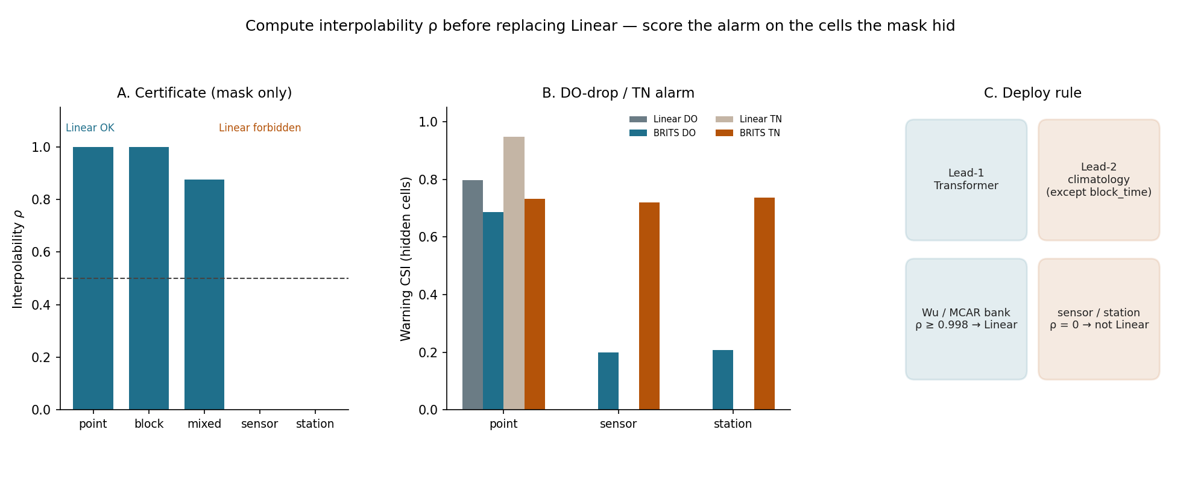
Graphical abstract. A mask-only interpolability rate ρ decides whether Linear is admissible. When ρ = 0, Linear warning CSI on hidden cells is 0; BRITS recovers TN exceedance. At two-month oxygen lead, climatology is preferred except under block-time gaps.
1. Introduction
Lake and coastal managers now rely on automatic sensors to watch eutrophication, hypoxia, and bloom-related chemistry at sub-daily resolution. The operational need is a usable dissolved-oxygen and nutrient series for reconstruction and warning, not a leaderboard mean absolute error (MAE). Dianchi Lake is a well-studied plateau eutrophic system in Yunnan, China, where nutrient load, algal blooms, and DO swings have been documented for decades [14,22,23]. Coastal oxygen decline is a parallel management problem [5,24]. Both problems fail as structured missingness [1,2].
Instruments go offline for hours to days. A single parameter channel dies. A whole station or a profile column disappears. On the open Dianchi automatic high-frequency monitoring (AHFM) release the natural missing rate on a regular 4 h grid is 19.8% [3]. Of those missing cells, 96.9% occur while the entire station is silent. Isolated one-step holes are 0.6%. Station-outage lengths are heavy-tailed (cell-weighted median 3.5 days). Coastal oxygen products face the complementary geometry: biogeochemical profiles sample the interior as sparse columns, not as a dense cube [4].
Published reconstruction banks do not match that geometry. Wu et al. [10] reconstructed Dianchi water-quality fields with biased nonnegative tensor factorization under random 20–80% holes and 1–4 week gaps, reporting strong RMSE, MAE and Nash–Sutcliffe scores. We score linear interpolation, last observation carried forward (LOCF), and a MixHop recipe [11] under that bank. Linear wins all eight settings. The same Linear model has standardised MAE of about 0.68–0.70 when a sensor or a station is dark for the whole 6-day window. That published bank never left the interpolable regime. A manager who trusts that bank will deploy Linear into the failure mode that already dominates the archive.
The informatics advance is an interpolability certificate. For each artificially hidden cell we ask only whether the same station–variable still has an originally observed, still-visible neighbour in the window. The fraction of such cells is ρ. ρ is computed from the mask. It does not require training seven models. We show that ρ ≥ 0.5 recovers every Linear win on a 7 × 5 × 3 Dianchi grid, and that ρ = 0 on sensor and station is exactly where Linear’s warning CSI falls to zero.
A second medium tests whether the same named bank changes a forecast deployment. On an East China Sea shelf oxygen cube, a spatiotemporal Transformer [12] remains first at one-month lead after fair masked persistence is scored, but two-month hypoxia F1 prefers climatology under column-limited history.
The contributions are four. First, a mask-only certificate that states when Linear is admissible. Second, a dual-protocol table that explains Wu et al. [10] as an interpolable bank: their random and week-gap hides have ρ ≥ 0.998, so Linear must win. Third, a warning-decision table: deploying the MCAR champion (Linear) versus the operational champion (BRITS [6]) changes CSI on the cells the mask actually hid. Fourth, an ocean deploy rule at lead-1 versus lead-2. The broader interest is that another AHFM network can compute ρ without copying our MixHop weights.
The boundary is explicit. The ocean cube is World Ocean Atlas (WOA)–informed development oxygen, not GOBAI-O2 [4]; we do not analyse East China Sea frontal processes; a 0.06 µmol kg−1 lead-1 edge is statistically signed on this window and is not an operationally large gain. Transfer to another lake requires recomputing ρ. We do not invent a reconstructor that beats BRITS on station blackout.
2. Materials and methods
2.1. Scientific object
The object of inference is a decision rule under a named missingness bank: is Linear admissible, and does the wrong admission change a warning? Lake MAE and ocean RMSE are not on the same scale. We compare winner identity inside each medium, the interpolability scalar that predicts that identity, and warning skill on the cells the mask actually hid.
2.2. Pattern bank
For each evaluation window we hide originally observed cells with one named pattern (Table 1; Fig. 1). Training, where applicable, samples complementary views. Evaluation uses fixed patterns. Naturally missing cells are never hidden and never scored. Lake evaluation hide rates are r ∈ {0.10, 0.20, 0.30} with seed 42. Training hide rates are drawn uniformly from [0.15, 0.35].
Lake hide algorithms. point: MCAR on observed cells, hiding max(1, round(n_obs × r)) cells. block_time: repeat until the hidden count meets the target; draw a block length uniformly from 3–12 steps (12–48 h) and zero a random subset of stations and variables inside that block. sensor: drop 1 or 2 variables at all stations and times in the window (a dead channel). station: drop 1–3 whole stations for the entire window. mixed: half point and half block_time, with probability 0.5 also a lighter station drop; mixed is evaluation-only.
Ocean hide algorithms apply to oxygen history only (H = 12 months). Physics channels stay visible. Spatial masks are constant across the 12 months except block_time. Default keep_ratio = 0.25; default n_stations = 8. point: Bernoulli keep per voxel, broadcast over H (keep ≈ 0.25). block_time: a spatial block hidden for a contiguous time slab (keep ≈ 0.45). sensor: keep round(Z × keep_ratio) full depth layers; with Z = 5 this keeps one layer (keep 0.20). station: keep n_stations random water columns at all depths; eight columns give keep 0.089. argo: Yangtze-section proxy of 7 grid cells (keep 0.078); not live Argovis. none: dense oxygen history. Lake hide rates 10/20/30% are not ocean keep_ratio = 0.25. Compare lake rates with ocean point voxel keep.
Pattern | Lake automatic stations | Shelf oxygen history
point | MCAR on observed cells | Static random keep on the O2 grid (same voxels all 12 months)
block_time | Consecutive downtime slab | Time slab × spatial block
sensor | Drop 1–2 variables | Hide selected O2 depth layers; physics stays
station | Whole station blackout | Column-limited stations (keep set by column count)
mixed | Point + block (± station) | Compound of the above
argo | not used | Yangtze-section proxy (7 cells); not live Argovis
none | Natural missingness already present | Dense O2 history (upper bound)
Table 1. Shared Mask-View pattern bank. White cells in Figure 1 are hidden.
2.3. Lake study system and data
Lake Dianchi (Kunming, Yunnan) is a shallow plateau lake with a documented eutrophication history [14,22,23]. The ecological monitoring need is a complete multi-parameter AHFM record for DO, nutrients, and related chemistry. We use Dianchi-Water [3], a CC BY 4.0 release covering 22 automatic stations from 1 January 2022 to 30 December 2024. Nine variables are retained: water temperature (TEM, °C), pH, dissolved oxygen (DO, mg L−1), conductivity (CON, µS cm−1), turbidity (NTU), permanganate index (IMN, mg L−1), ammonia nitrogen (NH3-N, mg L−1), total phosphorus (TP, mg L−1), and total nitrogen (TN, mg L−1). Chlorophyll-a and phycocyanin were excluded because they exceed 87% missing in the source files. Cadence is 4-hourly. The long-format table has 116,783 records. After reindexing onto a complete 4 h calendar the panel is T = 6,568 steps × 22 stations × 9 variables = 1,300,464 cells, of which 19.8% are missing.
Raw GPS coordinates are withheld in the public release. Spatial models use the released pairwise Haversine distance matrix. The ultimate source is the China National Environmental Monitoring Center automatic-station stream [15]. An eight-stage QC pipeline produced the public parquet: schema and timestamp parsing; station-name filtering; geographic metadata harmonization; watershed back-fill; station-identity canonicalization; sentinel remap (−1 below detection, −2 no measurement, −3 equipment fault → NaN); duplicate reconciliation (3,800 rows); and final export. Split-wise missing rates after reindex are 25.7% (train), 13.0% (validation) and 14.3% (test). Per-station observation rates range from 30.6% to 89.3%.
2.4. Lake windows, split, models, and score
Windows have length L = 36 steps (6 days) and stride 18 steps (3 days). A window is kept only if every timestep lies inside one split. This yields 180 train, 60 validation and 120 test windows. Tensor shape is (batch, 36, 22, 9) with NaN on naturally missing cells. The split is chronological: train times ≤ 30 June 2023; validation 1 July–31 December 2023; test calendar year 2024. Standardisation (per-variable mean and standard deviation) is fit on training observed cells only. Deep models are fit on train windows only. Test corruptions are generated from seed 42 and frozen. The evaluation mask is the set of cells that were originally observed and then hidden.
Simple baselines are the tools operations already use: per-variable Mean; LOCF (forward then backward fill per station–variable); and Linear (pandas interpolate, both directions, per station–variable). Learned models use PyPOTS ≥ 1.5 unless noted, trained once on train windows (batch size min(32, n), 20 epochs, patience 5). SAITS: 2 layers, d_model = 64, 2 heads, d_ffn = 128, dropout 0.1. BRITS: RNN hidden size 64. GRIN*: StemGNN with 2 layers, d_model = 64; official GRIN is not in PyPOTS 1.5 [16]. MaskView-ST: MixHop 1- and 2-hop graph convolution plus temporal multi-head attention (4 heads, 3 ST blocks, hidden 64). Adjacency is a Gaussian of station distance (σ = 20 km), k-NN with k = 8 and 60 km cutoff, row-normalised with self-loops. AdamW, learning rate 10−3, weight decay 10−4, 40 epochs, gradient clip 1.0. Training samples K = 3 complementary views. Loss is L1 reconstruction on hidden-observed cells.
The ablation recipe spatial_plus_l0 uses the same graph, station-pattern upsampling, and consistency weight λ = 0, trained 30 epochs. It is not the default 105-grid model. We treat a 0.009 sensor MAE edge over BRITS as a sensitivity, not a second official winner. The default evaluation grid is 7 models × 5 patterns × 3 hide rates = 105 settings. Let z be the training-standardised observation and ẑ the imputation. Let E be the evaluation mask. The primary score is pooled standardised MAE = (1/|E|) Σ |ẑ − z| over E. We also record RMSE and a DO-only MAE on the same mask. We do not mix lake MAE with ocean RMSE.
2.5. Interpolability certificate
Let E be originally observed cells that are hidden. Cell (t, n, d) ∈ E is interpolable if there exists t′ ≠ t in the same evaluation window with (t′, n, d) originally observed and still visible. The window interpolability rate is ρ = |interpolable| / |E|. Linear is declared admissible if ρ ≥ 0.5. Both-sides interpolability (a visible time strictly before and after t) is reported as a diagnostic, not as the decision threshold. ρ is computed from masks only. It does not require trained models. We join ρ with frozen Linear and BRITS MAE to test whether the certificate predicts who wins on the 105-grid.
2.6. Dual-protocol and year-shift tests
Wu et al. [10] bank. On the same 120 test windows we hide random 20/40/60/80% of observed cells (point) and, separately, independent contiguous 1–4 week gaps on the full 2024 panel (gap length = weeks × 42 steps). Linear and LOCF see the full panel series. The MixHop recipe sees stitched 6-day windows with overlap averaging. This is a protocol contrast, not a reimplementation of tensor factorization. We also compute ρ on that bank.
Year-shift replay. Naturally missing cells have no labels. We copy another year’s missing calendar onto 2024 cells that were observed, matching (month, day, hour). Replay 2022→2024 hides 10.52% of observed 2024 cells (n_eval = 109,732). Replay 2023→2024 hides 3.46% (n_eval = 36,042). An MCAR control hides the same count. This asks whether real outage calendars already reverse ranking, or only tax Linear relative to MCAR.
2.7. Warning-decision evaluation
On 2024 test windows we hide at rate 0.20 under point, sensor, and station, then impute with Linear, LOCF, a transparent cross-site spatial mean (mean of other stations at the same time and variable), and BRITS (PyPOTS, 8 epochs, trained once on train windows). Labels are computed from originally observed values before hiding: a DO drop of at least 2 mg L−1 within 24 h, and TN at least 2 mg L−1. We score only decisions that depend on imputation. For DO, the 24 h warning window must overlap an artificially hidden DO cell. For TN, only hidden TN cells are scored. Precision, recall, F1 and CSI = TP / (TP+FP+FN) are reported. The core contrast is the MCAR champion (Linear) versus the 105-grid operational champion (BRITS).
2.8. Ocean study system, task, fair baselines, and deploy rule
The ecological analog is column-limited oxygen history, the geometry of biogeochemical profiles and of a sparse coastal product [4,5]. We do not treat the cube as a substitute for GOBAI-O2 or as a process study of East China Sea fronts. Domain: 118–128°E, 26–35°N; depths {10, 50, 100, 200, 500} dbar. Grid: 9 latitude × 10 longitude × 5 depth (1°). Water voxels: 450. Time: monthly January 2004 – December 2022 (228 months). Oxygen is a WOA18-informed development field (annual climatology plus AR(1) synthetic anomalies). Physical drivers stacked in a separate cube are temperature, salinity, stratification (N²), NOAA OISST v2 monthly sea-surface temperature, and 10 m wind (Open-Meteo ERA5 archive). Units are µmol kg−1.
Task: 12-month history → 1-, 2- and 3-month oxygen forecast. Split by target month: train ≤ December 2018; validation January 2019 – December 2020; test ≥ January 2021 (n = 22 test months). Climatology and z-scores use train only. Hybrid blend weight is tuned on validation. Mask seeds differ by split. Physics channels are never masked. Models are last-month persistence; month-of-year climatology; LSTM anomaly (hidden 64, 2 layers); spatiotemporal Transformer (hidden 64, 4 heads, 2 layers, spatial smoothness 0.01) [12]; and a validation-tuned hybrid. Locked Mask-View ablation uses 8 epochs, Adam 10−3, seed 42.
Fair sparse baselines ingest the same oxygen mask. persist_locf: last observed oxygen along history; remaining NaN filled with climatology. linear_time: per-voxel temporal interpolation of observed months, then the last month; under static spatial masks this equals persist_locf. spatial_linear: LOCF per column, then horizontal linear interpolation at each depth (needs ≥3 observed columns). Unmasked persistence in the original ablation ignored the mask. That invariance is an implementation artifact. After fair scoring, climatology is the simple bar because it does not need recent oxygen. Lead-1 RMSE is in µmol kg−1 on water voxels. Low-oxygen F1 uses a tenth-percentile threshold on this cube (195.09 µmol kg−1) because an absolute 60 µmol kg−1 event is rarer than 1% in the development field. Uncertainty on Δ = RMSEclim − RMSEST is a paired month-block bootstrap: resample the 22 test months with replacement, 200 times [17,18]; the Transformer is significantly better if the 5th percentile of Δ is > 0.
Ocean deploy rule (frozen ablation; no retrain). At lead-1, deploy the Transformer if its RMSE is below climatology. At lead-2, deploy climatology when its hypoxia F1 is at least that of the Transformer, except block_time, which remains a hybrid. The rule is read from frozen ablation without retraining.
2.9. Reproducibility
Headline tables are frozen CSV snapshots. A reviewer can rebuild every figure and this Word file without a GPU: git clone https://github.com/Az0998/maskview-aquatic-protocol.git ; pip install -r requirements.txt ; python scripts/build_cross_domain_tables.py ; python scripts/plot_pattern_bank.py ; python scripts/plot_rank_reversal.py ; python scripts/plot_keep_ratio_tax.py ; python scripts/plot_graphical_abstract.py ; python scripts/build_ems_docx.py. Frozen inputs: data/frozen/lake/ and data/frozen/ocean/. Seed 42. Dianchi source data: https://huggingface.co/datasets/anonymous-dianchi-2026/dianchi-water (CC BY 4.0). Optional GPU regeneration of the lake 105-grid uses the engine repository https://github.com/Az0998/dianchi-maskview-imputation. Certificate and warning scripts: eval_interpolability_certificate.py (CPU) and eval_downstream_protocol.py (BRITS, CUDA). Ocean engine: https://github.com/Az0998/ocean-do-forecast. We do not ship NetCDF cubes in the synthesis repository; the locked RMSE tables are the citable numerical record.
3. Results
3.1. How sensors actually fail
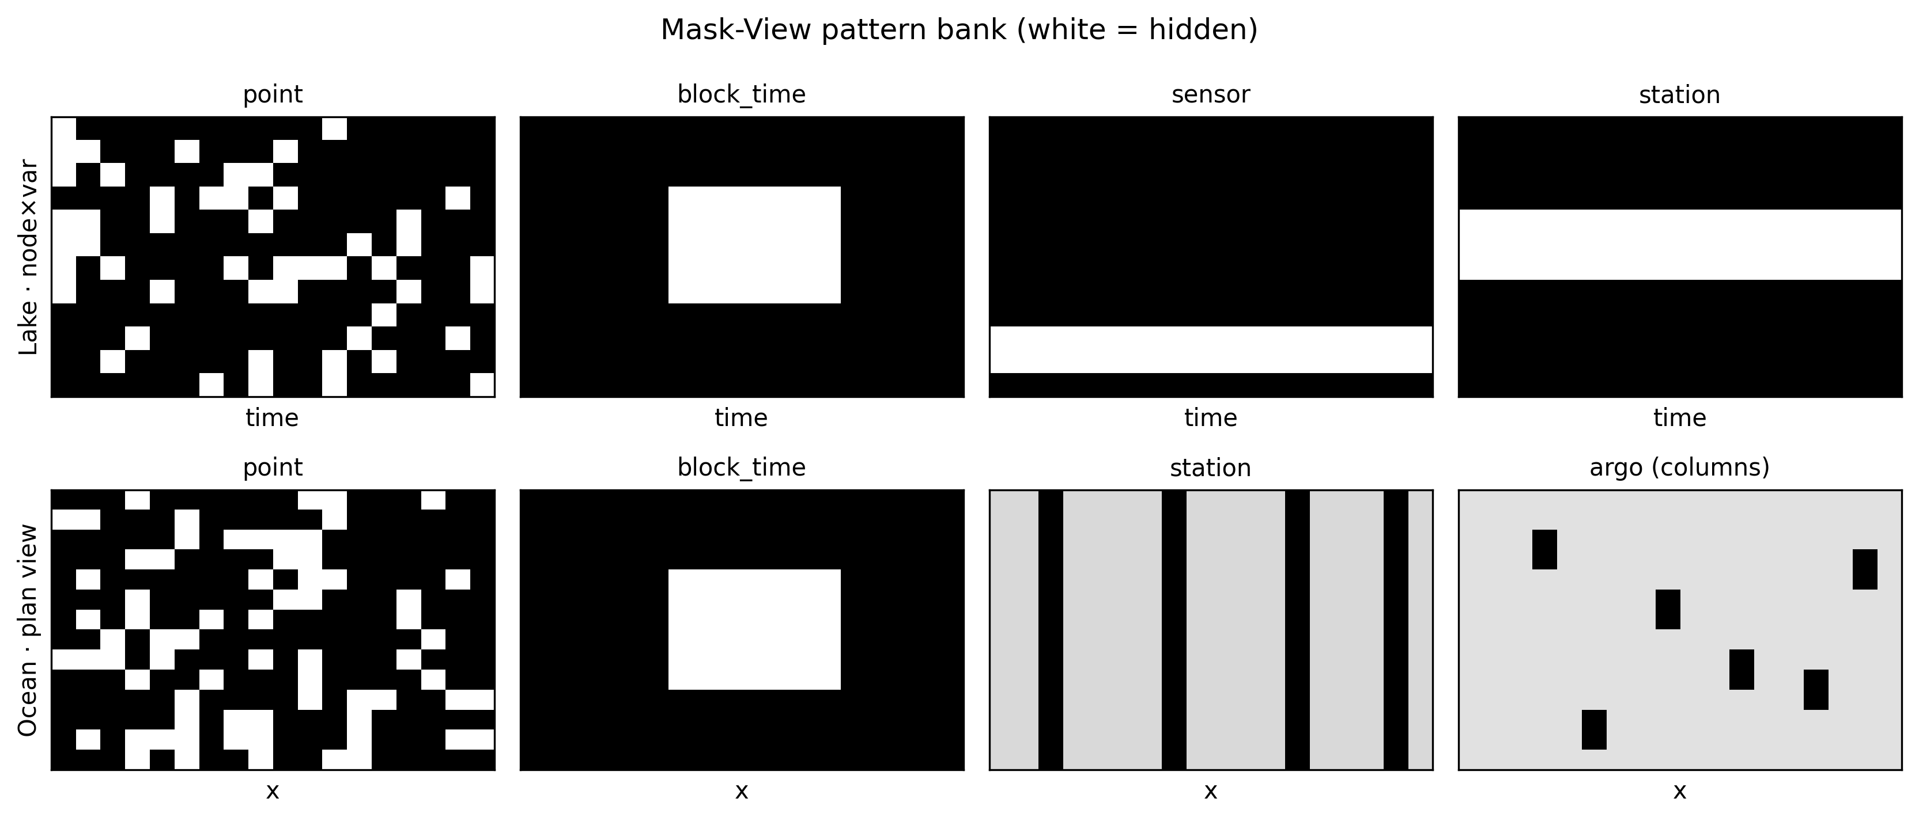
Fig. 1. Mask-View pattern bank. Top: lake windows (time × node–variable). Bottom: ocean plan-view masks, including Argo-like columns. White = hidden.
On Dianchi, 96.9% of naturally missing cells occur during full-station silence. Isolated one-step holes are 0.6%. Sensor-length gaps (≥1 day on a subset of variables) are 1.9%. The ecological record is therefore dominated by station blackouts, not by MCAR pinholes. A benchmark that only injects point holes is testing a minority failure mode.
3.2. Interpolability certificate predicts the Linear win
Table 2 reports ρ for every Mask-View setting and for the Wu et al. [10] bank. Point mean ρ is 0.9999; block-time mean ρ is 0.9998; mixed mean ρ is 0.8751. Sensor and station have ρ = 0 at every rate: once the channel or the site is dark for the whole window, no temporal neighbour remains. EcoInf random mean ρ is 0.9995; week-gap ρ is 1.0000. Declaring Linear admissible when ρ ≥ 0.5 matches a Linear win on 15/15 Mask-View settings. Sensor at 20% has MaskView-ST as the 105-grid MAE winner, but Linear remains forbidden (ρ = 0), so the certificate still separates Linear-legal from Linear-illegal. The scalar is computed from the mask. A second lake can copy the check without training seven models.
Bank | Setting | ρ | ρ both-sides | Linear MAE | BRITS MAE | 105-grid winner | Linear OK
Mask-View | point@10% | 1.0000 | 0.9335 | 0.151 | 0.429 | Linear | yes
Mask-View | point@20% | 0.9999 | 0.9238 | 0.161 | 0.429 | Linear | yes
Mask-View | point@30% | 0.9999 | 0.9126 | 0.171 | 0.431 | Linear | yes
Mask-View | block_time@10% | 0.9999 | 0.8958 | 0.264 | 0.448 | Linear | yes
Mask-View | block_time@20% | 0.9999 | 0.8782 | 0.252 | 0.436 | Linear | yes
Mask-View | block_time@30% | 0.9995 | 0.8790 | 0.246 | 0.441 | Linear | yes
Mask-View | sensor@10% | 0.0000 | 0.0000 | 0.680 | 0.431 | BRITS | no
Mask-View | sensor@20% | 0.0000 | 0.0000 | 0.691 | 0.416 | MaskView-ST | no
Mask-View | sensor@30% | 0.0000 | 0.0000 | 0.716 | 0.443 | BRITS | no
Mask-View | station@10% | 0.0000 | 0.0000 | 0.687 | 0.437 | BRITS | no
Mask-View | station@20% | 0.0000 | 0.0000 | 0.680 | 0.441 | BRITS | no
Mask-View | station@30% | 0.0000 | 0.0000 | 0.668 | 0.426 | BRITS | no
Mask-View | mixed@10% | 0.8347 | 0.7544 | 0.278 | 0.435 | Linear | yes
Mask-View | mixed@20% | 0.9034 | 0.8183 | 0.250 | 0.431 | Linear | yes
Mask-View | mixed@30% | 0.8872 | 0.7909 | 0.263 | 0.433 | Linear | yes
Wu random | random_20pct | 1.0000 | 0.9252 | — | — | Linear | yes
Wu random | random_40pct | 0.9999 | 0.8981 | — | — | Linear | yes
Wu random | random_60pct | 0.9998 | 0.8477 | — | — | Linear | yes
Wu random | random_80pct | 0.9982 | 0.6989 | — | — | Linear | yes
Wu week-gap | 1week | 1.0000 | 1.0000 | — | — | Linear | yes
Wu week-gap | 2week | 1.0000 | 1.0000 | — | — | Linear | yes
Wu week-gap | 3week | 1.0000 | 1.0000 | — | — | Linear | yes
Wu week-gap | 4week | 1.0000 | 1.0000 | — | — | Linear | yes
Table 2. Interpolability certificate. ρ is the fraction of hidden cells that still have an in-window temporal neighbour on the same station–variable. Linear OK means ρ ≥ 0.5. Wu et al. [10] MAE is not joined here; ranking under that bank is Linear in Table 4.
3.3. Supporting MAE ranking under Mask-View
Over 105 lake model–settings, linear interpolation wins 9 individual rate cells. BRITS wins 5, all of them sensor or station. MaskView-ST wins 1. Table 3 reports pattern-averaged standardised MAE. Linear is strongest on point, block-time, and mixed gaps. Those patterns leave temporal neighbours inside the 6-day window, which is why ρ ≈ 1 and Linear is admissible. A pooled mean MAE would have ranked MaskView-ST first (0.388 versus Linear 0.411) and hidden the reversal.
On sensor dropout, Linear and LOCF collapse because no within-series support remains. BRITS recovers cross-variable information. The spatial_plus_l0 recipe improves sensor MAE from the default MixHop 0.441 to 0.421, which is 0.009 below BRITS 0.430. We treat that as a sensitivity, not a second winner. MixHop’s station-outage MAE remains about 0.105 above BRITS (MaskView-ST 0.539, spatial_plus_l0 0.540, BRITS 0.435); Linear is 0.679. MixHop aggregates a local k-NN graph; BRITS mixes flattened cross-station channels. The failure is informative: a local graph is the wrong inductive bias when the whole site is dark.
Pattern | Linear | MaskView-ST | spatial_plus_l0 | BRITS | Winner (105-grid)
point | 0.161 | 0.297 | 0.295 | 0.429 | Linear
block_time | 0.254 | 0.326 | 0.313 | 0.442 | Linear
sensor | 0.696 | 0.441 | 0.421 | 0.430 | BRITS
station | 0.679 | 0.539 | 0.540 | 0.434 | BRITS
mixed | 0.264 | 0.339 | 0.334 | 0.433 | Linear
Table 3. Dianchi pattern-averaged standardised MAE (mean of 10/20/30% rates). Lower is better. Winner is the default 105-grid model; spatial_plus_l0 is an ablation recipe.
3.4. The Wu et al. bank never leaves the interpolable regime
The Wu et al. [10] bank does not produce ranking reversal (Table 4). Linear remains first at random 20/40/60/80% and at 1–4 week contiguous gaps. Table 2 already showed why: random mean ρ = 0.999 and week-gap ρ = 1.0. Week gaps of 1–4 weeks still leave neighbours on the full 2024 panel, so Linear is interpolating, not extrapolating off the end of a 6-day window. Ranking therefore depends on which missingness bank is used, not on swapping the lake.
Setting | ρ | Linear | LOCF | spatial_plus_l0 | Winner
random 20% | 1.0000 | 0.160 | 0.205 | 0.292 | Linear
random 40% | 0.9999 | 0.183 | 0.228 | 0.306 | Linear
random 60% | 0.9998 | 0.209 | 0.247 | 0.340 | Linear
random 80% | 0.9982 | 0.242 | 0.275 | 0.408 | Linear
1-week gap | 1.0000 | 0.311 | 0.357 | 0.349 | Linear
2-week gap | 1.0000 | 0.285 | 0.340 | 0.378 | Linear
3-week gap | 1.0000 | 0.341 | 0.416 | 0.401 | Linear
4-week gap | 1.0000 | 0.402 | 0.475 | 0.427 | Linear
Table 4. Same Dianchi 2024 test windows under the Wu et al. [10] missingness bank. Standardised MAE. Linear wins all eight settings. ρ never falls below 0.998.
Replaying the 2022 outage calendar onto observed 2024 cells (hide rate 10.52%) yields Linear MAE 0.383 versus MCAR at the same count 0.168. Replaying 2023 (3.46%) yields 0.328 versus 0.147. Linear still wins both replays. The MixHop recipe does not (0.494 and 0.474). Structure therefore approximately doubles Linear MAE relative to MCAR without flipping the winner. Ranking reversal appears only when the evaluation window itself has no temporal neighbours (Mask-View sensor and station). The calendar of real outages is interpolable along the year: neighbouring days still exist outside a 6-day window. The operational stress test is window-scale blackout, which is the station-silence geometry that already accounts for 96.9% of natural holes, taken at the scale of the evaluation window rather than the year.
3.5. Wrong Linear admission changes DO-drop and TN warnings
Table 5 scores warning skill only on decisions that depend on the imputation. On point holes (ρ ≈ 1) Linear is the warning champion: DO-drop CSI 0.798 versus BRITS 0.687, and TN CSI 0.948 versus 0.733. On sensor and station (ρ = 0) Linear CSI is identically zero. There is no in-window neighbour, so Linear cannot emit a usable reconstructed series on the hidden cells. BRITS recovers TN CSI to 0.720 (sensor) and 0.736 (station). DO-drop CSI under BRITS remains weak (0.200 / 0.208) because 24 h drop detection needs a short temporal contrast that a fully dark site does not provide. The flip is still decisive: deploying the MCAR champion produces no true positives on the hidden cells; deploying BRITS produces a usable TN alarm and a weak but non-zero DO alarm.
Cross-site spatial mean is a no-architecture borrow from other stations at the same time. On station DO it can exceed BRITS (CSI 0.337 versus 0.208). We report that as a sensitivity. The official operational model on the 105-grid remains BRITS. LOCF matches Linear CSI = 0 on sensor and station, as expected from ρ = 0.
Pattern | Task | Linear CSI | Linear F1 | BRITS CSI | BRITS F1 | CSI flip
point | DO drop | 0.798 | 0.887 | 0.687 | 0.815 | no
point | TN exceed | 0.948 | 0.974 | 0.733 | 0.846 | no
sensor | DO drop | 0.000 | — | 0.200 | 0.334 | yes
sensor | TN exceed | 0.000 | — | 0.720 | 0.837 | yes
station | DO drop | 0.000 | — | 0.208 | 0.345 | yes
station | TN exceed | 0.000 | — | 0.736 | 0.848 | yes
Table 5. Warning skill at hide rate 0.20, scored only on imputation-dependent decisions. DO drop: ≥2 mg L−1 within 24 h. TN exceed: ≥2 mg L−1. CSI flip means BRITS CSI > Linear CSI on a Linear-forbidden mask (ρ = 0).
3.6. Ocean: lead-1 Transformer, lead-2 climatology under column masks
Table 6 is the deploy rule. At one-month lead the Transformer remains first under every mask, including station (keep 0.089; RMSE 5.232 versus climatology 5.298) and the Argo-section proxy (keep 0.078; 5.241). Fair persist_locf never beats climatology (5.298 µmol kg−1). At two-month lead, hypoxia F1 prefers climatology (0.719) over the Transformer (0.68–0.69) on point, sensor, station, mixed and argo. block_time remains hybrid. Dense-history Transformer skill is therefore not a licence to replace climatology at lead-2 except when the gap is a temporary time slab.
Pattern | Keep | Lead-1 deploy | ST RMSE | Clim RMSE | Lead-2 deploy | Lead-2 F1 ST | Lead-2 F1 clim | Lead-2 F1 → clim
none | 1.000 | Transformer | 3.876 | 5.298 | hybrid/climatology | 0.701 | 0.719 | no
point | 0.249 | Transformer | 5.016 | 5.298 | climatology | 0.683 | 0.719 | yes
block | 0.267 | Transformer | 4.994 | 5.298 | climatology | 0.702 | 0.719 | yes
block_time | 0.450 | Transformer | 4.273 | 5.298 | hybrid | 0.698 | 0.719 | no
sensor | 0.200 | Transformer | 5.075 | 5.298 | climatology | 0.692 | 0.719 | yes
station | 0.089 | Transformer | 5.232 | 5.298 | climatology | 0.688 | 0.719 | yes
mixed | 0.205 | Transformer | 5.071 | 5.298 | climatology | 0.688 | 0.719 | yes
argo | 0.078 | Transformer | 5.241 | 5.298 | climatology | 0.685 | 0.719 | yes
Table 6. Ocean deploy rule from frozen Mask-View ablation (no retrain). RMSE in µmol kg−1. Lead-2 F1 uses the cube tenth-percentile hypoxia threshold (195.09 µmol kg−1).
Table 7 reports the supporting lead-1 RMSE that the deploy rule reads. Persistence scored on unmasked history is an oracle last-month score. It is not a sparse baseline. persist_locf uses only kept oxygen. Temporal linear interpolation equals persist_locf under static spatial masks, because a last-month forecast only needs the endpoint. Horizontal interpolation of sparse columns is worse than persistence (RMSE 12–15). The competitive simple bar is therefore climatology.
Pattern | Keep | persist_locf | Climatology | ST | ST vs dense | clim − ST
none | 1.000 | 8.265 | 5.298 | 3.876 | — | 1.422
block_time | 0.450 | 10.049 | 5.298 | 4.273 | +10% | 1.025
point | 0.249 | 6.176 | 5.298 | 5.016 | +29% | 0.282
sensor | 0.200 | 5.990 | 5.298 | 5.075 | +31% | 0.223
station | 0.089 | 5.599 | 5.298 | 5.232 | +35% | 0.066
argo | 0.078 | 5.538 | 5.298 | 5.241 | +35% | 0.057
Table 7. East China Sea lead-1 RMSE (µmol kg−1). persist_locf ingests the same mask; climatology does not need recent oxygen.
The remaining station and section edges look small enough to be noise if one only inspects overlapping marginal RMSE intervals. The paired difference is the right test. Month-resampled Δ stays positive in all 200 replicates: dense history 1.426 [1.344, 1.537]; point 0.296 [0.264, 0.343]; station 0.078 [0.064, 0.093]; section 0.062 [0.051, 0.071]. Retrain RMSE tracks the locked ablation to within 0.02 µmol kg−1. The residual 0.06 µmol kg−1 at the default eight-column mask is statistically signed on this window. It is not operationally large. That is why Table 6 still deploys the Transformer at lead-1 and still refuses it at lead-2 under column masks.
3.7. Keep versus geometry
The default table confounds rate with geometry. Station keeps 0.089 of water voxels. Point keeps 0.25. A keep scan (Fig. 2; Table 8) separates the two. On point (the lake 10/20/30% analog) the Transformer wins every rate. Matching voxel keep, columns are only modestly harsher. Four columns (keep 0.044) shrink Δ to 0.013, but the paired interval still excludes zero. Operational sparsity therefore does not invert lead-1 ranking. It taxes the learned advantage mainly by how much oxygen history remains. Longer leads go back to climatology.
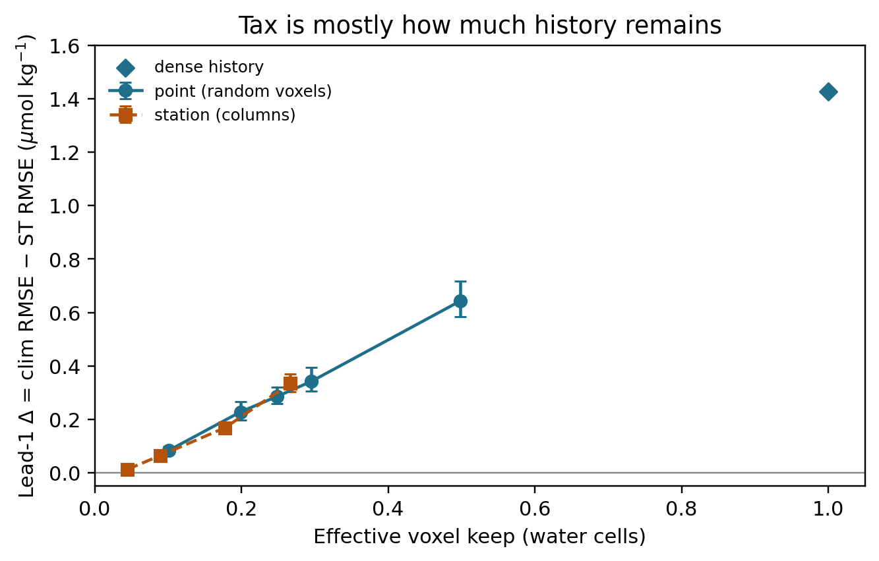
Fig. 2. Lead-1 Δ = climatology RMSE − Transformer RMSE versus effective voxel keep. Error bars are paired month-block 5–95% intervals (n = 22, 200 resamples). Point is the lake 10/20/30% analog; station varies column count.
Setting | Geometry | Keep | ST | Δ (clim−ST) | Δ 5–95%
point 10% | point | 0.101 | 5.214 | 0.084 | [0.071, 0.098]
point 20% | point | 0.199 | 5.069 | 0.228 | [0.197, 0.267]
point 30% | point | 0.295 | 4.956 | 0.342 | [0.306, 0.394]
4 columns | station | 0.044 | 5.284 | 0.013 | [0.006, 0.022]
8 columns (default) | station | 0.089 | 5.233 | 0.064 | [0.054, 0.075]
16 columns | station | 0.178 | 5.129 | 0.169 | [0.155, 0.184]
24 columns | station | 0.267 | 4.963 | 0.335 | [0.304, 0.369]
Table 8. Keep scan, 8-epoch ablation recipe. Δ is climatology RMSE minus Transformer RMSE (µmol kg−1). The Transformer remains first in every row at lead-1.
3.8. Cross-media winner identity
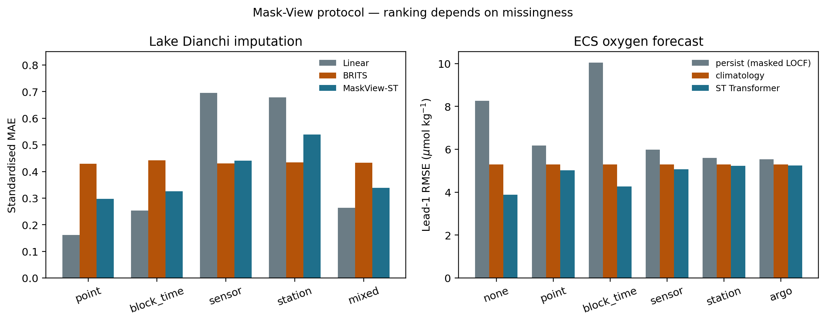
Fig. 3. Rankings under the shared bank. Left: Dianchi standardised MAE for Linear, BRITS and MaskView-ST. Right: East China Sea lead-1 RMSE for persist_locf, climatology and the Transformer.
Easy lake gaps reward Linear because ρ is high. Hard lake gaps forbid Linear because ρ = 0, and they flip warning CSI. Dense ocean history rewards a Transformer at lead-1. Column-limited history does not let persistence steal that win, but it does send lead-2 hypoxia F1 back to climatology. A benchmark that only injects point holes, or that scores persistence on unmasked history, would have missed both decision flips. Table 9 records winner identity on shared pattern names.
Pattern | Lake winner | Ocean lead-1 best | Ocean lead-2 best | Ocean ST degradation
point | Linear | st_transformer | climatology | 0.294
block_time | Linear | st_transformer | hybrid_clim_st | 0.102
sensor | BRITS | st_transformer | climatology | 0.309
station | BRITS | st_transformer | climatology | 0.350
mixed | Linear | st_transformer | climatology | 0.308
Table 9. Shared-pattern winner identity. Degradation is relative to dense-history ST RMSE.
4. Discussion
4.1. The transferable object is the certificate
Another AHFM network can compute ρ on its own masks and decide whether Linear is legal before fitting BRITS. The threshold ρ ≥ 0.5 was sufficient to recover every Linear win on this 105-grid. It is a decision threshold, not a universal physical constant. A second lake should recompute ρ and re-check the threshold; it should not copy our MixHop weights and declare the problem solved.
Wu et al. [10] remain the closest Dianchi reconstruction study. They showed that a biased tensor ensemble can reconstruct Dianchi under random and week-gap missingness. We show that that missingness bank never leaves the interpolable regime (ρ ≥ 0.998), and that the same lake reverses ranking and warning CSI under operational masks. The two papers are complementary. A reader who only cites the tensor RMSE will over-trust Linear on the next station outage.
4.2. Warning CSI is the management object
MAE ranking and warning ranking agree on the qualitative split: Linear on point holes, learned or cross-site models when ρ = 0. They do not agree on how good the operational winner is. BRITS recovers TN exceedance (CSI 0.72–0.74) because a dark site can still borrow a nutrient level from other variables or other times in the learned dynamics. Recovering a 24 h DO drop needs a short temporal contrast that a fully dark site does not provide, so BRITS DO CSI stays near 0.21. We report that gap. A paper that advertised “BRITS solves station blackout” from MAE alone would have over-claimed the warning.
The operational mistake is still well defined. If Linear is deployed because an MCAR or Wu-bank table said so, the hidden-cell warning has CSI = 0. That is a management failure, not a decimal on a leaderboard. Spatial mean can beat BRITS on station DO CSI as a transparent cross-site borrow. We keep BRITS as the official operational model because it is the 105-grid winner; spatial mean is the inductive-bias check that a site-dark window must borrow in space.
4.3. Ocean lead-2 is a second decision flip
For coastal oxygen, the analog is a profile-limited interior [4,5,24]. Climatology does not need last month’s oxygen. A learned model does. When history is dense, the Transformer buys more than 1 µmol kg−1 at lead-1 (F1 0.74). When history is eight columns, the purchase is 0.06 µmol kg−1. At lead-2 the hypoxia F1 purchase disappears except under block-time gaps. A hypoxia product that advertises learned skill under dense reanalysis is not licensed to claim the same skill under Argo-like sampling two months ahead.
4.4. Failed cases and limits of transfer
MixHop does not close the lake station-outage gap to BRITS [20]. We do not hide that. A local distance graph is a poor model of a silent site. Year-shift replay does not reverse ranking. Treating Mask-View station as “what actually happened last year” would be a misreading. Station silence is the dominant cell geometry; the year-scale calendar still leaves interpolable neighbours. The stress test is window-scale blackout.
The ocean cube is WOA-informed development oxygen. Ranking under masks holds as a protocol demonstration. A hypoxia early-warning product for the East China Sea would need time-varying oxygen targets [4,19]. Process-level fronts are out of scope. Unmasked persistence invariance is not a finding. After fair scoring, climatology is the simple method to beat. Lake 10/20/30% should be compared with ocean point keep, not with keep_ratio = 0.25 on station.
We did not reimplement Wu et al. tensor factorization. Dual-protocol tables use our Linear, LOCF and MixHop models under their hide design. Linear wins that design because ρ never falls below 0.998. That is a protocol result, not a claim that tensor factorization is weak. Single-author, two media, one lake network, one development cube: we did not add a second lake or GOBAI-O2. Transfer copies the certificate, then re-scores local baselines. We do not claim that BRITS will win station dropout on every network, or that ρ = 0.5 is the right threshold everywhere. BRITS warning uses an 8-epoch reuse, not a tuned operational system.
4.5. What an operations team should do
Compute ρ on the hide you actually face. If ρ is high, use linear interpolation; it is cheaper, and it wins both MAE and warning CSI on point holes. If ρ = 0, do not use Linear or LOCF. Use a model that can borrow from other variables or other sites, and score the alarm on the hidden cells rather than on a pooled MAE. If the task is a one-month oxygen forecast, a Transformer can beat climatology even under column masks, but the edge shrinks with keep. At two-month lead, use climatology unless the gap is a temporary time slab. These rules travel because they are attached to a named interpolability condition, not to a lake name.
5. Conclusions
Missingness protocol is part of the scientific claim because it changes who is allowed to interpolate and who should raise a hypoxia or nutrient alarm. On Dianchi, a mask-only certificate ρ separates Linear-legal hides from Linear-forbidden hides on 15/15 settings, explains why the Wu et al. [10] bank never reverses ranking, and predicts a warning CSI collapse when Linear is deployed into sensor or station blackout. On a shelf oxygen cube, the same named bank keeps a Transformer at lead-1 and returns hypoxia F1 to climatology at lead-2 under column-limited keep. Compute ρ before claiming that a learned model replaces Linear, and score the alarm on the cells the mask actually hid.
Software availability
Item | Detail
Name | Mask-View interpolability certificate
Developer | Senjie Zhang
Contact | 3079099853@qq.com
Year first available | 2026
Hardware required | CPU for ρ and frozen tables; optional NVIDIA GPU for BRITS warning
Software required | Python ≥ 3.10, pandas, numpy; optional PyPOTS / PyTorch
Program language | Python
Availability | https://github.com/Az0998/maskview-aquatic-protocol (MIT)
Lake / ocean engines | https://github.com/Az0998/dianchi-maskview-imputation ; https://github.com/Az0998/ocean-do-forecast
Cost | Free
Software availability. Frozen CSVs rebuild every table and figure without a GPU.
Data availability
Frozen tables and figures are in https://github.com/Az0998/maskview-aquatic-protocol. Lake engine: https://github.com/Az0998/dianchi-maskview-imputation. Ocean engine: https://github.com/Az0998/ocean-do-forecast. Dianchi-Water: https://huggingface.co/datasets/anonymous-dianchi-2026/dianchi-water (CC BY 4.0).
CRediT authorship contribution statement
Senjie Zhang: Conceptualization, Methodology, Software, Formal analysis, Writing – original draft, Writing – review and editing.
Acknowledgements
The author thanks the China National Environmental Monitoring Center for the automatic-station data-release system.
Declaration of competing interest
The author declares no competing interests.
Funding
This research received no external funding.
Declaration of generative AI
English grammar was checked with automated writing tools. The author designed the protocol, ran the analyses, verified every number against frozen tables, and takes full responsibility for the text.
References
[1] Little, R.J.A., Rubin, D.B., 2019. Statistical Analysis with Missing Data, 3rd ed. Wiley, Hoboken, NJ.
[2] van Buuren, S., 2018. Flexible Imputation of Missing Data, 2nd ed. CRC Press, Boca Raton, FL.
[3] Zhang, S., 2026. dianchi-water: high-frequency multi-station surface water quality dataset for the Dianchi Lake basin (2022–2024). Hugging Face Datasets. https://huggingface.co/datasets/anonymous-dianchi-2026/dianchi-water (accessed 1 September 2026).
[4] Sharp, J.D., Fassbender, A.J., Carter, B.R., Johnson, G.C., Schultz, C., Dunne, J.P., 2023. GOBAI-O2: temporally and spatially resolved fields of ocean interior dissolved oxygen over nearly two decades. Earth Syst. Sci. Data 15, 4481–4518.
[5] Breitburg, D., Levin, L.A., Oschlies, A., Grégoire, M., Chavez, F.P., Conley, D.J., Garçon, V., Gilbert, D., Gutiérrez, D., Isensee, K., Jacinto, G.S., Limburg, K.E., Montes, I., Naqvi, S.W.A., Pitcher, G.C., Rabalais, N.N., Roman, M.R., Rose, K.A., Seibel, B.A., Telszewski, M., Yasuhara, M., Zhang, J., 2018. Declining oxygen in the global ocean and coastal waters. Science 359, eaam7240.
[6] Cao, W., Wang, D., Li, J., Zhou, H., Li, L., Li, Y., 2018. BRITS: bidirectional recurrent imputation for time series. In: Advances in Neural Information Processing Systems 31.
[7] Du, W., Côté, D., Liu, Y., 2023. SAITS: self-attention-based imputation for time series. Expert Syst. Appl. 219, 119619.
[8] Che, Z., Purushotham, S., Cho, K., Sontag, D., Liu, Y., 2018. Recurrent neural networks for multivariate time series with missing values. Sci. Rep. 8, 6085.
[9] Cini, A., Marisca, I., Alippi, C., 2022. Filling the GApS: multivariate time series imputation by graph neural networks. In: International Conference on Learning Representations.
[10] Wu, X., Shan, K., Wang, L., Wang, J., Shang, M., 2025. Spatiotemporal water quality data reconstruction: a tensor factorization framework. Ecol. Inform. 90, 103283. https://doi.org/10.1016/j.ecoinf.2025.103283.
[11] Abu-El-Haija, S., Perozzi, B., Kapoor, A., Alipourfard, N., Lerman, K., Harutyunyan, H., Ver Steeg, G., Galstyan, A., 2019. MixHop: higher-order graph convolutional architectures via sparsified neighborhood mixing. In: Proceedings of the 36th International Conference on Machine Learning, pp. 21–29.
[12] Vaswani, A., Shazeer, N., Parmar, N., Uszkoreit, J., Jones, L., Gomez, A.N., Kaiser, Ł., Polosukhin, I., 2017. Attention is all you need. In: Advances in Neural Information Processing Systems 30.
[13] Paerl, H.W., Huisman, J., 2008. Blooms like it hot. Science 320, 57–58.
[14] Huang, C., Wang, X., Yang, H., Li, Y., Wang, Y., Chen, X., Xu, L., 2014. Satellite data regarding the eutrophication response to human activities in the plateau lake Dianchi in China from 1974 to 2009. Sci. Total Environ. 485–486, 1–11.
[15] China National Environmental Monitoring Center (CNEMC), 2026. National surface water quality automatic monitoring data release system. https://szzdjc.cnemc.cn (accessed 1 September 2026).
[16] Du, W., 2026. PyPOTS: a Python toolbox for data mining on partially-observed time series. https://pypots.com (accessed 1 September 2026).
[17] Wilks, D.S., 2019. Statistical Methods in the Atmospheric Sciences, 4th ed. Elsevier, Amsterdam.
[18] Jolliffe, I.T., Stephenson, D.B., 2012. Forecast Verification: A Practitioner’s Guide in Atmospheric Science, 2nd ed. Wiley, Chichester.
[19] Zheng, G., Li, M., Harding, L.W. Jr., DiGiacomo, P.M., 2024. Hypoxia forecasting for Chesapeake Bay using artificial intelligence. Artif. Intell. Earth Syst. 3, e230054.
[20] Kipf, T.N., Welling, M., 2017. Semi-supervised classification with graph convolutional networks. In: International Conference on Learning Representations.
[21] Yi, X., Zheng, Y., Zhang, J., Li, T., 2016. ST-MVL: filling missing values in geo-sensory time series data. In: Proceedings of the 25th International Joint Conference on Artificial Intelligence, pp. 2704–2710.
[22] Gao, W., Howarth, R.W., Swaney, D.P., Hong, B., Guo, H.C., 2015. Enhanced N input to Lake Dianchi Basin from 1980 to 2010: drivers and implications. Environ. Pollut. 198, 234–242.
[23] Zhang, Y., Ma, R., Zhang, M., Duan, H., Loiselle, S., Xu, J., 2015. Fourteen-year record (2000–2013) of the spatial and temporal dynamics of floating algae blooms in Lake Dianchi, China. Remote Sens. 7, 11203–11222.
[24] Diaz, R.J., Rosenberg, R., 2008. Spreading dead zones and consequences for marine ecosystems. Science 321, 926–929.

