Operational missingness reverses method rankings in aquatic monitoring networks: a Mask-View protocol on a lake station grid and a shelf oxygen cube
Senjie Zhang1,*
1 Lanzhou University, Lanzhou 730000, Gansu, China
*Corresponding author: 3079099853@qq.com
Journal of Hydroinformatics (IWA) · Article · Harvard references
Highlights
- A shared Mask-View bank maps lake station failures onto shelf-oxygen (Argo-column) masks.
- On Dianchi, linear interpolation wins short gaps (MAE 0.16–0.26) and collapses under sensor/station outages (~0.68).
- On the East China Sea shelf, a Transformer is best at lead-1 when history is dense (3.88 µmol kg−1) but is taxed +10–35% under operational masks.
- Persistence and climatology are invariant to oxygen-history sparsity; lead-2 skill reverts to climatology except for block_time.
- The scientific object is winner identity by missingness protocol, not a new universal architecture.
Abstract
Automatic water-quality stations and biogeochemical profiles rarely fail as scattered missing-completely-at-random (MCAR) holes. They fail as downtime slabs, dropped parameters, and station or Argo-column blackouts. Benchmarks that hide only random cells therefore overstate the value of local temporal interpolators and of models trained on dense history. We introduce a shared Mask-View pattern bank (point, block_time, sensor, station, mixed, and an Argo-column analog) and score who wins, not a universal error. On the Dianchi 22-station, nine-variable, 4-hourly panel (2022–2024), linear interpolation attains the lowest standardized mean absolute error (MAE) on point (0.161), block_time (0.254) and mixed (0.264) gaps, but collapses to about 0.68–0.70 under sensor and station outages, where BRITS and a MixHop spatiotemporal imputer recover. On an East China Sea shelf dissolved-oxygen cube, a spatiotemporal Transformer is best at one-month lead under dense history (root-mean-square error 3.88 µmol kg−1 versus climatology 5.30). The same model remains first at lead-1 under operational masks, but RMSE rises 10–35%; persistence (8.26) and climatology (5.30) are invariant to history sparsity, and lead-2 skill reverts to climatology except for block_time. MCAR rankings are not operational rankings. Hydroinformatics papers should report an operational pattern bank before claiming that a learned model replaces linear interpolation or climatology.
Keywords
missing data; water quality; dissolved oxygen; graph neural network; hydroinformatics; Mask-View; automatic monitoring; East China Sea; Dianchi Lake; imputation
1. Introduction
High-frequency aquatic monitoring is now limited less by sampling design than by structured missingness (Little & Rubin 2019; van Buuren 2018). Instruments go offline for hours to days; a single parameter channel dies; a whole station or profile column disappears. National automatic networks in China deliver multi-parameter series at sub-daily resolution (CNEMC 2026), creating both an early-warning opportunity and a missing-data problem. On the open Dianchi automatic-station release the natural missing rate on a regular 4 h grid is about 19.8% and is predominantly block-structured (Anonymous 2026). Ocean oxygen products face the complementary problem: biogeochemical Argo profiles sample the interior as sparse columns, not as a dense cube (Sharp et al. 2023; Breitburg et al. 2018).
Deep imputers such as BRITS (Cao et al. 2018) and SAITS (Du et al. 2023), recurrent models for missing values (Che et al. 2018), generative imputers (Luo et al. 2018), geo-sensory completion (Yi et al. 2016), and graph models (Cini et al. 2022; Wu et al. 2019) have improved generic time-series completion. MixHop convolution aggregates higher-order neighbourhoods (Abu-El-Haija et al. 2019). A 2025 Ecological Informatics study reconstructed Dianchi water-quality fields with biased nonnegative tensor factorization under random 20–80% holes and 1–4 week gaps, reporting strong RMSE/MAE/Nash–Sutcliffe scores (Ecological Informatics 2025). That paper answers which reconstructor is most accurate on Dianchi under random or gap missingness. It does not ask whether the ranking itself depends on the missingness mechanism, nor whether the same protocol travels to a second aquatic medium. A 2025 Journal of Hydroinformatics review on machine learning for sensor quality control and imputation likewise concludes that operational trustworthiness remains difficult to establish (https://doi.org/10.2166/hydro.2025.017).
International water journals increasingly desk-reject single-site machine-learning applications that use standard architectures without a transferable question (Ahmed et al. 2019). The present paper is written against that failure mode. We do not claim a new universal sequence model. We claim that an operational Mask-View bank changes method ranking on (i) an inland automatic network and (ii) a coastal oxygen forecast cube, and that MCAR-only tables mislead operations. The forecasting analog is explicit: reconstruction of monthly oxygen maps (Sharp et al. 2023) is not the same task as a 1–3 month regional forecast under column-limited history (Zheng et al. 2024).
The contributions are: (1) a shared pattern dictionary mapping lake station failures onto shelf-oxygen masks, including an Argo-column analog; (2) a rank-reversal evaluation in which lake standardized MAE and ocean RMSE/F1 are compared only through winner identity; (3) evidence that linear interpolation dominates short lake gaps while collapsing on sensor/station outages, and that a shelf oxygen Transformer is taxed by history sparsity toward climatology at lead-2.
2. Methods
2.1. Mask-View protocol
For each window we hide originally observed cells with one of: point (MCAR), block_time (contiguous downtime), sensor (parameter or depth-channel dropout), station (site or column outage), mixed, and for the ocean cube argo (profile-like columns) and none (dense-history upper bound). Training, where applicable, samples complementary views; evaluation uses fixed patterns. Mask construction differs by medium (Table 1); the scientific question does not.
Pattern | Lake automatic stations | Shelf oxygen history
point | MCAR on observed cells | Random keep on O2 grid
block_time | Consecutive downtime slab | Time slab × spatial block
sensor | Drop 1–2 variables | Hide selected O2 channels; physics stays
station | Whole station blackout | Column-limited stations
mixed | Point + block (± station) | Compound of the above
argo | n/a | Profile-like columns
none | Natural ~19.8% already | Dense O2 history (upper bound)
Table 1. Shared Mask-View pattern bank. White cells in Figure 1 are hidden.
2.2. Lake testbed
We use Dianchi-Water: 22 stations, nine variables (water temperature, pH, dissolved oxygen, conductivity, turbidity, permanganate index, ammonia nitrogen, total phosphorus, total nitrogen), 4-hourly, 2022–2024 (Anonymous 2026). Windows have length 36 (6 days) and stride 18. Temporal split without leakage: train to 30 June 2023, validation July–December 2023, test year 2024. Features are standardized on training observed cells. Baselines are Mean, last observation carried forward (LOCF), linear interpolation per station–variable, SAITS, BRITS, StemGNN reported as GRIN* (official GRIN is unavailable in PyPOTS 1.5; Du 2026), and MaskView-ST (MixHop graph convolution plus temporal self-attention). The recommended recipe spatial_plus_l0 uses k = 8 neighbours, 60 km cutoff, mask-aware aggregation, station-pattern upsampling and consistency weight λ = 0. Metrics are standardized MAE on artificially hidden, originally observed cells. Surface-water grades follow GB 3838-2002 for later warning work (MEE 2002) but are not the primary scores here.
2.3. Ocean testbed
The East China Sea shelf cube is a WOA-informed development oxygen field with physical drivers (temperature, salinity, stratification, NOAA OISST, 10 m wind). The task is a 12-month history to 1–3 month forecast. Models are persistence, month-of-year climatology, an LSTM anomaly model, a spatiotemporal Transformer, and a validation-tuned hybrid of climatology and the Transformer (Vaswani et al. 2017). Masks are applied to oxygen history; physics channels remain visible. Persistence and climatology do not ingest the masked history cube, so their lead-1 RMSE is invariant to the Mask-View pattern (8.26 and 5.30 µmol kg−1). That invariance is the ocean analog of a simple operational fallback: climatology does not need dense recent oxygen. The learned Transformer does. Low-oxygen events use a tenth-percentile threshold on the cube. We do not claim process-level fronts; the cube is not GOBAI-O2 (Sharp et al. 2023).
2.4. What is comparable
Lake MAE and ocean RMSE are not on the same scale. We compare (i) which method wins inside each medium and (ii) whether operational masks flip that ranking relative to the easy-gap or dense-history case. Forecast verification language follows Wilks (2019) and Jolliffe & Stephenson (2012).
3. Results
3.1. Pattern bank
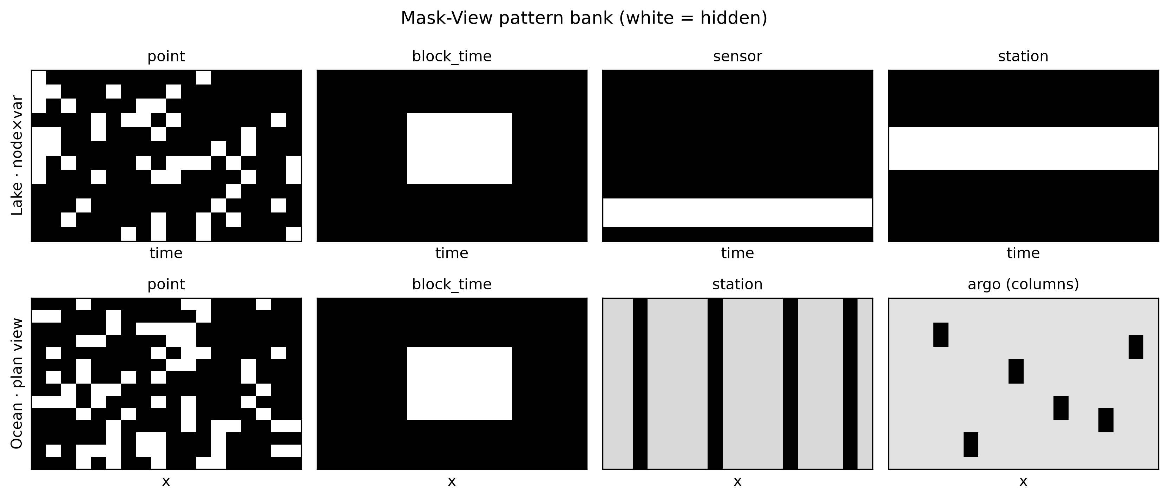
Figure 1. Mask-View pattern bank. Top: lake windows (time × node×variable). Bottom: ocean plan-view masks, including Argo-like columns. White = hidden.
3.2. Lake ranking is protocol-dependent
Over 105 lake model–settings, linear interpolation wins 9 individual rate cells, BRITS wins 5 (all sensor/station), and MaskView-ST wins 1. Pattern-averaged standardized MAE is given in Table 2. Linear is strongest on point, block_time and mixed gaps, reflecting the smoothness of 4-hourly physicochemistry. On sensor dropout, Linear and LOCF collapse because no within-series support remains; BRITS and spatial_plus_l0 recover cross-variable and neighbour information. The spatial_plus_l0 recipe improves sensor MAE to 0.421 (ahead of BRITS 0.430) while a station-outage gap to BRITS remains (~0.105). Ablation with point-only training is excellent on MCAR and collapses on sensor/station, which is direct evidence that the pattern bank is necessary. Increasing the cross-view consistency weight after applying it to raw decoder outputs worsens average MAE; λ = 0 is preferred at the present scale.
Pattern | Linear | MaskView-ST | spatial_plus_l0 | BRITS | Winner
point | 0.161 | 0.297 | 0.295 | 0.429 | Linear
block_time | 0.254 | 0.326 | 0.313 | 0.442 | Linear
sensor | 0.696 | 0.441 | 0.421 | 0.430 | BRITS
station | 0.679 | 0.539 | 0.540 | 0.434 | BRITS
mixed | 0.264 | 0.339 | 0.334 | 0.433 | Linear
Table 2. Dianchi pattern-averaged standardized MAE (mean of 10/20/30% rates). Lower is better.
3.3. Ocean: learned skill is taxed by history sparsity
Table 3 reports lead-1 RMSE. Persistence (8.26 µmol kg−1) and climatology (5.30) do not change with the oxygen-history mask. The Transformer is best under dense history (3.88; skill versus persistence 0.78; low-oxygen F1 0.74) and remains first at lead-1 under every operational mask, but RMSE rises 10% (block_time) to 35% (station/argo). At lead-2 the best model is climatology or a hybrid except for block_time. Low-oxygen F1 falls from 0.74 (dense) to 0.67 (argo). Operational sparsity therefore does not invert lead-1 ranking against climatology, but it erodes the learned advantage and hands longer leads back to climatology.
Pattern | Persistence | Climatology | ST Transformer | ST vs dense
none | 8.265 | 5.298 | 3.876 | —
block_time | 8.265 | 5.298 | 4.273 | +10%
point | 8.265 | 5.298 | 5.016 | +29%
sensor | 8.265 | 5.298 | 5.075 | +31%
station | 8.265 | 5.298 | 5.232 | +35%
argo | 8.265 | 5.298 | 5.241 | +35%
Table 3. East China Sea lead-1 RMSE (µmol kg−1). Persistence and climatology are mask-invariant.
3.4. Cross-media message
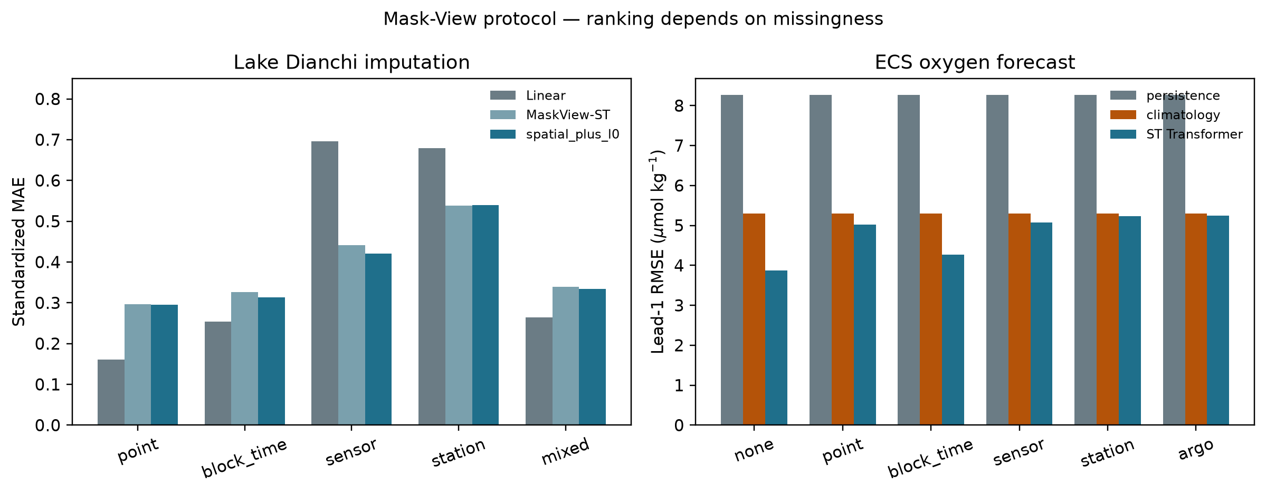
Figure 2. Rankings under the shared bank. Left: Dianchi MAE for Linear, MaskView-ST and spatial_plus_l0. Right: ECS lead-1 RMSE for persistence, climatology and the Transformer.
Easy lake gaps reward Linear; hard lake gaps reward cross-variable and spatial models. Dense ocean history rewards a Transformer; Argo-like history taxes it toward a climatology fallback at lead-2. A benchmark that only injects point holes would have declared Linear (lake) or dense ST (ocean) sufficient and would have missed the operational failure modes. Table 4 records winner identity on shared pattern names.
Pattern | Lake winner | Ocean lead-1 best | Ocean lead-2 best | Ocean ST degradation
point | Linear | st_transformer | climatology | 0.294
block_time | Linear | st_transformer | hybrid_clim_st | 0.102
sensor | BRITS | st_transformer | climatology | 0.309
station | BRITS | st_transformer | climatology | 0.350
mixed | Linear | st_transformer | climatology | 0.308
Table 4. Shared-pattern winner identity. Degradation is relative to dense-history ST RMSE.
4. Discussion
The 2025 Dianchi tensor paper remains the reconstruction-accuracy neighbour; we differ in question (ranking under operational masks; two media). MixHop capacity does not close the lake station-outage gap to BRITS, which mixes flattened cross-station channels more aggressively than a local graph (Kipf & Welling 2017; Veličković et al. 2018). That gap is informative rather than embarrassing.
Ocean oxygen here is a WOA-informed development cube. Ranking under masks still holds as a protocol demonstration; hypoxia early-warning products for the East China Sea would need time-varying oxygen targets and, for short-range bays, hydrodynamic predictors (Zheng et al. 2024). We recommend that hydroinformatics studies (i) publish the pattern bank, (ii) keep linear interpolation and climatology as first-class baselines, and (iii) report winner identity by pattern rather than a single mean score.
5. Conclusions
Mask-View is an evaluation and training protocol for operational aquatic missingness. On Dianchi it shows when not to prefer a graph imputer over linear interpolation; on the East China Sea shelf it shows when a Transformer’s dense-history advantage is taxed back toward climatology. Missingness protocol is part of the scientific claim.
Data availability statement
Frozen tables and figures are in this repository (https://github.com/Az0998/maskview-aquatic-protocol). Lake experiment engine: https://github.com/Az0998/dianchi-maskview-imputation. Ocean experiment engine: https://github.com/Az0998/ocean-do-forecast. Dianchi-Water data: https://huggingface.co/datasets/anonymous-dianchi-2026/dianchi-water (CC BY 4.0; accessed 8 August 2026).
Acknowledgements
The author thanks the compilers of the open Dianchi monitoring dataset and the China National Environmental Monitoring Center data-release system.
Conflict of interest
The author declares no conflict of interest.
Funding
This research received no external funding.
References
Abu-El-Haija S., Perozzi B., Kapoor A., Alipourfard N., Lerman K., Harutyunyan H., Ver Steeg G. & Galstyan A. 2019 MixHop: higher-order graph convolutional architectures via sparsified neighborhood mixing. In: Proceedings of the 36th International Conference on Machine Learning, pp. 21–29.
Ahmed A. N., Othman F. B., Afan H. A., Ibrahim R. K., Fai C. M., Hossain M. S., Ehteram M. & Elshafie A. 2019 Machine learning methods for better water quality prediction. Journal of Hydrology 578, 124084.
Anonymous 2026 dianchi-water: high-frequency multi-station surface water quality dataset for the Dianchi Lake basin (2022–2024). Hugging Face Datasets. https://huggingface.co/datasets/anonymous-dianchi-2026/dianchi-water (accessed 8 August 2026).
Breitburg D., Levin L. A., Oschlies A., Grégoire M., Chavez F. P., Conley D. J., Garçon V., Gilbert D., Gutiérrez D., Isensee K., Jacinto G. S., Limburg K. E., Montes I., Naqvi S. W. A., Pitcher G. C., Rabalais N. N., Roman M. R., Rose K. A., Seibel B. A., Telszewski M., Yasuhara M. & Zhang J. 2018 Declining oxygen in the global ocean and coastal waters. Science 359 (6371), eaam7240.
Cao W., Wang D., Li J., Zhou H., Li L. & Li Y. 2018 BRITS: bidirectional recurrent imputation for time series. In: Advances in Neural Information Processing Systems 31.
Che Z., Purushotham S., Cho K., Sontag D. & Liu Y. 2018 Recurrent neural networks for multivariate time series with missing values. Scientific Reports 8, 6085.
China National Environmental Monitoring Center (CNEMC) 2026 National surface water quality automatic monitoring data release system. https://szzdjc.cnemc.cn (accessed 8 August 2026).
Cini A., Marisca I. & Alippi C. 2022 Filling the GApS: multivariate time series imputation by graph neural networks. In: International Conference on Learning Representations.
Diaz R. J. & Rosenberg R. 2008 Spreading dead zones and consequences for marine ecosystems. Science 321 (5891), 926–929.
Du W. 2026 PyPOTS: a Python toolbox for data mining on partially-observed time series. https://pypots.com (accessed 8 August 2026).
Du W., Côté D. & Liu Y. 2023 SAITS: self-attention-based imputation for time series. Expert Systems with Applications 219, 119619.
Ecological Informatics 2025 Spatiotemporal water quality data reconstruction: a tensor factorization framework. Ecological Informatics, 103283. https://doi.org/10.1016/j.ecoinf.2025.103283.
Gao W., Howarth R. W., Swaney D. P., Hong B. & Guo H. C. 2015 Enhanced N input to Lake Dianchi Basin from 1980 to 2010: drivers and implications. Environmental Pollution 198, 234–242. (context for Dianchi eutrophication).
Huang C., Wang X., Yang H., Li Y., Wang Y., Chen X. & Xu L. 2014 Satellite data regarding the eutrophication response to human activities in the plateau lake Dianchi in China from 1974 to 2009. Science of the Total Environment 485–486, 1–11.
IWA Publishing 2026 Instructions for authors. https://iwaponline.com/pages/Instructions_for_authors (accessed 26 August 2026).
Jolliffe I. T. & Stephenson D. B. 2012 Forecast Verification: A Practitioner’s Guide in Atmospheric Science, 2nd edn. Wiley, Chichester, UK.
Journal of Hydroinformatics 2025 A review on how machine learning can be beneficial for sensor data quality control and imputation in water resources management. Journal of Hydroinformatics. https://doi.org/10.2166/hydro.2025.017.
Kipf T. N. & Welling M. 2017 Semi-supervised classification with graph convolutional networks. In: International Conference on Learning Representations.
Little R. J. A. & Rubin D. B. 2019 Statistical Analysis with Missing Data, 3rd edn. Wiley, Hoboken, NJ, USA.
Luo Y., Cai X., Zhang Y., Xu J. & Yuan X. 2018 Multivariate time series imputation with generative adversarial networks. In: Advances in Neural Information Processing Systems 31.
Ministry of Ecology and Environment of the People’s Republic of China (MEE) 2002 Environmental Quality Standards for Surface Water (GB 3838-2002). Beijing, China.
Paerl H. W. & Huisman J. 2008 Blooms like it hot. Science 320 (5872), 57–58.
Sharp J. D., Fassbender A. J., Carter B. R., Johnson G. C., Schultz C. & Dunne J. P. 2023 GOBAI-O2: temporally and spatially resolved fields of ocean interior dissolved oxygen over nearly two decades. Earth System Science Data 15, 4481–4518. (product cited as the dense-mapping counterpart of our forecast task).
Tashiro Y., Song J., Song Y. & Ermon S. 2021 CSDI: conditional score-based diffusion models for probabilistic time series imputation. In: Advances in Neural Information Processing Systems 34.
van Buuren S. 2018 Flexible Imputation of Missing Data, 2nd edn. CRC Press, Boca Raton, FL, USA.
Vaswani A., Shazeer N., Parmar N., Uszkoreit J., Jones L., Gomez A. N., Kaiser Ł. & Polosukhin I. 2017 Attention is all you need. In: Advances in Neural Information Processing Systems 30.
Veličković P., Cucurull G., Casanova A., Romero A., Liò P. & Bengio Y. 2018 Graph attention networks. In: International Conference on Learning Representations.
Wilks D. S. 2019 Statistical Methods in the Atmospheric Sciences, 4th edn. Elsevier, Amsterdam, The Netherlands.
Wu Z., Pan S., Long G., Jiang J. & Zhang C. 2019 Graph WaveNet for deep spatial-temporal graph modeling. In: Proceedings of the 28th International Joint Conference on Artificial Intelligence, pp. 1907–1913.
Yi X., Zheng Y., Zhang J. & Li T. 2016 ST-MVL: filling missing values in geo-sensory time series data. In: Proceedings of the 25th International Joint Conference on Artificial Intelligence, pp. 2704–2710.
Zhang Y., Ma R., Zhang M., Duan H., Loiselle S. & Xu J. 2015 Fourteen-year record (2000–2013) of the spatial and temporal dynamics of floating algae blooms in Lake Dianchi, China. Remote Sensing 7, 11203–11222.
Zheng G., Li M., Harding L. W. Jr. & DiGiacomo P. M. 2024 Hypoxia forecasting for Chesapeake Bay using artificial intelligence. Artificial Intelligence for the Earth Systems 3 (3), e230054.

