Lovely Professional University
Section: EM017 CA: 3
Max. Mark: 50
Note: Make a single pdf file and upload on UMS, with code and snapshots.
_____________________________________________________________________________________
Q1: Consider the article.txt file and perform the following text-mining operations:
- Read the article.txt file.
- Display first few rows of the file.
- Clean the text and display first few rows after cleaning.
- Calculate the number of time word repeated in the document
- Display the number of time each word repeated.
- Make a colorful word cloud

Q2: Create the following charts along with their code (hint: echo command) in Rmarkdown to create the html dashboard, present everything as professional and with inference of these charts:
- Consider the cars dataset in R and develop the following graph:
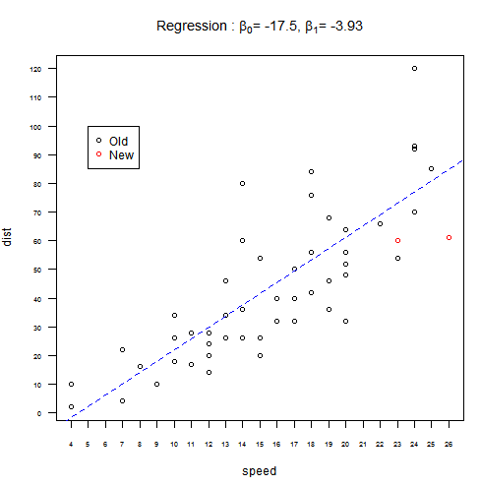
- Consider the airquality dataset and plot the following histograms with multiple colors:
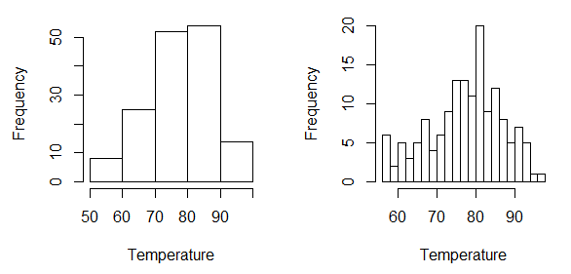
- Develop a pie chart by calculating from the following dataset to show the ratio of male and female.
Rollnumber | Name | Gender
101 | John | Male
102 | Ken | Female
103 | Dolly | Female
104 | Peter | Male
105 | Harry | Male

